Q1.Write a JavaScript program to perform an online quiz
CODE:
<!DOCTYPE html>
<html lang="en">
<head>
<meta charset="UTF-8">
<meta name="viewport" content="width=device-width, initial-scale=1.0">
<title>Online Quiz</title>
<style>
body {
font-family: Arial, sans-serif;
background-color: #f0f8ff;
color: #333;
text-align: center;
}

h1 {
color: #4682b4;
}

.question {
margin: 20px 0;
}

.options {
margin: 10px 0;
}

.result {
margin-top: 20px;
font-size: 20px;
}

.button {
padding: 10px 20px;
background-color: #4682b4;
color: white;
border: none;
cursor: pointer;
}

.button:hover {
background-color: #5f9ea0;
}
</style>
</head>
<body>

<h1>Online Quiz</h1>

<div id="quiz-container">
<!-- Question 1 -->
<div class="question" id="q1">
<p>1. What is the capital of France?</p>
<div class="options">
<input type="radio" name="q1" value="A"> A. Berlin<br>
<input type="radio" name="q1" value="B"> B. Madrid<br>
<input type="radio" name="q1" value="C"> C. Paris<br>
<input type="radio" name="q1" value="D"> D. Rome
</div>
</div>

<!-- Question 2 -->
<div class="question" id="q2">
<p>2. Who wrote "Romeo and Juliet"?</p>
<div class="options">
<input type="radio" name="q2" value="A"> A. Charles Dickens<br>
<input type="radio" name="q2" value="B"> B. William Shakespeare<br>
<input type="radio" name="q2" value="C"> C. Jane Austen<br>
<input type="radio" name="q2" value="D"> D. Mark Twain
</div>
</div>

<!-- Question 3 -->
<div class="question" id="q3">
<p>3. What is the square root of 64?</p>
<div class="options">
<input type="radio" name="q3" value="A"> A. 6<br>
<input type="radio" name="q3" value="B"> B. 7<br>
<input type="radio" name="q3" value="C"> C. 8<br>
<input type="radio" name="q3" value="D"> D. 9
</div>
</div>

<!-- Submit Button -->
<button class="button" onclick="checkAnswers()">Submit Quiz</button>

<!-- Result -->
<div id="result" class="result"></div>
</div>

<script>
function checkAnswers() {
let score = 0;

// Check Question 1
if (document.querySelector('input[name="q1"]:checked') && document.querySelector('input[name="q1"]:checked').value === "C") {
score++;
}

// Check Question 2
if (document.querySelector('input[name="q2"]:checked') && document.querySelector('input[name="q2"]:checked').value === "B") {
score++;
}

// Check Question 3
if (document.querySelector('input[name="q3"]:checked') && document.querySelector('input[name="q3"]:checked').value === "C") {
score++;
}

// Display result
const resultDiv = document.getElementById("result");
resultDiv.innerHTML = `You scored ${score} out of 3!`;

// Optional: Provide feedback based on score
if (score === 3) {
resultDiv.innerHTML += "<br>Excellent!";
} else if (score === 2) {
resultDiv.innerHTML += "<br>Good Job!";
} else {
resultDiv.innerHTML += "<br>Better luck next time!";
}
}
</script>

</body>
</html>

OUTPUT:

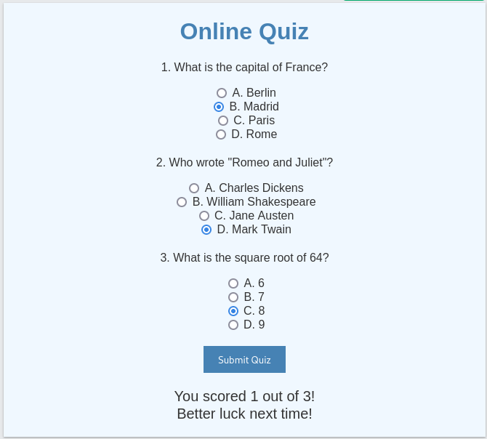

Q2) Write a JavaScript program to Wish a user at different hours of a day. Use
appropriate dialog boxes for wishing the user. Display the dynamic clock on the
web page. Make use of CSS and HTML5 elements for creative and attractive
design.

CODE:<!DOCTYPE html>
<html lang="en">
<head>
<meta charset="UTF-8">
<meta name="viewport" content="width=device-width, initial-scale=1.0">
<title>Dynamic Greeting and Clock</title>
<style>
body {
background-color: #f2f4f7;
font-family: 'Arial', sans-serif;
display: flex;
justify-content: center;
align-items: center;
height: 100vh;
margin: 0;
}

.container {
text-align: center;
background-color: #fff;
border-radius: 15px;
padding: 50px;
box-shadow: 0 4px 8px rgba(0, 0, 0, 0.2);
width: 300px;
}

h1 {
font-size: 2rem;
color: #4CAF50;
}

.greeting {
font-size: 1.5rem;
margin-top: 20px;
color: #333;
}

.clock {
font-size: 2.5rem;
margin-top: 30px;
color: #333;
font-weight: bold;
letter-spacing: 2px;
}

.time-of-day {
color: #FF6347;
font-size: 1rem;
margin-top: 10px;
}
</style>
</head>
<body>

<div class="container">
<h1>Welcome to the Dynamic Greeting</h1>
<div class="greeting" id="greeting">Loading greeting...</div>
<div class="clock" id="clock">00:00:00</div>
<div class="time-of-day" id="time-of-day"> </div>
</div>

<script>
// Function to update the clock and greeting
function updateTime() {
const now = new Date();
const hours = now.getHours();
const minutes = now.getMinutes();
const seconds = now.getSeconds();

// Format time to always show two digits for hours, minutes, and seconds
const formattedTime = `${formatTime(hours)}:${formatTime(minutes)}:${formatTime(seconds)}`;

// Update the clock on the webpage
document.getElementById('clock').innerText = formattedTime;

// Greet the user based on the time of day
let greetingMessage = "";
let timeOfDayMessage = "";

if (hours >= 5 && hours < 12) {
greetingMessage = "Good Morning!";
timeOfDayMessage = "It's a fresh start to the day!";
// Alert the user with morning greeting
if (hours === 5 && minutes === 0 && seconds === 0) {
alert(greetingMessage);
}
} else if (hours >= 12 && hours < 17) {
greetingMessage = "Good Afternoon!";
timeOfDayMessage = "Hope you're having a productive day!";
// Alert the user with afternoon greeting
if (hours === 12 && minutes === 0 && seconds === 0) {
alert(greetingMessage);
}
} else if (hours >= 17 && hours < 21) {
greetingMessage = "Good Evening!";
timeOfDayMessage = "Relax and enjoy the evening!";
// Alert the user with evening greeting
if (hours === 17 && minutes === 0 && seconds === 0) {
alert(greetingMessage);
}
} else {
greetingMessage = "Good Night!";
timeOfDayMessage = "Sleep well and recharge for tomorrow!";
// Alert the user with night greeting
if (hours === 0 && minutes === 0 && seconds === 0) {
alert(greetingMessage);
}
}

// Update the greeting and time-of-day message on the webpage
document.getElementById('greeting').innerText = greetingMessage;
document.getElementById('time-of-day').innerText = timeOfDayMessage;
}

// Helper function to format the time (always show two digits)
function formatTime(time) {
return time < 10 ? `0${time}` : time;
}

// Update the clock every second
setInterval(updateTime, 1000);
</script>

</body>
</html>

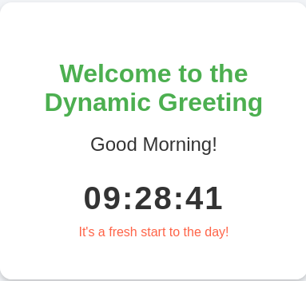
OUTPUT:

Q3.Write the java script program to display the grade [A, B,C,D] based on the marks
entered by student(take the input into text boxes). Enter the marks of 4 subjects and
calculate the average( using button). If the avg>90 then A, avg>80 then B, if avg>70
then C, if avg>60 then D.
CODE:
<!DOCTYPE html>
<html lang="en">
<head>
<meta charset="UTF-8">
<meta name="viewport" content="width=device-width, initial-scale=1.0">
<title>Student Grade Calculator</title>
<style>
body {
font-family: Arial, sans-serif;
background-color: #f9f9f9;
display: flex;
justify-content: center;
align-items: center;
height: 100vh;
margin: 0;
}

.container {
background-color: #fff;
padding: 30px;
border-radius: 10px;
box-shadow: 0 4px 8px rgba(0, 0, 0, 0.2);
width: 300px;
text-align: center;
}

h1 {
color: #4CAF50;
}

input[type="number"] {
padding: 10px;
margin: 10px 0;
width: 80%;
border-radius: 5px;
border: 1px solid #ccc;
}

button {
padding: 10px 20px;
background-color: #4CAF50;
color: white;
border: none;
border-radius: 5px;
cursor: pointer;
font-size: 16px;
}

button:hover {
background-color: #45a049;
}

.result {
margin-top: 20px;
font-size: 20px;
font-weight: bold;
}
</style>
</head>
<body>

<div class="container">
<h1>Grade Calculator</h1>

<!-- Form for entering marks -->
<div>
<label for="sub1">Subject 1:</label>
<input type="number" id="sub1" placeholder="Enter marks" min="0" max="100">
</div>
<div>
<label for="sub2">Subject 2:</label>
<input type="number" id="sub2" placeholder="Enter marks" min="0" max="100">
</div>
<div>
<label for="sub3">Subject 3:</label>
<input type="number" id="sub3" placeholder="Enter marks" min="0" max="100">
</div>
<div>
<label for="sub4">Subject 4:</label>
<input type="number" id="sub4" placeholder="Enter marks" min="0" max="100">
</div>

<!-- Button to calculate grade -->
<button onclick="calculateGrade()">Calculate Grade</button>

<!-- Display the result -->
<div class="result" id="result"></div>
</div>

<script>
function calculateGrade() {
// Get the marks from the input fields
var sub1 = parseInt(document.getElementById("sub1").value);
var sub2 = parseInt(document.getElementById("sub2").value);
var sub3 = parseInt(document.getElementById("sub3").value);
var sub4 = parseInt(document.getElementById("sub4").value);

// Validate if any subject marks are empty or invalid
if (isNaN(sub1) || isNaN(sub2) || isNaN(sub3) || isNaN(sub4)) {
document.getElementById("result").innerHTML = "Please enter valid marks for all subjects.";
return;
}

// Calculate the average marks
var average = (sub1 + sub2 + sub3 + sub4) / 4;

// Determine the grade based on the average
var grade = "";
if (average > 90) {
grade = "A";
} else if (average > 80) {
grade = "B";
} else if (average > 70) {
grade = "C";
} else if (average > 60) {
grade = "D";
} else {
grade = "F";
}

// Display the grade and average
document.getElementById("result").innerHTML = `Average: ${average.toFixed(2)} <br> Grade: ${grade}`;
}
</script>

</body>
</html>
OUTPUT:
