220962019_week6
rollno:09
class:CSE AI AND ML sec A

1) Develop a web application using Django framework to demonstrate the transfer of
multiple parameters between web pages. User should be presented with a dropdown
list containing car manufacturers, a text box which takes model name of the
manufacturer and a submit button. On submitting the web page, the user is forwarded
to a new page. This new page should display the selected car manufacturer name and
the model name.
=================================================================
# carapp/forms.py
from django import forms

class CarForm(forms.Form):
# List of car manufacturers
MANUFACTURERS = [
('toyota', 'Toyota'),
('honda', 'Honda'),
('ford', 'Ford'),
('bmw', 'BMW'),
('mercedes', 'Mercedes'),
]

manufacturer = forms.ChoiceField(choices=MANUFACTURERS, label="Car Manufacturer")
model_name = forms.CharField(max_length=100, label="Model Name")
===================================================================
# carapp/views.py
from django.shortcuts import render
from .forms import CarForm

def car_form(request):
if request.method == 'POST':
form = CarForm(request.POST)
if form.is_valid():
manufacturer = form.cleaned_data['manufacturer']
model_name = form.cleaned_data['model_name']
return render(request, 'carapp/result.html', {'manufacturer': manufacturer, 'model_name': model_name})
else:
form = CarForm()
return render(request, 'carapp/car_form.html', {'form': form})
=====================================================================
<!-- carapp/templates/carapp/car_form.html -->
<html>
<body>
<h2>Car Model Form</h2>
<form method="POST">
{% csrf_token %}
<div>
<label for="id_manufacturer">Car Manufacturer:</label>
{{ form.manufacturer }}
</div>
<div>
<label for="id_model_name">Model Name:</label>
{{ form.model_name }}
</div>
<button type="submit">Submit</button>
</form>
</body>
</html>
==================================================
OUTPUT:
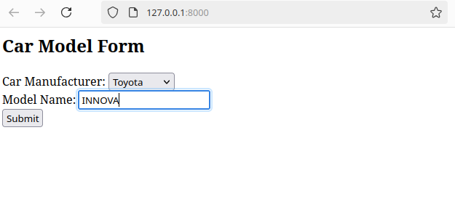
2) Create a page firstPage.html with two TextBoxes [Name, Roll], DropDownList
[Subjects], and a button. Create another page secondPage.html with a label and a
button. When the user clicks the button in first Page, he should be sent to the second
page and display the contents passed from first page in the label. The button in second
page should navigate the user back to firstPage. Use Django sessions to transfer
information.
==============================================
from django.shortcuts import render, redirect
from django.http import HttpResponse

def first_page(request):
if request.method == 'POST':
# Get form data from the request
name = request.POST.get('name')
roll = request.POST.get('roll')
subject = request.POST.get('subject')

# Store data in session
request.session['name'] = name
request.session['roll'] = roll
request.session['subject'] = subject

return redirect('second_page')
return render(request, 'firstPage.html')

def second_page(request):
# Retrieve data from session
name = request.session.get('name', '')
roll = request.session.get('roll', '')
subject = request.session.get('subject', '')

context = {'name': name, 'roll': roll, 'subject': subject}

if request.method == 'POST':
return redirect('first_page')

return render(request, 'secondPage.html', context)

================================================

<!DOCTYPE html>
<html>
<head>
<title>First Page</title>
</head>
<body>
<h1>Enter Your Details</h1>
<form method="POST">
{% csrf_token %}
<label for="name">Name:</label>
<input type="text" id="name" name="name" required><br><br>

<label for="roll">Roll Number:</label>
<input type="text" id="roll" name="roll" required><br><br>

<label for="subject">Subject:</label>
<select id="subject" name="subject" required>
<option value="Math">Math</option>
<option value="Science">Science</option>
<option value="History">History</option>
<option value="English">English</option>
</select><br><br>

<button type="submit">Submit</button>
</form>
</body>
</html>

===================================================================

<!DOCTYPE html>
<html>
<head>
<title>Second Page</title>
</head>
<body>
<h1>Your Details</h1>
<p>Name: {{ name }}</p>
<p>Roll Number: {{ roll }}</p>
<p>Subject: {{ subject }}</p>

<form method="POST">
{% csrf_token %}
<button type="submit">Go Back to First Page</button>
</form>
</body>
</html>
============================================================
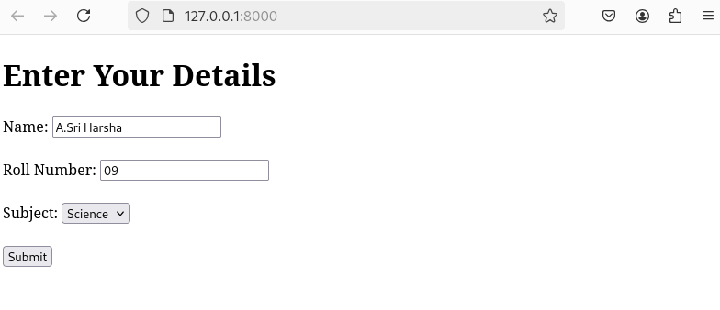
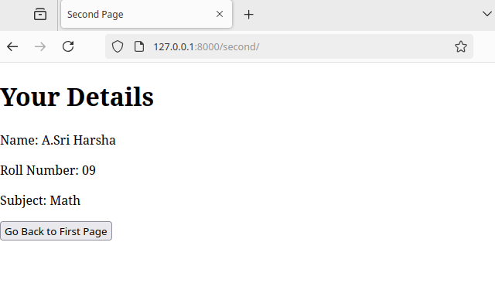
Output:

