WEEK -4
A.SRI HARSHA
AI AND ML (SEC A)
REG NO:220962019

1. Write a web page which contains table with 3 X 3 dimensions (fill some data) and one
image. Style the rows with alternate color. Move the table and image together from
right to left when button is clicked.
CODE:
<!DOCTYPE html>
<html lang="en">
<head>
<meta charset="UTF-8">
<meta name="viewport" content="width=device-width, initial-scale=1.0">
<title>Move Table and Image</title>
<script src="https://code.jquery.com/jquery-3.6.0.min.js"></script>
<style>
table {
width: 300px;
border-collapse: collapse;
margin: 20px 0;
}
td, th {
border: 1px solid #000;
padding: 10px;
text-align: center;
}
/* Apply alternating row colors */
.alternate-color tr:nth-child(odd) {
background-color: #f2f2f2; /* Light gray for odd rows */
}
.alternate-color tr:nth-child(even) {
background-color: #d9f7be; /* Light green for even rows */
}
#tableAndImage {
position: relative;
}
img {
width: 100px;
height: 100px;
margin-left: 20px;
}
button {
padding: 10px 20px;
margin: 20px 0;
}
</style>
</head>
<body>

<button id="moveButton">Move Table and Image</button>

<div id="tableAndImage">
<table class="alternate-color">
<tr>
<th>Header 1</th>
<th>Header 2</th>
<th>Header 3</th>
</tr>
<tr>
<td>Row 1, Cell 1</td>
<td>Row 1, Cell 2</td>
<td>Row 1, Cell 3</td>
</tr>
<tr>
<td>Row 2, Cell 1</td>
<td>Row 2, Cell 2</td>
<td>Row 2, Cell 3</td>
</tr>
<tr>
<td>Row 3, Cell 1</td>
<td>Row 3, Cell 2</td>
<td>Row 3, Cell 3</td>
</tr>
</table>
<img src="https://encrypted-tbn0.gstatic.com/images?q=tbn:ANd9GcRpp23FWRxwEJ42yvOFgv0Xp4H-nNA903X3WA&s" alt="Sample Image">
</div>

<script type="text/javascript">
$(document).ready(function() {
$('#moveButton').click(function() {
$('#tableAndImage').animate({ left: '0px' }, 1000); // 1000ms = 1 second
});

// Initially position the table and image off-screen to the right
$('#tableAndImage').css('left', '500px');
});
</script>

</body>
</html>
OUTPUT:
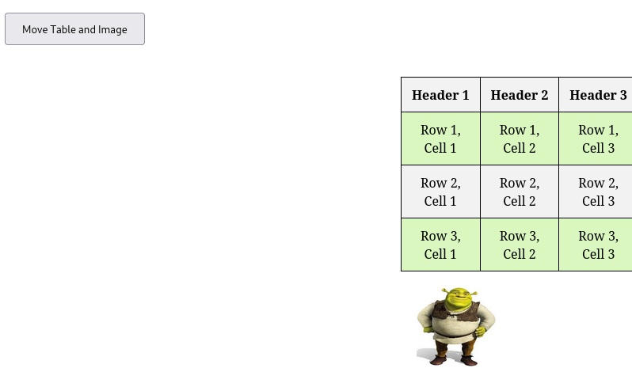

2. Design a calculator to perform basic arithmetic operations. Use textboxes and buttons
to design web page.
CODE:
<!DOCTYPE html>
<html lang="en">
<head>
<meta charset="UTF-8">
<meta name="viewport" content="width=device-width, initial-scale=1.0">
<title>Basic Calculator</title>
<script src="https://code.jquery.com/jquery-3.6.0.min.js"></script>
<style>
body {
font-family: Arial, sans-serif;
display: flex;
justify-content: center;
align-items: center;
height: 100vh;
margin: 0;
background-color: #f0f0f0;
}
.calculator {
background-color: #fff;
border-radius: 10px;
padding: 20px;
box-shadow: 0 0 10px rgba(0, 0, 0, 0.1);
}
.calculator input {
width: 100%;
padding: 10px;
font-size: 20px;
margin-bottom: 10px;
text-align: right;
border-radius: 5px;
border: 1px solid #ccc;
}
.calculator button {
width: 60px;
height: 60px;
font-size: 20px;
background-color: #4CAF50;
color: white;
border: none;
border-radius: 5px;
margin: 5px;
cursor: pointer;
}
.calculator button:hover {
background-color: #45a049;
}
.calculator .row {
display: flex;
justify-content: center;
}
</style>
</head>
<body>

<div class="calculator">
<input type="text" id="display" disabled>

<div class="row">
<button class="button" onclick="appendToDisplay('7')">7</button>
<button class="button" onclick="appendToDisplay('8')">8</button>
<button class="button" onclick="appendToDisplay('9')">9</button>
<button class="button" onclick="appendToDisplay('+')">+</button>
</div>
<div class="row">
<button class="button" onclick="appendToDisplay('4')">4</button>
<button class="button" onclick="appendToDisplay('5')">5</button>
<button class="button" onclick="appendToDisplay('6')">6</button>
<button class="button" onclick="appendToDisplay('-')">-</button>
</div>
<div class="row">
<button class="button" onclick="appendToDisplay('1')">1</button>
<button class="button" onclick="appendToDisplay('2')">2</button>
<button class="button" onclick="appendToDisplay('3')">3</button>
<button class="button" onclick="appendToDisplay('*')">*</button>
</div>
<div class="row">
<button class="button" onclick="appendToDisplay('0')">0</button>
<button class="button" onclick="clearDisplay()">C</button>
<button class="button" onclick="calculateResult()">=</button>
<button class="button" onclick="appendToDisplay('/')">/</button>
</div>
</div>

<script>
function appendToDisplay(value) {
// Append the value to the display input box
document.getElementById("display").value += value;
}

function clearDisplay() {
// Clear the display input box
document.getElementById("display").value = '';
}

function calculateResult() {
// Get the expression from the display input
var expression = document.getElementById("display").value;

try {
// Evaluate the expression and display the result
var result = eval(expression);
document.getElementById("display").value = result;
} catch (error) {
// If there is an error (like invalid input), clear the display
document.getElementById("display").value = 'Error';
}
}
</script>

</body>
</html>
OUTPUT:
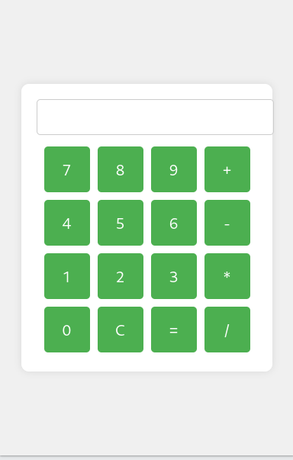

3. Create a web page to design a birthday card shown below.
CODE:
<!DOCTYPE html>
<html lang="en">
<head>
<meta charset="UTF-8">
<meta name="viewport" content="width=device-width, initial-scale=1.0">
<title>Birthday Card Designer</title>
<script src="https://code.jquery.com/jquery-3.6.0.min.js"></script>
<style>
body {
font-family: Arial, sans-serif;
}
#container {
display: flex;
}
#controls {
width: 300px;
padding: 10px;
border-right: 2px solid #ccc;
}
#card {
width: 300px;
height: 400px;
border: 2px solid black;
text-align: center;
padding: 20px;
display: flex;
flex-direction: column;
justify-content: center;
align-items: center;
background-color: yellow;
}
.border-none {
border: none;
}
.border-double {
border: 5px double black;
}
.border-solid {
border: 5px solid black;
}
img {
width: 100px;
height: auto;
}
</style>
</head>
<body>

<div id="container">
<div id="controls">
<label>Choose a background color:</label>
<select id="bgColor">
<option value="yellow">Yellow</option>
<option value="pink">Pink</option>
<option value="lightblue">Light Blue</option>
</select><br><br>

<label>Choose a font:</label>
<select id="fontFamily">
<option value="Verdana">Verdana</option>
<option value="Arial">Arial</option>
<option value="Times New Roman">Times New Roman</option>
</select><br><br>

<label>Specify a numeric font size:</label>
<input type="number" id="fontSize" value="25"><br><br>

<label>Choose a border style:</label><br>
<input type="radio" name="borderStyle" value="none" checked> None
<input type="radio" name="borderStyle" value="double"> Double
<input type="radio" name="borderStyle" value="solid"> Solid<br><br>

<input type="checkbox" id="addImage" checked> Add the Default Picture<br><br>

<label>Enter the greeting text below:</label><br>
<textarea id="greetingText" rows="3">Happy Birthday, and many more</textarea><br><br>

<button id="updateCard">Update</button>
</div>

<div id="card">
<p id="greeting">Happy Birthday, and many more</p>
<img id="cakeImage" src="https://files.creamats.com/cache/products/images/2/j/a/600x600/0/5/673f3ddc07046fac67f1033e99bae8821ef675/80605-birthday-stamp.webp" alt="Birthday Cake">
</div>
</div>

<script>
$(document).ready(function () {
$('#updateCard').click(function () {
// Update background color
$('#card').css('background-color', $('#bgColor').val());

// Update font style and size
$('#greeting').css({
'font-family': $('#fontFamily').val(),
'font-size': $('#fontSize').val() + 'px'
});

// Update border style
let borderClass = $('input[name="borderStyle"]:checked').val();
$('#card').removeClass('border-none border-double border-solid').addClass('border-' + borderClass);

// Update greeting text
$('#greeting').text($('#greetingText').val());

// Toggle image
if ($('#addImage').is(':checked')) {
$('#cakeImage').show();
} else {
$('#cakeImage').hide();
}
});
});
</script>

</body>
</html>
OUTPUT:

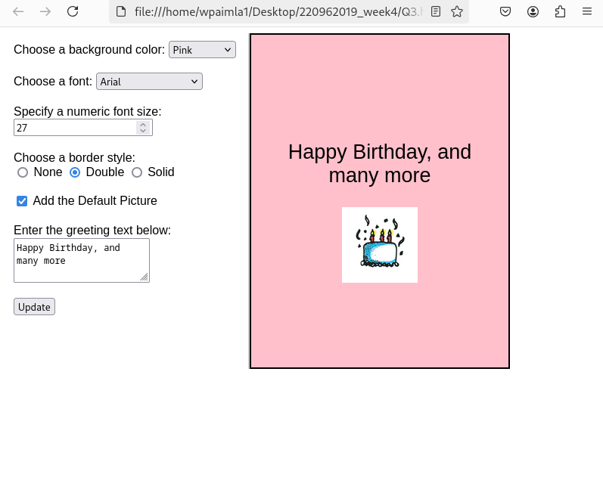
4. Design a webpage. The page contains:
• Dropdown list with HP, Nokia, Samsung, Motorola, Apple as items.
• Checkbox with Mobile and Laptop as items. Textbox where you enter quantity.
• There is a button with text as ‘Produce Bill’.
On Clicking Produce Bill button, alert should be displayed with total amount.
CODE:
<!DOCTYPE html>
<html lang="en">
<head>
<meta charset="UTF-8">
<meta name="viewport" content="width=device-width, initial-scale=1.0">
<title>Product Bill</title>
<style>
body {
font-family: Arial, sans-serif;
background-color: #f4f4f9;
display: flex;
justify-content: center;
align-items: center;
height: 100vh;
margin: 0;
}
.container {
background-color: #ffffff;
padding: 20px;
border-radius: 8px;
box-shadow: 0 0 10px rgba(0, 0, 0, 0.1);
width: 300px;
}
h2 {
text-align: center;
}
label {
display: block;
margin-bottom: 10px;
}
select, input, button {
width: 100%;
padding: 10px;
margin: 10px 0;
border-radius: 5px;
border: 1px solid #ccc;
}
.checkbox-group {
display: flex;
justify-content: space-between;
}
.checkbox-group label {
margin-right: 15px;
margin-left: 5px;
}
button {
background-color: #4CAF50;
color: white;
border: none;
cursor: pointer;
}
button:hover {
background-color: #45a049;
}
</style>
</head>
<body>

<div class="container">
<h2>Order Form</h2>

<label for="brand">Choose Brand:</label>
<select id="brand">
<option value="HP">HP</option>
<option value="Nokia">Nokia</option>
<option value="Samsung">Samsung</option>
<option value="Motorola">Motorola</option>
<option value="Apple">Apple</option>
</select>

<label>Choose Product Type:</label>
<div class="checkbox-group">
<label><input type="checkbox" id="mobile"> Mobile</label>
<label><input type="checkbox" id="laptop"> Laptop</label>
</div>

<label for="quantity">Enter Quantity:</label>
<input type="number" id="quantity" min="1" value="1">

<button onclick="produceBill()">Produce Bill</button>
</div>

<script>
function produceBill() {

var brand = document.getElementById('brand').value;

var mobileSelected = document.getElementById('mobile').checked;
var laptopSelected = document.getElementById('laptop').checked;

var quantity = document.getElementById('quantity').value;

var prices = {
"Mobile": 500,
"Laptop": 1000
};

var totalAmount = 0;
if (mobileSelected) {
totalAmount += prices["Mobile"] * quantity;
}
if (laptopSelected) {
totalAmount += prices["Laptop"] * quantity;
}

if (totalAmount > 0) {
alert("Total Amount for " + quantity + " item(s) of selected products is: $" + totalAmount);
} else {
alert("Please select a product type to generate the bill.");
}
}
</script>

</body>
</html>

OUTPUT:
