220962019_week5

1) Create a web form which allows the teacher to enter the student details like name,
date of birth, address, contact number, email id and marks of English, Physics and
Chemistry. After filling all the information and on clicking submit button, details
should be added to a textarea displayed on the same page. Display the total
percentage of marks obtained in a label.
======================================
MyForm/urls.py
"""
URL configuration for MyForm project.

The `urlpatterns` list routes URLs to views. For more information please see:
https://docs.djangoproject.com/en/5.1/topics/http/urls/
Examples:
Function views
1. Add an import: from my_app import views
2. Add a URL to urlpatterns: path('', views.home, name='home')
Class-based views
1. Add an import: from other_app.views import Home
2. Add a URL to urlpatterns: path('', Home.as_view(), name='home')
Including another URLconf
1. Import the include() function: from django.urls import include, path
2. Add a URL to urlpatterns: path('blog/', include('blog.urls'))
"""
from django.contrib import admin
from django.urls import path,include

urlpatterns = [
path('admin/', admin.site.urls),
path('', include('studentapp.urls')),
]
===================================
student_form.html
<!DOCTYPE html>
<html lang="en">
<head>
<meta charset="UTF-8">
<meta name="viewport" content="width=device-width, initial-scale=1.0">
<title>Student Details Form</title>
<script type="text/javascript">
function calculatePercentage() {
// Get the marks entered by the teacher
var english = parseFloat(document.getElementById("english").value);
var physics = parseFloat(document.getElementById("physics").value);
var chemistry = parseFloat(document.getElementById("chemistry").value);

// Calculate the total and percentage
var totalMarks = english + physics + chemistry;
var percentage = (totalMarks / 300) * 100;

// Display the total and percentage in the result section
document.getElementById("result").value = "Name: " + document.getElementById("name").value + "\n" +
"Date of Birth: " + document.getElementById("dob").value + "\n" +
"Address: " + document.getElementById("address").value + "\n" +
"Contact Number: " + document.getElementById("contact").value + "\n" +
"Email: " + document.getElementById("email").value + "\n" +
"Marks (English): " + english + "\n" +
"Marks (Physics): " + physics + "\n" +
"Marks (Chemistry): " + chemistry + "\n" +
"Total Marks: " + totalMarks + "\n" +
"Percentage: " + percentage.toFixed(2) + "%";
}
</script>
</head>
<body>
<h1>Enter Student Details</h1>
<form action="" method="post">
{% csrf_token %}
<label for="name">Name:</label><br>
<input type="text" id="name" name="name" required><br><br>

<label for="dob">Date of Birth:</label><br>
<input type="date" id="dob" name="dob" required><br><br>

<label for="address">Address:</label><br>
<input type="text" id="address" name="address" required><br><br>

<label for="contact">Contact Number:</label><br>
<input type="text" id="contact" name="contact" required><br><br>

<label for="email">Email ID:</label><br>
<input type="email" id="email" name="email" required><br><br>

<label for="english">Marks in English:</label><br>
<input type="number" id="english" name="english" min="0" max="100" required><br><br>

<label for="physics">Marks in Physics:</label><br>
<input type="number" id="physics" name="physics" min="0" max="100" required><br><br>

<label for="chemistry">Marks in Chemistry:</label><br>
<input type="number" id="chemistry" name="chemistry" min="0" max="100" required><br><br>

<button type="button" onclick="calculatePercentage()">Submit</button><br><br>

<label for="result">Student Details and Result:</label><br>
<textarea id="result" rows="10" cols="50" readonly></textarea><br>
</form>
</body>
</html>
==================================================
views.py
from django.shortcuts import render

def index(request):
# Process form data if any
if request.method == "POST":
# Fetch data from the form and process if needed
pass

return render(request, 'student_form.html')
================================================
urls
rom django.urls import path
from . import views

urlpatterns = [
path('', views.index, name='index'),
]
=================================================
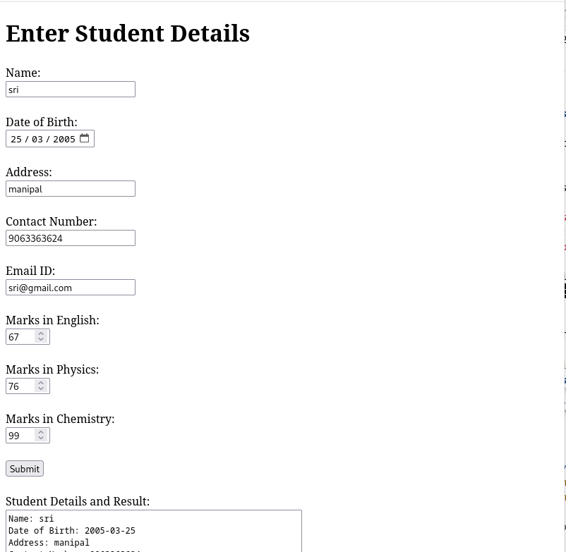
OUTPUT:

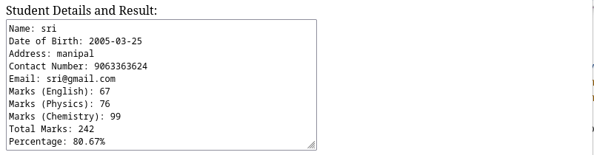
2) Create a web form with employee ids in dropdown list. Use a textbox for accepting
date of joining. Add a button named “Am I Eligible for Promotion”. On clicking
the button, if he has more than 5 years of experience, then display “YES” else
“NO” in the label control.
======================================
MyForm/urls.py
"""
URL configuration for MyForm project.

The `urlpatterns` list routes URLs to views. For more information please see:
https://docs.djangoproject.com/en/5.1/topics/http/urls/
Examples:
Function views
1. Add an import: from my_app import views
2. Add a URL to urlpatterns: path('', views.home, name='home')
Class-based views
1. Add an import: from other_app.views import Home
2. Add a URL to urlpatterns: path('', Home.as_view(), name='home')
Including another URLconf
1. Import the include() function: from django.urls import include, path
2. Add a URL to urlpatterns: path('blog/', include('blog.urls'))
"""
from django.contrib import admin
from django.urls import path,include

urlpatterns = [
path('admin/', admin.site.urls),
path('', include('studentapp.urls')),
]
===================================
student_form1.html
<!DOCTYPE html>
<html lang="en">
<head>
<meta charset="UTF-8">
<meta name="viewport" content="width=device-width, initial-scale=1.0">
<title>Employee Promotion Eligibility</title>
<script>
function checkEligibility() {
// Get the selected employee ID and date of joining
var employeeId = document.getElementById("employeeId").value;
var dateOfJoining = document.getElementById("dateOfJoining").value;

// Ensure both fields are filled
if (!employeeId || !dateOfJoining) {
alert("Please fill in all fields.");
return;
}

// Convert the date of joining to a Date object
var joiningDate = new Date(dateOfJoining);
var currentDate = new Date();

// Calculate the difference in years
var experience = currentDate.getFullYear() - joiningDate.getFullYear();
var monthDifference = currentDate.getMonth() - joiningDate.getMonth();

// Adjust if the employee hasn't reached their anniversary yet this year
if (monthDifference < 0 || (monthDifference === 0 && currentDate.getDate() < joiningDate.getDate())) {
experience--;
}

// Display the eligibility message based on the experience
if (experience >= 5) {
document.getElementById("eligibilityMessage").innerText = "YES";
} else {
document.getElementById("eligibilityMessage").innerText = "NO";
}
}
</script>
</head>
<body>

<h2>Employee Promotion Eligibility</h2>
<form action="javascript:void(0);">
<!-- Employee ID Dropdown -->
<label for="employeeId">Employee ID:</label>
<select id="employeeId" name="employeeId">
<option value="">Select Employee</option>
<option value="101">101</option>
<option value="102">102</option>
<option value="103">103</option>
<option value="104">104</option>
<!-- Add more employee IDs as needed -->
</select><br><br>

<!-- Date of Joining Textbox -->
<label for="dateOfJoining">Date of Joining:</label>
<input type="date" id="dateOfJoining" name="dateOfJoining"><br><br>

<!-- Button to Check Eligibility -->
<button type="button" onclick="checkEligibility()">Am I Eligible for Promotion</button><br><br>

<!-- Eligibility Result -->
<label id="eligibilityMessage"></label>
</form>

</body>
</html>
==================================================
views.py
from django.shortcuts import render

def index(request):
# Process form data if any
if request.method == "POST":
# Fetch data from the form and process if needed
pass

return render(request, 'student_form1.html')
================================================
urls
rom django.urls import path
from . import views

urlpatterns = [
path('', views.index, name='index'),
]
=================================================
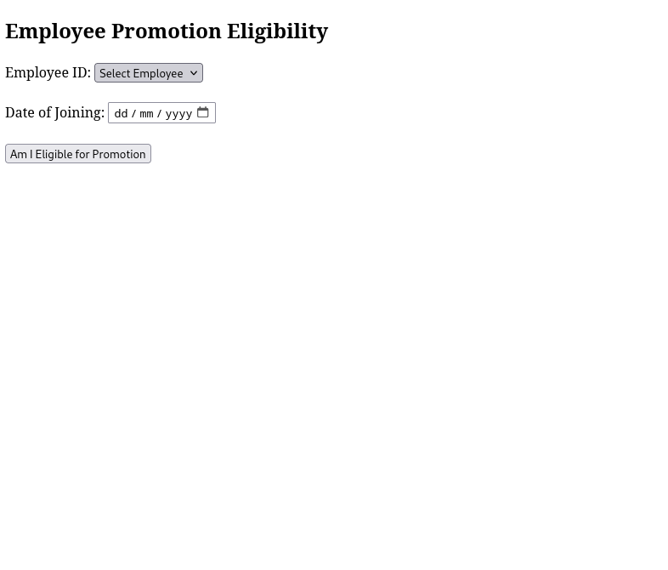
OUTPUT:

