1. Design the student bio-data form using button, label, textbox, radio button, table and
checkbox using CSS.
CODE:
<!DOCTYPE html>
<html lang="en">
<head>
<meta charset="UTF-8">
<meta name="viewport" content="width=device-width, initial-scale=1.0">
<title>Student Bio-Data Form</title>
<style>
/* Reset some default browser styles */
body, h1, form, fieldset {
margin: 0;
padding: 0;
}

body {
font-family: Arial, sans-serif;
background-color: #f2f2f2;
color: #333;
padding: 10px;
}

h1 {
text-align: center;
color: #4CAF50;
margin-bottom: 30px;
}

/* Main form container */
.form-container {
background-color: #fff;
border-radius: 8px;
padding: 20px;
width: 50%;
margin: 0 auto;
}

/* Fieldset styles for grouping inputs */
fieldset {
border: 5px solid #ddd;
padding: 20px;
margin-bottom: 20px;
border-radius: 8px;
}

legend {
font-weight: bold;
font-size: 18px;
color: #4CAF50;
}

/* Label styling */
label {
font-size: 16px;
display: block;
margin-bottom: 8px;
}

/* Input fields */
input[type="text"],
input[type="email"],
input[type="date"] {
width: 100%;
padding: 8px;
margin-bottom: 15px;
border-radius: 5px;
border: 1px solid #ccc;
}

/* Radio buttons and checkboxes */
input[type="radio"],
input[type="checkbox"] {
margin-right: 8px;
}

/* Table Styles */
table {
width: 100%;
border-collapse: collapse;
margin-top: 10px;
}

table th, table td {
padding: 8px;
border: 1px solid #ddd;
text-align: left;
}

table th {
background-color: #f9f9f9;
}

/* Button Styles */
button {
background-color: #4CAF50;
color: white;
padding: 10px 20px;
border: none;
border-radius: 5px;
cursor: pointer;
font-size: 16px;
margin: 5px;
}

button[type="reset"] {
background-color: #f44336;
}

button:hover {
background-color: #45a049;
}

button[type="reset"]:hover {
background-color: #d32f2f;
}
</style>
</head>
<body>
<div class="form-container">
<h1>Student Bio-Data Form</h1>
<form action="#" method="POST">
<!-- Personal Information Section -->
<fieldset>
<legend>Personal Information</legend>
<label for="fullName">Full Name:</label>
<input type="text" id="fullName" name="fullName" required><br><br>

<label for="dob">Date of Birth:</label>
<input type="date" id="dob" name="dob" required><br><br>

<label for="gender">Gender:</label><br>
<input type="radio" id="male" name="gender" value="Male">
<label for="male">Male</label>
<input type="radio" id="female" name="gender" value="Female">
<label for="female">Female</label><br><br>

<label for="email">Email:</label>
<input type="email" id="email" name="email" required><br><br>
</fieldset>

<!-- Address Section -->
<fieldset>
<legend>Address</legend>
<label for="street">Street Address:</label>
<input type="text" id="street" name="street"><br><br>

<label for="city">City:</label>
<input type="text" id="city" name="city"><br><br>

<label for="state">State:</label>
<input type="text" id="state" name="state"><br><br>

<label for="zip">Zip Code:</label>
<input type="text" id="zip" name="zip"><br><br>
</fieldset>

<!-- Subjects Table Section -->
<fieldset>
<legend>Subjects</legend>
<table>
<tr>
<th>Select</th>
<th>Subject</th>
</tr>
<tr>
<td><input type="checkbox" id="math" name="subjects" value="Math"></td>
<td><label for="math">Math</label></td>
</tr>
<tr>
<td><input type="checkbox" id="science" name="subjects" value="Science"></td>
<td><label for="science">Science</label></td>
</tr>
<tr>
<td><input type="checkbox" id="english" name="subjects" value="English"></td>
<td><label for="english">English</label></td>
</tr>
</table>
</fieldset>

<!-- Submit Button -->
<div class="buttons">
<button type="submit">Submit</button>
<button type="reset">Reset</button>
</div>
</form>
</div>
</body>
</html>

OUTPUT:

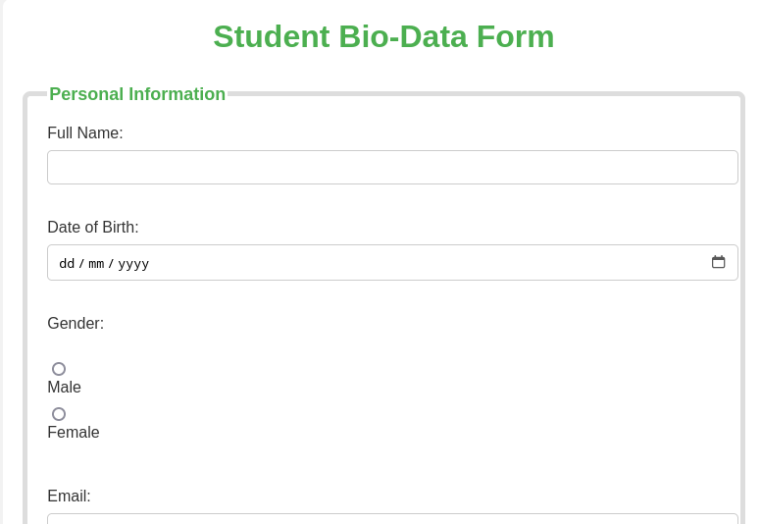

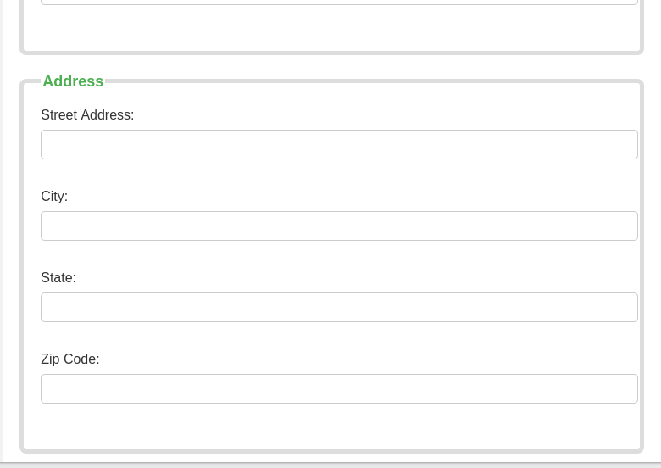

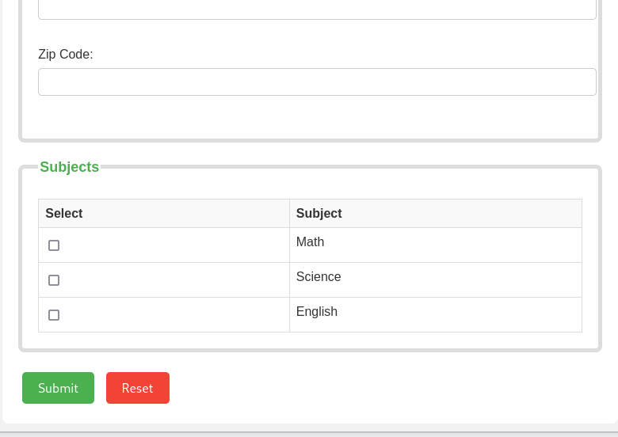

3. Create a web page using bootstrap as mentioned. Divide the page in to 2 parts top and
bottom, then divide the bottom into 3 parts and design each top and bottom part using
different input groups, input, badges, buttons and button groups. Make the design more
attractive using bootstrap.
CODE:
<!DOCTYPE html>
<html lang="en">
<head>
<meta charset="UTF-8">
<meta name="viewport" content="width=device-width, initial-scale=1.0">
<title>Basic Bootstrap Page</title>
<!-- Include Bootstrap CSS -->
<link href="https://cdn.jsdelivr.net/npm/bootstrap@5.3.0-alpha1/dist/css/bootstrap.min.css" rel="stylesheet">
</head>
<body>

<div class="container">
<!-- Top Section -->
<div class="bg-light p-4 my-4">
<h2 class="text-center">Welcome to Our Webpage</h2>
<div class="input-group mb-3">
<span class="input-group-text" id="basic-addon1">@</span>
<input type="text" class="form-control" placeholder="Enter your username">
</div>
</div>

<!-- Bottom Section -->
<div class="row">
<!-- Left Part -->
<div class="col-md-4">
<button class="btn btn-primary mb-2">Primary Button</button>
<button class="btn btn-secondary">Secondary Button</button>
</div>

<!-- Middle Part -->
<div class="col-md-4">
<h4>Badges</h4>
<span class="badge bg-primary">Primary</span>
<span class="badge bg-secondary">Secondary</span>
</div>

<!-- Right Part -->
<div class="col-md-4">
<div class="input-group">
<input type="text" class="form-control" placeholder="Search">
<button class="btn btn-outline-secondary" type="button">Search</button>
</div>
</div>
</div>
</div>

<!-- Bootstrap JS and dependencies -->
<script src="https://cdn.jsdelivr.net/npm/@popperjs/core@2.11.6/dist/umd/popper.min.js"></script>
<script src="https://cdn.jsdelivr.net/npm/bootstrap@5.3.0-alpha1/dist/js/bootstrap.min.js"></script>

</body>
</html>
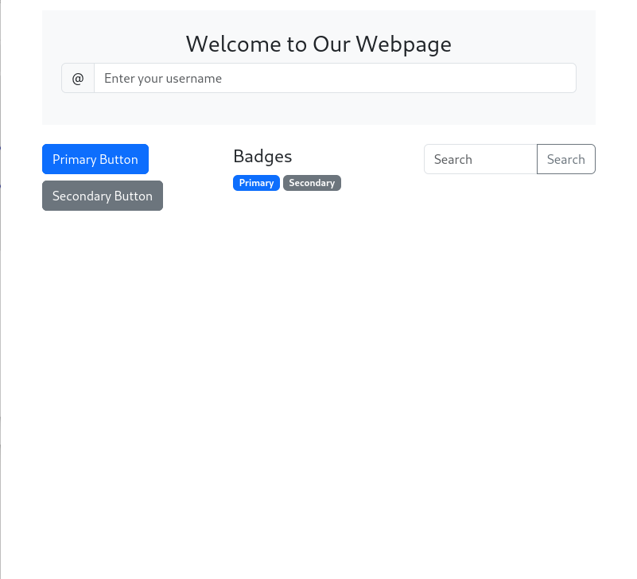
OUTPUT:

4. Design your class timetable using bootstrap table and carousel.
CODE
<!DOCTYPE html>
<html lang="en">
<head>
<meta charset="UTF-8">
<meta name="viewport" content="width=device-width, initial-scale=1.0">
<title>Class Timetable</title>
<!-- Include Bootstrap CSS -->
<link href="https://cdn.jsdelivr.net/npm/bootstrap@5.3.0-alpha1/dist/css/bootstrap.min.css" rel="stylesheet">
</head>
<body>

<div class="container my-5">
<h2 class="text-center mb-4">Class Timetable</h2>

<!-- Bootstrap Carousel for days of the week -->
<div id="timetableCarousel" class="carousel slide" data-bs-ride="carousel">
<div class="carousel-inner">
<!-- Monday -->
<div class="carousel-item active">
<h4 class="text-center">Monday</h4>
<table class="table table-bordered">
<thead>
<tr>
<th>Time</th>
<th>Subject</th>
<th>Instructor</th>
</tr>
</thead>
<tbody>
<tr>
<td>9:00 AM - 10:00 AM</td>
<td>Math</td>
<td>Dr. Smith</td>
</tr>
<tr>
<td>10:00 AM - 11:00 AM</td>
<td>English</td>
<td>Ms. Johnson</td>
</tr>
<tr>
<td>11:00 AM - 12:00 PM</td>
<td>Chemistry</td>
<td>Dr. Lee</td>
</tr>
</tbody>
</table>
</div>

<!-- Tuesday -->
<div class="carousel-item">
<h4 class="text-center">Tuesday</h4>
<table class="table table-bordered">
<thead>
<tr>
<th>Time</th>
<th>Subject</th>
<th>Instructor</th>
</tr>
</thead>
<tbody>
<tr>
<td>9:00 AM - 10:00 AM</td>
<td>History</td>
<td>Mr. Brown</td>
</tr>
<tr>
<td>10:00 AM - 11:00 AM</td>
<td>Biology</td>
<td>Dr. Adams</td>
</tr>
<tr>
<td>11:00 AM - 12:00 PM</td>
<td>Computer Science</td>
<td>Prof. Green</td>
</tr>
</tbody>
</table>
</div>

<!-- Wednesday -->
<div class="carousel-item">
<h4 class="text-center">Wednesday</h4>
<table class="table table-bordered">
<thead>
<tr>
<th>Time</th>
<th>Subject</th>
<th>Instructor</th>
</tr>
</thead>
<tbody>
<tr>
<td>9:00 AM - 10:00 AM</td>
<td>Physics</td>
<td>Dr. White</td>
</tr>
<tr>
<td>10:00 AM - 11:00 AM</td>
<td>Math</td>
<td>Dr. Smith</td>
</tr>
<tr>
<td>11:00 AM - 12:00 PM</td>
<td>Economics</td>
<td>Mr. Gray</td>
</tr>
</tbody>
</table>
</div>

<!-- Thursday -->
<div class="carousel-item">
<h4 class="text-center">Thursday</h4>
<table class="table table-bordered">
<thead>
<tr>
<th>Time</th>
<th>Subject</th>
<th>Instructor</th>
</tr>
</thead>
<tbody>
<tr>
<td>9:00 AM - 10:00 AM</td>
<td>English</td>
<td>Ms. Johnson</td>
</tr>
<tr>
<td>10:00 AM - 11:00 AM</td>
<td>Chemistry</td>
<td>Dr. Lee</td>
</tr>
<tr>
<td>11:00 AM - 12:00 PM</td>
<td>Biology</td>
<td>Dr. Adams</td>
</tr>
</tbody>
</table>
</div>

<!-- Friday -->
<div class="carousel-item">
<h4 class="text-center">Friday</h4>
<table class="table table-bordered">
<thead>
<tr>
<th>Time</th>
<th>Subject</th>
<th>Instructor</th>
</tr>
</thead>
<tbody>
<tr>
<td>9:00 AM - 10:00 AM</td>
<td>History</td>
<td>Mr. Brown</td>
</tr>
<tr>
<td>10:00 AM - 11:00 AM</td>
<td>Math</td>
<td>Dr. Smith</td>
</tr>
<tr>
<td>11:00 AM - 12:00 PM</td>
<td>Computer Science</td>
<td>Prof. Green</td>
</tr>
</tbody>
</table>
</div>
</div>

<!-- Carousel Controls -->
<button class="carousel-control-prev" type="button" data-bs-target="#timetableCarousel" data-bs-slide="prev">
<span class="carousel-control-prev-icon" aria-hidden="true"></span>
<span class="visually-hidden">Previous</span>
</button>
<button class="carousel-control-next" type="button" data-bs-target="#timetableCarousel" data-bs-slide="next">
<span class="carousel-control-next-icon" aria-hidden="true"></span>
<span class="visually-hidden">Next</span>
</button>
</div>

<!-- Bootstrap JS and dependencies -->
<script src="https://cdn.jsdelivr.net/npm/@popperjs/core@2.11.6/dist/umd/popper.min.js"></script>
<script src="https://cdn.jsdelivr.net/npm/bootstrap@5.3.0-alpha1/dist/js/bootstrap.min.js"></script>
</body>
</html>
OUTPUT:

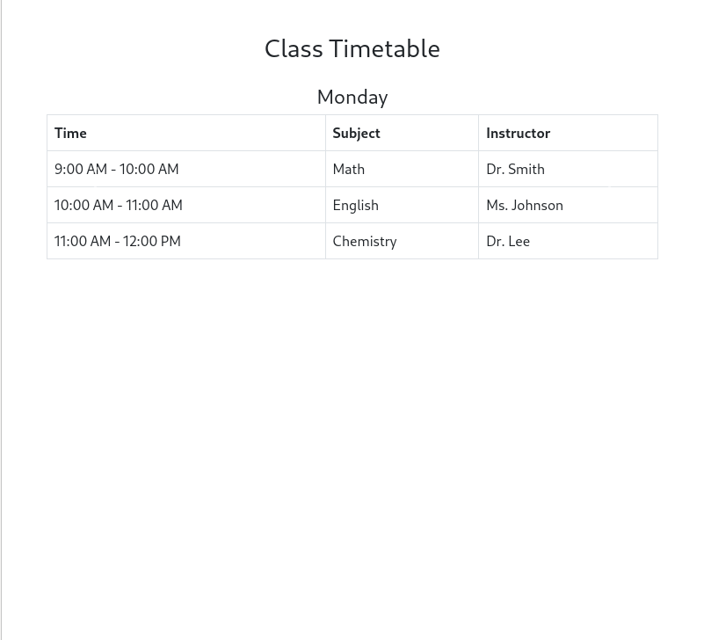

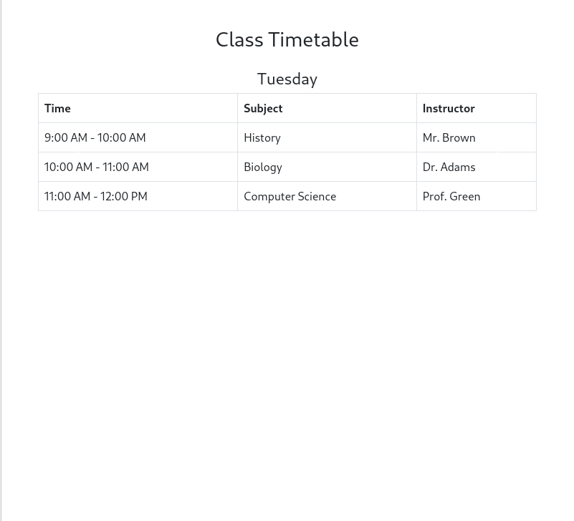
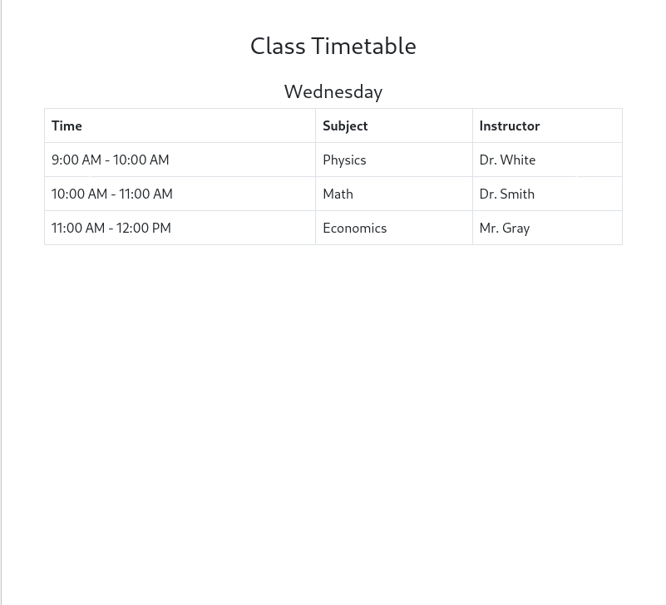

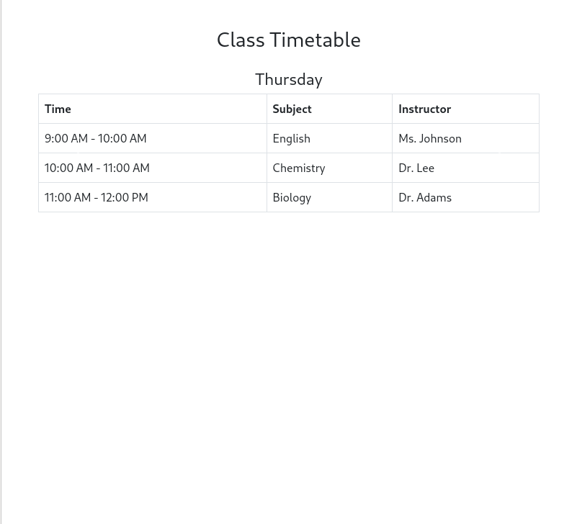
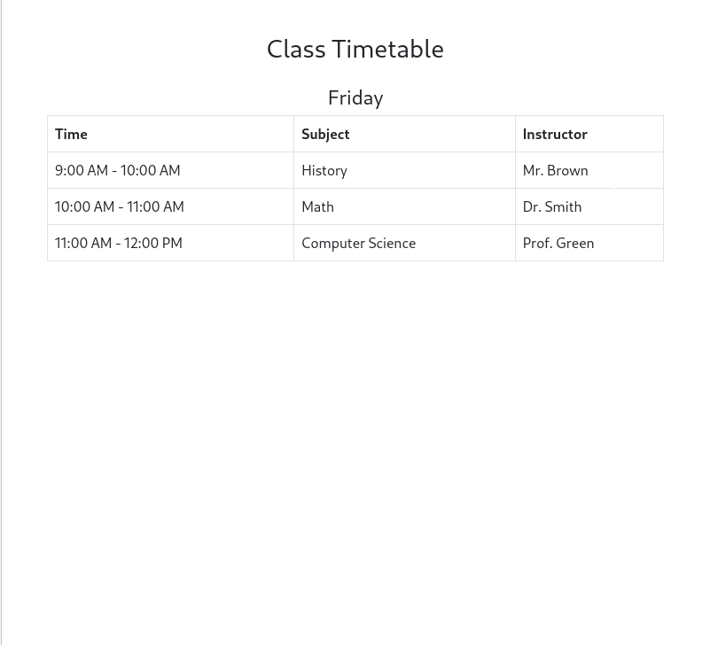
*********************THE END*****************************

