Variables:-

Variables are containers that you can store values in. You start by declaring a variable with the var keyword, followed by any name you want to call it:

Ex:var myVariable;

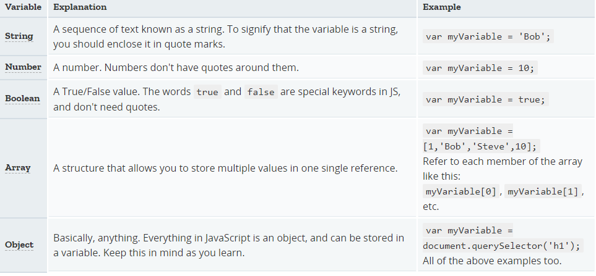

**Operators**

An [operator](https://developer.mozilla.org/en-US/docs/Glossary/operator) is a mathematical symbol which produces a result based on two values (or variables). In the following table you can see some of the simplest operators, along with some examples to try out in the JavaScript console.

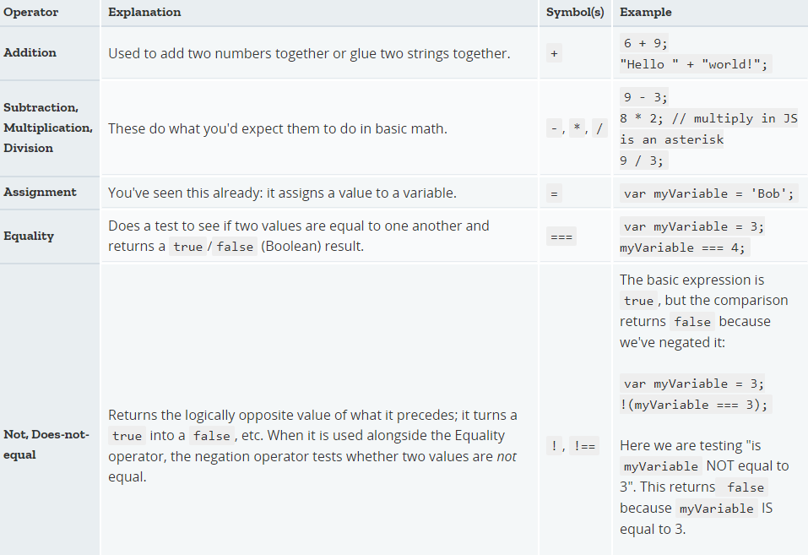

### Conditionals

Conditionals are code structures which allow you to test if an expression returns true or not, running alternative code revealed by its result. A very common form of conditionals is the if ... else statement. For example:

var iceCream = 'chocolate';

if (iceCream === 'chocolate') {

alert('Yay, I love chocolate ice cream!');

} else {

alert('Awwww, but chocolate is my favorite...');

}

The expression inside the if ( ... ) is the test — this uses the identity operator (as described above) to compare the variable iceCream with the string chocolate to see if the two are equal. If this comparison returns true, the first block of code is run. If the comparison is not true, the first block is skipped and the second code block, after the else statement, is run instead.

### Functions

[Functions](https://developer.mozilla.org/en-US/docs/Glossary/Function) are a way of packaging functionality that you wish to reuse. When you need the procedure you can call a function, with the function name, instead of rewriting the entire code each time. You have already seen some uses of functions above, for example:

1. var myVariable = document.querySelector('h1');
2. alert('hello!');