JAVA-basics

Java is robust technology widely used to develop application software.
Java is an object-oriented programming language with its own runtime environment.

What is Java?
- Java is an object-oriented programming language originally developed by Sun Microsystems and released in 1995.
- Java was originally developed by James Gosling at Sun Microsystems (which has since merge into Oracle Corporation).
- Java programs are platform independent which means they can be run on any operating system with any type of processor as long as the Java interpreter is available on that system.
- Java code that runs on one platform does not need to be recompiled to run on another platform, it’s called “write once, run anywhere” (WORA).
- Java Virtual Machine (JVM) executes Java code, but is written in platform specific languages such as C/C++/ASM etc. JVM is not written in Java and hence cannot be platform independent and Java interpreter is actually a part of JVM.

Where is Java being Used?
Earlier java was only used to design and program small computing devices but later adopted as one of the platform independent programming language and now according to Sun, 3 billion devices run java.
Java is one of the most important programming language in today’s IT industries.
- JSP – Java is used to create web applications like PHP and ASP, JSP(Java Server Pages) used with normal HTML tags, which helps to create dynamic web pages.
- Applets – This is another type of Java program that used within a web page to add many new features to a web browser.
- J2EE – The software Java 2 Enterprise Edition are used by various companies to transfer data based on XML structured documents between one another.
- JavaBeans – This is something like Visual Basic, a reusable software component that can be easily assemble to create some new and advanced application.
- Mobile – Besides the above technology, Java is also used in mobile devices, many kind of games and services built-in Java. Today, all leading mobile service provider like Nokia, Siemens, Vodafone are using Java technology.

Types of Java Applications
Web Application Java is used to create server-side web applications. Currently, servlet, jsp, struts, jsf etc. technologies are used.
Standalone Application It is also known as desktop application or window-based application. An application that we need to install on every machine or server such as media player, antivirus etc. AWT and Swing are used in java for creating standalone applications.
Enterprise Application An application that is distributed in nature, such as banking applications etc. It has the advantage of high level security, load balancing and clustering. In java, EJB is used for creating enterprise applications.
Mobile Application Java is used to create application softwares for mobile devices. Currently Java ME is used for creating applications for small devices, and also Java is programming language for Google Android application development.

Facts about Java
- Object Oriented – In java everything is an Object. Java can be easily expanded since it is based on the Object model.
- Platform independent – C and C++ are platform dependency languages hence the application programs written in one Operating system cannot run in any other Operating system, but in platform independence language like Java application programs written in one Operating system can able to run on any Operating system.
- Simple – Java is designed to be easy to learn. If you understand the basic concept of OOP java would be easy to master.
- Secure – With Java’s secure feature it enables to develop virus-free, tamper-free systems. Authentication techniques are based on public-key encryption.
- Architectural- neutral – Java compiler generates an architecture-neutral object file format which makes the compiled code to be executable on many processors, with the presence Java runtime system.
- Portable – being architectural neutral and having no implementation dependent aspects of the specification makes Java portable. Compiler and Java is written in ANSI C with a clean portability boundary which is a POSIX subset.
- Robust – Java makes an effort to eliminate error prone situations by emphasizing mainly on compile time error checking and runtime checking.
- Multi-threaded – With Java’s multi-threaded feature it is possible to write programs that can do many tasks simultaneously. This design feature allows developers to construct smoothly running interactive applications.
- Interpreted – Java byte code is translated on the fly to native machine instructions and is not stored anywhere. The development process is more rapid and analytical since the linking is an incremental and light weight process.
- High Performance – With the use of Just-In-Time compilers Java enables high performance.
- Distributed – Java is designed for the distributed environment of the internet.
- Dynamic – Java is considered to be more dynamic than C or C++ since it is designed to adapt to an evolving environment. Java programs can carry an extensive amount of run-time information that can be used to verify and resolve accesses to objects on run-time.

Different Editions of Java Technology
- Java SE – Java SE or Java Standard Edition provides tools and API’s that you can use to create server applications, desktop applications, and even applets. These programs developed using Java SE can be run on almost every popular operating system, including Linux, Macintosh, Solaris, and Windows.
- JEE – Based on the foundation framework of the standard edition, Java Enterprise Edition helps in web application service, component model and enterprise class service oriented architecture (SOA).
- JME – Java Micro Edition or JME for short is an accumulation of Java APIs that are used for the development of software for devices like mobile phones, PDAs, TV set-top boxes, game programming. The platform of micro edition generally consists of an easy user interface, a robust security model and a wide variety of built-in networks for running Java based application.

What you will need to run Java
- You will need the Java software development kit from http://java.sun.com/
- Follow the instructions on Sun’s website to install it.
- Make sure that you add the java bin directory to your PATH environment variable.

Popular Java Editors
To write your java programs you will need a text editor. There are even more sophisticated IDE available in the market. But for now, you can consider one of the following:
- Notepad – On Windows machine you can use any simple text editor like Notepad (Recommended for this tutorial), TextPad.
- Netbeans – is a Java IDE that is open source and free which can be downloaded from http://www.netbeans.org/index.html
- Eclipse – is also a java IDE developed by the eclipse open source community and can be downloaded from http://www.eclipse.org/

JAVA program structure:

To understand structure and features of class I have used example of Hello Java program here. There is few lines in program and the major task of the program is to print “Hello Java” text.

Example:
public class Hello{
public static void main(String[] args)
{
System.out.println("Hello Java");
}}

The above example has been used to print “Hello Java” on the screen.
You have to keep in mind that, Java code is case sensitive.
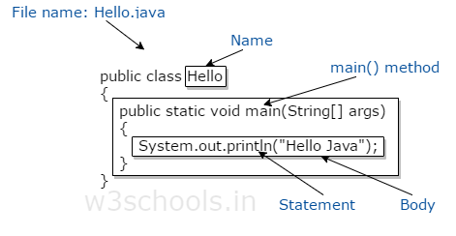

EXPLANATION:

public class Hello
- This creates a class called Hello.
- All class names required to start with a capital letter.
- The word public means that it is accessible by any other classes.

{…}
The 2 curly brackets are used to group all the commands together so it is known that the commands belong to that class.

public static void main
- The word public means that it is accessible by any other classes.
- The word static means that it is unique.
- The word void means this main method has no return value.
- main is a method where the program starts.
You will notice that the main method code has been moved to some spaces left. This is called indentation which used to make a program easier to read and understand.

System.out.println();
- System is a final class name and cannot be instantiated. Therefore all its members (fields and methods) will be static, and we understand that it is an utility class. As per javadoc, “…Among the facilities provided by the System class are standard input, standard output, and error output streams; access to externally defined properties and environment variables; a means of loading files and libraries; and a utility method for quickly copying a portion of an array…”
- out is static member in System class which is instance of java.io.PrintStream. Its access specifiers are public final. This gets instantiated during startup and gets mapped with standard output console of the host. This stream is open by itself immediately after its instantiation and ready to accept data. When running a program from windows command line, it is the standard console.
- println method prints text on the screen with newline. There are multiple println methods with different arguments (overloading). Every println makes a call to print method and adds a newline. print calls write() and the story goes on like that.
- The data that is to be printed is put inside brackets. You will also notice that the words in inverted commas because they are what is called a string. Each letter is a character and a series of characters grouped together is called a string. Strings always be put between inverted commas. You must have to put a semi-colon after every command to show that it is the end of the command.

JAVA virtual machine:

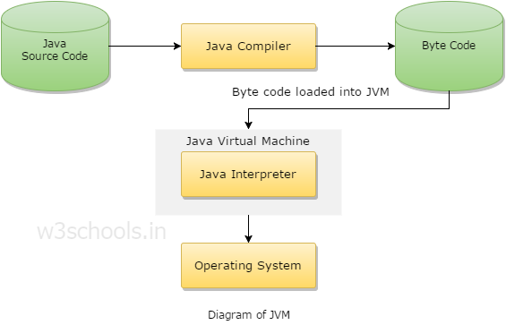
JVM generates a .class(Bytecode) file, and that file can be run in any OS, but JVM should have in OS, because JVM is platform dependent.

How to compile a java file using javac command.
Example:
c:\jdk\appdemo> javac Testfile.java
Program Output:
Testfile.java compile successfully.

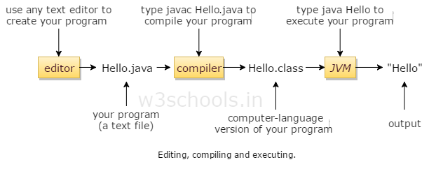

JAVA data types:

Data types in any of the language means that what are the various type of data the variables can have in that particular language. Information is stored in a computer memory with different data types. Whenever a variable is declared it becomes necessary to define data type that what will be the type of data that variable can hold.

Data Types available in java are:
Primary Data Type (Java supports 8 primitive data types): byte, short, int, long, float, double, char and boolean.
Non-Primitive Data Types: string, array etc.

Integer Types
Type | Contains | Default | Size | Range
byte | Signed integer | 0 | 8 bit or  1 byte | -27聽to 27-1 or  -128 to 127
short | Signed integer | 0 | 16 bit or  2 bytes | -215聽to 215-1 or  -32768 to 32767
int | Signed integer | 0 | 32 bit or  4 bytes | -231聽to 231-1 or  -2147483648 to 2147483647
long | Signed integer | 0 | 64 bit or  8 bytes | -263聽to 263-1 or  -9223372036854775808 to  9223372036854775807

Rational Numbers
Type | Contains | Default | Size | Range
float | IEEE 754 floating point  single-precision | 0.0f | 32 bit or  4 bytes | 卤1.4E-45 to  卤3.40282347E+38F
double | IEEE 754 floating point  double-precision | 0.0 | 64 bit or  8 bytes | 卤439E-324 to  卤1.7976931348623157E+308

Characters
Type | Contains | Default | Size | Range
char | Unicode character  unsigned | \u0000 | 16 bits or  2 bytes | 0 to 216-1 or  \u0000 to \uFFFF

Conditional
Type | Contains | Default | Size | Range
boolean | true or false | false | 1 bit | true or false

Data Types and Variable Declarations in Java
Example:
class DataTypes{
public static void main(String args[]){
byte byteVar = 5;
short shortVar = 20;
int intVar = 30;
long longVar = 60;
float floatVar = 20;
double doubleVar = 20.123;
boolean booleanVar = true;
char charVar ='W';

System.out.println("Value Of byte Variable is " + byteVar);
System.out.println("Value Of short Variable is " + shortVar);
System.out.println("Value Of int Variable is " + intVar);
System.out.println("Value Of long Variable is " + longVar);
System.out.println("Value Of float Variable is " + floatVar);
System.out.println("Value Of double Variable is " + doubleVar);
System.out.println("Value Of boolean Variable is " + booleanVar);
System.out.println("Value Of char Variable is " + charVar);
}
}
Program Output:
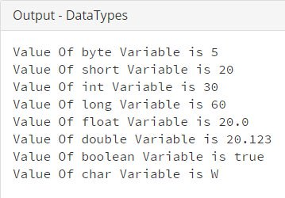

JAVA VARIABLES:

Variables are the identifier of the memory location, which used to save data temporary for later use.

Rules of Declaring variables in Java
- Variable name can consist of Capital letters A-Z, lowercase letters a-z, digits 0-9, and two special characters such as underscore and dollar Sign.
- The first character must be a letter.
- Blank spaces cannot be used in variable names.
- Java keywords can not be used as variable names.
- Variable names are case-sensitive.

Variable Definition in Java
Syntax:
type variable_name;
type variable_name, variable_name, variable_name;
Example:
/* variable definition and initialization */int width, height=5;char letter='C';float age, area;double d;
/* actual initialization */
width = 10;
age = 26.5;
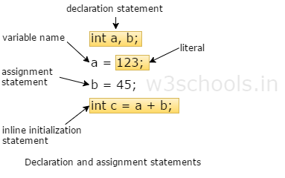

Types of Variable in Java
There are three types of variables in Java:
- Local variables
- Instance variables
- Class/Static variables

Local variables
A variable that is declared within the method that is called local variables.

Instance variables
A non static variable that is declared within the class but not in the method is called instance variable.
A variable which is created inside the class but outside the method, is known as instance variable. Instance variable doesn't get memory at compile time. It gets memory at run time when object(instance) is created. That is why, it is known as instance variable.

Class/Static variables
A variable that is declared with static聽keyword in a class but not in the method is called static or class variable.
Example:
class A{ int amount=100; //instance variable static int pin=2315; //static variable

void method(){
int age=35; //local variable
} }

tasks: write programs of
- Java Program to Swapping Two Numbers without Using a Temporary Variable
- Java Program to Swapping Two Numbers Using a Temporary Variable

JAVA MODIFIER

Access control modifier
There are four access modifiers available in Java, used to set access levels for classes, variable methods and constructor.
- Scope only inside the same package (default)
- Scope is visible to world (public)
- Scope within the package and all sub classes (protected)
- Scope only within the classes only (private)

JAVA OPERATORS

Java operator is a symbol that is used to perform mathematical or logical manipulations. Java language is rich with built-in operators.
There are many types of operators available in java such as Arithmetic Operators, Relational Operators, Logical Operators, Bitwise Operators, Assignment Operators and Misc Operators.

Arithmetic Operators
Operator | Description
+ | Addition
– | Subtraction
* | Multiplication
/ | Division
% | Modulus
++ | Increment
−− | Decrement

Relational Operators
Operator | Description
== | Is equal to
!= | Is not equal to
> | Greater than
< | Less than
>= | Greater than or equal to
<= | Less than or equal to

Logical Operators
Operator | Description
&& | And operator. Performs a logical conjunction on two expressions.  (if both expressions evaluate to True, result is True. If either expression evaluates to False, result is False)
|| | Or operator. Performs a logical disjunction on two expressions.  (if either or both expressions evaluate to True, result is True)
! | Not operator. Performs logical negation on an expression.

Assignment Operators
Operator | Description
= | Assign
+= | Increments, then assigns
-= | Decrements, then assigns
*= | Multiplies, then assigns
/= | Divides, then assigns
%= | Modulus, then assigns
<<= | Left shift and assigns
>>= | Right shift and assigns
&= | Bitwise AND assigns
^= | Bitwise exclusive OR and assigns
|= | Bitwise inclusive OR and assigns

Misc Operators
Operator | Description
Conditional(Ternary) Operator ( ? : ) | Operator is used to decide which value should be assigned to the variable.
instanceOf Operator | Object reference variables

TASKS:
- Java Program to Calculate Simple and Compound Interest
- Java Program to Calculate the Area of a Circle

JAVA KEYWORDS

Java Keywords must be in your information because you can not use them as variable name.

Java Reserved Keywords List
You can’t use keyword as identifier in your Java programs, its reserved words in Java library and used to perform an internal operation.
abstract | assert | boolean | break
byte | case | catch | char
class | const | continue | default
do | double | else | enum
extends | final | finally | float
for | goto | if | implements
import | instanceof | int | interface
long | native | new | package
private | protected | public | return
short | static | strictfp | super
switch | synchronized | this | throw
throws | transient | try | void
volatile | while
true, false and null are not reserved words but cannot be used as identifiers, because it’s literals of built-in types.

JAVA ARRAYS

An array is a one of the data structure in Java, that can store a fixed size sequential collection of elements of same data type.

Define an Array in Java
Syntax:
datatype[] identifier; //preferred wayor
datatype identifier[];
Example:
char[] refVar;int[] refVar;short[] refVar;long[] refVar;int[][] refVar; //two-dimensional array

Initialize an Array in Java
By using new operator array can be initialize.
int[] age = new int[5]; //5 is the size of array.
Arrays can be initialized at declaration time also:
int age[5]={22,25,30,32,35};
Initializing each element separately in loop:
Example:
public class Sample {

public static void main(String args[]) {
int[] newArray = new int[5];

// Initializing elements of array seperately
for (int n = 0; n < newArray.length; n++) {
newArray[n] = n;
}
}}

A pictorial representation of the array:
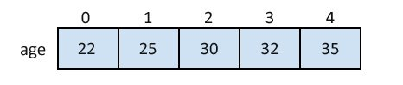

Accessing Array Elements in Java
Example:
public class Sample {

public static void main(String args[]) {
int[] newArray = new int[5];

// Initializing elements of array seperately
for (int n = 0; n < newArray.length; n++) {
newArray[n] = n;
}
System.out.println(newArray[2]); // Assigning 2nd element of array value
}}
Program Output:
2

TASKS
- Java Program to find odd or even numbers in an Array
- Java Program to Convert String to ArrayList
- Java Program to Find Largest and Smallest Number in an Array

Flow control-
JAVA DECISION MAKING

Java decision-making statements allows you to make decision, based upon the result of a condition.
Java supports following decision-making statements:
- if statement
- if-else statement
- else-if statement
- switch statement

Java if statements
Java if statements is used to execute some code, if a condition is true otherwise if condition is false, execute nothing.
Syntax:
if(condition){
statement 1;
statement 2;
...}
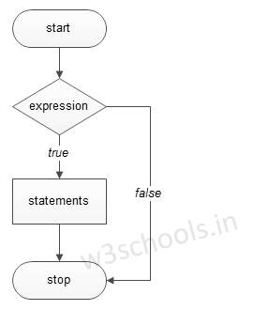
Example:
public class Sample{

public static void main(String args[]){
int a=20, b=30;

if(b>a)
System.out.println("b is greater");
}}

Java if-else statement
Java if else statements is used to execute some code, if a condition is true otherwise if condition is false, execute nothing, or execute some other code.
Syntax:
if(condition){
//execute your code}else{
//execute your code}
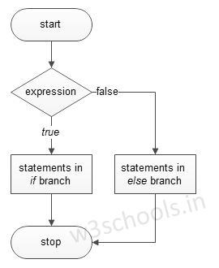
Example:
public class Sample {

public static void main(String args[]) {
int a = 80, b = 30;

if (b > a) {
System.out.println("b is greater");
}
else {
System.out.println("a is greater");
}
}}

Java else-if statements

Java else if is a like doing another if condition for a true or false value.
Syntax:
if(condition){
//execute your code}else if(condition n){
//execute your code}else{
//execute your code}
Example:
public class Sample {

public static void main(String args[]) {
int a = 30, b = 30;

if (b > a) {
System.out.println("b is greater");
}
else if(a > b){
System.out.println("a is greater");
}
else {
System.out.println("Both are equal");
}
}}
Java switch statement
Java switch statement is used when you have multiple possibilities for the if statement.
Syntax:
switch(variable){case 1:
//execute your codebreak;
case n:
//execute your codebreak;
default:
//execute your codebreak;}
Example:
public class Sample {

public static void main(String args[]) {
int a = 5;
switch (a) {
case 1:
System.out.println("You chose One");
break;
case 2:
System.out.println("You chose Two");
break;
case 3:
System.out.println("You chose Three");
break;
case 4:
System.out.println("You chose Four");
break;
case 5:
System.out.println("You chose Five");
break;
default:
System.out.println("Invalid Choice. Enter a no between 1 and 5");
break;
}
}
}

JAVA LOOPS

Sometimes we want a Java program to repeat something over and over again, loops are used to make a program do something more than one time.
Java loops execute a block of commands a specified number of times, until a condition is met.
Java supports following types of loops:
- while loops
- do while loops
- for loops
All are slightly different and provides loops for different situations.

Java Loop Control Statements
Loop control statements is used to change normal sequence of execution of loop.
Statement | Syntax | Description
break statement | break; | Is used to terminate loop or switch statements.
continue statement | continue; | Is used to suspend the execution of current loop iteration and transfer control to the loop for the next iteration.
goto statement | goto labelName;labelName: statement; | It’s transfer current program execution sequence to some other part of the program.

Examples;

While (condition) {
statement(s);
Incrementation;
}

Syntax:
do{
statement(s);
}while( condition );

Syntax:
for ( init; condition; increment ){
statement(s);
}

The continue keyword is used to skip the particular recursion only in a loop execution, which may be a for loop, while loop, do while or for each loop.
Example:
class BreakAndContinue{
public static void main(String args[])
{
// Illustrating break statement (execution stops when value of i becomes to 4.)
System.out.println("Break Statement\n....................");

for(int i=1;i<=5;i++)
{
if(i==4) break;
System.out.println(i);
}
// Illustrating continue statement (execution skipped when value of i becomes to 1.)
System.out.println("Continue Statement\n....................");
for(int i=1;i<=5;i++)
{
if(i==1) continue;
System.out.println(i);
}
}}
Program Output:
Break Statement
………………..
1
2
3
Continue Statement
………………..
2
3
4
5

JAVA STRING CLASSES

String is a sequence of character in java, widely used as object.

Strings Initialization in Java
There are two ways to declare a string in Java, and the most common way to create a string is to write:
Example:
String name = "Alex";
Through char array:
public class Sample {

public static void main(String args[]) {
char[] nameArray = {'A', 'l', 'e', 'x'};
String name = new String(nameArray);
System.out.println(name);
}}
Program Output:
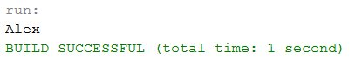

Concatenating Strings
concat() method can be used to attach strings.
Example:
public class Sample {

public static void main(String args[]) {
String str1 = "Hello ", str2 = "World!";
System.out.println(str1.concat(str2));
}}
+ operator is more commonly used to attach strings.
"Hello," + " world" + "!"
Program Output:
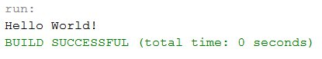

Java String Case
Java toUpperCase() and toLowerCase() method is used to change string case.
Example:
public class Sample {

public static void main(String args[]) {
String str1 = "Hello";
System.out.println(str1.toUpperCase());
System.out.println(str1.toLowerCase());
}}
Program Output:
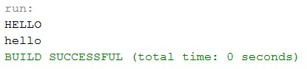

Java Trim String
Java trim() method is used to eliminates white spaces before and after string.
Example:
public class Sample {

public static void main(String args[]) {
String str = " Hello ";
System.out.println(str.trim());
}}
Program Output:
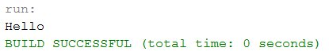

Java String length
Java length() method is used to get length of the string.
Example:
public class Sample {

public static void main(String args[]) {
String str = "Cloud";
System.out.println(str.length());
}}
Program Output:
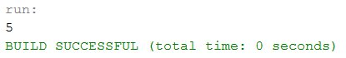

JAVA DATE & TIME

Getting Current Date and Time
This is a very easy method to get current date and time in Java. You can use a simple Date object with toString() method to print the current date and time as follows −

Example
import java.util.Date;
public class DateDemo {

public static void main(String args[]) {
// Instantiate a Date object
Date date = new Date();

// display time and date using toString()
System.out.println(date.toString());
}}
This will produce the following result −

Output
on May 04 09:51:52 CDT 2009

JAVA OBJECTS & CLASSES

As Java is a Object Oriented Programming language, Java has following OOPS features.
- Encapsulation
- Inheritance
- Polymorphism
- Abstraction
- Classes
- Objects
- Method
- Message Parsing

Object and Class in Java
Object in Java
Class in Java
Instace Variable in Java
Method in Java
Example of Object and class that maintains the records of student
Annonymous Object
In this doc, we will learn about java objects and classes. In object-oriented programming technique, we design a program using objects and classes.
Object is the physical as well as logical entity whereas class is the logical entity only.

Object in Java
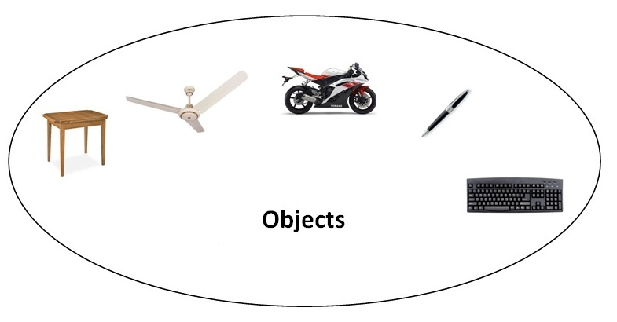
An entity that has state and behavior is known as an object e.g. chair, bike, marker, pen, table, car etc. It can be physical or logical (tangible and intangible). The example of intangible object is banking system.
An object has three characteristics:
- state: represents data (value) of an object.
- behavior: represents the behavior (functionality) of an object such as deposit, withdraw etc.
- identity: Object identity is typically implemented via a unique ID. The value of the ID is not visible to the external user. But, it is used internally by the JVM to identify each object uniquely.
For Example: Pen is an object. Its name is Reynolds, color is white etc. known as its state. It is used to write, so writing is its behavior.
Object is an instance of a class. Class is a template or blueprint from which objects are created. So object is the instance(result) of a class.
Object Definitions:
- Object is a real world entity.
- Object is a run time entity.
- Object is an entity which has state and behavior.
- Object is an instance of a class.

Class in Java
A class is a group of objects which have common properties. It is a template or blueprint from which objects are created. It is a logical entity. It can't be physical.
A class in Java can contain:
- fields
- methods
- constructors
- blocks
- nested class and interface

Syntax to declare a class:

- class <class_name>{
- field;
- method;
- }

Instance variable in Java
A variable which is created inside the class but outside the method, is known as instance variable. Instance variable doesn't get memory at compile time. It gets memory at run time when object(instance) is created. That is why, it is known as instance variable.

Method in Java
In java, a method is like function i.e. used to expose behavior of an object.

Advantage of Method
- Code Reusability
- Code Optimization

new keyword in Java
The new keyword is used to allocate memory at run time. All objects get memory in Heap memory area.

Object and Class Example: main within class
In this example, we have created a Student class that have two data members id and name. We are creating the object of the Student class by new keyword and printing the objects value.
Here, we are creating main() method inside the class.
File: Student.java

- class Student{
- int id;//field or data member or instance variable
- String name;

- public static void main(String args[]){
- Student s1=new Student();//creating an object of Student
- System.out.println(s1.id);//accessing member through reference variable
- System.out.println(s1.name);
- }
- }
Test it Now
Output:
0
null

Object and Class Example: main outside class
In real time development, we create classes and use it from another class. It is a better approach than previous one. Let's see a simple example, where we are having main() method in another class.
We can have multiple classes in different java files or single java file. If you define multiple classes in a single java source file, it is a good idea to save the file name with the class name which has main() method.
File: TestStudent1.java

- class Student{
- int id;
- String name;
- }
- class TestStudent1{
- public static void main(String args[]){
- Student s1=new Student();
- System.out.println(s1.id);
- System.out.println(s1.name);
- }
- }
Test it Now
Output:
0
null

3 Ways to initialize object
There are 3 ways to initialize object in java.
- By reference variable
- By method
- By constructor

1) Object and Class Example: Initialization through reference
Initializing object simply means storing data into object. Let's see a simple example where we are going to initialize object through reference variable.
File: TestStudent2.java

- class Student{
- int id;
- String name;
- }
- class TestStudent2{
- public static void main(String args[]){
- Student s1=new Student();
- s1.id=101;
- s1.name="Sonoo";
- System.out.println(s1.id+" "+s1.name);//printing members with a white space
- }
- }
Test it Now
Output:
101 Sonoo
We can also create multiple objects and store information in it through reference variable.
File: TestStudent3.java

- class Student{
- int id;
- String name;
- }
- class TestStudent3{
- public static void main(String args[]){
- //Creating objects
- Student s1=new Student();
- Student s2=new Student();
- //Initializing objects
- s1.id=101;
- s1.name="Sonoo";
- s2.id=102;
- s2.name="Amit";
- //Printing data
- System.out.println(s1.id+" "+s1.name);
- System.out.println(s2.id+" "+s2.name);
- }
- }
Test it Now
Output:
101 Sonoo
102 Amit

2) Object and Class Example: Initialization through method
In this example, we are creating the two objects of Student class and initializing the value to these objects by invoking the insertRecord method. Here, we are displaying the state (data) of the objects by invoking the displayInformation() method.
File: TestStudent4.java

- class Student{
- int rollno;
- String name;
- void insertRecord(int r, String n){
- rollno=r;
- name=n;
- }
- void displayInformation(){System.out.println(rollno+" "+name);}
- }
- class TestStudent4{
- public static void main(String args[]){
- Student s1=new Student();
- Student s2=new Student();
- s1.insertRecord(111,"Karan");
- s2.insertRecord(222,"Aryan");
- s1.displayInformation();
- s2.displayInformation();
- }
- }
Test it Now
Output:
111 Karan
222 Aryan
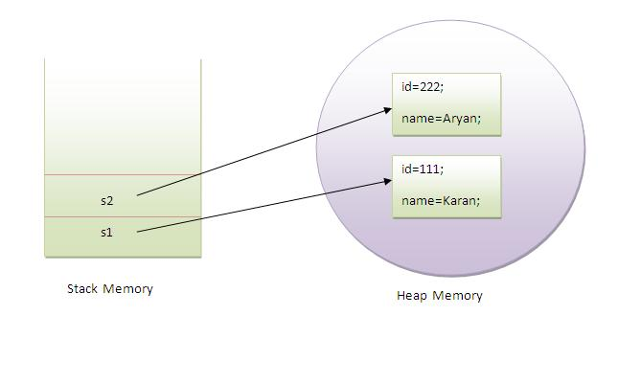
As you can see in the above figure, object gets the memory in heap memory area. The reference variable refers to the object allocated in the heap memory area. Here, s1 and s2 both are reference variables that refer to the objects allocated in memory.

3) Object and Class Example: Initialization through constructor
We will learn about constructors in java later.

Constructor in Java

Constructor in java is a special type of method that is used to initialize the object.
Java constructor is invoked at the time of object creation. It constructs the values i.e. provides data for the object that is why it is known as constructor.

Rules for creating java constructor
There are basically two rules defined for the constructor.
- Constructor name must be same as its class name
- Constructor must have no explicit return type

Types of java constructors
There are two types of constructors:
- Default constructor (no-arg constructor)
- Parameterized constructor
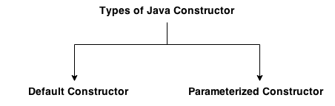

Java Default Constructor
A constructor that have no parameter is known as default constructor.

Syntax of default constructor:

- <class_name>(){}

Example of default constructor
In this example, we are creating the no-arg constructor in the Bike class. It will be invoked at the time of object creation.

- class Bike1{
- Bike1(){System.out.println("Bike is created");}
- public static void main(String args[]){
- Bike1 b=new Bike1();
- }
- }
Output:
Bike is created

Rule: If there is no constructor in a class, compiler automatically creates a default constructor.
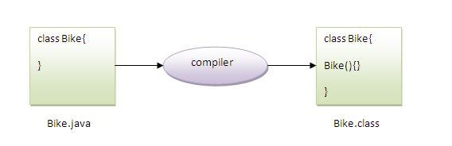

Q) What is the purpose of default constructor?
Default constructor provides the default values to the object like 0, null etc. depending on the type.

Example of default constructor that displays the default values

- class Student3{
- int id;
- String name;

- void display(){System.out.println(id+" "+name);}

- public static void main(String args[]){
- Student3 s1=new Student3();
- Student3 s2=new Student3();
- s1.display();
- s2.display();
- }
- }
Output:
0 null
0 null
Explanation:In the above class,you are not creating any constructor so compiler provides you a default constructor.Here 0 and null values are provided by default constructor.

Java parameterized constructor
A constructor that have parameters is known as parameterized constructor.

Why use parameterized constructor?
Parameterized constructor is used to provide different values to the distinct objects.

Example of parameterized constructor
In this example, we have created the constructor of Student class that have two parameters. We can have any number of parameters in the constructor.

- class Student4{
- int id;
- String name;

- Student4(int i,String n){
- id = i;
- name = n;
- }
- void display(){System.out.println(id+" "+name);}

- public static void main(String args[]){
- Student4 s1 = new Student4(111,"Karan");
- Student4 s2 = new Student4(222,"Aryan");
- s1.display();
- s2.display();
- }
- }
Output:
111 Karan
222 Aryan

Constructor Overloading in Java
Constructor overloading is a technique in Java in which a class can have any number of constructors that differ in parameter lists.The compiler differentiates these constructors by taking into account the number of parameters in the list and their type.

Example of Constructor Overloading

- class Student5{
- int id;
- String name;
- int age;
- Student5(int i,String n){
- id = i;
- name = n;
- }
- Student5(int i,String n,int a){
- id = i;
- name = n;
- age=a;
- }
- void display(){System.out.println(id+" "+name+" "+age);}

- public static void main(String args[]){
- Student5 s1 = new Student5(111,"Karan");
- Student5 s2 = new Student5(222,"Aryan",25);
- s1.display();
- s2.display();
- }
- }
Output:
111 Karan 0
222 Aryan 25

Java Copy Constructor
There is no copy constructor in java. But, we can copy the values of one object to another like copy constructor in C++.
There are many ways to copy the values of one object into another in java. They are:
- By constructor
- By assigning the values of one object into another
- By clone() method of Object class
In this example, we are going to copy the values of one object into another using java constructor.

- class Student6{
- int id;
- String name;
- Student6(int i,String n){
- id = i;
- name = n;
- }

- Student6(Student6 s){
- id = s.id;
- name =s.name;
- }
- void display(){System.out.println(id+" "+name);}

- public static void main(String args[]){
- Student6 s1 = new Student6(111,"Karan");
- Student6 s2 = new Student6(s1);
- s1.display();
- s2.display();
- }
- }
Test it Now
Output:
111 Karan
111 Karan

Copying values without constructor
We can copy the values of one object into another by assigning the objects values to another object. In this case, there is no need to create the constructor.

- class Student7{
- int id;
- String name;
- Student7(int i,String n){
- id = i;
- name = n;
- }
- Student7(){}
- void display(){System.out.println(id+" "+name);}

- public static void main(String args[]){
- Student7 s1 = new Student7(111,"Karan");
- Student7 s2 = new Student7();
- s2.id=s1.id;
- s2.name=s1.name;
- s1.display();
- s2.display();
- }
- }
Test it Now
Output:
111 Karan
111 Karan

Java static keyword
Static variable
Program of counter without static variable
Program of counter with static variable
Static method
Restrictions for static method
Why main method is static ?
Static block
Can we execute a program without main method ?
The static keyword in java is used for memory management mainly. We can apply java static keyword with variables, methods, blocks and nested class. The static keyword belongs to the class than instance of the class.
The static can be:
- variable (also known as class variable)
- method (also known as class method)

1) Java static variable
If you declare any variable as static, it is known static variable.
- The static variable can be used to refer the common property of all objects (that is not unique for each object) e.g. company name of employees,college name of students etc.
- The static variable gets memory only once in class area at the time of class loading.

Advantage of static variable
It makes your program memory efficient (i.e it saves memory).

Understanding problem without static variable

- class Student{
- int rollno;
- String name;
- String college="ITS";
- }
Suppose there are 500 students in my college, now all instance data members will get memory each time when object is created.All student have its unique rollno and name so instance data member is good.Here, college refers to the common property of all objects.If we make it static,this field will get memory only once.

Java static property is shared to all objects.

Example of static variable

- //Program of static variable

- class Student8{
- int rollno;
- String name;
- static String college ="ITS";

- Student8(int r,String n){
- rollno = r;
- name = n;
- }
- void display (){System.out.println(rollno+" "+name+" "+college);}

- public static void main(String args[]){
- Student8 s1 = new Student8(111,"Karan");
- Student8 s2 = new Student8(222,"Aryan");

- s1.display();
- s2.display();
- }
- }
Test it Now
Output:111 Karan ITS
222 Aryan ITS
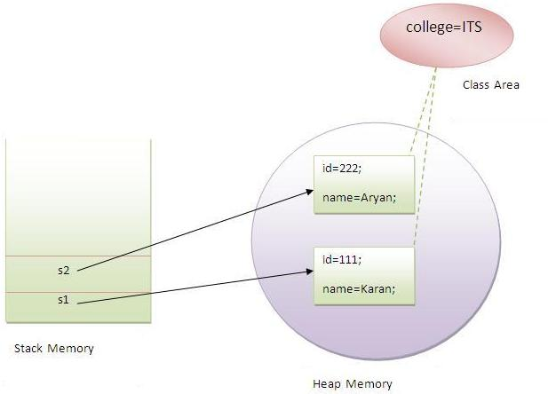

2) Java static method
If you apply static keyword with any method, it is known as static method.
- A static method belongs to the class rather than object of a class.
- A static method can be invoked without the need for creating an instance of a class.
- static method can access static data member and can change the value of it.

Example of static method

- //Program of changing the common property of all objects(static field).

- class Student9{
- int rollno;
- String name;
- static String college = "ITS";

- static void change(){
- college = "BBDIT";
- }

- Student9(int r, String n){
- rollno = r;
- name = n;
- }

- void display (){System.out.println(rollno+" "+name+" "+college);}

- public static void main(String args[]){
- Student9.change();

- Student9 s1 = new Student9 (111,"Karan");
- Student9 s2 = new Student9 (222,"Aryan");
- Student9 s3 = new Student9 (333,"Sonoo");

- s1.display();
- s2.display();
- s3.display();
- }
- }
Test it Now
Output:111 Karan BBDIT
222 Aryan BBDIT
333 Sonoo BBDIT

Another example of static method that performs normal calculation

- //Program to get cube of a given number by static method

- class Calculate{
- static int cube(int x){
- return x*x*x;
- }

- public static void main(String args[]){
- int result=Calculate.cube(5);
- System.out.println(result);
- }
- }

Output:125

this keyword in java
There can be a lot of usage of java this keyword. In java, this is a reference variable that refers to the current object.

Usage of java this keyword
Here is given the 3 usage of java this keyword.
- this can be used to refer current class instance variable.
- this can be used to invoke current class method (implicitly)
- this() can be used to invoke current class constructor.

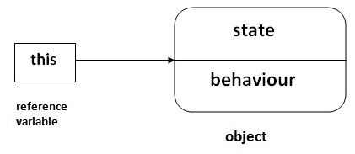

1) this: to refer current class instance variable
The this keyword can be used to refer current class instance variable. If there is ambiguity between the instance variables and parameters, this keyword resolves the problem of ambiguity.

Understanding the problem without this keyword
Let's understand the problem if we don't use this keyword by the example given below:

- class Student{
- int rollno;
- String name;
- float fee;
- Student(int rollno,String name,float fee){
- rollno=rollno;
- name=name;
- fee=fee;
- }
- void display(){System.out.println(rollno+" "+name+" "+fee);}
- }
- class TestThis1{
- public static void main(String args[]){
- Student s1=new Student(111,"ankit",5000f);
- Student s2=new Student(112,"sumit",6000f);
- s1.display();
- s2.display();
- }}
Output:
0 null 0.0
0 null 0.0
In the above example, parameters (formal arguments) and instance variables are same. So, we are using this keyword to distinguish local variable and instance variable.

Solution of the above problem by this keyword

- class Student{
- int rollno;
- 1String name;
- float fee;
- Student(int rollno,String name,float fee){
- this.rollno=rollno;
- this.name=name;
- this.fee=fee;
- }
- void display(){System.out.println(rollno+" "+name+" "+fee);}
- }

- class TestThis2{
- public static void main(String args[]){
- Student s1=new Student(111,"ankit",5000f);
- Student s2=new Student(112,"sumit",6000f);
- s1.display();
- s2.display();
- }}

Output:
111 ankit 5000
112 sumit 6000

Real usage of this() constructor call
The this() constructor call should be used to reuse the constructor from the constructor. It maintains the chain between the constructors i.e. it is used for constructor chaining. Let's see the example given below that displays the actual use of this keyword.

- class Student{
- int rollno;
- String name,course;
- float fee;
- Student(int rollno,String name,String course){
- this.rollno=rollno;
- this.name=name;
- this.course=course;
- }
- Student(int rollno,String name,String course,float fee){
- this(rollno,name,course);//reusing constructor
- this.fee=fee;
- }
- void display(){System.out.println(rollno+" "+name+" "+course+" "+fee);}
- }
- class TestThis7{
- public static void main(String args[]){
- Student s1=new Student(111,"ankit","java");
- Student s2=new Student(112,"sumit","java",6000f);
- s1.display();
- s2.display();
- }}
Output:
111 ankit java null
112 sumit java 6000

Example on reusing of constructor:::
//Java code for using 'this' keyword to
//refer current class instance variables

class Test
{
int a;
int b;
int c;

// Parameterized constructor
Test(int a, int b)
{
this.a = a;
this.b = b;
}
Test(int a,int b,int c){
this(a,b);
this.c=c;
}
void display()
{
//Displaying value of variables a and b
System.out.println("a = " + a + " b = " + b+" "+c);
}

public static void main(String[] args)
{
Test object = new Test(10, 20);
Test obj2=new Test(10,20,30);
object.display();
obj2.display();
}
}

Final Keyword In Java
Final variable
Final method
Final class
Is final method inherited ?
Blank final variable
Static blank final variable
Final parameter
Can you declare a final constructor
The final keyword in java is used to restrict the user. The java final keyword can be used in many context. Final can be:
- variable
- method
- class
The final keyword can be applied with the variables, a final variable that have no value it is called blank final variable or uninitialized final variable. It can be initialized in the constructor only. The blank final variable can be static also which will be initialized in the static block only. We will have detailed learning of these. Let's first learn the basics of final keyword.
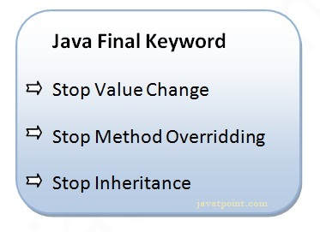

1) Java final variable
If you make any variable as final, you cannot change the value of final variable(It will be constant).

Example of final variable
There is a final variable speedlimit, we are going to change the value of this variable, but It can't be changed because final variable once assigned a value can never be changed.

- class Bike9{
- final int speedlimit=90;//final variable
- void run(){
- speedlimit=400;
- }
- public static void main(String args[]){
- Bike9 obj=new Bike9();
- obj.run();
- }
- }//end of class
Test it Now
Output:Compile Time Error

2) Java final method
If you make any method as final, you cannot override it.

Example of final method

- class Bike{
- final void run(){System.out.println("running");}
- }

- class Honda extends Bike{
- void run(){System.out.println("running safely with 100kmph");}

- public static void main(String args[]){
- Honda honda= new Honda();
- honda.run();
- }
- }
Test it Now
Output:Compile Time Error

3) Java final class
If you make any class as final, you cannot extend it.

Example of final class

- final class Bike{}

- class Honda1 extends Bike{
- void run(){System.out.println("running safely with 100kmph");}

- public static void main(String args[]){
- Honda1 honda= new Honda();
- honda.run();
- }
- }
Test it Now
Output:Compile Time Error

Inheritance in Java

Inheritance in java is a mechanism in which one object acquires all the properties and behaviors of parent object.
The idea behind inheritance in java is that you can create new classes that are built upon existing classes. When you inherit from an existing class, you can reuse methods and fields of parent class, and you can add new methods and fields also.
Inheritance represents the IS-A relationship, also known as parent-child relationship.

Why use inheritance in java
- For Method Overriding (so runtime polymorphism can be achieved).
- For Code Reusability.

Syntax of Java Inheritance

- class Subclass-name extends Superclass-name
- {
- //methods and fields
- }
The extends keyword indicates that you are making a new class that derives from an existing class. The meaning of "extends" is to increase the functionality.
In the terminology of Java, a class which is inherited is called parent or super class and the new class is called child or subclass.

Java Inheritance Example
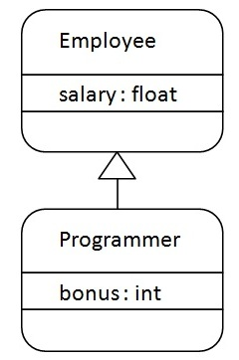
As displayed in the above figure, Programmer is the subclass and Employee is the superclass. Relationship between two classes is Programmer IS-A Employee.It means that Programmer is a type of Employee.

- class Employee{
- float salary=40000;
- }
- class Programmer extends Employee{
- int bonus=10000;
- public static void main(String args[]){
- Programmer p=new Programmer();
- System.out.println("Programmer salary is:"+p.salary);
- System.out.println("Bonus of Programmer is:"+p.bonus);
- }
- }
Programmer salary is:40000.0
Bonus of programmer is:10000
In the above example, Programmer object can access the field of own class as well as of Employee class i.e. code reusability.

Types of inheritance in java
On the basis of class, there can be three types of inheritance in java: single, multilevel and hierarchical.
In java programming, multiple and hybrid inheritance is supported through interface only. We will learn about interfaces later.
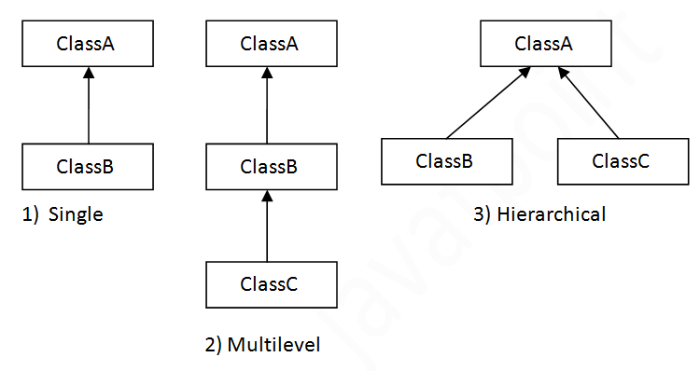

Note: Multiple inheritance is not supported in java through class.
When a class extends multiple classes i.e. known as multiple inheritance. For Example:
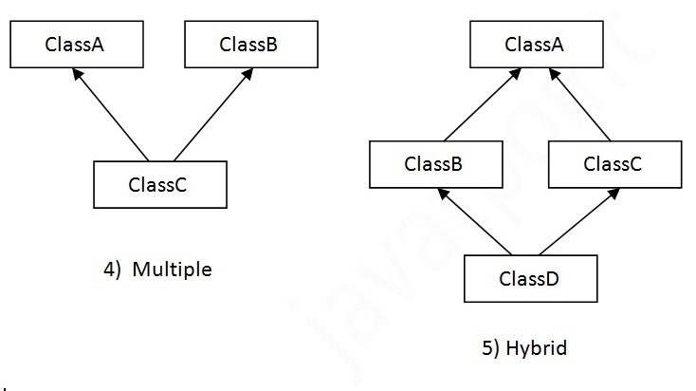

Single Inheritance Example
File: TestInheritance.java

- class Animal{
- void eat(){System.out.println("eating...");}
- }
- class Dog extends Animal{
- void bark(){System.out.println("barking...");}
- }
- class TestInheritance{
- public static void main(String args[]){
- Dog d=new Dog();
- d.bark();
- d.eat();
- }}
Output:
barking...
eating...

Multilevel Inheritance Example
File: TestInheritance2.java

- class Animal{
- void eat(){System.out.println("eating...");}
- }
- class Dog extends Animal{
- void bark(){System.out.println("barking...");}
- }
- class BabyDog extends Dog{
- void weep(){System.out.println("weeping...");}
- }
- class TestInheritance2{
- public static void main(String args[]){
- BabyDog d=new BabyDog();
- d.weep();
- d.bark();
- d.eat();
- }}
Output:
weeping...
barking...
eating...

Hierarchical Inheritance Example
File: TestInheritance3.java

- class Animal{
- void eat(){System.out.println("eating...");}
- }
- class Dog extends Animal{
- void bark(){System.out.println("barking...");}
- }
- class Cat extends Animal{
- void meow(){System.out.println("meowing...");}
- }
- class TestInheritance3{
- public static void main(String args[]){
- Cat c=new Cat();
- c.meow();
- c.eat();
- //c.bark();//C.T.Error
- }}
Output:
meowing...
eating...

Q) Why multiple inheritance is not supported in java?
To reduce the complexity and simplify the language, multiple inheritance is not supported in java.
Consider a scenario where A, B and C are three classes. The C class inherits A and B classes. If A and B classes have same method and you call it from child class object, there will be ambiguity to call method of A or B class.
Since compile time errors are better than runtime errors, java renders compile time error if you inherit 2 classes. So whether you have same method or different, there will be compile time error now.

- class A{
- void msg(){System.out.println("Hello");}
- }
- class B{
- void msg(){System.out.println("Welcome");}
- }
- class C extends A,B{//suppose if it were

- Public Static void main(String args[]){
- C obj=new C();
- obj.msg();//Now which msg() method would be invoked?
- }
- }

Compile Time Error

Java Polymorphism

Method Overloading in Java
Different ways to overload the method
By changing the no. of arguments
By changing the datatype
Why method overloading is not possible by changing the return type
Can we overload the main method
method overloading with Type Promotion
If a class has multiple methods having same name but different in parameters, it is known as Method Overloading.
If we have to perform only one operation, having same name of the methods increases the readability of the program.
Suppose you have to perform addition of the given numbers but there can be any number of arguments, if you write the method such as a(int,int) for two parameters, and b(int,int,int) for three parameters then it may be difficult for you as well as other programmers to understand the behavior of the method because its name differs.
So, we perform method overloading to figure out the program quickly.

Advantage of method overloading
Method overloading increases the readability of the program.

Different ways to overload the method
There are two ways to overload the method in java
- By changing number of arguments
- By changing the data type

In java, Method Overloading is not possible by changing the return type of the method only.

1) Method Overloading: changing no. of arguments
In this example, we have created two methods, first add() method performs addition of two numbers and second add method performs addition of three numbers.
In this example, we are creating static methods so that we don't need to create instance for calling methods.

- class Adder{
- static int add(int a,int b){return a+b;}
- static int add(int a,int b,int c){return a+b+c;}
- }
- class TestOverloading1{
- public static void main(String[] args){
- System.out.println(Adder.add(11,11));
- System.out.println(Adder.add(11,11,11));
- }}
Output:
22
33

2) Method Overloading: changing data type of arguments
In this example, we have created two methods that differs in data type. The first add method receives two integer arguments and second add method receives two double arguments.

- class Adder{
- static int add(int a, int b){return a+b;}
- static double add(double a, double b){return a+b;}
- }
- class TestOverloading2{
- public static void main(String[] args){
- System.out.println(Adder.add(11,11));
- System.out.println(Adder.add(12.3,12.6));
- }}

Output:
22
24.9

Q) Why Method Overloading is not possible by changing the return type of method only?
In java, method overloading is not possible by changing the return type of the method only because of ambiguity. Let's see how ambiguity may occur:

- class Adder{
- static int add(int a,int b){return a+b;}
- static double add(int a,int b){return a+b;}
- }
- class TestOverloading3{
- public static void main(String[] args){
- System.out.println(Adder.add(11,11));//ambiguity
- }}
Output:
Compile Time Error: method add(int,int) is already defined in class Adder
System.out.println(Adder.add(11,11)); //Here, how can java determine which sum() method should be called?

Note: Compile Time Error is better than Run Time Error. So, java compiler renders compiler time error if you declare the same method having same parameters.

Method Overriding in Java
Understanding problem without method overriding
Can we override the static method
method overloading vs method overriding
If subclass (child class) has the same method as declared in the parent class, it is known as method overriding in java.
In other words, If subclass provides the specific implementation of the method that has been provided by one of its parent class, it is known as method overriding.

Usage of Java Method Overriding
- Method overriding is used to provide specific implementation of a method that is already provided by its super class.
- Method overriding is used for runtime polymorphism

Rules for Java Method Overriding
- method must have same name as in the parent class
- method must have same parameter as in the parent class.
- must be IS-A relationship (inheritance).

Understanding the problem without method overriding
Let's understand the problem that we may face in the program if we don't use method overriding.

- class Vehicle{
- void run(){System.out.println("Vehicle is running");}
- }
- class Bike extends Vehicle{

- public static void main(String args[]){
- Bike obj = new Bike();
- obj.run();
- }
- }

Output:Vehicle is running
Problem is that I have to provide a specific implementation of run() method in subclass that is why we use method overriding.

Example of method overriding
In this example, we have defined the run method in the subclass as defined in the parent class but it has some specific implementation. The name and parameter of the method is same and there is IS-A relationship between the classes, so there is method overriding.

- class Vehicle{
- void run(){System.out.println("Vehicle is running");}
- }
- class Bike2 extends Vehicle{
- void run(){System.out.println("Bike is running safely");}

- public static void main(String args[]){
- Bike2 obj = new Bike2();
- obj.run();
- }

Output:Bike is running safely

Real example of Java Method Overriding
Consider a scenario, Bank is a class that provides functionality to get rate of interest. But, rate of interest varies according to banks. For example, SBI, ICICI and AXIS banks could provide 8%, 7% and 9% rate of interest.

- class Bank{
- int getRateOfInterest(){return 0;}
- }

- class SBI extends Bank{
- int getRateOfInterest(){return 8;}
- }

- class ICICI extends Bank{
- int getRateOfInterest(){return 7;}
- }

- class AXIS extends Bank{
- int getRateOfInterest(){return 9;}
- }

- class Test2{
- public static void main(String args[]){
- SBI s=new SBI();
- ICICI i=new ICICI();
- AXIS a=new AXIS();
- System.out.println("SBI Rate of Interest: "+s.getRateOfInterest());
- System.out.println("ICICI Rate of Interest: "+i.getRateOfInterest());
- System.out.println("AXIS Rate of Interest: "+a.getRateOfInterest());
- }
- }

Output:
SBI Rate of Interest: 8
ICICI Rate of Interest: 7
AXIS Rate of Interest: 9

Abstract class in Java
A class that is declared with abstract keyword, is known as abstract class in java. It can have abstract and non-abstract methods (method with body).
Before learning java abstract class, let's understand the abstraction in java first.

Abstraction in Java
Abstraction is a process of hiding the implementation details and showing only functionality to the user.
Another way, it shows only important things to the user and hides the internal details for example sending sms, you just type the text and send the message. You don't know the internal processing about the message delivery.
Abstraction lets you focus on what the object does instead of how it does it.

Ways to achieve Abstraction
There are two ways to achieve abstraction in java
- Abstract class (0 to 100%)
- Interface (100%)

Abstract class in Java
A class that is declared as abstract is known as abstract class. It needs to be extended and its method implemented. It cannot be instantiated.

Example abstract class

- abstract class A{}

abstract method
A method that is declared as abstract and does not have implementation is known as abstract method.

Example abstract method

- abstract void printStatus();//no body and abstract

Example of abstract class that has abstract method
In this example, Bike the abstract class that contains only one abstract method run. It implementation is provided by the Honda class.

- abstract class Bike{
- abstract void run();
- }
- class Honda4 extends Bike{
- void run(){System.out.println("running safely..");}
- public static void main(String args[]){
- Bike obj = new Honda4();
- obj.run();
- }
- }
O/p:
running safely..

Understanding the real scenario of abstract class
In this example, Shape is the abstract class, its implementation is provided by the Rectangle and Circle classes. Mostly, we don't know about the implementation class (i.e. hidden to the end user) and object of the implementation class is provided by the factory method.
A factory method is the method that returns the instance of the class. We will learn about the factory method later.
In this example, if you create the instance of Rectangle class, draw() method of Rectangle class will be invoked.
File: TestAbstraction1.java

- abstract class Shape{
- abstract void draw();
- }
- //In real scenario, implementation is provided by others i.e. unknown by end user
- class Rectangle extends Shape{
- void draw(){System.out.println("drawing rectangle");}
- }
- class Circle1 extends Shape{
- void draw(){System.out.println("drawing circle");}
- }
- //In real scenario, method is called by programmer or user
- class TestAbstraction1{
- public static void main(String args[]){
- Shape s=new Circle1();//In real scenario, object is provided through method e.g. getShape() method
- s.draw();
- }
- }
O/p:
drawing circle

Another example of abstract class in java
File: TestBank.java

- abstract class Bank{
- abstract int getRateOfInterest();
- }
- class SBI extends Bank{
- int getRateOfInterest(){return 7;}
- }
- class PNB extends Bank{
- int getRateOfInterest(){return 8;}
- }

- class TestBank{
- public static void main(String args[]){
- Bank b;
- b=new SBI();
- System.out.println("Rate of Interest is: "+b.getRateOfInterest()+" %");
- b=new PNB();
- System.out.println("Rate of Interest is: "+b.getRateOfInterest()+" %");
- }}
O/p:
Rate of Interest is: 7 %
Rate of Interest is: 8 %

Interface in Java
Interface
Example of Interface
Multiple inheritance by Interface
Why multiple inheritance is supported in Interface while it is not supported in case of class.
Marker Interface
Nested Interface
An interface in java is a blueprint of a class. It has static constants and abstract methods.
The interface in java is a mechanism to achieve abstraction. There can be only abstract methods in the java interface not method body. It is used to achieve abstraction and multiple inheritance in Java.
Java Interface also represents IS-A relationship.
It cannot be instantiated just like abstract class.

Why use Java interface?
There are mainly three reasons to use interface. They are given below.
- It is used to achieve abstraction.
- By interface, we can support the functionality of multiple inheritance.
- It can be used to achieve loose coupling.

Java 8 Interface Improvement
Since Java 8, interface can have default and static methods which is discussed later.

Internal addition by compiler

The java compiler adds public and abstract keywords before the interface method. More, it adds public, static and final keywords before data members.
In other words, Interface fields are public, static and final by default, and methods are public and abstract.

Understanding relationship between classes and interfaces
As shown in the figure given below, a class extends another class, an interface extends another interface but a class implements an interface.

Java Interface Example
In this example, Printable interface has only one method, its implementation is provided in the A class.

- interface printable{
- void print();
- }
- class A6 implements printable{
- public void print(){System.out.println("Hello");}

- public static void main(String args[]){
- A6 obj = new A6();
- obj.print();
- }
- }
Output:
Hello

Java Interface Example: Drawable
In this example, Drawable interface has only one method. Its implementation is provided by Rectangle and Circle classes. In real scenario, interface is defined by someone but implementation is provided by different implementation providers. And, it is used by someone else. The implementation part is hidden by the user which uses the interface.
File: TestInterface1.java

- //Interface declaration: by first user
- interface Drawable{
- void draw();
- }
- //Implementation: by second user
- class Rectangle implements Drawable{
- public void draw(){System.out.println("drawing rectangle");}
- }
- class Circle implements Drawable{
- public void draw(){System.out.println("drawing circle");}
- }
- //Using interface: by third user
- class TestInterface1{
- public static void main(String args[]){
- Drawable d=new Circle();//In real scenario, object is provided by method e.g. getDrawable()
- d.draw();
- }}
Output:
drawing circle

Java Interface Example: Bank
Let's see another example of java interface which provides the implementation of Bank interface.
File: TestInterface2.java

- interface Bank{
- float rateOfInterest();
- }
- class SBI implements Bank{
- public float rateOfInterest(){return 9.15f;}
- }
- class PNB implements Bank{
- public float rateOfInterest(){return 9.7f;}
- }
- class TestInterface2{
- public static void main(String[] args){
- Bank b=new SBI();
- System.out.println("ROI: "+b.rateOfInterest());
- }}

Output:
ROI: 9.15

Java Package
Java Package
Example of package
Accessing package
By import packagename.*
By import packagename.classname
By fully qualified name
Subpackage
Sending class file to another directory
-classpath switch
4 ways to load the class file or jar file
How to put two public class in a package
Static Import
Package class
A java package is a group of similar types of classes, interfaces and sub-packages.
Package in java can be categorized in two form, built-in package and user-defined package.
There are many built-in packages such as java, lang, awt, javax, swing, net, io, util, sql etc.
Here, we will have the detailed learning of creating and using user-defined packages.

Advantage of Java Package
1) Java package is used to categorize the classes and interfaces so that they can be easily maintained.
2) Java package provides access protection.
3) Java package removes naming collision.
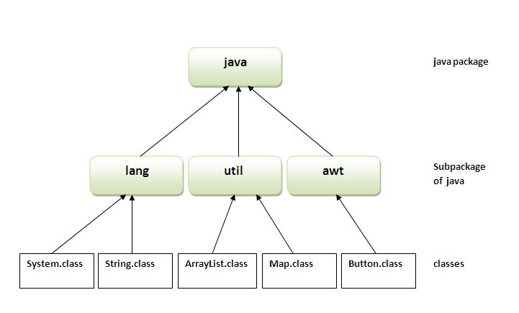

Simple example of java package
The package keyword is used to create a package in java.

- //save as Simple.java
- package mypack;
- public class Simple{
- public static void main(String args[]){
- System.out.println("Welcome to package");
- }
- }

How to compile java package
If you are not using any IDE, you need to follow the syntax given below:

- javac -d directory javafilename
For example

- javac -d . Simple.java
The -d switch specifies the destination where to put the generated class file. You can use any directory name like /home (in case of Linux), d:/abc (in case of windows) etc. If you want to keep the package within the same directory, you can use . (dot).

How to run java package program
You need to use fully qualified name e.g. mypack.Simple etc to run the class.
To Compile: javac -d . Simple.java
To Run: java mypack.Simple
Output:Welcome to package
The -d is a switch that tells the compiler where to put the class file i.e. it represents destination. The . represents the current folder.

How to access package from another package?
There are three ways to access the package from outside the package.
- import package.*;
- import package.classname;
- fully qualified name.

1) Using packagename.*
If you use package.* then all the classes and interfaces of this package will be accessible but not subpackages.
The import keyword is used to make the classes and interface of another package accessible to the current package.

Example of package that import the packagename.*

- //save by A.java
- package pack;
- public class A{
- public void msg(){System.out.println("Hello");}
- }

- //save by B.java
- package mypack;
- import pack.*;

- class B{
- public static void main(String args[]){
- A obj = new A();
- obj.msg();
- }
- }
Output:Hello

2) Using packagename.classname
If you import package.classname then only declared class of this package will be accessible.

Example of package by import package.classname

- //save by A.java

- package pack;
- public class A{
- public void msg(){System.out.println("Hello");}
- } class b{}

- //save by B.java
- package mypack;
- import pack.A;

- class B{
- public static void main(String args[]){
- A obj = new A();
- obj.msg();
- }
- }
Output:Hello

3) Using fully qualified name
If you use fully qualified name then only declared class of this package will be accessible. Now there is no need to import. But you need to use fully qualified name every time when you are accessing the class or interface.
It is generally used when two packages have same class name e.g. java.util and java.sql packages contain Date class.

Example of package by import fully qualified name

- //save by A.java
- package pack;
- public class A{
- public void msg(){System.out.println("Hello");}
- }

- //save by B.java
- package mypack;
- class B{
- public static void main(String args[]){
- pack.A obj = new pack.A();//using fully qualified name
- obj.msg();
- }
- }
Output:Hello

Note: If you import a package, subpackages will not be imported.
If you import a package, all the classes and interface of that package will be imported excluding the classes and interfaces of the subpackages. Hence, you need to import the subpackage as well.

Note: Sequence of the program must be package then import then class.
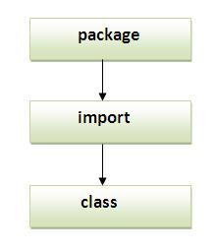

Access Modifiers in java
private access modifier
Role of private constructor
default access modifier
protected access modifier
public access modifier
Applying access modifier with method overriding
There are two types of modifiers in java: access modifiers and non-access modifiers.
The access modifiers in java specifies accessibility (scope) of a data member, method, constructor or class.
There are 4 types of java access modifiers:
- private
- default
- protected
- public
There are many non-access modifiers such as static, abstract, synchronized, native, volatile, transient etc. Here, we will learn access modifiers.

1) private access modifier
The private access modifier is accessible only within class.

Simple example of private access modifier
In this example, we have created two classes A and Simple. A class contains private data member and private method. We are accessing these private members from outside the class, so there is compile time error.

- class A{
- private int data=40;
- private void msg(){System.out.println("Hello java");}
- }

- public class Simple{
- public static void main(String args[]){
- A obj=new A();
- System.out.println(obj.data);//Compile Time Error
- obj.msg();//Compile Time Error
- }
- }

Role of Private Constructor
If you make any class constructor private, you cannot create the instance of that class from outside the class. For example:

- class A{
- private A(){}//private constructor
- void msg(){System.out.println("Hello java");}
- }
- public class Simple{
- public static void main(String args[]){
- A obj=new A();//Compile Time Error
- }
- }

Note: A class cannot be private or protected except nested class.

2) default access modifier
If you don't use any modifier, it is treated as default bydefault. The default modifier is accessible only within package.

Example of default access modifier
In this example, we have created two packages pack and mypack. We are accessing the A class from outside its package, since A class is not public, so it cannot be accessed from outside the package.

- //save by A.java
- package pack;
- class A{
- void msg(){System.out.println("Hello");}
- }

- //save by B.java
- package mypack;
- import pack.*;
- class B{
- public static void main(String args[]){
- A obj = new A();//Compile Time Error
- obj.msg();//Compile Time Error
- }
- }
In the above example, the scope of class A and its method msg() is default so it cannot be accessed from outside the package.

3) protected access modifier
The protected access modifier can be applied on the data member, method and constructor. It The protected access modifier is accessible within package and outside the package but through inheritance only.
can't be applied on the class.

Example of protected access modifier
In this example, we have created the two packages pack and mypack. The A class of pack package is public, so can be accessed from outside the package. But msg method of this package is declared as protected, so it can be accessed from outside the class only through inheritance.

- //save by A.java
- package pack;
- public class A{
- protected void msg(){System.out.println("Hello");}
- }

- //save by B.java
- package mypack;
- import pack.*;

- class B extends A{
- public static void main(String args[]){
- B obj = new B();
- obj.msg();
- }
- }
Output:Hello

4) public access modifier
The public access modifier is accessible everywhere. It has the widest scope among all other modifiers.

Example of public access modifier

- //save by A.java

- package pack;
- public class A{
- public void msg(){System.out.println("Hello");}
- }

- //save by B.java

- package mypack;
- import pack.*;

- class B{
- public static void main(String args[]){
- A obj = new A();
- obj.msg();
- }
- }
Output:Hello

Understanding all java access modifiers
Let's understand the access modifiers by a simple table.
Access Modifier | within class | within package | outside package by subclass only | outside package
Private | Y | N | N | N
Default | Y | Y | N | N
Protected | Y | Y | Y | N
Public | Y | Y | Y | Y

Encapsulation in Java
Encapsulation in java is a process of wrapping code and data together into a single unit, for example capsule i.e. mixed of several medicines.

We can create a fully encapsulated class in java by making all the data members of the class private. Now we can use setter and getter methods to set and get the data in it.
The Java Bean class is the example of fully encapsulated class.

Advantage of Encapsulation in java
By providing only setter or getter method, you can make the class read-only or write-only.
It provides you the control over the data. Suppose you want to set the value of id i.e. greater than 100 only, you can write the logic inside the setter method.

Simple example of encapsulation in java
Let's see the simple example of encapsulation that has only one field with its setter and getter methods.

- //save as Student.java
- package com.digitallync
- public class Student{
- private String name;

- public String getName(){
- return name;
- }
- public void setName(String name){
- this.name=name
- }
- }

- //save as Test.java
- package com.javatpoint;
- class Test{
- public static void main(String[] args){
- Student s=new Student();
- s.setName("vijay");
- System.out.println(s.getName());
- }
- }
Compile By: javac -d . Test.java
Run By: java com.javatpoint.Test
Output: vijay

