

**Social Media Marketing Proposal**

## Prepared for:

[Client.FirstName] [Client.LastName] [Client.Company] [Client.AddressLine1] [Client.AddressLine2] [Client.PhoneNumber]

[Client.Email]

## Prepared by:

**RUBILOGY**

[Wholly Owned By Dragon Ang Enterprise] (+60) 173 788 007

[builtwith@rubilogy.com](mailto:builtwith@rubilogy.com) [www.rubilogy.com](http://www.rubilogy.com/)

Why You Should Choose RUBILOGY

1.0 INTRODUCTION

* 1. HOW WE MARKET ON FACEBOOK
  2. Identify audience
  3. Figure out the right approach
  4. Scaling your campaign
  5. Twice as nice
  6. Reporting and monitoring

3.0 SCHEDULE

4.0 PACKAGES AND BILLING

## 1.0 INTRODUCTION

Facebook is one of the most popular social media platforms in the world, with more than 1.6 billion users. And people like to spend a lot of time on it, whether all at once or periodically throughout the day. This means there are billions and billions of eyes constantly scrolling through posts, videos, photos, status updates, and, yes, advertisements.

And when it comes to advertising, there is no company in the world that has more information about its users than Facebook. It includes much more than just your age, gender, and alma mater. While those things are valuable for marketing purposes, Facebook also knows which websites you visit and how often, how much time you spend doing various things online, and what you purchase. From a business marketing standpoint, that stuff is gold. And thankfully it’s right there for the taking, if you know where to find it and how to use it. That’s where RUBILOGY comes into play.

We are compact and bright team of marketing professionals, with an emphasis on social media campaigns. For the past year, we’ve helped startups, mom-and-pop shops, and big corporations realize the potential in Facebook marketing to grow a customer base, retain those customers, and bring new ones on board.



## HOW WE MARKET ON FACEBOOK

* 1. IDENTIFY AUDIENCE

First and foremost, RUBILOGY needs to know everything we can about your existing customer base. This includes what kind of habits they have in social media and elsewhere online. This information will also inform our approach to attracting new customers.

* 1. FIGURE OUT THE RIGHT APPROACH

After identifying your audience, we will figure out how to most effectively communicate with them. What do they respond to and why? This will also inform future marketing ideas.

* 1. SCALING YOUR CAMPAIGN

There are many ways we will approach your Facebook Marketing campaign, but unless we are targeting the right audience then it will be a disaster. Here is a rundown of how we can scale your marketing on Facebook to optimize results:

* **Custom:** Using your customer database, we will upload phone numbers, email addresses, Facebook user IDs, and app user IDs. That information will then be matched to as many user profiles as possible.
* **Lookalike:** Now that we have a picture of your customer database, Facebook can find similar users to open up a whole new set of potential customers.
* **Location:** This is important, especially for a local business. Ads will specifically target a region, city, state, or country that can purchase your products.
* **Age, Gender, Language:** Unless you’re targeting kids from 1 to 92, honing in on the right age, gender, and native language of users is important to effective marketing. Luckily, this is easy to do on Facebook.
* **Detailed Targeting:** This approach is used to target new customers or people who’ve never heard of your business before. It involves demographics, interests, behaviors, and other categories.
  1. TWICE AS NICE

If we find that one advertisement did better than others, we will take note. That ad can be repackaged with a few modifications to look new again, and thus attract just as much attention as the first time.

* 1. REPORTING AND MONITORING

RUBILOGY will measure analytics data such as advertising metrics, page-level metrics, engagement rate, total page “likes,” and other metrics. We will compile reports and present them to [Client.Company] on a monthly basis.

## 3.0 SCHEDULE

Facebook marketing campaigns are an ongoing process. We respond to what works and move on fast from what doesn’t work. Therefore, we anticipate a minimum of one week from the start to the date your campaign is launched. After that, we monitor and adjust, presenting reports to [Client.Company] on a monthly basis. Here’s how the process will look:

|  |  |  |
| --- | --- | --- |
| **Task** | **Timeline** | **Estimated Completion** |
| Research & Development | 2 days |  |
| Campaign Creation | 5 days |  |
| Monitoring & analytics | on-going |  |

## PACKAGES AND BILLING

Much goes into the cost of a Facebook marketing campaign. First and foremost, Facebook charges for ads two different ways: cost per click or cost per 1,000 ad views. And the package depends on the budget of your company. Please select which package you prefer:

* + - **Basic** Package
    - **Advanced** Package
    - **Premium** Package

The following for its outcome & price:

|  |  |  |
| --- | --- | --- |
| **Package** | **Outcome** | **Price(RM)** |
| **Basic**  (1 month) | Target Audience Est. Reach 5,000, Sales boost by 10%, Exposure + 5%. | 800 |
| **Advanced**  (3 months) | Target Audience Est. Reach 10,000, Sales boost by 20%, Exposure + 10%. | 2,300 |
| **Premium**  (6 months) | Target Audience Est. Reach 15,000, Sales boost by 30%, Exposure + 15%. | 4,500 |
| **Monitoring & Analytics** | Learn more about your audiences and the content they are most interested in. As you learn, adjust your ads to be more relevant for each target audience. | 500/month |

## Payment Method

* + - Bank Name : Alliance Bank
    - Account Holder : Dragon Ang Enterprise
    - Account Number : 0401-00-010427-988

Upon signing this agreement, [Client.Company] must pay full amount to begin work immediately, and monthly costs will be invoiced accordingly.

# RUBILOGY

[Wholly Owned By Dragon Ang Enterprise]

Signed By:

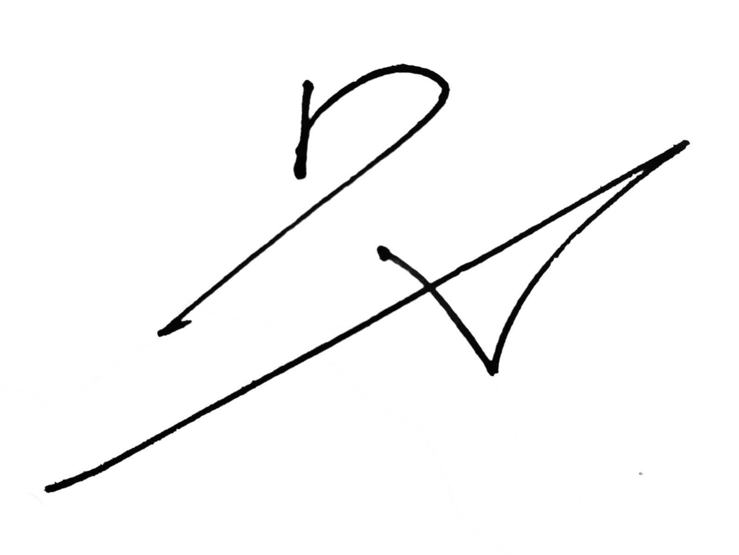Dragon Ang

Date: 1st of January 2017

[Client.Company] Signed By:

Date: 1st of January 2017