WELLSYNTH AI
Well Delivery Benchmarking

How It Works and Where We Are Today

Prepared for: Drilling Engineers & Operations Teams
August 2026

Executive Summary
WellSynth AI's Well Delivery Benchmarking system takes your daily drilling reports (DDRs) and automatically builds a performance comparison across all offset wells in a project. It answers the question every drilling team asks: are we ahead or behind, where exactly did we lose time, and what has worked before when this happened?
The system is built around a simple but powerful idea: compare each well's performance not against a plan or a single offset, but against the best demonstrated time for every specific operation, in every hole section, at every depth range — assembled from everything the field has actually achieved.
This document walks through what the system does today, how to read each screen, and where we are heading next. No software or coding knowledge is needed.

1. The Problem We Are Solving
When you review a well's performance, the visible losses are obvious — stuck pipe, equipment failure, waiting on weather. These appear in the NPT column. Everyone sees them, everyone reports them.
But these visible losses are usually a minority of the total time lost.
The rest is Invisible Lost Time (ILT). Connections that took 3.5 minutes instead of 2.2. A trip run dry instead of pumping out. Control-drilling at 40 RPM because that's how this crew has always done it. Each one is unremarkable on its own. Added up over a 40-day well, they are usually larger than the NPT.
You cannot see ILT by reading your own reports, because your reports say what you did — and what you did looks normal. ILT is only visible when you compare against someone in the same field, in the same hole section, doing the same operation, faster, with the report to prove it.
That comparison is what WellSynth AI builds automatically.
The industry name for this method is “best of best”. SPE and IADC papers define ILT the same way: identify the least time achieved for each activity across a group of wells, then subtract it from what you took. We are automating an accepted methodology and being unusually careful about the caveats.

2. How the Comparison Works

The Cell — The Unit of All Comparison
You cannot compare “day 12 of Well A” to “day 12 of Well B”. You cannot even compare the same measured depth across two wells — one might be in 12¼″ and the other in 8½″ because their casing points differ.
So every comparison is keyed on three things together. We call this a cell:
Hole Section | Depth Band (into section) | Activity
e.g. 8½″ | e.g. 0–820 ft into section | e.g. Tripping

- Hole Section: 12¼″ work is different from 8½″ work. They are never mixed.
- Depth Band: Measured from the top of each hole section, not from surface. This is critical — it means wells with different casing points are still compared correctly within each section.
- Activity: Drilling, tripping, casing, cementing, circulating, etc. A well that skipped a wiper trip should not set the benchmark for wells that ran one.

Everything downstream — the composite benchmark, the gap analysis, the attention list, and the root-cause analysis — is computed on these cells.

Evidence Grades — How Sure Are We?
For any cell, we count how many separate wellbores demonstrated it. This determines how much weight we give the number:
Grade | Wellbores | What It Means | How We Use It
Firm | 4 or more | A demonstrated floor. Multiple crews achieved this or better. | Headline numbers. Drives the attention list.
Indicative | 2–3 | Real evidence, but not enough to call it a floor. | Shown and labelled. Never used to accuse anyone.
Insufficient | 0–1 | One well's time wearing a benchmark's clothes. | Reported but never treated as a standard.

A large number of “Insufficient” cells is not a fault — it is the system honestly reporting its evidence. The fix is always more offset wells, never a lower threshold.

3. What You See — The Dashboard Screens
The benchmarking dashboard has six tabs, each designed to answer a specific question. Here is what each one does and how to read it.

3.1 Attention — “What should I act on?”
This is the most important screen. The rest of the system produces a correct measurement layer — curves, tables, ratios. But the whole premise of ILT is that you cannot see it in your own data. A product that hands you a chart and asks you to spot the problem has failed at exactly what it promised.
So the first screen is a short ranked list of the things that deserve your attention right now.
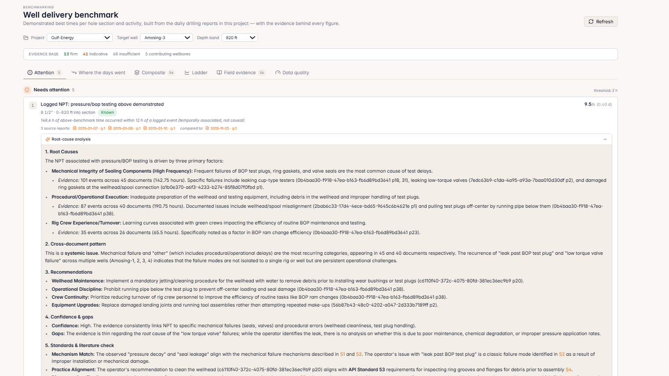
Figure 1. The Attention tab. Each item is ranked by hours at stake, carries an evidence tier, cites its source reports, and expands into a full root-cause analysis.
How to read it:
- Ranked by hours at stake, not by severity. Your scarcest resource is attention; hours are the currency.
- Each item shows what deviated, how many hours, which cell, how sure we are, and which reports it came from.
- Every item is traceable to a specific page in a specific report. Click the source links to verify.
- The badge shows the tier: Known (in your reports), Detected (computed against Firm evidence), or Suspected (inferred).
- An empty list is a real answer — it means the well is tracking the benchmark. The list is never padded to look busy.

Root-Cause Analysis: Each attention item expands to show a detailed root-cause analysis — primary causes ranked by frequency, cross-document patterns showing whether an issue is systemic or isolated, concrete recommendations, an explicit confidence-and-gaps statement, and a check against industry standards and literature. Every claim cites the specific reports and pages behind it.

3.2 Where the Days Went — “How does the gap break down?”
A single “you lost 18 days” number is unusable and unfalsifiable. This screen breaks that number down into buckets that add up exactly.
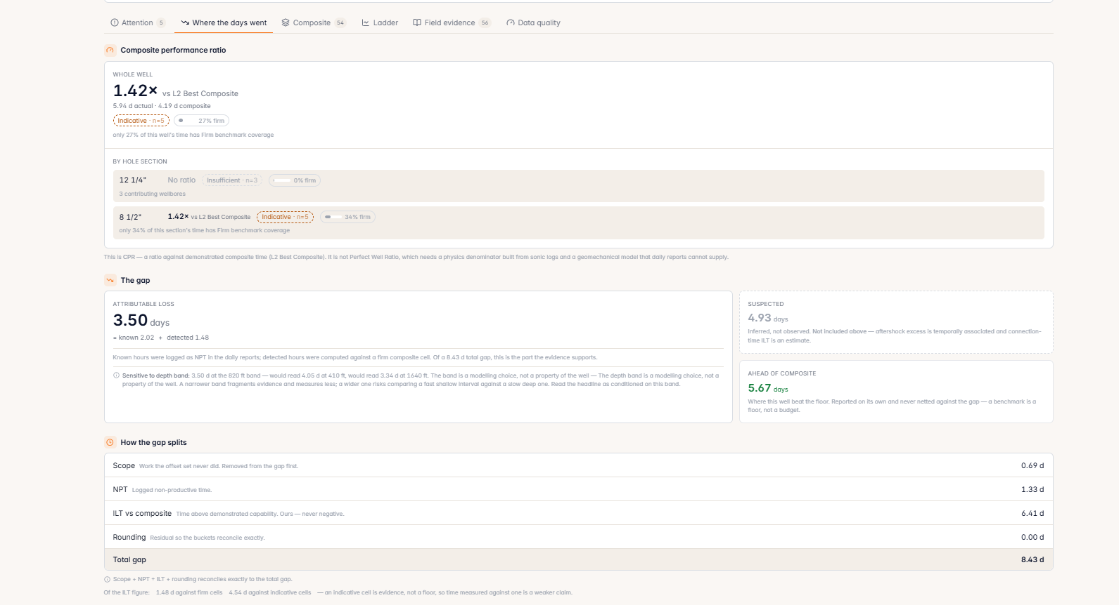
Figure 2. Composite Performance Ratio, the attributable-loss headline, and the four buckets the gap splits into — which reconcile exactly to the total.

Composite Performance Ratio (CPR)
At the top, the CPR tells you how your well compares to the best demonstrated composite:
- 1.0× means you matched the composite exactly.
- 1.42× means you took 42% longer than what the field has demonstrated is achievable.
- The ratio is shown whole-well and per hole section, each with its own evidence grade and the share of that scope's time actually backed by Firm benchmark coverage.
- This is labelled “L2 Best Composite” — not a technical limit, not a perfect well. It is what has actually been demonstrated.

The Gap — Attributable Loss vs. Suspected
The gap between your well and the composite is split into ordered buckets. The order matters, because each stage removes time the next one is not allowed to claim:
Bucket | What It Is | Example
1. Scope | Work your well did that no offset well did. Removed first, so you are never penalised for additional work. | A contingency string, extra coring, an additional logging run.
2. NPT | Non-productive time from your own reports. We do not re-decide what was NPT. | Stuck pipe, equipment failure, waiting on weather.
3. ILT | The residual: time above demonstrated capability with no scope reason and no NPT flag. This is the invisible lost time. | Slower connections, extra circulation, cautious drilling.

Key rule: Scope + NPT + ILT + Rounding = Total Gap, exactly. If the numbers do not reconcile, the breakdown cannot be trusted — so we make sure they always do.
Ahead of composite is reported separately. Where your well beat the floor, that is shown on its own and never netted against the gap — because a benchmark is a floor, not a budget. Netting would let a fast section quietly pay for a slow one and hide both.
Sensitivity is disclosed. The headline is recomputed at half and double the depth band and shown alongside, so you can see how much the band choice moves the answer rather than discovering it later.

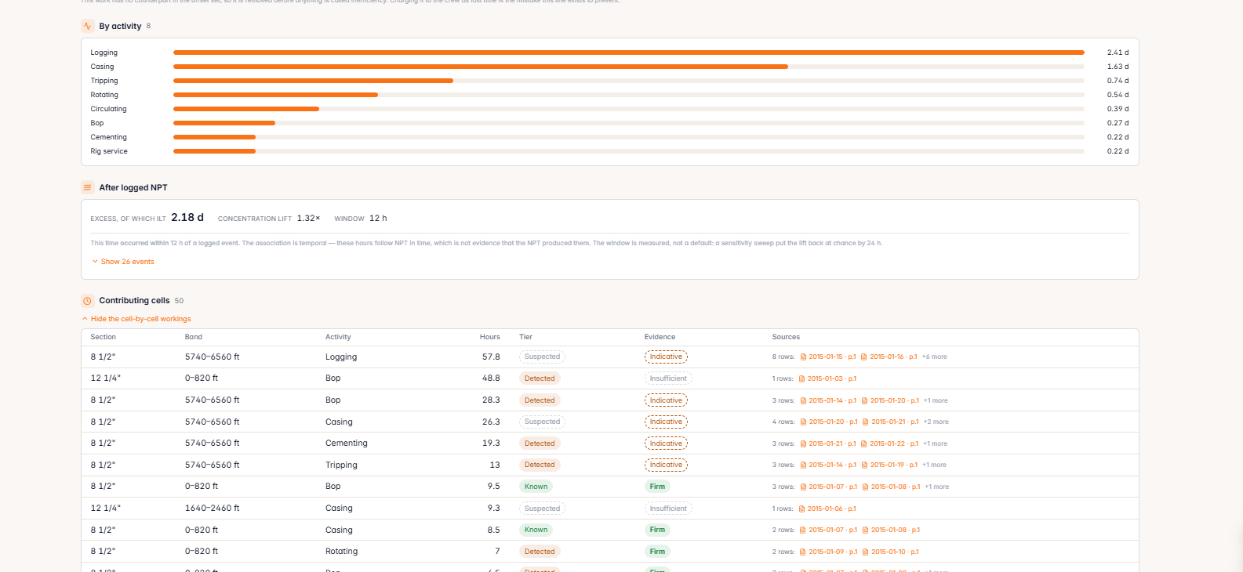
Figure 3. ILT broken down by activity, the NPT recovery tail with its concentration-lift honesty check, and the cell-by-cell workings behind every figure.

By Activity
A horizontal bar chart breaks down ILT by activity — logging, casing, tripping, rotating, circulating, BOP, cementing, rig service — so you can see at a glance which operations consumed the most above-benchmark time.

After Logged NPT — The Recovery Tail
After a major NPT event, the next shift is often slower — the hole needs work, the crew is cautious, the mud needs conditioning. None of that gets logged as NPT, but it is a real cost.
- The system measures excess time occurring within 12 hours of each logged NPT event.
- Concentration Lift is the honesty check, and the first thing to read. It asks whether excess time is genuinely concentrated near NPT events, or whether that is simply where excess time falls anyway. 1.0× means chance. A lift meaningfully above 1.0 is a real signal worth investigating.
- The 12-hour window was measured against the corpus, not assumed — and it is one tour, the unit a recovery is actually managed in.
- The association is always labelled temporal, never causal. The system reports; you judge.

Contributing Cells
Below the summaries, the full cell-by-cell workings are available: every section, band, activity and hour count, with its loss tier, its evidence grade, and links to the source rows. This is the audit trail behind the headline.

3.3 Composite — “What exactly am I being compared to?”
This is the cell-by-cell grid showing the best demonstrated time for every combination of hole section, depth band, and activity — and, for each one, exactly who demonstrated it and where to verify it.
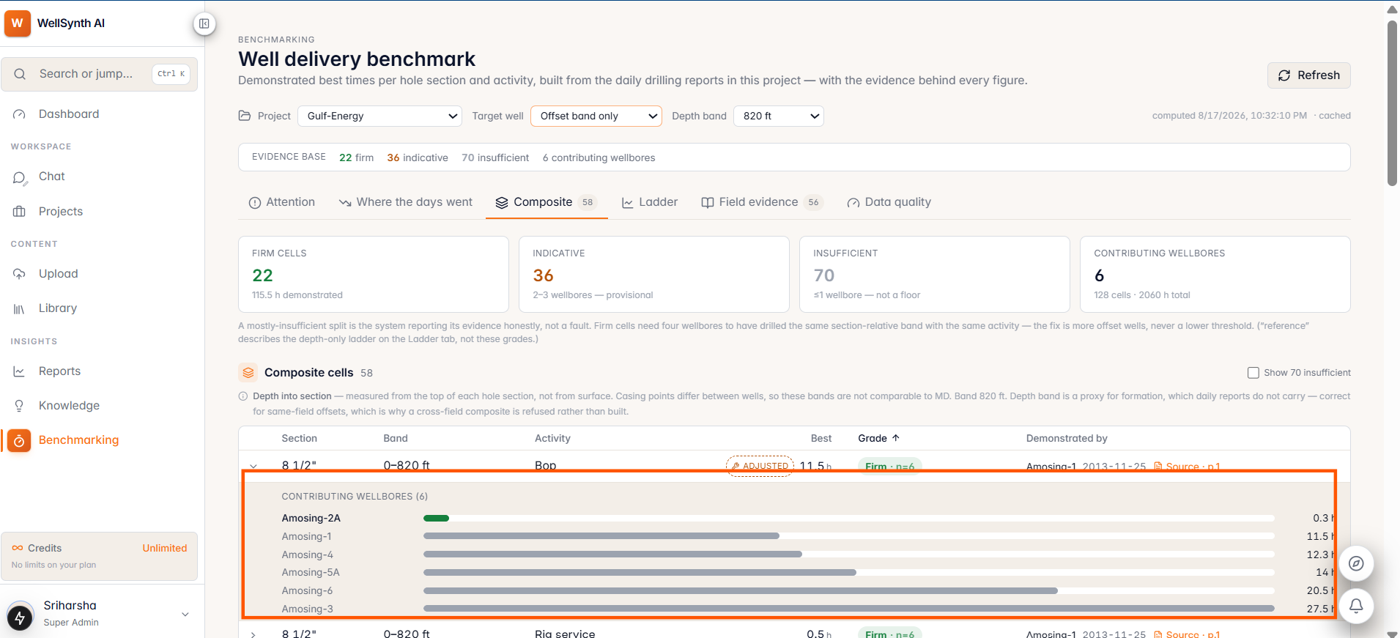
Figure 4. Expanding a composite cell reveals every contributing wellbore and its individual time, so the spread of field performance behind a single benchmark figure is visible.
How to read it:
- Each row is one cell: a specific activity in a specific depth band of a specific hole section.
- “Best” is the demonstrated floor — the fastest time any offset well achieved for that cell, after our outlier guard has checked it.
- “Demonstrated by” names the exact well, date, and report page. This is the whole design — a benchmark you cannot audit is one you cannot argue with, and one you cannot argue with will be dismissed the first time it is inconvenient.
- The grade badge (Firm · n=6, Firm · n=5, and so on) shows how many wellbores back each cell.
- Expand any row to see the contributing wellbores as a bar chart — so a benchmark is never just a number, it is a distribution you can inspect.

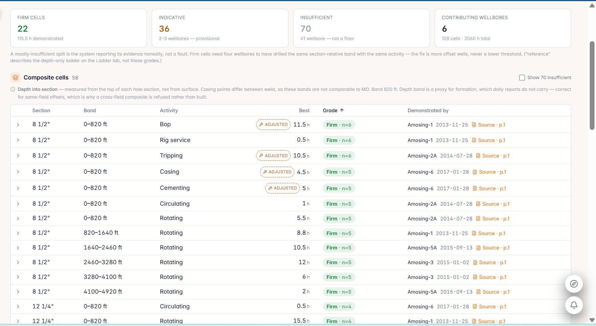
Figure 5. The composite grid. Every cell carries its best demonstrated time, its evidence grade, and the well, date and page that demonstrated it.
The ADJUSTED badge — outlier protection. The fastest row is not always the benchmark. If a single observation is wildly detached from everything else in its own cell — for example one hour of “tripping” that was really end-of-well rig-down — the system steps up to the next corroborated value and marks the cell ADJUSTED, with the reason in plain words.
The guard can only ever raise a floor, which means it can only ever lower what the system claims you lost. That direction is deliberate: a tool doing statistics on someone else's operations should err toward claiming less.

3.4 Ladder (Depth vs Days) — “The familiar picture”
This is the classic depth-vs-days chart that appears in every AFE and every post-well review — your well, the offsets, the best-composite curve, the field median (P50), and a technical-limit line. It is the shared language of the discipline, so it stays; but the claims now come from the Composite tab, because comparing wells at equal depth is exactly the category error the cell exists to prevent.
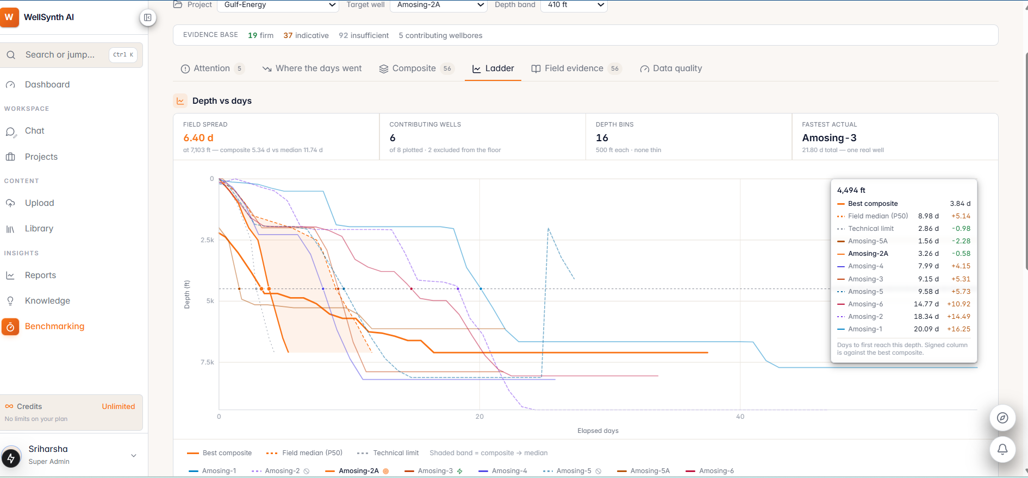
Figure 6. The Ladder chart with Amosing-2A selected. Hovering any depth gives days-to-depth for every well and its signed delta against the best composite.
How to read it:
- The target well is drawn as a heavy coloured line. Offset wells are thinner and desaturated — they are context, not content.
- The shaded band between the best composite and the field median shows the range of demonstrated performance.
- Dashed curves are wells excluded from setting the benchmark. They are still plotted and still counted — we never hide a well.
- The hover panel lists every well's days to first reach that depth, with the signed column measured against the best composite — so you can see who is ahead and behind without measuring distances by eye.

Four summary cards sit above the chart:
- Field Spread: the spread of well times at the current depth, with composite and median called out.
- Contributing Wells: how many wells feed the benchmark, and how many were excluded from the floor.
- Depth Bins: the bin size in use, and whether any bin is too thin to be reliable.
- Fastest Actual: which real well reached TD fastest — one real well, not an assembled composite.

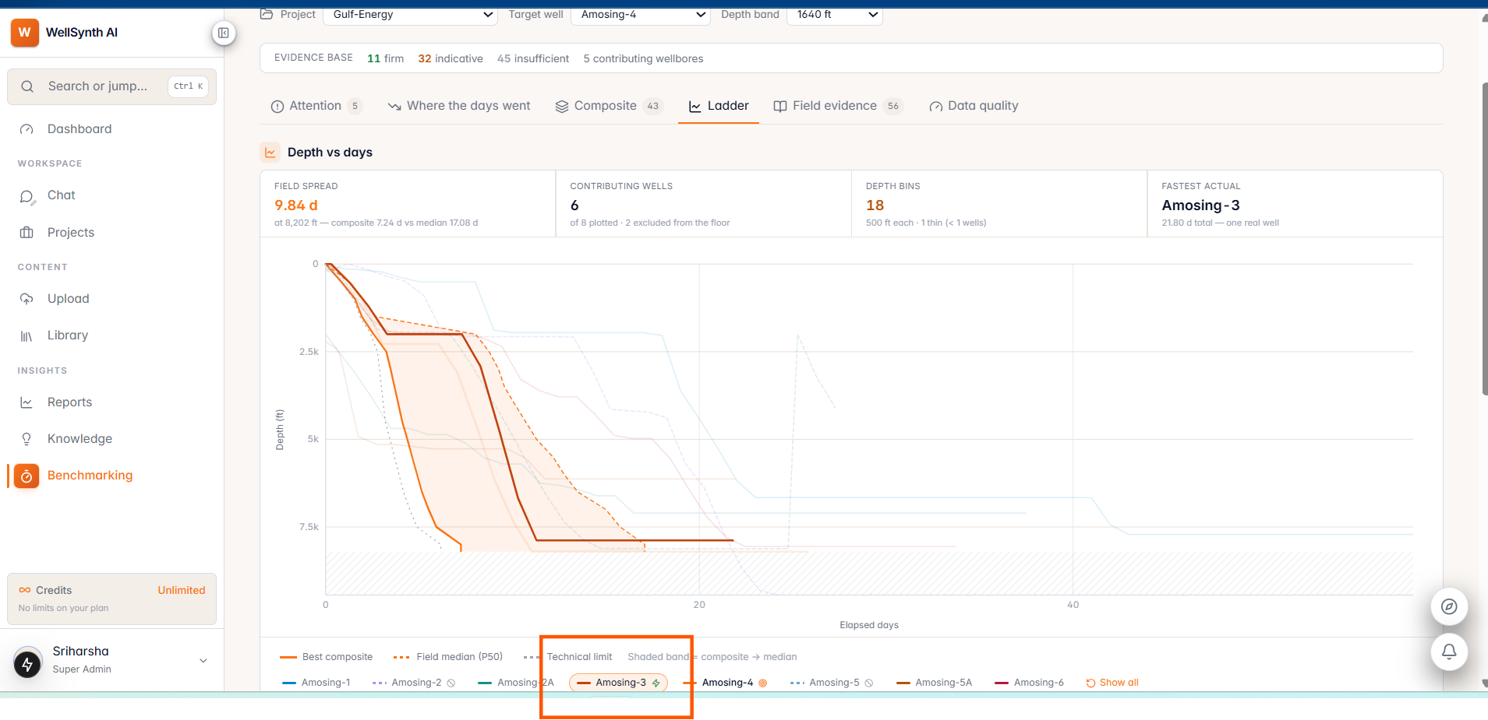
Figure 7. The same chart with a different target well and a wider depth band. Greyed depth ranges mark bins with too few contributing wells to support a firm floor.
Thin bins are greyed deliberately. A benchmark line drawn through a single well looks exactly as authoritative as one drawn through eight. Shading the thin ranges keeps that difference visible.

Pace Against the Ladder
Below the chart, a pace table converts the picture into precise numbers you can quote in a review.
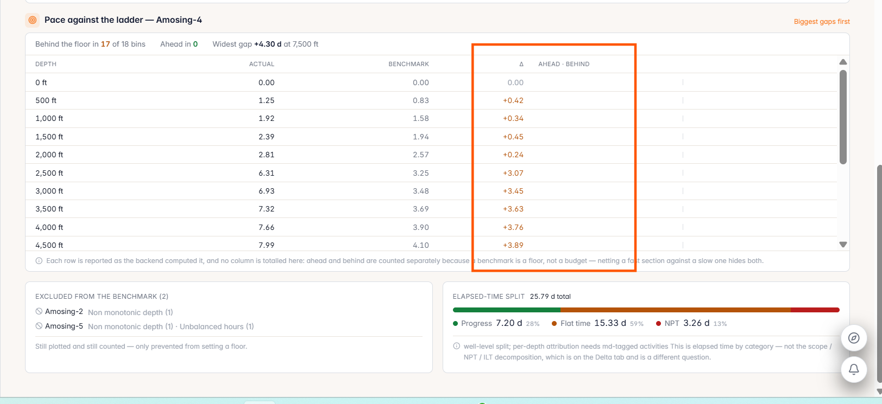
Figure 8. The pace table: actual versus benchmark at every depth bin, with the delta called out — plus the wells excluded from setting a floor and the elapsed-time split.
- Each depth bin shows actual days, benchmark days, and the delta between them.
- Ahead and behind are counted separately and no column is totalled, because a benchmark is a floor rather than a budget — netting a fast section against a slow one would hide both.
- Excluded wells are named with their reason (for example non-monotonic depth, or unbalanced hours). They remain plotted and counted; they are only prevented from setting a floor.
- The elapsed-time split shows progress, flat time and NPT as a share of the well. Note that this is elapsed time by category — it is a different question from the scope / NPT / ILT decomposition, which lives on the gap screen.

3.5 Field Evidence — “What has this field tried before?”
When you hit losses at 2,100 m, the question is not “what does the textbook say?” — it is “what have we done about this here, and did it work?” That answer is buried in your own DDRs, and nobody has ever been able to read it across a whole campaign.
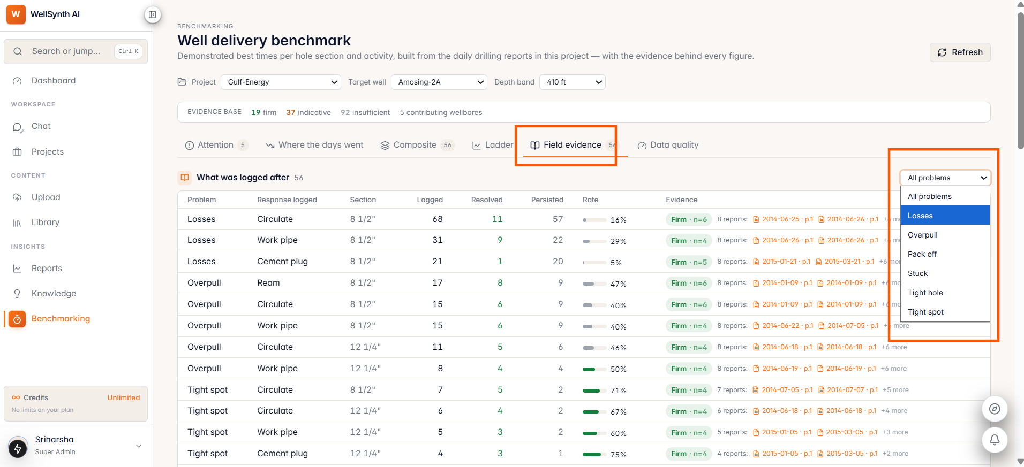
Figure 9. Field evidence: for every problem and the response logged after it, how often it was tried, how often the problem stopped, and the reports behind each count.
How to read it:
- Each row reads: problem → response logged → hole section → times logged → resolved → persisted → rate.
- “Resolved” means the same problem did not recur within 48 hours of that response. Recurrence is the outcome measure — no model judges whether something worked.
- Filter by problem type — losses, overpull, pack off, stuck, tight hole, tight spot — using the dropdown.
- Evidence grades apply here too. Below the threshold the rate is withheld entirely rather than shown thin: a “4 of 5 — 80%” from a single wellbore is exactly the number that gets a procedure changed on one well's experience.
- Every row cites the specific reports where each occurrence was found.

This is evidence, never a recommendation. The wording is always “X was logged N times; M resolved”, never “try X”. The product reports what your field did. Deciding what to do next is your job — and it depends on pore pressure, offset seismic, rig capability and commercial context, none of which is in a daily report.

3.6 Data Quality — “Can I trust any of this?”
Every number in this product is derived from PDFs that were never designed to be machine-read. If the parse is wrong, the benchmark is wrong — and a confident wrong benchmark is worse than none. So the quality of the input is a full screen, not a footnote.
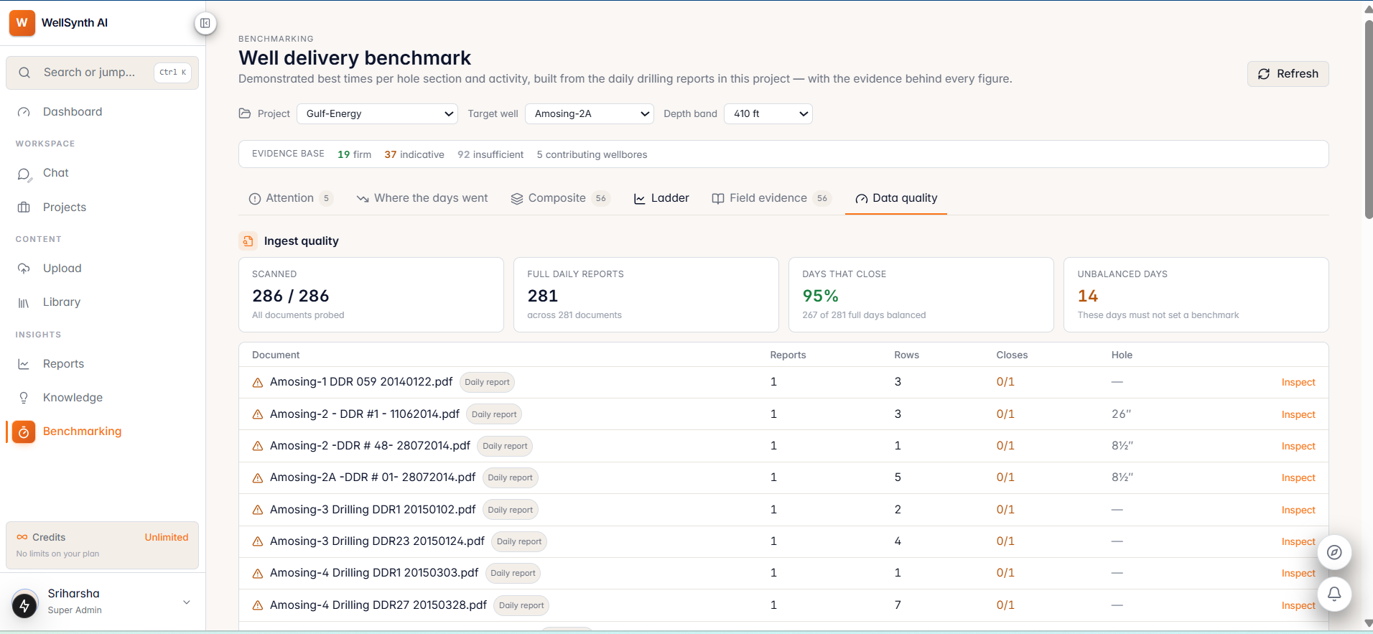
Figure 10. Ingest quality. Every document is probed and reported: how many reports parsed, how many rows, whether the day closes to 24 hours, and which hole section it covers.
What you see:
- Scanned: every document probed, with none skipped silently.
- Full Daily Reports: how many parsed as complete daily reports.
- Days That Close: the share of full reports whose activity hours sum to 24. This is a free correctness gate that needs no reference data — the only quality signal that scales to a field we know nothing about.
- Unbalanced Days: reports that do not close. These are quarantined and must not set a benchmark.

Each document row shows the reports found, rows extracted, whether it closes, and the hole section it covers, with an Inspect action to examine any document directly.
Wells excluded from setting the benchmark are named with their reason — for example depth running backwards, which is real for a sidetrack and a parse error otherwise. They are still plotted and still counted. Nothing is hidden; it is only prevented from becoming a standard.

4. Key Design Principles
A few principles govern how the system behaves. They are worth understanding, because they explain why the numbers act the way they do.

A benchmark is a floor, not a budget
Where you beat the composite, that outperformance is reported on its own and never netted against losses elsewhere. A fast shallow section cannot quietly pay for a slow deep one, and genuine outperformance does not get erased in the averaging.

Scope is removed first
Work your well did that no offset did — a contingency string, extra coring, an additional logging run — comes out of the gap before anything is attributed, and is listed item by item rather than as a bare number. Charging that work to the crew as inefficiency would be unfair precisely to the team that did extra work because someone asked them to.

Evidence is graded, and the grade gates the claim
Firm cells drive headline numbers and generate attention items. Indicative cells are shown and labelled but never used to accuse anyone. Insufficient cells are reported and never treated as a standard. The fix for thin evidence is always more offset wells, never a lower threshold.

No model computes an engineering quantity
Language models normalise vocabulary and explain results that were already computed. Every hour, depth and ratio comes from a typed column via a deterministic calculation. A model is never asked what a number should be.

The system refuses rather than guesses
A composite spanning two fields is refused with a reason and a remedy. A ratio without firm evidence returns no value and says why. An empty attention list states which of three things is true — including the good one, that the well is tracking the benchmark. A product that can only produce numbers will eventually produce a wrong one confidently, and that is the failure this design guards against hardest.

The depth band is a modelling choice, and we say so
The default band is 820 ft (250 m). Narrower bands fragment the evidence so fewer cells reach Firm; wider bands let a fast shallow interval set the floor for a slow deep one. There is no single right answer, so the headline is recomputed at half and double the band and shown alongside. Quote the number with the band.

5. Where We Are and What’s Next

Working Today
- Full DDR parsing with 24-hour closure validation across every document, and quarantine for reports that do not balance.
- Cell-based composite benchmark keyed on hole section, depth band and activity, with per-cell evidence grading.
- Source citation on every composite cell — well, date and page — with click-through to the report.
- Outlier guard that raises a floor when the fastest observation is detached from its own cell, and says so on the cell.
- Three-way gap decomposition — scope, NPT and ILT — reconciling exactly to the total gap.
- Composite Performance Ratio by whole well and by hole section, with firm-coverage share.
- Loss tiers separating what was logged, what was computed against firm evidence, and what was inferred.
- Attention-first presentation with ranked items and expandable root-cause analysis.
- Depth-vs-days ladder with offset curves, benchmark band, thin-bin shading and a pace table.
- Field evidence: response effectiveness measured from the activity sequence, with recurrence as the outcome.
- NPT recovery-tail analysis with a concentration-lift check that reports when there is no signal.
- Band sensitivity disclosed on the headline figure.
- Data quality as a first-class screen, with document-level inspection.
- Deterministic computation — the same corpus always produces the same output.

What We Are Building Next
- Formation-indexed comparison: today depth band stands in for formation, which is sound for same-field offsets and refused across fields. When formation tops are available we compare on geology directly. The screen already declares which axis is in use.
- A more quantitative ladder: the gap drawn on the chart rather than read from a table, hole-section banding down the depth axis, click-through from any point on a curve to the report page that explains it, and a “days behind” cumulative view.
- Broader field coverage: every well added moves cells from Insufficient toward Firm. The system is designed to get stronger with each upload rather than needing to be rebuilt.
- The live lane: intra-day ingestion for tracking a well as it drills, with provisional data replaced wholesale when the authoritative daily report arrives.
- Chat integration: ask questions about these results in plain language, answered from the same computed facts and the same citations, so the chat and the dashboard can never disagree.

6. Summary
WellSynth AI automates the “best of best” methodology the industry already trusts, and adds the three things that make it usable in a real review:

- Traceability — every number traces to a specific well, date and page in a daily report. You can open the source and check it.
- Honesty — evidence grades, loss tiers, outlier guards and band sensitivity mean the system tells you how sure it is, not only what it found.
- Fairness — scope comes out before anything is attributed, ILT is never negative, and outperformance is reported rather than netted away.

The result is a benchmark that survives an engineering review: not a target someone invented, but a time your own field has already demonstrated — with the report to prove it.
And it improves with every well uploaded. More offset data means more firm cells, stronger evidence, and a more reliable floor for the wells that follow.

Questions or feedback? Reach out to the WellSynth AI team.

