DSCI 5350 Assignment1 Satyasriharsha Buddha

**Instructions:**

Change the terminal Title to your Full Name.

At each and every step provide screenshot of the solutions.

It must be submitted as a word document with screenshots and explanation of what each piece of code is performing

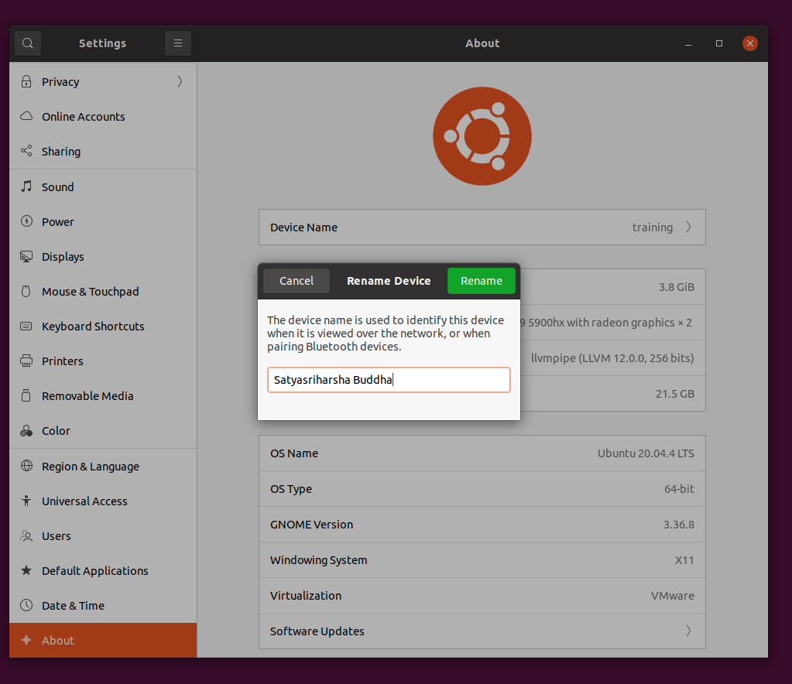

Linux Assignment

1.Create a new text file named person.txt in a new directory (name of the directory: Your Lastname) in /home/training

Contents of the person.txt file should be

FirstName,LastName,Age

John,Doe,20

Alan,Bruce,45

Tamzin,Blake,25

Maryam,Pope,24

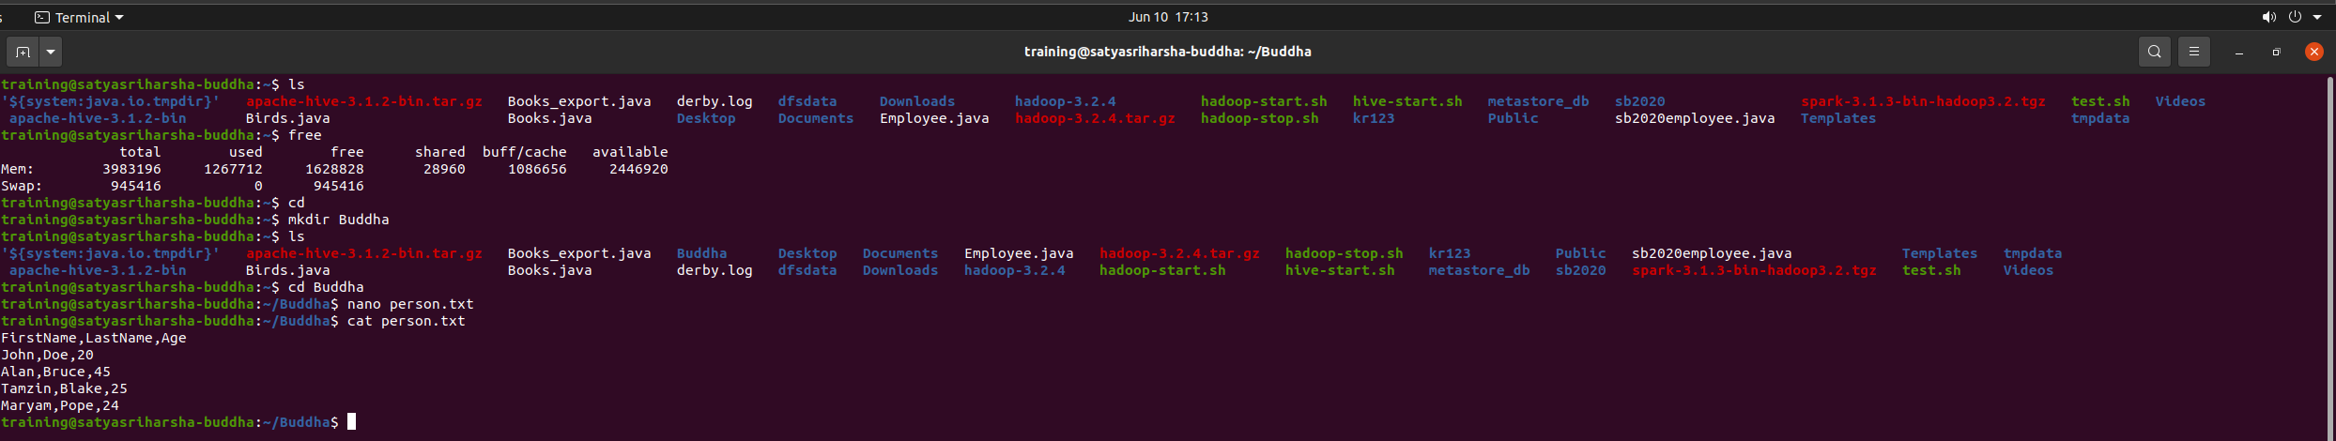

2.Create a copy of the text file (named copy_person.txt) in same directory

3.Move copy_person.txt to a new directory (name of the directory: Your FirstName) that should be at same level as your Lastname directory.



4.Delete the Lastname directory.

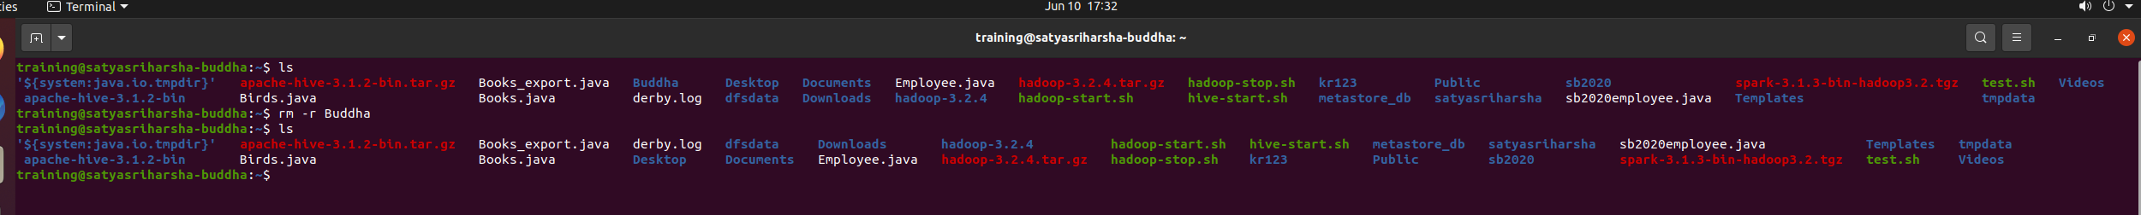

5.Append “Aysha,Sims,28” to the file (file from step 3 ) present in new directory.

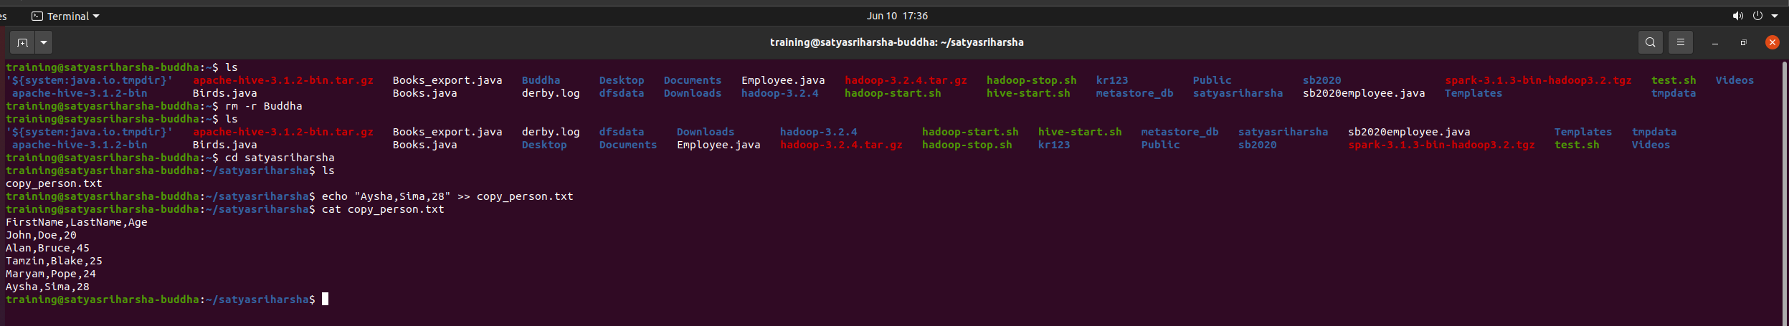

6.Rename copy_person.txt to person.txt

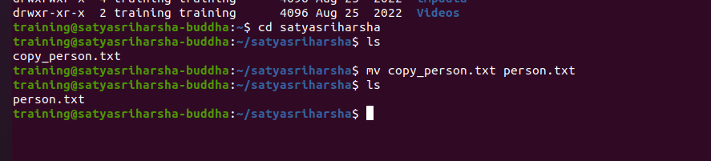

7.Find the file “.bashrc” in /home/training



8.Display the access permissions set to the files present in /home/training.

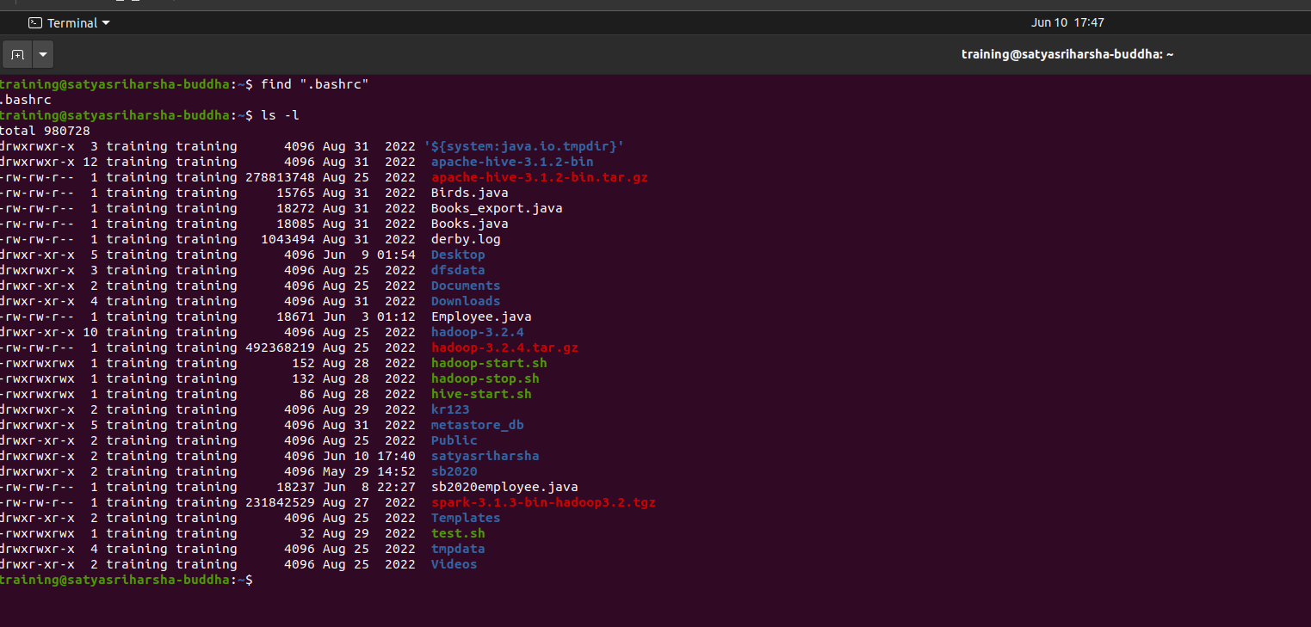

9.Search if there is person with firstname “Alan” in person.txt file. (Do not use cat command for this question)

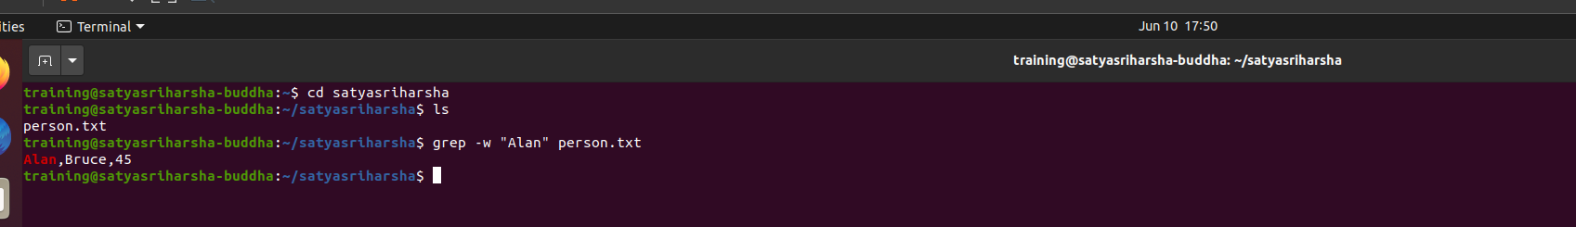

**HDFS Assignment:**

1. Create a new directory (named your EUID) at root level.
2. Create a new person.txt file and put it in the above created directory. (Here Person.txt file is the same file as in step 1 of Linux assignment.
3. Display the contents of person.txt file

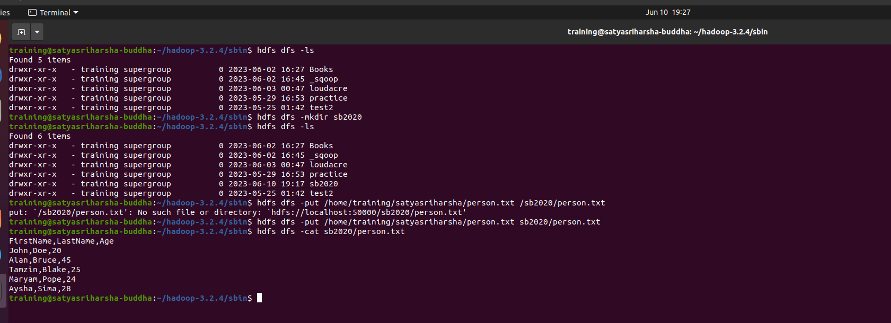

**Sqoop Assignment**

1.Import Books table from mysql to HDFS using ‘$’ as delimiter. Import the table into a newly created directory at root level (directory name: Your Firstname) without creating subdirectory for books table.

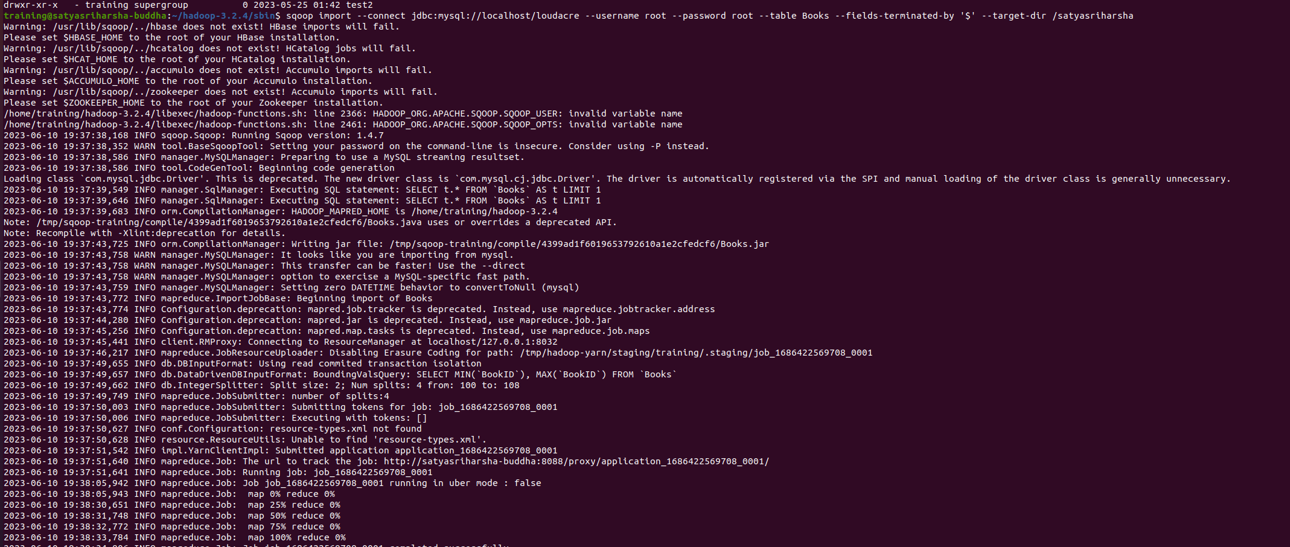

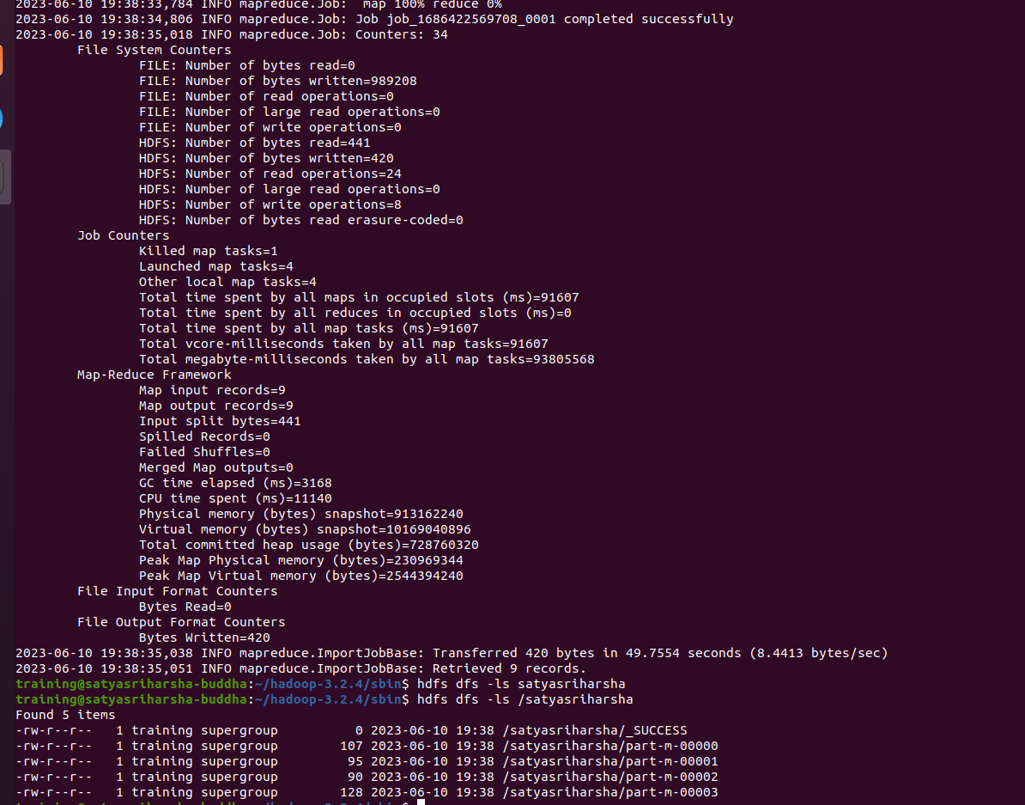

2.Append the same table again and provide the screenshot of appended file. What happens if you append the same table again?

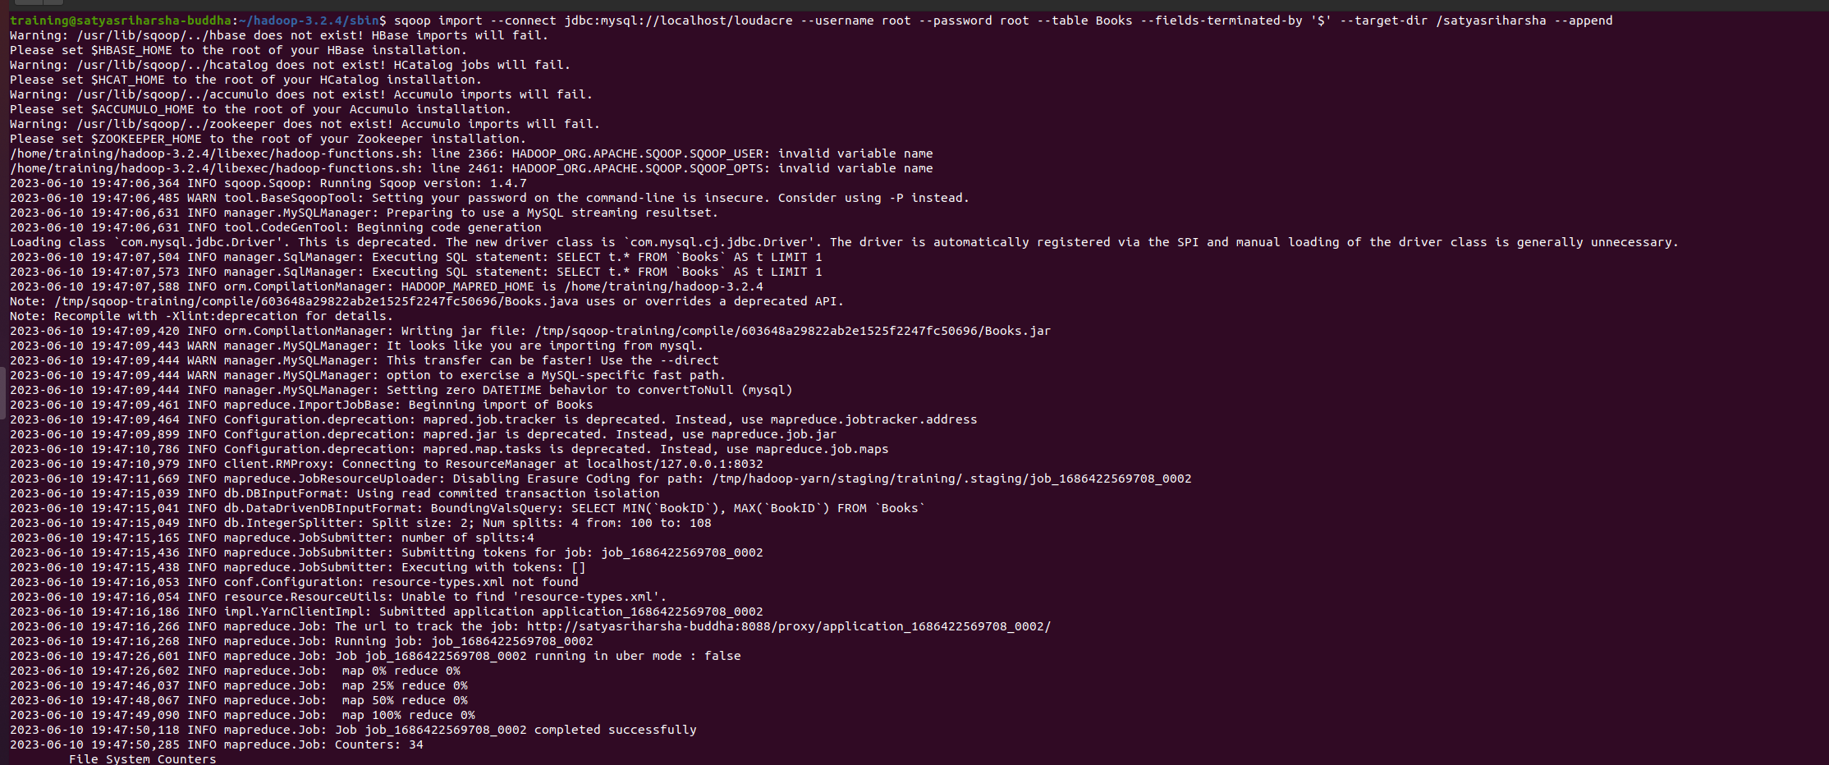

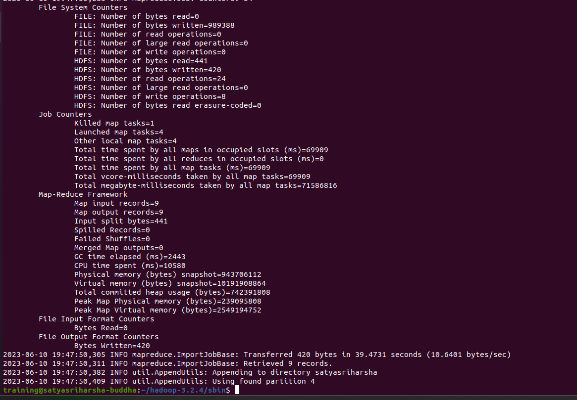

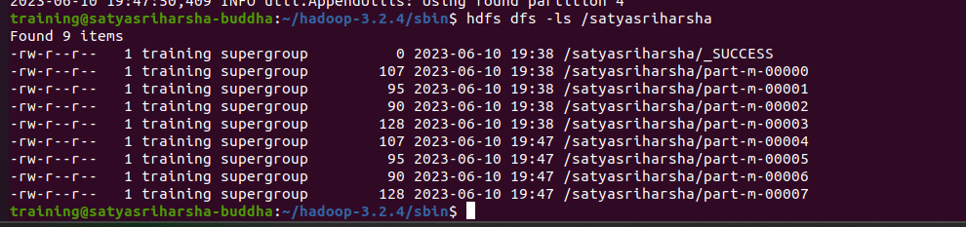

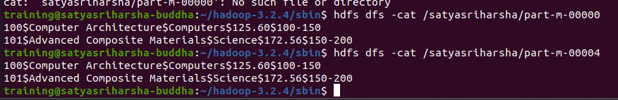

The data is appended and duplicated.

3.Import all the tables except Books table from loudacre database to the above created directory by creating individual subdirectory for each table.

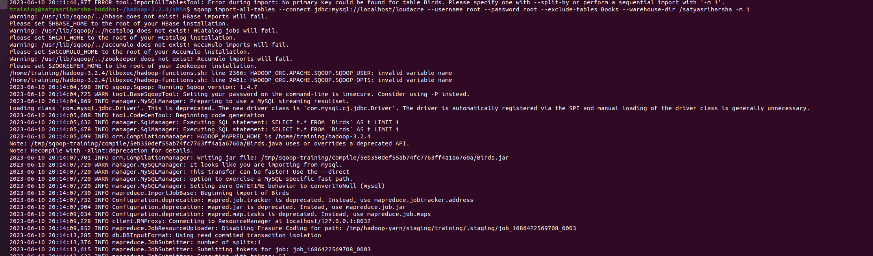

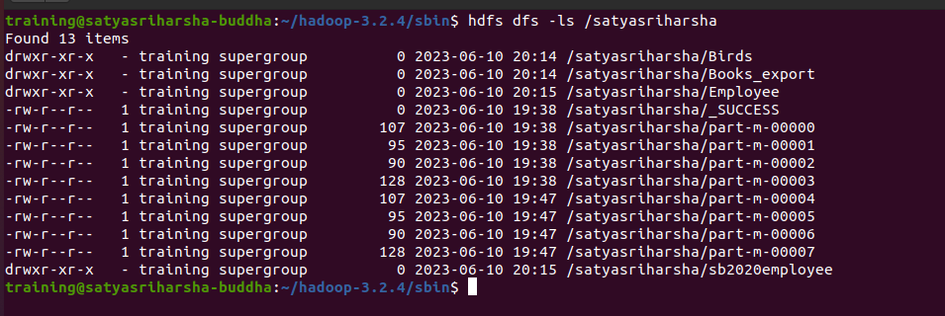

4,Import Birds table along with data to Hive using ‘@’ as a delimiter and one mapper and then export the same table to MySQL. Use Birds_EUID as table name in MYSQL to ensure that it is different from original Birds table

