Hands on Assignment(SQL)
Date:6-07-26(Monday)
Creating a new user in database:
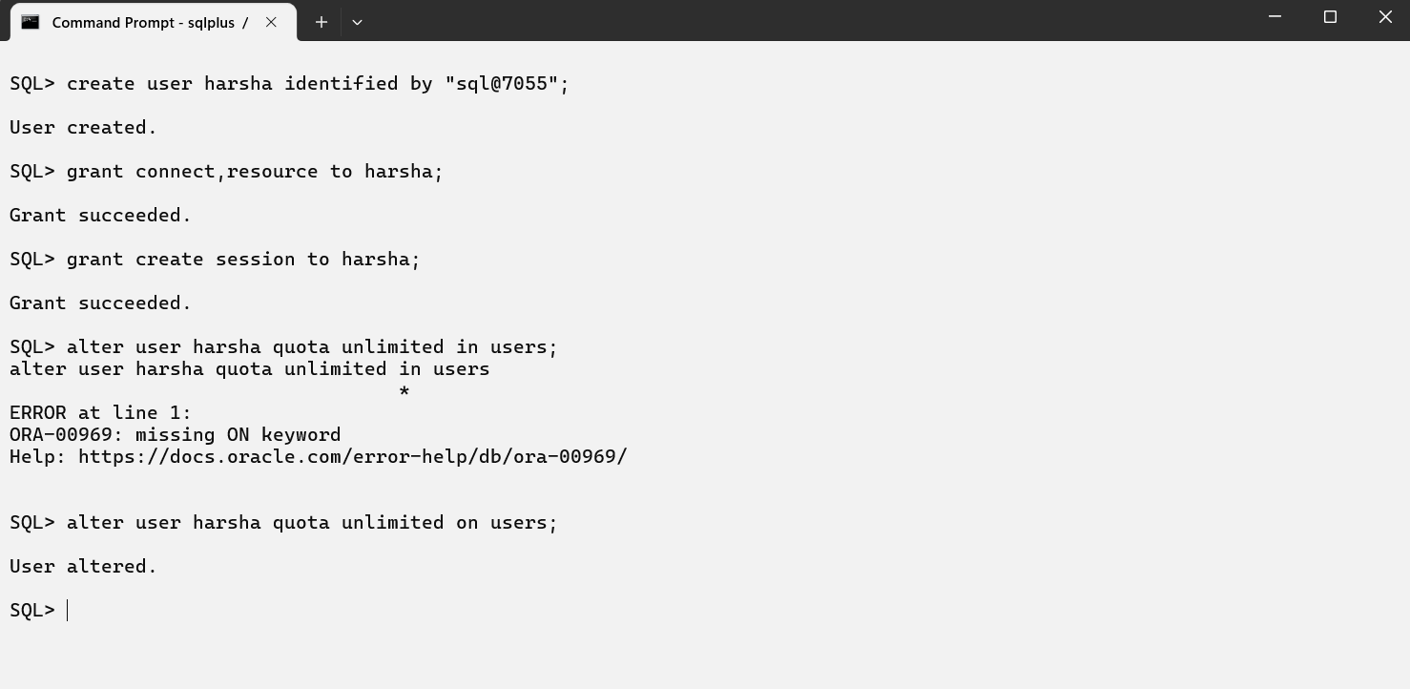

Date:7-07-26(Tuesday)
Data using the SELECT Statement:
SQL> create table dept(dept_no number(2),dname varchar2(20),address varchar2(30));
Table created.
SQL> insert into dept values(&dept_no,'&dname','&address');
Enter value for dept_no: 10
Enter value for dname: 'ram'
Enter value for address: 'guntur'
old 1: insert into dept values(&dept_no,'&dname','&address')
new 1: insert into dept values(10,''ram'',''guntur'')
SQL> insert into dept values(&dept_no,'&dname','&address');
Enter value for dept_no: 10
Enter value for dname: ram
Enter value for address: guntur
old 1: insert into dept values(&dept_no,'&dname','&address')
new 1: insert into dept values(10,'ram','guntur')
1 row created.
SQL> insert into dept values(&dept_no,'&dname','&address');
Enter value for dept_no: 20
Enter value for dname: sai
Enter value for address: vijayawada
old 1: insert into dept values(&dept_no,'&dname','&address')
new 1: insert into dept values(20,'sai','vijayawada')
1 row created.
SQL> insert into dept values(&dept_no,'&dname','&address');
Enter value for dept_no: 30
Enter value for dname: arun
Enter value for address: mangalagiri
old 1: insert into dept values(&dept_no,'&dname','&address')
new 1: insert into dept values(30,'arun','mangalagiri')
1 row created.
SQL> insert into dept values(&dept_no,'&dname','&address');
Enter value for dept_no: 40
Enter value for dname: harsha
Enter value for address: tenali
old 1: insert into dept values(&dept_no,'&dname','&address')
new 1: insert into dept values(40,'harsha','tenali')
1 row created.
SQL> insert into dept values(&dept_no,'&dname','&address');
Enter value for dept_no: 50
Enter value for dname: ravi
Enter value for address: ongole
old 1: insert into dept values(&dept_no,'&dname','&address')
new 1: insert into dept values(50,'ravi','ongole')
1 row created.
SQL> insert into dept values(&dept_no,'&dname','&address');
Enter value for dept_no: 60
Enter value for dname: venkey
Enter value for address: vinukonda
old 1: insert into dept values(&dept_no,'&dname','&address')
new 1: insert into dept values(60,'venkey','vinukonda')

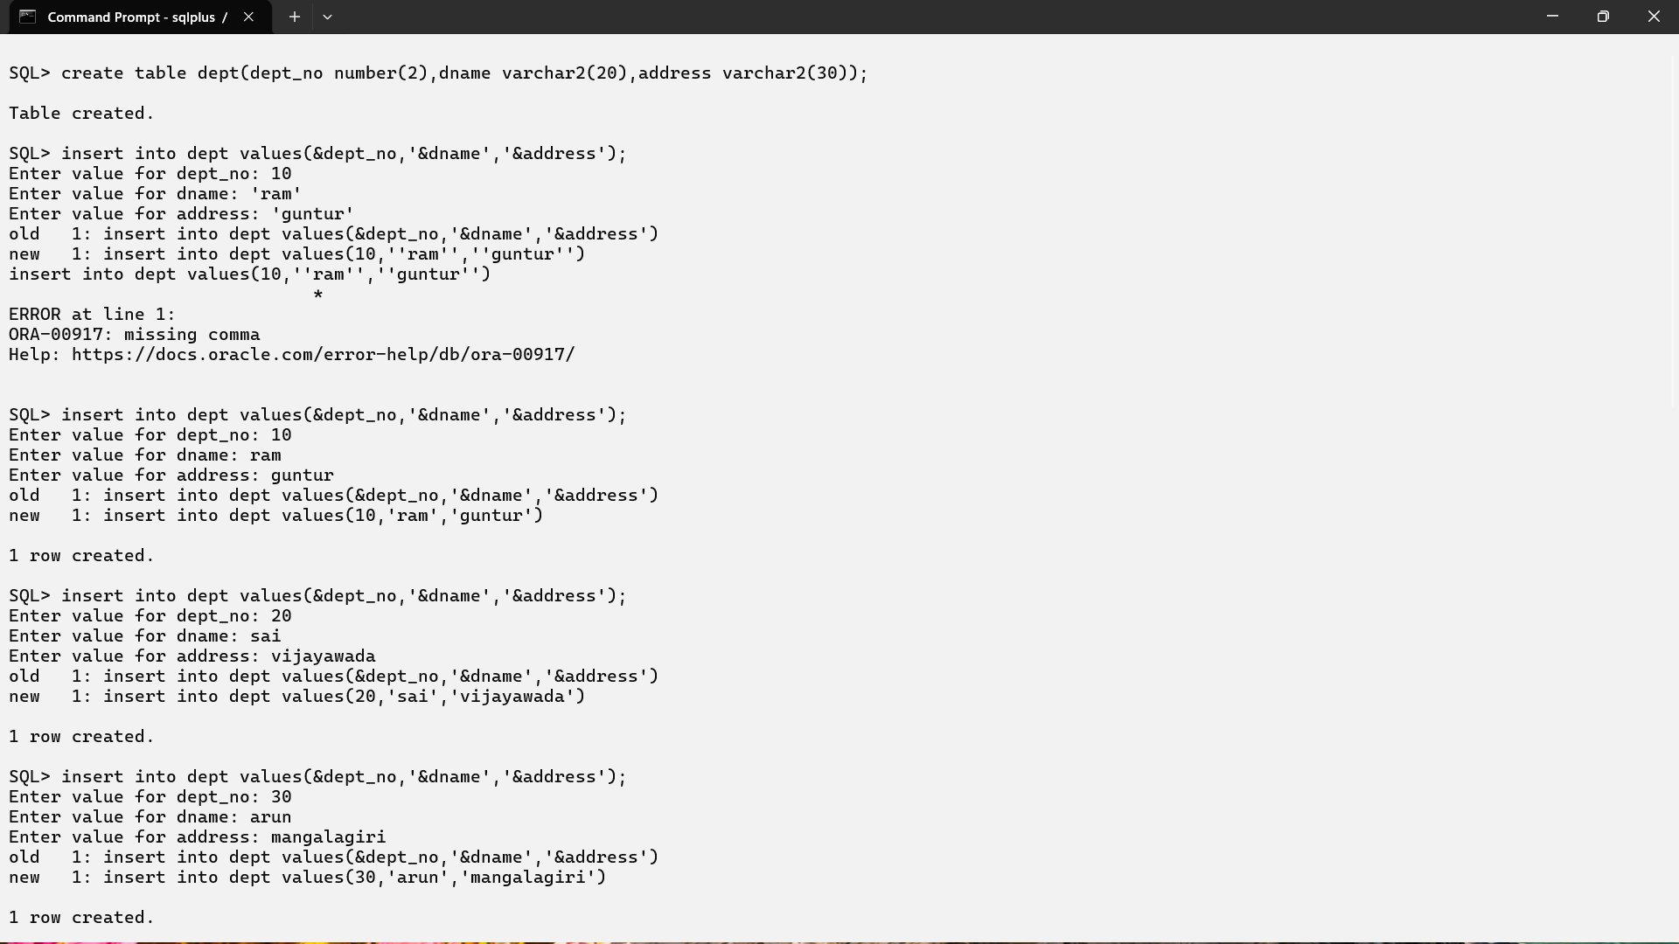

SQL> create table emp(emp_no number(5),ename varchar2(20),job varchar2(20),sal number(8),dept_no number(20));
Table created.
SQL> insert into emp values(&emp_no,'&ename','&job',&sal,&dept_no);
Enter value for emp_no: 7369
Enter value for ename: smith
Enter value for job: clerk
Enter value for sal: 800
Enter value for dept_no: 20
old 1: insert into emp values(&emp_no,'&ename','&job',&sal,&dept_no)
new 1: insert into emp values(7369,'smith','clerk',800,20)
1 row created.
SQL> insert into emp values(&emp_no,'&ename','&job',&sal,&dept_no);
Enter value for emp_no: 7499
Enter value for ename: allen
Enter value for job: salesman
Enter value for sal: 1600
Enter value for dept_no: 30
old 1: insert into emp values(&emp_no,'&ename','&job',&sal,&dept_no)
new 1: insert into emp values(7499,'allen','salesman',1600,30)

1 row created.

SQL> insert into emp values(&emp_no,'&ename','&job',&sal,&dept_no);
Enter value for emp_no: 7566
Enter value for ename: jones
Enter value for job: manager
Enter value for sal: 2975
Enter value for dept_no: 20
old 1: insert into emp values(&emp_no,'&ename','&job',&sal,&dept_no)
new 1: insert into emp values(7566,'jones','manager',2975,20)
1 row created.
SQL> insert into emp values(&emp_no,'&ename','&job',&sal,&dept_no);
Enter value for emp_no: 7566
Enter value for ename: jones
Enter value for job: analyst
Enter value for sal: 3000
Enter value for dept_no: 20
old 1: insert into emp values(&emp_no,'&ename','&job',&sal,&dept_no)
new 1: insert into emp values(7566,'jones','analyst',3000,20)
1 row created.
SQL> insert into emp values(&emp_no,'&ename','&job',&sal,&dept_no);
Enter value for emp_no: 7788
Enter value for ename: king
Enter value for job: president
Enter value for sal: 5000
Enter value for dept_no: 10
old 1: insert into emp values(&emp_no,'&ename','&job',&sal,&dept_no)
new 1: insert into emp values(7788,'king','president',5000,10)
1 row created.
SQL> insert into emp values(&emp_no,'&ename','&job',&sal,&dept_no);
Enter value for emp_no: 7902
Enter value for ename: ford
Enter value for job: analyst
Enter value for sal: 3000
Enter value for dept_no: 20
old 1: insert into emp values(&emp_no,'&ename','&job',&sal,&dept_no)
new 1: insert into emp values(7902,'ford','analyst',3000,20)
1 row created.
SQL> insert into emp values(&emp_no,'&ename','&job',&sal,&dept_no);
Enter value for emp_no: 7934
Enter value for ename: miller
Enter value for job: clerk
Enter value for sal: 1300
Enter value for dept_no: 10
old 1: insert into emp values(&emp_no,'&ename','&job',&sal,&dept_no)
new 1: insert into emp values(7934,'miller','clerk',1300,10)
1 row created.
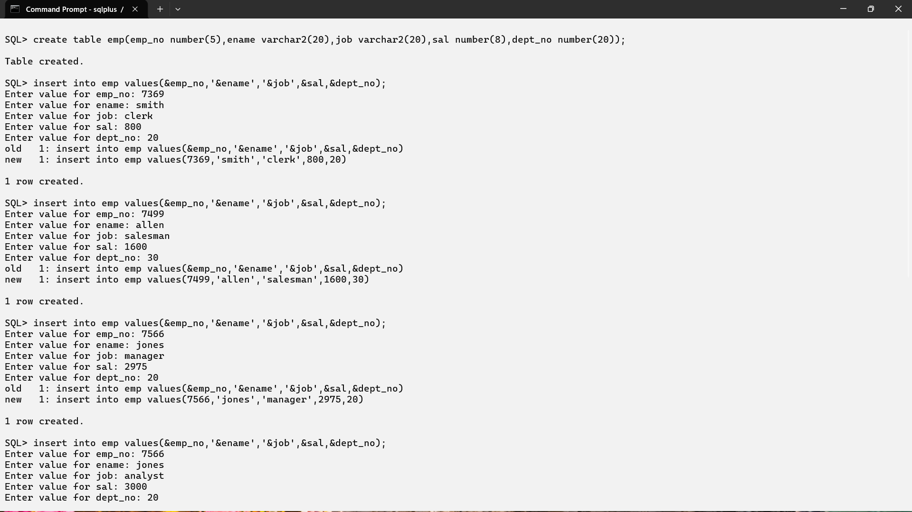
SQL> desc dept;
Name Null? Type
----------------------------------------- -------- ----------------------------
DEPT_NO NUMBER(2)
DNAME VARCHAR2(20)
ADDRESS VARCHAR2(30)
SQL> select * from dept;
DEPT_NO DNAME ADDRESS
---------- -------------------- ------------------------------
10 ram guntur
20 sai vijayawada
30 arun mangalagiri
40 harsha tenali
50 ravi ongole
60 venkey vinukonda
6 rows selected.
SQL> desc emp;
Name Null? Type
----------------------------------------- -------- ----------------------------
EMP_NO NUMBER(5)
ENAME VARCHAR2(20)
JOB VARCHAR2(20)
SAL NUMBER(8)
DEPT_NO NUMBER(20)
SQL> select *from emp;
EMP_NO ENAME JOB SAL DEPT_NO
---------- -------------------- -------------------- ---------- ----------
7369 smith clerk 800 20
7499 allen salesman 1600 30
7566 jones manager 2975 20
7566 jones analyst 3000 20
7788 king president 5000 10
7902 ford analyst 3000 20
7934 miller clerk 1300 10
7 rows selected.
SQL> select ename,dept_no from emp where emp_no=7788;
ENAME DEPT_NO
-------------------- ----------
king 10
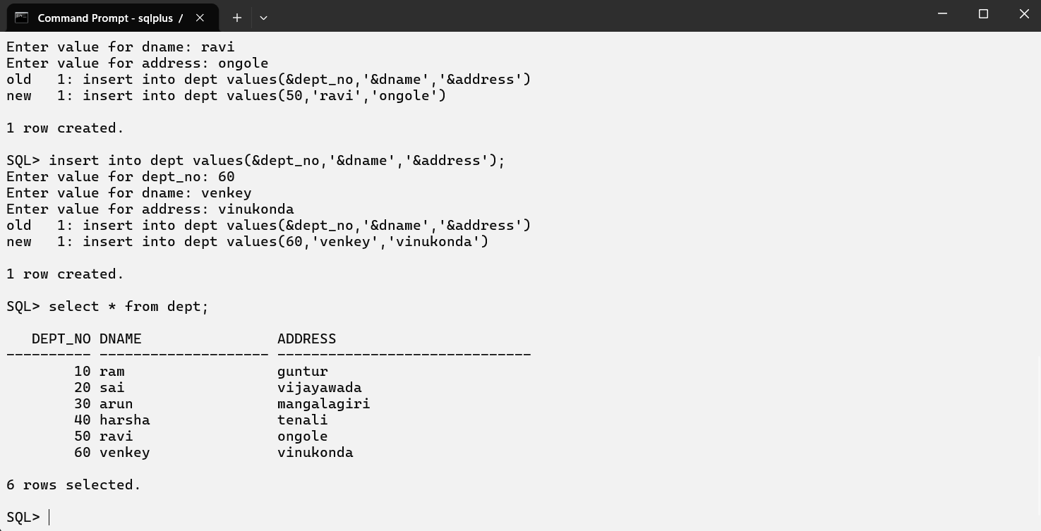

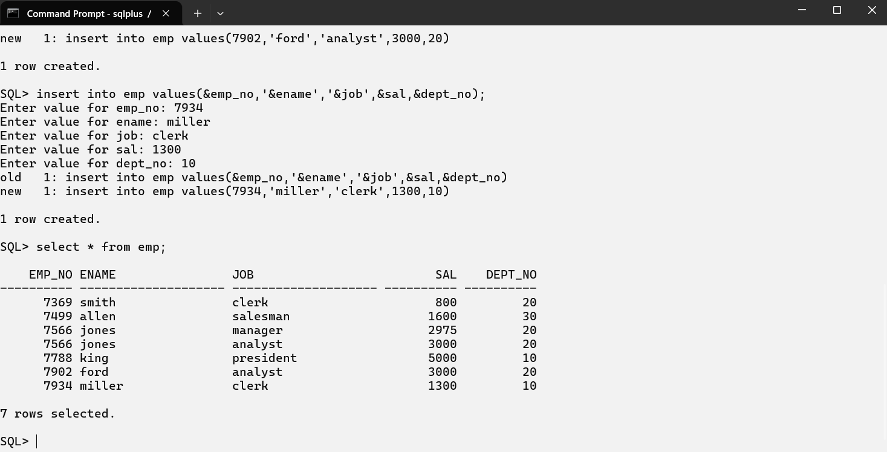

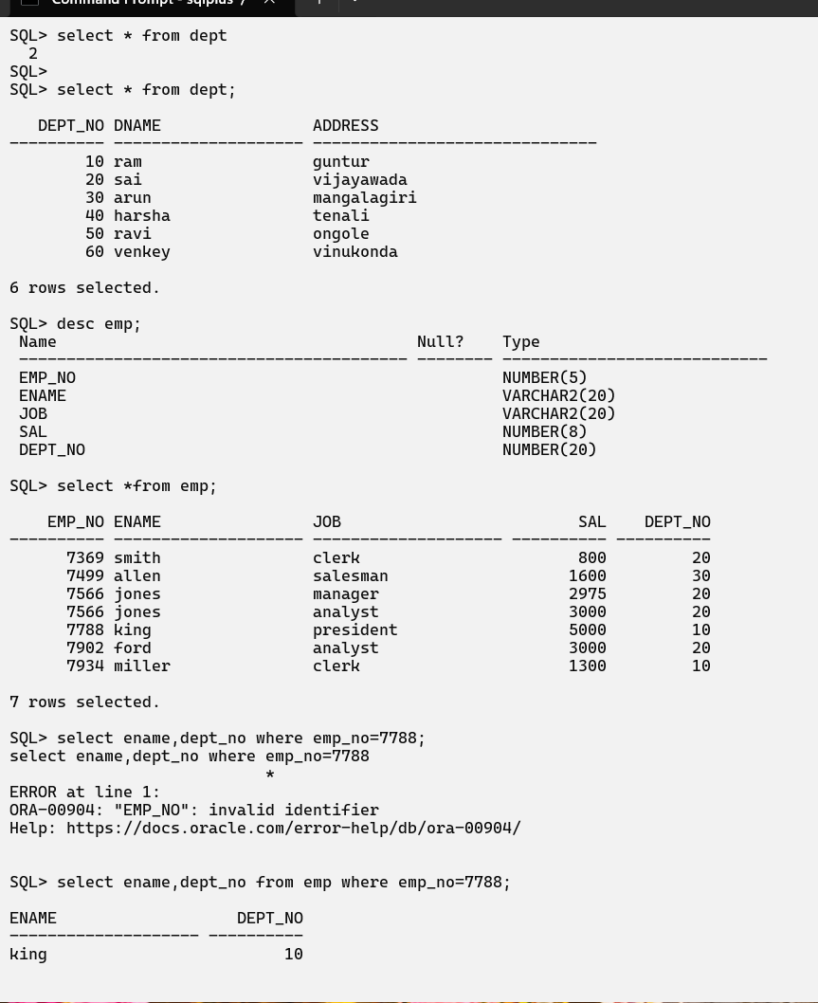

Date:8-07-26(Wednesday)
Restricting and sorting data:
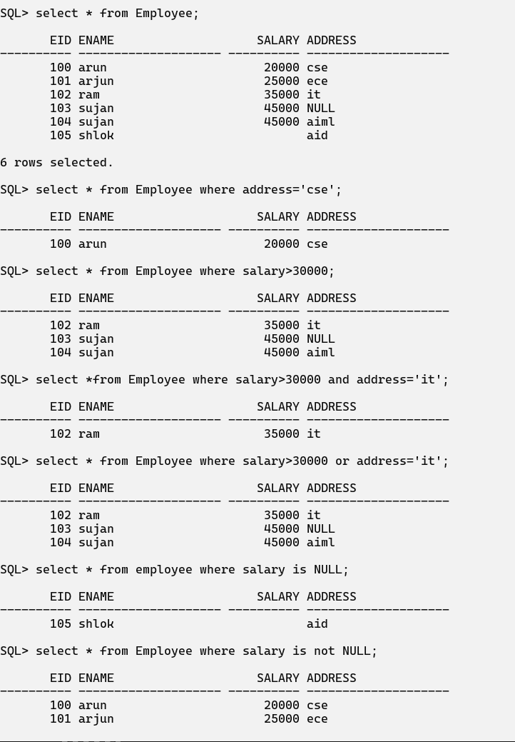
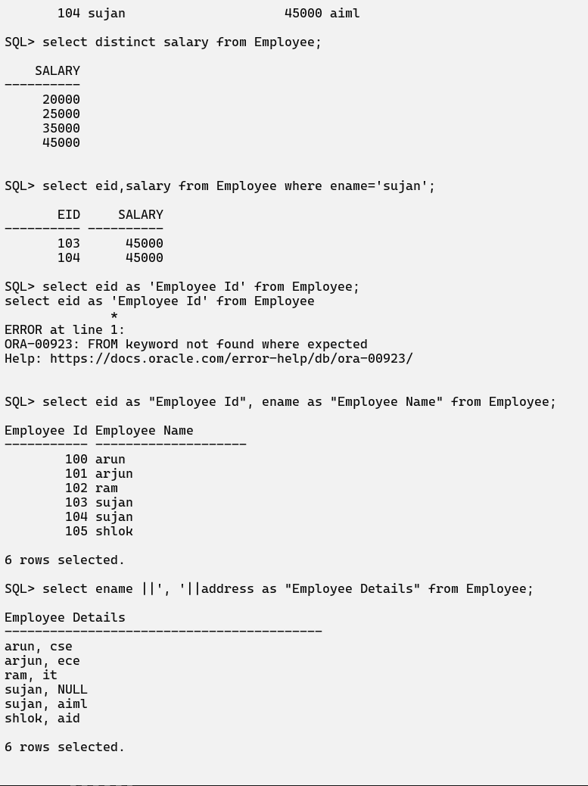

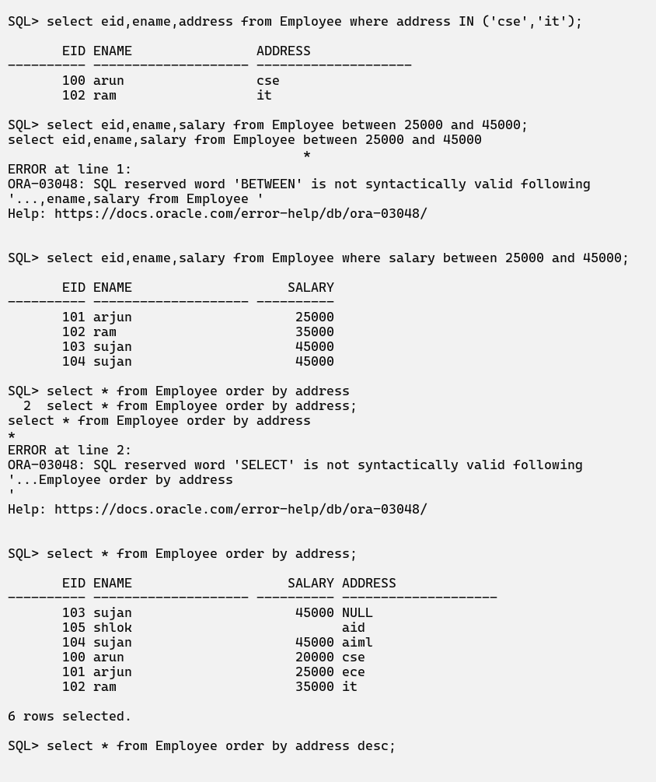
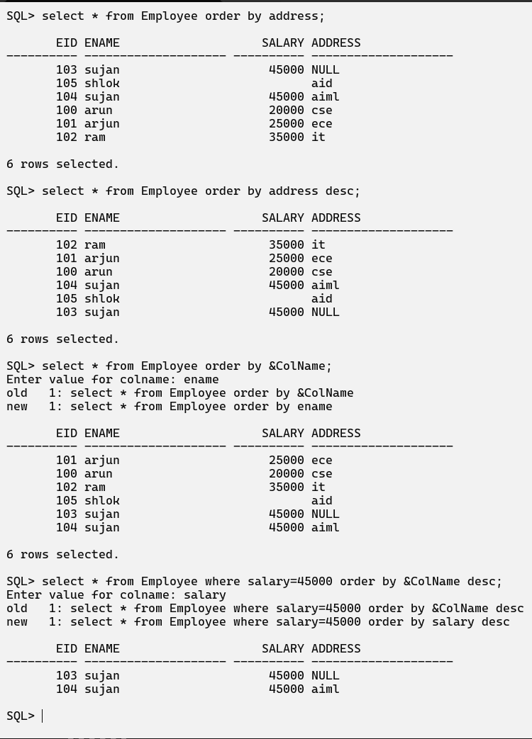
Date: 09-07-26
Using single row function to customize the output:
1. Character Functions
2. Numeric Functions
3. Date Functions
4. Conversion Functions
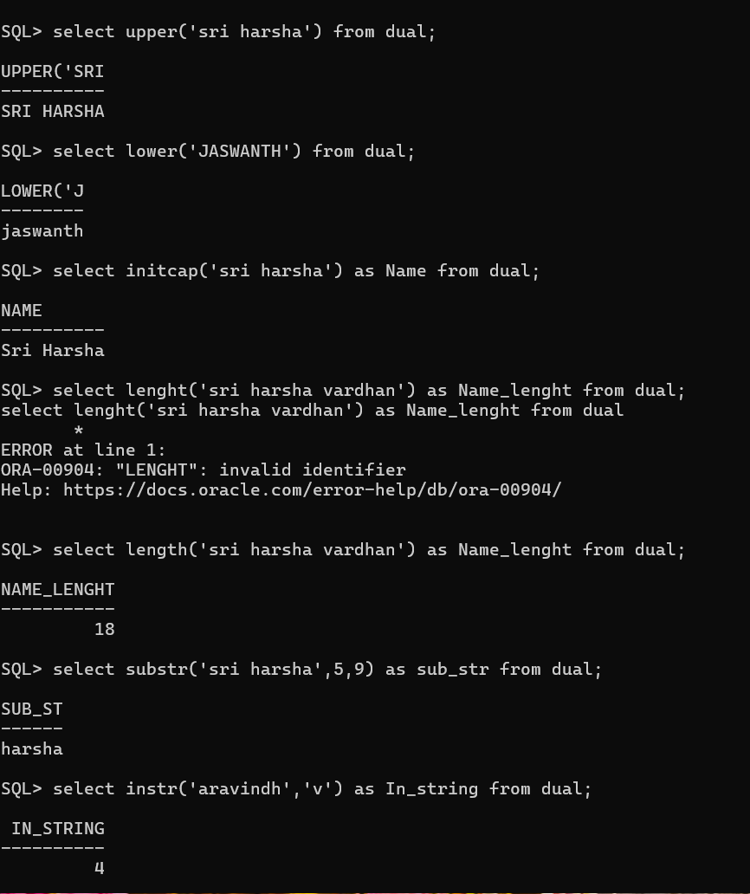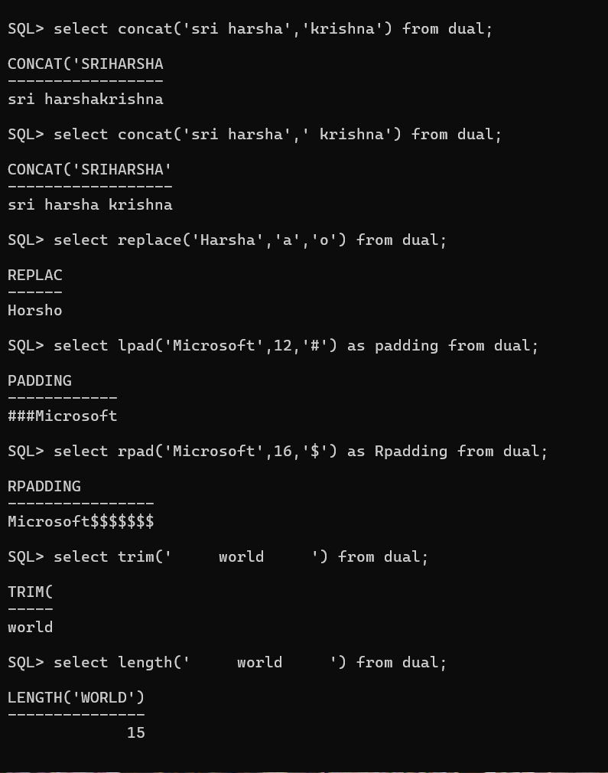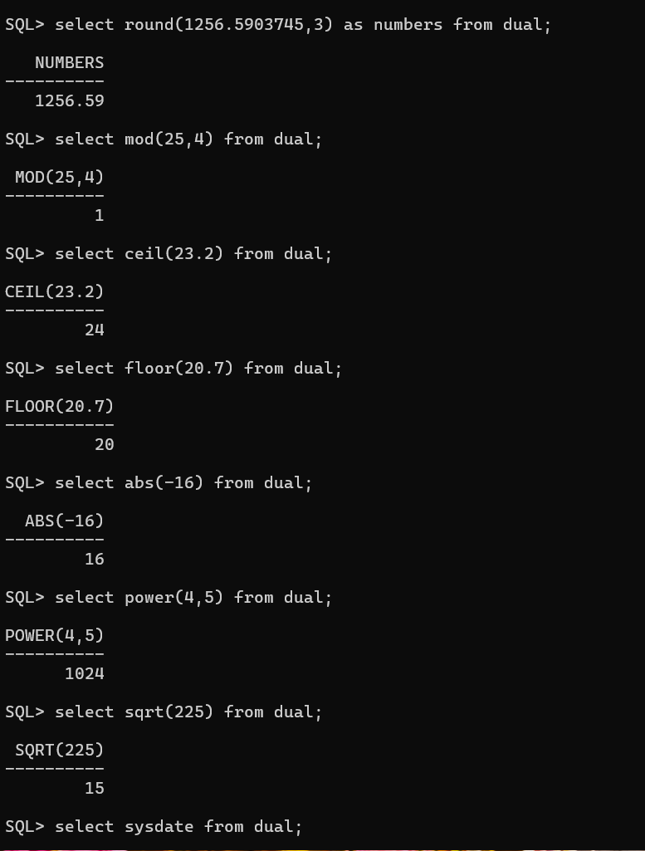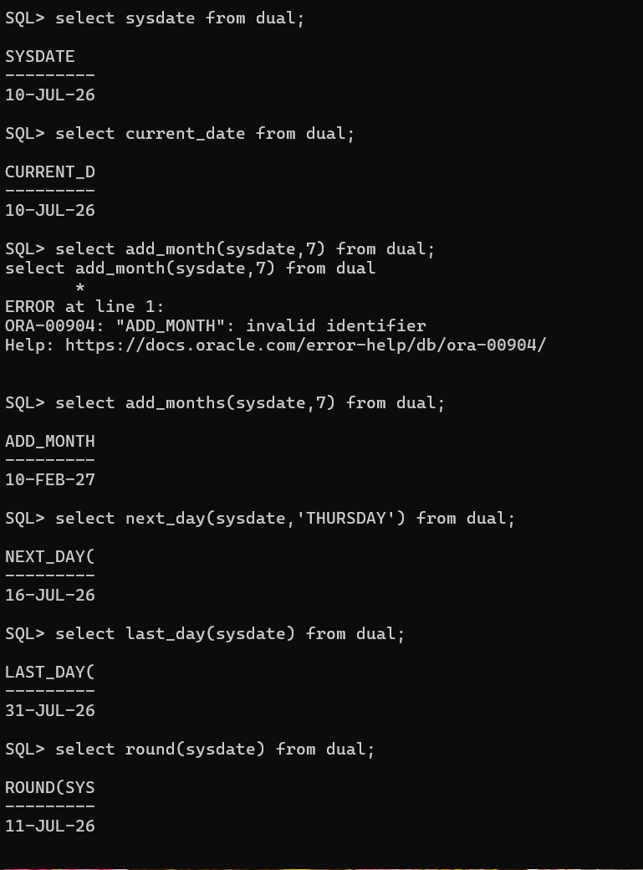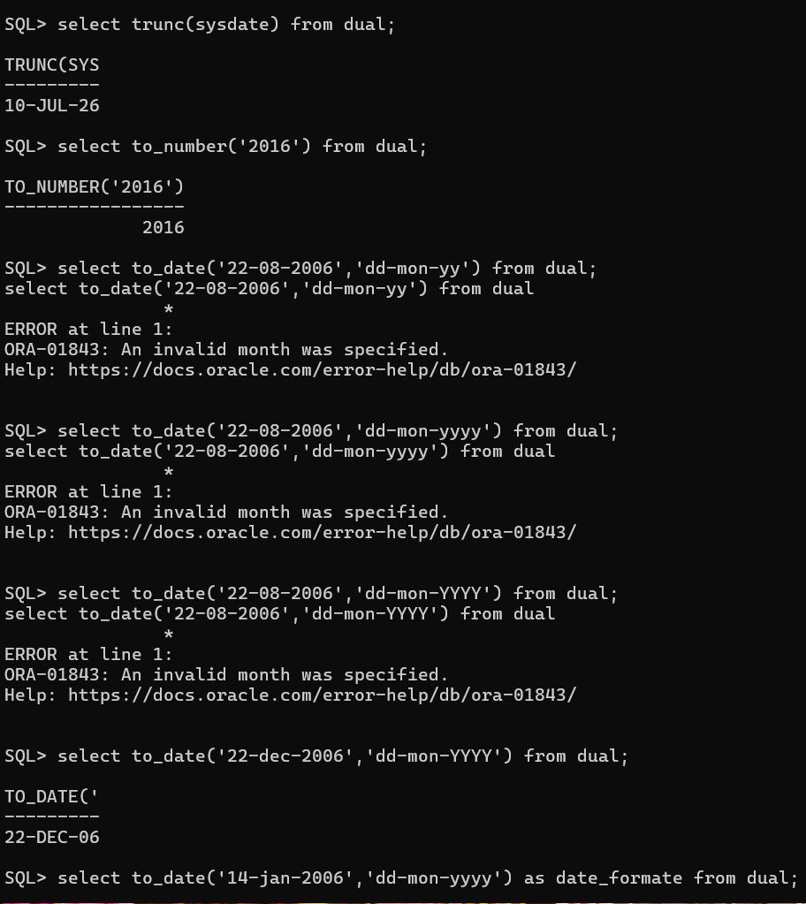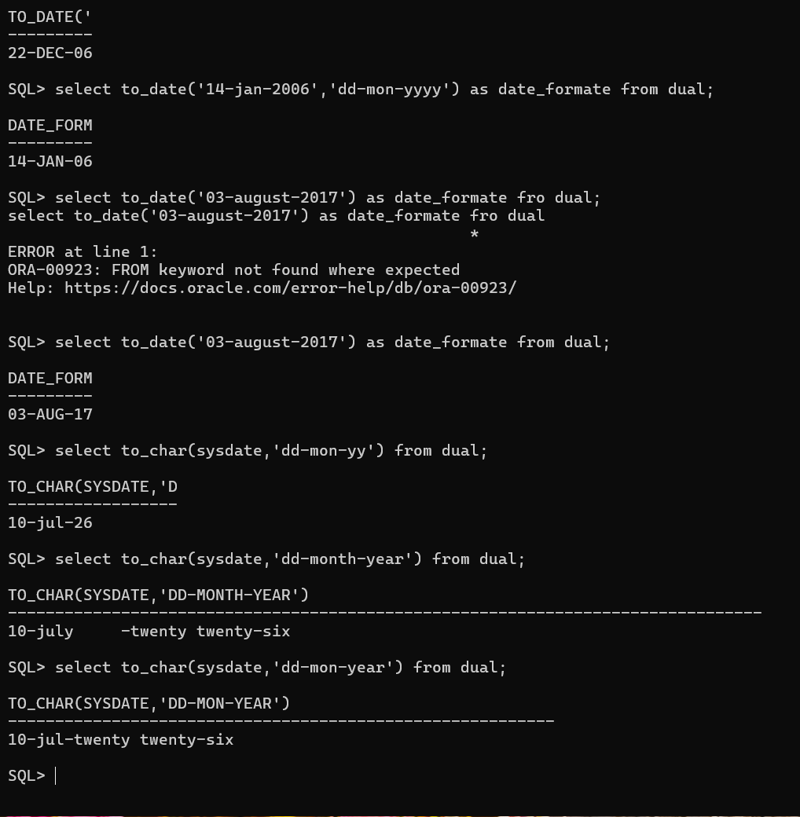
Date:10-07-26
Like Operator
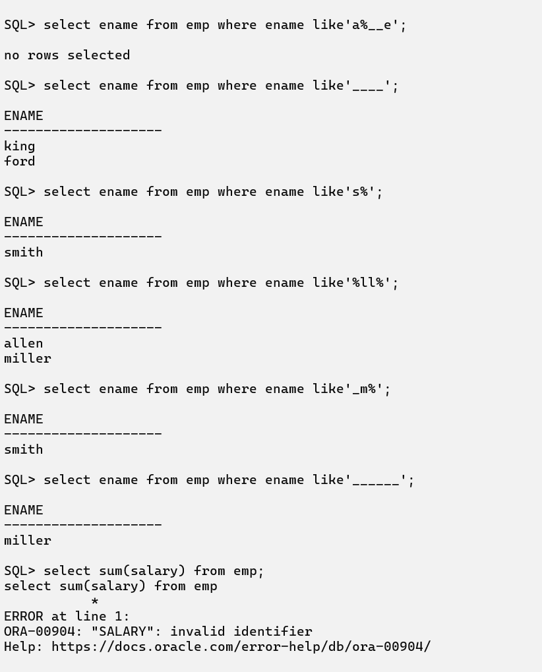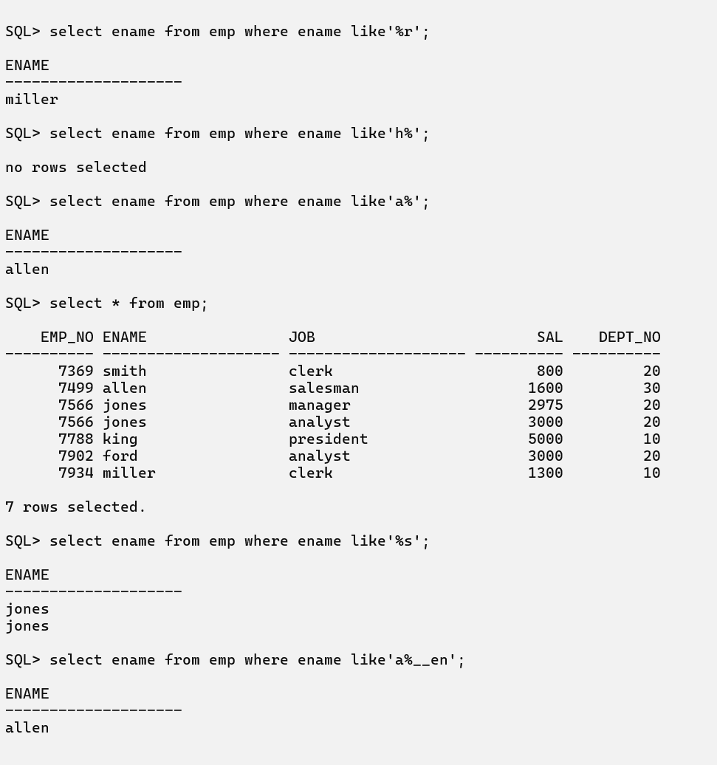
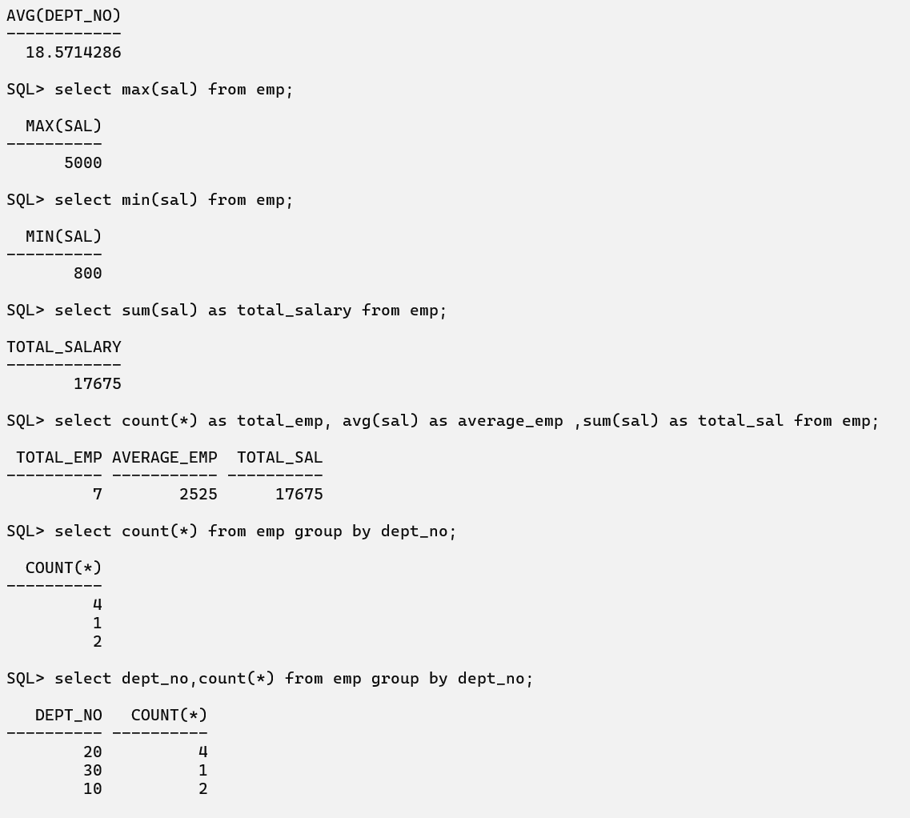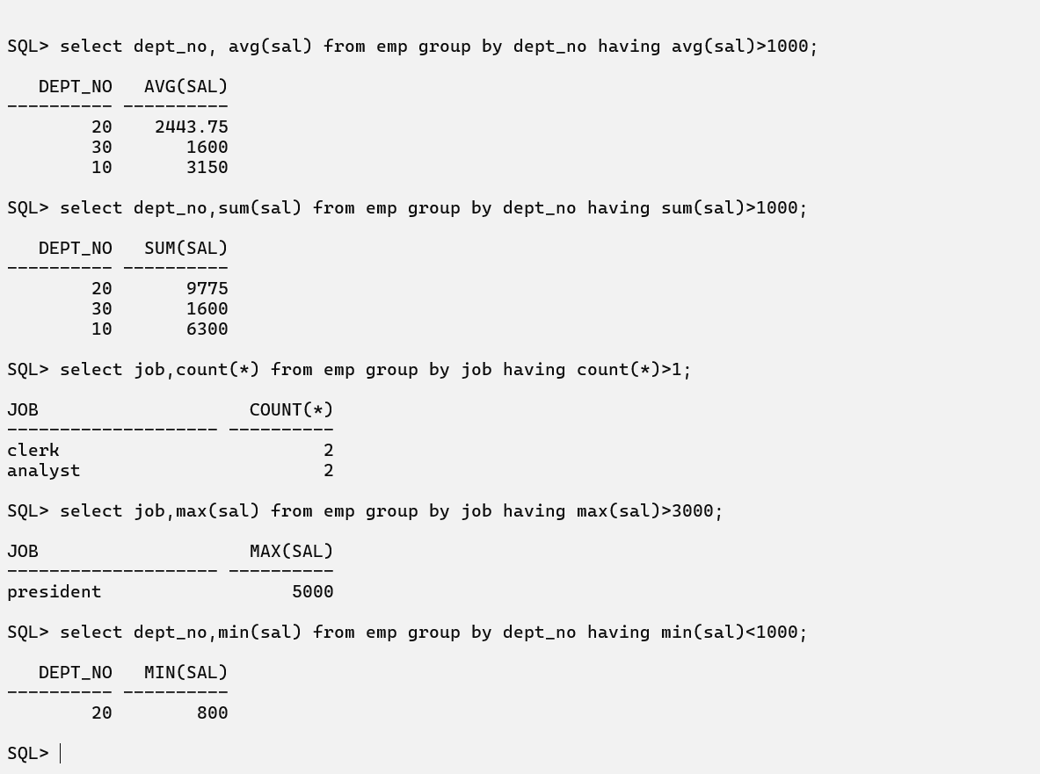
Date:11-07-26
SET Operators: 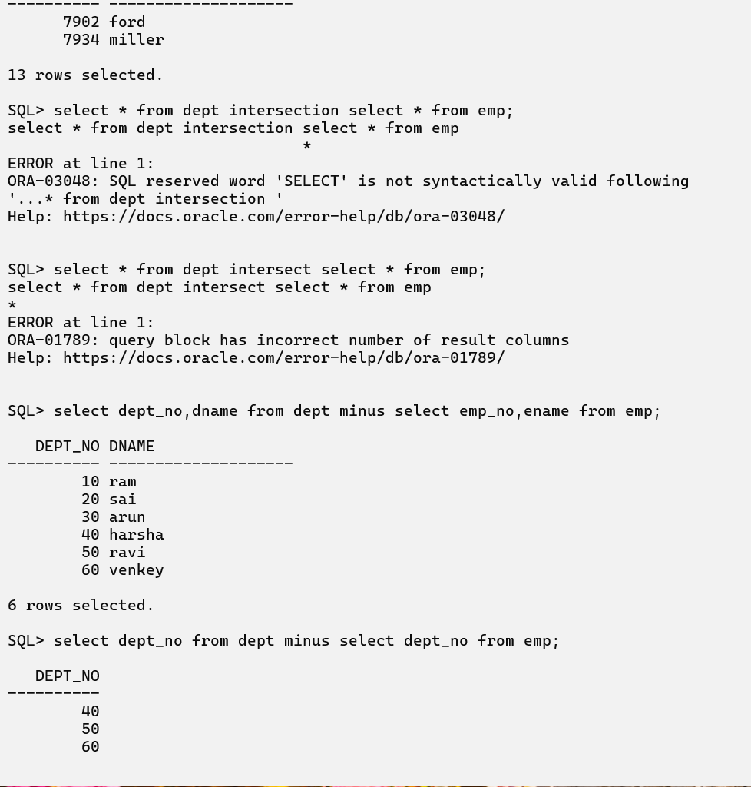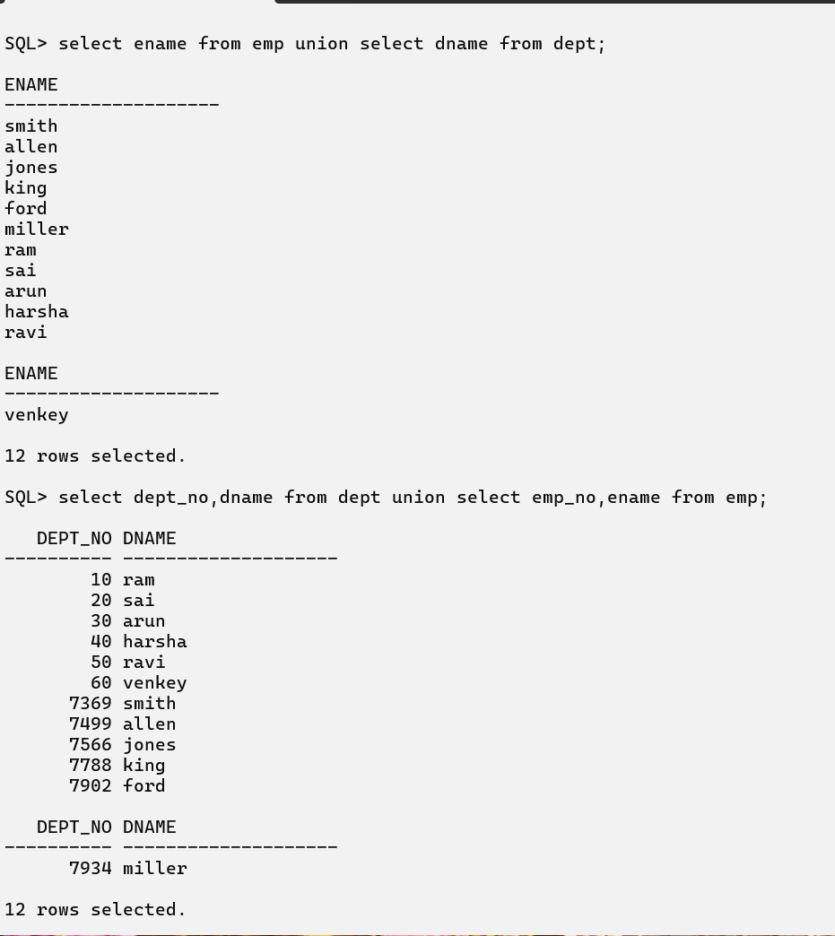
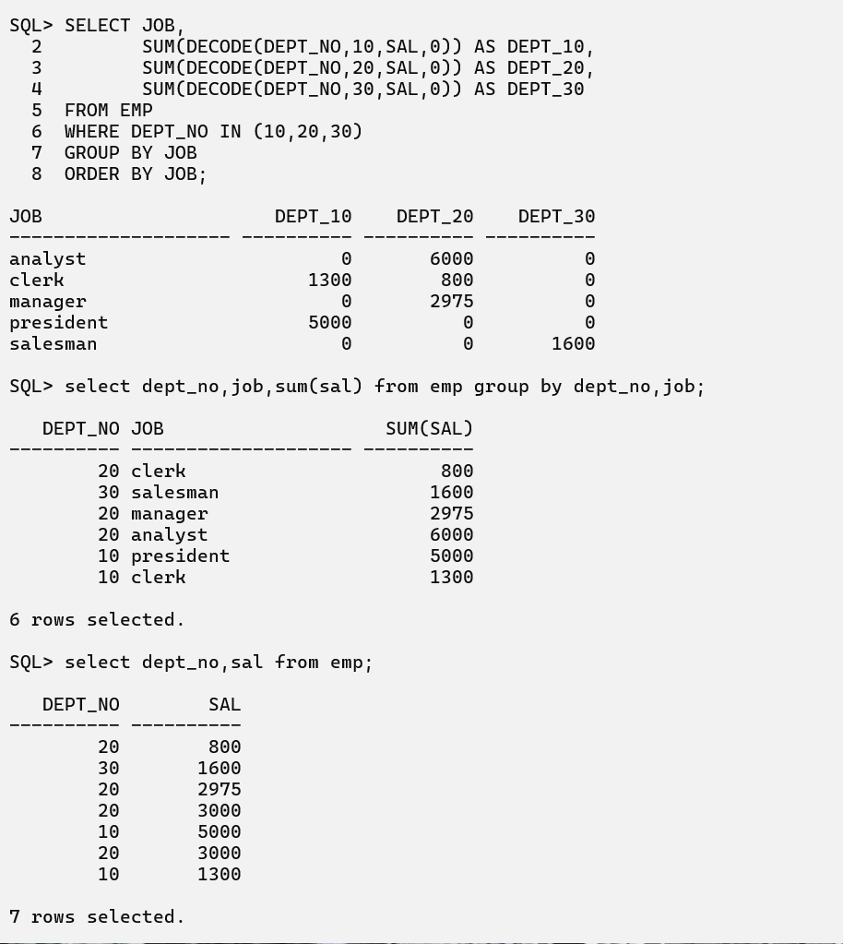
Date:13-07-26
Displaying Data using Joins:
