# Machine Learning Engineer Nanodegree

## Lending Club *Investor ML*

## Predict whether individual loan application will be charged off?

Sriharsha M S  
April 23rd, 2018

## I. Definition

### Project Overview

LendingClub is an online financial community that brings together creditworthy borrowers and savvy investors so that both can benefit financially. They replace the high cost and complexity of bank lending with a faster, smarter way to borrow and invest. Since 2007, LendingClub has been bringing borrowers and investors together, transforming the way people access credit. Over the last 10 years, LendingClub helped millions of people take control of their debt, grow their small businesses, and invest for the future.

LendingClub balances different investors on its platform. The mechanics of the platform allow LendingClub to meet the objectives of many different types of investors, including retail investors. Here’s how it works.  Once loans are approved to the LendingClub platform, they are randomly allocated at a grade and term level either to a program designed for retail investors purchasing interests in fractions of loans (e.g. LendingClub Notes) or to a program intended for institutional investors.  This helps ensure that investors have access to comparable quality loans no matter which type of investor they are. LendingClub goal is to meet incoming investor demand for interests in fractional loans as much as possible.

The design of LendingClub platform emphasizes how important retail investors are to LendingClub.  For LendingClub retail investors are key component of our diverse marketplace strategy. Retail investors are—and will always be—the heart of the LendingClub marketplace.

This project “*Investor ML*” tool specifically built keeping retail investors in mind. *Investor ML* aims to predict probability risk of borrower being charged off and not fully pay loan amount, called “**Risk Rate %**”. LendingClub can provide “**Risk Rate %**” predictions from Investor ML for each loan of borrower as an additional indicator for investors to make investment decisions. Retail investors use loan information, borrower information like fico score, loan grade etc. and decide to invest in fractional loans. Additional statistic “**Risk Rate %**” learned from historical loans may also act as additional information and help retail investors to diversify their investment.

The datasets are provided by LendingClub, we will use lending data from 2007-2011 and be trying to classify and predict whether or not the borrower paid back their loan in full. Data is available to download https://www.lendingclub.com/info/download-data.action.

### Problem Statement

The two most critical questions in the lending industry are: 1) How risky is the borrower? 2) Given the borrower’s risk, should we lend him/her? The answer to the first question determines the interest rate the borrower would have. Interest rate measures among other things (such as time value of money) the riskiness of the borrower, i.e. the riskier the borrower, the higher the interest rate. With interest rate in mind, we can then determine if the borrower is eligible for the loan.

Investors (lenders) provide loans to borrowers in exchange for the promise of repayment with interest. That means the lender only makes profit (interest) if the borrower pays off the loan and don’t get charged off. However, if borrower doesn’t repay the loan and get charged off, then the lender loses money.

We will address the second question indirectly by trying to predict if the borrower will repay the loan fully or get charged off. Using the historical dataset of all loans, we have the ground truth of loans that are charged off and fully paid. We will build machine learning classifier to learn from the loans and use it to predict the “Risk Rate %” off loan being charged off.

*Investor ML* is supervised learning, binary classification problem. *Investor ML* classifier model fits the training data and learns to classify the loans target variable charged off or fully paid.

*Investor ML* solution will consist of,

1. Exploratory analysis and understanding of historical loans of data
2. Build intuitions select and prepare features, treat missing values, scale numerical features, encode categorical features.
3. Prepare target label of charged off or not, study the class imbalance and handle if class imbalance is an issue.
4. Build multiple classifiers use performance metric to choose the ensemble models.
5. Save the model so that saved model can be used to infer loan and provide probability of “Risk Rate%”.

### Metrics

We will also use ROC AUC statistic for model comparison to choose the model based in class imbalance solution to compare between model-not balanced and model-balanced.

Before presenting the ROC curve (= Receiver Operating Characteristic curve), the concept of **confusion matrix** must be understood. When we make a binary prediction, there can be 4 types of outcomes:

* We predict 0 while we should have the class is actually 0: this is called a **True Negative**, i.e. we correctly predict that the class is negative (0). For example, an antivirus did not detect a harmless file as a virus.
* We predict 0 while we should have the class is actually 1: this is called a **False Negative**, i.e. we incorrectly predict that the class is negative (0). For example, an antivirus failed to detect a virus.
* We predict 1 while we should have the class is actually 0: this is called a **False Positive**, i.e. we incorrectly predict that the class is positive (1). For example, an antivirus considered a harmless file to be a virus.
* We predict 1 while we should have the class is actually 1: this is called a **True Positive**, i.e. we correctly predict that the class is positive (1). For example, an antivirus rightfully detected a virus.

To get the confusion matrix, we go over all the predictions made by the model, and count how many times each of those 4 types of outcomes occur:

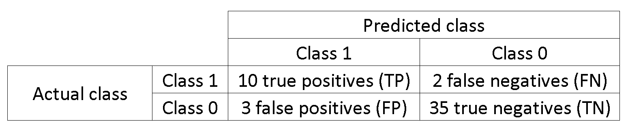

In this example of a confusion matrix, among the 50 data points that are classified, 45 are correctly classified and the 5 are misclassified.

Since to compare two different models it is often more convenient to have a single metric rather than several ones, we compute two metrics from the confusion matrix, which we will later combine into one:

* [True positive rate](https://en.wikipedia.org/wiki/Sensitivity_and_specificity#Sensitivity) (**TPR**), aka. sensitivity, [hit rate](https://en.wikipedia.org/wiki/Hit_rate), and [recall](https://en.wikipedia.org/wiki/Information_retrieval#Recall), which is defined as TPTP+FNTPTP+FN. Intuitively this metric corresponds to the proportion of positive data points that are correctly considered as positive, with respect to all positive data points. In other words, the higher TPR, the fewer positive data points we will miss.
* [False positive rate](https://en.wikipedia.org/wiki/False_positive_rate) (**FPR**), aka. [fall-out](https://en.wikipedia.org/wiki/Information_retrieval#Fall-out), which is defined as FPFP+TNFPFP+TN. Intuitively this metric corresponds to the proportion of negative data points that are mistakenly considered as positive, with respect to all negative data points. In other words, the higher FPR, the more negative data points will be misclassified.

To combine the FPR and the TPR into one single metric, we first compute the two-former metrics with many different threshold, then plot them on a single graph, with the FPR values on the abscissa and the TPR values on the ordinate. The resulting curve is called ROC curve, and the metric we consider is the AUC of this curve, which we call AUROC.

The following figure shows the AUROC graphically:

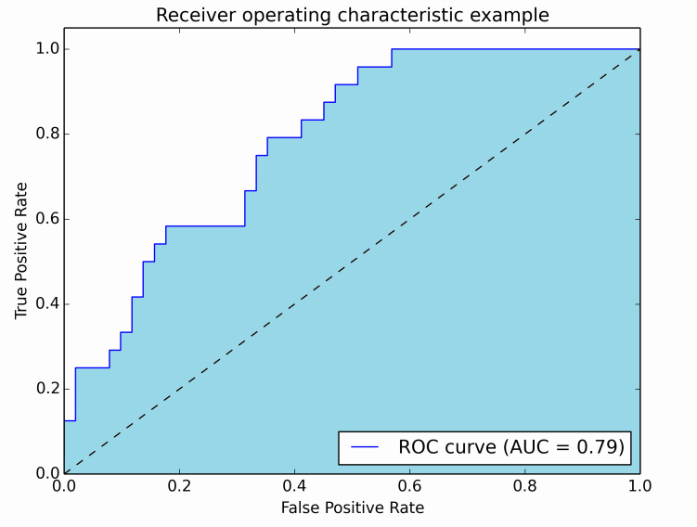

In this figure, the blue area corresponds to the Area Under the curve of the Receiver Operating Characteristic (AUROC). The dashed line in the diagonal we present the ROC curve of a random predictor: it has an AUROC of 0.5. The random predictor is commonly used as a baseline to see whether the model is useful.

Investor ML, is particularly interested in predicting if the borrower will get charged off i.e. probability of “Risk Rate %”. It would seem that using accuracy as a metric for evaluating a particular model's performance would be appropriate.

$$Accuracy=\frac{ True Positive+ True Negative }{ Total Population}$$

Additionally, identifying borrower that fully pay back loan would be detrimental to Investor ML, since they are looking to invest on individual who will pay back loan. Therefore, a model's ability to precisely predict those who get charged off is more important than the model's ability to recall. We can use F-beta score as a metric that considers both precision and recall:

$$Fβ=\left(1+β2\right)⋅\frac{precision⋅recall}{\left(β2⋅precision\right)+recall}$$

In particular, when β=0.5, more emphasis is placed on precision. This is called the **F**0.5 score (or F-score for simplicity).

We will use Accuracy, F-score metric to compare, measure the variance of the model and choose the final model and predict to “Risk Rate %”.

## II. Analysis

### Data Exploration

**Missing Values**

After analyzing all the missing values, decided to keep a threshold of 40% of column population to analyze the data. Original dataset had Dataset has 42542 data points with 151 variables each. After applying threshold of 40% column population dataset changed and dataset has 42542 data points with 60 variables each. More discussion and strategies of handling missing values is discussed on data processing section.

**Additional removals**

Some identifier features like id, urls are not needed and removed. Based on profiling analysis, remove following features

* Dataset has 3 duplicate rows, lets remove duplicates
* application\_type all of them are individual except missing 7
* collections\_12\_mths\_ex\_med has all the value 0.0 except missing 152
* fico\_range\_high is highly correlated to fico\_range\_low, so let’s remove fico\_range\_high feature
* initial\_list\_status has f as value excluding missing 7
* hardship\_flag is having all same values as 'N' except missing data
* out\_prncp has all feature values as 0.0 except missing values
* out\_prncp\_inv has all feature values 0.0 except missing values
* policy\_code has all feature values 1 except missing values
* tax\_liens as all values are 0.0 except 1 and others are missing
* title, purpose have similar values like debt consolidation et al, so remove title use only purpose
* desc is verbose text and some of the desc is like title or purpose. Not using verbose text to analyze so remove

After above step we are left with features dataset that has 42542 data points with 41 variables each.

**Data Profiling**

Panda profiling was used to do the basic data exploration, following are the details of data exploration.

|  |  |
| --- | --- |
| **Variables types** |  |
| **Numeric** | 16 |
| **Categorical** | 20 |
| **Boolean** | 4 |
| **Date** | 0 |
| **Text (Unique)** | 0 |
| **Rejected** | 1 |
| **Unsupported** | 0 |

**Dataset info**

|  |  |
| --- | --- |
| **Number of variables** | 41 |
| **Number of observations** | 42542 |
| **Total size in memory** | 13.3 MiB |
| **Average record size in memory** | 328.0 B |

* [acc\_now\_delinq](file:///MS2/learnspace/udacity/mlnd/capstone/loans_data_profiling.html#pp_var_acc_now_delinq) is highly skewed (γ1 = 103.07)  **Skewed**
* [acc\_now\_delinq](file:///MS2/learnspace/udacity/mlnd/capstone/loans_data_profiling.html#pp_var_acc_now_delinq) has 36 / 100.0% missing values **Missing**
* [addr\_state](file:///MS2/learnspace/udacity/mlnd/capstone/loans_data_profiling.html#pp_var_addr_state) has 7 / 100.0% missing values **Missing**
* [addr\_state](file:///MS2/learnspace/udacity/mlnd/capstone/loans_data_profiling.html#pp_var_addr_state) has a high cardinality: 51 distinct values  **Warning**
* [annual\_inc](file:///MS2/learnspace/udacity/mlnd/capstone/loans_data_profiling.html#pp_var_annual_inc) is highly skewed (γ1 = 29.035)  **Skewed**
* [annual\_inc](file:///MS2/learnspace/udacity/mlnd/capstone/loans_data_profiling.html#pp_var_annual_inc) has 11 / 100.0% missing values **Missing**
* [application\_type](file:///MS2/learnspace/udacity/mlnd/capstone/loans_data_profiling.html#pp_var_application_type) has 7 / 100.0% missing values **Missing**
* [collections\_12\_mths\_ex\_med](file:///MS2/learnspace/udacity/mlnd/capstone/loans_data_profiling.html#pp_var_collections_12_mths_ex_med) has 152 / 100.0% missing values **Missing**
* [delinq\_2yrs](file:///MS2/learnspace/udacity/mlnd/capstone/loans_data_profiling.html#pp_var_delinq_2yrs) has 36 / 100.0% missing values **Missing**
* [delinq\_amnt](file:///MS2/learnspace/udacity/mlnd/capstone/loans_data_profiling.html#pp_var_delinq_amnt) is highly skewed (γ1 = 206.16)  **Skewed**
* [delinq\_amnt](file:///MS2/learnspace/udacity/mlnd/capstone/loans_data_profiling.html#pp_var_delinq_amnt) has 36 / 100.0% missing values **Missing**
* [desc](file:///MS2/learnspace/udacity/mlnd/capstone/loans_data_profiling.html#pp_var_desc) has 13299 / 100.0% missing values **Missing**
* [desc](file:///MS2/learnspace/udacity/mlnd/capstone/loans_data_profiling.html#pp_var_desc) has a high cardinality: 28965 distinct values  **Warning**
* [dti](file:///MS2/learnspace/udacity/mlnd/capstone/loans_data_profiling.html#pp_var_dti) has 7 / 100.0% missing values **Missing**
* [earliest\_cr\_line](file:///MS2/learnspace/udacity/mlnd/capstone/loans_data_profiling.html#pp_var_earliest_cr_line) has 36 / 100.0% missing values **Missing**
* [earliest\_cr\_line](file:///MS2/learnspace/udacity/mlnd/capstone/loans_data_profiling.html#pp_var_earliest_cr_line) has a high cardinality: 531 distinct values  **Warning**
* [emp\_length](file:///MS2/learnspace/udacity/mlnd/capstone/loans_data_profiling.html#pp_var_emp_length) has 7 / 100.0% missing values **Missing**
* [emp\_title](file:///MS2/learnspace/udacity/mlnd/capstone/loans_data_profiling.html#pp_var_emp_title) has 2631 / 100.0% missing values **Missing**
* [emp\_title](file:///MS2/learnspace/udacity/mlnd/capstone/loans_data_profiling.html#pp_var_emp_title) has a high cardinality: 30660 distinct values  **Warning**
* [fico\_range\_high](file:///MS2/learnspace/udacity/mlnd/capstone/loans_data_profiling.html#pp_var_fico_range_high) is highly correlated with [fico\_range\_low](file:///MS2/learnspace/udacity/mlnd/capstone/loans_data_profiling.html#pp_var_fico_range_low) (ρ = 1) **Rejected**
* [fico\_range\_low](file:///MS2/learnspace/udacity/mlnd/capstone/loans_data_profiling.html#pp_var_fico_range_low) has 7 / 100.0% missing values **Missing**
* [grade](file:///MS2/learnspace/udacity/mlnd/capstone/loans_data_profiling.html#pp_var_grade) has 7 / 100.0% missing values **Missing**
* [hardship\_flag](file:///MS2/learnspace/udacity/mlnd/capstone/loans_data_profiling.html#pp_var_hardship_flag) has 7 / 100.0% missing values **Missing**
* [home\_ownership](file:///MS2/learnspace/udacity/mlnd/capstone/loans_data_profiling.html#pp_var_home_ownership) has 7 / 100.0% missing values **Missing**
* [initial\_list\_status](file:///MS2/learnspace/udacity/mlnd/capstone/loans_data_profiling.html#pp_var_initial_list_status) has 7 / 100.0% missing values **Missing**
* [inq\_last\_6mths](file:///MS2/learnspace/udacity/mlnd/capstone/loans_data_profiling.html#pp_var_inq_last_6mths) has 36 / 100.0% missing values **Missing**
* [int\_rate](file:///MS2/learnspace/udacity/mlnd/capstone/loans_data_profiling.html#pp_var_int_rate) has 7 / 100.0% missing values **Missing**
* [int\_rate](file:///MS2/learnspace/udacity/mlnd/capstone/loans_data_profiling.html#pp_var_int_rate) has a high cardinality: 395 distinct values  **Warning**
* [last\_credit\_pull\_d](file:///MS2/learnspace/udacity/mlnd/capstone/loans_data_profiling.html#pp_var_last_credit_pull_d) has 11 / 100.0% missing values **Missing**
* [last\_credit\_pull\_d](file:///MS2/learnspace/udacity/mlnd/capstone/loans_data_profiling.html#pp_var_last_credit_pull_d) has a high cardinality: 128 distinct values  **Warning**
* [last\_fico\_range\_high](file:///MS2/learnspace/udacity/mlnd/capstone/loans_data_profiling.html#pp_var_last_fico_range_high) has 7 / 100.0% missing values **Missing**
* [last\_fico\_range\_low](file:///MS2/learnspace/udacity/mlnd/capstone/loans_data_profiling.html#pp_var_last_fico_range_low) has 7 / 100.0% missing values **Missing**
* [loan\_amnt](file:///MS2/learnspace/udacity/mlnd/capstone/loans_data_profiling.html#pp_var_loan_amnt) has 7 / 100.0% missing values **Missing**
* [loan\_status](file:///MS2/learnspace/udacity/mlnd/capstone/loans_data_profiling.html#pp_var_loan_status) has 7 / 100.0% missing values **Missing**
* [open\_acc](file:///MS2/learnspace/udacity/mlnd/capstone/loans_data_profiling.html#pp_var_open_acc) has 36 / 100.0% missing values **Missing**
* [out\_prncp](file:///MS2/learnspace/udacity/mlnd/capstone/loans_data_profiling.html#pp_var_out_prncp) has 7 / 100.0% missing values **Missing**
* [out\_prncp\_inv](file:///MS2/learnspace/udacity/mlnd/capstone/loans_data_profiling.html#pp_var_out_prncp_inv) has 7 / 100.0% missing values **Missing**
* [policy\_code](file:///MS2/learnspace/udacity/mlnd/capstone/loans_data_profiling.html#pp_var_policy_code) has 7 / 100.0% missing values **Missing**
* [pub\_rec](file:///MS2/learnspace/udacity/mlnd/capstone/loans_data_profiling.html#pp_var_pub_rec) has 36 / 100.0% missing values **Missing**
* [pub\_rec\_bankruptcies](file:///MS2/learnspace/udacity/mlnd/capstone/loans_data_profiling.html#pp_var_pub_rec_bankruptcies) has 1372 / 100.0% missing values **Missing**
* [purpose](file:///MS2/learnspace/udacity/mlnd/capstone/loans_data_profiling.html#pp_var_purpose) has 7 / 100.0% missing values **Missing**
* [revol\_bal](file:///MS2/learnspace/udacity/mlnd/capstone/loans_data_profiling.html#pp_var_revol_bal) has 7 / 100.0% missing values **Missing**
* [revol\_util](file:///MS2/learnspace/udacity/mlnd/capstone/loans_data_profiling.html#pp_var_revol_util) has 97 / 100.0% missing values **Missing**
* [revol\_util](file:///MS2/learnspace/udacity/mlnd/capstone/loans_data_profiling.html#pp_var_revol_util) has a high cardinality: 1120 distinct values  **Warning**
* [sub\_grade](file:///MS2/learnspace/udacity/mlnd/capstone/loans_data_profiling.html#pp_var_sub_grade) has 7 / 100.0% missing values **Missing**
* [tax\_liens](file:///MS2/learnspace/udacity/mlnd/capstone/loans_data_profiling.html#pp_var_tax_liens) is highly skewed (γ1 = 205.99)  **Skewed**
* [tax\_liens](file:///MS2/learnspace/udacity/mlnd/capstone/loans_data_profiling.html#pp_var_tax_liens) has 112 / 100.0% missing values **Missing**
* [term](file:///MS2/learnspace/udacity/mlnd/capstone/loans_data_profiling.html#pp_var_term) has 7 / 100.0% missing values **Missing**
* [title](file:///MS2/learnspace/udacity/mlnd/capstone/loans_data_profiling.html#pp_var_title) has 19 / 100.0% missing values **Missing**
* [title](file:///MS2/learnspace/udacity/mlnd/capstone/loans_data_profiling.html#pp_var_title) has a high cardinality: 21258 distinct values  **Warning**
* [total\_acc](file:///MS2/learnspace/udacity/mlnd/capstone/loans_data_profiling.html#pp_var_total_acc) has 36 / 100.0% missing values **Missing**
* [verification\_status](file:///MS2/learnspace/udacity/mlnd/capstone/loans_data_profiling.html#pp_var_verification_status) has 7 / 100.0% missing values **Missing**
* [zip\_code](file:///MS2/learnspace/udacity/mlnd/capstone/loans_data_profiling.html#pp_var_zip_code) has 7 / 100.0% missing values **Missing**
* [zip\_code](file:///MS2/learnspace/udacity/mlnd/capstone/loans_data_profiling.html#pp_var_zip_code) has a high cardinality: 838 distinct values  **Warning**
* Dataset has 6 duplicate rows **Warning**

Basic intuitions formed based on the profiling of the data.

I have reviewed each and every feature its Quantile statistic, Descriptive statistic, Histogram, Common Values, extreme values, I show one feature Dti and its values below, for each feature refer loans\_data\_profiling.html, go to feature and toggle details.

**Feature** **Analysis**:

**dti**  
Numeric

|  |  |
| --- | --- |
| **Distinct count** | 2895 |
| **Unique (%)** | 0.0% |
| **Missing (n)** | 7 |
| **Infinite (%)** | 0.0% |
| **Infinite (n)** | 0 |
| **Mean** | 13.373 |
| **Minimum** | 0 |
| **Maximum** | 29.99 |
| **Zeros (%)** | 0.0% |
| * [Statistics](file:///MS2/learnspace/udacity/mlnd/capstone/loans_data_profiling.html#quantiles-1925086808184474782)   Quantile statistics   |  |  | | --- | --- | | **Minimum** | 0 | | **5-th percentile** | 2.1 | | **Q1** | 8.2 | | **Median** | 13.47 | | **Q3** | 18.68 | | **95-th percentile** | 23.92 | | **Maximum** | 29.99 | | **Range** | 29.99 | | **Interquartile range** | 10.48 | |  |

|  |  |
| --- | --- |
| Descriptive statistics  **Standard deviation** | 6.7263 |
| **Coef of variation** | 0.50298 |
| **Kurtosis** | -0.85174 |
| **Mean** | 13.373 |
| **MAD** | 5.6401 |
| **Skewness** | -0.029922 |
| **Sum** | 568820 |
| **Variance** | 45.243 |
| **Memory size** | 332.4 KiB |

* [Histogram](file:///MS2/learnspace/udacity/mlnd/capstone/loans_data_profiling.html#quantiles-1925086808184474782)

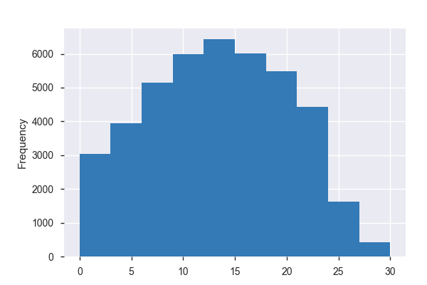

**Correlation plots for features**:

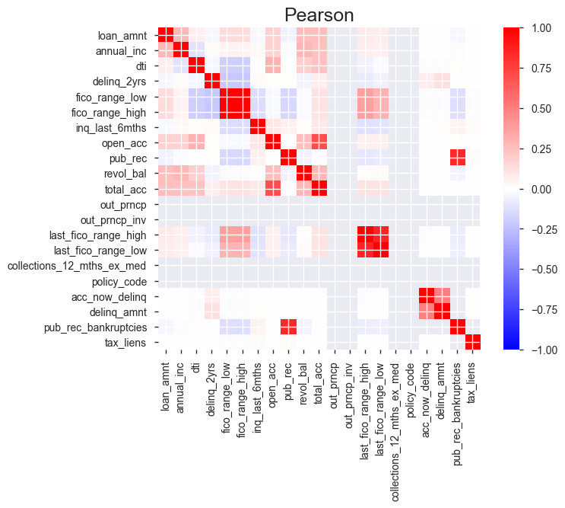

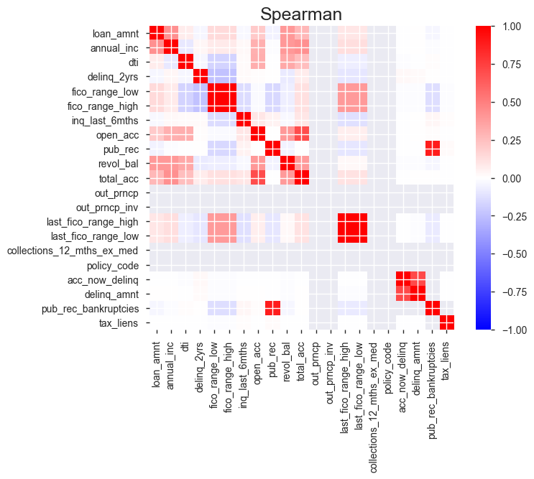

**Preparing Target Label**

**loan\_status** is converted as target response variable for Investor ML classification problem. Following are the value counts of loan\_status field.

| **Loan\_status** | **Count** |
| --- | --- |
| Fully Paid. | 34116 |
| Charged Off. | 5670 |
| Does not meet the credit policy. Status:Fully ... | 1988 |
| Does not meet the credit policy. Status:Charge... | 761 |

For our project we just need to know whether loans are charged off or not. We will convert the Fully Paid & Does not meet the credit policy. Status:Fully Paid to 0, Charged Off & Does not meet the credit policy. Status:Charged Off to 1. After doing this change

| **Loan\_status** | **Count** |
| --- | --- |
| 0 | 36104 |
| 1 | 6431 |

**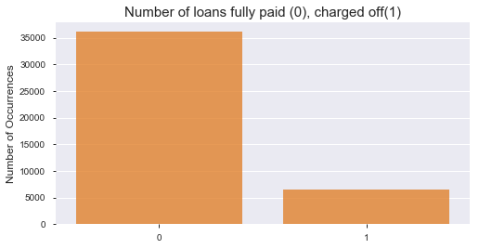**

We see that data set is pretty imbalanced as expected where positive examples (“charged off”) are only ~18%. We will handle imbalanced class issue later.

### Exploratory Visualization

Analysis of loans based on fico score and whether they are charged off or fully paid. FICO score is key metric credit rating used to learn about the borrower credit, this analysis will help us understand how FICO score relates to borrower ability to fully pay or charged off.

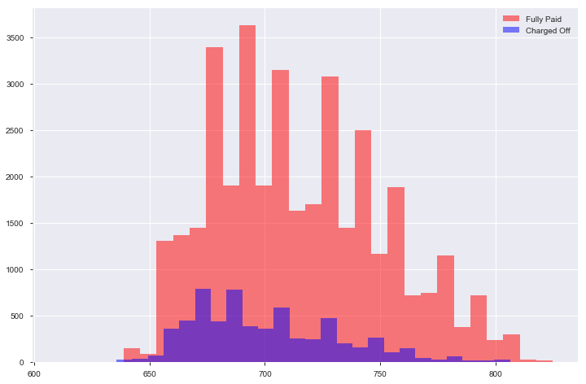

* Though loan applicants have good FICO score, 750+, we can see some loans are not paid off.
* Highest number of loans paid off are in b/w below 660 to 700 FICO score.

Why do borrowers take loan? Using feature purpose, we can plot and see purpose stated by borrower, and how many of the stated purpose loans are charged off or fully paid.

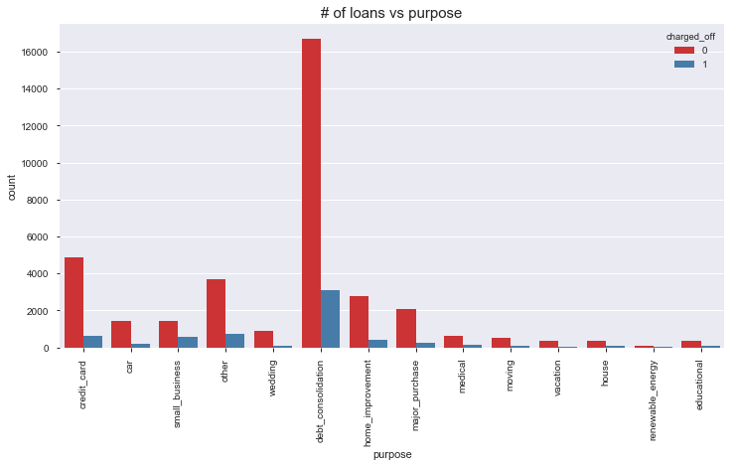

* Most of the loans are being requested for debt\_consolidation
* Most not fully paid loans are also of purpose debt\_consolidation

How does interest rates correlate to FICO score? Using feature interest rate and FICO, we can plot Pearson correlation plot, which will show how the interest rates are correlated to FICO score.

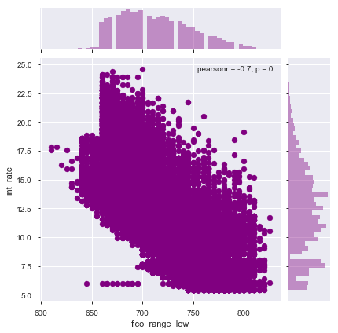

* Higher the fico score, lower the interest rate, there is a correlation b/w fico score & interest rate.

### Algorithms and Techniques

*Investor ML* is supervised learning, binary classification problem. We will use various Ensemble methods for our classifier. Ensemble methods can be defined as combining several different models (base learners) into final model (meta learner) to reduce the generalization error. It relies on the assumption that each model would look at a different aspect of the data which yield to capturing part of the truth. Combining good performing models, that were trained independently will capture more of the truth than a single model. Therefore, this would result in more accurate predictions and lower generalization errors.

* Almost always ensemble model performance gets improved as we add more models.
* Try to combine models that are as much different as possible. This will reduce the correlation between the models that will improve the performance of the ensemble model that will lead to significantly outperform the best model. In the worst case where all models are perfectly correlated, the ensemble would have the same performance as the best model and sometimes even lower if some models are very bad. As a result, pick models that are as good as possible.

Diﬀerent ensemble methods construct the ensemble of models in diﬀerent ways. Below are the most common methods:

* Blending: Averaging the predictions of all models.
* Bagging: Build different models on different datasets and then take the majority vote from all the models. Given the original dataset, we sample with replacement to get the same size of the original dataset. Therefore, each dataset will include, on average, 2/3 of the original data and the rest 1/3 will be duplicates. Since each model will be built on a different dataset, it can be seen as a different model. For example: *Random Forest* improves default bagging trees by reducing the likelihood of strong features to picked on every split. In other word, it reduces the number of features available at each split from *n* features to, for example, *n/2* or *log(n)*features. This will reduce correlation –> reduce variance.
* Boosting: Build models sequentially. That means each model learns from the residuals of the previous model. The output will be all output of each single model weighted by the learning rate λ. It reduces the bias resulted from bagging by learning sequentially from residuals of previous trees (models).
* Stacking: Build k models called base learners. Then fit a model to the output of the base learners to predict the final output.

We’ll be using Random Forest (bagging), Gradient Boosting (boosting), XGBoosting (boosting) and Logistic Regression classifiers as base learners.

**Logistic Regression**

Logistic regression, despite its name, is a linear model for classification rather than regression. Logistic regression is also known in the literature as logit regression, maximum-entropy classification (MaxEnt) or the log-linear classifier. In this model, the probabilities describing the possible outcomes of a single trial are modeled using a [logistic function](https://en.wikipedia.org/wiki/Logistic_function).

The implementation of logistic regression in scikit-learn can be accessed from class [**LogisticRegression**](http://scikit-learn.org/stable/modules/generated/sklearn.linear_model.LogisticRegression.html#sklearn.linear_model.LogisticRegression). This implementation can fit binary, is used for *Investor ML* logistic regression with optional L2 or L1 regularization.

As an optimization problem, binary class L2 penalized logistic regression minimizes the following cost function:

\underset{w, c}{min\,} \frac{1}{2}w^T w + C \sum_{i=1}^n \log(\exp(- y_i (X_i^T w + c)) + 1) .

Similarly, L1 regularized logistic regression solves the following optimization problem

\underset{w, c}{min\,} \|w\|_1 + C \sum_{i=1}^n \log(\exp(- y_i (X_i^T w + c)) + 1) .

**Random Forest**

In random forests (see [**RandomForestClassifier**](http://scikit-learn.org/stable/modules/generated/sklearn.ensemble.RandomForestClassifier.html#sklearn.ensemble.RandomForestClassifier)  classes), each tree in the ensemble is built from a sample drawn with replacement (i.e., a bootstrap sample) from the training set. In addition, when splitting a node during the construction of the tree, the split that is chosen is no longer the best split among all features. Instead, the split that is picked is the best split among a random subset of the features. As a result of this randomness, the bias of the forest usually slightly increases (with respect to the bias of a single non-random tree) but, due to averaging, its variance also decreases, usually more than compensating for the increase in bias, hence yielding an overall better model.

The scikit-learn implementation combines classifiers by averaging their probabilistic prediction, instead of letting each classifier vote for a single class.

**XGboostClassifier**

XGBoost is an optimized distributed gradient boosting system designed to be highly **efficient**, **flexible** and **portable**. It implements machine learning algorithms under the Gradient Boosting framework. XGBoost provides a parallel tree boosting (also known as GBDT, GBM) that solve many data science problems in a fast and accurate way. Xgboost module in python has a sklearn wrapper called XGBClassifier which we will use.

**GradientBoostingClassifier**

[Gradient Tree Boosting](https://en.wikipedia.org/wiki/Gradient_boosting) or Gradient Boosted Regression Trees (GBRT) is a generalization of boosting to arbitrary differentiable loss functions. GBRT is an accurate and effective off-the-shelf procedure that can be used for classification problems. Gradient Tree Boosting models are used in a variety of areas including Web search ranking and ecology.

The advantages of GBRT are:

* Natural handling of data of mixed type (= heterogeneous features)
* Predictive power
* Robustness to outliers in output space (via robust loss functions)

The disadvantages of GBRT are:

* Scalability, due to the sequential nature of boosting it can hardly be parallelized.

Modeling would be consisted of following parts:

* Strategies to deal with missing values. Discussed later in details in Data processing section.
* All identified numerical features are scaled and categorical variables are one-hot encoded, details discussed in Data processing section.
* Strategies to deal with imbalanced datasets. Discussed later in details in Implementation section.
* Build ensemble models. Discussed later in details in Implementation and refinement section.
* Model will be chosen based on runtime, metrics discussed Metrics section.
* Entire data will be fit and final model will be saved, final saved model can be used to infer “Risk Rate %” of a new borrower loan application to predict loan\_status being charged off.

### Benchmark

Looking at the distribution of classes (those who get charged off, and those who pay back), it's clear most individuals fully pay back loan. Suppose if we were building model to predict whether an individual loan will be pay back. This can greatly affect accuracy, since we could simply say "this person will pay back loan" and generally be right, without ever looking at the data! Making such a statement would be called naive, since we have not considered any information to substantiate the claim. It is always important to consider the naive prediction for your data, to help establish a benchmark for whether a model is performing well. That been said, using that prediction would be pointless: If we predicted all people pay back loan, Investor ML would identify all loan application as fully payable loans and would not answer or help us find “Risk Rate %” as all loans are paid back.

**Benchmark metrics of Naïve Predictor**:

Looking at the distribution of classes (those who charged off, and those who fully pay), it's clear most individuals fully pay back loan. This can greatly affect accuracy, since we could simply say "this person will pay back loan" and generally be right, without ever looking at the data! Making such a statement would be called naive, since we have not considered any information to substantiate the claim. Also, as we are trying to predict "Risk Rate%", we can’t say loan gets charged off. To define a naive predictor, we will use Gausian NB model to help establish a benchmark predictor. Using this as benchmark, we can use all other linear or ensemble models to compare to say whether a model is performing well or not.

**Gaussian Naive Bayes**

[**GaussianNB**](http://scikit-learn.org/stable/modules/generated/sklearn.naive_bayes.GaussianNB.html#sklearn.naive_bayes.GaussianNB) implements the Gaussian Naive Bayes algorithm for classification. The likelihood of the features is assumed to be Gaussian:

P(x_i \mid y) &= \frac{1}{\sqrt{2\pi\sigma^2_y}} \exp\left(-\frac{(x_i - \mu_y)^2}{2\sigma^2_y}\right)

The parameters \sigma_y and \mu_y are estimated using maximum likelihood.

|  |  |  |
| --- | --- | --- |
| **Model Name** | **Accuracy** | **F-score** |
| Naive Predictor | 0.557071 | 0.2567 |

Going through the metrics of Naïve Predictor we can say that it has poor accuracy of 0.5570 & bad f-score of 0.2567.

## III. Methodology

### Data Preprocessing

Feature selection based on intuition

* Based on above profiling, by spending some time, going through each feature and analyzing each feature, we can first identify the categorical features & numerical features that are populated well to be used for modeling.
* Pandas profiling also profiles the details of highly correlated features using which we don’t need to select some features if they are highly co-related, for example, fico\_range\_high & fico\_range\_low, they both are highly co-related so we can use one of them for our analysis and modeling.

Selected categorical features, intuitions for selection

- addr\_state: Not selected, as this feature as high cardinality, has 51 distinct values, though the state might be a good indicator, am hesitant use this feature for first pass as using this one hot encoding features may increase by 51.

- earliest\_cr\_line: Not selected, should be converted to numerical by calculating the number of months from the loan date, not considered for first pass.

- emp\_length: Selected, this feature might help us know duration of employment and how it influences paying off loan.

- emp\_title: Selected, as purpose gives better indicator and also features will explode using this feature and one hot encoding.

- grade: Selected, LC grade might influence paying off loan.

- home\_ownership: Selected, this feature might help us know how home\_ownership influence paying off loan.

- int\_rate: Selected, different interest rate might influence loan getting paid off, lower interest rate means less amount to be paid off, so loan may have been paid

- last\_credit\_pull\_d: Not selected, converting the loan application month to last credit pull month might be helpful feature

- purpose: Selected, purpose might indicate the usage, which might corelate to loan being paid off.

- sub\_grade: Selected, may be good indicator of paying off loan.

- term: Selected, may be longer term, less monthly commitment and may paying off loan.

- title: Not selected, purpose is better feature than title, too many categories to convert as one hot encode features.

- url: Not selected, url identifier.

- verification\_status: Selected, indicator, better verification state, likely to pay off loan.

- zipcode: Not selected, indicates living neighborhood and changes of pay off loan. Too many zip codes to convert as one hot encode features.

Selected numerical features, intuitions for selection

- acc\_now\_delinq: Selected, considering this feature, as once we add more data, it might be valuable.

- annual\_inc: selected, income informs how good the loan applicant has the ability to pay back.

- delinq\_2yrs: selected, if applicant delinquency in past 2 yr may be good indicator.

- delinq\_amnt: Not selected, as most of the values is 0, 36missing and 2 other values may.

- dti: Selected, dti may be a good indicator of borrower’s debt to income ration and informs the ability of applicant to pay back loan.

- fico\_range\_high : Not selected, as its highly correlated to fico\_range\_low, which will be used.

- fico\_range\_low: Selected, it might tell credit rating of applicant, which by itself is a good measure of loan applicant ability to pay back.

- inq\_last\_6mths: Selected, shows multiple credit enquire, which may indicate pursuance of loan applicant for various debts.

- last\_fico\_range\_high: Not selected, as it is highly correlated to last\_fico\_range\_low and last\_fico\_range\_low will be used.

- last\_fico\_range\_low: Selected, this feature might help us know how loan applicant maintained his credit.

- loan\_amnt: Selected, higher the loan\_amnt, less likely loan will be paid off.

- mths\_since\_last\_delinq: Selected, more month’s good loan applicant.

- open\_acc: Selected, Median open acc is better.

- pub\_rec: Selected, derogatory public records, less likely to pay off loan.

- pub\_rec\_bankruptcies: Selected, more/any bankruptcy less likely to pay off loan.

- revol\_bal: Selected, more revol\_bal, likely to pay off loan.

- revol\_util: Selected, more revol\_util, likely to pay off loan.

- tax\_lines: Not selected, all 42429 of tax\_lines is 0, and 1 is 1 and 112 missing.

- total\_acc: Selected, median account is a good indicator.

**Missing Values**

During data exploration we learnt that there are missing values in the dataset. We have to treat missing values differently for both numerical features and categorical features.

1. **Handling numerical features missing values**

Following are missing numerical features. Dataset has 42535 data points with 15 numerical variables each.

acc\_now\_delinq 29

annual\_inc 4

delinq\_2yrs 29

int\_rate 0

dti 0

fico\_range\_low 0

inq\_last\_6mths 29

last\_fico\_range\_low 0

loan\_amnt 0

open\_acc 29

pub\_rec 29

pub\_rec\_bankruptcies 1365

revol\_bal 0

revol\_util 90

total\_acc 29

There are several strategies to impute missing values like, median, mean and mode imputation. As all above features are sensitive information related to individual financials, imputing mean, median strategies might not be right, so it is better to impute 0 for NA values than mean, median or mode strategies. Let’s impute missing values as 0.

1. **Handling categorical features missing values**

Following are missing numerical features. Dataset has 42535 data points with 7 numerical variables each.

emp\_length 0

grade 0

home\_ownership 0

purpose 0

sub\_grade 0

term 0

verification\_status 0

No missing values in categorical features.

**Normalizing Numerical Features**

It is often good practice to perform some type of scaling on numerical features. Note that once scaling is applied, observing the data in its raw form will no longer have the same original meaning. I will use StandardScaler to scale the features around the mean.

**One-hot encoding of categorical features**

Above we found that there are about 7 categorical features that are non-numeric. Typically, learning algorithms expect input to be numeric, which requires that non-numeric features (called *categorical variables*) be converted. One popular way to convert categorical variables is by using the **one-hot encoding** scheme. One-hot encoding creates a *"dummy"* variable for each possible category of each non-numeric feature. For example, assume someFeature has three possible entries: A, B, or C. We then encode this feature into someFeature\_A,  someFeature\_B and someFeature\_C.

|  |  |  |  |  |  |
| --- | --- | --- | --- | --- | --- |
|  | **someFeature** |  | **someFeature\_A** | **someFeature\_B** | **someFeature\_C** |
| 0 | B |  | 0 | 1 | 0 |
| 1 | C | ----> **one-hot encode** ----> | 0 | 0 | 1 |
| 2 | A |  | 1 | 0 | 0 |

After above preprocessing, we have dataset of 42535 records, 93 features, 1 response variable with value 1 or 0.

### Implementation

**Shuffle and Split Data**

Now all categorical variables have been converted into numerical features, and all numerical features have been normalized. As always, we will now split the data (both features and their labels) into training and test sets. 80% of the data will be used for training and 20% for testing.

**Strategies to deal with imbalanced datasets**

Classification problems in most real-world applications have imbalanced data sets. In other words, the positive examples (minority class) are a lot less than negative examples (majority class). We can see that in spam detection, ads click, loan approvals, etc. In our example, the positive examples (people who charged off) were only ~18% from the total examples. Therefore, accuracy is no longer a good measure of performance for different models because if we simply predict all examples to belong to the negative class, we achieve 81% accuracy. Better metrics for imbalanced data sets are AUC (area under the ROC curve) and f1-score. However, that’s not enough because class imbalance influences a learning algorithm during training by making the decision rule biased towards the majority class by implicitly learns a model that optimizes the predictions based on the majority class in the dataset. As a result, we’ll explore different methods to overcome class imbalance problem.

Under-Sample: Under-sample the majority class with or w/o replacement by making the number of positive and negative examples equal. One of the drawbacks of under-sampling is that it ignores a good portion of training data that has valuable information. In our example, it would lose around ~27000+ examples. However, it’s very fast to train.

Over-Sample: Over-sample the minority class with or w/o replacement by making the number of positive and negative examples equal. We’ll add around ~27000+ samples from the training data set with this strategy. It’s a lot more computationally expensive than under-sampling. Also, it’s more prune to overfitting due to repeated examples.

EasyEnsemble: Sample several subsets from the majority class, build a classifier on top of each sampled data, and combine the output of all classifiers. More details can be found here.

Synthetic Minority Oversampling Technique (SMOTE): It over-samples the minority class but using synthesized examples. It operates on feature space not the data space.

Following are the results of AUC obtained after employing different balancing techniques discussed above.

Original model's average AUC: 0.825141686061

Under-sampled model's average AUC: 0.844144632797

Over-sampled model's average AUC: 0.836151343324

EasyEnsemble model's average AUC: 0.872006664839

SMOTE model's average AUC: 0.830762241789

EasyEnsemble method has the highest 10-folds CV with average AUC = 0.872006664839. So, we use EasyEnsemble technique to handle the imbalanced class problem.

**Creating a Training and Predicting Pipeline**

A training and predicting pipeline that allows you to quickly and effectively train models using various sizes of training data and perform predictions on the testing data. We will also chart and generate metrics table to capture the running time, performance of models based on various performance metrics discussed earlier. As discussed in Algorithms & Techniques section, using training & predictive pipeline, we will evaluate

* Logistic Regression (linear classifier)
* GradientBoostingClassifier (Ensemble boosting decision tree classifier)
* XGBoostClassifier (Ensemble boosting parallel decision tree classifier)

XGBClassifier trained on 340 samples.

XGBClassifier trained on 3402 samples.

XGBClassifier trained on 34028 samples.

LogisticRegression trained on 340 samples.

LogisticRegression trained on 3402 samples.

LogisticRegression trained on 34028 samples.

GradientBoostingClassifier trained on 340 samples.

GradientBoostingClassifier trained on 3402 samples.

GradientBoostingClassifier trained on 34028 samples.

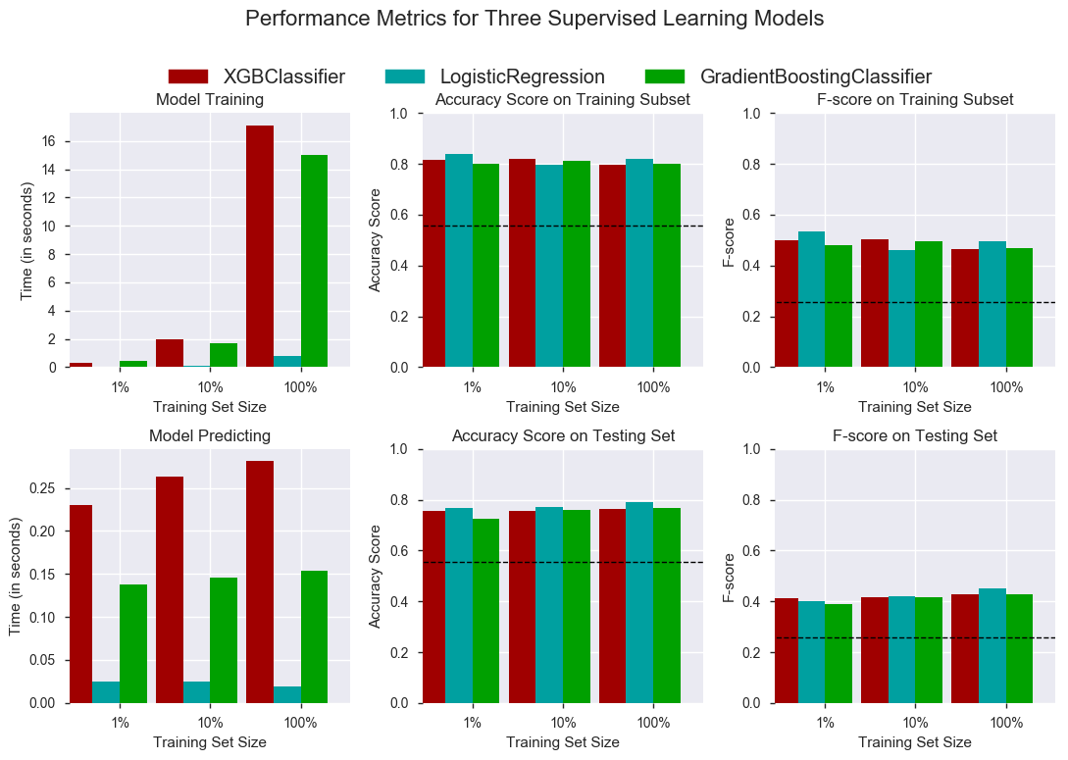

|  |  |  |  |  |  |  |  |  |
| --- | --- | --- | --- | --- | --- | --- | --- | --- |
|  | **model** | **matthews\_corrcoef** | **roc\_auc\_score** | **precision\_score** | **recall\_score** | **f1\_score** | **accuracy** | **fscore** |
| **1** | Naive Predictor | 0.201287 | 0.696211 | 0.220243 | 0.75972 | 0.341489 | 0.557071 | 0.2567 |
| **2** | XGBClassifier340 | 0.441011 | 0.858439 | 0.367037 | 0.846812 | 0.512109 | 0.756083 | 0.413943 |
| **3** | XGBClassifier3402 | 0.450757 | 0.87416 | 0.370445 | 0.861586 | 0.51812 | 0.757729 | 0.418113 |
| **4** | XGBClassifier34028 | 0.462447 | 0.884929 | 0.379299 | 0.866252 | 0.527587 | 0.765487 | 0.427344 |
| **5** | LogisticRegression340 | 0.376855 | 0.824225 | 0.360721 | 0.699844 | 0.476065 | 0.767133 | 0.399432 |
| **6** | LogisticRegression3402 | 0.420559 | 0.848994 | 0.376618 | 0.769051 | 0.505624 | 0.772658 | 0.419423 |
| 7 | LogisticRegression34028 | 0.459705 | 0.870451 | 0.405491 | 0.792379 | 0.536457 | 0.792994 | 0.449374 |
| **8** | GradientBoostingClassifier340 | 0.418919 | 0.843553 | 0.340653 | 0.868585 | 0.489376 | 0.72599 | 0.387793 |
| **9** | GradientBoostingClassifier3402 | 0.446944 | 0.871031 | 0.370395 | 0.852255 | 0.516372 | 0.758669 | 0.417619 |
| **10** | GradientBoostingClassifier34028 | 0.464679 | 0.884464 | 0.380757 | 0.867807 | 0.529286 | 0.766663 | 0.428901 |

We can see from the above charts and data that, EasySampling, LogisticRegression performs better than, XGBoostClassifier & GradientBoostingClassifier. Considering running time, 100% training size data, variance (train / test of accuracy score is close), F-score.

### Refinement

**Model Tuning for hyper parameters**

From above implementation section it is clear that using Easy Sampling and LogisticRegression gives the best performance of the model. But we have not tuned any hyper parameters of the Logistic Regression or Easy Samplings BalancedBaggingClassifier following are the hyper parameters selected to tune.

Logistic Regression

solvers (['newton-cg', 'lbfgs', 'liblinear', 'sag']).

'C': [0.1, 1.0, 1.5]

BalancedBaggingClassifier

n-estimators : range(20,81,10)

Used GridSearch with Cross validation optimizing for custom fbeta\_score found following tuned parameters from the best estimator as.

Logistic Regression

solvers (['sag']).

'C': [1.5]

BalancedBaggingClassifier

n-estimators : [10]

Following is the result of tuned model with tuned hyper parameters.

Unoptimized model ------

Accuracy score on testing data: 0.7931

F-score on testing data: 0.4495

Optimized Model ------

Final accuracy score on the testing data: 0.7936

Final F-score on the testing data: 0.4507

Best Classifier ------ BalancedBaggingClassifier(base\_estimator=LogisticRegression(C=1.5, class\_weight=None, dual=False, fit\_intercept=True, intercept\_scaling=1, max\_iter=100, multi\_class='ovr', n\_jobs=1, penalty='l1', random\_state=10, solver='liblinear', tol=0.0001, verbose=0, warm\_start=False), bootstrap=True, bootstrap\_features=False, max\_features=1.0, max\_samples=1.0, n\_estimators=10, n\_jobs=1, oob\_score=False, random\_state=10, ratio='auto', replacement=False, verbose=0, warm\_start=False)

Updated performance metric for GridSearchTunedLR classifier

|  |  |  |  |  |  |  |  |  |
| --- | --- | --- | --- | --- | --- | --- | --- | --- |
|  | **model** | **matthews\_corrcoef** | **roc\_auc\_score** | **precision\_score** | **recall\_score** | **f1\_score** | **accuracy** | **fscore** |
| **1** | Naive Predictor | 0.201287 | 0.696211 | 0.220243 | 0.75972 | 0.341489 | 0.557071 | 0.2567 |
| **2** | XGBClassifier340 | 0.441011 | 0.858439 | 0.367037 | 0.846812 | 0.512109 | 0.756083 | 0.413943 |
| **3** | XGBClassifier3402 | 0.450757 | 0.87416 | 0.370445 | 0.861586 | 0.51812 | 0.757729 | 0.418113 |
| **4** | XGBClassifier34028 | 0.462447 | 0.884929 | 0.379299 | 0.866252 | 0.527587 | 0.765487 | 0.427344 |
| **5** | LogisticRegression340 | 0.376855 | 0.824225 | 0.360721 | 0.699844 | 0.476065 | 0.767133 | 0.399432 |
| **6** | LogisticRegression3402 | 0.420559 | 0.848994 | 0.376618 | 0.769051 | 0.505624 | 0.772658 | 0.419423 |
| **7** | LogisticRegression34028 | 0.459705 | 0.870451 | 0.405491 | 0.792379 | 0.536457 | 0.792994 | 0.449374 |
| **8** | GradientBoostingClassifier340 | 0.418919 | 0.843553 | 0.340653 | 0.868585 | 0.489376 | 0.72599 | 0.387793 |
| **9** | GradientBoostingClassifier3402 | 0.446944 | 0.871031 | 0.370395 | 0.852255 | 0.516372 | 0.758669 | 0.417619 |
| **10** | GradientBoostingClassifier34028 | 0.464679 | 0.884464 | 0.380757 | 0.867807 | 0.529286 | 0.766663 | 0.428901 |
| **11** | **GridSearchTunedLR** | **0.462095** | **0.870490** | **0.406598** | **0.795490** | **0.538138** | **0.793582** | **0.450661** |

**Feature importance**

An important task when performing supervised learning on a dataset is determining which features provide the most predictive power. By focusing on the relationship between only a few crucial features and the target label we simplify our understanding of the phenomenon, which is most always a useful thing to do. In the case of this project, that means we wish to identify a small number of features that most strongly predict whether an individual will be charged off or not. Using ensemble model RandomForestClassifier, we can find out the top twenty features,

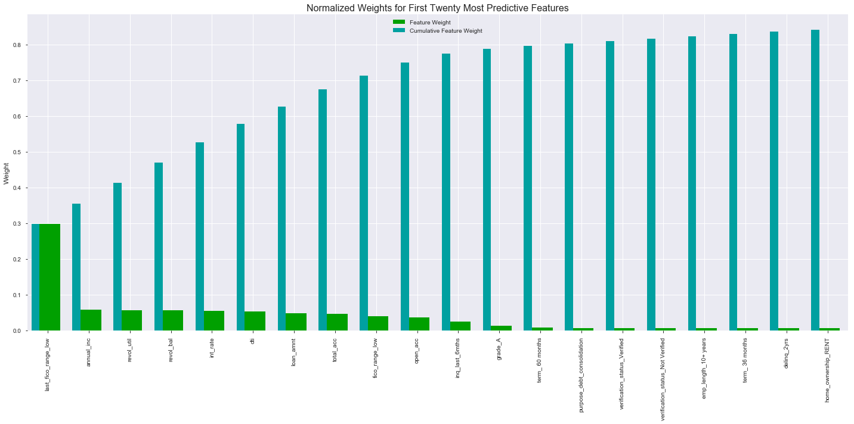 Top 20 important features

|  |  |
| --- | --- |
| **Importances** | **Features** |
| 0.246455 | last\_fico\_range\_low |
| 0.0572329 | annual\_inc |
| 0.0544118 | revol\_util |
| 0.0542158 | dti |
| 0.0523224 | int\_rate |
| 0.0520493 | revol\_bal |
| 0.0496855 | loan\_amnt |
| 0.0466982 | total\_acc |
| 0.042266 | fico\_range\_low |
| 0.0408149 | open\_acc |
| 0.0281177 | inq\_last\_6mths |
| 0.00973854 | term\_ 36 months |
| 0.0094579 | verification\_status\_Not Verified |
| 0.00941782 | purpose\_debt\_consolidation |
| 0.00903726 | delinq\_2yrs |
| 0.00870967 | term\_ 60 months |
| 0.00869922 | home\_ownership\_MORTGAGE |
| 0.00810152 | emp\_length\_10+ years |
| 0.00795508 | verification\_status\_Verified |
| 0.00786212 | home\_ownership\_RENT |

Feature selection of using top 20 features wasn’t prudent in our case, so we will use the tuned best classifier with full dataset instead of top 20 feature

Final Model trained on full data

------

Final Model Train time 1.84824609756 s full data

------

Accuracy on testing data: 0.7936

F-score on testing data: 0.4507

Final Model trained on reduced to 81 features data

------

Final Model Train time 0.940053939819 s full data

------

Accuracy on testing data: 0.7921

F-score on testing data: 0.4472

**Model Ensemble**

We’ll build ensemble models using four different models as base learners:

* LogisticRegression
* GradientBoostingClassifier
* XGBoostClassifier
* RandomForestClassifier

The ensemble models will be built using two different methods:

Blending (average) ensemble model. Fits the base learners to the training data and then, at test time, average the predictions generated by all the base learners. Use VotingClassifier from sklearn that: Fits all the base learners on the training data, at test time, use all base learners to predict test data and then take the average of all predictions.

Stacked ensemble model: Fits the base learners to the training data. Next, use those trained base learners to generate predictions (meta-features) used by the meta-learner (assuming we have only one layer of base learners).

There are few different ways of training stacked ensemble model:

Fitting the base learners to all training data and then generate predictions using the same training data it was used to fit those learners. This method is more prune to overfitting because the meta learner will give more weights to the base learner who memorized the training data better, i.e. meta-learner won’t generate well and would overfit. Split the training data into 2 to 3 different parts that will be used for training, validation, and generate predictions. It’s a suboptimal method because held out sets usually have higher variance and different splits give different results as well as learning algorithms would have fewer data to train. Use k-folds cross validation where we split the data into k-folds. We fit the base learners to the (k -1) folds and use the fitted models to generate predictions of the held-out fold. We repeat the process until we generate the predictions for all the k-folds. When done, refit the base learners to the full training data. This method is more reliable and will give models that memorize the data less weight. Therefore, it generalizes better on future data.

We’ll use logistic regression as the meta-learner for the stacked model. Note that we can use k-folds cross validation to validate and tune the hyperparameters of the meta learner. We will not tune the hyperparameters of any of the base learners or the meta-learner; however, we will use some of the values recommended by the [Data-driven advice for applying machine learning to bioinformatics problems](file:///MS2/learnspace/udacity/mlnd/capstone/Data-driven%20advice%20for%20applying%20machine%20learning%20to%20bioinformatics%20problems) and

<https://www.analyticsvidhya.com/blog/2016/03/complete-guide-parameter-tuning-xgboost-with-codes-python/>.

We will use ROC chart to choose the ensemble model. Observing the below ROC plotted generated from ensemble models fit for test data.

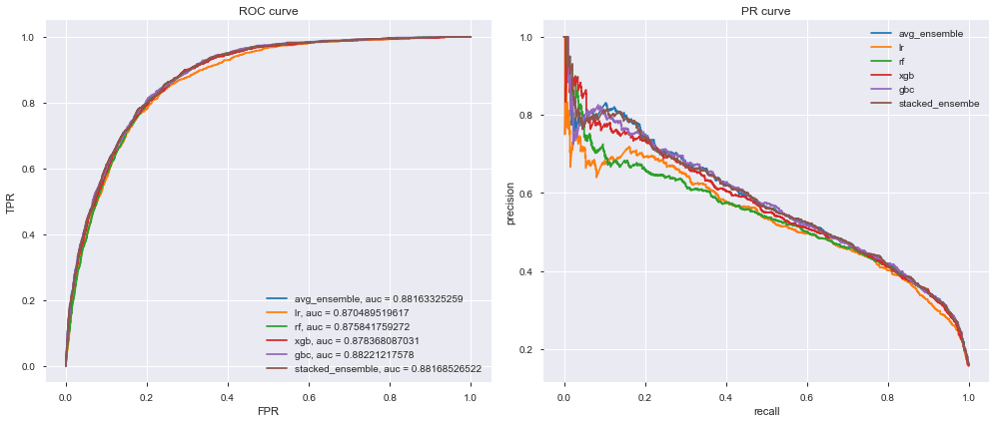We can see from the chart above; stacked ensemble model has improved the performance.

Final model test METRICS

Accuracy on testing data: 0.8723

F-score on testing data: 0.5579

Accuracy: 87.23%

Recall: 39.27%

Precision: 62.35%

F1: 48.19%

[[6916 305]

[ 781 505]]

precision recall f1-score support

0 0.90 0.96 0.93 7221

1 0.62 0.39 0.48 1286

avg / total 0.86 0.87 0.86 8507

Updated performance metrics after ensemble model selection

|  |  |  |  |  |  |  |  |  |
| --- | --- | --- | --- | --- | --- | --- | --- | --- |
|  | **model** | **matthews\_corrcoef** | **roc\_auc\_score** | **precision\_score** | **recall\_score** | **f1\_score** | **accuracy** | **fscore** |
| **1** | Naive Predictor | 0.201287 | 0.696211 | 0.220243 | 0.75972 | 0.341489 | 0.557071 | 0.2567 |
| **2** | XGBClassifier340 | 0.441011 | 0.858439 | 0.367037 | 0.846812 | 0.512109 | 0.756083 | 0.413943 |
| **3** | XGBClassifier3402 | 0.450757 | 0.87416 | 0.370445 | 0.861586 | 0.51812 | 0.757729 | 0.418113 |
| **4** | XGBClassifier34028 | 0.462447 | 0.884929 | 0.379299 | 0.866252 | 0.527587 | 0.765487 | 0.427344 |
| **5** | LogisticRegression340 | 0.376855 | 0.824225 | 0.360721 | 0.699844 | 0.476065 | 0.767133 | 0.399432 |
| **6** | LogisticRegression3402 | 0.420559 | 0.848994 | 0.376618 | 0.769051 | 0.505624 | 0.772658 | 0.419423 |
| **7** | LogisticRegression34028 | 0.459705 | 0.870451 | 0.405491 | 0.792379 | 0.536457 | 0.792994 | 0.449374 |
| **8** | GradientBoostingClassifier340 | 0.418919 | 0.843553 | 0.340653 | 0.868585 | 0.489376 | 0.72599 | 0.387793 |
| **9** | GradientBoostingClassifier3402 | 0.446944 | 0.871031 | 0.370395 | 0.852255 | 0.516372 | 0.758669 | 0.417619 |
| **10** | GradientBoostingClassifier34028 | 0.464679 | 0.884464 | 0.380757 | 0.867807 | 0.529286 | 0.766663 | 0.428901 |
| **11** | **GridSearchTunedLR** | **0.462095** | **0.870490** | **0.406598** | **0.795490** | **0.538138** | **0.793582** | **0.450661** |
| **12** | **Stacked Ensemble Final Model** | **0.427706** | **0.881685** | **0.623457** | **0.392691** | **0.481870** | **0.872340** | **0.557888** |

## IV. Results

### Model Evaluation and Validation

Let’s check best base classifier, tuned base classifier and final stacked model. Compare their results for various different set of inputs, to validate robustness and obtain their outputs. Also plot the ROC curves to perform sensitivity analysis.

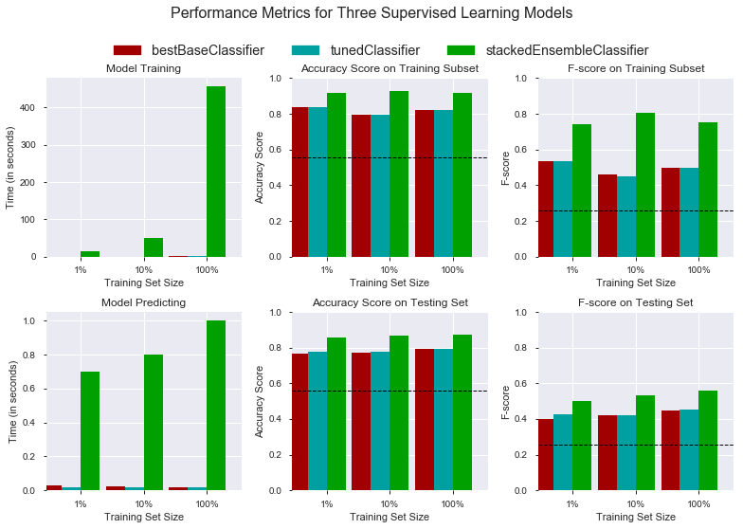

From the above chart we can observe that though stackedEnsembleClassifier is high cost time in training and predict, it is better in terms of variance and better performance metrics of accuracy & F-score. We can also see that model is robust for varied inputs. ROC chart shows the sensitivity analysis for the stackedEnsembleClassifier.

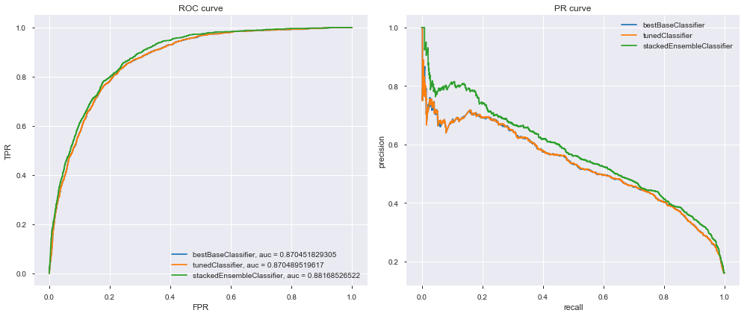Above ROC plot shows the sensitivity analysis and stackedEnsembleClassifier with AUC 0.88168 is better than bestBaseClassifier and tunedClassifier.

### Justification

By looking at the metrics we discussed in Metrics section, for naïve predictor, unoptimized model, optimized model and final model (stackedEnsembelClassifier),

|  |  |  |  |  |
| --- | --- | --- | --- | --- |
| **Metric** | **Benchmark Predictor** | **Unoptimized Model** | **Optimized Model** | **Stacked Ensemble Final Model** |
| Accuracy Score | 0.557071 | 0.793112 | 0.793582 | 0.87234 |
| F-score | 0.2567 | 0.449532 | 0.450661 | 0.55788 |

It is clear that Stacked Ensemble Final Model proves out to be the best model for *InvestorML.* We can also look at the additional metric to validate our results.

|  |  |  |  |  |
| --- | --- | --- | --- | --- |
| **Metric** | **Benchmark Predictor** | **Unoptimized Model** | **Optimized Model** | **Stacked Ensemble Final Model** |
| **matthews\_corrcoef** | 0.201287 | 0.459866 | 0.462095 | 0.427706 |
| **roc\_auc\_score** | 0.696211 | 0.870452 | 0.87049 | 0.881685 |
| **precision\_score** | 0.220243 | 0.405653 | 0.406598 | 0.623457 |
| **recall\_score** | 0.75972 | 0.792379 | 0.79549 | 0.392691 |
| **f1\_score** | 0.341489 | 0.536598 | 0.538138 | 0.48187 |
| **accuracy** | 0.557071 | 0.793112 | 0.793582 | 0.87234 |
| **fscore** | 0.2567 | 0.449532 | 0.450661 | 0.557888 |

* In terms of accuracy, F-score Stacked Ensemble Final Model is much better.
* The Stacked Ensemble Final Model has larger accuracy and F-score compared to Benchmark Naive Predictor, unoptimized model, optimized model.

We will use Stacked Ensemble Final Model to predict whether a loan by individual will be charged off.

We will save the model using a joblib so that we can use this saved model, infer a new loan will be paid or not based on application data and use Investor ML in real time. Final model, we fit using all data available.

Test saved model, final model results on par with our best model, performance metric is increased due to increase in data as we used all the data available.

Accuracy on testing data: 0.8969

F-score on testing data: 0.6729

For any new loan application data of a new loan, features should be transformed to transformed final scaled 15 numerical features and transformed once hot encoded categorical features.

Using these new features as input to the saved model loaded, we can predict prob “Risk Rate%” for each loan.

“Risk Rate %” is the additional statistic available for investor to choose a particular loan for investment.

## V. Conclusion

### Free-Form Visualization

Partial dependence plots to see what the most important features and their relationships with are whether the borrower will most likely pay the loan in full before mature data. we will plot only the top 8 features to make it easier to read. Note that the partial plots are based on Gradient Boosting model.

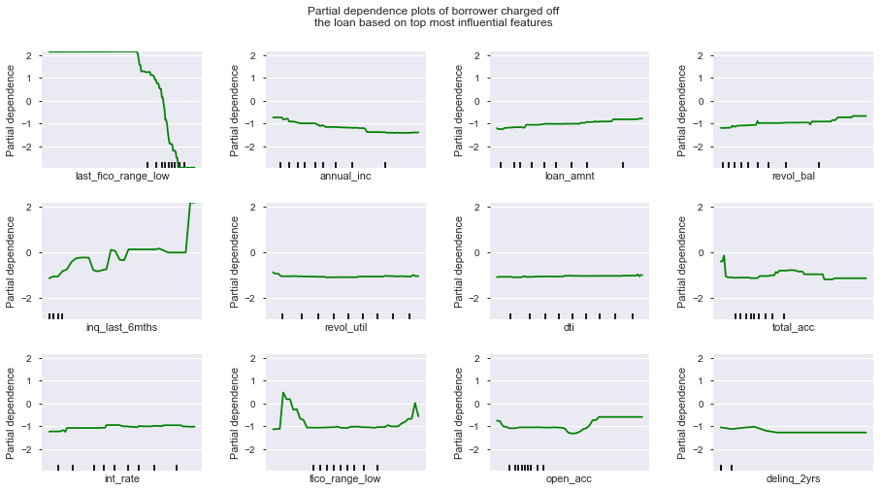As expected borrowers with lower annual income and less FICO scores are higly likely to get charged off; however, borrowers with lower interest rates (riskier) and higher revol\_bal are more likely to pay the loan fully.

### Reflection

Most classification problems in the real world are imbalanced. Also, almost always data sets have missing values. In this project, we covered strategies to deal with both missing values and imbalanced data sets. We also explored different ways of building ensembles which can give better performance. Below are some interesting learnings.

* There is no definitive guide of which algorithms to use given any situation. What may work on some data sets may not necessarily work on others. Therefore, always evaluate methods using cross validation to get a reliable estimate.
* Sometimes we may be willing to give up some improvement to the model if that would increase the complexity much more than the percentage change in the improvement to the evaluation metrics.
* EasyEnsemble usually performs better than any other resampling methods.
* Missing values sometimes add more information to the model than we might expect.
* Though important features have higher predictive power if runtime and performance is not much impacted we can use all features to get the best predictions from the model
* Using voting classifier or stacked ensemble might increase the complexity of the model, provided we are getting better predictions, it’s better to use these advanced techniques to choose the best model.
* Note that loan application data of a new loan should be transformed to transformed final scaled 15 numerical features and transformed once hot encoded categorical features. Using these new features as input to the final stacked ensemble model, we can predict prob “Risk Rate%” for each loan.
* “Risk Rate %” is the additional statistic available for investor to choose a particular loan for investment.

### Improvement

Following are some of the additional improvements that can be done,

* In some classification problems, False Negatives are a lot more expensive than False Positives. Therefore, we can reduce cut-off points to reduce the False Negatives.
* When building ensemble models, try to use good models that are as different as possible to reduce correlation between the base learners. We could’ve enhanced our stacked ensemble model by adding Dense Neural Network and some other kind of base learners as well as adding more layers to the stacked model.
* Add binary features for each feature that has missing values to check if each example is missing or not.
* Use more data to train model, this will generalize by regularizing the model by learning about more input training data.
* Use deep learning rnn (LSTM) networks to evaluate if it provides better performance than the chosen model.
* Tune additional hyper parameters to see if the results are improved.
* Use hardware accelerator like GPU to improve the model training and inferring to reduce the run time of model.

## VI. References

1. <http://economics.ucr.edu/job_candidates/Bagherpour-Paper.pdf>
2. <https://www.lendingclub.com/info/download-data.action>
3. <https://www.lendingclub.com>
4. <http://scikit-learn.org/stable/index.html>
5. <https://github.com/pandas-profiling/pandas-profiling>
6. <http://xgboost.readthedocs.io/en/latest/python/python_api.html#module-xgboost.sklearn>
7. <https://www.analyticsvidhya.com/blog/2016/02/complete-guide-parameter-tuning-gradient-boosting-gbm-python/>
8. <https://www.analyticsvidhya.com/blog/2016/03/complete-guide-parameter-tuning-xgboost-with-codes-python/>