Introduction:-
The vital signs of people is crucial in today's medicine. It’s imperative that today to make a portable and low cost Electronic Health Monitoring Kit to deploy in rural areas and health camps in order to measure vital signs in longer period for proper analysis of the patient and to take actions accordingly.

Description:-
Controller board (Arduino based Dev Board) collects the data from all the Sensors (EGC, Heart Beat, Temperature) and sends the data to the WiFi module (NodeMCU) through SPI communication channel. This data is sent to the Cloud (Raspberry Pi 3) in JSON format through WiFi communication. The received data is imported for Data Analysis. Once the Data Analysis is done the results are displayed on a web portal hosted on the Cloud. It can be accessed in any browser platform by connecting to the Cloud. The entire process can be viewed on an OLED screen.

Hardware:-
- Controller Board ( Arduino Based Dev. Board)
- WiFi Module (NodeMCU)
- Cloud (Raspberry Pi 3 Model B+)
- Display Module (OLED)
- Sensors
Software:-
- Arduino Dev. Environment
- Python Dev. Environment (Python 3)
- GNU Linux (Raspbian)
- Data Analytics (Pandas)
- Web Frame Work (Bottle)

Block Diagram:-
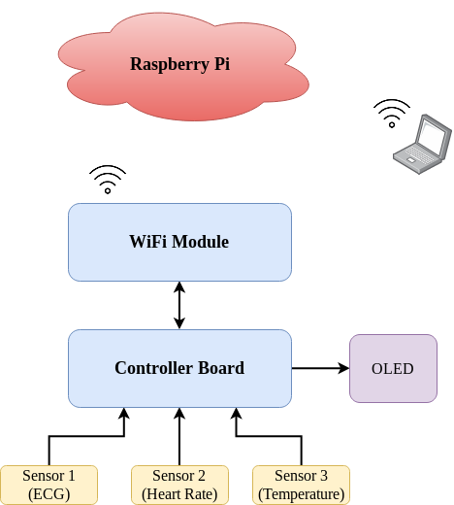

Conclusion:-
With this project we can build a Portable and Low Cost Health Monitoring Kit to deploy in Health Camps and Rural areas.

Name of the Guide: - By:-
Mr. S. Karunakar Reddy 15AG1A0425 (SRI HARSHA .M.V.S)
15AG1A04B8 (RAVI TEJA .T)
15AG1A04C0 (DEEPTHI .T)

