RESEARCHGRAPH AI: A SEMANTIC ACADEMIC RESEARCH INTELLIGENCE PLATFORM USING LARGE LANGUAGE MODELS AND KNOWLEDGE GRAPHS
A dissertation submitted to the Jawaharlal Nehru Technological University, Hyderabad in partial fulfillment of the requirement for the award of degree of

BACHELOR OF TECHNOLOGY IN
COMPUTER SCIENCE AND ENGINEERING

Submitted by

B. Sriharsha (23B81A0551)

B. Pranay Kumar (23B81A0538)
B. Rajyavardhan (23B81A0541)

Under the Guidance of
Ms S Satya Sudha
Assistant Professor



Department of Computer Science and Engineering

CVR COLLEGE OF ENGINEERING
(An UGC Autonomous Institution, Affiliated to JNTUH, Accredited by NBA, and NAAC)
Vastunagar, Mangalpalli (V), Ibrahimpatnam (M), Ranga Reddy (Dist.) - 501510, Telangana State

2026-2027


CVR COLLEGE OF ENGINEERING
(An UGC Autonomous Institution, Affiliated to JNTUH, Accredited by NBA, and NAAC)
Vastunagar, Mangalpalli (V), Ibrahimpatnam (M), Ranga Reddy (Dist.) - 501510, Telangana State.

DEPARTMENT OF COMPUTER SCIENCE AND ENGINEERING

CERTIFICATE

This is to certify that the Project Work Stage-I entitled "ResearchGraph AI: A Semantic Academic Research Intelligence Platform Using Large Language Models and Knowledge Graphs" is submitted by B. Sriharsha (23B81A0551), B. Pranay Kumar (23B81A0538),
B. Rajyavardhan (23B81A0541) in partial fulfillment of the requirements for the award of the degree of Bachelor of Technology in Computer Science and Engineering for the academic year 2026–2027.

Project Supervisor Professor in-charge project
Ms S Satya Sudha
Assistant Proffessor

Professor and Head, CSE (Dr. A. Vani Vathsala)
DECLARATION

We, hereby declare that this Project Work Stage-I report titled "ResearchGraph AI: A Semantic Academic Research Intelligence Platform Using Large Language Models and Knowledge Graphs" submitted to the Department of Computer Science and Engineering, CVR College of Engineering, is a record of original work done by me under the guidance of Ms S Satya Sudha . The information and data given in the report is authentic to the best of my knowledge. This project report has not been submitted to any other university or institution for the award of any degree or diploma, nor has it been published previously.

B.Sriharsha(23B81A0551)
B. Pranay Kumar (23B81A0538)
B. Rajyavardhan (23B81A0541)

Date:
Place:
TABLE OF CONTENTS

Chapter | Contents | Page No.
 | List of Tables | 5
 | List of Figures | 5
 | Abbreviations and Symbols | 6
1 | INTRODUCTION
 | 1.1 Introduction | 7
 | 1.2 Motivation | 8
 | 1.3 Problem Statement | 8
 | 1.4 Project Objectives | 9
 | 1.5 Scope of the Project | 9
 | 1.6 Project Report Organization | 10
2 | LITERATURE REVIEW
 | 2.1 Existing Work | 11
 | 2.2 Comparative Study of Existing Systems | 12
 | 2.3 Limitations of Existing Systems | 13
3 | REQUIREMENT ANALYSIS | 16
 | 3.1 Functional Requirements | 16
 | 3.2 Non-Functional Requirements | 18
 | 3.3 Hardware Requirements | 19
 | 3.4 Software Requirements | 19
 | 3.5 User Requirements | 20
4 | SYSTEM DESIGN
 | 4.1 Introduction and Proposed System Architecture | 21
 | 4.2 Workflow of the Proposed System | 22
 | 4.3 Proposed Algorithms / GraphRAG Pipeline | 23
 | 4.4 Use Case Diagram | 24
 | 4.5 Activity Diagram | 24
 | 4.6 Sequence Diagram | 25
 | 4.7 Class Diagram | 25
 | 4.8 Advantages of the Proposed System | 28
 | 4.9 Datasets and Technology stack
 | REFERENCES | 29

LIST OF TABLES
Table No. | Table Title | Page No.
Table 2.3 | Literature Review | 11
Table 2.4 | Comparison Limitations and ResearchGraph | 12
Table 3.3 | Hardware Requirements | 16
Table 3.4 | Software Requirements | 16
Table 4.9.1 | Datasets | 26
Table 4.9.2 | Technology Stack | 27
LIST OF FIGURES
Figure No. | Figure Title | Page No.
Figure 4.1 | Overall System Architecture | 19
Figure 4.2 | GraphRAG Workflow | 21
Figure 4.5 | Semantic Retrieval Workflow | 23
Figure 4.6 | Use Case Diagram | 24
Figure 4.7 | Activity Diagram | 24
Figure 4.8 | Sequence Diagram | 25
Figure 4.9 | Class Diagram | 25
ABBREVIATIONS
Abbreviation | Meaning
AI | Artificial Intelligence
LLM | Large Language Model
NLP | Natural Language Processing
RAG | Retrieval-Augmented Generation
GraphRAG | Graph-based Retrieval-Augmented Generation
KG | Knowledge Graph
API | Application Programming Interface
UI | User Interface
DB | Database
DFD | Data Flow Diagram
UML | Unified Modeling Language
SQL | Structured Query Language
JSON | JavaScript Object Notation
SYMBOLS
Symbol | Meaning
→ | Relationship between entities
∈ | Belongs to
∀ | For all
∑ | Summation
% | Percentage

INTRODUCTION

1.1 Introduction
The rapid growth of digital technology has significantly increased the volume of scientific research publications across various disciplines. Every year, millions of research papers are published in journals, conferences, and online repositories. Although this growth contributes to scientific advancement, it also makes it increasingly difficult for researchers and students to locate relevant papers, compare research methodologies, and identify emerging research trends. The traditional process of manually searching, reading, and analyzing numerous research papers is time-consuming and often results in incomplete literature reviews.
Academic search platforms such as Google Scholar, IEEE Xplore, SpringerLink, ACM Digital Library, and Semantic Scholar provide access to a vast collection of research publications. However, these platforms primarily rely on keyword-based search and citation indexing, presenting research papers as individual documents without explicitly showing the relationships among authors, research methods, datasets, algorithms, and application domains. As a result, researchers must manually analyze multiple papers to understand how different research works are interconnected.
Recent developments in Artificial Intelligence, particularly Large Language Models (LLMs), semantic search, and Knowledge Graphs, have introduced new possibilities for improving academic research. Large Language Models enable natural language interaction with research content, while semantic search retrieves documents based on contextual meaning rather than exact keyword matching. Knowledge Graphs organize research information into interconnected entities, allowing users to explore relationships among papers, authors, datasets, and methodologies.
ResearchGraph AI is proposed as a semantic academic research intelligence platform that combines Large Language Models, Knowledge Graphs, vector databases, and Retrieval-Augmented Generation (GraphRAG) to improve the research process. The platform automatically collects research papers from scholarly repositories, extracts meaningful information, generates semantic embeddings for efficient retrieval, and constructs a Knowledge Graph representing relationships among research entities. When users submit natural language queries, the system retrieves relevant information from both the vector database and the Knowledge Graph before generating citation-supported responses using a Large Language Model.
The proposed system aims to simplify literature review, improve research paper discovery, support comparative analysis, identify research gaps, and provide researchers with an intelligent environment for academic knowledge exploration.

1.2 Motivation
The motivation for developing ResearchGraph AI arises from the increasing challenges faced by researchers in managing the growing volume of scientific publications. Every day, new research papers introduce innovative methods, datasets, and algorithms, making it difficult for researchers to stay updated with the latest developments. Conducting a comprehensive literature review often requires reading dozens of research papers, comparing methodologies, analyzing experimental results, and identifying research gaps. This process is both time-consuming and labor-intensive.
Although existing academic search engines provide efficient access to research papers, they are primarily designed for document retrieval rather than knowledge discovery. They do not effectively represent the relationships among research entities or provide intelligent explanations about how different research works are connected.
The emergence of Large Language Models, semantic vector search, and Knowledge Graphs offers an opportunity to transform the traditional research process. By integrating these technologies into a unified platform, researchers can interact with academic literature using natural language, obtain citation-supported answers, visualize relationships among research concepts, and quickly understand the current state of research within a specific domain.
The motivation behind this project is to develop an intelligent research assistant that reduces manual effort, improves research efficiency, and supports researchers in making informed decisions throughout the literature review process.

1.3 Problem Statement
The exponential growth of academic publications has made literature review increasingly difficult for students, researchers, and academicians. Existing academic search platforms primarily rely on keyword-based retrieval and citation analysis, requiring users to manually examine multiple research papers to identify relevant information. This approach consumes significant time and often leads to incomplete understanding of research topics.
Furthermore, traditional Retrieval-Augmented Generation (RAG) systems mainly depend on semantic similarity and do not explicitly utilize structured relationships among research entities such as authors, datasets, algorithms, methodologies, and research domains. Consequently, generated responses may lack contextual reasoning and fail to explain the connections among related research works.
Therefore, there is a need for an intelligent academic research platform capable of combining semantic retrieval, Knowledge Graph reasoning, and Large Language Models to provide accurate, context-aware, citation-supported, and explainable research assistance.

1.4 Project Objectives
The primary objective of ResearchGraph AI is to develop an intelligent academic research platform that simplifies literature exploration using Artificial Intelligence, Knowledge Graphs, and semantic retrieval techniques.
The specific objectives of the proposed system are:
- To collect research papers from scholarly repositories such as OpenAlex and arXiv.
- To preprocess research papers and generate semantic embeddings for efficient retrieval.
- To construct a Knowledge Graph representing relationships among papers, authors, datasets, algorithms, and research domains.
- To integrate semantic retrieval with graph-based reasoning using the GraphRAG framework.
- To enable researchers to search research papers using natural language queries.
- To generate citation-supported responses using Large Language Models.
- To automate literature review generation.
- To compare multiple research papers based on methodologies, datasets, and evaluation metrics.
- To identify potential research gaps and emerging research trends.
- To visualize relationships among research entities through an interactive Knowledge Graph.
1.5 Scope of the Project
The scope of ResearchGraph AI is focused on improving academic research by integrating semantic search, Knowledge Graphs, vector databases, and Large Language Models into a single intelligent platform. The proposed system collects research papers from publicly available scholarly repositories, processes the textual content, generates semantic embeddings, extracts research entities, and constructs a Knowledge Graph representing the relationships among different research concepts.
The platform enables users to perform semantic searches, compare research papers, generate literature reviews, visualize research relationships, and obtain citation-supported answers through natural language interaction. Although the initial implementation primarily focuses on Computer Science research papers, the system architecture is designed to support multiple research domains with minimal modifications.
The proposed platform is intended for students, researchers, faculty members, and academic institutions seeking an efficient solution for literature exploration and research knowledge discovery.

1.6 Project Report Organization
This report is organized into four chapters to provide a structured description of the proposed system.
Chapter 1 – Introduction presents the background, motivation, problem statement, objectives, scope, and organization of the project.
Chapter 2 – Literature Review discusses the existing research related to semantic search, Knowledge Graphs, Retrieval-Augmented Generation, GraphRAG, and intelligent academic research systems. It also identifies the limitations of existing approaches and the research gaps addressed by the proposed system.
Chapter 3 – Requirement Analysis describes the functional requirements, non-functional requirements, hardware requirements, software requirements, and user requirements necessary for implementing the proposed platform.
Chapter 4 – System Design explains the overall architecture, workflow, GraphRAG pipeline, system modules, technology stack, datasets, algorithms, UML diagrams, and Data Flow Diagrams used in the development of ResearchGraph AI.

2. LITERATURE SURVEY
2.1 Existing Work:
For ResearchGraph AI, the literature survey mainly focuses on RAG, GraphRAG, Large Language Models, and Knowledge Graphs.
Existing studies show that RAG can retrieve relevant information and provide it to an LLM for generating better answers. GraphRAG improves this approach by using Knowledge Graphs to understand relationships between different pieces of information.
Other studies have explored combining LLMs and Knowledge Graphs for better reasoning. Knowledge Graph Embeddings are also used to represent relationships between entities such as papers, authors, and datasets.
However, most existing systems focus on individual technologies or general-purpose applications. They do not provide a complete platform specifically designed for academic research, including paper search, paper comparison, literature review generation, relationship visualization, and research-gap identification.
2.2 Comparative Study of Existing Systems
Author(s) / Year | Title / Focus of Study | Methodology | Key Findings | Research Gap / Limitation
XGraphRAG Authors (2025) | XGraphRAG: Interactive Visual Analysis for Graph-based Retrieval-Augmented Generation | The framework provides interactive visual analysis of GraphRAG pipelines, allowing retrieval results to be traced through graph construction and query processing. | The study demonstrates that visual analysis can help users understand GraphRAG retrieval behavior, identify critical retrieval cases, and analyze opportunities for improvement. | The work focuses on GraphRAG analysis and visualization rather than an end-to-end academic research intelligence platform for paper discovery, comparison, and research-gap identification.
IEEE ICTBAI Authors (2025) | A Survey of Retrieval-Augmented Generation (RAG) for Large Language Models | The study reviews RAG architectures and discusses retrieval, augmentation, and generation mechanisms used to provide external knowledge to Large Language Models. | The survey highlights the importance of retrieval quality and external knowledge in improving grounded LLM responses and reducing hallucination-related problems. | The study is a general RAG survey and does not specifically address Knowledge Graph integration for academic research exploration.
S. Pan et al. (2024) | Unifying Large Language Models and Knowledge Graphs: A Roadmap | The authors review approaches for integrating LLMs and Knowledge Graphs and categorize them according to how LLMs and KGs support and enhance each other. | The study shows that combining LLMs with Knowledge Graphs can support factual grounding, reasoning, knowledge construction, and question answering. | It provides a broad roadmap and conceptual framework rather than a complete academic research platform evaluated on scholarly datasets.
T. T. Procko and O. Ochoa (2024) | Graph Retrieval-Augmented Generation for Large Language Models: A Survey | The authors analyze GraphRAG approaches that combine graph structures with Retrieval-Augmented Generation to improve retrieval and reasoning. Different graph retrieval and reasoning strategies are discussed. | The survey indicates that graph-based retrieval can provide structured context and support complex or multi-hop reasoning beyond conventional vector retrieval. | The reviewed approaches are general-purpose and do not specifically provide a complete platform for academic paper relationships, literature review, and research-gap analysis.
Table 2.1. Comparative Literature Survey
2.3 Limitations of Existing Systems
Existing Research | ResearchGraph AI Contribution
RAG mainly retrieves semantically similar textual chunks. | Combines semantic vector retrieval with relationship-aware graph retrieval.
Knowledge Graph approaches organize entities and relationships but may lack detailed document context. | Uses Neo4j for graph relationships and ChromaDB for detailed research-paper text.
GraphRAG research is mostly general-purpose. | Targets academic entities such as papers, authors, datasets, algorithms, models, domains, and metrics.
Existing systems do not combine all academic research workflows in one platform. | Supports paper search, question answering, literature review, comparison, graph exploration, and research-gap analysis.
Table 2.3 Limitations of Existing Systems

REQUIREMENT ANALYSIS

3.1 Introduction
Requirement Analysis is one of the most important phases in software development, as it identifies and documents the requirements necessary for designing and implementing the proposed system. It helps developers understand user expectations, system functionalities, performance requirements, and operational constraints before implementation begins.
For ResearchGraph AI, the requirement analysis focuses on understanding the needs of researchers, students, and academicians who require an intelligent platform for exploring academic literature. The proposed system combines semantic search, Knowledge Graphs, vector databases, and Large Language Models to provide efficient research paper retrieval, relationship analysis, literature review generation, and research gap identification. The requirements identified in this chapter serve as the foundation for designing and developing the proposed system.

3.2 Functional Requirements
Functional requirements describe the services and operations that the proposed system must perform to satisfy user needs.

FR1: User Authentication
- The system shall allow users to create an account and log in securely.
- The system shall maintain user profiles and personalized research history.

FR2: Research Paper Collection
- The system shall retrieve research papers from academic repositories such as OpenAlex and arXiv.
- The system shall collect metadata including title, authors, publication year, abstract, DOI, and publication source.

FR3: Document Processing
- The system shall extract text from PDF research papers.
- The system shall preprocess and divide documents into smaller text chunks.

FR4: Semantic Embedding Generation
- The system shall convert text chunks into vector embeddings.
- The generated embeddings shall be stored in the vector database.

FR5: Knowledge Graph Construction
- The system shall identify entities such as authors, papers, datasets, algorithms, models, research domains, and evaluation metrics.
- The system shall automatically create relationships among these entities.
- The Knowledge Graph shall be stored in Neo4j.

FR6: Semantic Search
- The system shall accept natural language queries.
- The system shall retrieve semantically similar document chunks using vector search.

FR7: AI Question Answering
- The system shall generate citation-supported responses using a Large Language Model.
- The responses shall be generated using both semantic retrieval and graph relationships.

FR8: Literature Review Generation
- The system shall automatically generate literature reviews from retrieved research papers.
- The generated review shall summarize methodologies, datasets, advantages, limitations, and future work.

FR9: Research Paper Comparison
- The system shall compare multiple research papers based on datasets, algorithms, methodologies, performance metrics, and research contributions.

FR10: Knowledge Graph Visualization
- The system shall display an interactive graph showing relationships among research entities.

FR11: Research Gap Identification
- The system shall identify potential research gaps by analyzing relationships among papers and detecting unexplored combinations of research concepts.

3.3 Non-Functional Requirements
Non-functional requirements define the quality attributes and performance expectations of the proposed system.

Performance
- The system should retrieve relevant research papers within a few seconds.
- Graph queries should execute efficiently for large datasets.
- AI responses should be generated with minimal latency.

Scalability
- The system should support indexing thousands of research papers.
- The Knowledge Graph should expand dynamically as new papers are added.

Reliability
- Retrieved research information should remain accurate and consistent.
- The platform should provide reliable citation-supported responses.

Availability
- The application should be accessible through modern web browsers.
- The backend services should remain available throughout normal operation.

Security
- User authentication should protect user accounts.
- Communication between frontend and backend should use secure HTTPS connections.
- User data should remain confidential.

Maintainability
- The software should follow a modular architecture.
- New academic repositories and AI models should be integrated without significant modifications.

Portability
- The application should support Windows, Linux, and macOS.
- Cloud deployment should be supported
3.4 Hardware Requirements
Component | Specification
Processor | Intel Core i5 (8th Generation or above)
RAM | Minimum 8 GB (16 GB Recommended)
Storage | 20 GB Free SSD Space
Internet | Broadband Internet Connection
Graphics | Integrated Graphics or Better
Table 3.3 Hardware Requirements
3.5 Software Requirements
Software | Purpose
Operating System | Windows 10/11 or Linux
Programming Language | Python, TypeScript
Frontend | React + Tailwind CSS
Backend | FastAPI
Graph Database | Neo4j
Vector Database | ChromaDB
Database | PostgreSQL
AI Framework | LangChain
PDF Processing | PyMuPDF
Embedding Model | BAAI/BGE-large-en-v1.5
Large Language Model | Gemini / Llama 3
Version Control | Git & GitHub
Table 3.4 Software Requirements

3.6 User Requirements
The proposed system is intended to satisfy the requirements of different categories of users.

Research Students
- Search research papers using natural language.
- Generate literature reviews.
- Compare multiple research papers.
- Save research papers for future reference.

Faculty Members
- Analyze research trends.
- Monitor recent publications.
- Guide students during literature review.

Researchers
- Explore semantic relationships among research papers.
- Identify research gaps.
- Generate citation-supported answers.
- Compare research methodologies.

Administrator
- Manage research paper repositories.
- Update indexed papers.
- Monitor system performance.
- Maintain databases.

3.7 System Constraints
The proposed system is subject to the following constraints.
- Availability of open-access research papers.
- API rate limits imposed by academic repositories.
- Processing time required for embedding generation.
- Computational resources required for Large Language Models.
- Internet connectivity for accessing external APIs.

3.8 Assumptions
The development of the proposed system is based on the following assumptions.
- Research papers are available through public academic repositories.
- PDF documents are readable and properly formatted.
- Academic metadata obtained from APIs is accurate.
- The embedding model effectively captures semantic meaning.
- The Large Language Model generates responses based only on retrieved contextual information.

SYSTEM DESIGN

4.1 Introduction and Proposed System Architecture:
System design defines the architecture, components, workflows, and interactions required for developing the proposed system. It acts as a blueprint that describes how different modules communicate to achieve the desired functionality. A well-designed architecture improves scalability, maintainability, reliability, and future enhancements.ResearchGraph AI follows a modular architecture in which every component performs a specific task. The system begins by collecting research papers from academic repositories. These papers are processed to generate semantic embeddings and structured knowledge graphs. During query processing, semantic retrieval and graph traversal work together to provide context-aware information to a Large Language Model, which finally generates citation-supported responses for the user. The proposed architecture separates data collection, document processing, embedding generation, graph construction, semantic retrieval, and response generation into independent modules. This modular design allows individual components to be upgraded or replaced without affecting the entire system
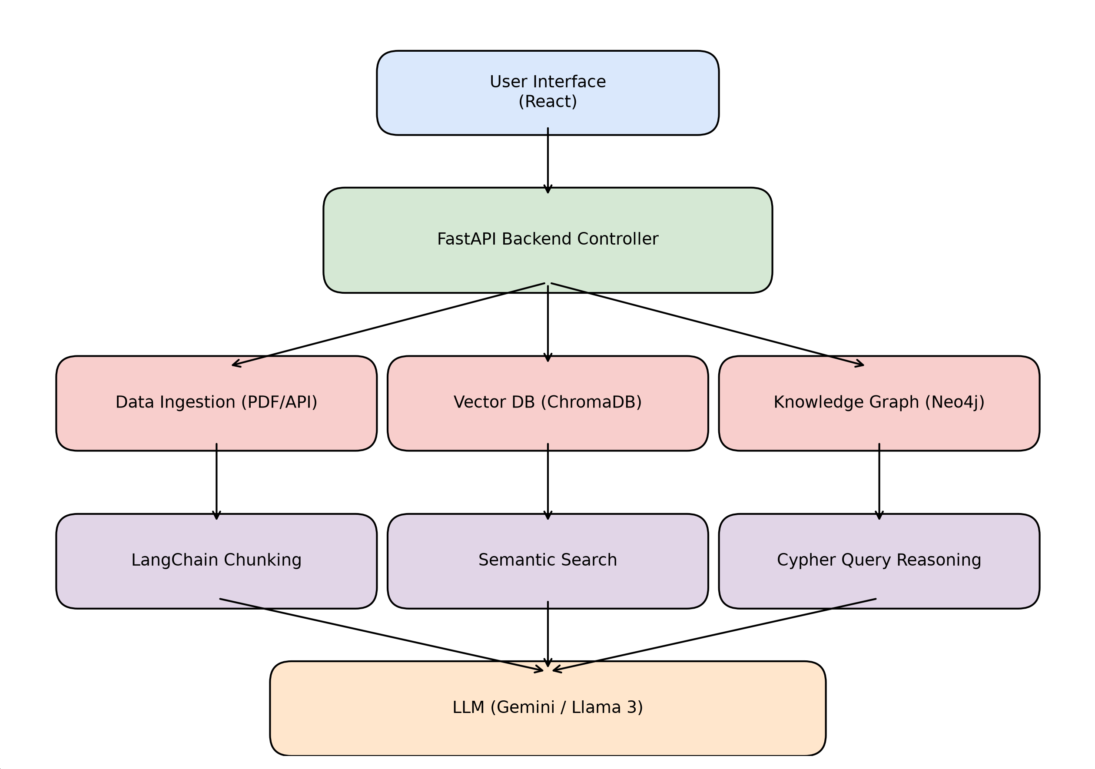
Figure 4.1 Overall System Architecture
The proposed architecture of ResearchGraph AI follows a layered approach to efficiently process research papers and generate intelligent responses. It consists of six major layers that work together to provide semantic search, knowledge graph reasoning, and AI-assisted research support.

Presentation Layer:
This layer provides the user interface through which users can search research papers, interact with the AI assistant, generate literature reviews, compare research papers, and visualize knowledge graphs.

Application Layer:
The application layer acts as the central controller of the system. It processes user requests, communicates with external APIs, manages interactions with the vector database and knowledge graph, and coordinates response generation using the Large Language Model.

Data Collection Layer:
This layer collects research papers and their metadata from scholarly repositories such as OpenAlex and arXiv. The collected information includes the paper title, authors, abstract, publication year, DOI, journal, and PDF link.

Document Processing Layer:
The retrieved research papers are processed by extracting text from PDF documents, cleaning the content, generating metadata, and dividing the text into smaller chunks for efficient semantic retrieval.

Semantic Retrieval Layer:
The processed text chunks are converted into vector embeddings using an embedding model and stored in ChromaDB. During query processing, the user's question is also converted into an embedding, and the most relevant document chunks are retrieved based on semantic similarity.

Knowledge Graph Layer:
This layer constructs a Knowledge Graph by extracting entities such as research papers, authors, datasets, algorithms, and research domains. These entities are connected through semantic relationships and stored in Neo4j to support graph-based reasoning.

AI Response Generation Layer:
The retrieved document chunks and graph relationships are combined and provided to a Large Language Model. Based on this contextual information, the model generates citation-supported answers, literature reviews, paper summaries, comparative analyses, and research gap suggestions.
4.2 Workflow of the Proposed System
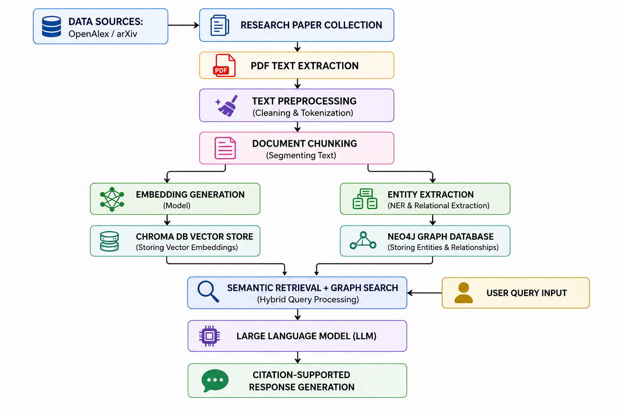

Figure 4.2 GraphRAG Workflow
The workflow of ResearchGraph AI begins with collecting research papers from academic repositories such as OpenAlex and arXiv. The retrieved PDF documents are processed to extract textual content, which is then cleaned and divided into smaller chunks. Each chunk is converted into semantic embeddings and stored in the vector database, while important entities and their relationships are extracted and stored in the Neo4j Knowledge Graph.When a user submits a research query, the system converts the query into an embedding and retrieves the most relevant document chunks from the vector database. Simultaneously, the Knowledge Graph is queried to identify related entities and their relationships. The retrieved contextual information from both sources is combined and passed to the Large Language Model, which generates an accurate, citation-supported response and presents it to the user

4.3 Proposed Algorithm / GraphRAG Pipeline
The proposed system follows a Graph Retrieval-Augmented Generation (GraphRAG) pipeline, which combines semantic vector retrieval with Knowledge Graph reasoning to generate accurate and context-aware responses. Unlike traditional Retrieval-Augmented Generation (RAG), which retrieves information only based on semantic similarity, GraphRAG enhances retrieval by utilizing relationships among research entities stored in a Knowledge Graph.
The GraphRAG pipeline consists of the following stages:

Step 1: Research Paper Collection
Research papers are collected from scholarly repositories such as OpenAlex and arXiv. The system retrieves paper metadata including title, authors, abstract, publication year, DOI, and PDF links.

Step 2: Document Processing
The downloaded PDF documents are processed using a PDF parser to extract textual content. The extracted text is cleaned and divided into smaller chunks to improve semantic retrieval.

Step 3: Embedding Generation
Each document chunk is converted into a high-dimensional vector representation using a pre-trained embedding model. The generated embeddings capture the semantic meaning of the text and are stored in ChromaDB for efficient similarity search.

Step 4: Knowledge Graph Construction
The system extracts important entities such as research papers, authors, datasets, algorithms, methods, and research domains. These entities are connected using semantic relationships and stored as nodes and edges in the Neo4j Knowledge
Graph.
Step 5: User Query Processing
When a user submits a research query, the query is converted into an embedding using the same embedding model. The vector database retrieves the most semantically relevant document chunks, while the Knowledge Graph retrieves related entities and their relationships.

Step 6: Context Aggregation
The retrieved document chunks and graph relationships are combined to create a comprehensive context. This enriched context provides both textual information and structural knowledge required for accurate reasoning.

Step 7: Response Generation
The aggregated context is supplied to the Large Language Model, which generates a citation-supported response. The response may include literature reviews, papersummaries, comparative analysis, research gap identification, or answers to user queries.
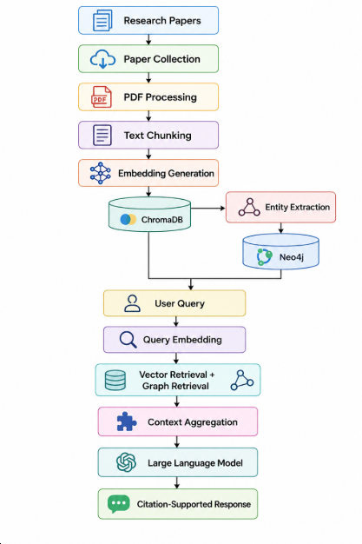

Figure 4.2 GraphRAG Workflow
4.4 Use Case Diagram:
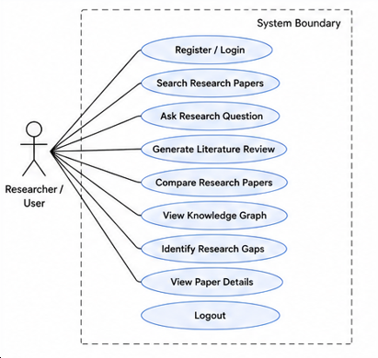

Figure 4.4 Use Case Diagram
4.5 Activity Diagram:
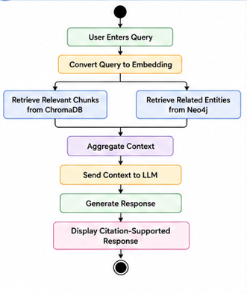

Figure 4.5 Activity Diagram
4.6 Sequence Diagram:
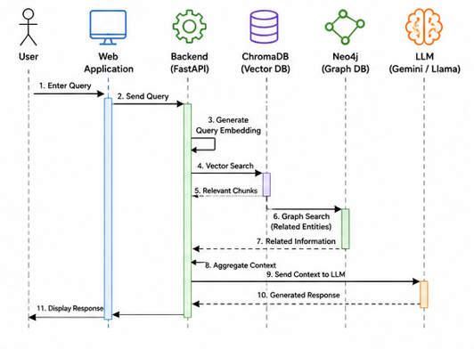
Figure 4.6 Sequence Diagram
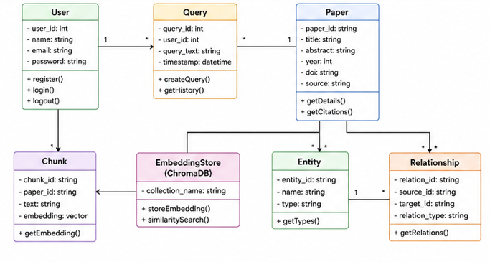
4.7 Class Diagram:
Figure 4.7 Class Diagram
4.9 Datasets and Technology Stack

4.9.1 Datasets:
The performance of the proposed system depends on the quality and the relevance of the academic research papers collected from trusted scholarly and repositories. Instead of relying on a static dataset, the proposed system dynamically retrieves recently published research papers through academic APIs. This enables the platform to maintain an up-to-date knowledge base for semantic retrieval and question answering.
The collected research papers undergo preprocessing, text extraction, chunking, embedding generation, and knowledge graph construction before becoming available for user queries.
The primary data sources used in the proposed system are listed below.
Source | Description | Purpose
OpenAlex API | Provides metadata of scholarly publications, including title, abstract, authors, institutions, DOI, publication year, and citation information. | Research paper collection
arXiv API | Provides open-access preprints in domains such as Computer Science, Artificial Intelligence, Mathematics, and Physics. | Full-text research papers
Research Paper PDFs | PDF versions of research papers obtained through OpenAlex or arXiv. | Text extraction and embedding generation
Figure 4.9.1 Dataset
After collecting the research papers, the textual content is extracted and divided into smaller chunks. Each chunk is converted into semantic embeddings and stored in the vector database, while important entities and their relationships are represented in the Neo4j Knowledge Graph.

4.9.2 Technology Stack
The proposed system combines modern web technologies, Artificial Intelligence frameworks, vector databases, and graph databases to build an intelligent academic research platform.

Layer | Technology Used | Purpose
Frontend | React.js | User Interface
Styling | Tailwind CSS | Responsive UI Design
Backend | FastAPI | REST API and Business Logic
Programming Language | Python | Backend Development
PDF Processing | PyMuPDF | Extract Text from Research Papers
Text Processing | LangChain | Document Chunking and Retrieval Pipeline
Embedding Model | BAAI/bge-large-en-v1.5 | Semantic Embedding Generation
Vector Database | ChromaDB | Store and Retrieve Embeddings
Knowledge Graph | Neo4j | Store Research Entities and Relationships
Graph Query Language | Cypher | Graph Traversal and Query Processing
Large Language Model | Gemini / Llama 3 | Natural Language Response Generation
Database | PostgreSQL | User and Application Data
APIs | OpenAlex API, arXiv API | Research Paper Collection
Version Control | Git & GitHub | Source Code Management
Deployment | Vercel, Render | Frontend and Backend Deployment
Figure 4.9.1 Technology Stack

Justification for Technology Selection
- React.js provides a responsive and interactive user interface for searching papers and visualizing knowledge graphs.
- FastAPI efficiently manages API requests and integrates AI services with low latency.
- OpenAlex and arXiv supply continuously updated academic research papers.
- PyMuPDF extracts textual content from PDF documents with high accuracy.
- LangChain simplifies document chunking, retrieval, and integration with LLMs.
- ChromaDB enables fast semantic search by storing vector embeddings.
- Neo4j represents relationships among papers, authors, methods, datasets, and research domains through a Knowledge Graph.
- Gemini/Llama 3 generates context-aware, citation-supported responses by combining vector retrieval and graph reasoning.
- PostgreSQL manages user information and application-related data efficiently
REFERENCES
- [1]. S. Pan, L. Luo, Y. Wang, C. Chen, J. Wang and X. Wu, "Unifying Large Language Models and Knowledge Graphs: A Roadmap," in IEEE Transactions on Knowledge and Data Engineering, vol. 36, no. 7, pp. 3580-3599, July 2024, doi: 10.1109/TKDE.2024.3352100 .
- https://doi.org/10.1109/TKDE.2024.3352100
- [2].T. T. Procko and O. Ochoa, "Graph Retrieval-Augmented Generation for Large Language Models: A Survey," 2024 Conference on AI, Science, Engineering, and Technology (AIxSET), Laguna Hills, CA, USA, 2024, pp. 166-169, doi: 10.1109/AIxSET62544.2024.00030.
- https://ieeexplore.ieee.org/document/10771030
- [3]. Y. Ma et al., "A Survey of Retrieval-Augmented Generation (RAG) for Large Language Models," 2025 International Conference on Trustworthy Big Data and Artificial Intelligence (ICTBAI), Tokyo, Japan, 2025, pp. 7-13, doi: 10.1109/ICTBAI68361.2025.00008.
- https://doi.org/10.1109/ICTBAI68361.2025.00008
- [4].Q. Wang, Z. Mao, B. Wang and L. Guo, "Knowledge Graph Embedding: A Survey of Approaches and Applications," in IEEE Transactions on Knowledge and Data Engineering, vol. 29, no. 12, pp. 2724-2743, 1 Dec. 2017, doi: 10.1109/TKDE.2017.2754499.
- https://ieeexplore.ieee.org/document/8047276
- LangChain Documentation. https://python.langchain.com/
- Neo4j Documentation. https://neo4j.com/docs/
- ChromaDB Documentation. https://docs.trychroma.com/
- OpenAlex API Documentation. https://docs.openalex.org/
- arXiv API Documentation. https://info.arxiv.org/help/api/
- Google Scholar. https://scholar.google.com/
- IEEE Xplore Digital Library. https://ieeexplore.ieee.org/
- Semantic Scholar. https://www.semanticscholar.org/
- FastAPI Documentation. https://fastapi.tiangolo.com/
- React Documentation. https://react.dev/

