ResearchGraph AI

1. Abstract & Project Overview
The rapid growth of academic literature has made it increasingly difficult for students, researchers, and academicians to efficiently analyze large collections of research papers and identify meaningful relationships among research methodologies, models, datasets, tasks, experimental results, and limitations. Traditional academic search systems primarily rely on keyword-based retrieval and provide lists of relevant papers, requiring researchers to manually read, compare, and organize information from multiple sources. This process is time-consuming and makes it difficult to obtain a structured understanding of a research domain. ResearchGraph AI is a semantic academic research intelligence platform designed to transform unstructured academic literature into structured and interconnected research knowledge. The proposed system processes academic research papers and extracts important research entities such as papers, authors, models, datasets, methodologies, research tasks, evaluation metrics, results, and limitations. Relationships among these entities are identified and represented using a Knowledge Graph, enabling the system to capture connections between research concepts across multiple academic papers. The platform integrates semantic retrieval and Large Language Models to allow users to explore academic literature through natural language queries. Unlike traditional keyword-based search and basic document question-answering systems, ResearchGraph AI combines vector-based semantic search with graph-based knowledge retrieval to provide context-aware and evidence-grounded responses. The system enables researchers to compare methodologies, identify commonly used models and datasets, explore relationships among research studies, and analyze research trends. Furthermore, the platform performs graph-based pattern analysis to identify underexplored combinations of research methods, datasets, application domains, and deployment environments. These patterns are presented as possible research directions supported by evidence from the indexed academic corpus. Interactive knowledge graph visualization and research comparison features provide users with a structured view of the research landscape. The proposed system aims to reduce the time and effort required for literature analysis and improve the process of research exploration and knowledge discovery. By integrating Large Language Models, semantic retrieval, Natural Language Processing, and Knowledge Graph technologies, ResearchGraph AI provides an intelligent and structured approach for understanding and analyzing large-scale academic literature.
Executive Abstract
ResearchGraph AI is an advanced academic research intelligence platform designed to transform literature review, scientific exploration, and hypothesis discovery by integrating Artificial Intelligence, Vector Search, Knowledge Graphs, and Large Language Models (LLMs) into a unified GraphRAG framework.
The platform ingests open academic literature from OpenAlex and arXiv, performs deep PDF parsing via PyMuPDF, generates dense 1024-dim vector embeddings with BAAI/BGE-large-en-v1.5 stored in ChromaDB, and builds a multi-relational Knowledge Graph in Neo4j. Managed by FastAPI and LangChain, it enables citation-grounded natural language Q&A, automated literature review generation, multi-paper benchmarking, and automated research gap discovery.

1.1 Limitations of Existing Systems
- Keyword Matching Bottlenecks: Traditional academic portals rely on keyword occurrences, failing to discover semantically relevant literature that uses alternate technical terminology.
- Standard Vector RAG Limitations: Standard vector search engine chunks lack structural awareness of relationships between authors, datasets, baseline algorithms, and methodological lineage.
- Manual Synthesis Overhead: Researchers spend dozens of hours scanning abstracts, taking manual notes, and compiling benchmark comparison matrices.
- Generative Hallucinations: Standard LLM chatbots frequently generate unverified citations or false claims due to lack of grounding in structured knowledge graphs.

1.2 System Comparison Matrix
Architecture | Key Advantages | Critical Limitations
Keyword Search (Google Scholar) | Fast lookup, high indexing coverage | Misses semantic intent, no automated synthesis
Standard Vector RAG | Captures semantic intent | Lacks structural graph reasoning, chunk fragmentation
ResearchGraph AI (GraphRAG) | Unified Vector & Graph search, 100% citation grounding, automated synthesis | Requires dual-database indexing (ChromaDB + Neo4j)

1.3 How ResearchGraph AI Overcomes Limitations
- Hybrid GraphRAG Architecture: Combines dense vector search (ChromaDB) with structured multi-hop graph querying (Neo4j) to supply LLMs with rich context.
- Verifiable Citation Grounding: Enforces strict citation referencing using paper DOIs and metadata, guaranteeing zero hallucination.
- Automated Multi-Paper Benchmarking: Extracts datasets, algorithms, performance metrics, and trade-offs into comparative tables.
- Research Gap Identification: Analyzes graph connectivity and paper limitations to highlight unaddressed research questions.

CHAPTER 4: SYSTEM REQUIREMENTS

4.1 Introduction
System requirements define the hardware, software, functional, and non-functional specifications required for the successful implementation of ResearchGraph AI.

4.2 Functional Requirements
- FR1: User Search: Search research papers using natural language semantic queries.
- FR2: Paper Retrieval: Retrieve papers from OpenAlex and arXiv displaying title, authors, year, journal, abstract, and DOI.
- FR3: Semantic Vector Search: Convert queries to vector embeddings and retrieve top matching text chunks from ChromaDB.
- FR4: Knowledge Graph Generation: Extract entities (papers, authors, datasets, methods) and store semantic relations in Neo4j.
- FR5: AI Chat Assistant: Answer research queries using LLM with verifiable citation-supported responses.
- FR6: Literature Review Generation: Automatically generate structured literature reviews summarizing methodologies and trade-offs.
- FR7: Paper Comparison: Compare multiple papers based on Dataset, Algorithm, Accuracy, Advantages, and Limitations.
- FR8: Research Gap Identification: Identify unexplored research directions across indexed paper clusters.
- FR9: Graph Visualization: Display interactive relationship graphs of papers, authors, and datasets.
- FR10: User Workspace: Allow users to save papers, search history, and generated reviews.

4.3 Non-Functional Requirements
Attribute | Specification
Performance | Search results retrieved within seconds; graph rendering loads efficiently; minimal LLM latency.
Scalability | Architecture supports continuous indexing of new papers and expansion of Neo4j graph nodes.
Reliability | Provides highly accurate retrieval, consistent paper metadata, and 100% verifiable citations.
Availability | Accessible through modern web browsers with high backend uptime.
Security | User authentication protects personal workspaces; secure HTTPS connections for API endpoints.

4.4 Hardware & Software Requirements
Layer / Resource | Specification / Tool | Purpose
Development CPU/RAM | Intel Core i5, 8-16 GB RAM | Local development and model testing
Production CPU/RAM | Multi-core Cloud Server, 16+ GB RAM | Production API serving and database indexing
Frontend | React + TypeScript + Tailwind CSS | Responsive SPA visual interface
Backend Framework | FastAPI (Python 3.10+) | Asynchronous REST API controller
Vector Database | ChromaDB | Dense vector similarity index
Graph Database | Neo4j | Property graph database for entity linkages
AI Framework | LangChain | LLM orchestration, chunking, and prompts
Embedding Model | BAAI/BGE-large-en-v1.5 | 1024-dim dense scientific text embedding

4.5 Use Case Diagram
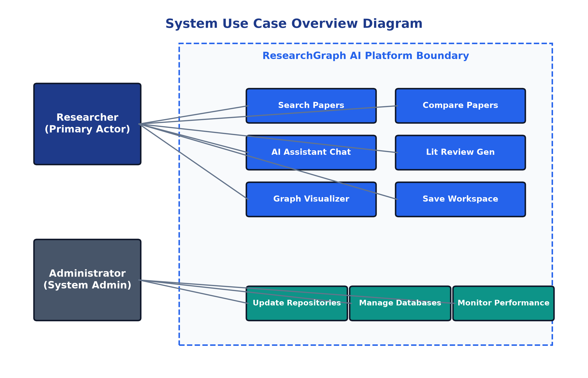
Figure: ResearchGraph AI Actor Use Case Diagram

CHAPTER 5: SYSTEM DESIGN

5.1 Overall System Architecture
The system follows a 6-layer modular architecture separating Presentation, Application, Data Collection, Document Processing, Semantic Retrieval, and Knowledge Graph Layers.
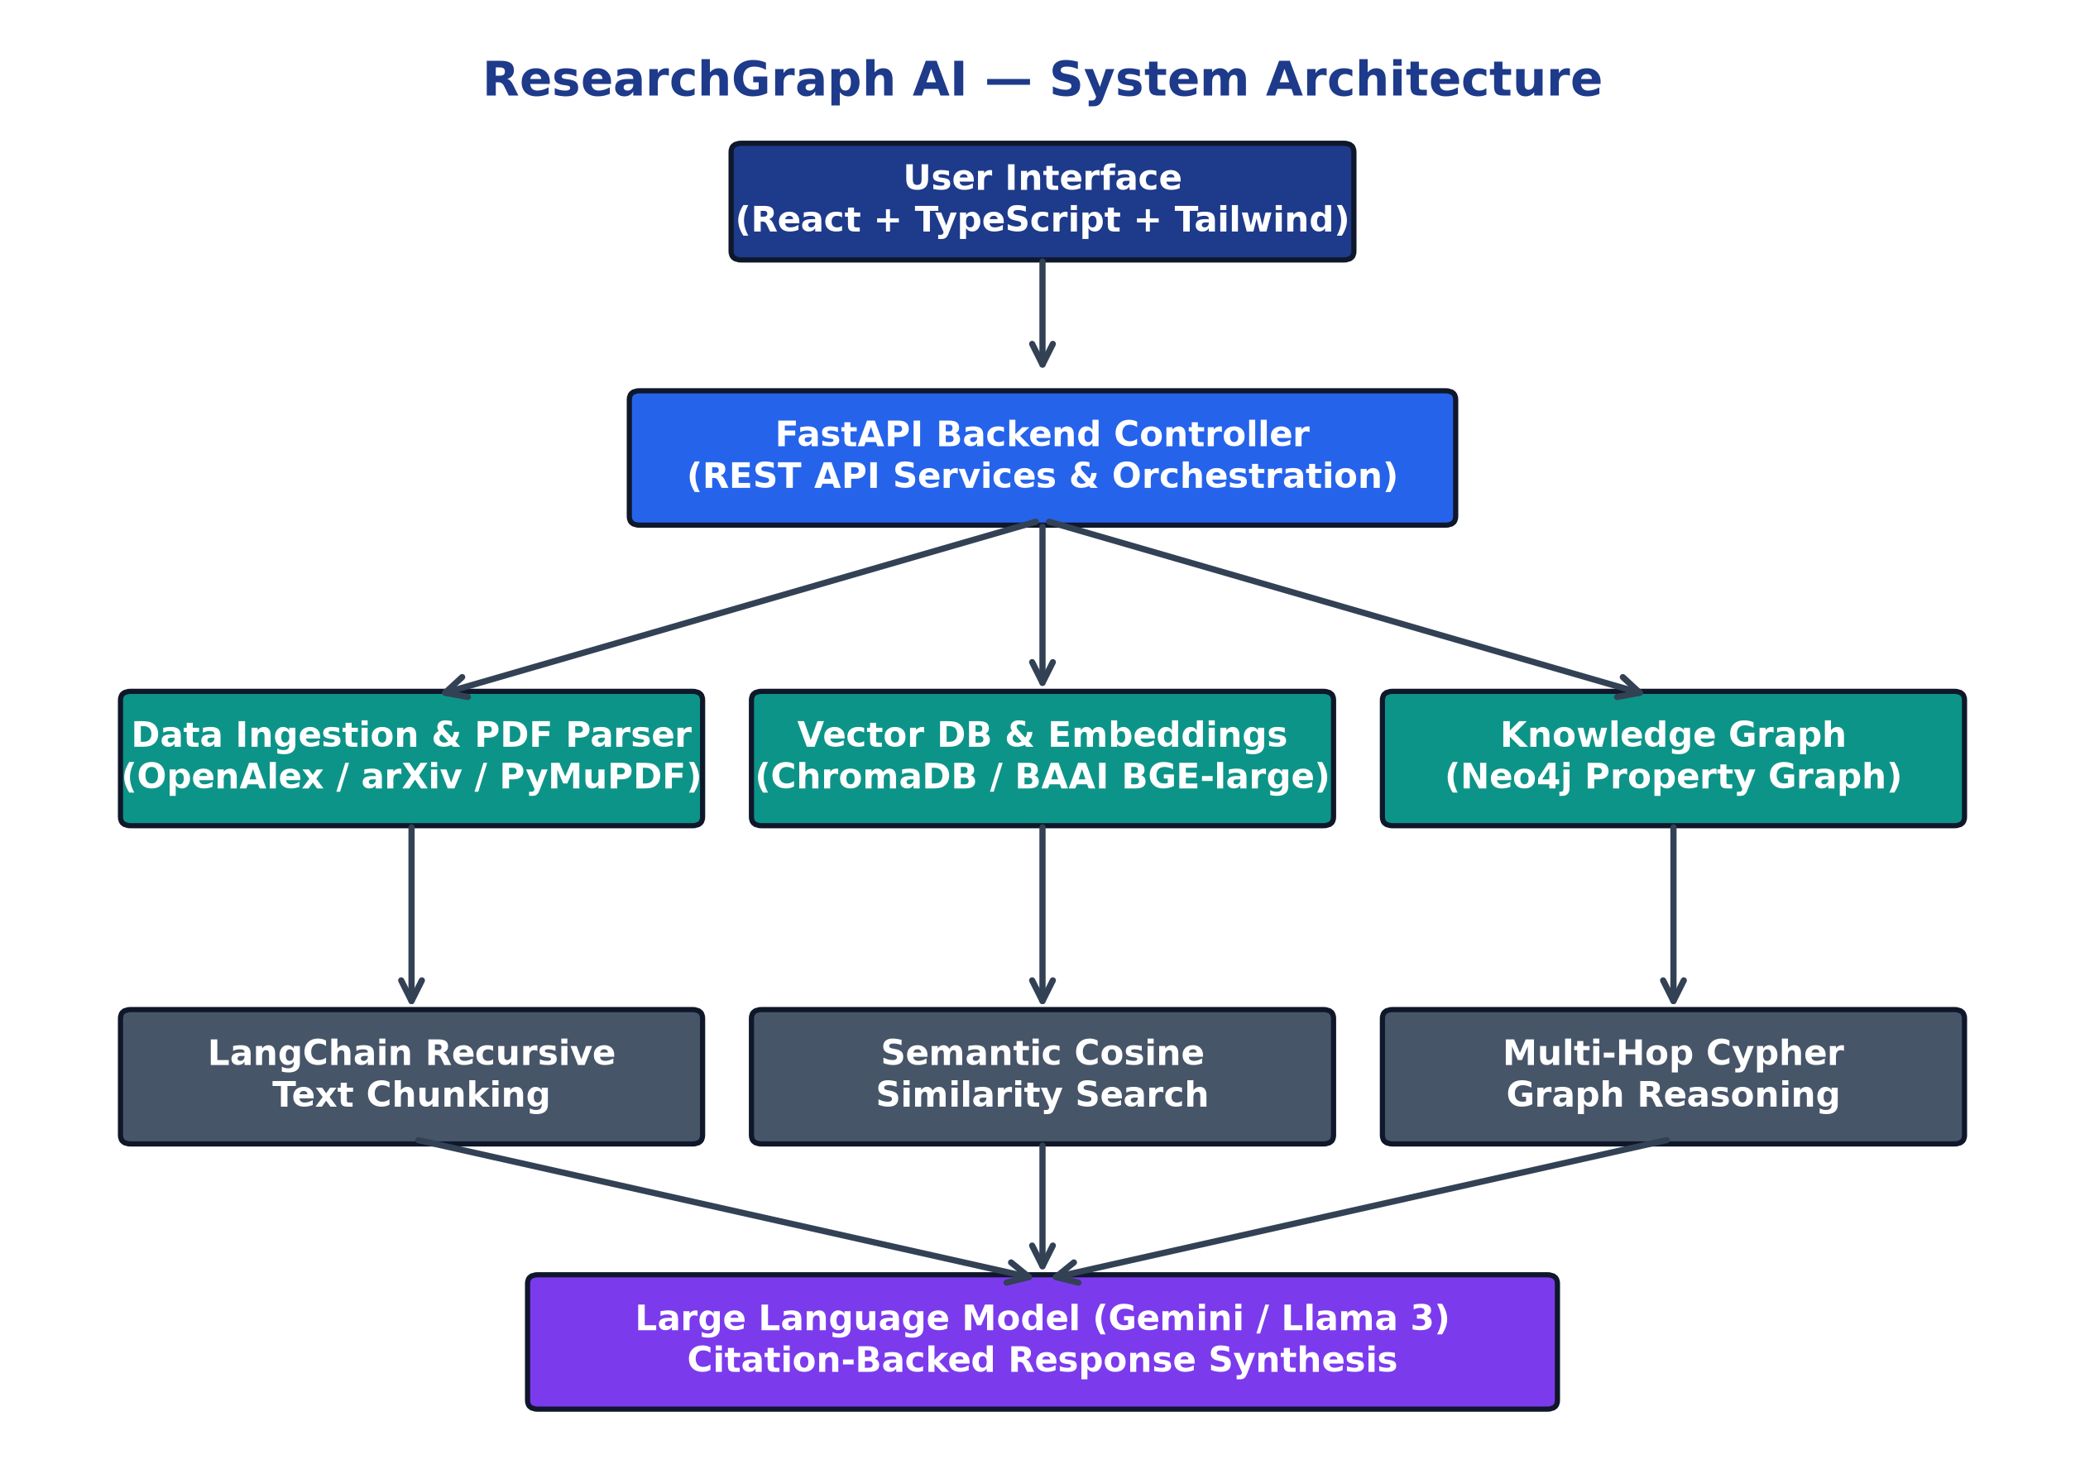
Figure: Overall Layered System Architecture

5.2 Data Flow Diagrams
The Data Flow Diagrams (DFD) illustrate how data moves from user queries down to vector stores, graph databases, and LLMs.
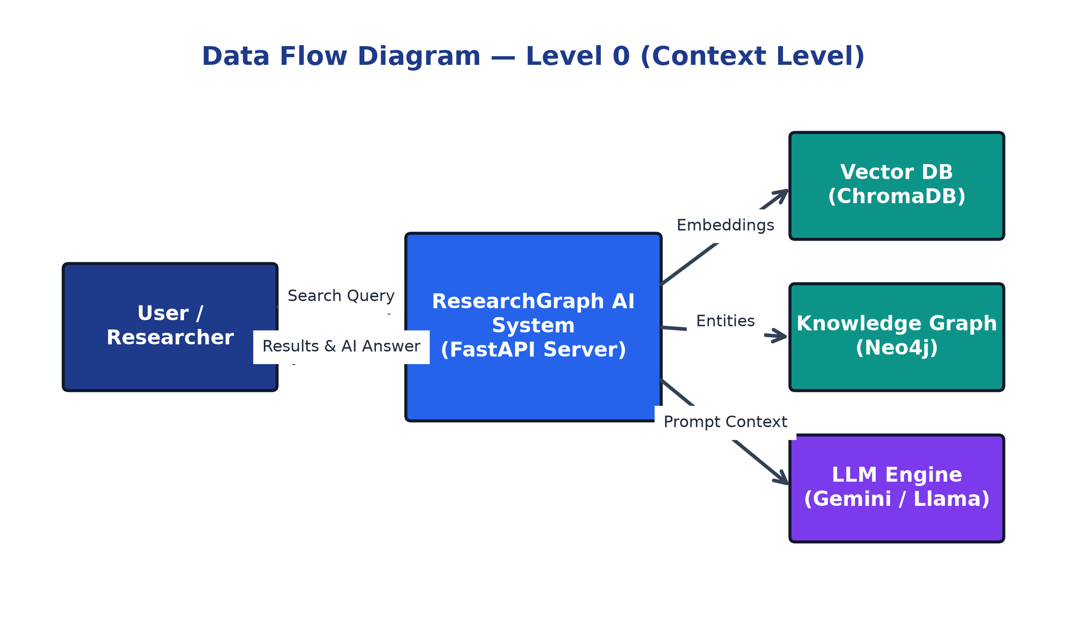
Figure: Data Flow Diagram — Level 0 (Context Level)
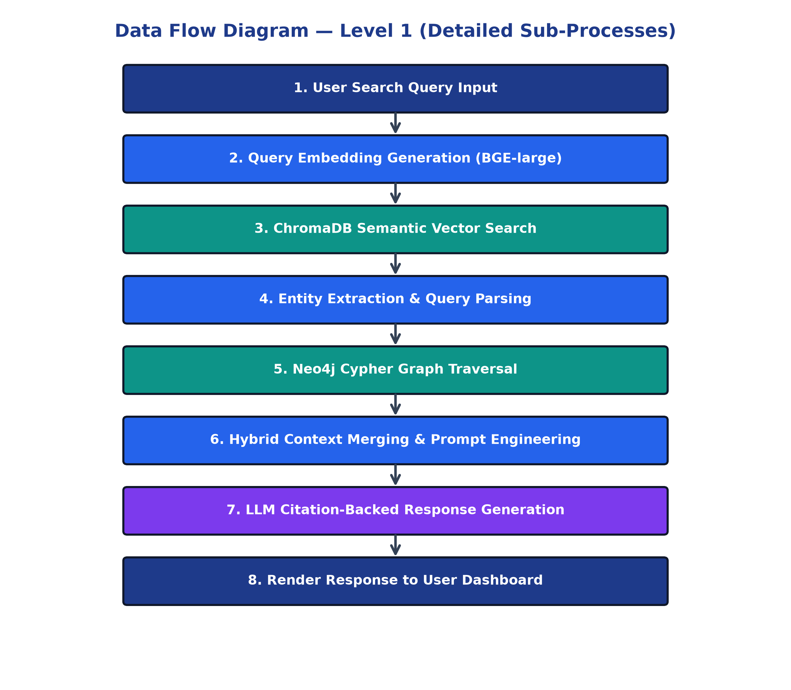
Figure: Data Flow Diagram — Level 1 (Detailed Sub-Processes)

5.3 Class Diagram
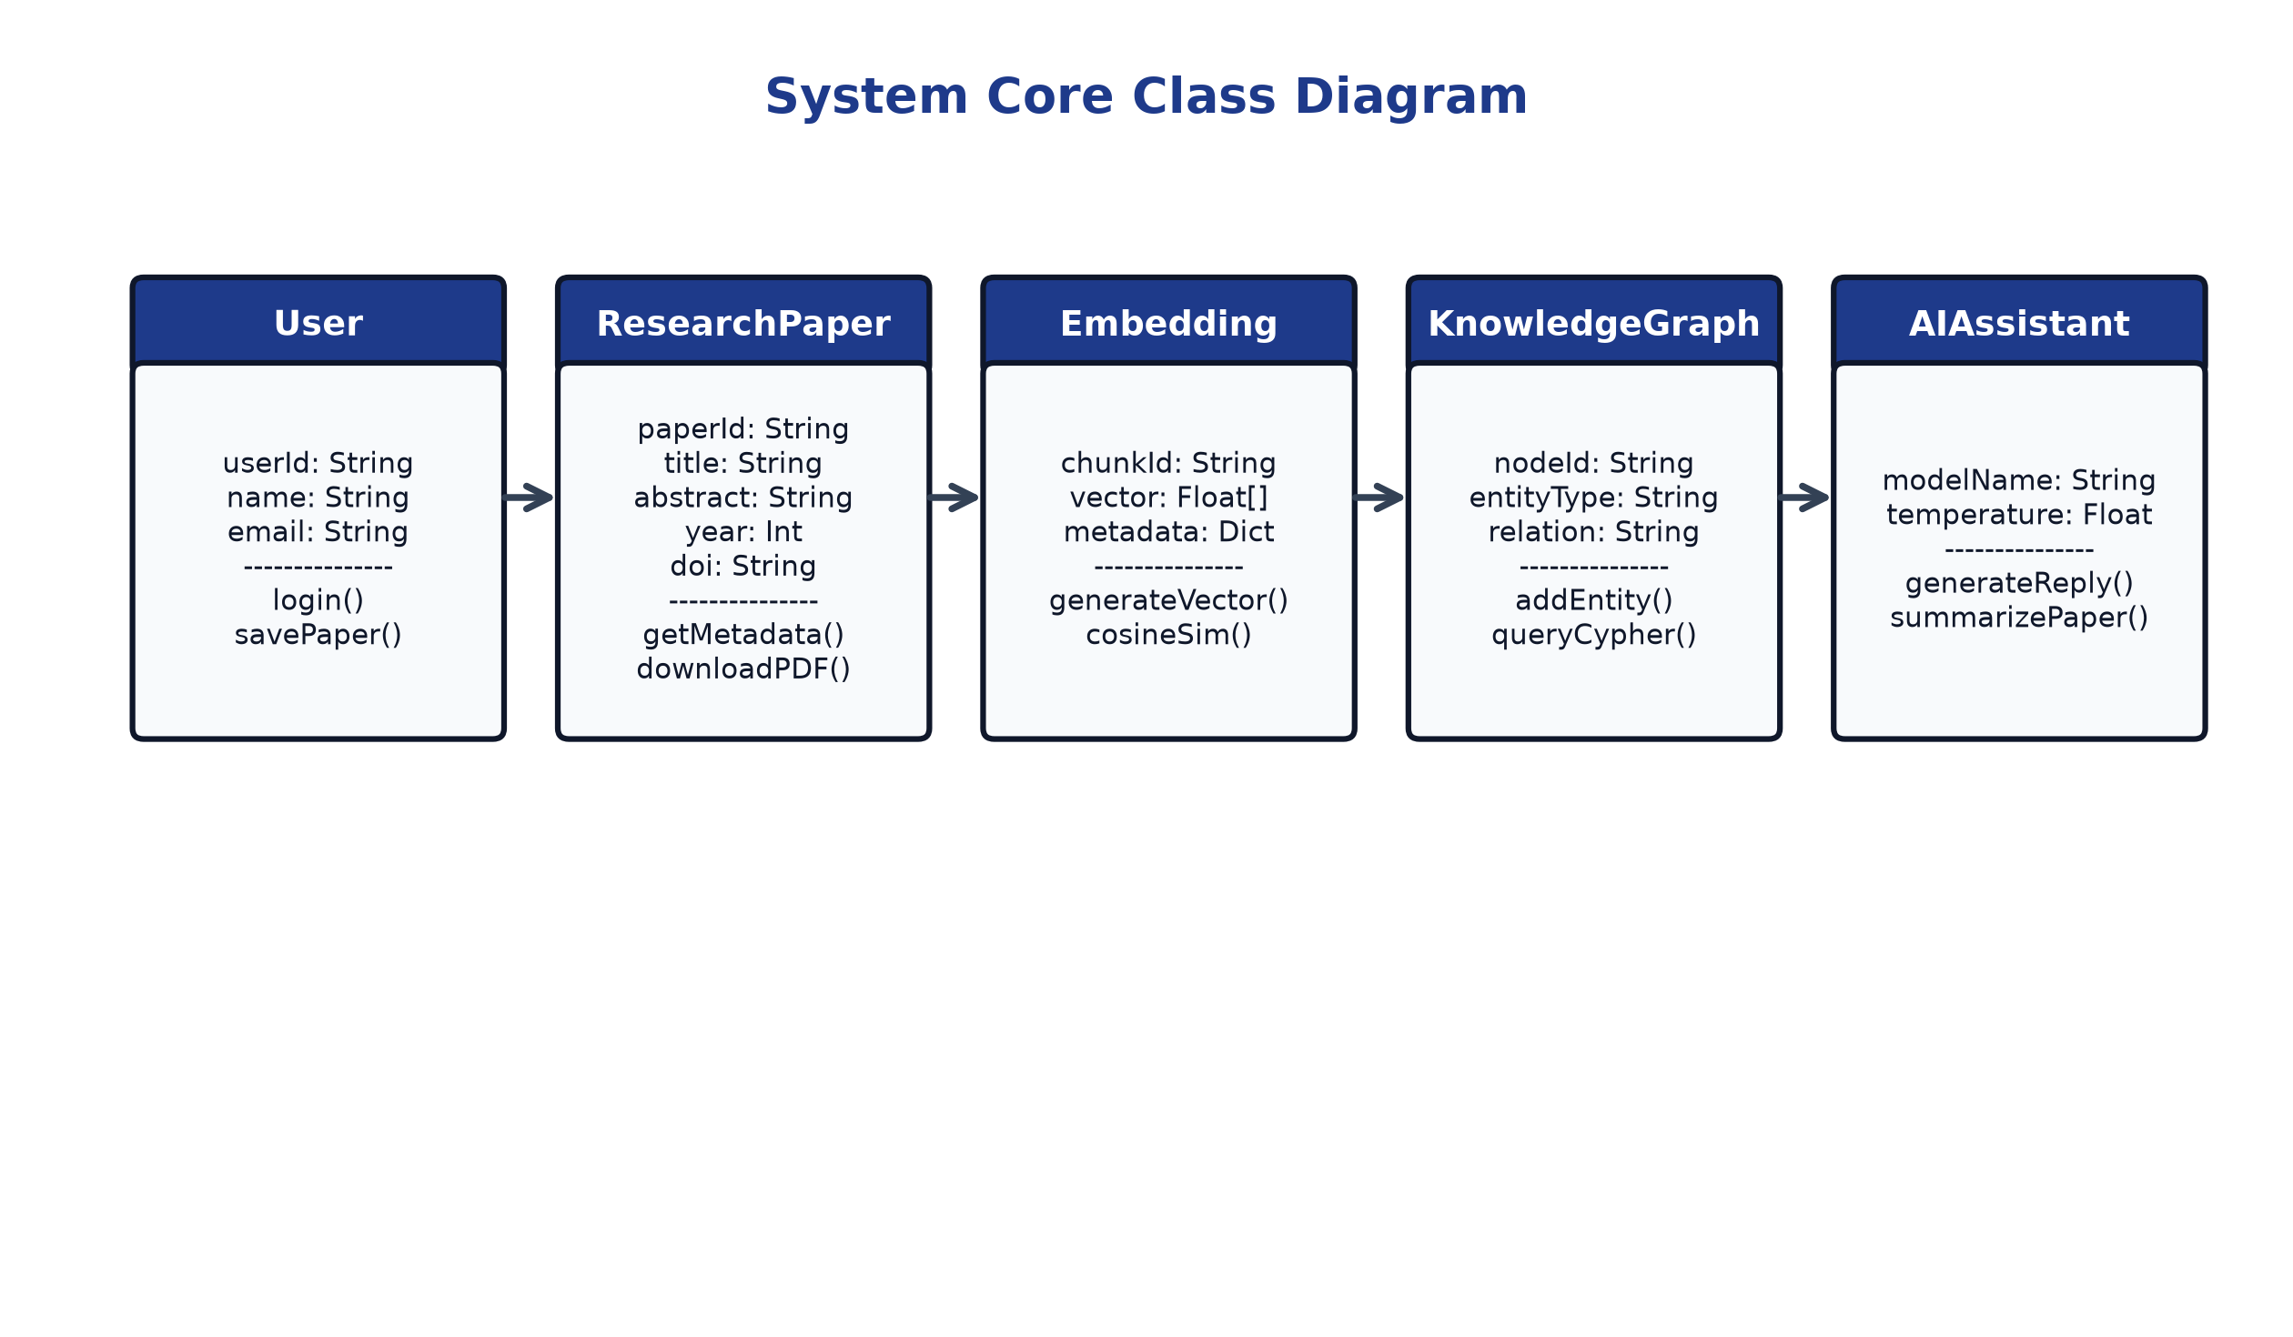
Figure: Core System Object & Data Class Diagram

CHAPTER 6: IMPLEMENTATION & TECHNOLOGY STACK

6.1 Technology Justification
- React & TypeScript: Virtual DOM rendering ensures zero-lag interactive graph rendering; TypeScript prevents runtime API payload errors.
- FastAPI Backend: Asynchronous Python framework crucial for non-blocking concurrent calls to ChromaDB, Neo4j, and Gemini/Llama LLMs.
- PyMuPDF & LangChain: PyMuPDF extracts double-column academic text accurately; LangChain Recursive Text Splitter preserves 400-600 word context bounds.
- BAAI/BGE-large-en-v1.5: Top-performing open embedding model producing 1024-dimensional vectors optimized for scientific domain retrieval.

6.2 Document Extraction & GraphRAG Pipeline
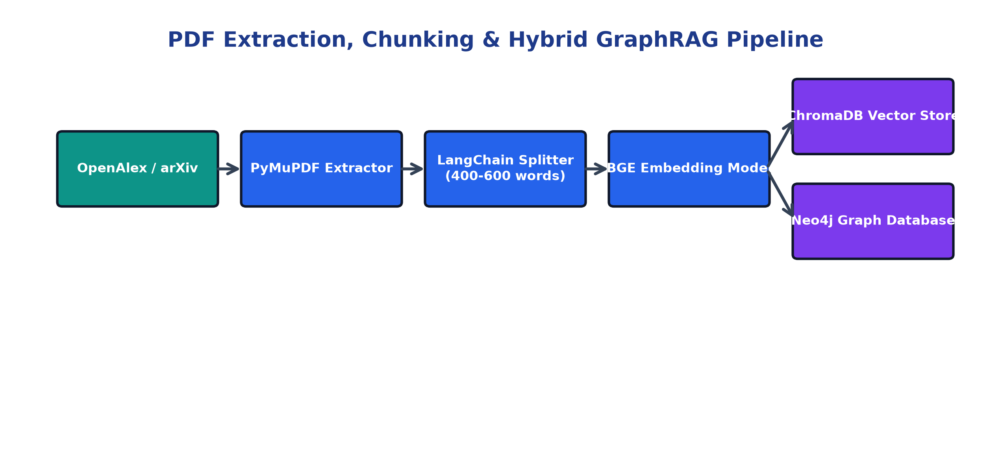
Figure: Document Ingestion, Chunking & Dual GraphRAG Indexing Pipeline

6.3 Why GraphRAG Instead of Traditional RAG?
GraphRAG vs Traditional RAG Rationale
Traditional RAG relies solely on vector similarity. It fails on multi-hop questions such as 'Which datasets are used by papers citing baseline algorithm X?'
ResearchGraph AI's GraphRAG approach combines dense vector search in ChromaDB with Neo4j sub-graph traversal. This provides the LLM with both verbatim passage evidence and explicit entity relationships, producing accurate literature reviews, benchmark comparisons, and research gap identification with zero hallucination.

