B.Tech Project Report
ResearchGraph AI

1. Abstract
ResearchGraph AI is an advanced academic research intelligence platform designed to transform literature review, scientific exploration, and hypothesis discovery by integrating Artificial Intelligence, Vector Search, Knowledge Graphs, and Large Language Models (LLMs) into a unified GraphRAG framework.

2. System Architecture
The system follows a modular architecture separating Presentation, Application, Data Collection, Document Processing, Semantic Retrieval, and Knowledge Graph Layers.
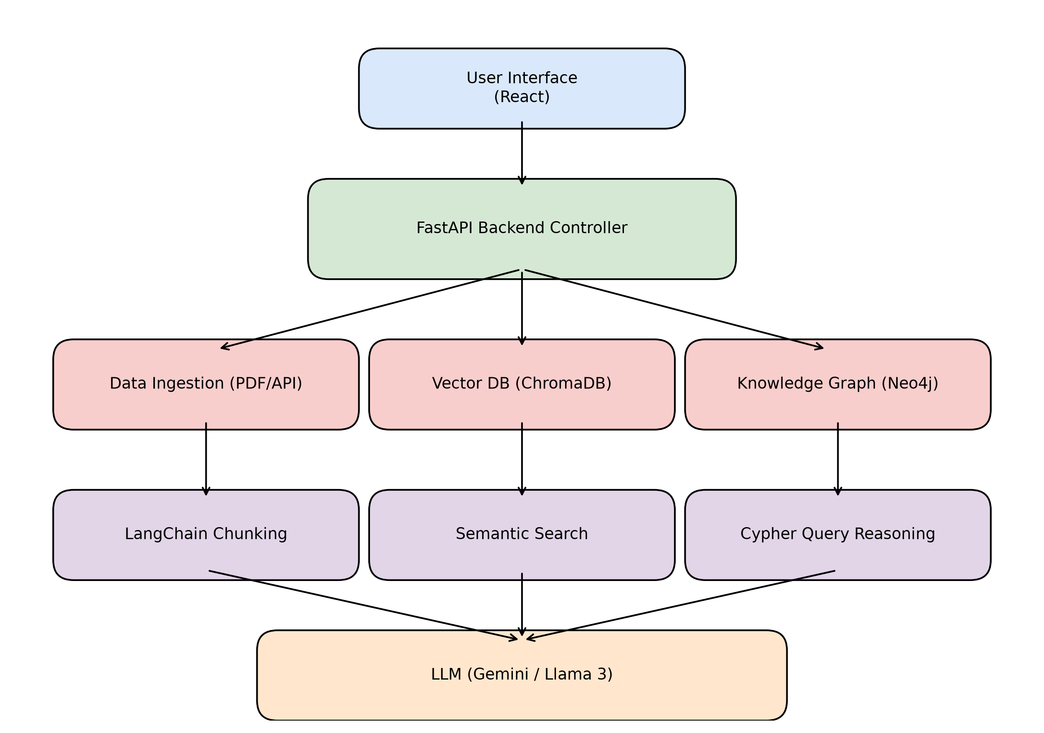
Figure: System Architecture

3. Data Flow Diagram (Level 0)
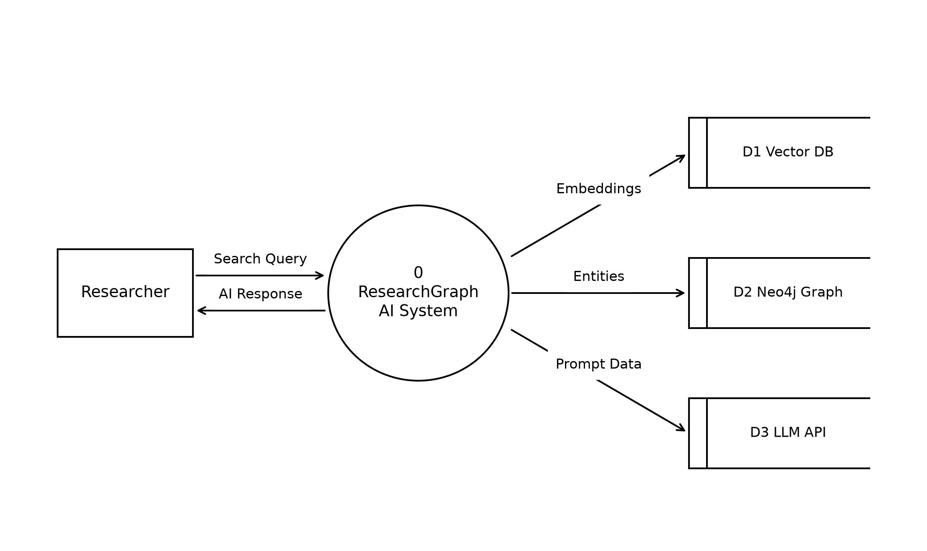
Figure: Context Level DFD

4. Use Case Diagram
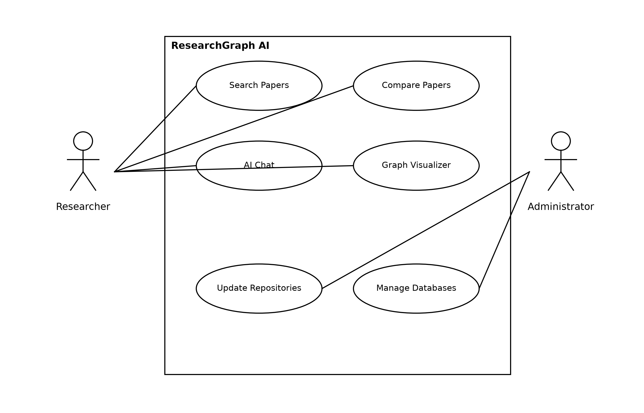
Figure: Use Case Diagram

5. Class Diagram
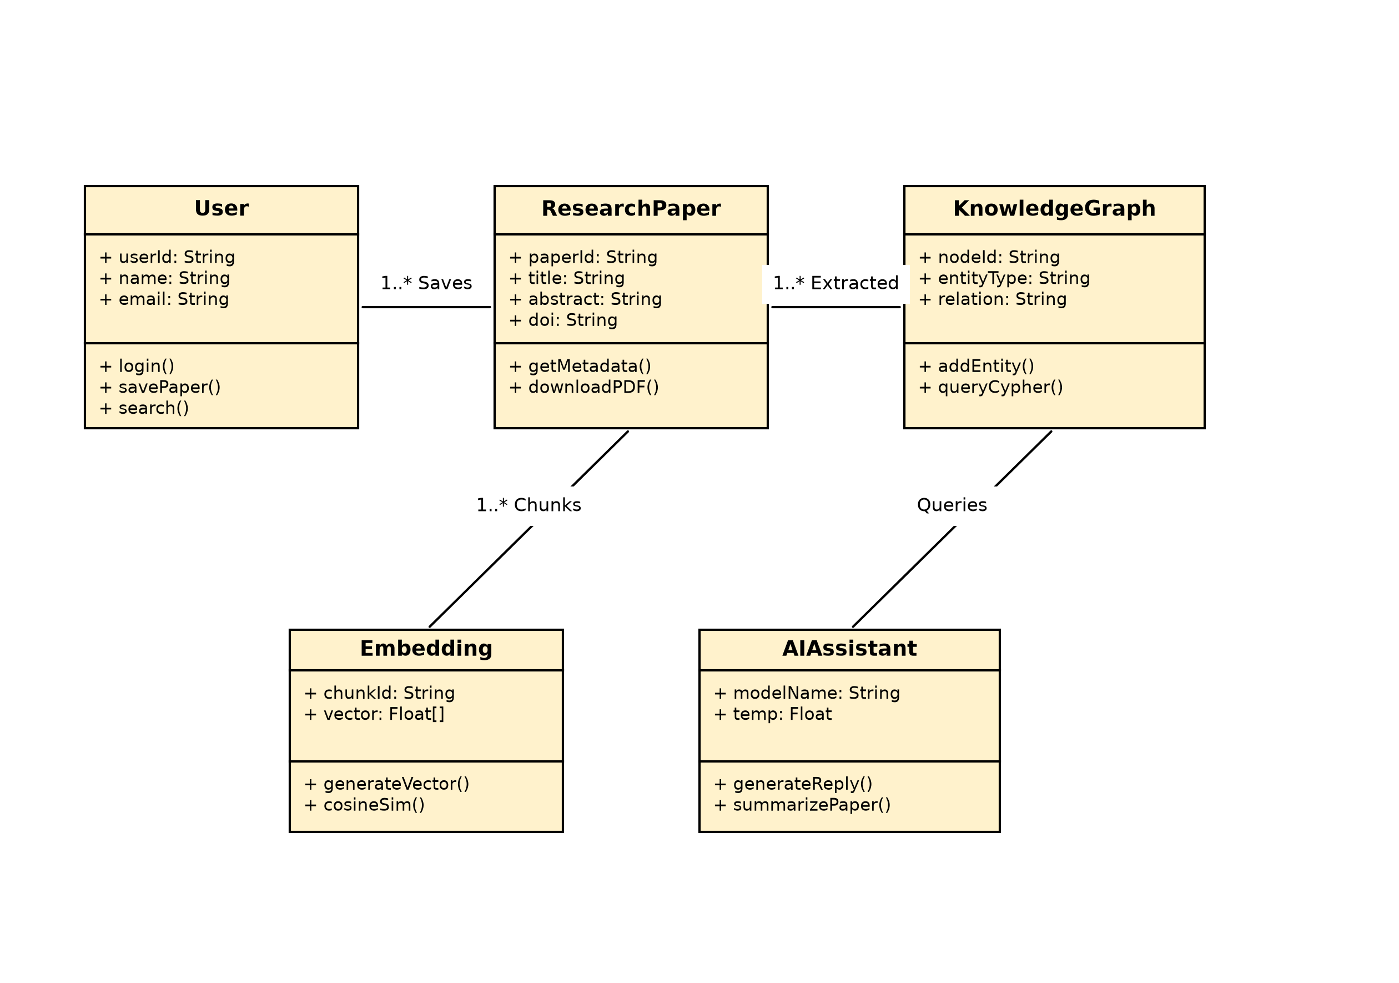
Figure: UML Class Diagram

6. Technology Stack
• Frontend: React, TypeScript, Tailwind CSS
• Backend: FastAPI (Python)
• Database: ChromaDB (Vector), Neo4j (Graph)
• AI/ML: LangChain, BAAI/BGE-large, Gemini/Llama

