Assignment
Starbucks Coffee Company
AIM:
To develop a fully responsive multi-page Starbucks Coffee Company website clone that showcases product menus, store locator, user authentication pages (sign-in/join now), and gift card offerings. The website aims to provide an engaging user experience with smooth navigation, interactive components (marquee banners, mobile menu, expandable footer), and a consistent brand identity across all pages.
PAGE-WISE PROGRAM CODE:
Html Code:
- index.html (Entry Page):
<!DOCTYPE html>
<html lang="en">

<head>
<meta charset="UTF-8">
<meta name="viewport" content="width=device-width, initial-scale=1.0">
<link rel="stylesheet" href="../style/index.css">
<link rel="shortcut icon" href="https://about.starbucks.com/uploads/2024/10/cropped-favicon-300x300.png" type="image/x-icon">
<title>Starbucks Coffee Company</title>
</head>

<body>

<header>
<div class="logo">
<div>
<img class="logo-img" src="../images/logo.webp" alt="logo">
</div>
<div>
<img class="icon" id="bar" src="../images/bars.svg" alt="">
<img class="icon" id="cross" src="../images/cross.svg" alt="">
</div>
</div>
<!--------------------------------------------------------------------------->
<div class="nav">
<div>
<ul>
<a href="home.html" id="home">
<li>HOME</li>
</a>
<a href="menu.html" id="menu">
<li>MENU</li>
</a>
<a href="gift-card.html">
<li>GIFT CARDS</li>
</a>
</ul>
</div>

<div class="nav-option">
<div class="location">
<img class="icon" src="../images/location.svg" alt="">
<div>
<a class="store" href="store.html">Find a store</a>
</div>
</div>

<div class="account">
<div>
<a class="button1" href="sign-in.html">Sign in</a>
</div>
<div>
<a class="button2" href="join-now.html">Join now</a>
</div>
</div>
</div>
</div>
<!------------------------------------------------------------------------->
</header>

<div class="top-banner">
<p class="header2">Welcome Starbucks</p>
</div>

<div class="banner">

<div class="marquee-container">
<div class="marquee-track">

<div class="banner-item" style="background-color: rgb(245, 228, 197);">
<img src="../images/drink3.png">

<div class="banner-text">
<h2>Mango season is here</h2>
<p>The flavour of the season, now in every sip and bite.</p>
<a href="#" class="button1">Buy Now</a>
</div>
</div>

<div class="banner-item" style="background: linear-gradient(-135deg, #E9B35B, #FFE3B5, #F9CF86, #6d4606);">
<img src="../images/drink4.png">

<div class="banner-text">
<p>New</p>
<h2>Try the Blonde Roast!</h2>
<p>Bright, sweet citrus notes and a smooth body makes this a classic</p>
<a href="#" class="button1">Buy Now</a>
</div>
</div>

<div class="banner-item" style=" background-image: url('../images/background-image\ \(2\).png'); background-size: cover;background-position: center;position: relative;">
<img src="../images/drink2.png">

<div class="banner-text">
<p style="color: white;">Starbucks</p>
<h2 style="color: white;">Beverage Subscription</h2>
<p style="color: white;">Starbucks Subscription is Back! Sip Your Favourites for Less.Tap for details.</p>
<a href="#" class="button1" style="color: white;">Know More</a>
</div>
</div>

</div>
</div>

</div>

<div class="coffee-section">
<pre class="title">Learn more about the world of coffee!
</pre>
<div class="coffee-card">
<h3>Art & Science of Coffee Brewing</h3>
<pre>Master the perfect brew with Starbucks! Learn the art
and science of coffee brewing.
</pre>
<a href="#" class="button3">Learn More</a>
</div>
</div>

<div class="style">
<pre>An average active adult requires 2,000 kcal energy per day,
however, calorie needs may vary.
Image for representation purpose only.
FSSAI Lic. No. 10015022003801</pre>
</div>

<!------------------------------------------------------------------------------------------------------------>

<footer>

<div class="footer-opt">

<div class="footer-logo">
<img src="../images/logo.webp" alt="">
</div>

<div>
<div class="footer-head">
<h3>About Us</h3>
<img class="icon arrow 1" src="../images/angle-down.svg" alt="">
</div>

<div class="footer-list">
<ul>
<a href="#">
<li>Our Heritage</li>
</a>
<a href="#">
<li>Coffeehouse</li>
</a>
<a href="#">
<li>Our Company</li>
</a>
</ul>
</div>
</div>

<div>
<div class="footer-head">
<h3>Responsibility</h3>
<img class="icon arrow 2" src="../images/angle-down.svg" alt="">
</div>

<div class="footer-list">
<ul>
<a href="#">
<li>Diversity</li>
</a>
<a href="#">
<li>Community</li>
</a>
<a href="#">
<li>Ethical Sourcing</li>
</a>
<a href="#">
<li>Environmental Stewardship</li>
</a>
<a href="#">
<li>Learn More</li>
</a>
<a href="#">
<li>Bonus Star</li>
</a>

</ul>
</div>
</div>

<div>
<div class="footer-head">
<h3>Legal</h3>
<img class="icon arrow 3" src="../images/angle-down.svg" alt="">
</div>

<div class="footer-list">
<ul>
<a href="#">
<li>Disclaimer</li>
</a>
<a href="#">
<li>Food Safety</li>
</a>
<a href="#">
<li>Nutritional Details</li>
</a>
</ul>
</div>
</div>

<div>
<div class="footer-head">
<h3>Quick Links</h3>
<img class="icon arrow 4" src="../images/angle-down.svg" alt="">
</div>

<div class="footer-list">
<ul>
<a href="#">
<li>FAQs</li>
</a>
<a href="#">
<li>Customer Service</li>
</a>
<a href="#">
<li>Delivery</li>
</a>
<a href="#">
<li>Loyalty Program Terms and Conditions</li>
</a>
<a href="#">
<li>Starbucks India Mobile App Terms of Use</li>
</a>
<a href="#">
<li>Personalized offer</li>
</a>
<a href="#">
<li>Store Names</li>
</a>
<a href="#">
<li>Protein Combos</li>
</a>
<a href="#">
<li>Cookie Policy</li>
</a>
<a href="#">
<li>Harry Potter</li>
</a>
<a href="#">
<li>Privacy Policy</li>
</a>
</ul>
</div>
</div>

</div>

<div class="footer-opt2">
<div class="social">
<h4 style="color: white;margin-bottom: 20px;margin-left: 10px;">SOCIAL MEDIA</h4>
<a href="#">
<img class="icon" src="../images/brewing_files/instagram.svg" alt="">
</a>
<a href="#">
<img class="icon" src="../images/brewing_files/facebook.svg" alt="">
</a>
<a href="#">
<img class="icon" src="../images/brewing_files/twitter.svg" alt="">
</a>
</div>

<div class="copy-desc">
<a href="#">Web Accessibility</a>
<a href="#">Privacy Statement</a>
<a href="#">Terms of Use</a>
<a href="#">Contact Us</a>
</div>

<div class="copy-right">
<h5> &copy; 2026 Starbucks Coffee Company. All rights reserved.</h5>
</div>
</div>

</footer>

<script src="../style/app.js"></script>
</body>
</html>

- home.html:
<!DOCTYPE html>
<html lang="en">

<head>
<meta charset="UTF-8">
<meta name="viewport" content="width=device-width, initial-scale=1.0">
<link rel="stylesheet" href="../style/index.css">
<link rel="shortcut icon" href="https://about.starbucks.com/uploads/2024/10/cropped-favicon-300x300.png" type="image/x-icon">
<title>Starbucks Coffee Company</title>
</head>

<body>

<header>
<div class="logo">
<div>
<img class="logo-img" src="../images/logo.webp" alt="logo">
</div>
<div>
<img class="icon" id="bar" src="../images/bars.svg" alt="">
<img class="icon" id="cross" src="../images/cross.svg" alt="">
</div>
</div>
<!--------------------------------------------------------------------------->
<div class="nav">
<div>
<ul>
<a href="home.html" id="home">
<li>HOME</li>
</a>
<a href="menu.html" id="menu">
<li>MENU</li>
</a>
<a href="gift-card.html">
<li>GIFT CARDS</li>
</a>
</ul>
</div>

<div class="nav-option">
<div class="location">
<img class="icon" src="../images/location.svg" alt="">
<div>
<a class="store" href="store.html">Find a store</a>
</div>
</div>

<div class="account">
<div>
<a class="button1" href="sign-in.html">Sign in</a>
</div>
<div>
<a class="button2" href="join-now.html">Join now</a>
</div>
</div>
</div>
</div>
<!------------------------------------------------------------------------->
</header>

<div class="top-banner">
<p class="header2">Welcome Starbucks</p>
</div>

<div class="banner">

<div class="marquee-container">
<div class="marquee-track">

<div class="banner-item" style="background-color: rgb(245, 228, 197);">
<img src="../images/drink3.png">

<div class="banner-text">
<h2>Mango season is here</h2>
<p>The flavour of the season, now in every sip and bite.</p>
<a href="#" class="button1">Buy Now</a>
</div>
</div>

<div class="banner-item" style="background: linear-gradient(-135deg, #E9B35B, #FFE3B5, #F9CF86, #6d4606);">
<img src="../images/drink4.png">

<div class="banner-text">
<p>New</p>
<h2>Try the Blonde Roast!</h2>
<p>Bright, sweet citrus notes and a smooth body makes this a classic</p>
<a href="#" class="button1">Buy Now</a>
</div>
</div>

<div class="banner-item" style=" background-image: url('../images/background-image\ \(2\).png'); background-size: cover;background-position: center;position: relative;">
<img src="../images/drink2.png">

<div class="banner-text">
<p style="color: white;">Starbucks</p>
<h2 style="color: white;">Beverage Subscription</h2>
<p style="color: white;">Starbucks Subscription is Back! Sip Your Favourites for Less.Tap for details.</p>
<a href="#" class="button1" style="color: white;">Know More</a>
</div>
</div>

</div>
</div>

</div>

<div class="coffee-section">
<pre class="title">Learn more about the world of coffee!
</pre>
<div class="coffee-card">
<h3>Art & Science of Coffee Brewing</h3>
<pre>Master the perfect brew with Starbucks! Learn the art
and science of coffee brewing.
</pre>
<a href="#" class="button3">Learn More</a>
</div>
</div>

<div class="style">
<pre>An average active adult requires 2,000 kcal energy per day,
however, calorie needs may vary.
Image for representation purpose only.
FSSAI Lic. No. 10015022003801</pre>
</div>

<!------------------------------------------------------------------------------------------------------------>

<footer>

<div class="footer-opt">

<div class="footer-logo">
<img src="../images/logo.webp" alt="">
</div>

<div>
<div class="footer-head">
<h3>About Us</h3>
<img class="icon arrow 1" src="../images/angle-down.svg" alt="">
</div>

<div class="footer-list">
<ul>
<a href="#">
<li>Our Heritage</li>
</a>
<a href="#">
<li>Coffeehouse</li>
</a>
<a href="#">
<li>Our Company</li>
</a>
</ul>
</div>
</div>

<div>
<div class="footer-head">
<h3>Responsibility</h3>
<img class="icon arrow 2" src="../images/angle-down.svg" alt="">
</div>

<div class="footer-list">
<ul>
<a href="#">
<li>Diversity</li>
</a>
<a href="#">
<li>Community</li>
</a>
<a href="#">
<li>Ethical Sourcing</li>
</a>
<a href="#">
<li>Environmental Stewardship</li>
</a>
<a href="#">
<li>Learn More</li>
</a>
<a href="#">
<li>Bonus Star</li>
</a>

</ul>
</div>
</div>

<div>
<div class="footer-head">
<h3>Legal</h3>
<img class="icon arrow 3" src="../images/angle-down.svg" alt="">
</div>

<div class="footer-list">
<ul>
<a href="#">
<li>Disclaimer</li>
</a>
<a href="#">
<li>Food Safety</li>
</a>
<a href="#">
<li>Nutritional Details</li>
</a>
</ul>
</div>
</div>

<div>
<div class="footer-head">
<h3>Quick Links</h3>
<img class="icon arrow 4" src="../images/angle-down.svg" alt="">
</div>

<div class="footer-list">
<ul>
<a href="#">
<li>FAQs</li>
</a>
<a href="#">
<li>Customer Service</li>
</a>
<a href="#">
<li>Delivery</li>
</a>
<a href="#">
<li>Loyalty Program Terms and Conditions</li>
</a>
<a href="#">
<li>Starbucks India Mobile App Terms of Use</li>
</a>
<a href="#">
<li>Personalized offer</li>
</a>
<a href="#">
<li>Store Names</li>
</a>
<a href="#">
<li>Protein Combos</li>
</a>
<a href="#">
<li>Cookie Policy</li>
</a>
<a href="#">
<li>Harry Potter</li>
</a>
<a href="#">
<li>Privacy Policy</li>
</a>
</ul>
</div>
</div>

</div>

<div class="footer-opt2">
<div class="social">
<h4 style="color: white;margin-bottom: 20px;margin-left: 10px;">SOCIAL MEDIA</h4>
<a href="#">
<img class="icon" src="../images/brewing_files/instagram.svg" alt="">
</a>
<a href="#">
<img class="icon" src="../images/brewing_files/facebook.svg" alt="">
</a>
<a href="#">
<img class="icon" src="../images/brewing_files/twitter.svg" alt="">
</a>
</div>

<div class="copy-desc">
<a href="#">Web Accessibility</a>
<a href="#">Privacy Statement</a>
<a href="#">Terms of Use</a>
<a href="#">Contact Us</a>
</div>

<div class="copy-right">
<h5> &copy; 2026 Starbucks Coffee Company. All rights reserved.</h5>
</div>
</div>

</footer>

<script src="../style/app.js"></script>
</body>
</html>

- menu.html:
<!DOCTYPE html>
<html lang="en">

<head>
<meta charset="UTF-8">
<meta name="viewport" content="width=device-width, initial-scale=1.0">
<link rel="stylesheet" href="../style/index.css">
<link rel="stylesheet" href="../style/menu.css">
<link rel="shortcut icon" href="https://about.starbucks.com/uploads/2024/10/cropped-favicon-300x300.png" type="image/x-icon">
<title>Menu: Starbucks Coffee Company</title>
</head>

<body>

<header>
<div class="logo">
<div>
<img class="logo-img" src="../images/logo.webp" alt="logo">
</div>
<div>
<img class="icon" id="bar" src="../images/bars.svg" alt="">
<img class="icon" id="cross" src="../images/cross.svg" alt="">
</div>
</div>
<!--------------------------------------------------------------------------->
<div class="nav">
<div>
<ul>
<a href="home.html">
<li>HOME</li>
</a>
<a href="menu.html" id="menu">
<li>MENU</li>
</a>
<a href="gift-card.html">
<li>GIFT CARDS</li>
</a>
</ul>
</div>

<div class="nav-option">
<div class="location">
<img class="icon" src="../images/location.svg" alt="">
<div>
<a class="store" href="store.html">Find a store</a>
</div>
</div>

<div class="account">
<div>
<a class="button1" href="sign-in.html">Sign in</a>
</div>
<div>
<a class="button2" href="join-now.html">Join now</a>
</div>
</div>
</div>
</div>
<!------------------------------------------------------------------------->
</header>

<div class="menu">
<div class="menu-nav">
<a href="#">All Products</a>
<a href="#">Featured</a>
<a href="#">Previous Orders</a>
<a href="#">Favourite products</a>
</div>

<div class="menu-name">
<h3>Drinks</h3>
<ul>
<a href="#">
<li>Oleato <sup>TM</sup></li>
</a>
<a href="#">
<li>Iced Mango Matcha</li>
</a>
<a href="#">
<li>Alphonso Mango Frappuccino</li>
</a>
<a href="#">
<li>Alphonso Mango Cold Brew</li>
</a>
<a href="#">
<li>Sparkling Pineapple Cold Brew</li>
</a>
<a href="#">
<li>Tall Iced Shaken Espresso</li>
</a>
</ul>

<h3>Food</h3>
<ul>
<a href="#">
<li>Chilli Cheese Toast</li>
</a>
<a href="#">
<li>BBQ Chicken Wrap</li>
</a>
<a href="#">
<li>Spinach & Corn Sandwich</li>
</a>
<a href="#">
<li>Chicken Salad Sandwich</li>
</a>
<a href="#">
<li>Paneer Tikka Sandwich</li>
</a>
<a href="#">
<li>Avocado Salsa Sandwich</li>
</a>
</ul>

<h3>Merchandise</h3>
<ul>
<a href="#">
<li>Large Stationary Pouch</li>
</a>
<a href="#">
<li>Small Stationary Pouch</li>
</a>
<a href="#">
<li>Black Rollerball Pen</li>
</a>
<a href="#">
<li>Green Rollerball Pen</li>
</a>
<a href="#">
<li>Magnetic Bookmarks (Set of 3)</li>
</a>
<a href="#">
<li>Sticker Sheets (Set of 3)</li>
</a>
</ul>

<h3>Coffee at home</h3>
<ul>
<a href="#">
<li>Blonde roast 125 Gms</li>
</a>
<a href="#">
<li>Papua New Guinea Whole Bean 250g</li>
</a>
<a href="#">
<li>India Estates Blend 150 G</li>
</a>
<a href="#">
<li>Karadibetta Estate 150 G</li>
</a>
<a href="#">
<li>Margolly Estate 150 G</li>
</a>
<a href="#">
<li>Nullore Estate 150 G</li>
</a>
</ul>

</div>

<div class="menu-items">
<h1>Menu</h1>

<div class="item-head">
<h2>Drinks</h2>
</div>

<div class="order-menu-items">
<a href="#">
<div class="order-items">

<div>
<img src="https://about.starbucks.com/uploads/2024/01/Starbucks-Oleato-Golden-Foam-Iced-Shaken-Espresso.png" alt="">
</div>

<span>Oleato</span>

</div>
</a>

<a href="#">
<div class="order-items">

<div>
<img src="https://starbucksstatic.cognizantorderserv.com/Items/Small/webP/118282.webp" alt="">
</div>

<span>Iced Mango Matcha</span>

</div>
</a>

<a href="#">
<div class="order-items">

<div>
<img src="https://starbucksstatic.cognizantorderserv.com/Items/Small/webP/118274.webp" alt="">
</div>

<span>Alphonso Mango Frappuccino</span>

</div>
</a>

<a href="#">
<div class="order-items">

<div>
<img src="https://starbucksstatic.cognizantorderserv.com/Items/Small/webP/118278.webp" alt="">
</div>

<span>Alphonso Mango Cold Brew</span>

</div>
</a>

<a href="#">
<div class="order-items">

<div>
<img src="https://starbucksstatic.cognizantorderserv.com/Items/Small/webP/118285.webp" alt="">
</div>

<span>Sparkling Pineapple Cold Brew</span>

</div>
</a>

<a href="#">
<div class="order-items">

<div>
<img src="https://starbucksstatic.cognizantorderserv.com/Items/Small/webP/118292.webp" alt="">
</div>

<span>Tall Iced Shaken Espresso</span>

</div>
</a>

</div>

<!------------------------------------------------------------------------------------------------------------------->

<div class="item-head">
<h2>Drinks</h2>
</div>

<div class="order-menu-items">

<a href="#">
<div class="order-items">

<div>
<img src="https://starbucksstatic.cognizantorderserv.com/Items/Small/webP/104108.webp" alt="">
</div>

<span>Chilli Cheese Toast</span>

</div>
</a>

<a href="#">
<div class="order-items">

<div>
<img src="https://starbucksstatic.cognizantorderserv.com/Items/Small/webP/115299_1.webp" alt="">
</div>

<span>BBQ Chicken Wrap</span>

</div>
</a>

<a href="#">
<div class="order-items">

<div>
<img src="https://starbucksstatic.cognizantorderserv.com/Items/Small/webP/115583_1.webp" alt="">
</div>

<span>Spinach & Corn Sandwich</span>

</div>
</a>

<a href="#">
<div class="order-items">

<div>
<img src="https://starbucksstatic.cognizantorderserv.com/Items/Small/webP/101728_1.webp" alt="">
</div>

<span>Chicken Salad Sandwich</span>

</div>
</a>

<a href="#">
<div class="order-items">

<div>
<img src="https://starbucksstatic.cognizantorderserv.com/Items/Small/webP/100100_1.webp" alt="">
</div>

<span>Paneer Tikka Sandwich</span>

</div>
</a>

<a href="#">
<div class="order-items">

<div>
<img src="https://starbucksstatic.cognizantorderserv.com/Items/Small/webP/107566.webp" alt="">
</div>

<span>Avocado Salsa Sandwich</span>

</div>
</a>

</div>

<!------------------------------------------------------------------------------------------------------------------->

<div class="item-head">
<h2>Merchandise</h2>
</div>

<div class="order-menu-items">

<a href="#">
<div class="order-items">

<div>
<img src="https://starbucksstatic.cognizantorderserv.com/Items/Small/webP/118214.webp" alt="">
</div>

<span>Large Stationary Pouch</span>

</div>
</a>

<a href="#">
<div class="order-items">

<div>
<img src="https://starbucksstatic.cognizantorderserv.com/Items/Small/webP/118213.webp" alt="">
</div>

<span>Small Stationary Pouch</span>

</div>
</a>

<a href="#">
<div class="order-items">

<div>
<img src="https://starbucksstatic.cognizantorderserv.com/Items/Small/webP/118212.webp" alt="">
</div>

<span>Black Rollerball Pen</span>

</div>
</a>

<a href="#">
<div class="order-items">

<div>
<img src="https://starbucksstatic.cognizantorderserv.com/Items/Small/webP/118211.webp" alt="">
</div>

<span>Green Rollerball Pen</span>

</div>
</a>

<a href="#">
<div class="order-items">

<div>
<img src="https://starbucksstatic.cognizantorderserv.com/Items/Small/webP/118194.webp" alt="">
</div>

<span>Magnetic Bookmarks (Set of 3)</span>

</div>
</a>

<a href="#">
<div class="order-items">

<div>
<img src="https://starbucksstatic.cognizantorderserv.com/Items/Small/webP/118193.webp" alt="">
</div>

<span>Sticker Sheets (Set of 3)</span>

</div>
</a>

</div>

<!------------------------------------------------------------------------------------------------------------------->

<div class="item-head">
<h2>Coffee at home</h2>
</div>

<div class="order-menu-items">
<a href="#">
<div class="order-items">

<div>
<img src="https://starbucksstatic.cognizantorderserv.com/Items/Small/webP/109445_1.webp" alt="">
</div>

<span>Blonde roast 125 Gms</span>

</div>
</a>

<a href="#">
<div class="order-items">

<div>
<img src="https://starbucksstatic.cognizantorderserv.com/Items/Small/webP/M113634.webp" alt="">
</div>

<span>Papua New Guinea Whole Bean 250g</span>

</div>
</a>

<a href="#">
<div class="order-items">

<div>
<img src="https://starbucksstatic.cognizantorderserv.com/Items/Small/webP/A117260.webp" alt="">
</div>

<span>India Estates Blend 150 G</span>

</div>
</a>

<a href="#">
<div class="order-items">

<div>
<img src="https://starbucksstatic.cognizantorderserv.com/Items/Small/webP/A117437.webp" alt="">
</div>

<span>Nullore Estate 150 G</span>

</div>
</a>

<a href="#">
<div class="order-items">

<div>
<img src="https://starbucksstatic.cognizantorderserv.com/Items/Small/webP/A117435.webp" alt="">
</div>

<span>Karadibetta Estate 150 G</span>

</div>
</a>

<a href="#">
<div class="order-items">

<div>
<img src="https://starbucksstatic.cognizantorderserv.com/Items/Small/webP/A117436.webp" alt="">
</div>

<span>Margolly Estate 150 G</span>

</div>
</a>

</div>

</div>
</div>

<footer>

<div class="footer-opt">

<div class="footer-logo">
<img src="../images/logo.webp" alt="">
</div>

<div>
<div class="footer-head">
<h3>About Us</h3>
<img class="icon arrow 1" src="../images/angle-down.svg" alt="">
</div>

<div class="footer-list">
<ul>
<a href="#">
<li>Our Heritage</li>
</a>
<a href="#">
<li>Coffeehouse</li>
</a>
<a href="#">
<li>Our Company</li>
</a>
</ul>
</div>
</div>

<div>
<div class="footer-head">
<h3>Responsibility</h3>
<img class="icon arrow 2" src="../images/angle-down.svg" alt="">
</div>

<div class="footer-list">
<ul>
<a href="#">
<li>Diversity</li>
</a>
<a href="#">
<li>Community</li>
</a>
<a href="#">
<li>Ethical Sourcing</li>
</a>
<a href="#">
<li>Environmental Stewardship</li>
</a>
<a href="#">
<li>Learn More</li>
</a>
<a href="#">
<li>Bonus Star</li>
</a>

</ul>
</div>
</div>

<div>
<div class="footer-head">
<h3>Legal</h3>
<img class="icon arrow 3" src="../images/angle-down.svg" alt="">
</div>

<div class="footer-list">
<ul>
<a href="#">
<li>Disclaimer</li>
</a>
<a href="#">
<li>Food Safety</li>
</a>
<a href="#">
<li>Nutritional Details</li>
</a>
</ul>
</div>
</div>

<div>
<div class="footer-head">
<h3>Quick Links</h3>
<img class="icon arrow 4" src="../images/angle-down.svg" alt="">
</div>

<div class="footer-list">
<ul>
<a href="#">
<li>FAQs</li>
</a>
<a href="#">
<li>Customer Service</li>
</a>
<a href="#">
<li>Delivery</li>
</a>
<a href="#">
<li>Loyalty Program Terms and Conditions</li>
</a>
<a href="#">
<li>Starbucks India Mobile App Terms of Use</li>
</a>
<a href="#">
<li>Personalized offer</li>
</a>
<a href="#">
<li>Store Names</li>
</a>
<a href="#">
<li>Protein Combos</li>
</a>
<a href="#">
<li>Cookie Policy</li>
</a>
<a href="#">
<li>Harry Potter</li>
</a>
<a href="#">
<li>Privacy Policy</li>
</a>
</ul>
</div>
</div>

</div>

<div class="footer-opt2">
<div class="social">
<h4 style="color: white;margin-bottom: 20px;margin-left: 10px;">SOCIAL MEDIA</h4>
<a href="#">
<img class="icon" src="../images/brewing_files/instagram.svg" alt="">
</a>
<a href="#">
<img class="icon" src="../images/brewing_files/facebook.svg" alt="">
</a>
<a href="#">
<img class="icon" src="../images/brewing_files/twitter.svg" alt="">
</a>
</div>

<div class="copy-desc">
<a href="#">Web Accessibility</a>
<a href="#">Privacy Statement</a>
<a href="#">Terms of Use</a>
<a href="#">Contact Us</a>
</div>

<div class="copy-right">
<h5> &copy; 2026 Starbucks Coffee Company. All rights reserved.</h5>
</div>
</div>

</footer>

<script src="../style/app.js"></script>
</body>
</html>

- gift-card.html:
<!DOCTYPE html>
<html lang="en">

<head>
<meta charset="UTF-8">
<meta name="viewport" content="width=device-width, initial-scale=1.0">
<link rel="stylesheet" href="../style/gift-card.css">
<link rel="stylesheet" href="../style/index.css">
<link rel="shortcut icon" href="https://about.starbucks.com/uploads/2024/10/cropped-favicon-300x300.png" type="image/x-icon">
<title>Starbucks Coffee Company</title>
</head>

<body>

<header>
<div class="logo">
<div>
<img class="logo-img" src="../images/logo.webp" alt="logo">
</div>
<div>
<img class="icon" id="bar" src="../images/bars.svg" alt="">
<img class="icon" id="cross" src="../images/cross.svg" alt="">
</div>
</div>
<!--------------------------------------------------------------------------->
<div class="nav">
<div>
<ul>
<a href="home.html" >
<li>HOME</li>
</a>
<a href="menu.html">
<li>MENU</li>
</a>
<a href="gift-card.html" id="gift" >
<li>GIFT CARDS</li>
</a>
</ul>
</div>

<div class="nav-option">
<div class="location">
<img class="icon" src="../images/location.svg" alt="">
<div>
<a class="store" href="store.html">Find a store</a>
</div>
</div>

<div class="account">
<div>
<a class="button1" href="sign-in.html">Sign in</a>
</div>
<div>
<a class="button2" href="join-now.html">Join now</a>
</div>
</div>
</div>
</div>
<!------------------------------------------------------------------------->
</header>

<div class="corporate-wrapper">
<!-- FIRST SECTION: For all your corporate needs -->
<div class="corporate-hero">
<div class="corporate-content">
<h1 class="main-headline">For all your corporate needs</h1>
<p class="description-text">
From morning fuel to all-day events and corporate gifting options, let Starbucks be your partner
in creating unforgettable moments! Explore our catering options, book the perfect space for your
events, and delight your colleagues with our gift cards in just a snap.
</p>

<div class="features-row">
<!-- Gift a Starbucks card -->
<div class="feature-card">
<div class="card-icon"><img src="https://preprodtsbstorage.blob.core.windows.net/cms/uploads/Desktop_Gift_a_SB_720_39c4b0664f.webp" alt="gift1"></div>
<h3>Gift a Starbucks</h3>
<p>From signature Starbucks coffee blends to unique diwali gifts, discover a wide range of thoughtful products.</p>
</div>
<!-- Curated Hampers -->
<div class="feature-card">
<div class="card-icon"><img src="https://preprodtsbstorage.blob.core.windows.net/cms/uploads/Image_1_8aefe0e8bc.png" alt="gift2"></div>
<h3>Curated Hampers</h3>
<p>Thoughtfully curated corporate gift hampers that blend your brand's essence with the perfect gifting story.</p>
</div>
<!-- Back to campus collection -->
<div class="feature-card">
<div class="card-icon"><img src="https://preprodtsbstorage.blob.core.windows.net/cms/uploads/HP_Banner_mobile_750_px_600px_2x_e74a9ef86d.webp" alt="gift3"></div>
<h3>Back to campus collection</h3>
<p>Discover hand-drawn charm, whimsical illustrations and new arrivals – made to carry a little more personality across campus this summer.</p>
</div>
</div>
</div>
</div>

<!-- SECOND SECTION: Gift Cards -->
<div class="giftcards-section">
<div class="gift-header">
<h2>Gift Cards</h2>
</div>
<div class="dual-cards">
<!-- Starbucks Physical Cards block -->
<div class="gift-type">
<div class="badge-deco">✨ in-store & online</div>
<h3>Starbucks Physical Cards</h3>
<p class="gift-desc">Sip and enjoy the premium coffee experience – the perfect blend of convenience and indulgence.</p>
<div class="contact-link">
<a href="#" class="btn btn-primary">Contact Us</a>
</div>
<hr>
<small style="color:#5f6b64;">Available in select denominations</small>
</div>

<!-- Starbucks E-gift cards block -->
<div class="gift-type">
<div class="badge-deco">⚡ instant delivery</div>
<h3>Starbucks E-gift cards</h3>
<p class="gift-desc">Whether it's a friend, colleague, or someone special, treat them to their favorite Starbucks moments with ease.</p>
<a href="#" class="btn btn-primary">Order Now</a>
<hr>
<small style="color:#5f6b64;">Personalize & send via email or SMS</small>
</div>
</div>
</div>
</div>

<footer>

<div class="footer-opt">

<div class="footer-logo">
<img src="../images/logo.webp" alt="">
</div>

<div>
<div class="footer-head">
<h3>About Us</h3>
<img class="icon arrow 1" src="../images/angle-down.svg" alt="">
</div>

<div class="footer-list">
<ul>
<a href="#">
<li>Our Heritage</li>
</a>
<a href="#">
<li>Coffeehouse</li>
</a>
<a href="#">
<li>Our Company</li>
</a>
</ul>
</div>
</div>

<div>
<div class="footer-head">
<h3>Responsibility</h3>
<img class="icon arrow 2" src="../images/angle-down.svg" alt="">
</div>

<div class="footer-list">
<ul>
<a href="#">
<li>Diversity</li>
</a>
<a href="#">
<li>Community</li>
</a>
<a href="#">
<li>Ethical Sourcing</li>
</a>
<a href="#">
<li>Environmental Stewardship</li>
</a>
<a href="#">
<li>Learn More</li>
</a>
<a href="#">
<li>Bonus Star</li>
</a>

</ul>
</div>
</div>

<div>
<div class="footer-head">
<h3>Legal</h3>
<img class="icon arrow 3" src="../images/angle-down.svg" alt="">
</div>

<div class="footer-list">
<ul>
<a href="#">
<li>Disclaimer</li>
</a>
<a href="#">
<li>Food Safety</li>
</a>
<a href="#">
<li>Nutritional Details</li>
</a>
</ul>
</div>
</div>

<div>
<div class="footer-head">
<h3>Quick Links</h3>
<img class="icon arrow 4" src="../images/angle-down.svg" alt="">
</div>

<div class="footer-list">
<ul>
<a href="#">
<li>FAQs</li>
</a>
<a href="#">
<li>Customer Service</li>
</a>
<a href="#">
<li>Delivery</li>
</a>
<a href="#">
<li>Loyalty Program Terms and Conditions</li>
</a>
<a href="#">
<li>Starbucks India Mobile App Terms of Use</li>
</a>
<a href="#">
<li>Personalized offer</li>
</a>
<a href="#">
<li>Store Names</li>
</a>
<a href="#">
<li>Protein Combos</li>
</a>
<a href="#">
<li>Cookie Policy</li>
</a>
<a href="#">
<li>Harry Potter</li>
</a>
<a href="#">
<li>Privacy Policy</li>
</a>
</ul>
</div>
</div>

</div>

<div class="footer-opt2">
<div class="social">
<h4 style="color: white;margin-bottom: 20px;margin-left: 10px;">SOCIAL MEDIA</h4>
<a href="#">
<img class="icon" src="../images/brewing_files/instagram.svg" alt="">
</a>
<a href="#">
<img class="icon" src="../images/brewing_files/facebook.svg" alt="">
</a>
<a href="#">
<img class="icon" src="../images/brewing_files/twitter.svg" alt="">
</a>
</div>

<div class="copy-desc">
<a href="#">Web Accessibility</a>
<a href="#">Privacy Statement</a>
<a href="#">Terms of Use</a>
<a href="#">Contact Us</a>
</div>

<div class="copy-right">
<h5> &copy; 2026 Starbucks Coffee Company. All rights reserved.</h5>
</div>
</div>

</footer>

<script src="../style/app.js"></script>

</body>
</html>

- store.html:
<!DOCTYPE html>
<html lang="en">

<head>
<meta charset="UTF-8">
<meta name="viewport" content="width=device-width, initial-scale=1.0">
<link rel="stylesheet" href="../style/store.css">
<link rel="stylesheet" href="../style/index.css">
<link rel="shortcut icon" href="https://about.starbucks.com/uploads/2024/10/cropped-favicon-300x300.png" type="image/x-icon">
<title>Starbucks Coffee Company</title>
</head>

<body>

<header>
<div class="logo">
<div>
<img class="logo-img" src="../images/logo.webp" alt="logo">
</div>
<div>
<img class="icon" id="bar" src="../images/bars.svg" alt="">
<img class="icon" id="cross" src="../images/cross.svg" alt="">
</div>
</div>
<!--------------------------------------------------------------------------->
<div class="nav">
<div>
<ul>
<a href="home.html">
<li>HOME</li>
</a>
<a href="menu.html">
<li>MENU</li>
</a>
<a href="gift-card.html">
<li>GIFT CARDS</li>
</a>
</ul>
</div>

<div class="nav-option">
<div class="location">
<img class="icon" src="../images/location.svg" alt="">
<div>
<a class="store" href="store.html" id="store">Find a store</a>
</div>
</div>

<div class="account">
<div>
<a class="button1" href="sign-in.html">Sign in</a>
</div>
<div>
<a class="button2" href="join-now.html">Join now</a>
</div>
</div>
</div>
</div>
<!------------------------------------------------------------------------->
</header>

<div class="store">
<div class="store-search">
<div>
<div class="search">
<input type="text" placeholder="Find a store" id="search">
<img src="../images/brewing_files/search.svg" class="icon" id="search-icon" alt="">
</div>
<a href="#" class="button1">Filter</a>
</div>

<div>
<h2>We are unable to access your exact location.</h2>
<span>To find the Starbucks store, use the search feature, navigate using the map, or turn on location services.</span>
</div>

<div>
<a href="#">
<span>Privacy Notice</span>
<img src="../images/link.svg" class="icon" alt="">
</a>
<a href="#">
<span>Terms of Use</span>
<img src="../images/link.svg" class="icon" alt="">
</a>
<a href="#">
<span>Do Not Share My Personal Information</span>
<img src="../images/link.svg" class="icon" alt="">
</a>
</div>
</div>

<div class="mapouter">
<div class="gmap_canvas">
<iframe class="gmap_iframe" src="https://www.google.com/maps?q=Starbucks&output=embed" width="100%" height="100%" scrolling="no" marginheight="0" marginwidth="0" style="border:0;" allowfullscreen="" loading="lazy"></iframe>
</div>
</div>
</div>

<script src="../style/app.js"></script>
</body>
</html>

- sign-in.html:
<!DOCTYPE html>
<html lang="en">

<head>
<meta charset="UTF-8">
<meta name="viewport" content="width=device-width, initial-scale=1.0">
<link rel="stylesheet" href="../style/sign-in.css">
<link rel="stylesheet" href="../style/index.css">
<link rel="shortcut icon" href="https://about.starbucks.com/uploads/2024/10/cropped-favicon-300x300.png" type="image/x-icon">
<title>Starbucks Coffee Company</title>
</head>

<body>

<header>
<div class="logo">
<div>
<img class="logo-img" src="../images/logo.webp" alt="logo">
</div>
<div>
<img class="icon" id="bar" src="../images/bars.svg" alt="">
<img class="icon" id="cross" src="../images/cross.svg" alt="">
</div>
</div>
</header>

<div class="signin-container">
<div class="signin-card">
<div class="signin-header">
<img src="../images/logo.webp" alt="Starbucks Logo" class="logo">
<h1>Sign In</h1>
<p>Welcome back! Please sign in to your account</p>
</div>

<form class="signin-form">
<div class="input-group">
<label for="email">Email address</label>
<input type="email" id="email" placeholder="you@example.com" required>
</div>

<div class="input-group">
<label for="password">Password</label>
<input type="password" id="password" placeholder="Enter your password" required>
<a href="#" class="forgot-link">Forgot password?</a>
</div>

<button type="submit" class="signin-btn">Sign In</button>

<div class="divider">
<span>or</span>
</div>

<button type="button" class="google-btn">
<img src="../images/google.svg" alt="Google" class="google-icon">
Continue with Google
</button>

<button type="button" class="apple-btn">
<img src="../images/apple.svg" alt="Apple" class="apple-icon">
Continue with Apple
</button>
</form>

<div class="signup-link">
<p>Don't have an account? <a href="#">Join now</a></p>
</div>

<div class="terms">
<p>By signing in, you agree to our
<a href="#">Terms of Use</a> and
<a href="#">Privacy Notice</a>
</p>
</div>
</div>
</div>

</body>
</html>

- join-now.html:
<!DOCTYPE html>
<html lang="en">

<head>
<meta charset="UTF-8">
<meta name="viewport" content="width=device-width, initial-scale=1.0">
<link rel="stylesheet" href="../style/join-now.css">
<link rel="stylesheet" href="../style/index.css">
<link rel="shortcut icon" href="https://about.starbucks.com/uploads/2024/10/cropped-favicon-300x300.png" type="image/x-icon">
<title>Starbucks Coffee Company</title>
</head>

<body>

<header>
<div class="logo">
<div>
<img class="logo-img" src="../images/logo.webp" alt="logo">
</div>
<div>
<img class="icon" id="bar" src="../images/bars.svg" alt="">
<img class="icon" id="cross" src="../images/cross.svg" alt="">
</div>
</div>
</header>

<div class="join-container">
<div class="join-card">
<div class="join-header">
<img src="../images/logo.webp" alt="Starbucks Logo" class="logo">
<h1>Join now</h1>
<p>Create an account to start earning rewards</p>
</div>

<form class="join-form">
<div class="input-group">
<label for="fullname">Full name</label>
<input type="text" id="fullname" placeholder="Enter your full name" required>
</div>

<div class="input-group">
<label for="email">Email address</label>
<input type="email" id="email" placeholder="you@example.com" required>
</div>

<div class="input-group">
<label for="password">Password</label>
<input type="password" id="password" placeholder="Create a password" required>
<span class="password-hint">Must be at least 8 characters</span>
</div>

<div class="input-group">
<label for="confirm-password">Confirm password</label>
<input type="password" id="confirm-password" placeholder="Confirm your password" required>
</div>

<div class="checkbox-group">
<input type="checkbox" id="terms" required>
<label for="terms">I agree to the <a href="#">Terms of Use</a> and <a href="#">Privacy Notice</a></label>
</div>

<div class="checkbox-group">
<input type="checkbox" id="offers">
<label for="offers">Yes, I'd like to receive exclusive offers and promotions via email</label>
</div>

<button type="submit" class="join-btn">Join now</button>

<div class="divider">
<span>or</span>
</div>

<button type="button" class="google-btn">
<svg class="google-icon" width="20" height="20" viewBox="0 0 24 24" fill="none" xmlns="http://www.w3.org/2000/svg">
<path d="M22.56 12.25c0-.78-.07-1.53-.2-2.25H12v4.26h5.92c-.26 1.37-1.04 2.53-2.21 3.31v2.77h3.57c2.08-1.92 3.28-4.74 3.28-8.09z" fill="#4285F4"/>
<path d="M12 23c2.97 0 5.46-.98 7.28-2.66l-3.57-2.77c-.98.66-2.23 1.06-3.71 1.06-2.86 0-5.29-1.93-6.16-4.53H2.18v2.84C3.99 20.53 7.7 23 12 23z" fill="#34A853"/>
<path d="M5.84 14.09c-.22-.66-.35-1.36-.35-2.09s.13-1.43.35-2.09V7.07H2.18C1.43 8.55 1 10.22 1 12s.43 3.45 1.18 4.93l2.85-2.22.81-.62z" fill="#FBBC05"/>
<path d="M12 5.38c1.62 0 3.06.56 4.21 1.64l3.15-3.15C17.45 2.09 14.97 1 12 1 7.7 1 3.99 3.47 2.18 7.07l3.66 2.84c.87-2.6 3.3-4.53 6.16-4.53z" fill="#EA4335"/>
</svg>
Continue with Google
</button>

<button type="button" class="apple-btn">
<svg class="apple-icon" width="20" height="20" viewBox="0 0 24 24" fill="none" xmlns="http://www.w3.org/2000/svg">
<path d="M17.05 20.28c-.98.95-2.05.8-3.08.35-1.09-.46-2.09-.48-3.24 0-1.44.62-2.2.44-3.06-.35C2.79 15.25 3.51 7.59 9.05 7.31c1.35.04 2.29.73 3.07.75.78-.02 1.72-.71 3.07-.75 2.52.13 3.92 1.28 4.75 2.98-2.55 1.5-2.61 4.5-.15 6.12-.85 1.65-2.07 2.96-3.74 3.87zM12.07 7.3c-.24-2.01 1.49-3.74 3.26-4.04.24 1.84-1.53 3.57-3.26 4.04z" fill="#000000"/>
</svg>
Continue with Apple
</button>
</form>

<div class="signin-link">
<p>Already have an account? <a href="#">Sign in</a></p>
</div>
</div>
</div>

</body>
</html>

CSS Code:
- index.css:
/*========= Header ========*/
*{
list-style-type: none;
box-sizing: border-box;
margin: 0;
padding: 0;
text-decoration: none;
}
#home li{
text-decoration:#006e3e underline;
text-underline-offset: 20px;
color: #006e3e;
}
body{
max-width: 1600px;
overflow-x: hidden;
font-family: system-ui, -apple-system, BlinkMacSystemFont, 'Segoe UI', Roboto, Oxygen, Ubuntu, Cantarell, 'Open Sans', 'Helvetica Neue', sans-serif;
}
#bar, #cross{
display: none;
}
header{
display: flex;
align-items: center;
background-color: white;
height: 100px;
padding: 0 40px;
position: relative;
box-shadow: rgb(128,128,128,0.726) 0 1px 5px;
z-index: 100;
}
.icon{
width: 15px;
}
.logo-img{
width: 50px;
margin-right: 20px;
}
.nav{
width: 100%;
display: flex;
justify-content: space-between;
align-items: center;
}
.nav ul,
.nav div:nth-child(2),
.nav .location,
.nav .account{
display: flex;
align-items: center;
height: 100px;
}
.nav ul a{
height: 100%;
line-height: 14vh;
}
.nav ul li{
margin-left: 20px;
color: black;
font-weight: 700;
font-size: 16px;
display: flex;
align-items: center;
height: 100%;
border-bottom: 5px solid transparent;
}
.nav .location img{
padding-top: 5px;
}
.nav div:nth-child(2){
margin: 0 10px; /*margin: top-bottom left-right;*/
}
.nav .store{
color: black;
font-weight: 500;
margin-right: 30px;
}
.button1, .button2{
color: black;
padding: 5px 15px;
border: 1px solid black;
border-radius: 50px;
font-weight: 500;
font-size: 15px;
}
.button1:hover{
background-color: rgb(128,128,128,0.192);
}
.button2:hover{
background-color: grey;
}
.button2{
color: white;
background-color: black;
}

/*for tablet screen*/
@media only screen and (max-width:1024px){
#home li{
text-decoration: none;
color: #006e3e;
}
header{
flex-direction: column;
align-items: flex-start;
height: auto;
padding: 0;
}

.logo{
width: 100%;
height: 80px;
padding: 0 20px;

display: flex;
align-items: center;
justify-content: space-between;
}

#bar{
display: block;
}
#bar, #cross{
cursor: pointer;
}

.nav{
position: absolute;
top:101px;
left: 100%;
width: 100%;
height: 100vh;
background-color: white;
box-shadow: rgb(128,128,128,0.726) 0 1px 3px;
justify-content: left;
align-items: flex-start;
flex-direction: column;
transition: all 0.5s;
}

.nav div{
width: 100%;
}
.nav ul{
flex-direction: column;
height: auto;
justify-content: flex-start;
align-items: flex-start;
border-bottom: 1px solid rgb(187,184,184);
margin-left: 20px;
padding-bottom: 20px;
}
.nav ul li{
font-size: 14px;
padding: 20px;
margin: 0;
line-height: 1.2; /* Optional: controls text line height */
border-bottom: none;
}
.nav .nav-option{
flex-direction: column-reverse;
}
.nav .location{
padding-left: 40px;
height: 10px;
}
.nav .account{
width: 100%;
padding-left: 30px;
}
.nav .account div:first-child{
width: 100px;
min-width: 90px;
}
}

/*for phone screen*/
@media only screen and (max-width: 800px){
#home li{
text-decoration: none;
color: #006e3e;
}
header{
height: 80px;
padding: 0 20px;
}
.nav{
top:80px;
}
.logo-img{
width: 40px;
}
}

/*==================================================================================*/
/*======Banner(card)======*/
.banner{
margin-top: 30px;
padding: 0 40px;
}

.banner-item{
margin-bottom: 30px;
background-color: rgb(245, 228, 197);
border-radius: 5px;
display: flex;
align-items: center;
justify-content: space-between;/*space-betweenFirst item at start, last at end; space only between items.*/
padding: 20px 50px;
box-shadow: 0 2px 8px rgba(0.15,0.15,0.15,0.15);/*box-shadow: horizontal vertical blur spread color;*/
}

.banner .banner-item img{
width: 130px;
}

.banner-text{
flex: 1;
margin-left: 50px;
}

.banner-text h1{
font-size: 40px;
margin-bottom: 20px;
color: #1e1e1e;
}

.banner-text p{
font-size: 22px;
margin-bottom: 30px;
color: #1e1e1e;
}

.banner-text .button1{
background-color: #00754a;
color: white;
padding: 14px 40px;
border-radius: 30px;
border: none;
font-weight: 600;
align-self:self-end;
}

.banner-text .button1:hover{
background-color: #005f3b;
}

/* Mobile Responsive */

@media only screen and (max-width:800px){

.banner{
padding: 0 15px;
}

.banner-item{
display: flex;
flex-direction: row;
justify-content: space-between;
}

.banner .banner-item img{
width: 120px;
float: left;
}

.banner-text{
width: 55%;
float: right;
text-align: left;
}

.banner-text h1{
font-size: 30px;
white-space: normal;
}

.banner-text p{
font-size: 18px;
}
.banner-text .button1{
align-self: center;
}

}

/*=====================================================================================*/
/*marquee movement for the banners(cards)*/
.marquee-container{
overflow: hidden;
width: 100%;
}

.marquee-track{
display: flex;
gap: 20px;
width: max-content;
animation: marquee 18s linear infinite;
}

.banner-item{
flex-shrink: 0;
width: 600px;
margin-bottom: 0;
}

@keyframes marquee{
from{
transform: translateX(0);
}
to{
transform: translateX(-50%); /*Your CSS animation moves the whole track left.*/
}
}

.marquee-container:hover .marquee-track{
animation-play-state: paused;
}

@media only screen and (max-width:800px){

.banner-item{
width: 90vw;
}

}
/*======================================================================================*/
/*=====Header2=====*/
.top-banner{
background-color: rgb(27, 56, 47);
margin-top: 6px;
height: 75px;

display: flex;
align-items: center;
}

.header2{
color: white;
font-size: 25px;
padding-left: 45px;
}

/* Phone view */
@media (max-width: 768px){

.header2{
padding-left: 15px;
font-size: 20px;
}

}

/*=================================================================================*/
.coffee-section{
margin-top: 30px;
padding: 40px;
background-color: rgb(216, 214, 214);
}

.title{
font-size: 25px;
font-weight: bold;
margin-bottom: 20px;
color: rgb(27, 56, 47);
}

.coffee-card{
background-image: url('../images/brewing_files/brewing.jpg');
background-size: cover;
background-position: center;
background-repeat: no-repeat;

width: 90%;
height: 400px;

border-radius: 10px;

padding: 40px;
margin-left: 60px;

display: flex;
flex-direction: column;
justify-content: end;

color: white;
}

.coffee-card h3{
font-size: 30px;
margin-bottom: 15px;
}

.coffee-card pre{
font-size: 18px;
font-family: inherit;
}
.button3{
color: black;
padding: 5px 15px;
border-radius: 50px;
background-color: white;
font-weight: 500;
font-size: 15px;
width: 190px;
text-align: center;
}

@media only screen and (max-width:800px){
.title{
font-size: 21px;
font-weight: bold;
margin-bottom: 10px;
color: rgb(27, 56, 47);
}
.coffee-card{
margin-left: 30px;
}
.coffee-card pre{
font-size: 13px;
}
}
/*=======================================================================================*/
/*======<pre>======*/
.style{
text-align: center;
font-size: larger;
margin-top: 30px;
}

@media only screen and (max-width:800px){
.style{
font-size: large;
}
}

/*=======================================================================================*/
/*====== Footer ======*/
.arrow{
display: none;
}

footer{
margin-top: 30px;
box-shadow: inset rgba(128,128,128,0.726) 0 1px 3px;
background-color: rgb(27, 56, 47);
}

.footer-opt{
padding:30px;
border-bottom: 1px solid rgb(128,128,128,0.521);
display: flex;
justify-content: flex-start;
}

.footer-opt div{
margin: 0 15px;
width: 15vw;
}

.footer-head{
padding: 20px 0;
}

.footer-head h3{
color: rgb(0,0,0,0.8);
color: white;
}

.footer-list{
padding: 5px;
}

.footer-list li{
padding: 15px 0;
color: rgb(0,0,0,0.596);
font-weight: 500;
color: rgb(194, 194, 194);
}

.footer-logo img{
width: 90px;
height: auto;
margin-left: 60px;
margin-top: 25px;
}

@media only screen and (max-width:1024px){
.footer-opt{
flex-direction: column;
padding: 10px 0;
}
.footer-opt div{
width: 100%;
margin: 0;
padding: 10px 15px;
}
.footer-head{
display: flex;
justify-content:space-between;
}
.footer-head h3{
font-size: 17px;
font-weight: 500;
}
.footer-list{
display: none;
}
.arrow{
display: block;
cursor: pointer;
transition: all 0.5s;
}
.footer-list li{
padding: 13px 0;
}
.footer-logo{
padding-left: 15px;
margin-bottom: 10px;
}

.footer-logo img{
width: 50px;
margin-left: 10px;
}
}

/*========================================================================================================*/
/*===== Footer 2 =====*/
/* Footer Option 2 Styles */
/* Footer Option 2 Styles */
.footer-opt2 {
padding: 40px 50px;
display: flex;
justify-content: space-between;
align-items: center;
flex-wrap: wrap;
}

.footer-opt2 .social {
margin-left: -5px;
flex-shrink: 0;
}

.footer-opt2 .social .icon {
width: 40px;
padding: 5px;
margin-bottom: 30px;
opacity: 0.9;
border-radius: 50%;
transition: all 0.5s;
}

.footer-opt2 .social .icon:hover {
background-color: rgba(128, 128, 128, 0.281);
}

.footer-opt2 .copy-desc {
flex: 1;
text-align: center;
}

.footer-opt2 .copy-desc a {
color: white;
display: inline-block;
padding: 20px;
margin-bottom: 20px;
position: relative;
text-decoration: none;
}

.footer-opt2 .copy-desc a:hover {
text-decoration: underline;
}

.footer-opt2 .copy-desc a:not(:first-child) {
padding-left: 30px;
}

.footer-opt2 .copy-desc a:not(:first-child)::before {
content: "";
position: absolute;
left: 0;
top: 50%;
transform: translateY(-50%);
width: 2px;
height: 20px;
background-color: grey;
}

.footer-opt2 .copy-right {
color: white;
flex-shrink: 0;
text-align: right;
}

.footer-opt2 .copy-right h5 {
margin: 0;
}

/* Responsive Design */
@media only screen and (max-width: 1024px) {
.footer-opt2 {
padding: 40px 30px;
flex-direction: column;
text-align: center;
}

.footer-opt2 .copy-desc {
width: 100%;
}

.footer-opt2 .copy-desc a {
display: block;
padding-right: 0;
}

.footer-opt2 .copy-desc a:not(:first-child) {
padding-left: 0;
border-left: none;
}

.footer-opt2 .copy-desc a:not(:first-child)::before {
display: none;
}

.footer-opt2 .copy-right {
margin-top: 30px;
text-align: center;
}
}

/* Additional mobile optimization */
@media only screen and (max-width: 768px) {
.footer-opt2 {
padding: 30px 20px;
}

.footer-opt2 .social {
margin-left: 0;
}

.footer-opt2 .social .icon {
width: 35px;
margin-bottom: 20px;
}

.footer-opt2 .copy-desc a {
padding: 15px 0;
margin-bottom: 10px;
}

.footer-opt2 .copy-right h5 {
font-size: 12px;
}
}

- menu.css:
#menu li {
text-decoration:#006e3e underline;
text-underline-offset: 20px;
color: #006e3e;
}

.menu {
display: grid;
grid-template-columns: 300px auto;
grid-template-areas:
"menunav menunav menunav"
"menuname menuitems menuitems";
}

.menu-nav{
grid-area: menunav;
height: 60px;
background-color: white;
padding: 0 100px;
border-bottom: 1px solid rgb(128,128,128,0.445);
}

.menu-nav a:first-child{
text-decoration: underline;
text-underline-offset: 7px;
}

.menu-nav a{
line-height: 60px;
color: rgb(0,0,0,0.918);
font-size: 14px;
margin-right: 30px;
}

.sticky{
position: fixed;
top:0;
}

.menu-name{
grid-area: menuname;
background-color: white;
padding: 80px 0 0 100px;
max-width: 300px;
border-right: 1px solid grey;
}

.menu-name ul{
width: 100px;
}

.menu-name h3{
margin-top: 20px;
margin-bottom: 10px;
opacity: 0.8;
}

.menu-name a{
color: grey;
}

.menu-name a li{
padding: 10px 0;
}

.menu-items {
grid-area: menuitems;
background-color: white;
padding: 90px 200px 0 40px;
}

.menu-items a{
color: rgb(0,0,0,0.836);
}

.menu-items h1{
margin-bottom: 40px;
opacity: 0.8;
text-decoration: underline;
text-underline-offset: 10px;
}

.menu-items .item-head{
width: 100%;
padding: 25px 0;
margin-bottom: 40px;
border-bottom: 1px solid grey;
}

.order-menu-items{
display: grid;
justify-content: space-between;
grid-template-columns: auto auto;
margin-bottom: 40px;
}

.order-items{
margin: 20px 0;
display: flex;
align-items: center;
}

.order-items div{
background-color: rgb(27, 56, 47);
width: 120px;
height: 120px;
border-radius: 50%;
margin-right: 20px 20px;
overflow: hidden;
}

.order-items div img{
width: 100%;
height: 100%;
}

.order-items span{
margin-left: 20px;
font-size: 18px;
font-weight: 500;
}

@media only screen and (max-width:1024px){
#menu li{
text-decoration: none;
color: #006e3e;
}
.menu{
grid-template-columns: auto;
grid-template-areas:
"menunav menunav menunav"
"menuitems menuitems menuitems";
}

.menu-name{
display: none;
}

.menu-items{
padding-left:100px ;
padding-right: 100px;
}

.menu-items .order-menu-items .order-items div{
width: 80px;
height: 80px;
}
}

@media only screen and (max-width:800px){
#menu li{
text-decoration: none;
color: #006e3e;
}

.menu-nav{
display: none;
}

.menu-items{
padding: 40px 30px;
}

.menu-items h1{
margin-bottom: 20px;
}

.order-menu-items{
grid-template-columns: auto;
margin-bottom: 10px;
}

.order-menu-items .order-items{
margin-bottom: 5px;
}

.menu-items .order-menu-items .order-items span{
font-size: 14px;
}

.menu-items .item-head{
margin-bottom: 20px;
}

.menu-items .item-head h2{
font-size: 23px;
}
}

.cart-btn{
padding: 10px 18px;
border: none;
border-radius: 30px;
background-color: rgb(27, 56, 47);
color: white;
cursor: pointer;
font-weight: 600;
transition: 0.3s ease;
}

.cart-btn:hover{
background-color: rgb(18, 40, 33);
transform: scale(1.05);
}

- gift-card.css:
/* ========== CORPORATE & GIFT CARDS SECTION STYLES ========== */
/* These styles only affect the new sections - no header/footer interference */
body{
background-color: rgb(194, 193, 193);
}

#gift li{
color: #006e3e;
text-decoration:#006e3e underline;
text-underline-offset: 20px;
}
.corporate-wrapper {
max-width: 1280px;
margin: 2rem auto;
display: flex;
flex-direction: column;
gap: 3rem;
padding: 0 1.5rem;
}

/* ========== SECTION 1: CORPORATE NEEDS ========== */
.corporate-hero {
background: #ffffff;
border-radius: 2rem;
box-shadow: 0 12px 30px rgba(0, 0, 0, 0.05), 0 4px 8px rgba(0, 0, 0, 0.02);
overflow: hidden;
transition: transform 0.2s ease;
}

.corporate-hero:hover {
transform: translateY(-3px);
}

.corporate-content {
padding: 2.5rem 2.2rem 2rem 2.2rem;
}

.main-headline {
font-size: 2.2rem;
font-weight: 700;
letter-spacing: -0.01em;
line-height: 1.25;
color: #1e3932;
margin-bottom: 1.25rem;
border-left: 5px solid #008248;
padding-left: 1.2rem;
}

.description-text {
font-size: 1.05rem;
color: #2c2e2d;
margin-bottom: 2.2rem;
line-height: 1.5;
max-width: 90%;
}

.features-row {
display: flex;
flex-wrap: wrap;
gap: 1.8rem;
margin-top: 1rem;
}

.feature-card {
flex: 1;
min-width: 220px;
background: #fefaf5;
border-radius: 1.5rem;
padding: 1.6rem 1.4rem;
transition: all 0.25s;
border: 1px solid #f0e5d8;
box-shadow: 0 2px 5px rgba(0, 0, 0, 0.02);
}

.feature-card:hover {
background: #ffffff;
border-color: #d4e2d4;
box-shadow: 0 12px 20px rgba(0, 0, 0, 0.05);
}

.card-icon {
font-size: 2.2rem;
margin-bottom: 1rem;
display: inline-block;
}

.card-icon img{
width: 320px;
height: 300px;
}

.feature-card h3 {
font-size: 1.45rem;
font-weight: 600;
margin-bottom: 0.75rem;
color: #1e3932;
}

.feature-card p {
font-size: 0.95rem;
color: #3b4a44;
line-height: 1.45;
}

/* ========== SECTION 2: GIFT CARDS ========== */
.giftcards-section {
background: #ffffff;
border-radius: 2rem;
box-shadow: 0 12px 30px rgba(0, 0, 0, 0.05);
overflow: hidden;
}

.gift-header {
text-align: center;
padding: 2rem 2rem 0.5rem 2rem;
}

.gift-header h2 {
font-size: 2rem;
font-weight: 700;
color: #1e3932;
letter-spacing: -0.3px;
position: relative;
display: inline-block;
}

.gift-header h2:after {
content: '';
display: block;
width: 60px;
height: 3px;
background: #008248;
margin: 0.6rem auto 0;
border-radius: 2px;
}

.dual-cards {
display: flex;
flex-wrap: wrap;
gap: 2rem;
padding: 2rem 2rem 2.5rem 2rem;
}

.gift-type {
flex: 1;
min-width: 250px;
background: #fdf9f4;
border-radius: 1.5rem;
padding: 1.8rem;
transition: all 0.2s;
border: 1px solid #efe2d4;
text-align: center;
}

.gift-type:hover {
background: #ffffff;
border-color: #c8dfc4;
transform: translateY(-4px);
}

.gift-type h3 {
font-size: 1.7rem;
font-weight: 600;
margin-bottom: 0.75rem;
color: #1e3932;
}

.gift-desc {
font-size: 0.95rem;
color: #3a4a43;
margin: 1rem 0 1.5rem 0;
line-height: 1.45;
}

.btn {
display: inline-block;
background: transparent;
border: 1.5px solid #008248;
padding: 0.7rem 1.6rem;
border-radius: 40px;
font-weight: 600;
font-size: 0.9rem;
text-decoration: none;
color: #008248;
transition: all 0.2s;
cursor: pointer;
letter-spacing: 0.3px;
}

.btn-primary {
background: #008248;
color: white;
border: none;
box-shadow: 0 2px 6px rgba(0, 130, 72, 0.2);
}

.btn-primary:hover {
background: #006e3e;
transform: scale(1.02);
box-shadow: 0 5px 12px rgba(0, 130, 72, 0.25);
}

.btn-outline:hover {
background: #e9f4ef;
border-color: #008248;
color: #006e3e;
}

.contact-link {
margin-top: 1rem;
font-weight: 500;
}

hr {
margin: 0.5rem 0 0.8rem;
border: none;
border-top: 1px solid #e2d9cf;
}

.badge-deco {
display: inline-block;
background: #f1e9df;
border-radius: 40px;
font-size: 0.75rem;
padding: 0.2rem 1rem;
margin-bottom: 0.75rem;
color: #2b5e4c;
font-weight: 500;
}

.gift-type .badge-deco {
background: #e6f0ea;
}

/* responsiveness */
@media (max-width: 1024px) {
.card-icon img{
width: 200px;
height: 200px;
}
.corporate-content {
padding: 1.8rem;
}
.main-headline {
font-size: 1.8rem;
}
.description-text {
max-width: 100%;
}
.features-row {
gap: 1.2rem;
}
.dual-cards {
padding: 1.5rem;
gap: 1.2rem;
}
#gift{
text-decoration:none;
}
}

@media (max-width: 800px) {
.card-icon img{
width: 200px;
height: 200px;
}
.feature-card h3 {
font-size: 1.25rem;
}
.gift-type h3 {
font-size: 1.4rem;
}
.btn {
padding: 0.5rem 1.2rem;
}
#gift li{
text-decoration:none;
}
}

- store.css:
.mapouter{
position: relative;
text-align: center;
width: 100%;
height: 90vh;
}

.gmap_canvas{
overflow: hidden;
background: none;
width: 100%;
height: 90vh;
}

.gmap_canvas iframe{
height: 90vh;
width: 100%;
}

#store{
color: #006e3e;
}
.location{
text-decoration:#006e3e underline;
text-underline-offset: 20px;

}

.store {
display: flex;
}

.store-search{
margin: 30px 30px 20px 40px;
display: flex;
flex-direction: column;
justify-content: space-between;
gap: 20px;
}

.store-search > div:first-child{
display: flex;
justify-content: space-between;
align-items: center;
gap: 15px;
}

.search{
width: 75%;
border-bottom: 1px solid black;
padding: 5px;
padding-left: 0;
display: flex;
align-items: center;
gap: 10px;
}

.search input{
width: 100%;
font-size: 18px;
border: none;
outline: none;
}

.search .icon{
width: 18px;
opacity: 0.6;
cursor: pointer;
}

.store-search a{
color: rgb(27, 56, 47);
border-color: rgb(27, 56, 47);
}

.store-search h2{
margin-bottom: 20px;
}

.store-search span{
color: grey;
}

.store-search > div:nth-child(3) a{
display: block;
margin-bottom: 15px;
}

.store-search a > .icon{
width: 12px;
}

@media only screen and (max-width: 1024px){
.store{
flex-direction: column-reverse;
}

.mapouter{
height: 40vh;
}

.gmap_canvas{
height: 40vh;
}

.gmap_canvas iframe{
height: 40vh;
}

.store-search{
margin: 30px 30px 20px 20px;
}

.location{
text-decoration: none;
color: #006e3e;
}
}

- sign-in.css:
* {
margin: 0;
padding: 0;
box-sizing: border-box;
}

body {
font-family: -apple-system, BlinkMacSystemFont, 'Segoe UI', Roboto, Oxygen, Ubuntu, sans-serif;
background: linear-gradient(135deg, #f5f5f5 0%, #e8e8e8 100%);
min-height: 100vh;
}

/* Header Styles */
header {
background-color: white;
padding: 20px 40px;
border-bottom: 1px solid #e5e5e5;
box-shadow: 0 2px 4px rgba(0, 0, 0, 0.05);
}

.logo {
display: flex;
justify-content: space-between;
align-items: center;
}

.logo-img {
width: 50px;
height: 50px;
cursor: pointer;
}

.icon {
width: 24px;
height: 24px;
cursor: pointer;
}

#bar, #cross {
display: none;
}

/* Sign In Container */
.signin-container {
display: flex;
justify-content: center;
align-items: center;
min-height: calc(100vh - 91px);
padding: 40px 20px;
}

.signin-card {
background: white;
border-radius: 16px;
box-shadow: 0 10px 40px rgba(0, 0, 0, 0.1);
width: 100%;
max-width: 480px;
padding: 48px 40px;
}

.signin-header {
text-align: center;
margin-bottom: 32px;
}

.signin-header .logo {
width: 60px;
height: 60px;
margin-bottom: 20px;
display: block;
margin-left: auto;
margin-right: auto;
}

.signin-header h1 {
color: #1e3932;
font-size: 28px;
margin-bottom: 8px;
font-weight: 600;
}

.signin-header p {
color: #666;
font-size: 14px;
}

/* Form Styles */
.signin-form {
display: flex;
flex-direction: column;
gap: 24px;
}

.input-group {
display: flex;
flex-direction: column;
gap: 8px;
}

.input-group label {
color: #1e3932;
font-weight: 600;
font-size: 14px;
}

.input-group input {
padding: 12px 16px;
border: 1px solid #ddd;
border-radius: 8px;
font-size: 16px;
transition: all 0.3s ease;
outline: none;
font-family: inherit;
}

.input-group input:focus {
border-color: #1e3932;
box-shadow: 0 0 0 3px rgba(30, 57, 50, 0.1);
}

.input-group input::placeholder {
color: #bbb;
}

.forgot-link {
text-align: right;
font-size: 13px;
color: #1e3932;
text-decoration: none;
margin-top: 4px;
transition: color 0.3s ease;
}

.forgot-link:hover {
text-decoration: underline;
color: #0f2a24;
}

/* Buttons */
.signin-btn {
background-color: #1e3932;
color: white;
padding: 14px;
border: none;
border-radius: 8px;
font-size: 16px;
font-weight: 600;
cursor: pointer;
transition: all 0.3s ease;
margin-top: 8px;
}

.signin-btn:hover {
background-color: #0f2a24;
transform: translateY(-1px);
box-shadow: 0 4px 12px rgba(30, 57, 50, 0.2);
}

.signin-btn:active {
transform: translateY(0);
}

/* Divider */
.divider {
text-align: center;
position: relative;
margin: 8px 0;
}

.divider::before {
content: '';
position: absolute;
left: 0;
top: 50%;
width: 100%;
height: 1px;
background: #e5e5e5;
}

.divider span {
background: white;
padding: 0 16px;
position: relative;
color: #999;
font-size: 14px;
}

/* Social Login Buttons */
.google-btn,
.apple-btn {
display: flex;
align-items: center;
justify-content: center;
gap: 12px;
padding: 12px;
border: 1px solid #ddd;
border-radius: 8px;
background: white;
font-size: 14px;
font-weight: 500;
cursor: pointer;
transition: all 0.3s ease;
font-family: inherit;
}

.google-btn:hover,
.apple-btn:hover {
background-color: #f7f7f7;
border-color: #1e3932;
transform: translateY(-1px);
}

.google-btn:active,
.apple-btn:active {
transform: translateY(0);
}

.google-icon,
.apple-icon {
width: 20px;
height: 20px;
}

/* Sign Up Link */
.signup-link {
text-align: center;
margin-top: 32px;
padding-top: 24px;
border-top: 1px solid #e5e5e5;
}

.signup-link p {
color: #666;
font-size: 14px;
}

.signup-link a {
color: #1e3932;
text-decoration: none;
font-weight: 600;
transition: color 0.3s ease;
}

.signup-link a:hover {
text-decoration: underline;
color: #0f2a24;
}

/* Terms */
.terms {
text-align: center;
margin-top: 24px;
}

.terms p {
color: #999;
font-size: 12px;
line-height: 1.5;
}

.terms a {
color: #1e3932;
text-decoration: none;
transition: color 0.3s ease;
}

.terms a:hover {
text-decoration: underline;
color: #0f2a24;
}

/* Responsive Design */
@media only screen and (max-width: 1024px) {
header {
padding: 16px 20px;
}

.logo-img {
width: 40px;
height: 40px;
}

.signin-container {
min-height: calc(100vh - 73px);
padding: 20px;
}

.signin-container .signin-card .signin-header img{
width: 100px;
height:70px;
}

.signin-card {
padding: 32px 24px;
}

.signin-header h1 {
font-size: 24px;
}

.signin-header .logo {
width: 50px;
height: 50px;
}

.signin-btn {
padding: 12px;
}

.google-btn,
.apple-btn {
padding: 10px;
}
}

@media only screen and (max-width: 480px) {
.signin-card {
padding: 24px 20px;
}

.signin-header {
margin-bottom: 24px;
}

.signin-container .signin-card .signin-header img{
width: 100px;
height:70px;
}

.signin-form {
gap: 20px;
}

.input-group input {
padding: 10px 14px;
font-size: 14px;
}
}

- join-now.css:
/* Join Now Container */
.join-container {
display: flex;
justify-content: center;
align-items: center;
min-height: 100vh;
background: linear-gradient(135deg, #f5f5f5 0%, #e8e8e8 100%);
padding: 40px 20px;
}

.join-card {
background: white;
border-radius: 16px;
box-shadow: 0 10px 40px rgba(0, 0, 0, 0.1);
width: 100%;
max-width: 500px;
padding: 48px 40px;
}

/* Header */
.join-header {
text-align: center;
margin-bottom: 32px;
}

.join-header .logo {
width: 100px;
height: 70px;
object-fit: contain;
display: block;
margin-left: auto;
margin-right: auto;
margin-bottom: 20px;
transition: transform 0.3s ease;
}

.join-header .logo:hover {
transform: scale(1.05);
}

.join-header h1 {
color: #1e3932;
font-size: 28px;
margin-bottom: 8px;
font-weight: 600;
}

.join-header p {
color: #666;
font-size: 14px;
}

/* Form */
.join-form {
display: flex;
flex-direction: column;
gap: 20px;
}

.input-group {
display: flex;
flex-direction: column;
gap: 8px;
}

.input-group label {
color: #1e3932;
font-weight: 600;
font-size: 14px;
}

.input-group input {
padding: 12px 16px;
border: 1px solid #ddd;
border-radius: 8px;
font-size: 16px;
transition: all 0.3s ease;
outline: none;
font-family: inherit;
}

.input-group input:focus {
border-color: #1e3932;
box-shadow: 0 0 0 3px rgba(30, 57, 50, 0.1);
}

.input-group input::placeholder {
color: #bbb;
}

.password-hint {
font-size: 12px;
color: #999;
margin-top: 4px;
}

/* Checkbox Group */
.checkbox-group {
display: flex;
align-items: flex-start;
gap: 12px;
margin: 8px 0;
}

.checkbox-group input[type="checkbox"] {
width: 18px;
height: 18px;
margin-top: 2px;
cursor: pointer;
accent-color: #1e3932;
}

.checkbox-group label {
font-size: 13px;
color: #555;
line-height: 1.4;
cursor: pointer;
}

.checkbox-group a {
color: #1e3932;
text-decoration: none;
font-weight: 500;
}

.checkbox-group a:hover {
text-decoration: underline;
}

/* Join Button */
.join-btn {
background-color: #1e3932;
color: white;
padding: 14px;
border: none;
border-radius: 8px;
font-size: 16px;
font-weight: 600;
cursor: pointer;
transition: all 0.3s ease;
margin-top: 8px;
}

.join-btn:hover {
background-color: #0f2a24;
transform: translateY(-1px);
box-shadow: 0 4px 12px rgba(30, 57, 50, 0.2);
}

.join-btn:active {
transform: translateY(0);
}

/* Divider */
.divider {
text-align: center;
position: relative;
margin: 8px 0;
}

.divider::before {
content: '';
position: absolute;
left: 0;
top: 50%;
width: 100%;
height: 1px;
background: #e5e5e5;
}

.divider span {
background: white;
padding: 0 16px;
position: relative;
color: #999;
font-size: 14px;
}

/* Social Buttons */
.google-btn,
.apple-btn {
display: flex;
align-items: center;
justify-content: center;
gap: 12px;
padding: 12px;
border: 1px solid #ddd;
border-radius: 8px;
background: white;
font-size: 14px;
font-weight: 500;
cursor: pointer;
transition: all 0.3s ease;
font-family: inherit;
}

.google-btn:hover,
.apple-btn:hover {
background-color: #f7f7f7;
border-color: #1e3932;
transform: translateY(-1px);
}

.google-btn:active,
.apple-btn:active {
transform: translateY(0);
}

.google-icon,
.apple-icon {
width: 20px;
height: 20px;
}

/* Sign In Link */
.signin-link {
text-align: center;
margin-top: 32px;
padding-top: 24px;
border-top: 1px solid #e5e5e5;
}

.signin-link p {
color: #666;
font-size: 14px;
}

.signin-link a {
color: #1e3932;
text-decoration: none;
font-weight: 600;
transition: color 0.3s ease;
}

.signin-link a:hover {
text-decoration: underline;
color: #0f2a24;
}

/* Responsive Design */
@media only screen and (max-width: 768px) {
.join-card {
padding: 32px 24px;
}

.join-header h1 {
font-size: 24px;
}

.join-header .logo {
width: 100px;
height: 70px;
}
}

@media only screen and (max-width: 480px) {
.join-container {
padding: 20px;
}

.join-card {
padding: 24px 20px;
}

.join-header {
margin-bottom: 24px;
}

.join-header h1 {
font-size: 22px;
}

.join-header p {
font-size: 12px;
}

.join-form {
gap: 16px;
}

.input-group input {
padding: 10px 14px;
font-size: 14px;
}

.input-group label {
font-size: 13px;
}

.join-btn {
padding: 12px;
font-size: 14px;
}

.google-btn,
.apple-btn {
padding: 10px;
font-size: 13px;
}

.checkbox-group label {
font-size: 12px;
}

.signin-link p {
font-size: 13px;
}
}

JavaScript Code:
- app.js:
// ================= MOBILE NAV =================

const bar = document.querySelector("#bar");
const cross = document.querySelector("#cross");
const nav = document.querySelector(".nav");

bar.addEventListener('click', () => {

bar.style.display = 'none';

cross.style.display = 'block';

nav.style.left = '20%';

});

cross.addEventListener('click', () => {

bar.style.display = 'block';

cross.style.display = 'none';

nav.style.left = '100%';

});

// ================= RESIZE FIX =================

window.addEventListener('resize', () => {

if(window.innerWidth > 1024){

nav.style.left = '0';

bar.style.display = 'none';

cross.style.display = 'none';

}

else{

nav.style.left = '100%';

bar.style.display = 'block';

cross.style.display = 'none';

}

});

//Banner(card) movement:

//Banner(card) movement:

const track = document.querySelector(".marquee-track");

if(track){

const cards = [...track.children];

cards.forEach((card) => {

const clone = card.cloneNode(true);

track.appendChild(clone);

});

}

// ================= FOOTER ARROW =================

const arrow = document.querySelectorAll(".arrow");

arrow.forEach((e) => {

e.addEventListener('click', () => {

const footerlist = e.parentElement.nextElementSibling;

if(e.classList.contains('temp')){

e.classList.remove('temp');

footerlist.style.display = 'none';

e.style.transform = 'rotate(0deg)';
}

else{

e.classList.add('temp');

footerlist.style.display = 'block';

e.style.transform = 'rotate(180deg)';
}

});

});
OUTPUT: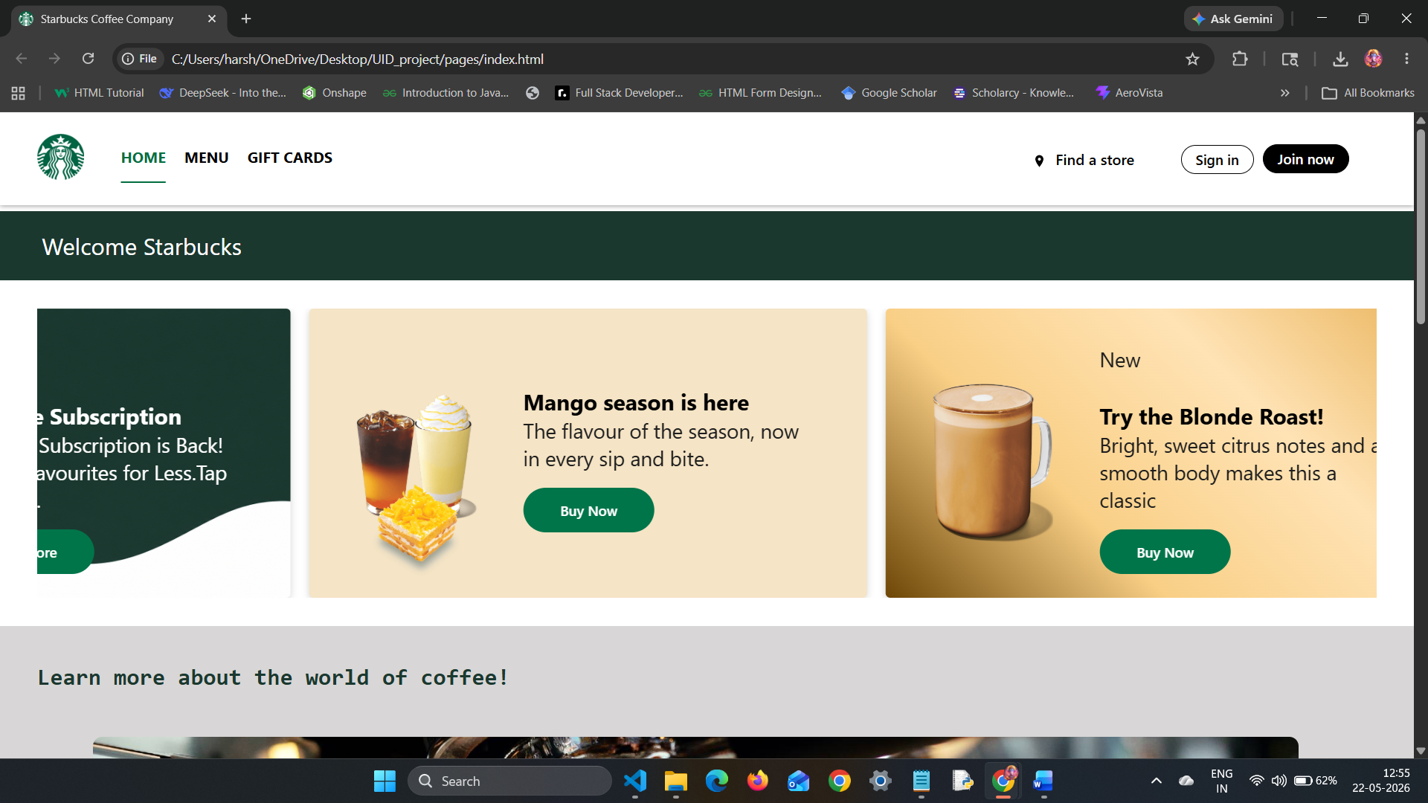
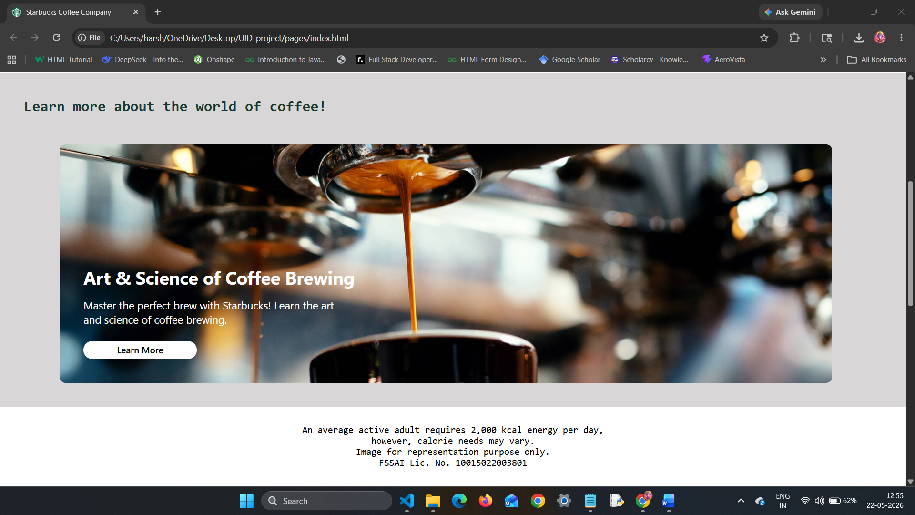
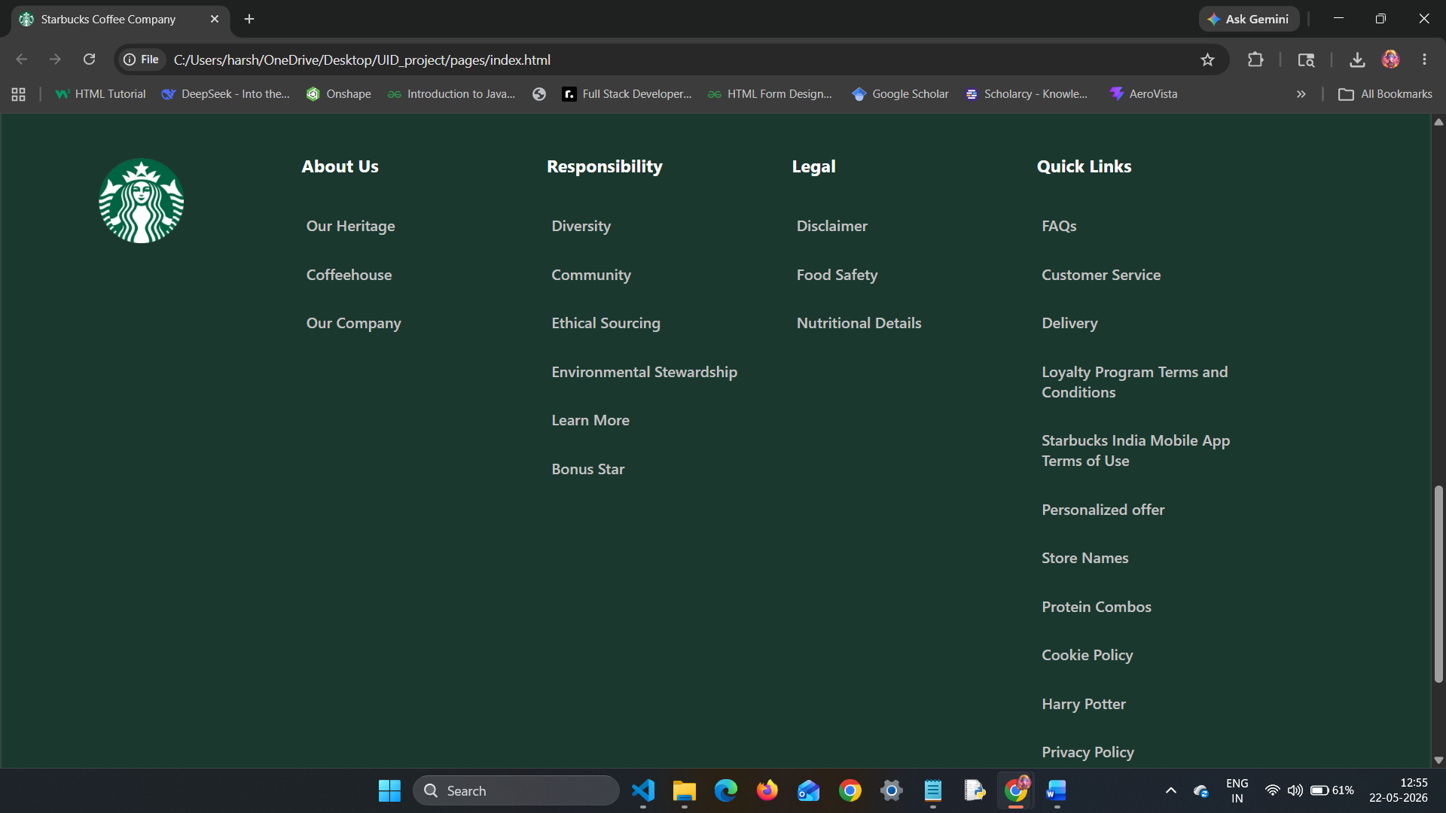
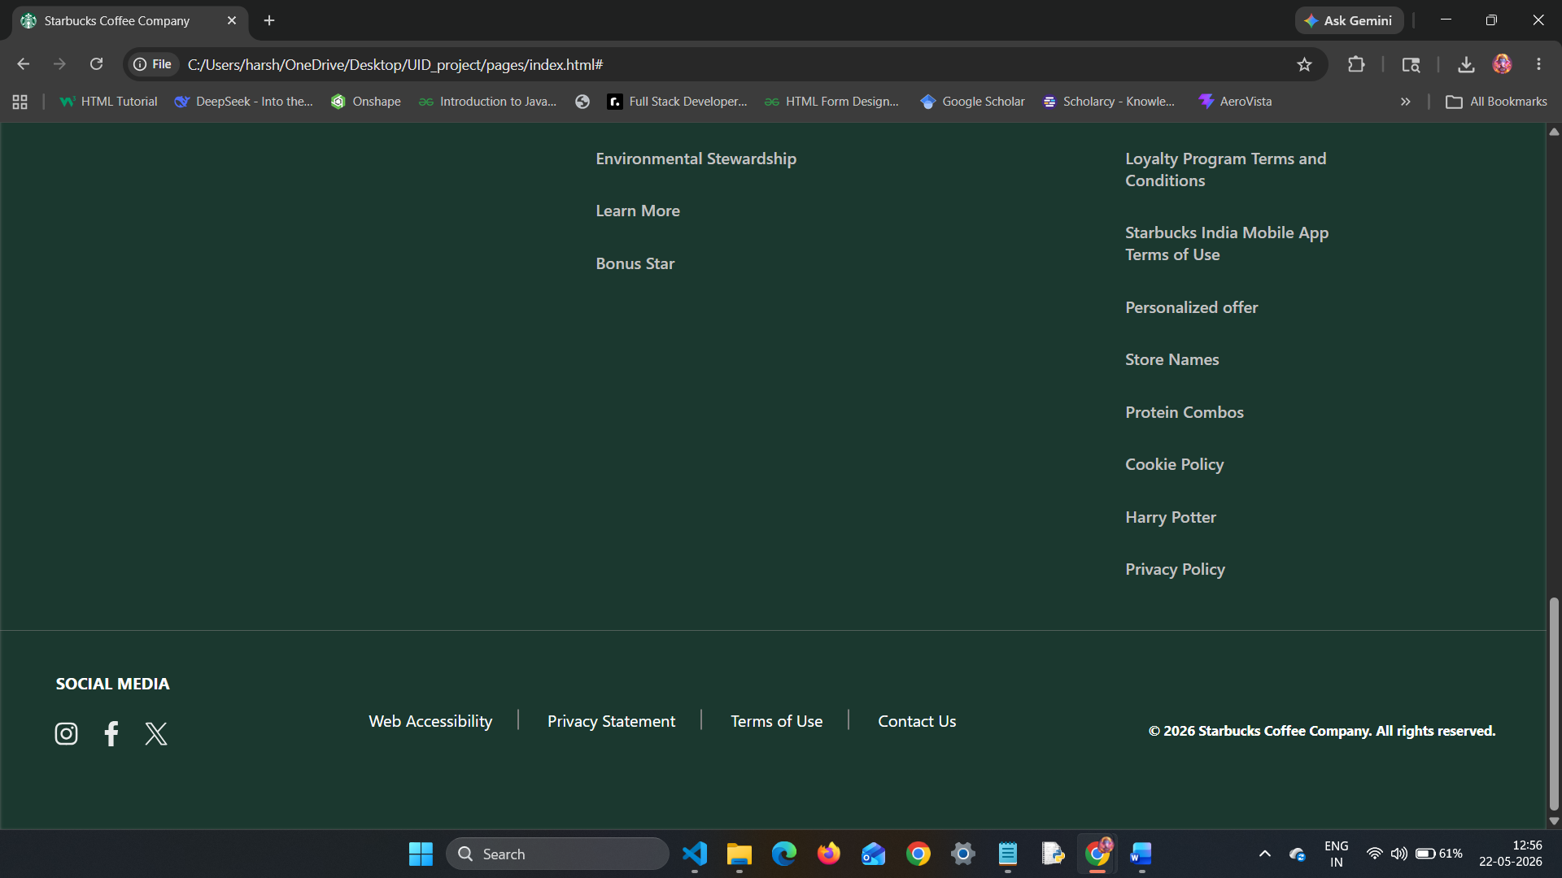
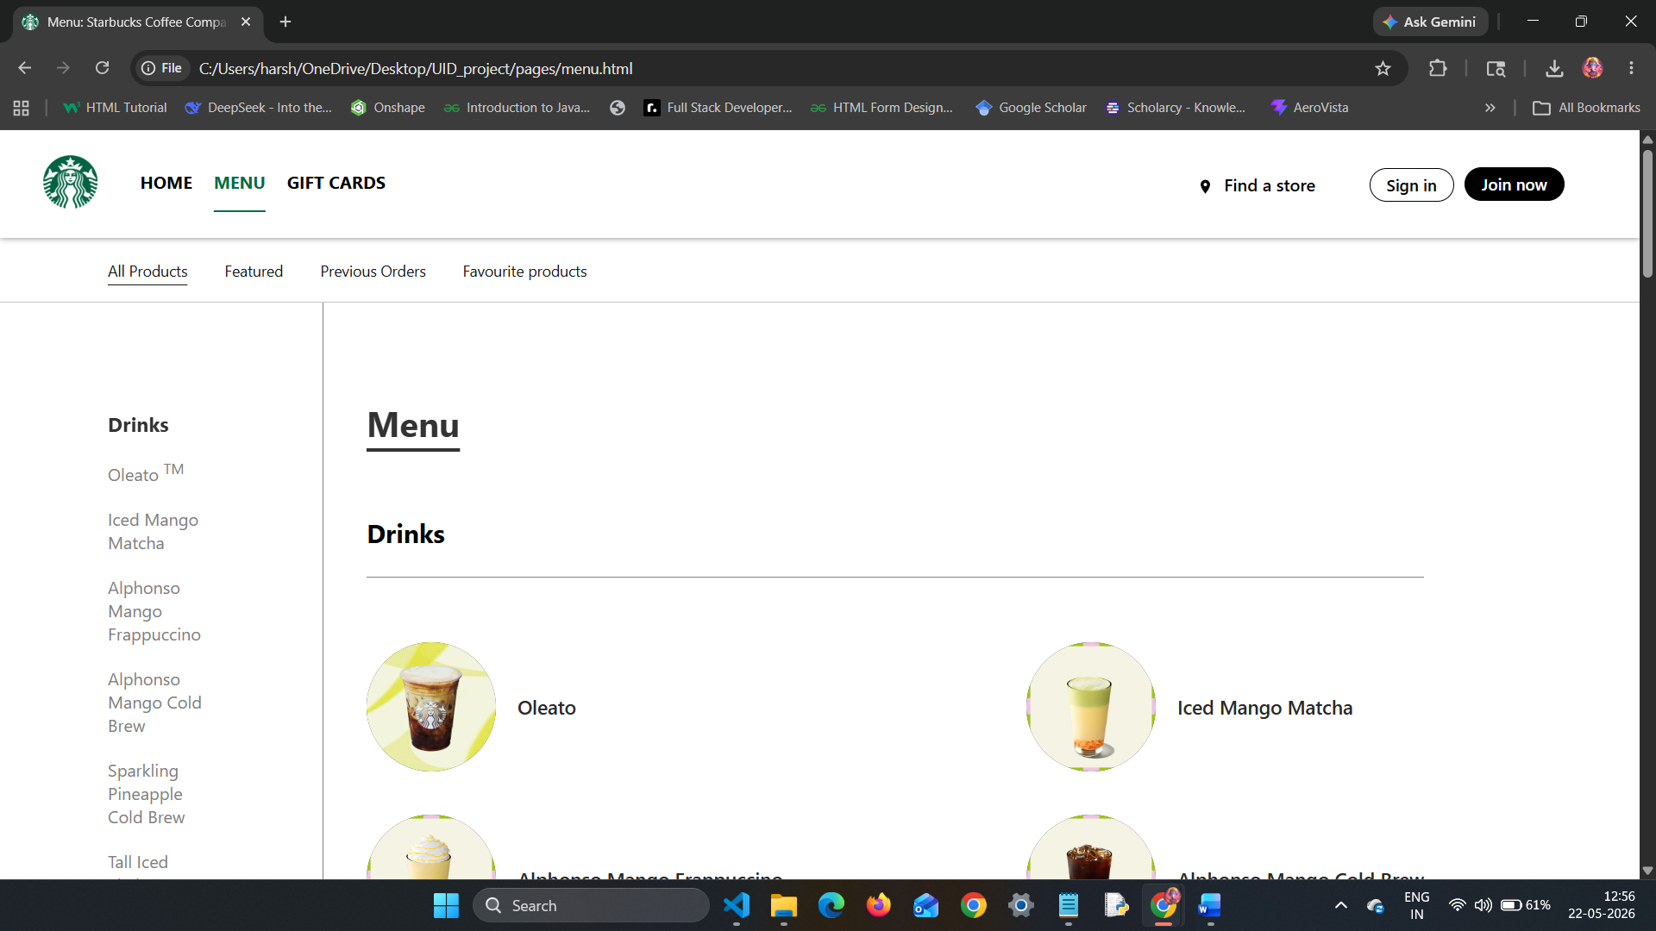
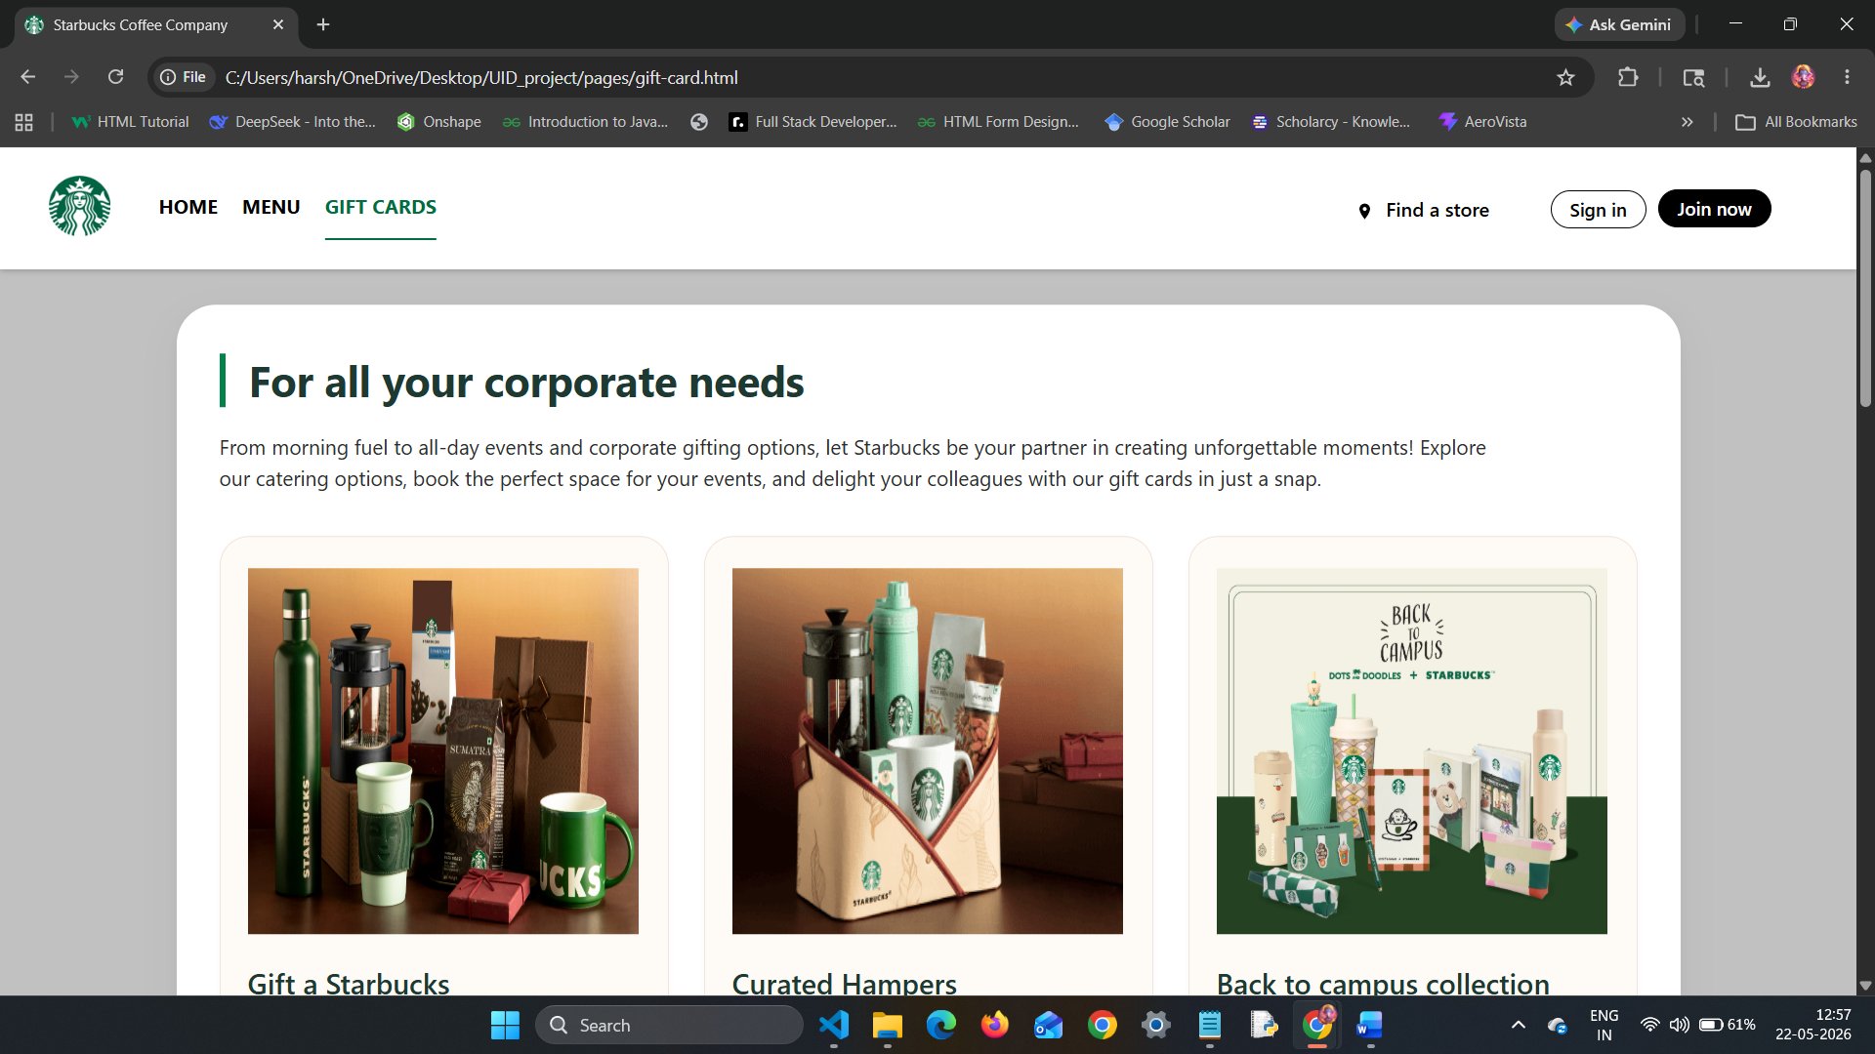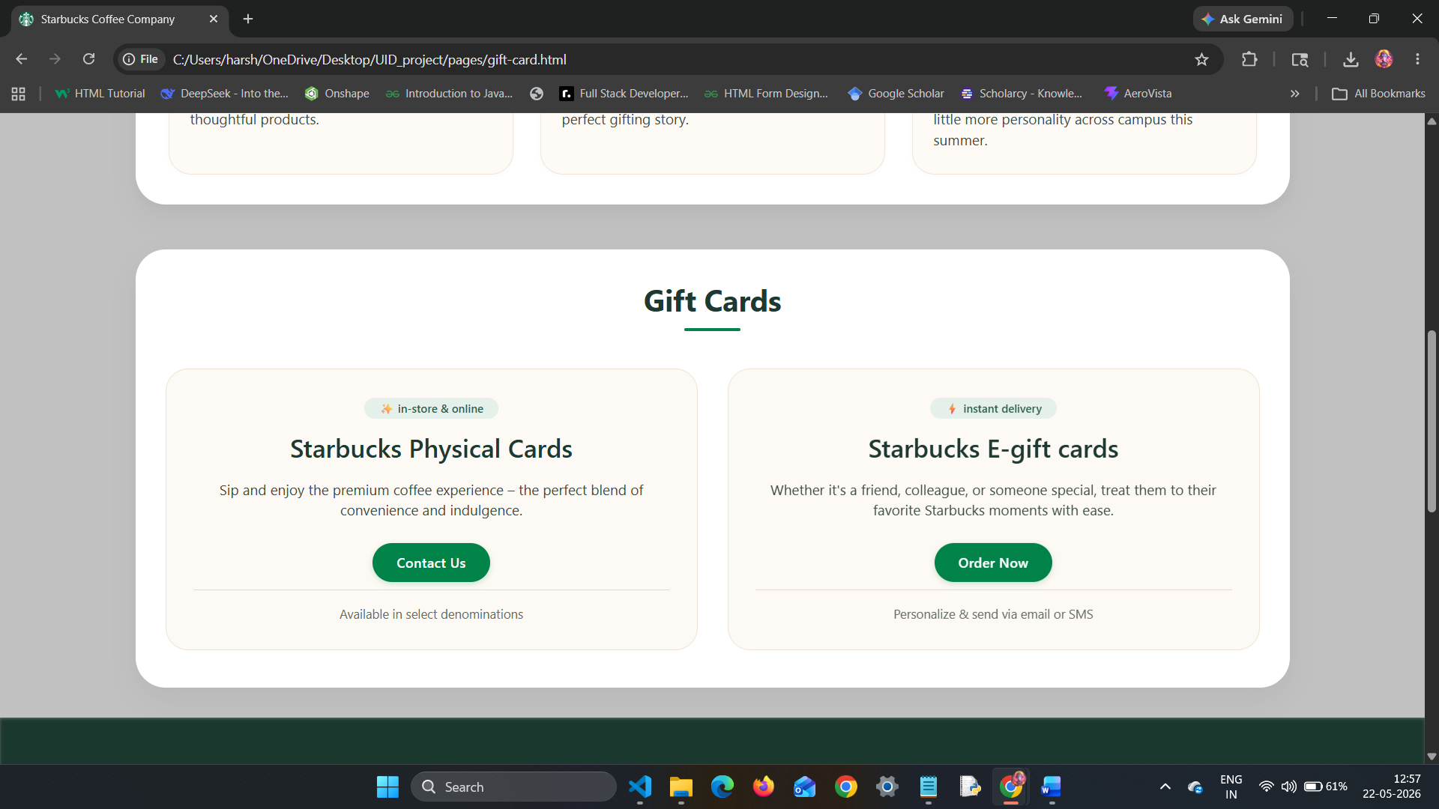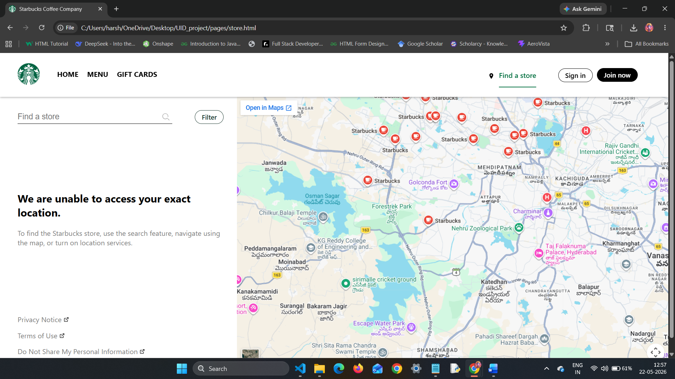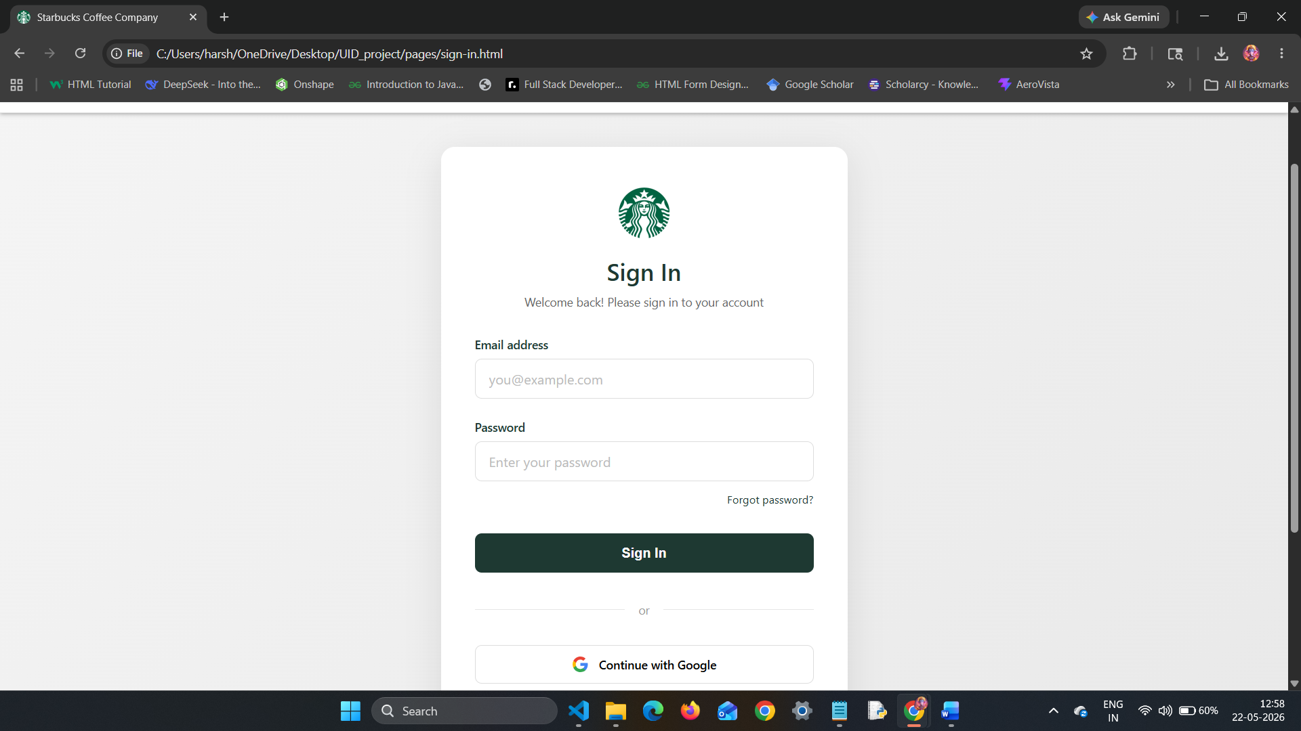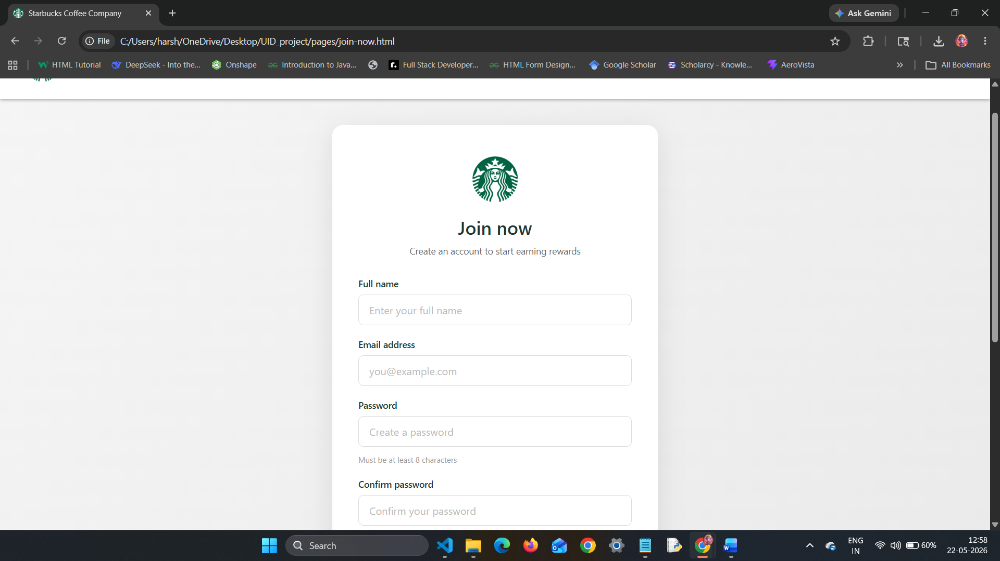
DETAILED TAG EXPLANATIONS:
HTML Tags
Tag | Usage in Project | Example
<!DOCTYPE html> | Declares HTML5 document type | <!DOCTYPE html>
<html lang="en"> | Root element with English language attribute | <html lang="en">
<head> | Contains meta information, title, CSS links | <head>...</head>
<meta charset="UTF-8"> | Enables special characters (₹, ©, ™) | <meta charset="UTF-8">
<meta name="viewport"> | Responsive scaling on mobile devices | <meta name="viewport" content="width=device-width, initial-scale=1.0">
<link> | Links external CSS and favicon | <link rel="stylesheet" href="../style/index.css">
<title> | Sets browser tab title | <title>Starbucks Coffee Company</title>
<body> | Contains all visible page content | <body>...</body>
<header> | Semantic container for navigation/logo | <header>...</header>
<div> | Generic container for grouping elements | <div class="logo">
<img> | Displays images (logo, products, icons) | <img class="logo-img" src="../images/logo.webp" alt="logo">
<ul>, <li> | Unordered list for navigation and footer links | <ul><li>HOME</li></ul>
<a> | Hyperlinks for navigation between pages | <a href="menu.html">MENU</a>
<footer> | Semantic container for footer content | <footer>...</footer>
<h1> to <h6> | Heading tags (h1, h2, h3 used for titles) | <h2>Mango season is here</h2>
<p> | Paragraph text for descriptions | <p>The flavour of the season...</p>
<pre> | Preformatted text (used for disclaimer) | <pre>An average active adult...</pre>
<form> | Container for sign-in/join forms | <form class="signin-form">
<input> | Form fields (text, email, password, checkbox) | <input type="email" id="email" required>
<label> | Labels for form inputs | <label for="email">Email address</label>
<button> | Clickable buttons (sign-in, join, buy now) | <button type="submit" class="signin-btn">Sign In</button>
<iframe> | Embeds Google Maps | <iframe src="https://www.google.com/maps?...">
<script> | Links external JavaScript file | <script src="../style/app.js"></script>

CSS Properties
Property | Usage | Example
display: flex | Creates flexible layouts (header, footer, product rows) | .nav { display: flex; }
display: grid | Creates grid layouts (menu page 2-column) | .menu { display: grid; grid-template-columns: 300px auto; }
position: fixed | Fixes top wrapper while scrolling | .top-wrapper { position: fixed; }
@media | Responsive breakpoints (1024px, 800px) | @media only screen and (max-width:1024px)
animation | Infinite marquee banner movement | animation: marquee 18s linear infinite;
transform: rotate() | Rotates footer arrow icons | transform: rotate(180deg);
border-radius: 50% | Creates circular product images | .order-items div { border-radius: 50%; }
object-fit: cover | Background image sizing for coffee card | background-size: cover;
::before pseudo-element | Creates vertical divider pipe in footer | .copy-desc a:not(:first-child)::before
box-shadow | Adds depth to cards and header | box-shadow: 0 12px 30px rgba(0,0,0,0.05);

JavaScript Concepts
Concept | Usage | Code Example
document.querySelector() | Selects DOM elements | const bar = document.querySelector("#bar");
addEventListener() | Attaches event handlers | bar.addEventListener('click', () => {...});
Arrow functions | Compact function syntax | () => { nav.style.left = '20%'; }
DOM manipulation | Changes element styles/properties | bar.style.display = 'none';
window.addEventListener('resize') | Responsive window resize handler | window.addEventListener('resize', () => {...});
Spread operator [...] | Converts NodeList to array | const cards = [...track.children];
forEach() loop | Iterates through arrays | cards.forEach((card) => {...});
cloneNode(true) | Deep clones DOM elements | const clone = card.cloneNode(true);
classList.contains() / add() / remove() | Toggles CSS classes | e.classList.contains('temp')
nextElementSibling | Traverses to next sibling element | e.parentElement.nextElementSibling

KEY FEATURES EXPLANATION:
Feature | How It Works
Infinite Marquee Banner | JavaScript clones all banner cards and appends to .marquee-track. CSS animation moves track left by 50% of its width, creating seamless loop. Pauses on hover.
Menu | On screens <1024px, .nav is positioned absolutely with left: 100% (hidden). Clicking bars sets left: 20% (showing sidebar). Clicking cross resets to 100%.
Expandable Footer | On mobile, .footer-list has display: none. Clicking arrow toggles to block and rotates arrow 180 degrees using CSS transform.
Active Page Highlight | Each page has an id on its nav link (e.g., id="home" on home page). CSS adds green underline with text-decoration: underline and text-underline-offset: 20px.
Circular Product Images | .order-items div has width: 120px, height: 120px, border-radius: 50%, and overflow: hidden. Image fills 100% of container.
Google Maps Integration | Simple iframe embed with src="https://www.google.com/maps?q=Starbucks&output=embed" displays interactive store map.

CONCLUSION:
The Starbucks Coffee Company website clone successfully demonstrates a fully responsive, multi-page front-end web application with consistent branding, interactive components (marquee banner, mobile menu, expandable footer), and multiple functional pages (home, menu, store, sign-in, join now, gift cards). The project showcases proficiency in:
- HTML5 for semantic structure across 7 interconnected pages
- CSS3 for responsive design, animations, and complex layouts (CSS Grid, Flexbox)
- JavaScript for DOM manipulation, event handling, and interactive UI components
- External libraries (Google Maps Embed API)
- Cross-page navigation with active page highlighting
- Mobile-first responsive design with two breakpoints (1024px, 800px)
The code is well-organized with separate CSS files for each page, a shared JavaScript file for common functionality, and a consistent design system throughout.

