**UR CABS Requirements Document**  
Started date: 2/08/2024 End Date: 30/08/2024  
  
  
 **Production Team**

* Project Admin: Dushadhini
* Designer Team: Suriya
* Development Team: Thiyoni Raj
* App Developer: Manoj
* Tester Team: Guru venkatesh

**Overview of the project:** · Website with CRM

· Customer Android App

· Driver Android App

**Domain:** urcabs.in   
  
**Mail id:** admin@urcabs.in , support@urcabs.in (needs to be create)  
  
**Logo : Not Chosen  
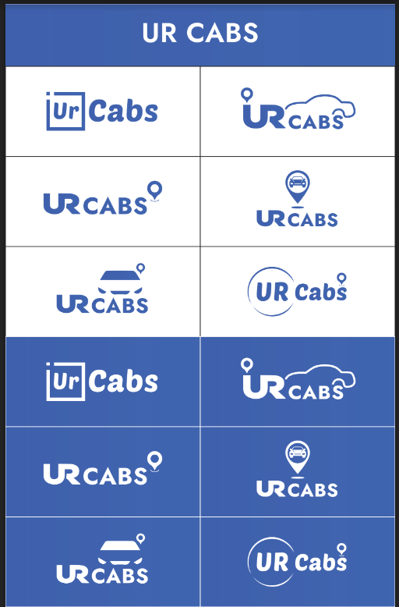  
  
  
Reference site:**1.<https://eshandroptaxi.in/>  
2. <https://saradroptaxi.in/>  
3. <https://sndroptaxi.com/>

**Website Design:**

1. **Home Page**
   * Introduction and overview of services.
   * Links to main sections: T&C, Contact, Partners/Drivers.
   * Need Book Now button.
   * In that   
      - Book your one way trip  
      - Book your round trip
2. **Online Booking Process**
   * Instant Online Quote: Users enter journey details (start, end)
   * New Customer Registration: First name, last name, email, mobile, address, password.
   * Existing Customer Login: Email and password.
   * Booking Details: Personal and passenger details, journey specifics (pick-up/drop-off locations, date, time), payment options.
3. **Fleet Information**
   * Description of available vehicles: Car, People Carrier, Executive People Carrier, 8 Seater Minibus.
   * Capacity and pricing details for each vehicle type.
4. **Service Information**
   * Detailed explanation of services offered: Airport Taxi Service, City Transport, Business Transport, Regular Transport, Tour Transport.
   * Additional options: Meet and Greet service, flight tracking.
5. **Contact** 
   * Address,Phone number, Mail id, Location

**CRM**Job Booking Modules

Driver Live location monitoring

Admin assigning

Zone base price / Google Mileage / Fixed Price Management

Special Day / Special Time Price

Promo code Management

Payment Management

· Weekly Auto Settlement with report ( Driver &amp; Admin )

· Driver Payment

Invoice Management

· Corporate

· End-user

· Dealer

User info, Past history etc..

· Bulk Email, SMS  
· Bulk Notification using APP

Multiple attributes

Account user, Cash user

Find a Job / Driver & filters

Multiple Level Account, Roles, status, Colour etc…

Driver Management, Weekly Settlement, tracking, performance, Earning, Payment

history

Payment History, Analytics

Place, Area, Location

Passenger Management

Rate Management

Activity Monitoring Dashboard

Notification.

**1.Driver Management**   
 - Onboarding request both from Application and Website (Details to be fetched from the database and to display in Application with Driver Details) & approval option, Driver removal option  
  
**2.Passenger Management**   
  
 - Outstation requests with Location (Source and Destination), Contact Number - OTP Verified, Schedule details to be displayed  
  
 - City Travel with Location (source within the coverage area & destination), Contact details  
  
3.Access to Modify the Rates per Car Category and Outstation Rentals. Dynamic (Automatic) price changes based on the factors like Peak / non-peak hours, Traffic congestion - Red / Orange

4.Activity Details - Driver / Vehicle Number wise, Alerts on change in Driver for same Car, Driver / Car / Customer on-boarding (initially), SOS alerts, Delay Alert if more than 30 minutes than the anticipated calculated time - fetch from customer application  
  
5.Notification push to Drivers or / and Passengers app about the updates  
  
  
**Driver App:**  
  
● Driver Registration with website request, after admin approval he/she can

access

● Geo-Location and Mobile Integration

● Credit Management

● Queue job / Completed Job

● Driver Tracking

● Job History

communication

● Chat with the Support Team

● Ticket Requests (like change in car details, Driver details if App managed by Owner)

● Messaging with Customers

Activity tracking

● Activity Logs

● Export Data(CSV & PDF)

Alerts and Notifications

Feedback System

● Customer Rating

**Passenger App:**

* Login & Sign up
* Booking
* Select the car pickup and drop-off
* Vehicle tracking
* Cancel jobs
* Driver Current Location
* Payment Cash / Card / Wallet
* Booking and Payment history
* Feedback System