Create Vehicle List Documentation

Seller Vehicle List create steps

Step 1 : Click the “Vehicle List Menu “

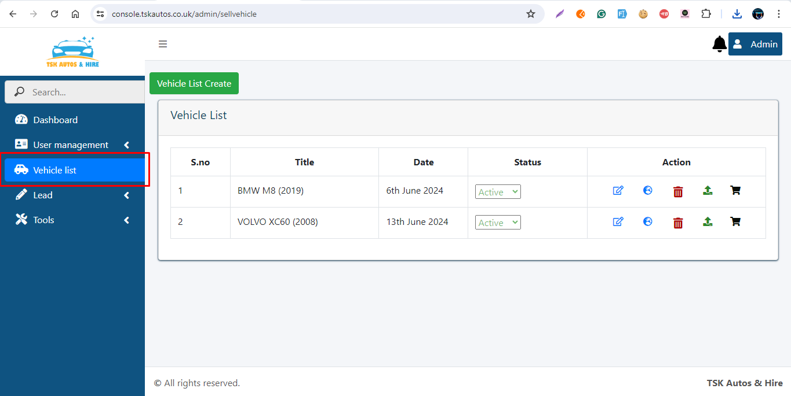

Step2 : Click the “Vehicle List Create” Button

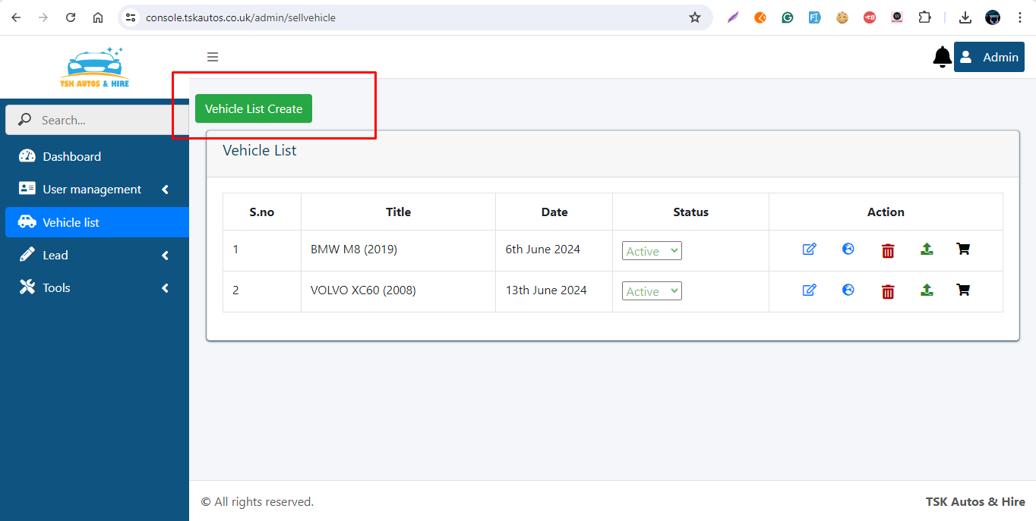

#### Step 3 : fill the “Car Brand & Model” Detail

#### 

#### Brand Input : Choose the Brand Name( Brand Name added Brand Menu)

#### Model Input : Brand Name Based Model name Load and choose the model name(Model name added model menu via brand based)

#### Register No : if Vehicle is used car when Register Number need or default metion None

#### Register No : Vehicle model year or Vehicle purchased year

#### Register Country : Vehicle Register Country

#### Register City : Vehicle Register City Name

#### Step 3 : fill the “Other Details”

#### 

#### Transmission Input : Choose the Transmission

#### 

#### Vehicle Status Input : choose the Vehicle New or Used Car

#### 

#### Engine Capacity CC : Fill the Engine Capacity

#### 

#### Fuel Type Input : Choose the Fuel Type

#### 

#### Color Input : choose the Color checkbox and Adjust the two colour radio range and click the save button when color automatically choosed

#### 

#### Milleage input : fill the Mileage via Miles

#### 

#### Vehicle Image : choose the vehicle website frontend view image

#### 

#### 

#### Step 4: Choose the “Vehicle Features”

#### if present in this vehicle choose the car features

#### 

#### Step 4: Fill “Client Details”

#### Fill the client details and vehicle price

#### 

#### Step 4: Fill “Meta Details (SEO)”

#### Meta details for rating details maintain

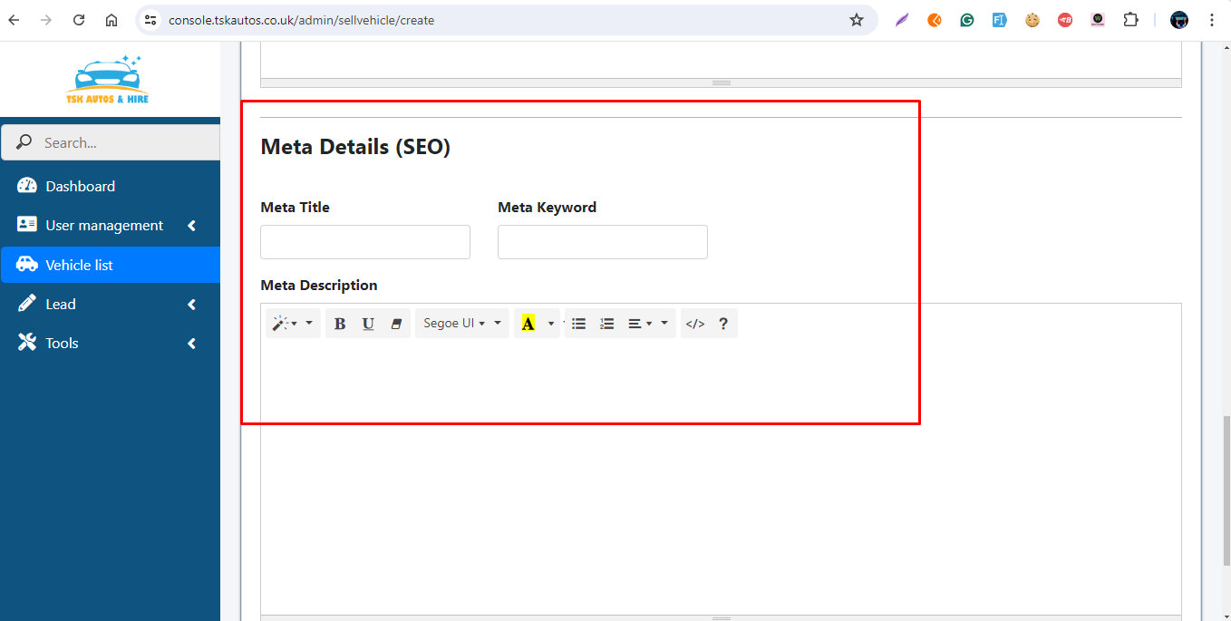

Step 6 : submit Button

Click the submit button, when go data save and go to vehicle list menu

Click the submit and continue button when data save and create page again , again create another vehicle list data

