Name:Ch.Srihitha
Roll No:2520030400

Skill - 1

Aim: To capture network packets and understand how Ethernet, IP, and TCP/UDP headers are added during data transmission.

Step 1: Install Wireshark

- Open the browser.
- Install Wireshark Wireshark • Go Deep | Download
- Install it using the default settings.
- Open Wireshark.

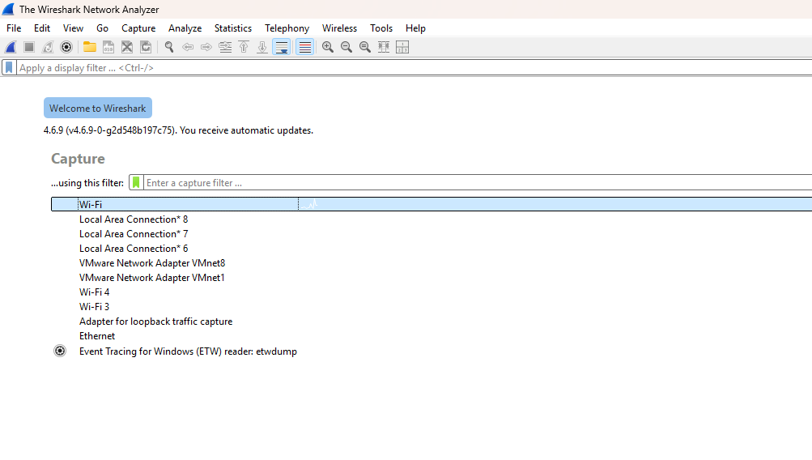

Step 2: Select your network interface
When Wireshark opens, you will see interfaces such as:
Wi-Fi, Ethernet, Bluetooth
- If you are connected through Wi-Fi, select Wi-Fi.
- Double-click the Wi-Fi interface.
- Packet capture will start.

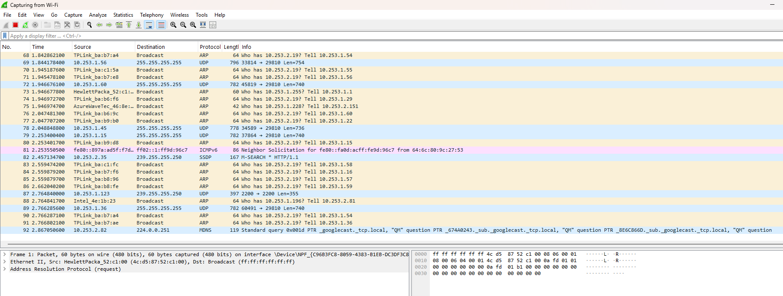

Step 3: Generate network traffic While Wireshark is capturing:
- Open a new browser tab.
- Visit a website such as https://www.google.com.
- Open two or three different websites.
- Wait for approximately 30 seconds.
- Return to Wireshark.
- Click the red Stop button.

You should now see captured packets.

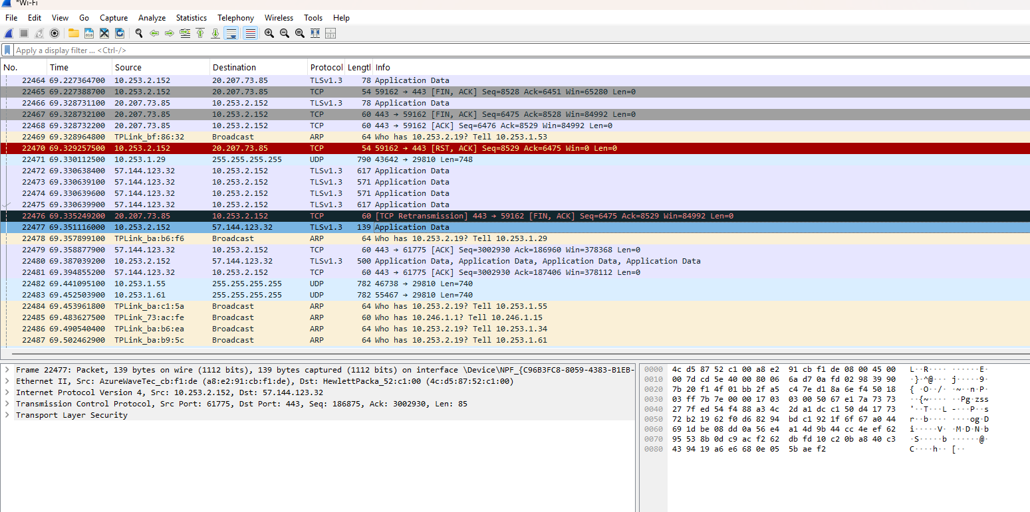

Step 4: Apply display filters
In the Wireshark filter bar, enter each filter separately and press Enter.

Filter | Purpose
tcp | Displays TCP packets
udp | Displays UDP packets
icmp | Displays ICMP packets
tcp.len > 0 | Displays TCP packets carrying data

tcp:
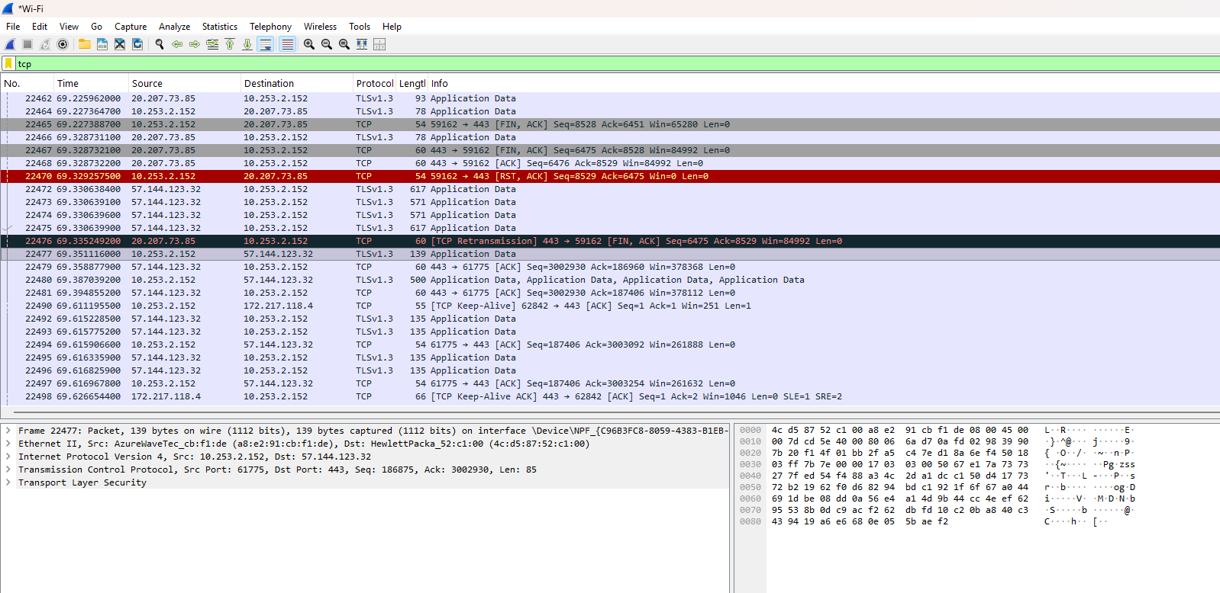
udp:
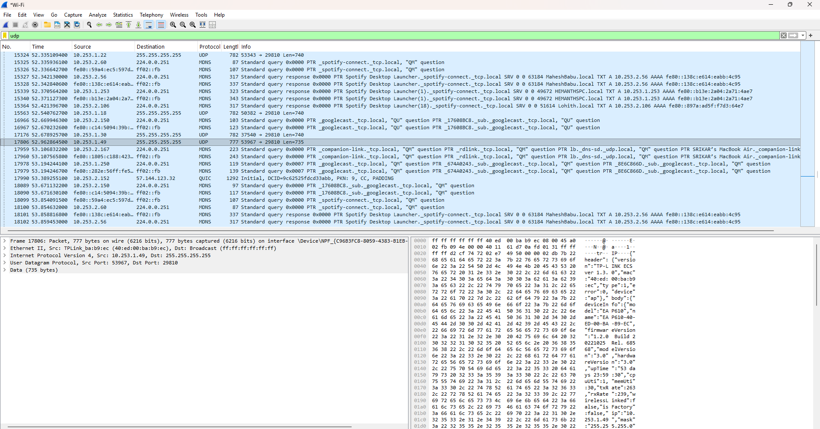

icmp:
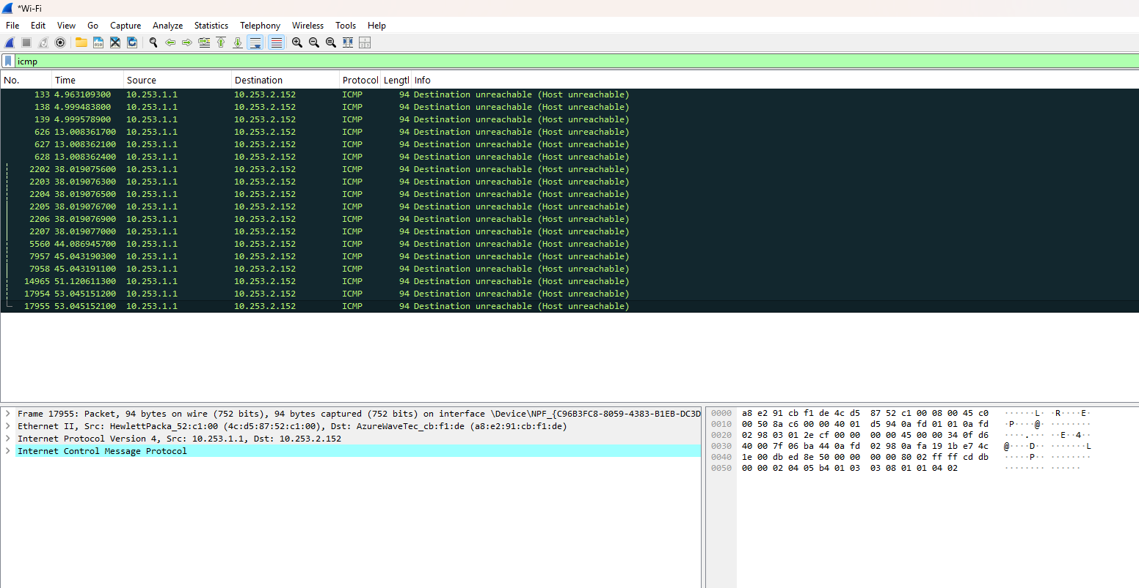
tcp.len>0:
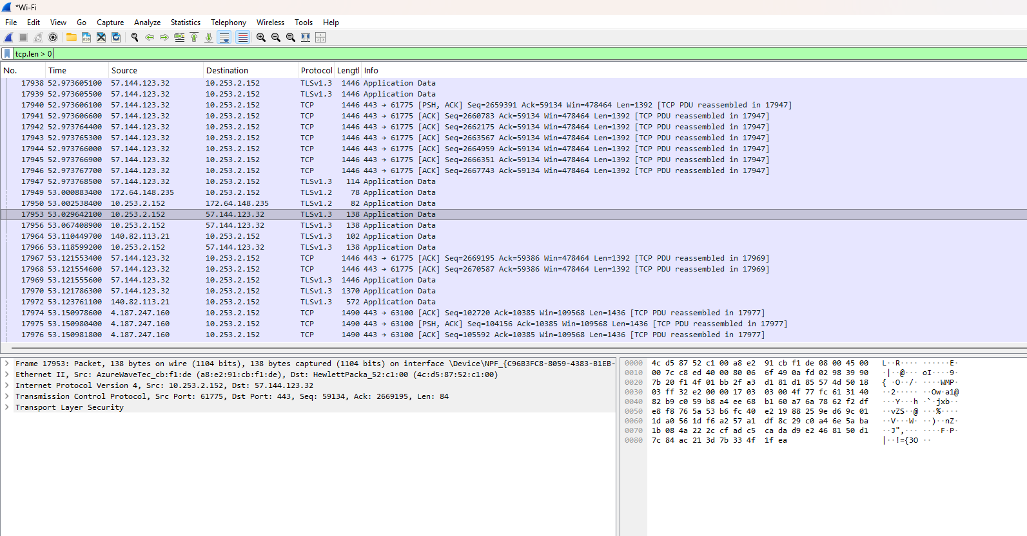

Step 5: Inspect packet headers
Select any TCP packet from the packet list.

In the packet details pane, expand these sections:
- Frame
- Ethernet II
- Internet Protocol Version 4
- Transmission Control Protocol

Record the following values:

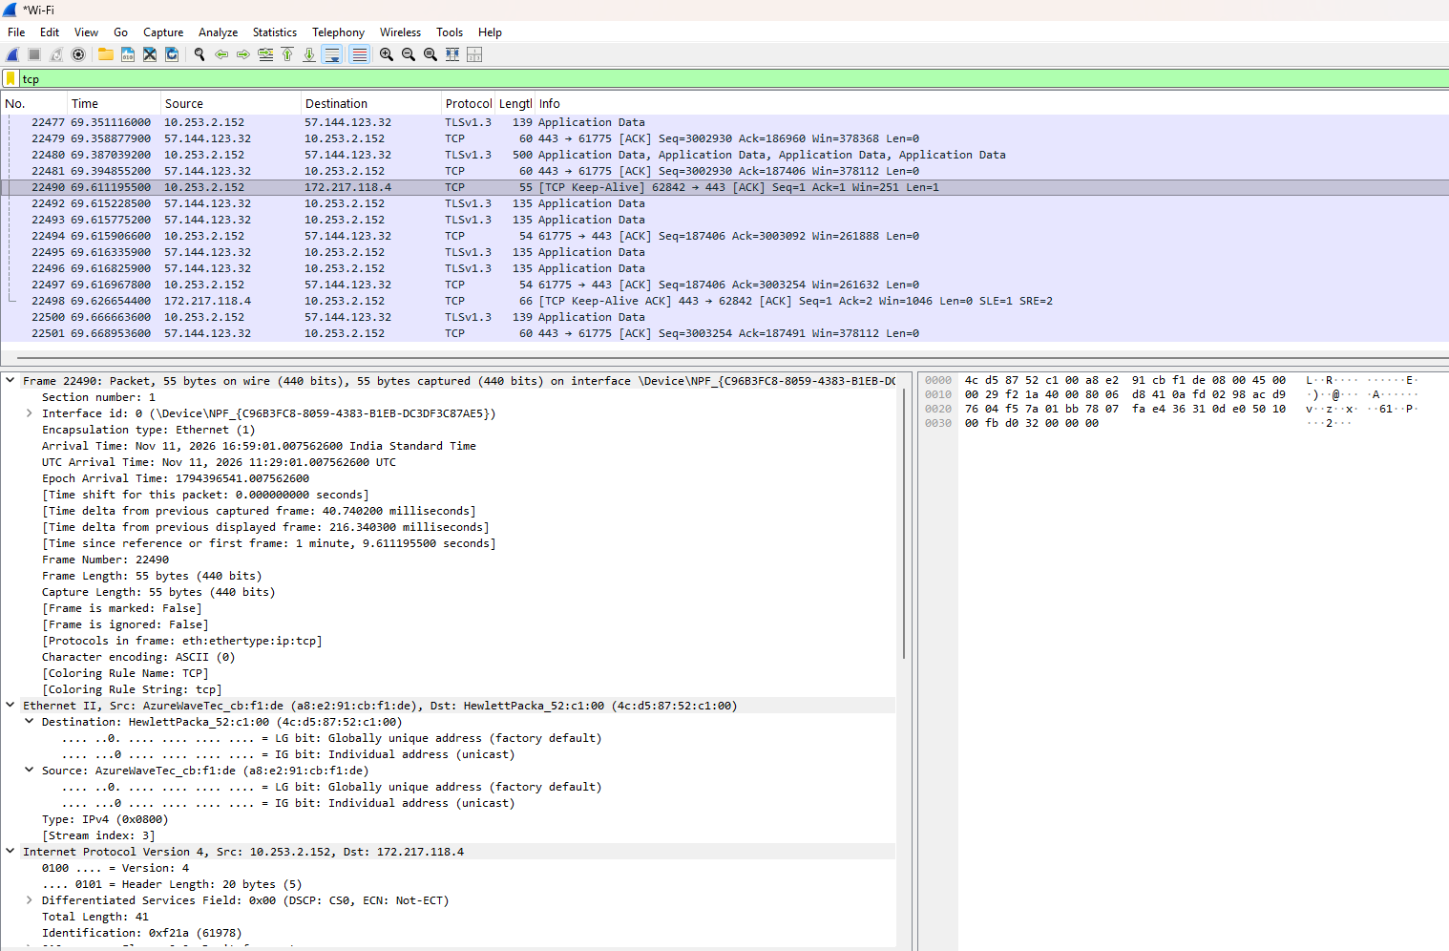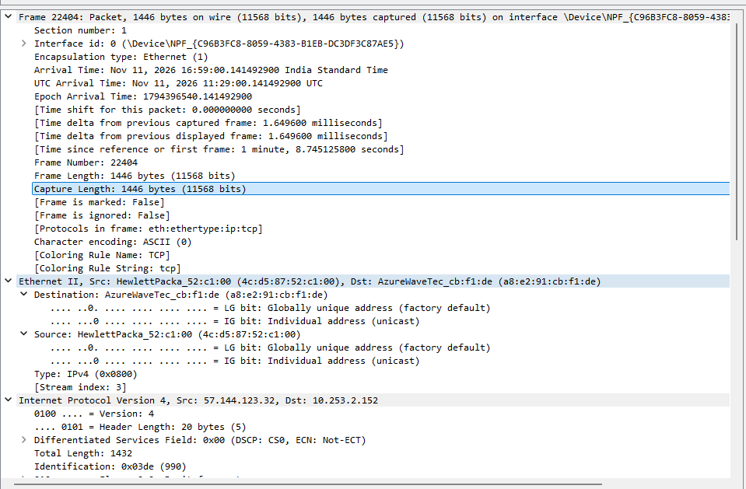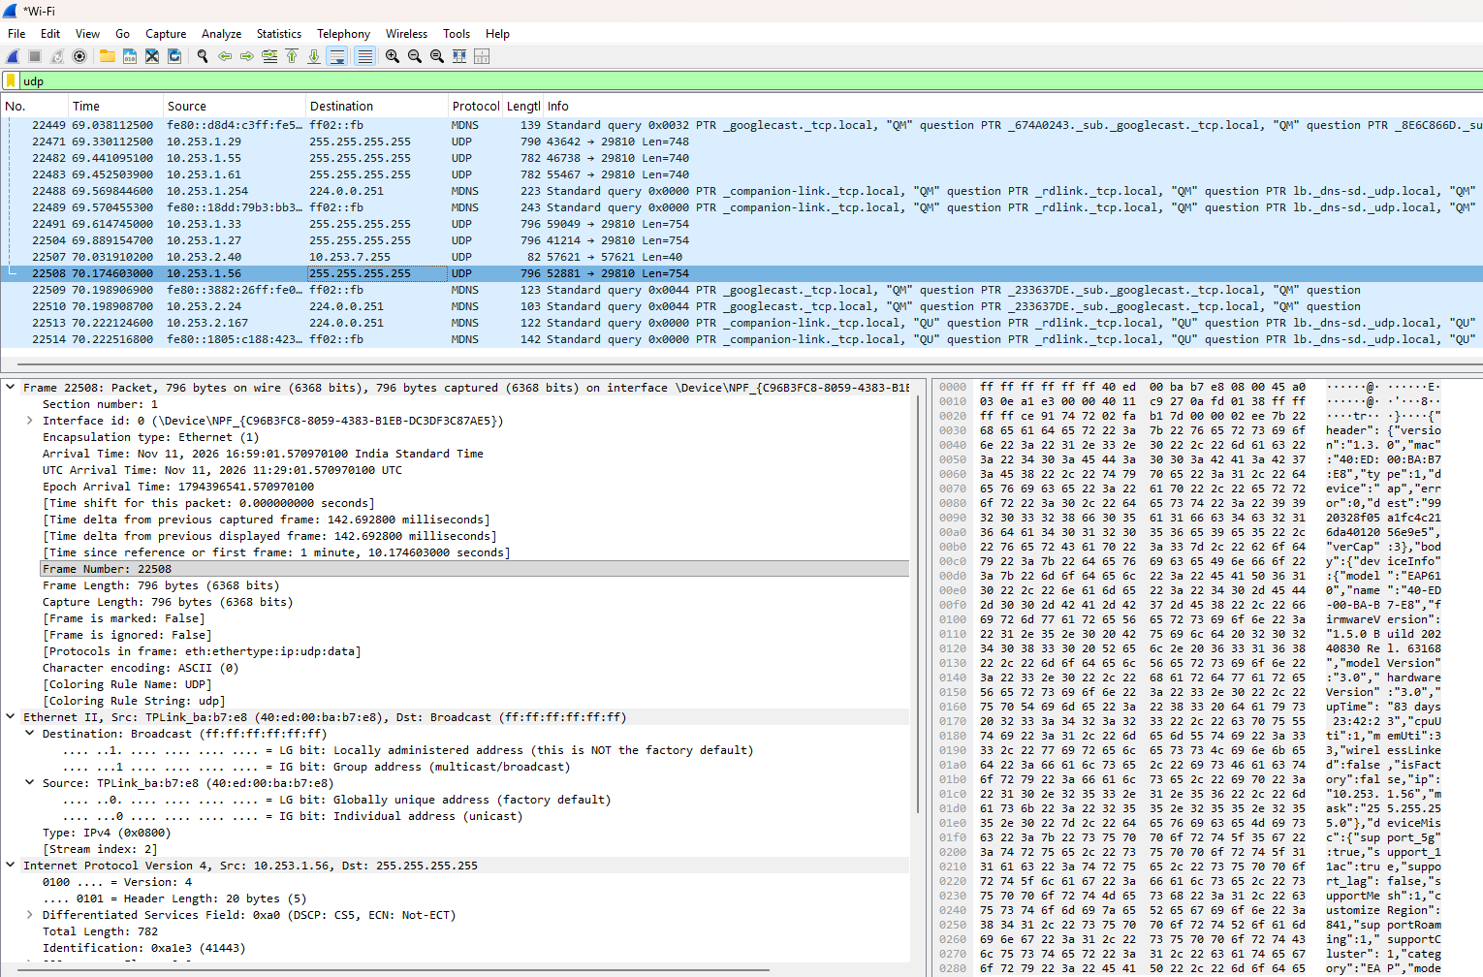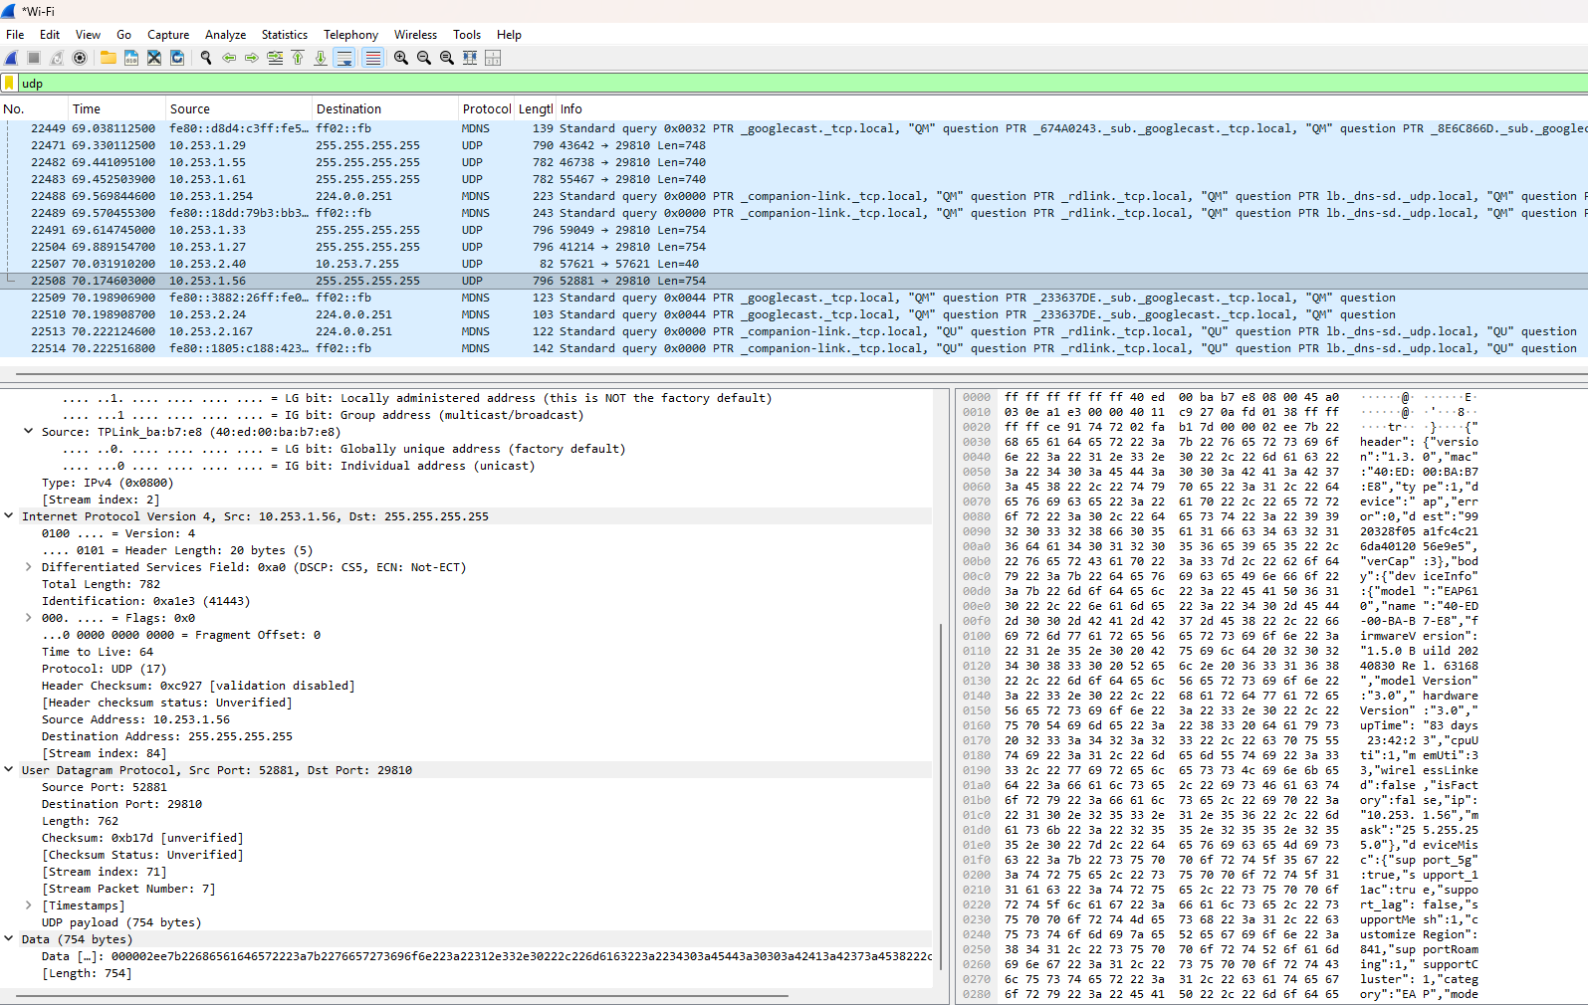

Parameter | Where to find it
Frame length | Frame
Ethernet Header | Ethernet II
Source MAC Address | Ethernet II
Destination MAC Address | Ethernet II
IPv4 Header Length | Internet Protocol Version 4
IPv4 Total Length | Internet Protocol Version 4
TCP Header Length | Transmission Control Protocol
TCP Segment Length | Transmission Control Protocol

Repeat the process for one UDP packet. Observe the UDP header and its length field.

Step 6: Calculate header overhead
For a basic Ethernet + IPv4 + TCP packet without TCP options:
TCP Calculation
Header Overhead = 14 + 20 + 20 = 54 bytes
Payload Efficiency = (1392 / 1446) × 100
= 96.27%
Overhead = (54 / 1446) × 100
= 3.73%
UDP Calculation
Header Overhead = 14 + 20 + 8 = 42 bytes
Payload Efficiency = (754 / 796) × 100
= 94.72%
Overhead = (42 / 796) × 100
= 5.28%

Steps to save a capture file

Step 1: Start capturing packets

1.Open Wireshark
2.Select your Wi-Fi or Ethernet interface.
3.Double-click the interface to start capturing packets.

Step 2: Stop the capture

Once you have generated sufficient network traffic:
- Click the red Stop button (top-left corner).
- Your captured packets will remain visible on the screen.

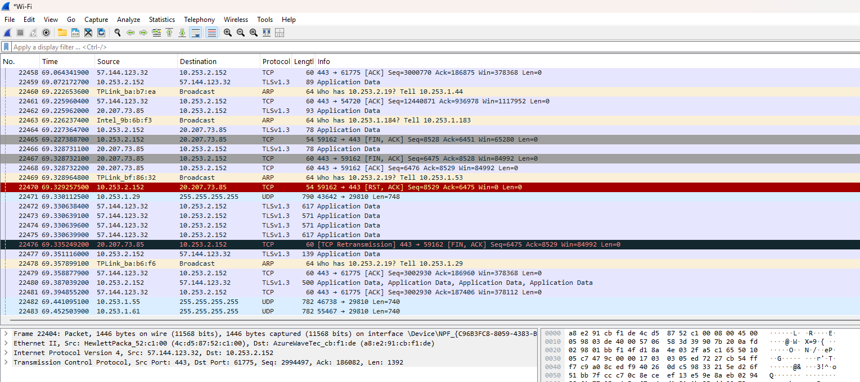

Step 3: Save the capture
  - Click File in the menu.
  - Select Save As.
  - Choose the folder where you want to save the file.
  - Enter a filename.
  - Keep the file format as pcapng.
  - Click Save.
For example: sender_capture.pcapng


