Vukanti Srihitha Reddy

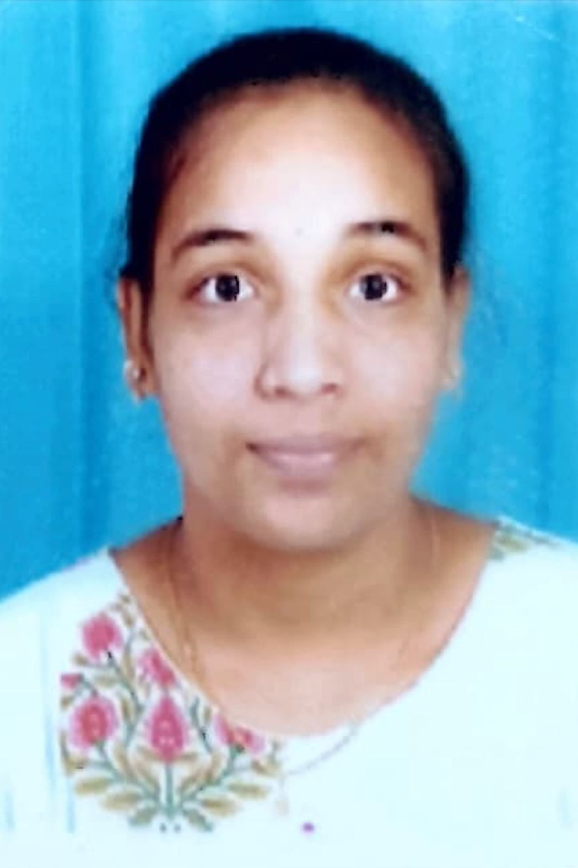

[srihithareddy0012@gmail.com](mailto:srihithareddy0012@gmail.com)

6305816668

Date of Birth: Dec. 12, 2001

**OBJECTIVE**

I am a Computer Science enthusiast with a problem-solving mindset, great team management, adaptability and communication skills as my assets . I strongly believe that my desire to learn and grow add to my skills and abilities. I am looking forward to a role where I get to leverage my skills and accelerate my growth while making a significant contribution to the growth of the firm.

**EDUCATION**

|  |  |  |  |
| --- | --- | --- | --- |
| **Course** | **Name of the Institution** | **Year of Passing** | **Percentage/GPA** |
| BTech | Teegala Krishna Reddy Engineering College | 2023 | 72.3 |
| Diploma | Jyothishmathi institute of technology and science | 2020 | 70.50 |
| High School | Brilliant Grammar High School | 2017 | 7.7 |

**PROJECT**

Chirography Documentation Using OCR in CNN Aug. 16, - Jan. 22, 2023 (**Mini Project**)

Team Size:3

Key Skills: Python, Google Colaboratory, Python

Energy efficient teaching-learning-based optimization for the discrete routing problem in wireless sensor networks. Feb 07 – Jun 20, 2023 (**Major Project**)

**DECLARATION**

I hereby declare that the above-mentioned information correct up to my knowledge and I bear the responsibility for the correctness of the above-mentioned particulars.

**SKILLS/KEY EXPERTISE**

**SOFT SKILLS:-**

Empathy

Resourceful

Organized

Detailed-oriented

Problem-solver

**TECHINCAL SKILLS:-**

C Language

C++

Java

Python(Begineer)

**INTERNSHIPS**

-> **Data Visualisation: Empowering Business with Effective Insights by TATA Company** Completed practical task modules in: Framing the Business Scenario Choosing the Right Visuals Creating Effective Visuals Communicating Insights and Analysis

-> **Software Engineering Virtual Experiences** Completed practical task modules in: Interface with stock price data feed Using JPMorgan Chase frameworks and Tools Display data visually for traders

**-> Developer & Technology Accenture Developer Program** Completed practical task modules in: Debugging algorithms Unit testing, User Acceptance Testing (UAT), Security Maturity Assessment, IAM policies and permissions, Securing the software development lifecycle (SDLC), shaping the problem Data and privacy.

**LANGUAGES**

English, Telugu, Hindi

**Date: 13-06-2023**

**(Vukanti Srihitha Reddy)**