# Terms and conditions

1. **My Bus**



**MyBus Helpine**

18000456789

**I**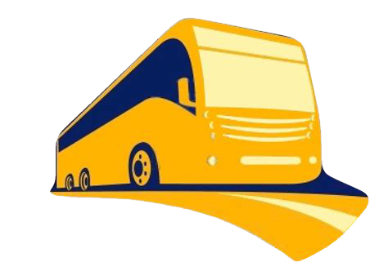

**Chennai**

**to**

**Coimbatore**

**Tuesday,June 01,2021**

**Morning Star Travels**

**Travels**

**Passenger name**

Ms. Radhika G

**Ticket No:**

THDT77749224

**Seat number(s)**

M21

**PNR No:**

E69690MLL8B

**Bus type**

Volvo A/C -Multi Axle Semi Sleeper (2+2)

**Reporting time**

PM

04:30

**Boarding point address**

**Location:**

Paradise Van Pickup

**Landmark:**

Opp. Paradise Hotel

**Total fare**

Rs. 800/-

**Departure time**

04:45

PM

**Address:** Morning Star Travels, Opp. Paradise Hotel,

Chennai,Tamil Nadu.

**Contact No:**27872949**,** 66387560

Female

**Gender:**

1. myBus* is ONLY a bus ticket agent. It does not operate bus services of its own. In order to provide a comprehensive choice of bus operators, departure times and prices to customers, it has tied up with many bus operators.

myBus' advice to customers is to choose bus operators they are aware of and whose service they are comfortable with.

**myBus' responsibilities include:**

* + 1. Issuing a valid ticket (a ticket that will be accepted by the busoperator) for its' network of bus operators
    2. Providing refund and support in the event of cancellation(3) Providing customer support and information in case of any delays / inconvenience **myBus' responsibilities do NOT include:**
    3. The bus operator's bus not departing / reaching on time
    4. The bus operator's employees being rude
    5. The bus operator's bus seats etc not being up to the customer'sexpectation
    6. The bus operator canceling the trip due to unavoidable reasons
    7. The baggage of the customer getting lost / stolen / damaged(6) The bus operator changing a customer's seat at the last minute to accommodate a lady / child
    8. The customer waiting at the wrong boarding point (please call thebus operator to find out the exact boarding point if you are not a regular traveler on that particular bus)
    9. The bus operator changing the boarding point and/or using a pickup vehicle at the boarding point to take customers to the bus departure point

1. The departure time mentioned on the ticket are only tentative timings. However the bus will not leave the source before the time that is mentioned on the ticket.

**My Bus contact details**

**Ahmedabad**

|

(079) 39412345

**Kolkata**

|

(033) 39412345

**Bangalore**

|

(080) 39412345

**Mumbai**

|

(022) 39412345

**Chennai**

|

(044) 39412345

**Pune**

|

(020) 39412345

**Coimbatore**

|

(0422) 3941234

**Vijayawada**

|

(0866) 3941234

**Delhi**

|

(011) 39412345

**Vizag**

|

(0891) 3941234

**Hyderabad**

|

(040) 39412345

**Whom should I call?**

**Boarding point related**

|

Bus operator (# on top of the ticket)

**Timing related queries**

|

Bus operator (# on top of the ticket)

**Cancellation**

|

redBus

**Refund**

|

redBus

1. Passengers are required to furnish the following at the time of boarding the bus:
   1. A copy of the ticket (A print out of the ticket or the print out of the ticket e-mail).
   2. A valid identity proof

Failing to do so, they may not be allowed to board the bus.

1. Change of bus: In case the bus operator changes the type of bus due to some reason, myBus will refund the differential amount to the customer upon being intimated by the customers in 24 hours of the journey.
2. Amenities for this bus as shown on myBus have been configured and provided by the bus provider (bus operator). These amenities will be provided unless there are some exceptions on certain days. Please note that myBus provides this information in good faith to help passengers to make an informed decision. The liability of the amenity not being made available lies with the operator and not with myBus.
3. In case one needs the refund to be credited back to his/her bank account, please write your cash coupon details to support@myBus.in * The home delivery charges (if any), will not be refunded in the event of ticket cancellation
4. In case a booking confirmation e-mail and sms gets delayed or fails because of technical reasons or as a result of incorrect e-mail ID / phone number provided by the user etc, a ticket will be considered 'booked' as long as the ticket shows up on the confirmation page of www.myBus.in
5. Grievances and claims related to the bus journey should be reported to myBus support team within 10 days of your travel date.

|  |  |
| --- | --- |
| **Cancellation time** | **Cancellation charges** |
| After **12:30 PM** on 28th May | Rs. 600 |
| Between **08:30 PM** on 24th May-**12:30 PM** on 28th May | Rs. 300 |
| Between **08:30 PM** -09:00PM on 20th May | Rs. 150 |
| Till **08:30 PM** on May20 | Rs. 60 |