**Design Principles and Pattern Assignment**

1. You have a Smartphone class and will have derived classes like IPhone, AndroidPhone, WindowsMobilePhone can be even phone names with brand, how would you design this system of Classes.

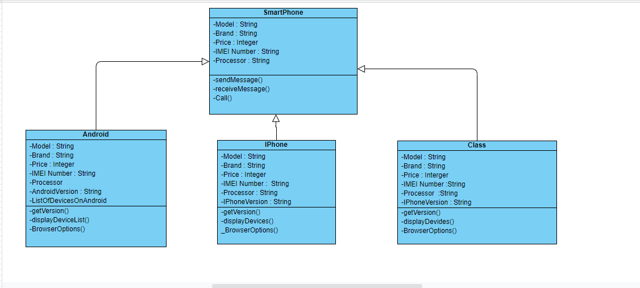

2.Write classes to provide Market Data and you know that you can switch to different vendors overtime like Reuters, wombat and may be even to direct exchange feed, how do you design your Market Data system.

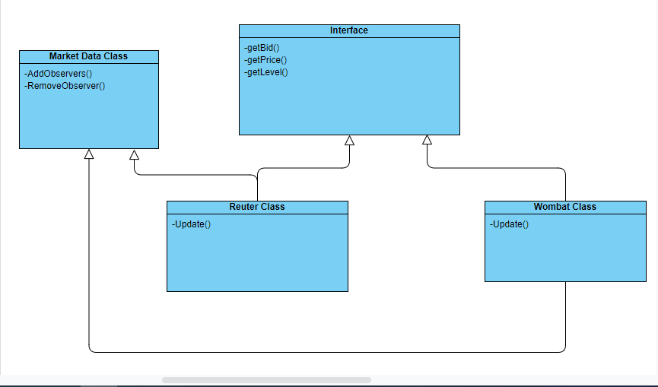

3.What is Singleton design pattern in Java? write code for thread-safe singleton in Java and handle Multiple Singleton cases shown in slide as well.

Singleton pattern says that just “define a class that has only one instance and it provides a point of global access. It has only single instance that should be created and single object can be used by all other classes.

Thread Safe Singleton

public class SingletonImplementation

{

private static SingletonImplementation instance;

private SingletonImplementation ()

{

// Statements

}

synchronized public static SingletonImplementation getInstance ()

{

if (instance == null)

{

instance = new () SingletonImplementation ();

}

return instance;

}

}

4. Design classes for Builder Pattern.

The builder pattern is an alternative way to represent complex objects, relationships and their actions.

