**JavaScript Assigment**

1. var add = (function(){

var counter = 0;

return function(){return counter+=1}})()

add();

add();

add();

In the above code,we have a function that is returning a function which a return value i.e counter .It is getting incremented for every call.The variable add is binded to the function.Therefore after calling the add function for three times it gets incremented three times.

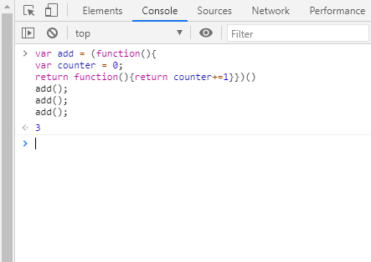

2.Array Methods

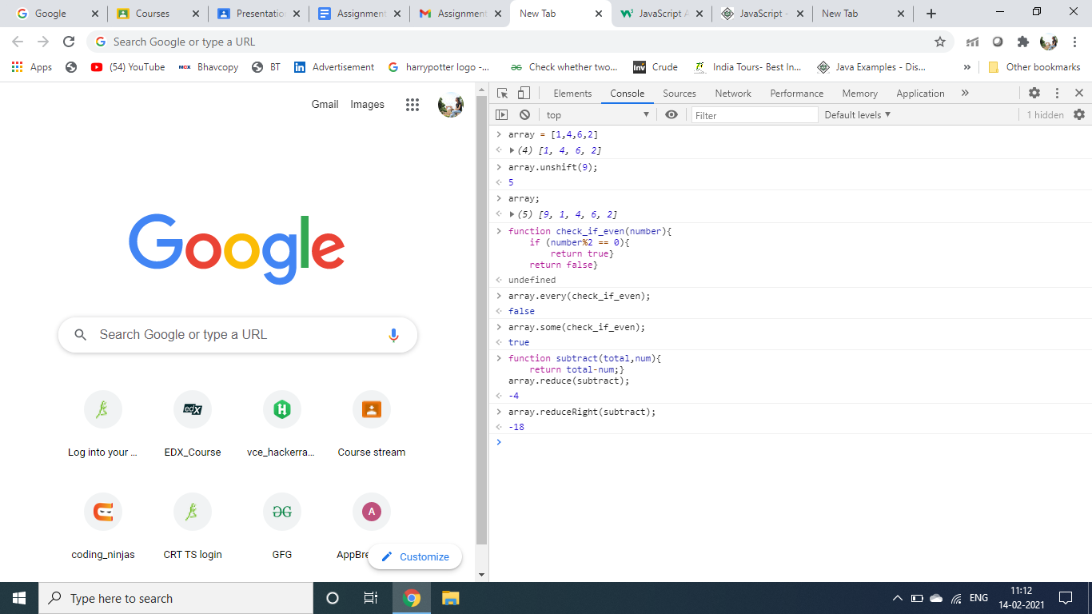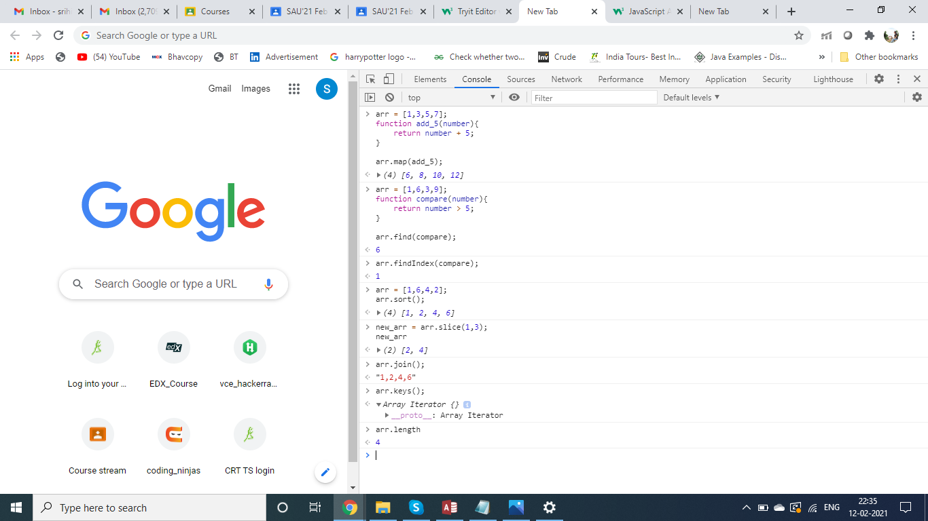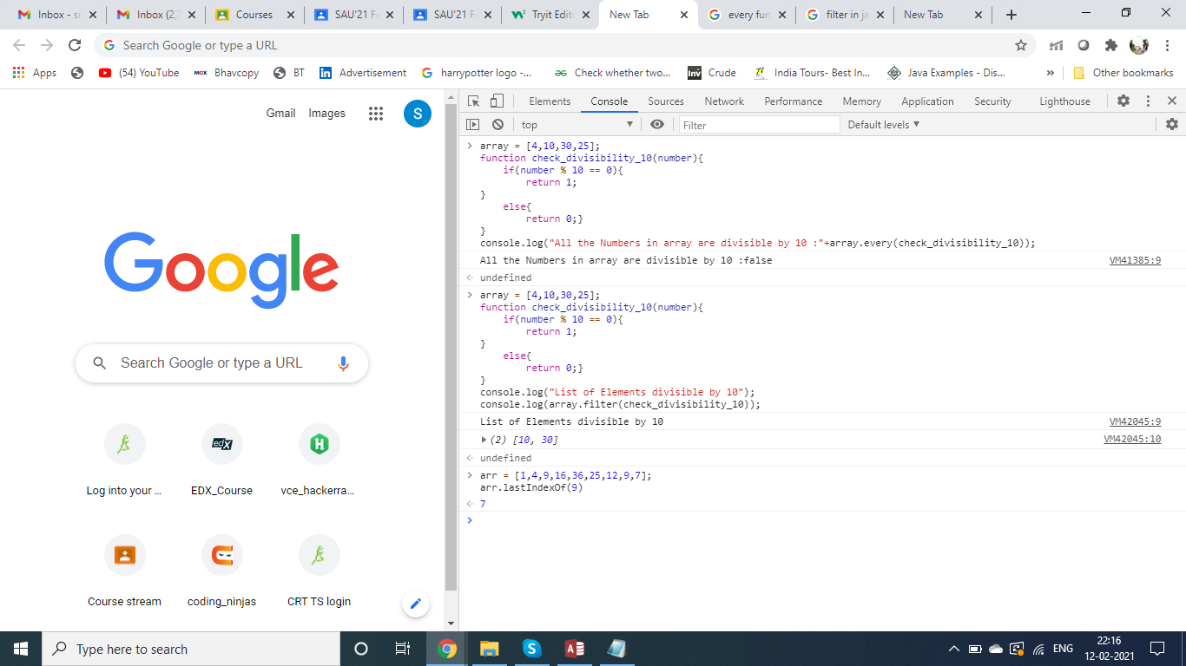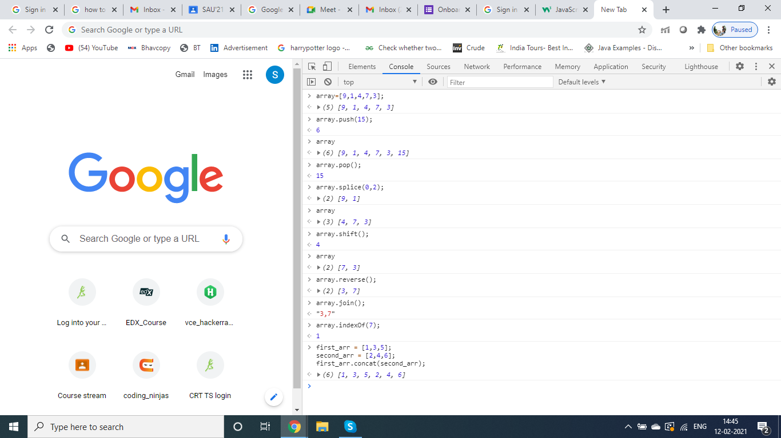

3.function myFunction() {

var input = "abbbbc";

var start_pattern = /^lion/i;

var last_pattern = /$cat/i;

if(start_pattern.test(input)){

console.log("True");

console.log(input.search(/lion/i));

}

else if(last_pattern.test(input)){

console.log("True");

console.log(input.search(/cat/i));

}

else if(/ab+c/.test(input)){

console.log("True");

console.log(input.search(/ab+c/));

}

else{

console.log("False")

}

}

myFunction();

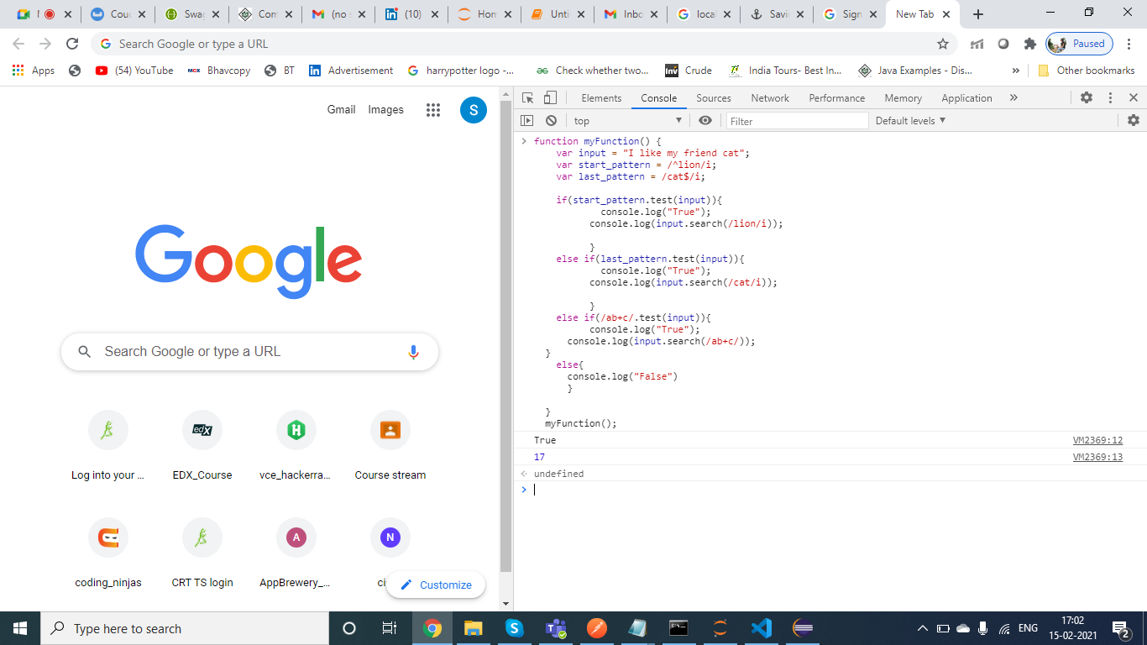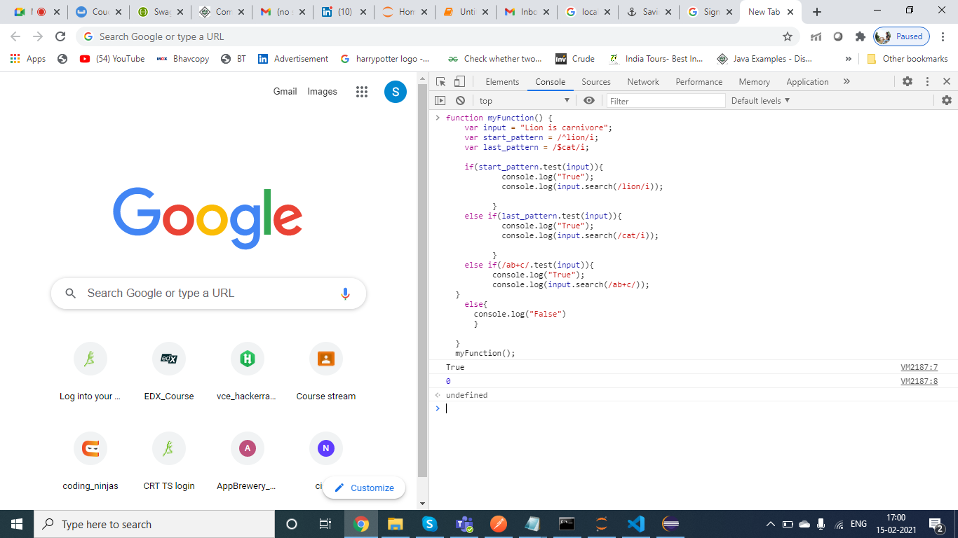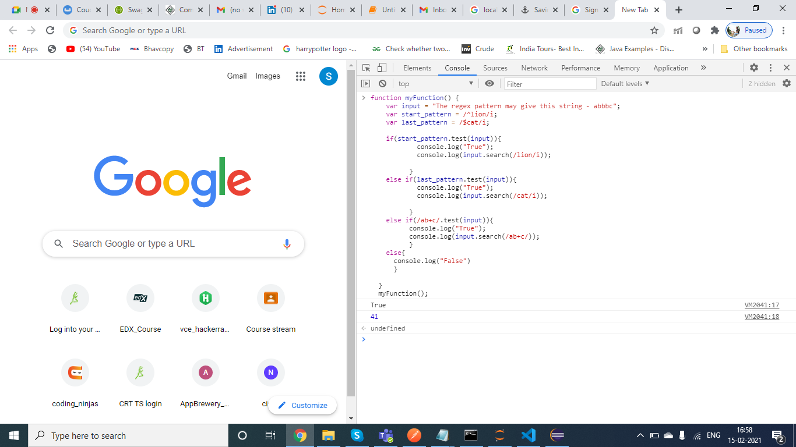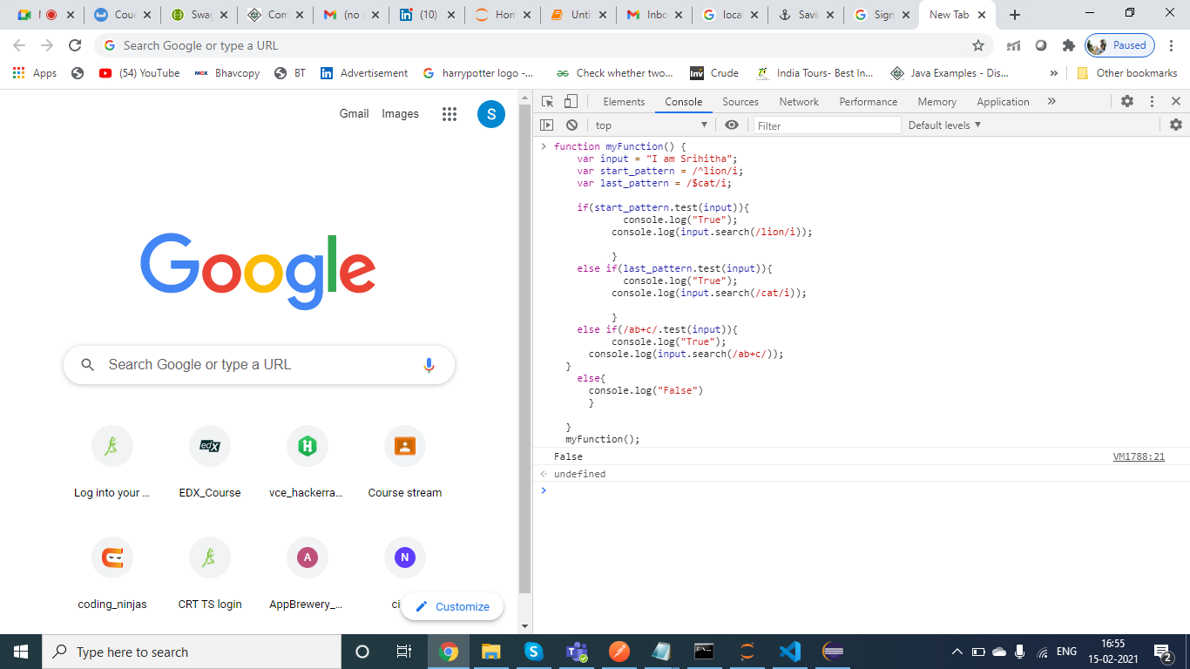

4. array = [1,4,9,3,7,2];

function multiply_by_10(number){

return number*10;}

function divisible_by_3(number){

if( number % 3 == 0){

return 1}

else{

return 0}}

array = array.sort();

array = array.map(multiply_by_10);

array.filter(divisible_by_3);

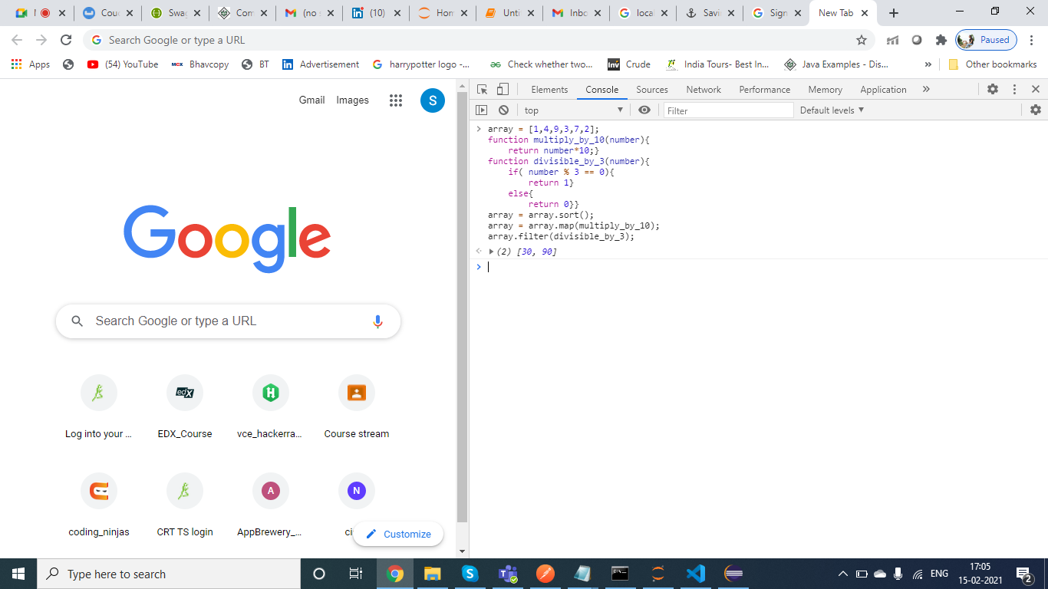

5. Both == and === are used for comparing the variables.

=== returns true only when both LHS and RHS has same variable with data type too.

In case of == ,it returns true they are of same type and value but whenever

we compare two variables with different datatype it tries to perform some conversions and then compares them.

Eg : 9=="9"

String is converted to number then compared,So it returns true.But these conversions are bit complex when

it involves undefined and null.

true === '1'

Since they belong to different data type we get false as result .