**SQL Assignment**

1. Create Student Database
2. Create the following table under the Student Database:
   1. StudentBasicInformation
      1. Columns
         1. StudentName
         2. StudentSurname
         3. StudentRollNo
         4. StudentAddress
         5. Add more three basic columns of the name of your own
   2. StudentAdmissionPaymentDetails
      1. Columns
         1. StudentRollNo
         2. AmountPaid
         3. AmountBalance
         4. Add more four basic columns of the name of your own
   3. StudentSubjectInformation
      1. Columns
         1. SubjectOpted
         2. StudentRollNo
         3. SubjectTotalMarks
         4. SubjectObtainedMarks
         5. StudentMarksPercentage
         6. Add more one columns of the name of your own
   4. SubjectScholarshipInformation
      1. Columns
         1. StudentRollNo
         2. ScholarshipName
         3. ScholarshipDescription
         4. ScholarshipAmount
         5. ScholarshipCategory
         6. Add more two columns of the name of your own
3. Insert more than 10 records in each and every table created
4. Snap of the all the tables once the insertion is completed

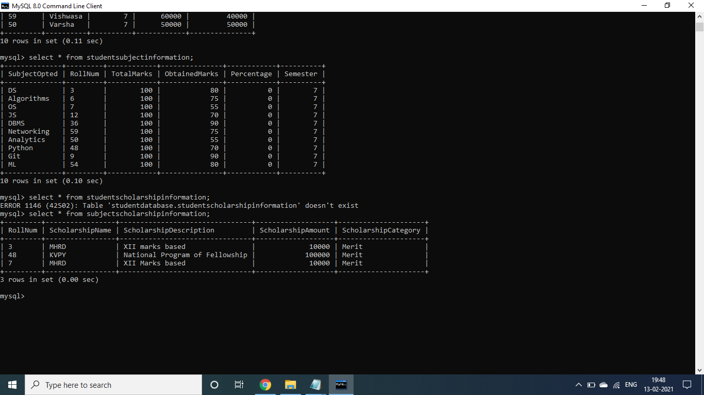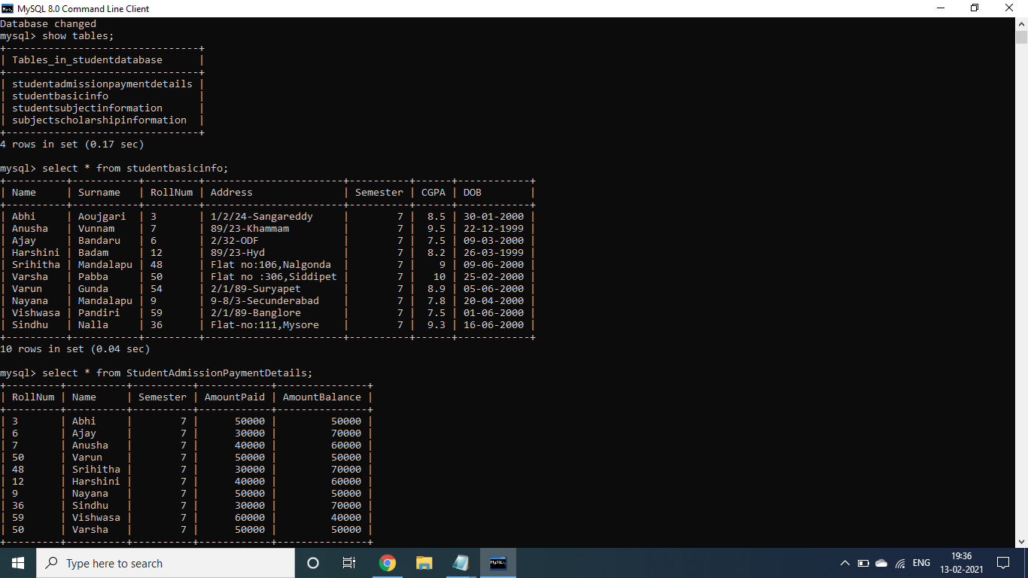

1. Update any 5 records of your choice in any table like update the StudentAddress with some other address content and likewise so on with any records of any table of your choice
2. Snap of the all the tables post updation

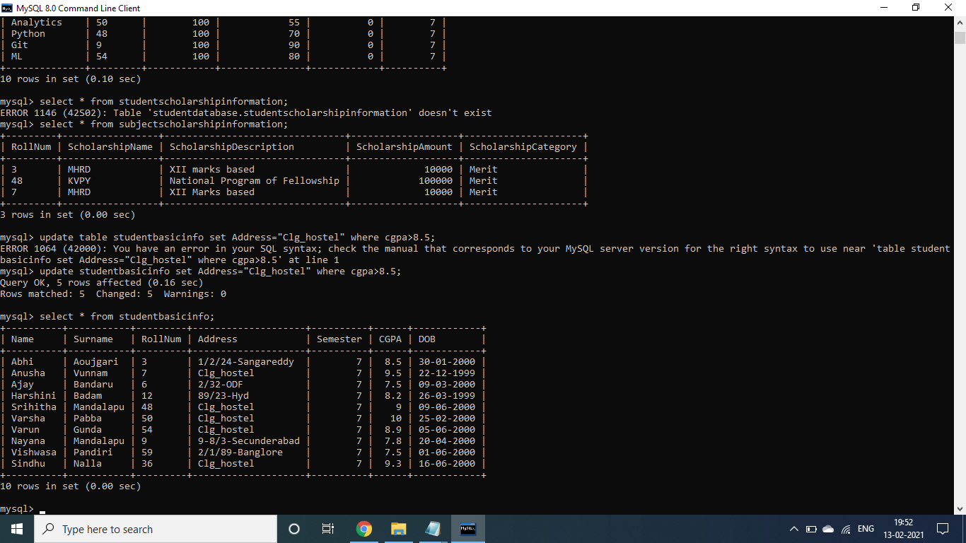

1. Select the student details records who has received the scholarship more than 5000Rs/-

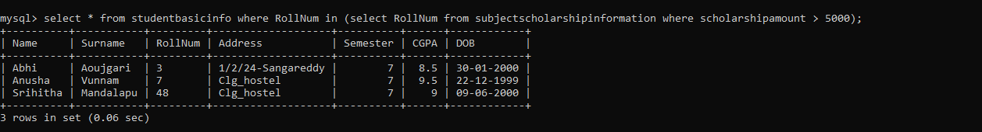

1. Select the students who opted for scholarship but has not got the scholarship

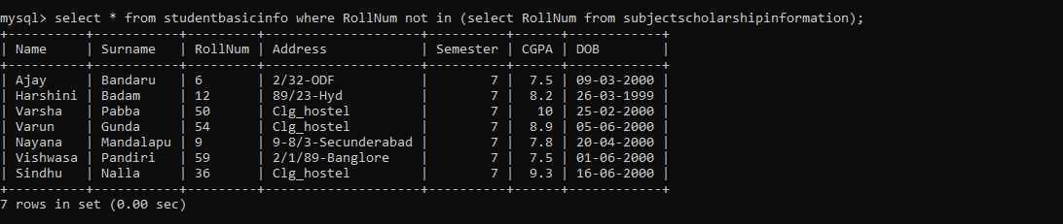

1. Fill in data for the percentage column i.e. StudentMarksPercentage in the table StudentSubjectInformation by creating and using the stored procedure created

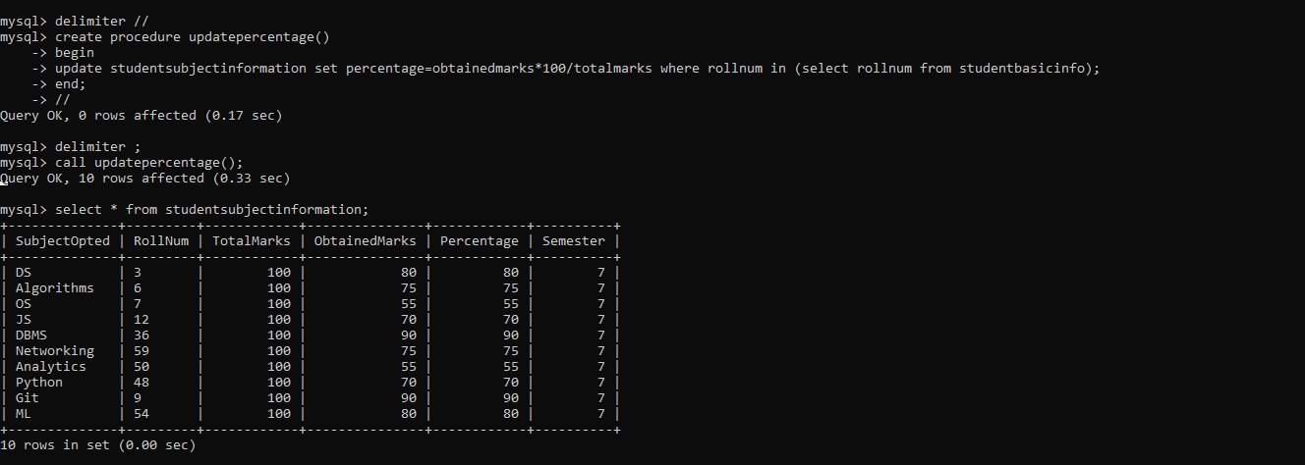

1. Decide the category of the scholarship depending upon the marks/percentage obtained by the student and likewise update the ScholarshipCategory column, create a stored procedure in order to handle this operation

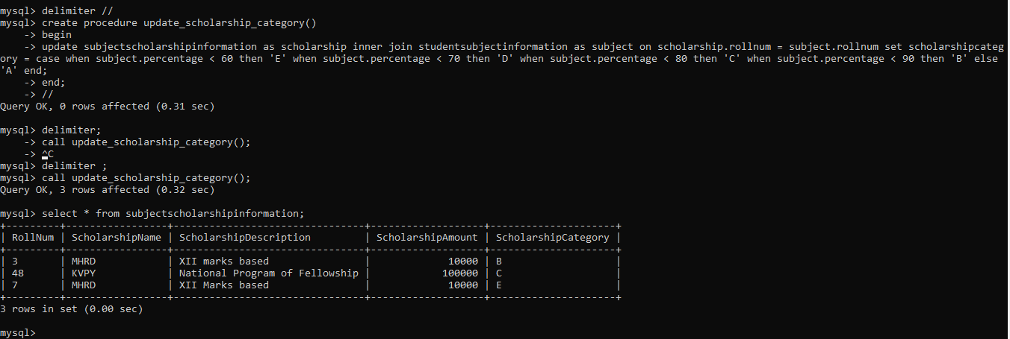

1. Create the View which shows balance amount to be paid by the student along with the student detailed information (use join)

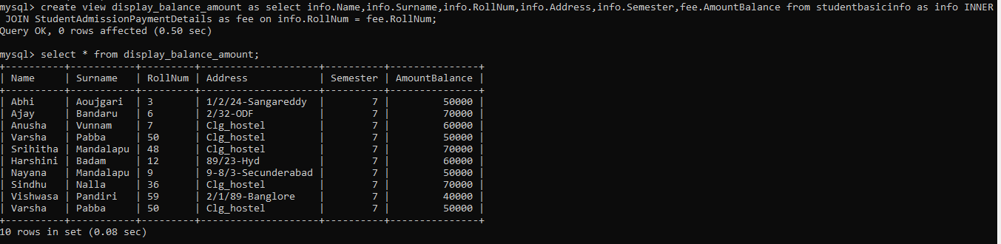

1. Get the details of the students who haven’t got any scholarship (use joins/subqueries)



1. Create Stored Procedure which will be return the amount balance to be paid by the student as per the student roll number passed through the stored procedure as the input

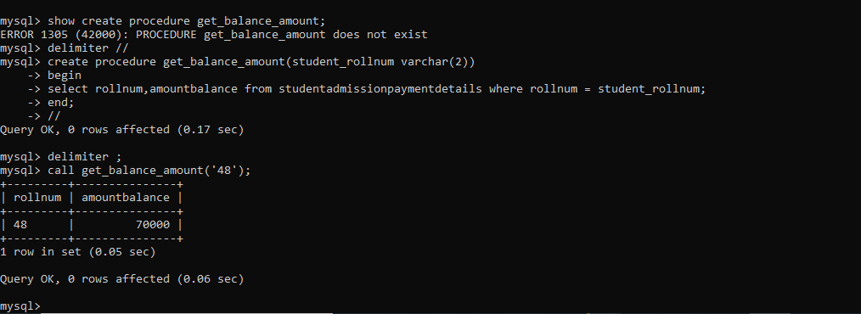

1. Retrieve the top five student details as per the StudentMarksPercentage values (use subqueries)

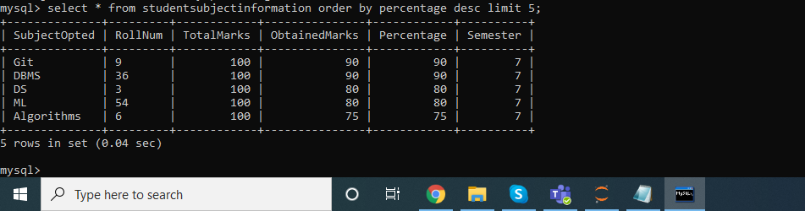

1. Try to use all the three types of join learned today in a relevant way, and explain the same why you thought of using that particular join for your selected scenarios (try to cover relevant and real time scenarios for all the three studied joins)

Left inner join in the below case shows the entire list of students along with their scholarships they are receiving.

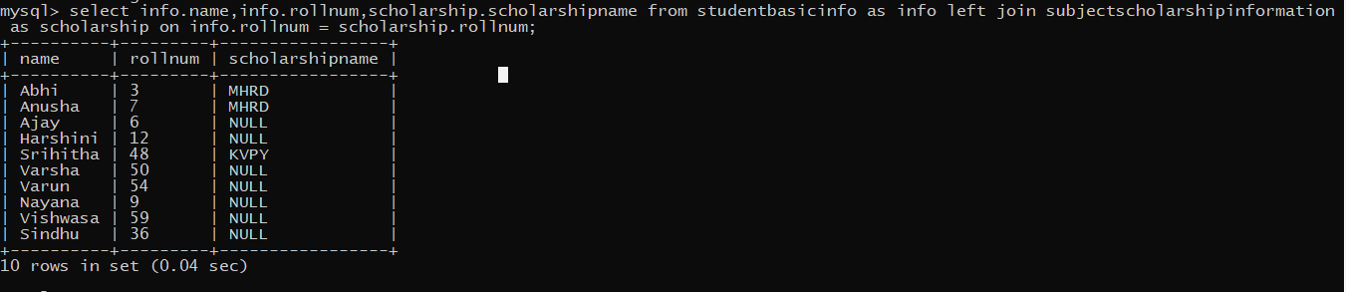

Right and inner join are used in the below scenario inorder to fetch the balance amount they need to pay in that particular semester. They returned the same result as we have same number coloumns in both the tables.

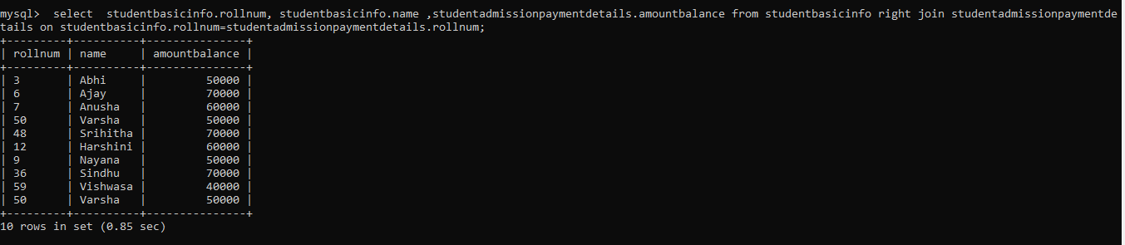

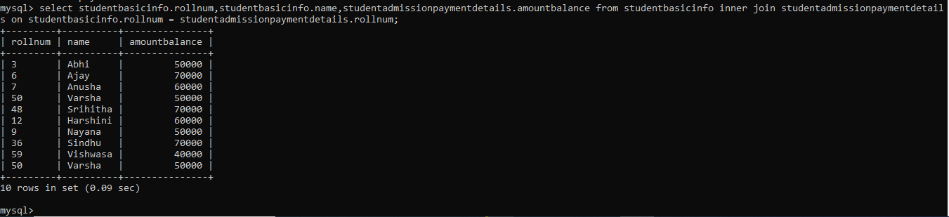

1. Mention the differences between the delete, drop and truncate commands

Drop and Truncate are DDL commands which changes the entire structure of the table.

Truncate deleted all the records but not the structure of the table. It just removes all the data from the table.

Drop deletes all the data with structure of table. Data is completely lost and can’t be rolled back

Delete can be used to remove the data with or without a condition or clause. Deletion of single or multiple rows depends on the query condition.

1. Get the count of the Scholarship category which is highly been availed by the students, i.e. get the count of the total number of students corresponding to the each scholarships category

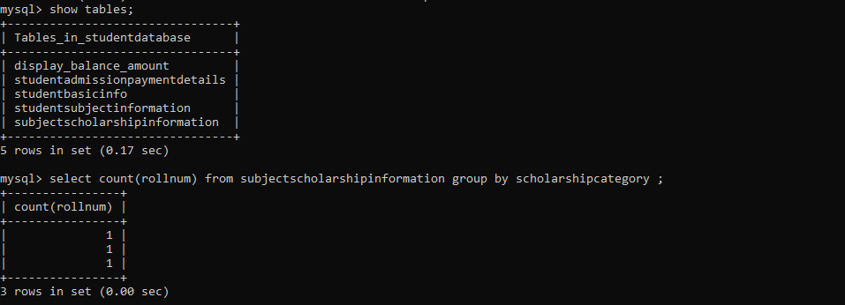

1. Along with the assignment no. 17 try to retrieve the maximum used scholarship category

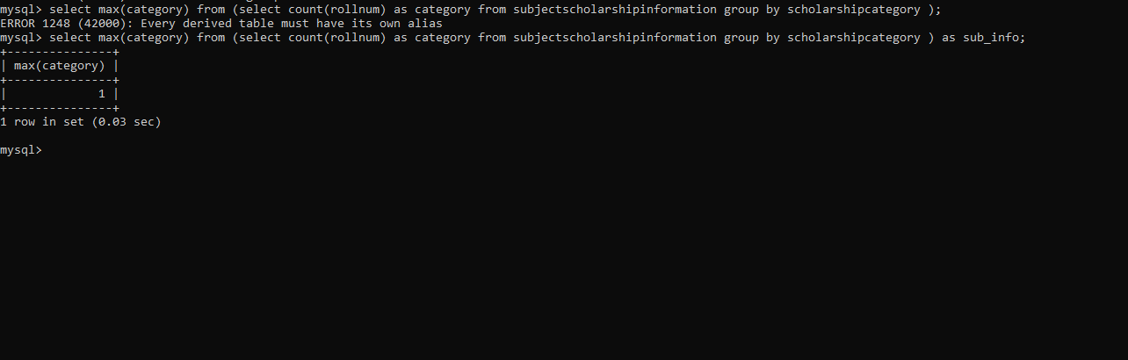

1. Retrieve the percentage of the students along with students detailed information who has scored the highest percentage along with availing the maximum scholarship amount.

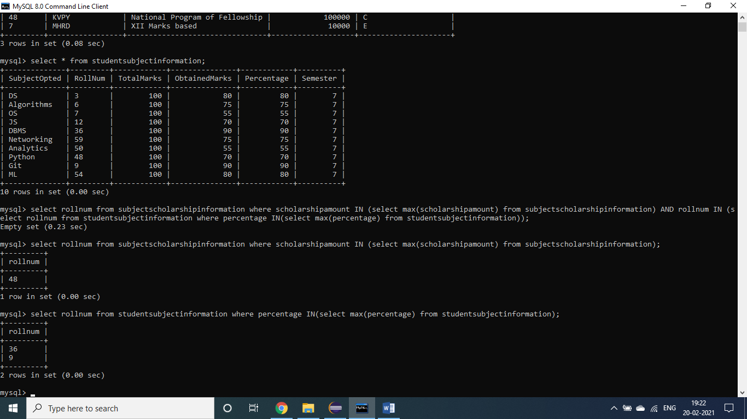

Students availing maximum marks (rollnum – 9,16) and scholarship (rollnum – 48) are different, therefore we are prompted with an empty set.

1. Difference between the Triggers, Stored Procedures, Views and Functions

Trigger is invoked whenever an event occurs. They are programs which automatically get executed when some condition is met.

Stored procedure is a collection of statements that are stored inside a database. It has a name, parameters and set of statements that performs specific task.

View is a virtual table where data is not stored permanently. It is created for security purposes and for querying data by joining tables to save time.

Function is same as a procedure, the only difference is that function can return value whereas a procedure cannot.