Lab Assignment 14.3
Name : T .Srihitha
Hall Ticket no : 2303A51260 Batch No : 19

Task -1:

Prompt:
The task is to develop a Personal Portfolio Website Generator using Python that automatically creates an HTML portfolio webpage. The website includes a navigation bar, About section, Projects section, and Contact form. The HTML and CSS are generated using a Python script and saved as an HTML file. When the program runs, it generates a complete portfolio website that can be opened in a browser.
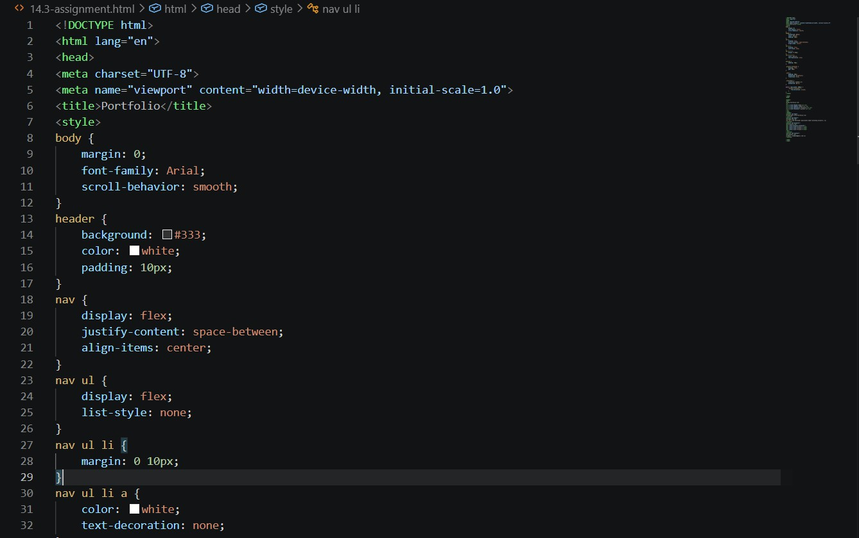

OUTPUT:

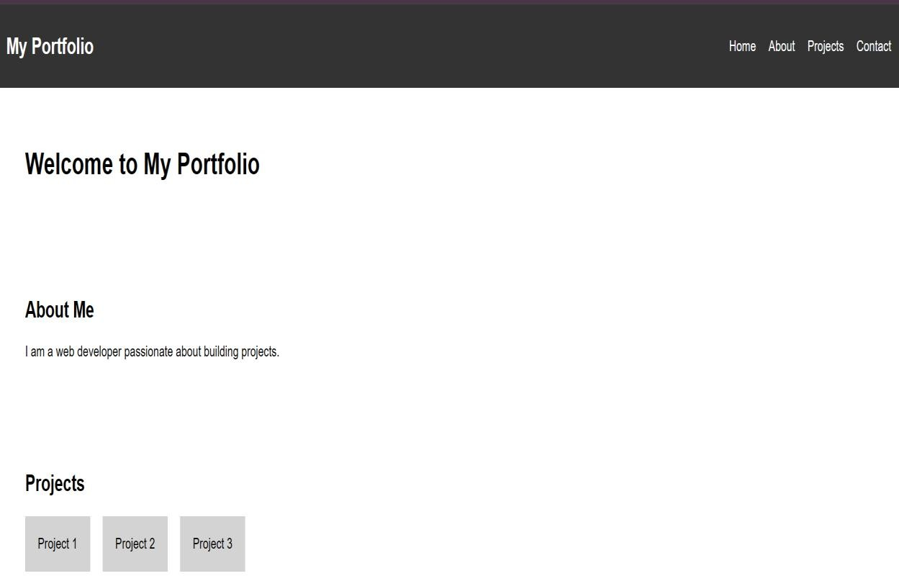

Justification: This project shows how Python can be used to automate website creation using file handling. It reduces manual work by generating HTML and CSS automatically. The project demonstrates integration of Python with web development concepts like HTML structure, CSS styling, and forms. It is useful for quickly creating portfolio websites for students and developers.

Task 2:

Prompt:
The task is to develop an AI-Generated Restaurant Landing Page using Python that automatically creates an HTML and CSS restaurant website. The website includes a navigation bar, home section, menu
section with food items and prices, gallery section, and contact form. The Python script generates the HTML content and saves it as a webpage file. The generated page should be visually styled and responsive using CSS grid and layout design.

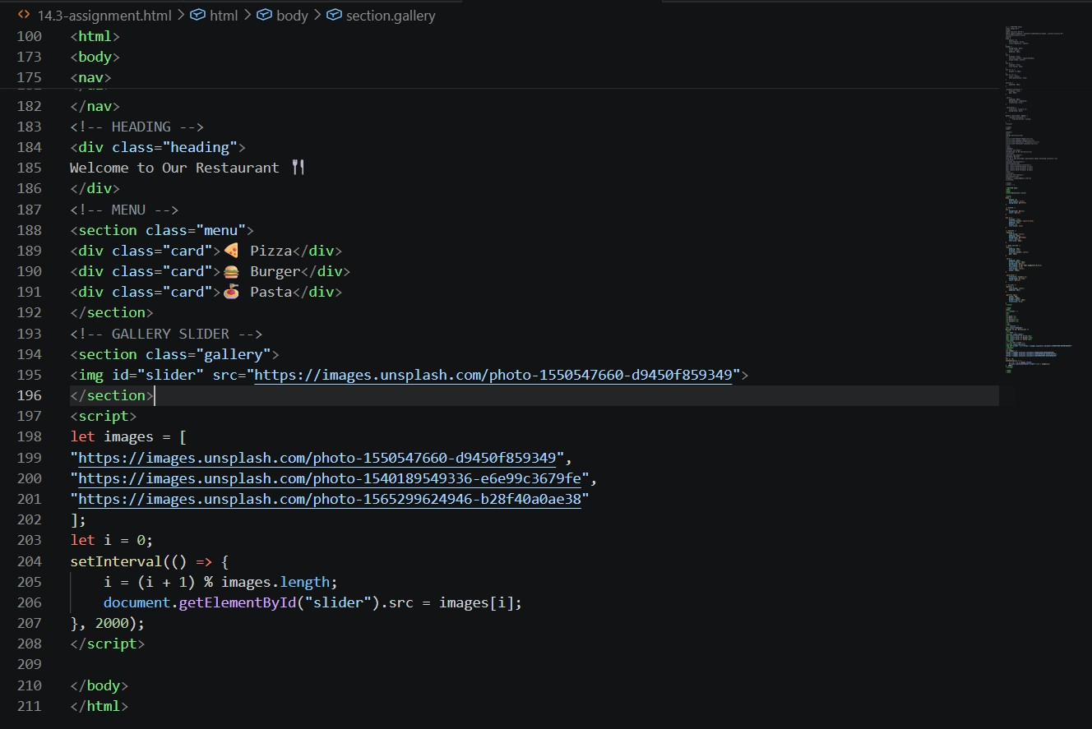

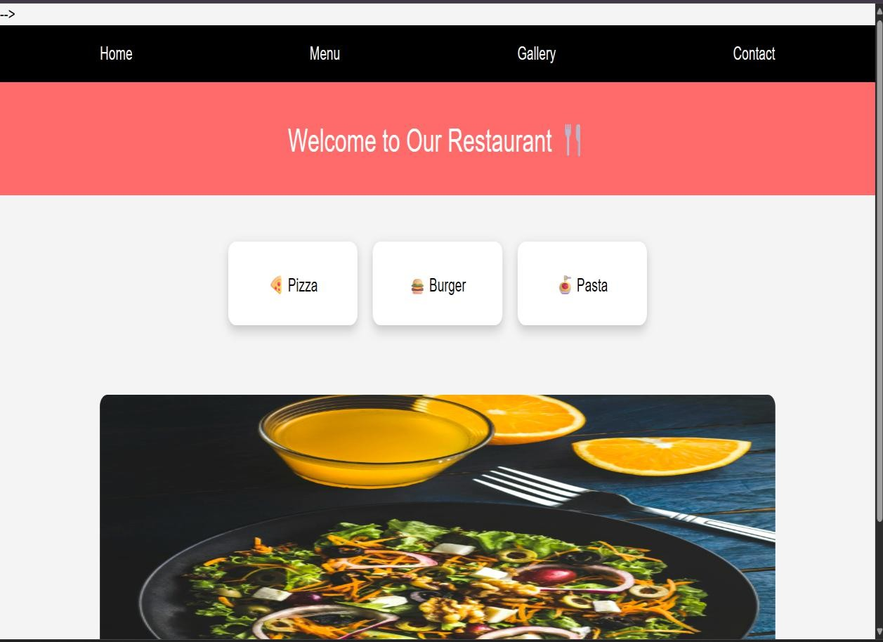
Output:

Justification:

This project demonstrates how Python can be used to automatically generate styled web pages using HTML and CSS. It reduces manual webpage creation by dynamically generating the restaurant website layout and menu items. The project shows integration of Python scripting with web development technologies. It is useful for automating landing page creation for restaurants or small businesses.

Task 3:
Prompt:
The task is to create an AI-Powered Event Registration Form for SR University Technical Fest using
HTML, CSS, and JavaScript. The form should include fields such as Name, Email, Phone Number, Department, and Event Selection. The form must be styled using CSS for a user-
friendly interface and implement JavaScript for real-time validation like email format, phone number length, and required field validation. The form should prevent submission if invalid data is entered.
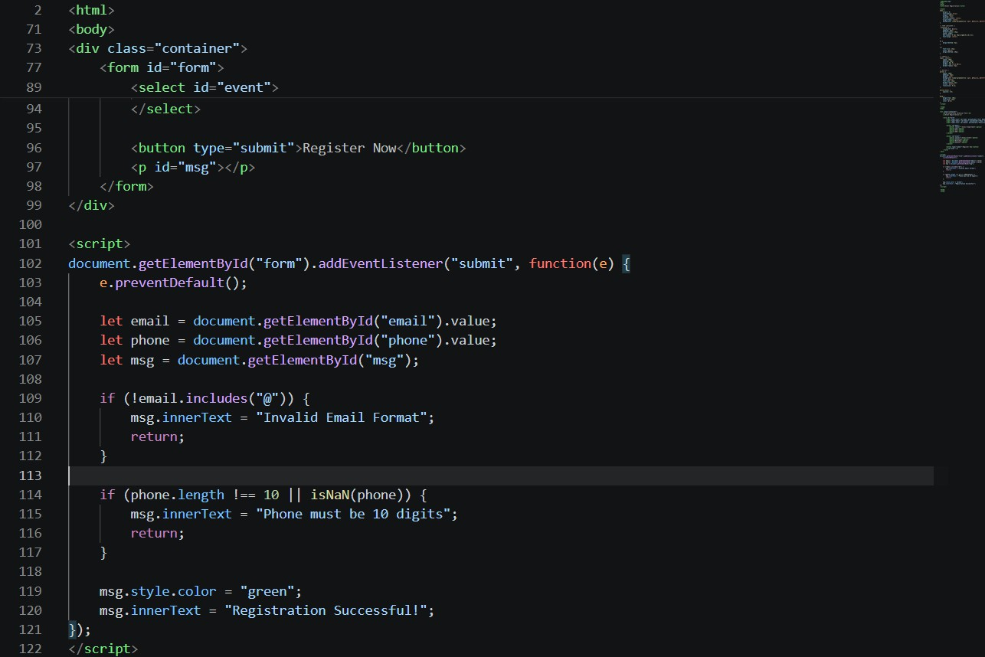
Output:

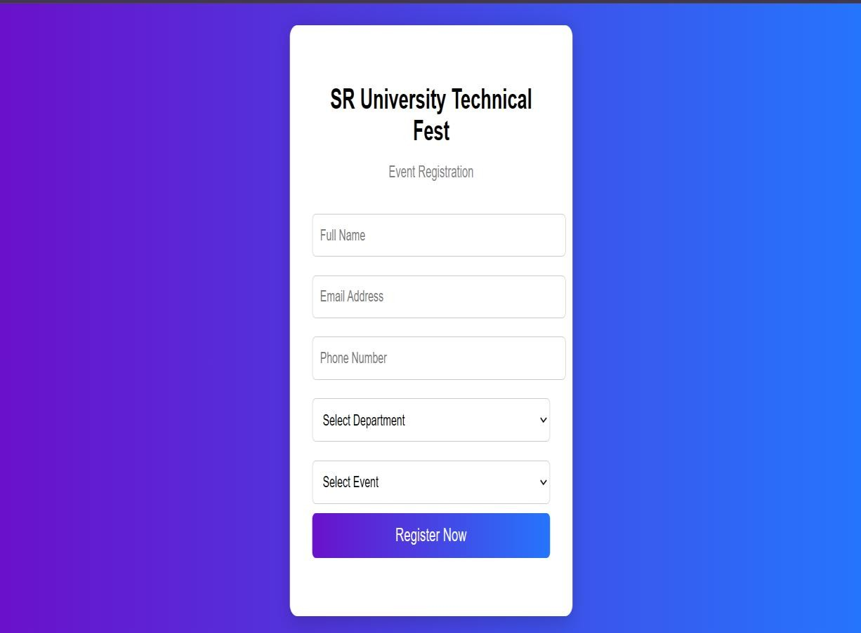
Justification:
This project demonstrates how AI tools like Copilot can assist in generating web forms with validation and styling automatically. It improves user experience by providing real-time validation and preventing incorrect form submissions. The project integrates HTML, CSS, and JavaScript to build an interactive web form. It is useful for event registrations and online data collection systems.

Task -4:
Prompt:
The task is to develop an AI-Assisted E-Commerce Product Page using HTML, CSS, and
JavaScript. The page should display products in a grid layout with product name, price, and an “Add to Cart” button. JavaScript should be used to implement cart functionality and update the cart item counter dynamically. The page should also provide visual feedback when a product is added to the cart.

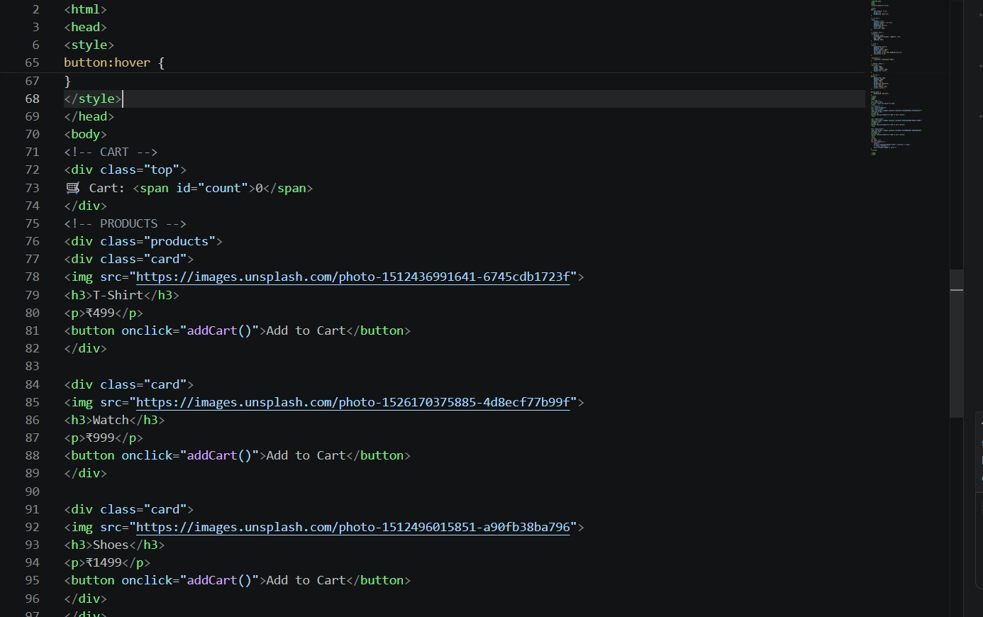
Output:
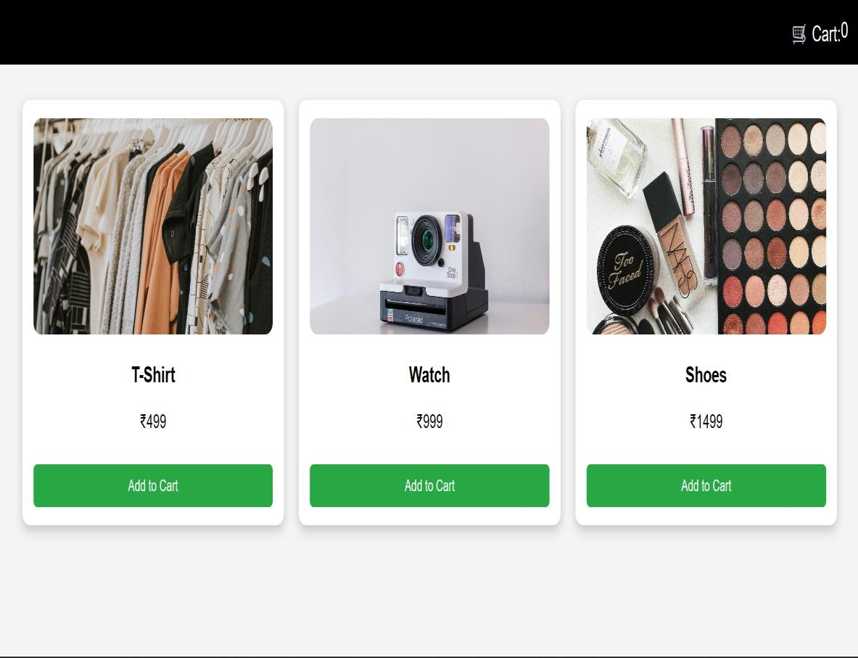
Justification:
This project demonstrates how AI tools like Copilot can help generate web development code for an e- commerce product page. It integrates HTML for structure, CSS for layout design, and JavaScript for cart functionality and interactivity. The project improves user experience through dynamic cart updates and visual feedback. It is useful for understanding basic e-commerce website functionality and front-end development concepts.

Task – 5:
Prompt: The task is to create a responsive web page layout using HTML and CSS that includes a header with navigation links, a main content section, and a footer. The layout should be responsive and adapt to different screen sizes such as desktop, tablet, and mobile using CSS media queries. AI tools can be used to generate responsive CSS and layout structure. The page should be clean, organized, and
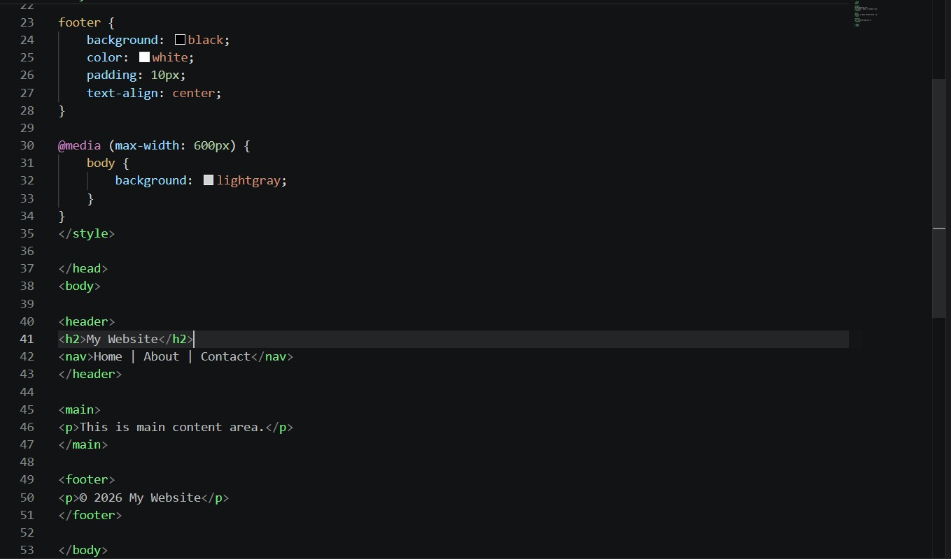
visually appealing.


Output:

Justification: This project demonstrates how responsive web design can be implemented using HTML and CSS with media queries. Using AI assistance helps in generating responsive layouts quickly and efficiently. The project improves understanding of layout design, navigation bars, content sections, and footers. It is useful for building modern websites that work across multiple devices and screen sizes.

