Lab Assignment 17.5
Name : T. Srihitha
Hall Ticket no : 2303A51260 Batch No : 19

Task -1:
Prompt: Develop a Python program to preprocess a loan dataset by handling missing values, encoding
categorical variables, scaling numerical features, and splitting the dataset into training and testing sets. Use pandas for data handling and scikit-learn for scaling and train-test splitting. The program should prepare the dataset for machine learning model training.
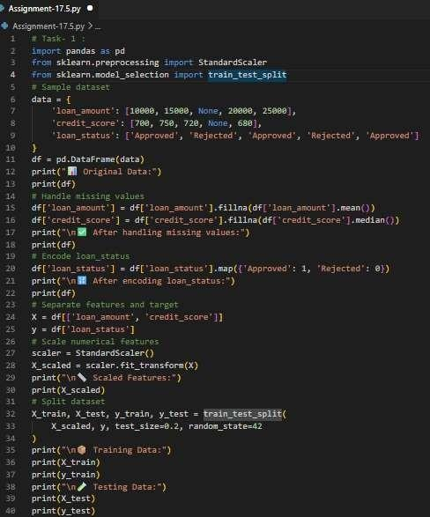

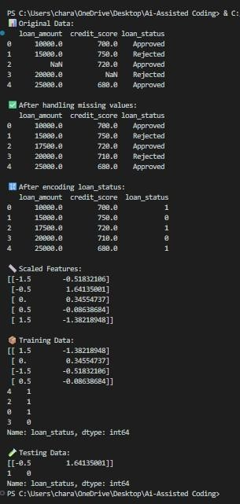
OUTPUT:
Justification: This task demonstrates data preprocessing techniques required before training a machine learning model. Missing values are handled using mean and median methods, categorical data is encoded into numerical format, and numerical features are scaled using StandardScaler. Finally, the dataset is split into training and testing sets to prepare it for machine learning algorithms. This improves model accuracy and data quality.

Task 2:

Prompt: Create a Python program to clean a social media user dataset by removing duplicate records, handling missing values in numerical columns, and preparing the dataset for further analysis. Use pandas for data manipulation and ensure the dataset is cleaned and structured properly.
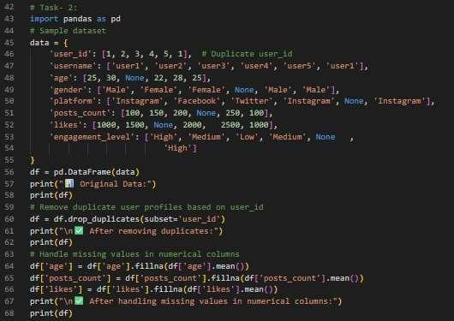

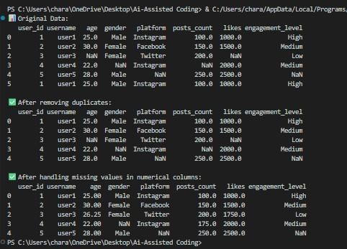
Output:
Justification: This task focuses on data cleaning and preprocessing techniques such as removing duplicate records and handling missing values. Cleaning data improves data quality and ensures accurate analysis and
machine learning results. Using pandas makes it easy to manipulate and preprocess large datasets efficiently. This step is essential in real-world data analysis and data science workflows.

Task 3:
Prompt:Develop a Python program to preprocess weather data by converting date columns to datetime format, handling missing values, performing feature engineering, and normalizing numerical values. Use pandas for data processing and MinMaxScaler for normalization.
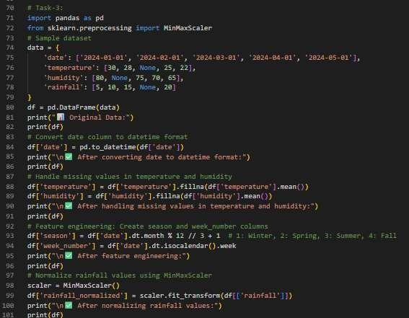

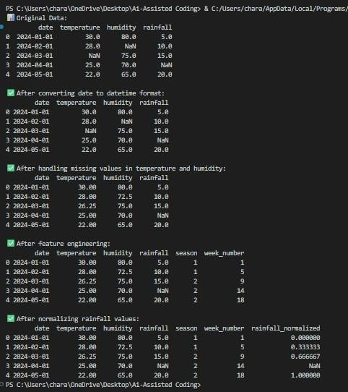
Output:
Justification: This task demonstrates feature engineering and data preprocessing techniques used in data
science and machine learning. Converting date columns allows extraction of useful features like season and week

number. Missing values are handled to maintain data consistency, and normalization ensures numerical values are scaled properly for machine learning models. These preprocessing steps improve model performance and data analysis accuracy.

Task -4:
Prompt: Create a Python program to preprocess a movie dataset by removing duplicate records, handling missing values, encoding categorical variables, and normalizing rating values. Use pandas for data cleaning and MinMaxScaler for normalization.
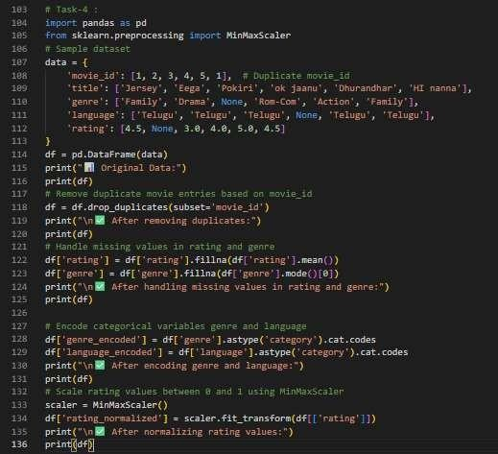

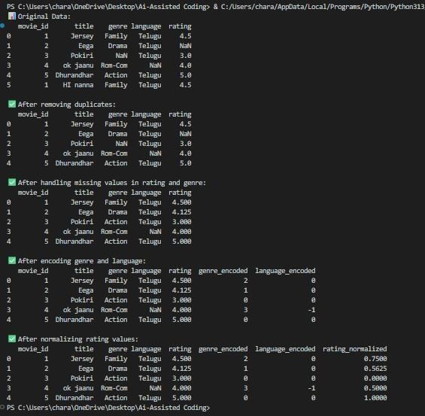
Output:
Justification: This task demonstrates data preprocessing techniques including duplicate removal, missing value handling, categorical encoding, and data normalization. Encoding categorical variables converts text data into numerical format for machine learning algorithms. Normalization scales rating values between 0 and 1 for better model performance. These preprocessing steps help prepare the dataset for machine learning and data analysis tasks.

