CALIFORNIA STATE UNIVERSITY LOS ANGELES

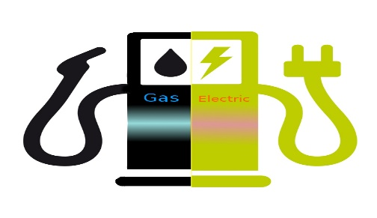

THE ELECTRIC AUTOMOBILE SALES IN NORWAY

SRIHITHA REDDY SIVANNAGARI

5270-BUSINESS INTELLIGENCE

PROF.SHILPA BALAN

OBJECTIVE OF THE STUDY:

Opplysningsrådet for Veitrafikken (OFV), an organization that deals with the road transportation in Norway. A recent survey released by OFV, revealed certain phenomenal aspects and changes in their publication under the title "Car Year 2016. Status and trends" which was about the all-time-high sales of electric cars in Norway. There are forty percent (compare to 7.4% for Sweden and 3.6% for Denmark) of fully electric and plug-in hybrid cars sales in Norway. No other country has this extent of popularity in electric vehicles. OFV reported that among the top ten most prevalent vehicles only one was a fossil fuel vehicle.

INFORMATION ABOUT THE RESEARCH TOPIC:

  Automobiles with turbines of one or more electric motors that use rechargeable batteries or energy stored devices, called electric vehicles. They are much efficient when compared to internal combustion engines. There are 100,000 all-electric (Battery only) vehicles on road and the count is still increasing in Norway. With major automobile manufacturers meeting buyers requirements models in electric cars, still we have only a few of them which are prominently used. The most popular electric car models are Nissan Leaf and Tesla Model S.

This data shows the gradual increase in the demand of the electric cars in Norway from the year 2007 to 2016. It also depicts the fall of the carbon levels in the country since 2007. As 98% of the country’s electricity produced via hydropower, Norway’s electric vehicles also helps decrease the carbon levels in the country. The data provides a comparison between diesel vehicles, bensin (petrol) vehicles, hybrid vehicles and electric vehicles. This comparison gives us an illustration of the variant levels of carbon dioxide released by the different types of vehicles. Knowledge about the importation of battery rechargeable vehicles can also be attained by the data. With these statistics Norway is aiming to get 400,000 battery-only vehicles on road.

RESEARCH QUESTIONS:

1. How did Norway, an oil realm, become a largest market for hybrid and plug-in vehicles?
2. What are the models in the electric vehicles that have highest sales?
3. Which are the companies with least sales?
4. How much is the increase of demand for electric vehicles over the years?
5. Why is the importing proportion of electric vehicles so high in the country?

DATA SET:

<https://www.kaggle.com/dmi3kno/newcarsalesnorway>.

CITATIONS:

* 1. Hockenos, Paul. “With Norway in Lead, Europe Set for Surge in Electric Vehicles.” e30.yale, 2017,

<http://e360.yale.edu/features/with-norway-in-the-lead-europe-set-for-breakout-on-electric-vehicles>.