CALIFORNIA STATE UNIVERSITY LOS ANGELES

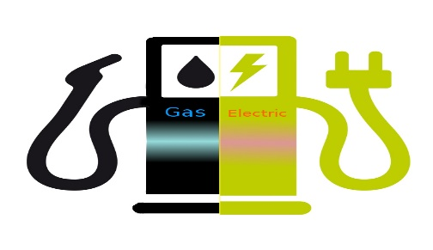

THE ELECTRIC AUTOMOBILE SALES IN NORWAY

SRIHITHA REDDY SIVANNAGARI

5270-BUSINESS INTELLIGENCE

PROF.SHILPA BALAN

Data Cleaning

Before Removing missing values:



After removing missing values:



Question 1: How did Norway, an oil realm, become a largest market for hybrid and plug-in vehicles?

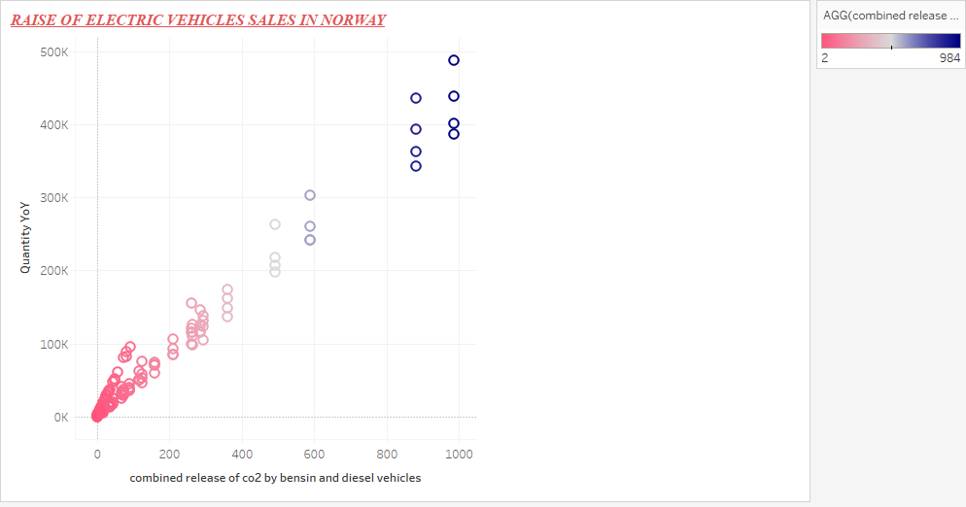

The visualization shows the release in the carbon di oxide from vehicles with internal combustion engine. Norway, an oil realm, becomes the largest market for hybrid and plug-in vehicles within a very short span. This is due to the increase in the environmental air pollution. I created a calculated field and named as combined release of co2 by bensin and diesel. The field is created to find the sum of the carbon dioxide released by vehicles using bensin and diesel as fuel. A scatter plot clearly depicts the increase of Carbon Dioxide over the years. This is one of the major reasons for a country like Norway to have high sales in elective vehicles throughout the world. Not only the new car sales but also import ratio of electric and hybrid vehicles increased over a past couple of years in Norway.

Question 2: What are the models in the electric vehicles that have highest sales?

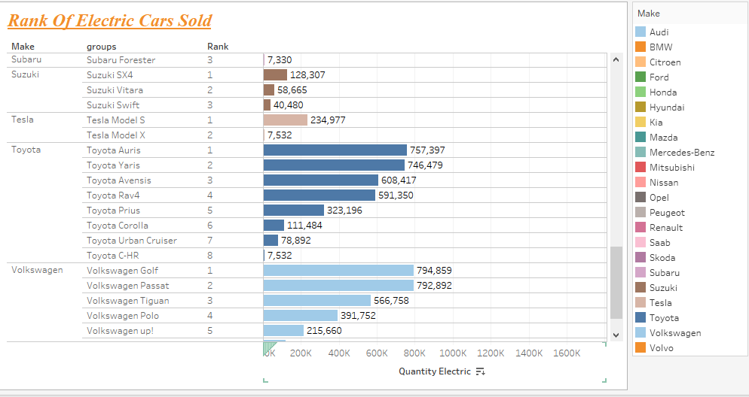

The above visualization depicts the ranks of the vehicles which have highest sales. As there are numerous models released by every company I grouped a few of the models (I series in BMW, A series in Audi). This was done to get a clear picture of which models of a particular companies are having high sales. As the idea is to visualize rank of company’s which produced a hybrid or electrical or vehicles which need bensin and diesel as fuel. Over the years, sales of companies releasing electric vehicles have increased gradually.

Question 3: Which are the companies with least sales?

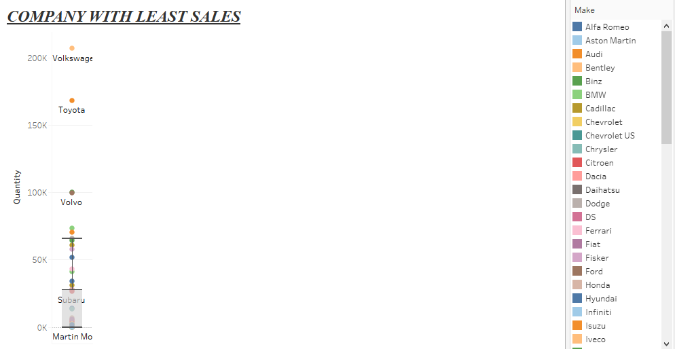

A box and whisker plot not only the company with least sales but also the range of companies with less sales comparatively. The fall in the sales of companies are due to various reasons. The visualization shows the companies whose sales dropped over the years due to increase in the demand for electric sales. The whisker shows all the companies which fall under the least sales region including the one with least sales comparatively.

Question 4: How much is the increase of demand for electric vehicles over the years?

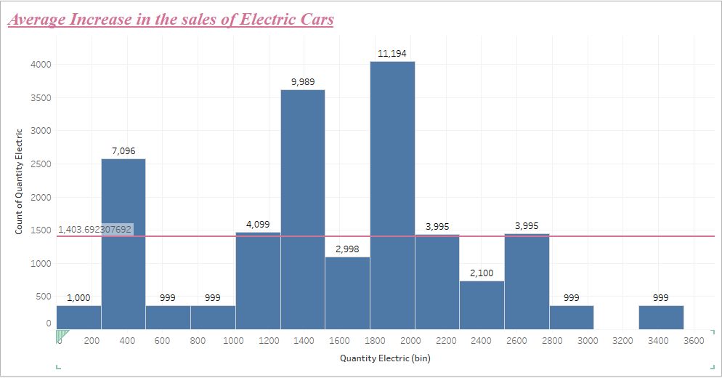

The above visualization shows the increase in demand of electric vehicles over the years. I chose histograms to depict the percentage of increase in the demand. Every bin resembles the models of different company’s sales. The reference line is to represent the avereage increase of all the electic vehicles.Percentage increase of every company’s increment is also shown in the visualization.

Question 5: Why is the importing proportion of electric vehicles so high in the country?

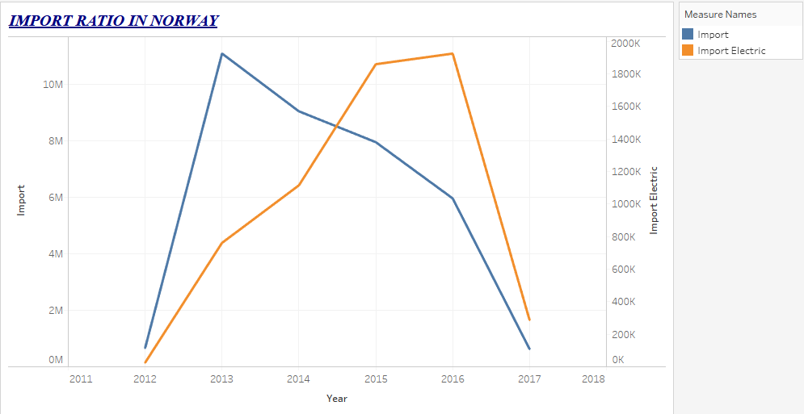

There is a gradual increase of import ration in Norway over years especially in the import ratio of electric vehicles. This is because of the rise in the demand for hybrid and electric vehicles. The visualization shows the graph where the rise and fall of both import ratio of all the vehicles and electric vehicles in particular. The fall might be because of the indigenous production of electric vehicles.

Dashboard: 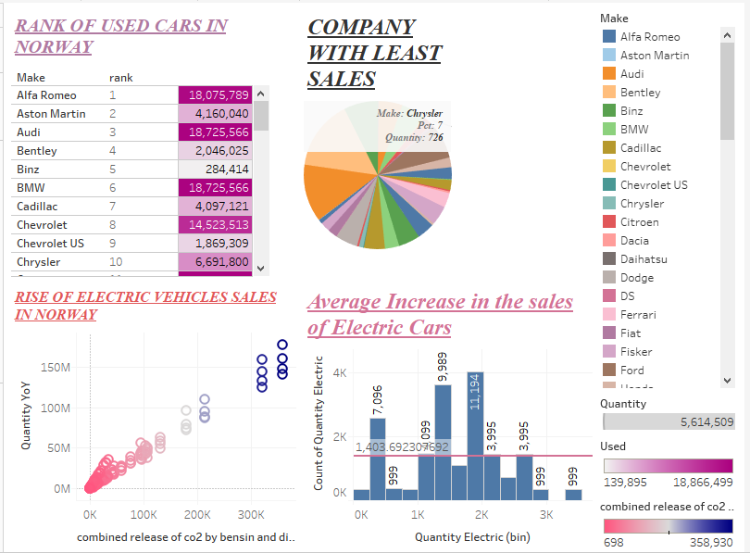

Storytelling:

1. Electric vehicles era:

Opplysningsrådet for Veitrafikken (OFV), an organization that deals with the road transportation in Norway. A recent survey released by OFV, revealed certain phenomenal aspects and changes in their publication under the title "Car Year 2016. Status and trends" which was about the all-time-high sales of electric cars in Norway. There are forty percent (compare to 7.4% for Sweden and 3.6% for Denmark) of fully electric and plug-in hybrid cars sales in Norway. No other country has this extent of popularity in electric vehicles. OFV reported that among the top ten most prevalent vehicles only one was a fossil fuel vehicle.

This data shows the gradual increase in the demand of the electric cars in Norway from the year 2007 to 2016. It also depicts the fall of the carbon levels in the country since 2007. As 98% of the country’s electricity produced via hydropower, Norway’s electric vehicles also helps decrease the carbon levels in the country. The data provides a comparison between diesel vehicles, bensin (petrol) vehicles, hybrid vehicles and electric vehicles. This comparison gives us an illustration of the variant levels of carbon dioxide released by the different types of vehicles. Knowledge about the importation of battery rechargeable vehicles can also be attained by the data. With these statistics Norway is aiming to get 400,000 battery-only vehicles on road.

There are three different data sets used in the visualization of Norway’s new car sales.

1. Increase in the demand of electric vehicles over petrol and diesel vehicles:

The first visualization is about why a country like Norway, an oil realm gradually become one of the top most market for electric vehicles. The country has very little population but the concern for them about the environmental pollution is certainly a big issue. Their immediate step was to reduce the increasing pollution and as a step towards their environmental protection, they have decided to reduce the usage of vehicles with internal combustion engine.



The visualization depicts the increase of carbon dioxide levels over the years. With the use of electric or hybrid vehicles this is completely minimized. The demand of plug-in electric vehicles in Norway is the largest [per capita](https://en.wikipedia.org/wiki/Per_capita) in the world. [Oslo](https://en.wikipedia.org/wiki/Oslo), Norway’s capital is recognized as the Electric Vehicles capital in the world. As of July 2016, the market concentration was 21.5 registered plug-in cars. Norway's fleet of electric cars is one of the cleanest in the world because [98% of the electricity generated in the country](https://en.wikipedia.org/wiki/Renewable_energy_in_Norway) comes from [hydropower](https://en.wikipedia.org/wiki/Hydropower). Norway became the first country where over one in every 100 passenger cars on the road was a plug-in electric.

The highest-ever monthly market share for the plug-in electric passenger segment was achieved in January 2017 with 37.5% of new car being sold. Also in January 2017, the electrified passenger car segment, consisting of plug-in hybrids, all-electric cars and conventional hybrids, for the first time ever surpassed combined sales of cars with a conventional diesel or gasoline engine, with a market share of 51.4% of new car sales that month

1. Fall in the demand for petrol and diesel vehicles:

This was oblivious as the vehicles which are battery rechargeable are more in demand than the ones with internal combustion engine.

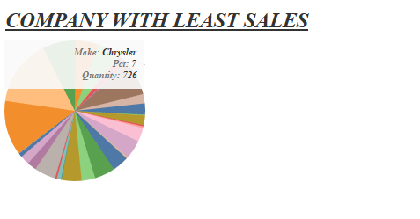

Norway is the clear electric vehicle pacesetter in Europe, which now has about 500,000 electric vehicles. China leads the world in EV usage, with about 600,000 all-electric vehicles on its roads and an ambitious plan to deploy 5m EVs by 2020. The US ranks third globally, with fewer than 500,000 Electric vehicles. But electric vehicle momentum is picking up in the US, as evidenced by the [400,000 people who have paid $1,000](http://fortune.com/2016/10/18/tesla-model-3-new-reservations/) to be on the waiting list for Tesla’s $35,000 Model 3 car.