**Exercise 1: Configuring a Basic Spring Application**

**Scenario:**

Your company is developing a web application for managing a library. You need to use the Spring Framework to handle the backend operations.

**OUTPUT :-**

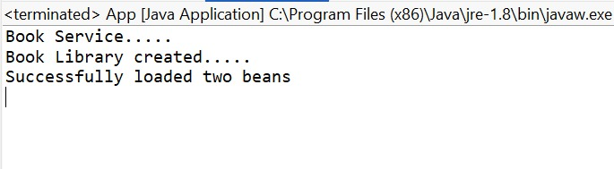

**Exercise 2: Implementing Dependency Injection**

**Scenario:**

In the library management application, you need to manage the dependencies between the BookService and BookRepository classes using Spring's IoC and DI.

**OUTPUT :-**

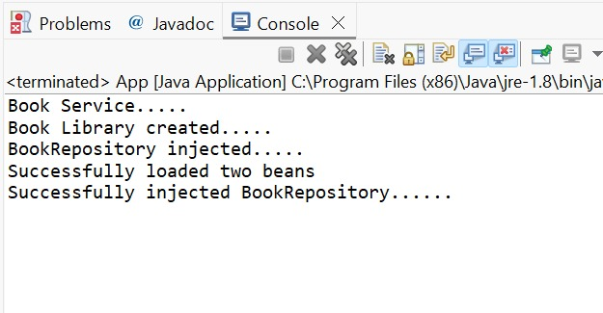

**Exercise 4: Creating and Configuring a Maven Project**

**Scenario:**

You need to set up a new Maven project for the library management application and add Spring dependencies.

**OUTPUT :-**

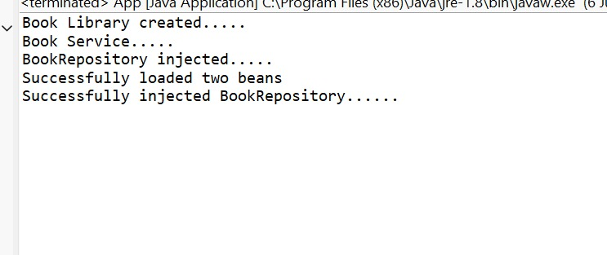

**Pom.xml**

<project xmlns="http://maven.apache.org/POM/4.0.0"

xmlns:xsi="http://www.w3.org/2001/XMLSchema-instance"

xsi:schemaLocation="http://maven.apache.org/POM/4.0.0

http://maven.apache.org/xsd/maven-4.0.0.xsd">

<modelVersion>4.0.0</modelVersion>

<groupId>com.spring.maven</groupId>

<artifactId>LibraryManagement</artifactId>

<version>0.0.1-SNAPSHOT</version>

<packaging>jar</packaging>

<name>LibraryManagement</name>

<url>http://maven.apache.org</url>

<properties>

<project.build.sourceEncoding>UTF-8</project.build.sourceEncoding>

</properties>

<dependencies>

<dependency>

<groupId>org.springframework</groupId>

<artifactId>spring-core</artifactId>

<version>5.3.31</version>

</dependency>

<dependency>

<groupId>org.springframework</groupId>

<artifactId>spring-context</artifactId>

<version>5.3.31</version>

</dependency>

<dependency>

<groupId>org.springframework</groupId>

<artifactId>spring-webmvc</artifactId>

<version>5.3.31</version>

</dependency>

<dependency>

<groupId>org.aspectj</groupId>

<artifactId>aspectjrt</artifactId>

<version>1.9.24</version>

</dependency>

<dependency>

<groupId>org.aspectj</groupId>

<artifactId>aspectjweaver</artifactId>

<version>1.9.24</version>

</dependency>

<dependency>

<groupId>junit</groupId>

<artifactId>junit</artifactId>

<version>3.8.1</version>

<scope>test</scope>

</dependency>

</dependencies>

<build>

<plugins>

<plugin>

<groupId>org.apache.maven.plugins</groupId>

<artifactId>maven-compiler-plugin</artifactId>

<version>3.10.1</version>

<configuration>

<source>1.8</source>

<target>1.8</target>

</configuration>

</plugin>

</plugins>

</build>

</project>