Experiment 1 : - Machine Learning Introduction
Introduction to “Machine learning”:-
Machine Learning (ML) is the field of computer science with the help of which computer systems can provide sense to data in much the same way as human beings do.
In simple words, ML is a type of artificial intelligence that extract patterns out of raw data by using an algorithm or method. The main focus of ML is to allow computer systems to learn from experience without being explicitly programmed or human intervention.
Machine learning is the broader category of algorithms that are able to take a data set and use it to identify patterns, discover insights and/or make predictions. Deep learning is a particular branch of machine learning that takes ML’s functionality and moves beyond its capabilities.
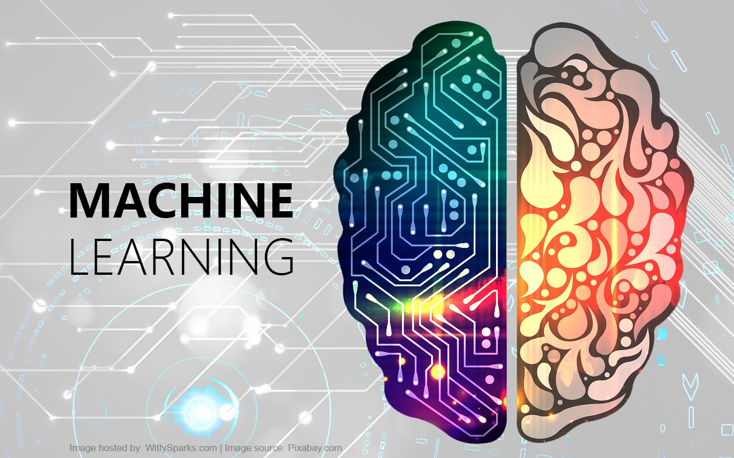

Fig. Machine Learning

Basically , Machine learning is a branch of artificial intelligence (AI) and computer science which focuses on the use of data and algorithms to imitate the way that humans learn, gradually improving its accuracy.
Image recognition is a well-known and widespread example of machine learning in the real world. It can identify an object as a digital image, based on the intensity of the pixels in black and white images or colour images, and many more real life examples of Machine learning are there.
Needs of Machine learning” :-
Human beings, at this moment, are the most intelligent and advanced species on earth because they can think, evaluate and solve complex problems. On the other side, AI is still in its initial stage and haven’t surpassed human intelligence in many aspects. Then the question is that what is the need to make machine learn? The most suitable reason for doing this is, “to make decisions, based on data, with efficiency and scale”.
Lately, organizations are investing heavily in newer technologies like Artificial Intelligence, Machine Learning and Deep Learning to get the key information from data to perform several real-world tasks and solve problems. We can call it data-driven decisions taken by machines, particularly to automate the process. These data-driven decisions can be used, instead of using programing logic, in the problems that cannot be programmed inherently. The fact is that we can’t do without human intelligence, but other aspect is that we all need to solve real-world problems with efficiency at a huge scale. That is why the need for machine learning arises.


Why to learn Machine learning :-
We have already discussed the need for machine learning, but another question arises that in what scenarios we must make the machine learn? There can be several circumstances where we need machines to take data-driven decisions with efficiency and at a huge scale. The followings are some of such circumstances where making machines learn would be more effective −

Lack of human expertise :
The very first scenario in which we want a machine to learn and take data-driven decisions, can be the domain where there is a lack of human expertise. The examples can be navigations in unknown territories or spatial planets.

Dynamic scenarios :
There are some scenarios which are dynamic in nature i.e. they keep changing over time. In case of these scenarios and behaviors, we want a machine to learn and take data-driven decisions. Some of the examples can be network connectivity and availability of infrastructure in an organization.

Difficulty in translating expertise into computational tasks :
There can be various domains in which humans have their expertise,; however, they are unable to translate this expertise into computational tasks. In such circumstances we want machine learning. The examples can be the domains of speech recognition, cognitive tasks etc.
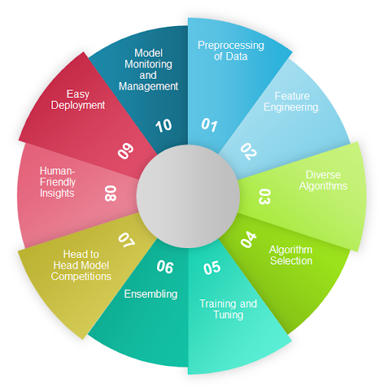
Features of Machine learning :-

Some other features of machine learning are :-

1- The ability to perform automated data visualization

2- Automation at its best

3- Customer engagement like never before

4- The ability to take efficiency to the next level when merged with IoT

5- The ability to change the mortgage market

6- Accurate data analysis

7- Business intelligence at its best
Advantages of Machine learning :-

1. Easily identifies trends and patterns
Machine Learning can review large volumes of data and discover specific trends and patterns that would not be apparent to humans. For instance, for an e-commerce website like Amazon, it serves to understand the browsing behaviors and purchase histories of its users to help cater to the right products, deals, and reminders relevant to them. It uses the results to reveal relevant advertisements to them.

2. No human intervention needed (automation)
With ML, you don’t need to babysit your project every step of the way. Since it means giving machines the ability to learn, it lets them make predictions and also improve the algorithms on their own. A common example of this is anti-virus softwares ; they learn to filter new threats as they are recognized. ML is also good at recognizing spam.

3. Continuous Improvement
As ML Algorithm gain experience, they keep improving in accuracy and efficiency. This lets them make better decisions. Say you need to make a weather forecast model. As the amount of data you have keeps growing, your algorithms learn to make more accurate predictions faster.

4. Handling multi-dimensional and multi-variety data
Machine Learning algorithms are good at handling data that are multi-dimensional and multi-variety, and they can do this in dynamic or uncertain environments.

5. Wide Applications
You could be an e-tailer or a healthcare provider and make ML work for you. Where it does apply, it holds the capability to help deliver a much more personal experience to customers while also targeting the right customers.
Disadvantages of Machine learning :-
With all those advantages to its powerfulness and popularity, Machine Learning isn’t perfect. The following factors serve to limit it:

1. Data Acquisition
Machine Learning requires massive data sets to train on, and these should be inclusive/unbiased, and of good quality. There can also be times where they must wait for new data to be generated.

2. Time and Resources
ML needs enough time to let the algorithms learn and develop enough to fulfill their purpose with a considerable amount of accuracy and relevancy. It also needs massive resources to function. This can mean additional requirements of computer power for you.

3. Interpretation of Results
Another major challenge is the ability to accurately interpret results generated by the algorithms. You must also carefully choose the algorithms for your purpose.

4. High error-susceptibility
Machine Learning is autonomous but highly susceptible to errors. Suppose you train an algorithm with data sets small enough to not be inclusive. You end up with biased predictions coming from a biased training set. This leads to irrelevant advertisements being displayed to customers. In the case of ML, such blunders can set off a chain of errors that can go undetected for long periods of time.And when they do get noticed, it takes quite some time to recognize the source of the issue, and even longer to correct it.

5. Lack of humans efforts
As most of the work done by machines which make the humans body stiff .They are now weak and not physically active ,which is really bad for their health.
Machine learning Models :-
Before discussing the machine learning model, we must need to understand the following formal definition of ML given by professor Mitchell −
“A computer program is said to learn from experience E with respect to some class of tasks T and performance measure P, if its performance at tasks in T, as measured by P, improves with experience E.”
The above definition is basically focusing on three parameters, also the main components of any learning algorithm, namely Task(T), Performance(P) and experience (E). In this context, we can simplify this definition as −
ML is a field of AI consisting of learning algorithms that −
- Improve their performance (P)
- At executing some task (T)
- Over time with experience (E)
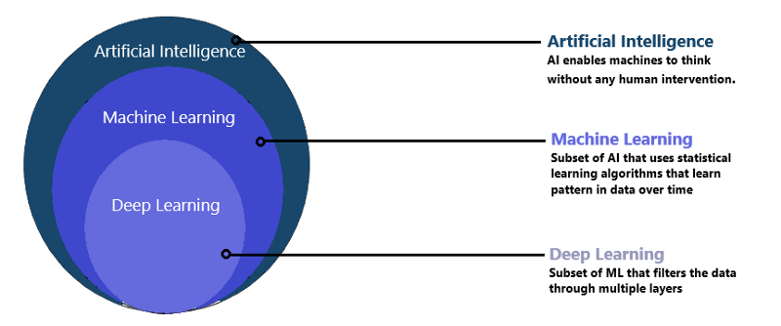
Fig . Machine Learning Models

Task(T) :-
From the perspective of problem, we may define the task T as the real-world problem to be solved. The problem can be anything like finding best house price in a specific location or to find best marketing strategy etc. On the other hand, if we talk about machine learning, the definition of task is different because it is difficult to solve ML based tasks by conventional programming approach.
A task T is said to be a ML based task when it is based on the process and the system must follow for operating on data points. The examples of ML based tasks are Classification, Regression, Structured annotation, Clustering, Transcription etc.

Experience (E) :-
As name suggests, it is the knowledge gained from data points provided to the algorithm or model. Once provided with the dataset, the model will run iteratively and will learn some inherent pattern. The learning thus acquired is called experience(E). Making an analogy with human learning, we can think of this situation as in which a human being is learning or gaining some experience from various attributes like situation, relationships etc. Supervised, unsupervised and reinforcement learning are some ways to learn or gain experience. The experience gained by out ML model or algorithm will be used to solve the task T.

Performance (P) :-
An ML algorithm is supposed to perform task and gain experience with the passage of time. The measure which tells whether ML algorithm is performing as per expectation or not is its performance (P). P is basically a quantitative metric that tells how a model is performing the task, T, using its experience, E. There are many metrics that help to understand the ML performance, such as accuracy score, F1 score, confusion matrix, precision, recall, sensitivity etc.
Challenges of Machine learning :-
While Machine Learning is rapidly evolving, making significant strides with cybersecurity and autonomous cars, this segment of AI as whole still has a long way to go. The reason behind is that ML has not been able to overcome number of challenges. The challenges that ML is facing currently are −
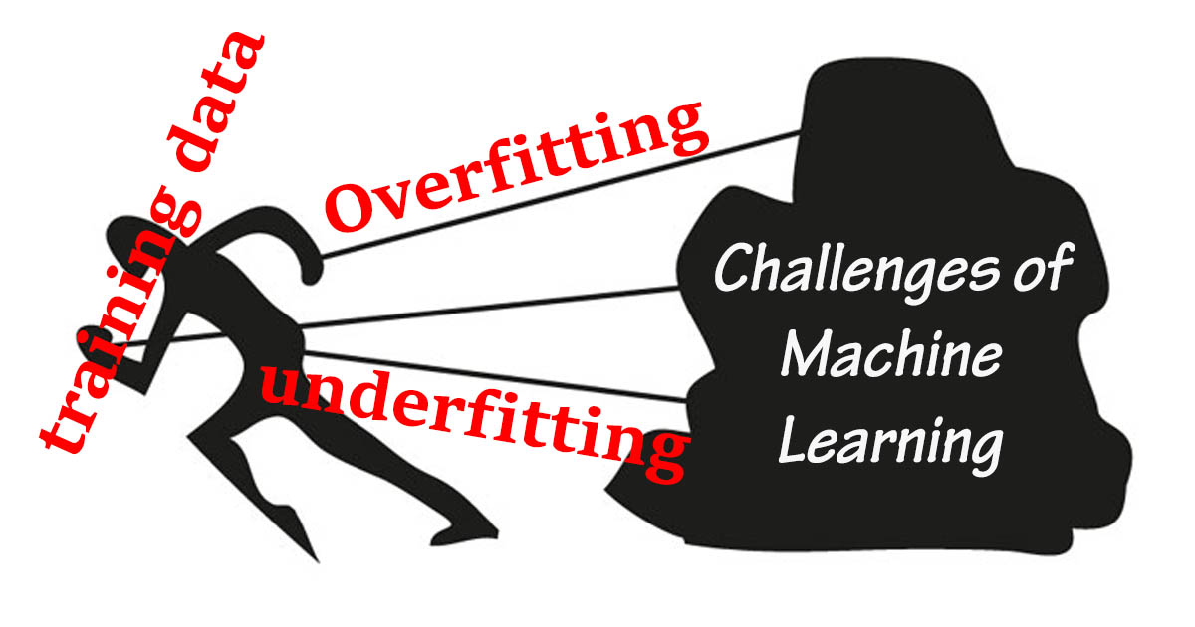

1. Quality of data − Having good-quality data for ML algorithms is one of the biggest challenges. Use of low-quality data leads to the problems related to data preprocessing and feature extraction.
2. Time-Consuming task − Another challenge faced by ML models is the consumption of time especially for data acquisition, feature extraction and retrieval.
3. Lack of specialist persons − As ML technology is still in its infancy stage, availability of expert resources is a tough job.
4. No clear objective for formulating business problems − Having no clear objective and well-defined goal for business problems is another key challenge for ML because this technology is not that mature yet.
5. Issue of overfitting & underfitting − If the model is overfitting or underfitting, it cannot be represented well for the problem.
6. Curse of dimensionality − Another challenge ML model faces is too many features of data points. This can be a real hindrance.
7. Difficulty in deployment − Complexity of the ML model makes it quite difficult to be deployed in real life.

Application of Machine learning :-
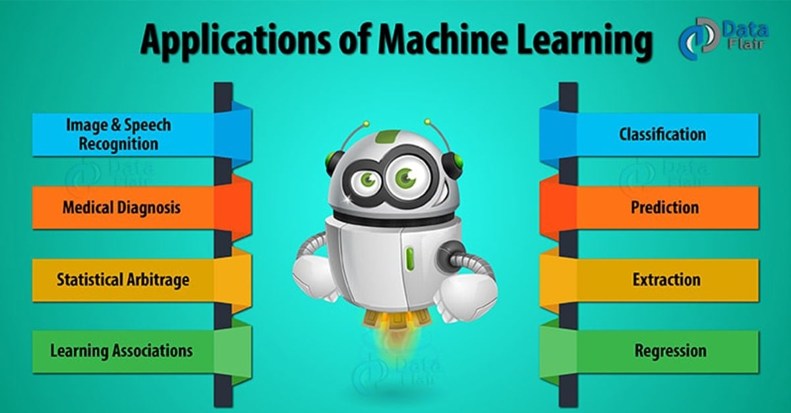

Machine Learning is the most rapidly growing technology and according to researchers we are in the golden year of AI and ML. It is used to solve many real-world complex problems which cannot be solved with traditional approach. Following are some real-world applications of ML −
- Emotion analysis
- Sentiment analysis
- Error detection and prevention
- Weather forecasting and prediction
- Stock market analysis and forecasting
- Speech synthesis
- Speech recognition
- Customer segmentation
- Object recognition
- Fraud detection
- Fraud prevention
- Recommendation of products to customer in online shopping.

Some Software of Machine learning :-
The following are the software of the machine learning :-

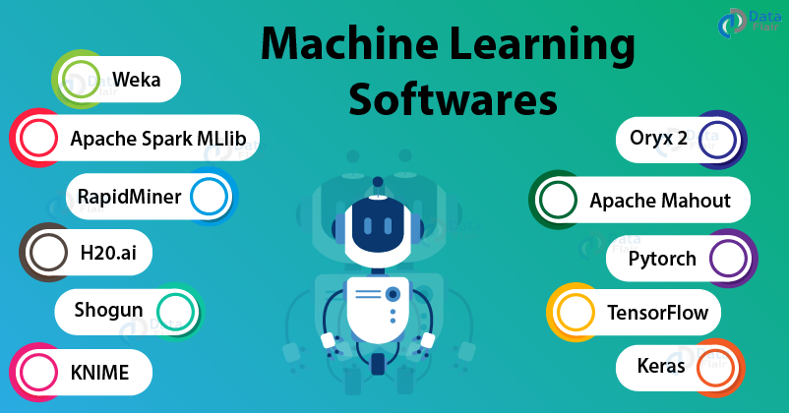
1. TensorFlow

2. Shogun

3. Apache Mahout

4. Apache Spark MLlib

5. Oryx 2

6. H20.ai

7. Pytorch

8. RapidMiner

9. Weka

10. KNIME

11. Keras

Experiment 2 : - Python Installation
Installing and using Python on Windows 10 is very simple. The installation procedure involves just three steps:
- Download the binaries
- Run the Executable installer
- Add Python to PATH environmental variables

Step 1: Download the Python Installer binaries
- Open the official Python website in your web browser. Navigate to the Downloads tab for Windows.
- Choose the latest Python 3 release. In our example, we choose the latest Python 3.7.3 version.
- Click on the link to download Windows x86 executable installer if you are using a 32-bit installer. In case your Windows installation is a 64-bit system, then download Windows x86-64 executable installer.


Step 2: Run the Executable Installer
- Once the installer is downloaded, run the Python installer.
- Check the Install launcher for all users check box. Further, you may check the Add Python 3.7 to path check box to include the interpreter in the execution path.
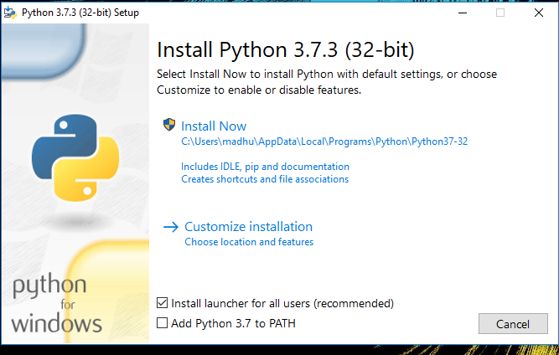

- Select Customize installation. Choose the optional features by checking the following check boxes:
- Documentation then pip
- tcl/tk and IDLE (to install tkinter and IDLE)
- Python test suite (to install the standard library test suite of Python)
- Install the global launcher for `.py` files. This makes it easier to start Python
- Install for all users.

- Click Next. This takes you to Advanced Options available while installing Python. Here, select the Install for all users and Add Python to environment variables check boxes.
- Optionally, you can select the Associate files with Python, Create shortcuts for installed applications and other advanced options. Make note of the python installation directory displayed in this step. You would need it for the next step. After selecting the Advanced options, click Install to start installation.
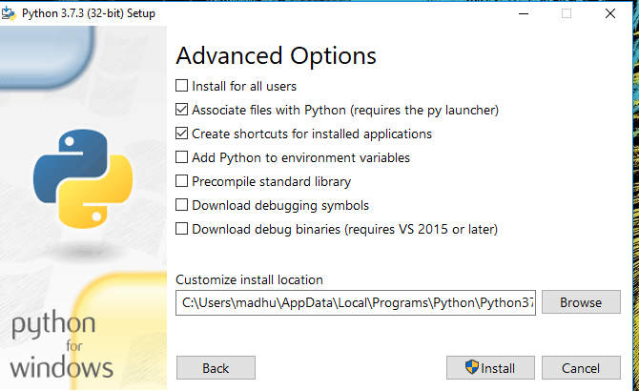

- Once the installation is over, you will see a Python Setup successful window.


Step 3: Add Python to environmental variables
The last (optional) step in the installation process is to add Python Path to the System Environment variables. This step is done to access Python through the command line. In case you have added Python to environment variables while setting the Advanced options during the installation procedure, you can avoid this step. Else, this step is done manually as follows. In the Start menu, search for “advanced system settings”. Select “View advanced system settings”. In the “System Properties” window, click on the “Advanced” tab and then click on the “Environment Variables” button. Locate the Python installation directory on your system. If you followed the steps exactly as above, python will be installed in below locations:
- C:\Program Files (x86)\Python37-32: for 32-bit installation
- C:\Program Files\Python37-32: for 64-bit installation
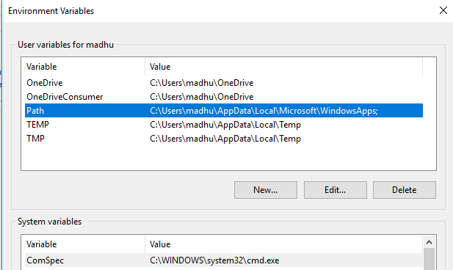
The folder name may be different from “Python37-32” if you installed a different version. Look for a folder whose name starts with Python. Append the following entries to PATH variable as shown below:

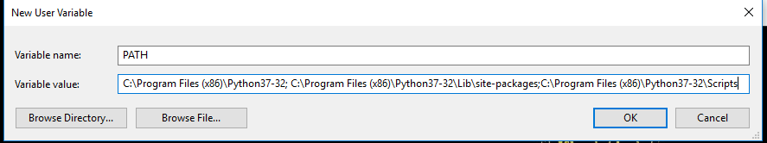

Step 4: Verify the Python Installation
You have now successfully installed Python 3.7.3 on Windows 10. You can verify if the Python installation is successful either through the command line or through the IDLE app that gets installed along with the installation. Search for the command prompt and type “python”. You can see that Python 3.7.3 is successfully installed.
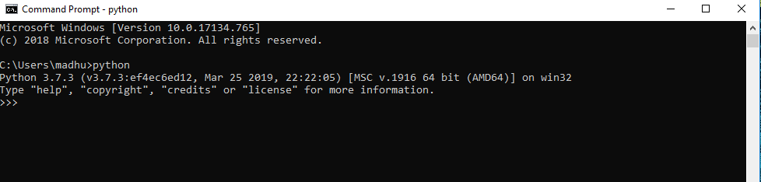
An alternate way to reach python is to search for “Python” in the start menu and click on IDLE (Python 3.7 64-bit). You can start coding in Python using the Integrated Development Environment(IDLE).
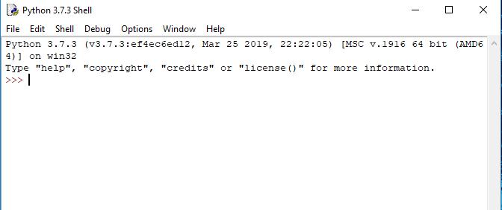
Hence, The python IDLE (interpreter or compiler) is installed in the system .
Or now available for our use and normal coding.
Experiment 3: - Anaconda Installation
Anaconda is open-source software that contains Jupyter, spyder, etc that is used for large data processing, data analytics, and heavy scientific computing. Anaconda works for R python programming languages.
Spyder(a sub-application of Anaconda) is used for python. Opencv for python will work in spyder. Package versions are managed by the package management system called conda.
To begin working with Anaconda, one must get it installed first. Follow the below instructions to Download and install Anaconda on your system:
The steps are following:-
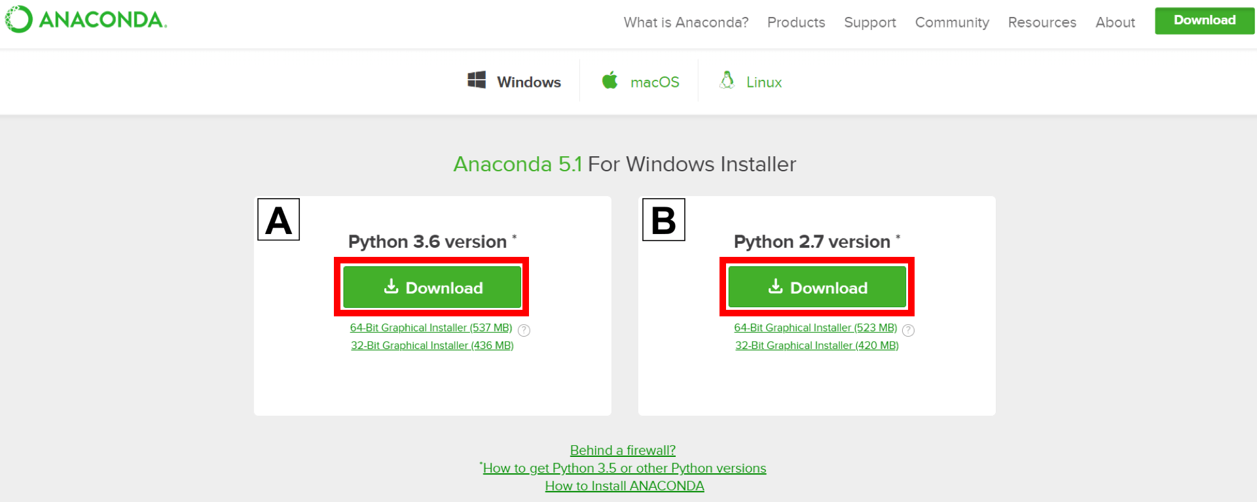
Step 1: Go to the Anaconda Website and choose a Python 3. x graphical installer (A) or a Python 2. x graphical installer (B). If you aren't sure which Python version you want to install, choose Python 3. Do not choose both.

Step 2: Locate your download and double-click it. Now at the bottom of the screen, the downloaded file will be shown.
later, open the file at the file location or you can also open it right there As it shown in the diagram .


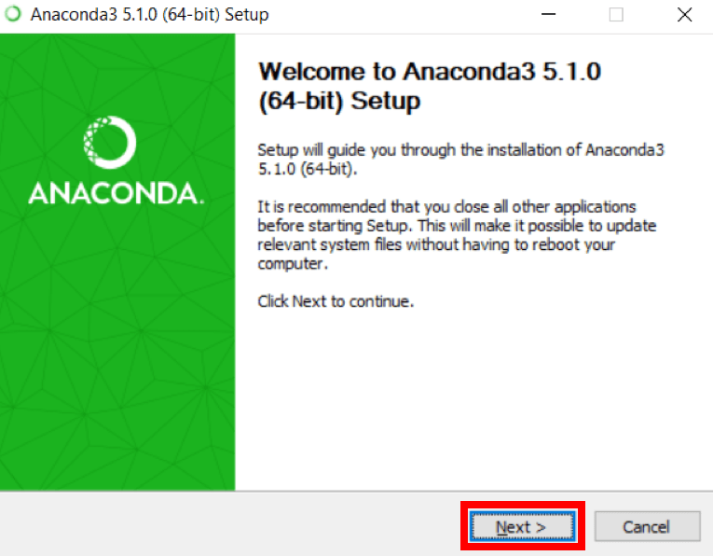
Step 3: When the next screen or window will appear then, click on Next. This “NEXT” meant to continue the futher installation process , along with the “CANCEL” button to stop the process .

Step 4: Read the license agreement and click on I Agree.


Step 5: As the next window will appear , Click on Next.
Step 6: Note your installation location and then click Next.
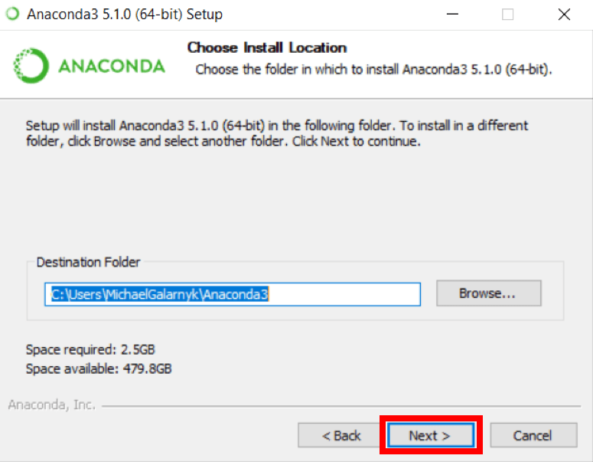
Step 7: This is an important part of the installation process. The recommended approach is to not check the box to add Anaconda to your path.
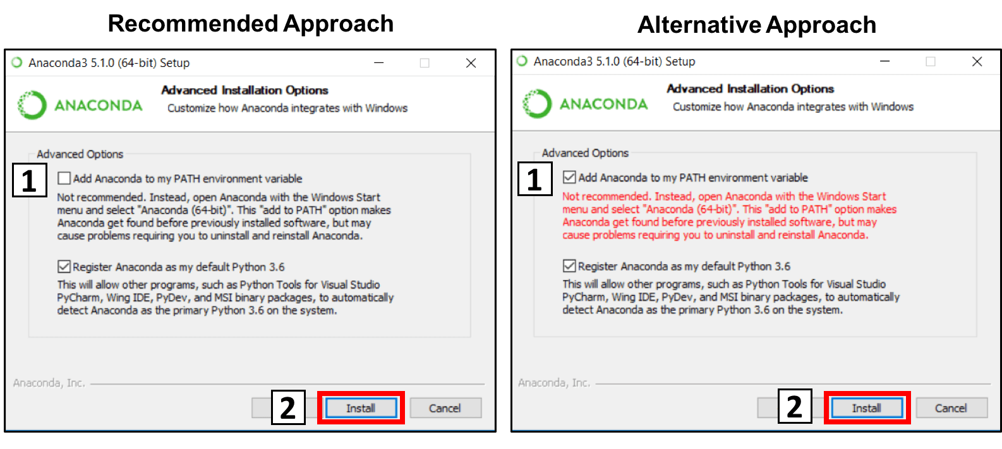
This means you will have to use Anaconda Navigator or the Anaconda Command Prompt (located in the Start Menu under "Anaconda") when you wish to use Anaconda (you can always add Anaconda to your PATH later if you don't check the box). If you want to be able to use Anaconda in your command prompt (or git bash, cmder, PowerShell, etc), please use the alternative approach and check the box.
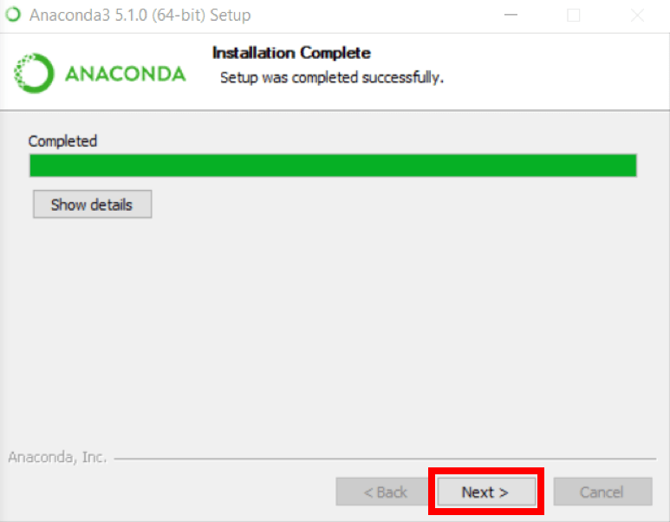
Step 8: After the whole process happen then we can futher continue our installation process , So after that , Click on Next.

Step 9: After that an additional window will appear, We can install Microsoft VSCode if we wish to, but it is optional.

Step 10: As the Optional window will be skipped, the ending step will gone a take place Click on Finish.
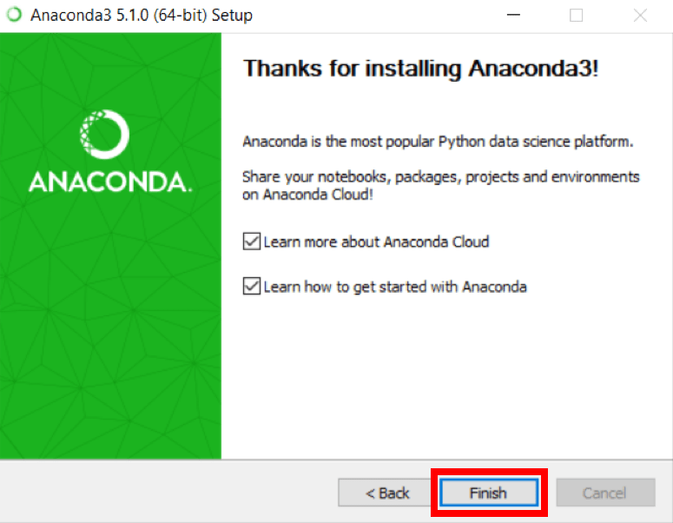Hence, the ANACONDA is installed now.
To verify whether the application is installed in the system or not. follow the further steps

Verify the Anaconda Installation :-
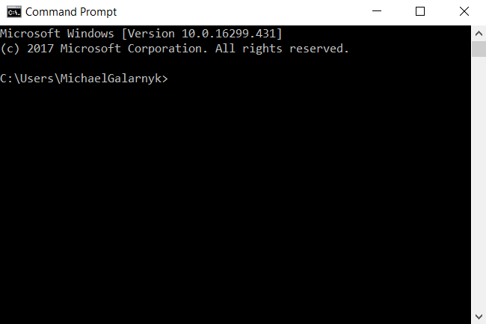
Step 1: Open a Command Prompt.
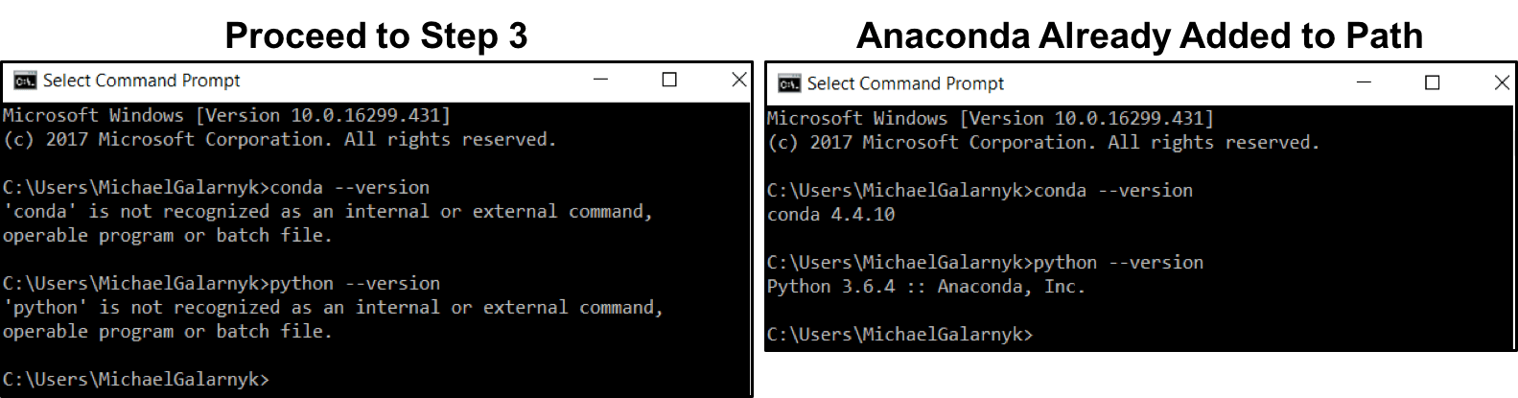

Step 2: Check if you already have Anaconda added to your path. Enter the commands below into your Command Prompt. This is checking if you already have Anaconda added to your path. If you get a command, not recognized error like in the left side of the image below, proceed to step 3. If you get an output similar to the right side of the image below, you have already added Anaconda to your path.
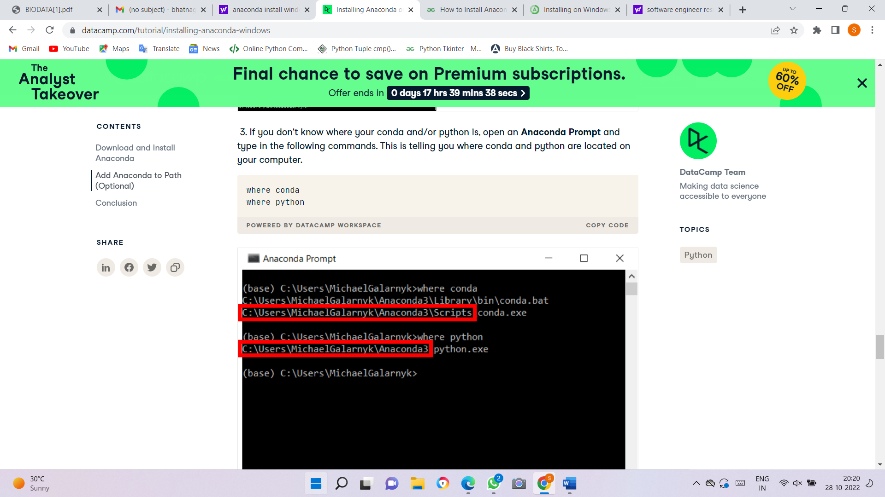
Step 3: If you don't know where your conda and/or python is, open an Anaconda Prompt and type in the following commands. This is telling you where conda and python are located on your computer.

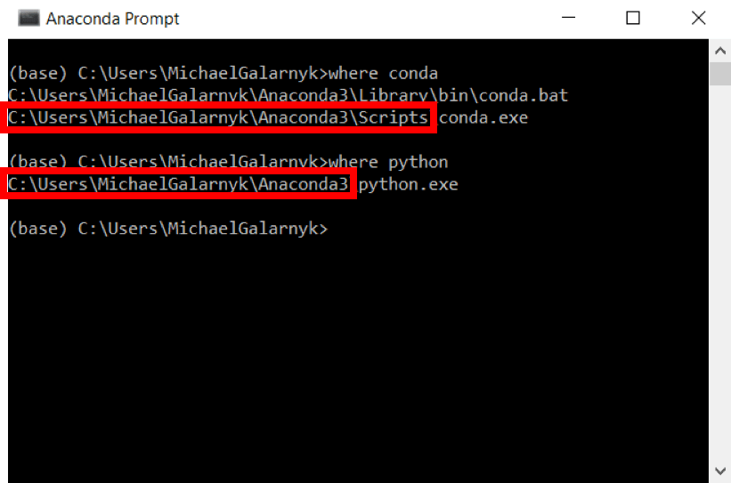
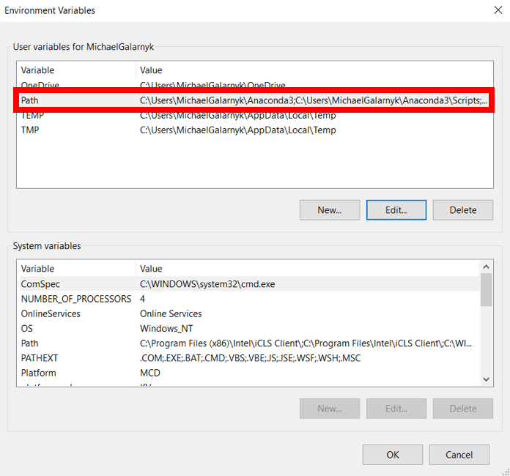
Step 4: Add conda and python to your PATH. You can do this by going to your Environment Variables and adding the output of step 3 (enclosed in the red rectangle) to your path. If you are having issues, here is a short video on adding conda and python to your PATH.
Step 5: Open a new Command Prompt. Try typing conda --version and python --version into the Command Prompt to check to see if everything went well.
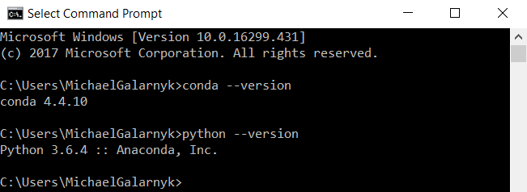
Hence, The Anaconda (interpreter or compiler) is installed in the system.
Or now available for our use and normal coding.

