
School of Computer Science and Engineering
Fall Semester 2026–2027
Course Project Report — Final Review
WAYPOINT
A Knowledge-Augmented Neuro-Symbolic Travel Planning System with Verifier-Guided Repair
Name | S.Srikar
Registration Number | 24BCE2486
Course Code | BCSE306L
Course Title | Artificial Intelligence
Slot | C1 + TC1
Semester | Fall Semester 2026–2027
Faculty | Gladys Gnana Kiruba B

Waypoint: A Knowledge-Augmented Neuro-Symbolic Travel Planning System with Verifier-Guided Repair

School of Computer Science and Engineering, Vellore Institute of Technology, Vellore, India

Abstract
Large language models (LLMs) read informal travel requests well but are unreliable planners: they produce inconsistent dates, overlapping activities and plans that ignore dependencies such as booking transport before accommodation or allowing time for visa processing. This project presents Waypoint, a web-based travel planner built as a knowledge-augmented neuro-symbolic system. An LLM interprets the user's free-text goal into a typed trip specification and later fills a day-by-day itinerary, while a deterministic symbolic engine validates and normalizes the specification, instantiates eleven knowledge-base rules into a task dependency graph, orders it by topological sorting, computes deadlines with a backward critical-path pass, and verifies the itinerary against hard constraints. Detected violations are returned to the LLM for at most two repair rounds, after which a deterministic repair procedure guarantees a plan with zero hard-constraint violations. Plans are saved to persistent per-user storage. In evaluation, the verifier detected 100% of injected faults across seven fault classes and their combinations (1,600 trials) with 0% false positives on 200 valid itineraries, and every faulty itinerary was repaired to zero hard violations; the specification normalizer produced a consistent trip in 100% of 600 corrupted interpreter outputs; and scheduling completed in under 0.5 ms for graphs of up to 20 tasks. A rule-based offline parser, used when no LLM is available, reached 79% field accuracy on held-out requests, which quantifies the role of the neural layer. The results show that pairing an LLM with a verifier converts fluent but unreliable output into plans whose structural correctness is guaranteed by construction.
Keywords— neuro-symbolic AI, large language models, automated planning, constraint verification, travel itinerary planning

I. INTRODUCTION

1.1 Background
Planning a trip is a structured problem hidden inside an unstructured request. A traveller says "Chennai to Kochi and Munnar for four nights in December, two of us, about ₹50,000", but a usable plan must resolve exact dates, assign nights to each city, sequence transport and accommodation bookings, respect lead times, fit activities into each day without conflicts and stay within budget. Neuro-symbolic artificial intelligence combines neural networks, which learn patterns from data and handle natural language, with symbolic systems, which represent knowledge explicitly and reason with rules [1]. Travel planning is a natural fit for this combination: the request is linguistic, while the constraints are logical and numeric.

1.2 Motivation
LLMs are now widely used to draft itineraries, but studies of their planning ability show that they frequently produce plans that violate constraints and cannot reliably verify their own output [2], [3]. On the TravelPlanner benchmark, even strong LLM agents rarely produce a plan that satisfies all constraints [4]. For a traveller the cost of such errors is concrete: a missed visa deadline, a hotel booked for the wrong night or a day scheduled with overlapping activities. The motivation of this project is to keep the language ability of an LLM while removing its responsibility for correctness.

1.3 Problem Statement
Given a free-text travel request that may describe one or several trips, each with one or more destinations, design and implement a system that (a) interprets the request into a structured specification, (b) organizes the preparatory tasks into a dependency-consistent schedule, (c) produces a day-by-day itinerary, (d) verifies the specification, schedule and itinerary against explicit constraints and repairs any violations, and (e) stores the resulting action plan persistently, such that the final plan contains no hard-constraint violations regardless of errors made by the language model.

1.4 Objectives
- Use an LLM to interpret user goals, including multi-city and multi-trip requests and relative dates.
- Build a symbolic engine that validates the interpretation, applies a knowledge base of planning rules, constructs a task dependency graph and verifies its consistency.
- Generate itineraries with an LLM inside a fixed day skeleton computed by the symbolic engine, and verify them against hard constraints.
- Implement a bounded verify–repair loop that guarantees zero hard-constraint violations in the final plan.
- Persist structured action plans and present them through an interactive web interface.
- Evaluate each layer with reproducible tests and report the results honestly.

1.5 Scope of the Work
The system plans leisure trips for one or more travellers, covering domestic and international journeys with ordered stops, transport legs, accommodation, daily activities, preparatory tasks and an estimated budget. It runs entirely in a web browser and supports three interchangeable language-model back ends: Claude through the claude.ai artifact runtime, any OpenAI-compatible endpoint (e.g. Google Gemini [14] or a local Ollama model [15]), and an offline rule-based parser. Live booking, real-time prices and availability, and payment are outside the scope; cost figures are LLM estimates and are labelled as such.

1.6 Organization of the Report
Section II reviews related research on LLM planning and neuro-symbolic methods. Section III defines the problem and the proposed solution. Section IV presents the methodology, architecture, algorithms and mathematical model. Section V describes the design and implementation. Section VI reports experimental results and discusses them. Section VII concludes and outlines future work.

II. LITERATURE REVIEW

2.1 Overview of Existing Research
Research relevant to this project falls into three groups. The first evaluates whether LLMs can plan on their own and finds that they mostly cannot produce valid plans without external checking [2], [4]. The second couples LLMs with symbolic planners or solvers, either by translating the problem into a formal language solved by a classical planner [5] or by checking LLM output with formal verification tools [6]. The third improves LLM reasoning through prompting and self-feedback, such as chain-of-thought prompting [7], interleaved reasoning and acting [8] and verbal self-reflection [9], or grounds generation in retrieved knowledge [10]. Classical AI planning and constraint satisfaction [11] provide the formal background for the symbolic side.

2.2 Review of Related Studies
Valmeekam et al. [2] evaluated LLMs on standard planning domains and found low rates of executable plans when the models plan autonomously, with better results when an external verifier is in the loop. Kambhampati et al. [3] argued that LLMs cannot plan or self-verify reliably, and proposed the LLM-Modulo framework, in which an LLM generates candidates and a bank of external critics checks them and returns feedback. Xie et al. [4] introduced TravelPlanner, a benchmark of realistic travel requests with hard and commonsense constraints, and reported a final pass rate of only 0.6% for a GPT-4-based agent. Liu et al. [5] proposed LLM+P, which translates a natural-language problem into PDDL, solves it with a classical planner and translates the plan back. Hao et al. [6] formalized travel planning constraints for an SMT solver, with an LLM translating requests into solver input. Chain-of-thought [7], ReAct [8] and Reflexion [9] improve LLM reasoning but keep correctness inside the model. Retrieval-augmented generation [10] grounds output in external documents but does not verify structured constraints.

2.3 Comparison of Existing Methods
TABLE I. COMPARISON OF EXISTING METHODS
Approach | Language understanding | Constraint guarantee | Dependency / deadline reasoning | Main limitation
LLM alone (chat itinerary) | Strong | None | Implicit, unreliable | Inconsistent dates and conflicts [2], [4]
Prompting / self-reflection [7]–[9] | Strong | None (self-check) | Implicit | Model checks its own errors
LLM+P [5] | LLM → PDDL | Planner-optimal | Explicit (PDDL) | Needs full formal domain model
LLM + SMT solver [6] | LLM → solver input | Solver-guaranteed | Explicit constraints | Solver setup and translation cost
LLM-Modulo [3] | Strong | External critics | Via critics | Framework, not a specific system
Waypoint (this work) | LLM + offline fallback | Verifier + deterministic repair | Rule-based task DAG with CPM deadlines | Small hand-built knowledge base

2.4 Research Gap
Formal approaches [5], [6] give strong guarantees but require a complete formal model and a solver that is heavy for a lightweight application. Prompting approaches [7]–[9] are lightweight but provide no guarantees. Few systems combine: (a) a verifier with a guaranteed deterministic fallback, so that the final plan is valid even when every LLM repair fails; (b) explicit reasoning about preparatory tasks and their deadlines, which travel benchmarks mostly omit; and (c) persistence and graceful degradation when the LLM is unavailable. Waypoint targets this gap with a small, transparent symbolic engine that runs in the browser.

2.5 Summary of the Literature Review
The literature agrees that LLMs should generate and interpret, while external symbolic components should verify [2], [3]. Waypoint follows this division: the LLM never decides correctness, and every structural property of the final plan is checked or computed deterministically.

III. PROBLEM DEFINITION AND OBJECTIVES

3.1 Problem Definition
The input is a natural-language request q and the current date tₙₒw. The output is a set of trip plans. Each plan contains a normalized trip specification, a task dependency graph with computed start-by and due dates, a day-by-day itinerary, a cost estimate and a verification report. The plan must satisfy all hard constraints defined in Section 4.5, and every assumption made while interpreting q must be recorded and shown to the user.

3.2 Existing System
Travellers currently plan by combining booking websites, maps and notes by hand, or by asking a general-purpose LLM chat assistant for an itinerary. Booking sites handle individual reservations but do not reason about the whole trip. Chat assistants produce complete, fluent itineraries but generate them in a single pass with no external checking.

3.3 Limitations of the Existing System
- Dates and night counts are often inconsistent across stops, and stated end dates may disagree with the itinerary.
- Activities can overlap or exceed a reasonable daily load; travel days may contain no travel.
- Dependencies such as "book transport before accommodation" or "apply for a visa well before departure" are not modelled, so infeasible deadlines go unnoticed.
- Assumptions made by the model are hidden, so the user cannot tell what was guessed.
- Plans are not stored as structured data and cannot be tracked or refined incrementally.

3.4 Proposed Solution
Waypoint separates interpretation from correctness. The LLM is used only where language understanding is needed: turning the request into a typed specification and proposing activities. All structural decisions are made by a deterministic engine: normalizing dates, chaining stops, deciding whether a border is crossed, generating preparatory tasks from knowledge-base rules, scheduling them, fixing the day skeleton and verifying the itinerary. When verification fails, the violations are sent back to the LLM as explicit feedback, and if they persist, a deterministic repair procedure fixes them.

3.5 Specific Objectives
- Interpret single-trip, multi-city and multi-trip requests, including relative dates such as "next month".
- Detect and correct inconsistent stop dates, missing night counts and invalid values in the interpreter output.
- Generate preparatory tasks from 11 explicit rules (R1–R11) and verify that the task graph is acyclic and its deadlines are ordered.
- Classify each task as on track, urgent, behind its recommended lead time or infeasible.
- Guarantee that final itineraries have full day coverage, valid non-overlapping times, daily load within the selected pace and transit on every travel day.
- Store plans per user and allow tasks to be checked off and plans to be refined.

3.6 Requirements and Constraints
TABLE II. REQUIREMENTS AND CONSTRAINTS
Type | Requirement / constraint
Functional | Accept free text; support multiple trips and stops; show pipeline progress; display itinerary, task graph, verification, budget and specification; save, reopen, refine and delete plans.
Correctness | No overlapping items, no invalid times, every trip day covered, daily active hours within the pace limit (relaxed 7 h, moderate 9 h, packed 11 h), transit on every travel day.
Robustness | Must work when the LLM returns malformed JSON, is rate-limited or is unavailable (offline fallback).
Transparency | Every assumption, correction and repair is shown to the user.
Deployment | Runs in a modern browser without installation; no server-side code required.
Constraint | Language-model calls are rate-limited and may fail; the repair loop is bounded to two LLM rounds per trip.

IV. PROPOSED METHODOLOGY

4.1 Overview of the Proposed Approach
The approach follows the generate–verify pattern recommended in [3]. The pipeline has seven stages: (1) LLM interpretation, (2) validation and normalization, (3) knowledge grounding, (4) task-graph construction and scheduling, (5) LLM itinerary generation inside a fixed skeleton, (6) verification with bounded repair, and (7) persistence. Stages 2, 3, 4 and 6 are deterministic; only stages 1 and 5 use the LLM.

4.2 System Architecture
Fig. 1 shows the architecture. The neural components (green) exchange JSON with the symbolic components (blue) through fixed schemas. The knowledge base supplies rules, lead times, pace limits and a city-to-country map. The plan store keeps each user's plans privately.
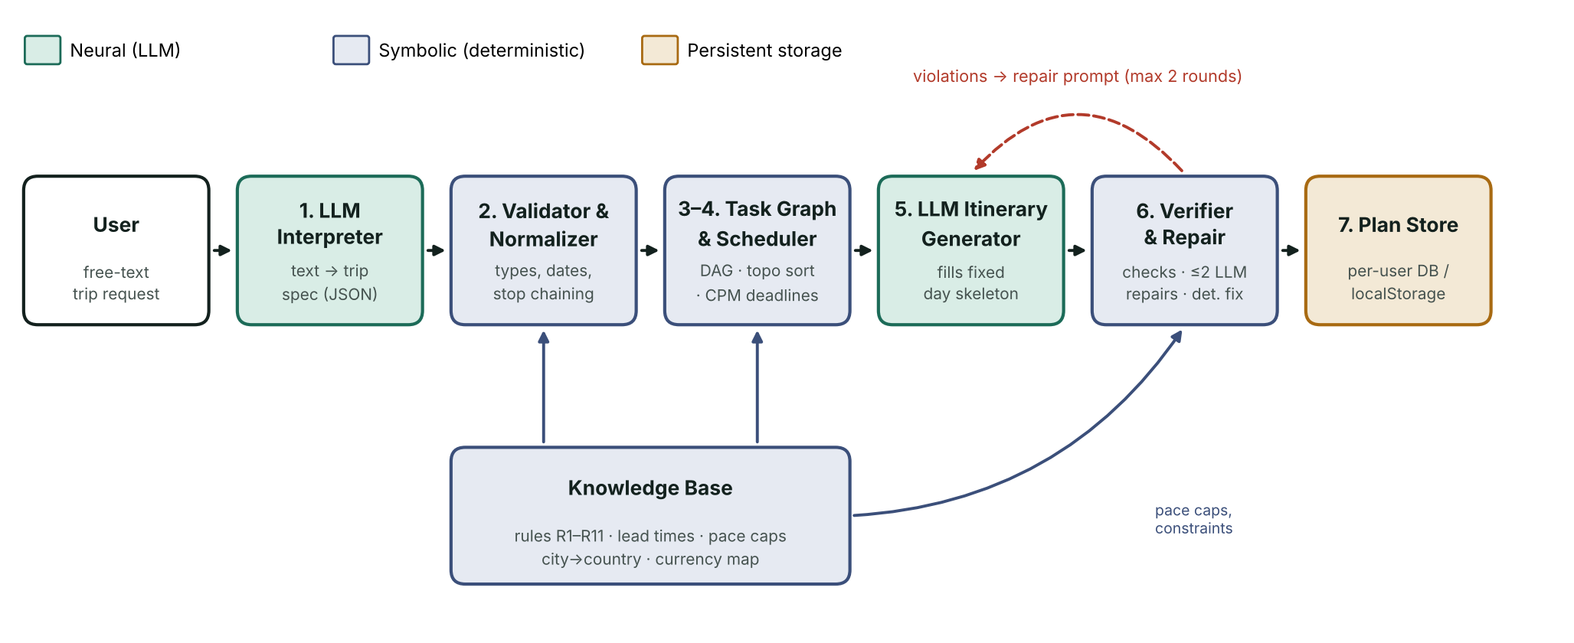
Fig. 1. System architecture of Waypoint (neural, symbolic and storage components)

4.3 Workflow of the Proposed System
- Interpret. The request and today's date are sent to the LLM with a schema-constrained prompt. The LLM returns trips, stops, dates, travellers, budget, interests, pace and transport modes, plus explicit lists of assumptions and open questions.
- Validate and normalize. Types are coerced, invalid dates rejected, night counts derived from dates or distributed from a stated end date, and stops chained back-to-back. Border crossing and currency are inferred from the knowledge base. Every correction is logged.
- Ground. A day skeleton is computed: one entry per date with its city and, on travel days, the origin, destination and mode of the journey.
- Graph and schedule. Rules R1–R11 are instantiated into tasks with dependencies, lead times and effort; the graph is sorted topologically and deadlines are computed by a backward pass.
- Generate itinerary. The LLM fills the fixed skeleton with timed activities and a cost breakdown; it cannot change dates or cities.
- Verify and repair. The verifier checks coverage, times, overlaps, load, transit and costs. Hard violations are sent back to the LLM (at most two rounds); any that remain are fixed deterministically.
- Save and present. The plan is stored and displayed with its verification report, task graph and budget.

4.4 Algorithm Design
Algorithm 1: Task graph scheduling
Input: tasks V with dependencies E, lead times ℓ(v), efforts e(v), departure date t₀, today tₙₒw.
1. Verify every dependency refers to an existing task; record any missing reference.
2. Compute in-degrees and run Kahn's algorithm [12] to obtain a topological order; if fewer than |V| tasks are ordered, report the remaining tasks as a cycle and stop.
3. Initialize each due date d(v) = t₀ − ℓ(v).
4. Visit tasks in reverse topological order; for each dependent w of v set d(v) = min(d(v), d(w) − e(w)), the backward pass of the critical path method [13].
5. Set start-by b(v) = d(v) − e(v) + 1 and depth(v) = longest path from a root.
6. Classify v as infeasible if tₙₒw + e(v) − 1 ≥ t₀, late if d(v) < tₙₒw, urgent if b(v) ≤ tₙₒw + 2, otherwise on track.
7. Check every edge (u, v) satisfies d(u) < b(v); report any violation.
Algorithm 2: Verify–repair loop
1. Generate itinerary I with the LLM from the skeleton.
2. Compute violations V(I). While V contains hard violations and fewer than two repair rounds have been used, send V and I to the LLM and replace I with the corrected output.
3. Apply deterministic repair: drop items with invalid times, sort items, shift overlapping items to the end of the previous item (or drop them if no room before 23:30), remove the latest sight or activity until load fits the pace limit, insert a transit block on travel days that lack one, and add any missing day.
4. Recompute V; by construction it contains no hard violations. Record every repair in the plan's log.

4.5 Mathematical Model
Trip specification. A trip is T = (o, ⟨s₁, …, sₖ⟩, t₀, n, B, π) with origin o, ordered stops sᵢ with nights nᵢ ≥ 1, start date t₀, travellers n, budget B and pace π. Stops are chained so that
start(s₁) = t₀, end(sᵢ) = start(sᵢ) + nᵢ, start(sᵢ₊₁) = end(sᵢ), t_end = end(sₖ)
so the trip has N = Σ nᵢ nights and N + 1 days, with no gaps or overlaps by construction.
Task schedule. The task graph G = (V, E) is a directed acyclic graph where (u, v) ∈ E means u must finish before v starts. Due dates are the fixed point of
d(v) = min( t₀ − ℓ(v), min₍ᵥ,w₎∈E [ d(w) − e(w) ] ), b(v) = d(v) − e(v) + 1
Itinerary constraints. For each day D with items k = 1…m sorted by start time, each item an interval [aₖ, bₖ) in minutes:
aₖ < bₖ ≤ 1439, aₖ₊₁ ≥ bₖ, Σ{k : typeₖ ∉ {transit, rest}} (bₖ − aₖ) ≤ 60·C(π)
with C(relaxed) = 7, C(moderate) = 9 and C(packed) = 11 hours. Coverage requires the set of itinerary dates to equal the skeleton dates, and every travel day must contain at least one transit item. The budget check is Σ cⱼ ≤ B·n if the budget is per person, otherwise Σ cⱼ ≤ B; exceeding it is reported as a warning because costs are estimates.
Complexity. Kahn's algorithm and the backward pass are O(|V| + |E|); verification is O(Σ m log m) over all days. Both are negligible compared with LLM latency.

4.6 Dataset Description
The system uses no training dataset; the LLM is used without fine-tuning. The knowledge base is hand-built and contains 11 planning rules with lead times, 3 pace limits, about 110 city-to-country mappings and 25 country-to-currency mappings. For evaluation, four test sets were created: (a) a development set of 20 gold-labelled requests used while building the offline parser; (b) a held-out set of 15 differently phrased requests written after the parser was frozen; (c) synthetic itineraries for fault injection, 200 per fault type; and (d) 600 corrupted interpreter outputs across six corruption types. All sets and scripts are included in the project files.

4.7 Tools and Technologies Used
TABLE III. TOOLS AND TECHNOLOGIES
Tool / technology | Purpose
JavaScript (ES2020), HTML5, CSS3 | Application, symbolic engine and user interface, with no framework
Claude via the claude.ai artifact runtime | LLM back end inside Claude; per-user database for plan storage
Google Gemini API (OpenAI-compatible endpoint) [14] | LLM back end when running outside Claude
Ollama with Llama 3.2 / Qwen 2.5 [15] | Local, key-free LLM back end
Browser localStorage | Plan storage when running locally
Node.js, jsdom | Unit tests, UI integration tests and evaluation scripts
Python (http.server, Matplotlib, Playwright) | Local web server, result figures and interface screenshots

V. SYSTEM DESIGN AND IMPLEMENTATION

5.1 System Design
The design separates pure logic from runtime concerns. The file engine.js contains only deterministic functions with no access to the network or the page, so it can be unit-tested in Node.js. The file ui.js contains two adapters, one for the language model and one for storage, plus the pipeline orchestration and the views. Each adapter selects the best available option at start-up and degrades gracefully: the LLM adapter tries Claude, then a configured OpenAI-compatible endpoint, then the offline parser; the storage adapter tries the per-user database, then browser storage.

5.2 Module Description
TABLE IV. MODULES AND RESPONSIBILITIES
Module | Layer | Responsibility
interpretPrompt / itineraryPrompt / repairPrompt | Neural interface | Schema-constrained prompts; today's date, skeleton and violations are embedded
normalizeSpec / normalizeTrip | Symbolic | Type coercion, date validation, night distribution, stop chaining, border and currency inference, assumption log
KB | Knowledge | Rules R1–R11, lead times, effort, pace caps, city→country and country→currency maps
daySkeleton | Symbolic | One entry per date with city and travel leg
buildTasks | Symbolic | Instantiates rules into tasks and dependencies; marks border tasks conditional when unknown
schedule | Symbolic | Kahn topological sort, cycle and reference checks, backward deadline pass, status
verifyItinerary / autoFixItinerary | Symbolic | Hard-constraint checks and guaranteed deterministic repair
budgetCheck / tripChecks | Symbolic | Budget comparison and the 11-item verification table
ruleParse / templateItinerary | Fallback | Offline interpretation and template itinerary when no LLM is available
LLM adapter | Runtime | Claude → OpenAI-compatible → offline; error diagnosis (HTTP status, network, quota)
Store adapter | Runtime | Per-user private database or localStorage; serialized writes
Views | Presentation | Route board, itinerary, task graph (SVG), verification, budget, specification

5.3 Algorithm Implementation
Dates are handled as ISO strings converted to whole UTC days, which avoids time-zone and daylight-saving errors. Stop chaining always recomputes dates from night counts; if the interpreter gave a conflicting date, the correction is recorded rather than silently applied. The scheduler is implemented exactly as Algorithm 1; its source is listed in Appendix A. The repair loop in Algorithm 2 runs per trip, so a request with several trips is planned and verified trip by trip, and overlaps between trips are reported as plan-level warnings. Border-crossing tasks (passport, entry rules, visa, insurance) are generated when a border is crossed, and are marked conditional when the countries cannot be determined, so that uncertain tasks produce warnings rather than failures.
TABLE V. KNOWLEDGE-BASE RULES
Rule | Statement | Lead (days)
R1 | Every trip starts from a confirmed scope: dates, travellers and budget | 45
R2 | Crossing a border needs a passport valid 6+ months past return | 60
R3 | Entry rules must be known before any booking is committed | 50
R4 | Each transport leg is booked after scope (and entry rules) are settled | 21 dom. / 30 intl.
R5 | A stay is booked after the leg that arrives there | 21
R6 | Visa applications need booked itineraries and take ~15 days | 30 (+15 effort)
R7 | Insurance is bought once the outbound journey is fixed | 14
R8 | Different currencies require forex or a travel card | 5
R9 | Timed-entry attractions are pre-booked after stays are fixed | 10
R10 | Tickets and offline maps are gathered after all bookings | 2
R11 | Packing comes last and depends on finalized documents | 1

5.4 Software and Hardware Requirements
TABLE VI. SOFTWARE AND HARDWARE REQUIREMENTS
Category | Requirement
Operating system | Windows 10/11, macOS or Linux
Browser | Recent Chrome, Edge or Firefox
Runtime (development) | Node.js LTS for build and tests; Python 3 for the local web server
LLM access (one of) | Claude account (hosted version); Gemini API key; or Ollama installed locally
Hardware (hosted / API) | Any laptop with 4 GB RAM
Hardware (local Ollama) | 8 GB RAM for a 3B model, 16 GB RAM for a 7B model; a GPU is optional but faster

5.5 Implementation Procedure
- Implemented the date algebra and normalizer, then unit-tested them with conflicting and incomplete interpreter outputs.
- Encoded the knowledge base and rule instantiation; implemented the scheduler and tested cycle detection and edge ordering.
- Defined the itinerary schema, verifier and deterministic repair; tested them against deliberately broken itineraries.
- Wrote schema-constrained prompts for interpretation, itinerary generation and repair.
- Built the LLM and storage adapters with fallbacks and explicit error messages.
- Built the interface: pipeline trace, route board, itinerary, task graph, verification, budget and specification views.
- Wrote integration tests in jsdom with simulated LLMs (well-behaved, error-prone and failing) and evaluation scripts for Section VI.
- Published the hosted version on claude.ai and packaged a local build with a cross-platform build script.

5.6 User Interface / Prototype
The interface (Fig. 2) has a control column with the request box, the LLM connection settings, a live seven-step pipeline trace and the list of saved plans. The plan sheet shows a departure-board style route strip, key facts, and tabs for the itinerary, the task graph, the verification report, the budget and the normalized specification. Each step of the pipeline is labelled as neural, symbolic, loop or storage, so the user can see which component did what.
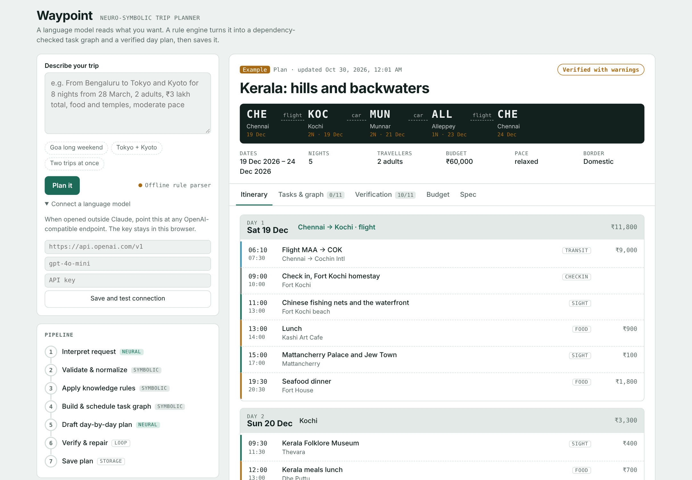
Fig. 2. Waypoint interface showing the itinerary view of a five-night Kerala trip

VI. RESULTS AND DISCUSSION

6.1 Experimental Setup
All experiments were run in Node.js against the same engine.js that the application uses, with today's date fixed at 29 October 2026 so that results are reproducible. Random test cases were generated with a seeded pseudo-random generator. Interface tests ran the complete page in jsdom with simulated language models. The scripts are eval.js, heldout.js, test.js and domtest.js.

6.2 Dataset Preparation and Preprocessing
Each request in the development and held-out sets was labelled with seven gold fields: origin, ordered stops, total nights, start date, adult travellers, budget amount and budget scope. Relative dates were resolved against the fixed test date. The held-out set deliberately uses phrasings not handled during development, such as "→" between cities, ordinal dates, "per head", numeric dates and budgets without a currency symbol. For fault injection, valid itineraries were generated for random trips of one to three stops, two to nine nights and all three pace settings; a fault was then injected and the itinerary passed to the verifier and the repair procedure.

6.3 Evaluation Metrics
- Field accuracy: percentage of requests for which a field exactly matches the gold label; exact match: all seven fields correct.
- Detection recall: percentage of faulty itineraries for which the verifier reports at least one hard violation; classification accuracy: the reported violation has the correct type.
- False-positive rate: percentage of valid itineraries incorrectly flagged.
- Repair success: percentage of faulty itineraries with zero hard violations after repair.
- Normalization consistency: percentage of corrupted specifications that yield a valid, internally consistent trip.
- Graph validity and latency: acyclicity, number of edge-order violations and time per scheduling call.

6.4 Experimental Results
A. Unit and integration tests
All 22 engine unit tests passed. The integration tests passed in three scenarios: offline (two trips from one request), a simulated error-prone LLM whose itinerary had 10 hard violations (reduced to 1 after LLM repair rounds and to 0 after deterministic repair), and an endpoint returning HTTP 429, which the interface reported with the provider's message before falling back.
B. Verifier fault injection
TABLE VII. VERIFIER FAULT-INJECTION RESULTS
Fault type | Trials | Detection recall (%) | Correct type (%) | Zero violations after repair (%)
Missing day | 200 | 100.0 | 100.0 | 100.0
Day outside trip | 200 | 100.0 | 100.0 | 100.0
Overlapping items | 200 | 100.0 | 100.0 | 100.0
Malformed time string | 200 | 100.0 | 100.0 | 100.0
End before start | 200 | 100.0 | 100.0 | 100.0
Exceeds pace limit | 200 | 100.0 | 100.0 | 100.0
Travel day without transit | 200 | 100.0 | 100.0 | 100.0
Three faults combined | 200 | 100.0 | — | 100.0

On 200 valid itineraries the false-positive rate was 0%. Every injected fault was detected and classified correctly, and repair always produced an itinerary with no hard violations.
C. Specification normalization
TABLE VIII. NORMALIZATION OF CORRUPTED INTERPRETER OUTPUT
Corruption type | Example | Consistent trips (of 100)
Wrong stop date | Second stop starts 9 days after trip start | 100
Missing nights with end date | Night count null; end date given | 100
End before start | End date 2 days before start | 100
Numbers as strings | adults "2", amount "45000", currency "inr" | 100
Invalid calendar date | 2027-02-30 | 100
Empty stop | Stop with empty city name | 100

D. Task graph scheduling
For trips of one to five stops, the generated graphs had 7–20 tasks and 9–48 edges (Fig. 3). All 15 graphs were acyclic with zero edge-order violations, and one scheduling call took 0.14–0.50 ms. The earliest task starts 45 days before departure for domestic trips and 61 days for international trips, set by rules R1 and R2 respectively.
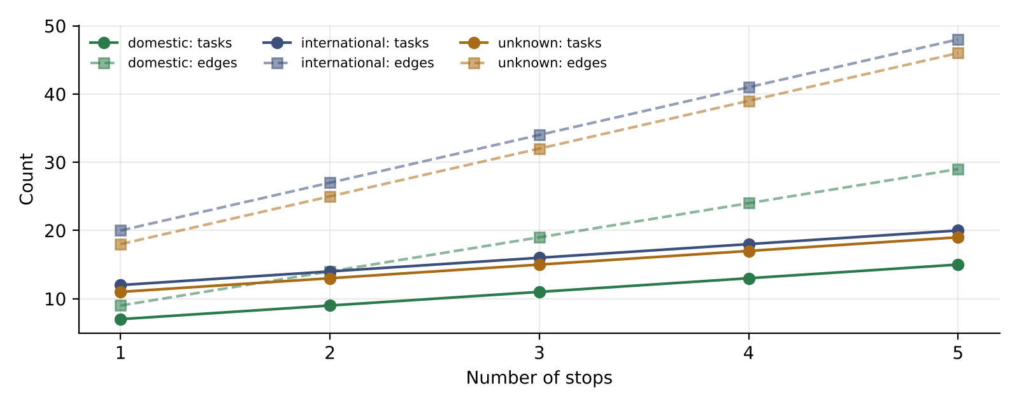
Fig. 3. Task-graph size versus number of stops
Fig. 4 shows how task status changes with time to departure for an international trip. At 7 and 14 days the visa task is classified infeasible because its 15-day processing time cannot finish before departure; from 21 days onward no task is infeasible, and at 90 days every task is on track.
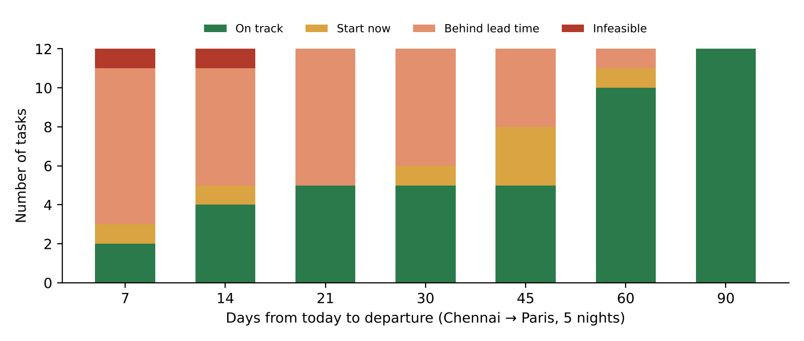
Fig. 4. Task status versus days to departure for a Chennai–Paris trip
E. Offline parser
The rule-based parser reached 100% exact match on the development set and 79% overall field accuracy (53.3% exact match) on the held-out set (Fig. 5). The development score is optimistic because the parser was built using those requests; the held-out score is the realistic estimate.
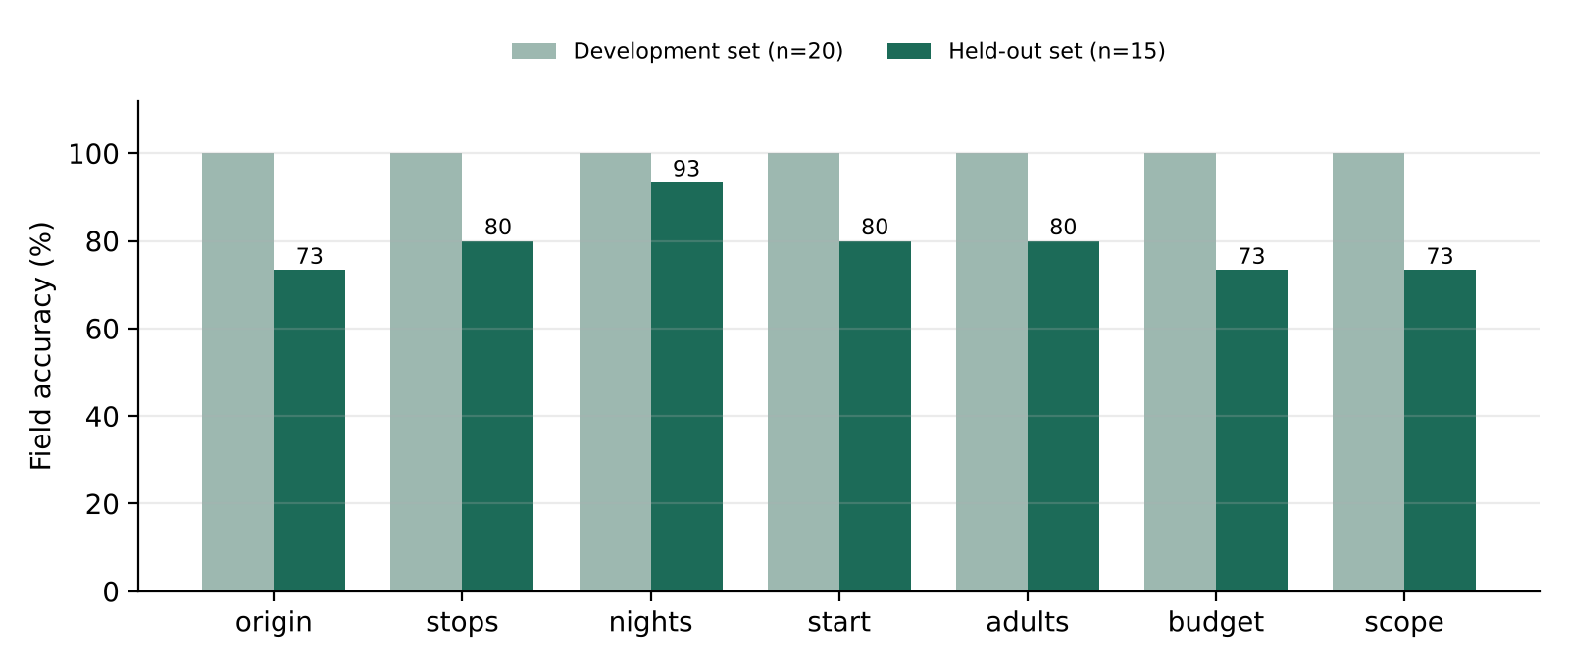
Fig. 5. Offline parser field accuracy on development and held-out requests
F. Case study
For the request "Chennai to Kochi, Munnar and Alleppey, 5 nights, 2 adults, ₹60,000, relaxed pace", the engine generated 11 tasks with the earliest starting 45 days before departure and verified a six-day itinerary. Ten of eleven checks passed. The remaining check was a budget warning: the estimated cost of ₹68,500 exceeded the ₹60,000 budget by 14%, which the interface reported together with a suggested saving. The task graph and verification report are shown in Appendix C.

6.5 Comparison with Existing Methods
TABLE IX. CAPABILITY COMPARISON WITH EXISTING APPROACHES
Capability | LLM alone | LLM+P [5] | LLM + SMT [6] | Waypoint
Free-text input | Yes | Yes | Yes | Yes
Guaranteed hard constraints | No | Yes (planner) | Yes (solver) | Yes (verifier + repair)
Preparatory tasks and deadlines | No | If modelled | No | Yes (R1–R11, CPM)
Works without the LLM | No | No | No | Yes (offline parser)
External solver required | No | Yes | Yes | No
Persistent, refinable plans | No | No | No | Yes

The reported 0.6% final pass rate of a GPT-4 agent on TravelPlanner [4] illustrates the weakness of LLM-only planning. Waypoint's 100% repair success is not directly comparable to that figure: it applies to Waypoint's own hard constraints on itineraries, not to TravelPlanner's constraint set or data. The comparison above is therefore qualitative.

6.6 Discussion of Results
The results support the central design decision. Because the itinerary is generated inside a skeleton fixed by the symbolic engine, the LLM cannot introduce date or sequencing errors; because the verifier is followed by a deterministic repair procedure, the structural correctness of the final itinerary does not depend on the LLM. The fault-injection results show that the verifier is complete with respect to the defined constraint classes and does not flag valid plans. The scheduling results show that deadline reasoning adds value an LLM does not provide: the system flags a visa application as infeasible two weeks before an international trip, a constraint that a fluent itinerary would not reveal.
The held-out parser result (79% field accuracy, 53.3% exact match) is the clearest evidence for the neural layer. Rule-based parsing fails on phrasings it has not seen, such as ordinal dates, arrows between cities and budgets written in words (Appendix B). Interpretation is therefore assigned to the LLM, while the rule-based parser serves only as a fallback. During testing, the Gemini endpoint returned HTTP 503 (overloaded) and 404 (model not available to new users); in each case the interface showed the provider's message and completed the plan with the offline fallback, confirming graceful degradation.

6.7 Limitations
- LLM interpretation quality was not measured quantitatively on the held-out set; the reported accuracy is for the offline parser only.
- The verifier guarantees structural constraints, not the quality of suggestions: an LLM may still propose a closed attraction or an unrealistic price.
- Costs are LLM estimates without live price data, so the budget check is advisory.
- The knowledge base is small and hand-built; lead times are general guidance, not destination-specific rules.
- When running locally, the API key is stored in the browser, which is suitable only for personal use.

VII. CONCLUSION AND FUTURE WORK

7.1 Summary of the Work
This project designed, implemented and evaluated Waypoint, a neuro-symbolic travel planner that uses an LLM to interpret goals and propose activities, and a deterministic engine to organize tasks, verify dependencies and constraints, and repair errors. The system runs in the browser, saves plans persistently and works with three language-model back ends, including a fully offline mode.

7.2 Major Findings
- A verifier followed by deterministic repair guaranteed zero hard-constraint violations in every tested case, including combined faults.
- Fixing the day skeleton symbolically before generation removes the most common LLM errors (dates and sequencing) by construction.
- Rule-based dependency scheduling exposes infeasible deadlines, such as visa processing, that LLM-only planning does not reveal.
- Rule-based interpretation alone generalizes poorly (79% held-out field accuracy), which justifies the neural interpretation layer.

7.3 Contributions
- A seven-stage neuro-symbolic pipeline in which the LLM never decides correctness.
- A bounded verify–repair loop with a guaranteed deterministic fallback.
- A rule-based task-dependency model for trip preparation with critical-path deadline computation and four-level status classification.
- A browser-only implementation with interchangeable LLM back ends, offline degradation and transparent pipeline tracing.
- A reproducible evaluation suite covering normalization, verification, repair, scheduling and parsing.

7.4 Limitations and Challenges
The main challenges were the unpredictability of LLM output formats, which required tolerant JSON parsing and strict normalization; the availability of free LLM APIs, which returned overload and model-retirement errors during testing; and character-encoding issues when running the page locally, which were solved by generating a standalone build with an explicit UTF-8 declaration. The limitations in Section 6.7 remain.

7.5 Future Enhancements
- Measure LLM interpretation accuracy on the held-out set and compare LLM-only and Waypoint plans on a larger benchmark.
- Add a place knowledge base with opening hours, closed days, entry fees and travel times, and verify itineraries against it.
- Support disruption replanning: when a leg is cancelled, recompute only the affected part of the task graph and itinerary.
- Express rules R1–R11 in a logic language such as Prolog for declarative reasoning.
- Add automatic retry with backoff and a request timeout for LLM calls, and a small backend proxy so API keys are never stored in the browser.
- Add weather-aware checks for outdoor activities.

ACKNOWLEDGMENT
The author thanks Prof. Gladys Gnana Kiruba B, School of Computer Science and Engineering, Vellore Institute of Technology, for guidance throughout this course project. Edit or extend as appropriate.

REFERENCES
[1] A. d'Avila Garcez and L. C. Lamb, "Neurosymbolic AI: The 3rd wave," Artif. Intell. Rev., vol. 56, no. 11, pp. 12387–12406, 2023.
[2] K. Valmeekam, M. Marquez, S. Sreedharan, and S. Kambhampati, "On the planning abilities of large language models—A critical investigation," in Proc. Adv. Neural Inf. Process. Syst. (NeurIPS), 2023.
[3] S. Kambhampati, K. Valmeekam, L. Guan, M. Verma, K. Stechly, S. Bhambri, L. Saldyt, and A. Murthy, "LLMs can't plan, but can help planning in LLM-Modulo frameworks," in Proc. Int. Conf. Mach. Learn. (ICML), 2024.
[4] J. Xie, K. Zhang, J. Chen, T. Zhu, R. Lou, Y. Tian, Y. Xiao, and Y. Su, "TravelPlanner: A benchmark for real-world planning with language agents," in Proc. Int. Conf. Mach. Learn. (ICML), 2024.
[5] B. Liu, Y. Jiang, X. Zhang, Q. Liu, S. Zhang, J. Biswas, and P. Stone, "LLM+P: Empowering large language models with optimal planning proficiency," arXiv:2304.11477, 2023.
[6] Y. Hao, Y. Chen, Y. Zhang, and C. Fan, "Large language models can plan your travels rigorously with formal verification tools," arXiv:2404.11891, 2024.
[7] J. Wei et al., "Chain-of-thought prompting elicits reasoning in large language models," in Proc. Adv. Neural Inf. Process. Syst. (NeurIPS), 2022.
[8] S. Yao et al., "ReAct: Synergizing reasoning and acting in language models," in Proc. Int. Conf. Learn. Represent. (ICLR), 2023.
[9] N. Shinn, F. Cassano, A. Gopinath, K. Narasimhan, and S. Yao, "Reflexion: Language agents with verbal reinforcement learning," in Proc. Adv. Neural Inf. Process. Syst. (NeurIPS), 2023.
[10] P. Lewis et al., "Retrieval-augmented generation for knowledge-intensive NLP tasks," in Proc. Adv. Neural Inf. Process. Syst. (NeurIPS), 2020.
[11] S. Russell and P. Norvig, Artificial Intelligence: A Modern Approach, 4th ed. Hoboken, NJ, USA: Pearson, 2020.
[12] A. B. Kahn, "Topological sorting of large networks," Commun. ACM, vol. 5, no. 11, pp. 558–562, 1962.
[13] J. E. Kelley and M. R. Walker, "Critical-path planning and scheduling," in Proc. Eastern Joint IRE-AIEE-ACM Comput. Conf., 1959, pp. 160–173.
[14] Google, "OpenAI compatibility | Gemini API," Google AI for Developers. [Online]. Available: https://ai.google.dev/gemini-api/docs/openai (accessed Oct. 29, 2026).
[15] Ollama, "Ollama." [Online]. Available: https://ollama.com (accessed Oct. 29, 2026).

APPENDIX

Appendix A: Source Code
The complete source consists of engine.js (symbolic engine, prompts and offline fallback), ui.js (adapters, pipeline and views), shell.html (markup and styles), build.js (build script), and the test and evaluation scripts test.js, domtest.js, eval.js and heldout.js. Two central excerpts follow.
A.1 Task scheduling (engine.js)
function schedule(tasks, tripStart, today) {
const byId = Object.fromEntries(tasks.map((t) => [t.id, t]));
const badRefs = [];
tasks.forEach((t) => t.deps.forEach((d) => { if (!byId[d]) badRefs.push(`${t.id} → ${d}`); }));
const dependents = Object.fromEntries(tasks.map((t) => [t.id, []]));
const indeg = Object.fromEntries(tasks.map((t) => [t.id, 0]));
tasks.forEach((t) => t.deps.forEach((d) => { if (byId[d]) { dependents[d].push(t.id); indeg[t.id]++; } }));
const q = tasks.filter((t) => indeg[t.id] === 0).map((t) => t.id);
const order = [];
while (q.length) {
const id = q.shift(); order.push(id);
for (const n of dependents[id]) if (--indeg[n] === 0) q.push(n);
}
if (order.length < tasks.length) {
return { ok: false, cycle: tasks.filter((t) => !order.includes(t.id)).map((t) => t.id), badRefs, tasks };
}
const out = tasks.map((t) => ({ ...t, due: D.add(tripStart, -t.lead), tightenedBy: null }));
const m = Object.fromEntries(out.map((t) => [t.id, t]));
for (const id of [...order].reverse()) {
const t = m[id];
for (const b of dependents[id]) {
const lim = D.add(m[b].due, -m[b].effort); // finish before b must start
if (lim < t.due) { t.due = lim; t.tightenedBy = b; }
}
}
const depth = {};
for (const id of order) depth[id] = Math.max(0, ...m[id].deps.filter((d) => m[d]).map((d) => depth[d] + 1));
out.forEach((t) => {
t.startBy = D.add(t.due, -(t.effort - 1));
t.depth = depth[t.id];
// infeasible: even starting today it cannot finish before departure; late: past the recommended lead time
t.status = D.add(today, t.effort - 1) >= tripStart ? "infeasible" : t.due < today ? "late" : t.startBy <= D.add(today, 2) ? "urgent" : "ok";
t.slack = D.diff(today, t.startBy);
});
// sanity: every edge respects ordering
const edgeViol = [];
out.forEach((t) => t.deps.forEach((d) => { if (m[d] && m[d].due > D.add(t.startBy, -1)) edgeViol.push(`${d} → ${t.id}`); }));
return { ok: true, order, badRefs, edgeViol, tasks: out.sort((a, b) => (a.startBy < b.startBy ? -1 : a.startBy > b.startBy ? 1 : a.depth - b.depth)) };
}
A.2 Verify–repair loop (ui.js)
// 5 + 6. ITINERARY with verify → repair loop (max 2 LLM repairs, then deterministic fix)
let anyWarn = false;
for (let i = 0; i < outTrips.length; i++) {
const t = outTrips[i];
const tag = outTrips.length > 1 ? `Trip ${i + 1}/${outTrips.length}: ` : "";
step("itin", "run", tag + (usedLLM ? "drafting with the model" : "offline template"));
let itin, log = [];
if (usedLLM) {
try { itin = await LLM.json(itineraryPrompt(t, t.skeleton), signal); }
catch (e) { if (e?.code === "cancelled" || signal.aborted) throw e; log.push(`Draft failed: ${e?.detail || e?.code || "error"}. Used template.`); setNote((e?.detail || ERR[e?.code] || "Itinerary call failed.") + " The day plan is a template."); itin = templateItinerary(t, t.skeleton); }
} else itin = templateItinerary(t, t.skeleton);
step("itin", "ok", tag + `${arr(itin?.days).length} day(s) drafted`);

step("verify", "run", tag + "checking constraints");
let viol = verifyItinerary(t, itin, t.skeleton);
log.push(`Attempt 1: ${viol.filter((x) => x.sev === "fail").length} hard violation(s).`);
for (let k = 0; usedLLM && k < 2 && viol.some((x) => x.sev === "fail"); k++) {
step("verify", "run", tag + `repair round ${k + 1}: ${viol.filter((x) => x.sev === "fail").length} violation(s)`);
try { itin = await LLM.json(repairPrompt(itin, viol.filter((x) => x.sev === "fail")), signal); }
catch (e) { if (e?.code === "cancelled" || signal.aborted) throw e; log.push(`Repair ${k + 1} failed: ${e?.detail || e?.code || "error"}.`); break; }
viol = verifyItinerary(t, itin, t.skeleton);
log.push(`Attempt ${k + 2}: ${viol.filter((x) => x.sev === "fail").length} hard violation(s).`);
}
const fixed = autoFixItinerary(t, itin, t.skeleton);
t.itin = fixed.itin; t.itinFixes = fixed.fixes;
if (fixed.fixes.length) log.push(`Deterministic repair applied ${fixed.fixes.length} change(s).`);
const finalViol = verifyItinerary(t, t.itin, t.skeleton);
t.repairLog = log;
t.budget2 = budgetCheck(t, t.itin);
t.checks = tripChecks(t, t.sched, [...finalViol, ...fixed.fixes.map((m) => ({ code: "coverage", sev: "warn", msg: `Auto-repaired: ${m}` }))], t.budget2, TODAY);
t.verdict = worst(t.checks.map((c) => c.sev));
if (t.verdict !== "pass") anyWarn = true;
}
step("itin", "ok", `${outTrips.length} itinerary(ies) drafted`);

Appendix B: Additional Results
TABLE X. HELD-OUT PARSER ERRORS BY CAUSE
Request (abridged) | Fields missed | Cause
Getaway to Munnar from Chennai … 14th of December, me and my wife, 40 thousand rupees | start, adults, budget, scope | Ordinal date, implicit traveller count, amount in words
Need a 4 day Goa trip for 6 college friends from Bengaluru … | origin, stops, adults | Destination without "to"; unrecognized group noun
Hyderabad → Hampi, 2 nights … | origin, stops | Arrow used instead of "to"
Coorg weekend from Bangalore, 2 people, 12k total … | budget, scope | Budget without currency symbol
From Chennai visit Pondicherry … | origin | Origin boundary not detected before "visit"
From Kochi, 2 nights in Munnar then 1 night in Thekkady … | all fields | "N nights in City" pattern not supported
Kolkata to Gangtok … 12/03/2027, 2 adults, 50k | start, budget, scope | Numeric date format; budget without currency

TABLE XI. TASK-GRAPH SCHEDULING RESULTS
Trip type | Stops | Tasks | Edges | Acyclic | Edge violations | Time (ms)
domestic | 1 | 7 | 9 | Yes | 0 | 0.14
domestic | 2 | 9 | 14 | Yes | 0 | 0.18
domestic | 3 | 11 | 19 | Yes | 0 | 0.24
domestic | 4 | 13 | 24 | Yes | 0 | 0.33
domestic | 5 | 15 | 29 | Yes | 0 | 0.38
international | 1 | 12 | 20 | Yes | 0 | 0.40
international | 2 | 14 | 27 | Yes | 0 | 0.48
international | 3 | 16 | 34 | Yes | 0 | 0.50
international | 4 | 18 | 41 | Yes | 0 | 0.44
international | 5 | 20 | 48 | Yes | 0 | 0.39
unknown | 1 | 11 | 18 | Yes | 0 | 0.24
unknown | 2 | 13 | 25 | Yes | 0 | 0.40
unknown | 3 | 15 | 32 | Yes | 0 | 0.44
unknown | 4 | 17 | 39 | Yes | 0 | 0.32
unknown | 5 | 19 | 46 | Yes | 0 | 0.38

Appendix C: Supplementary Tables or Figures
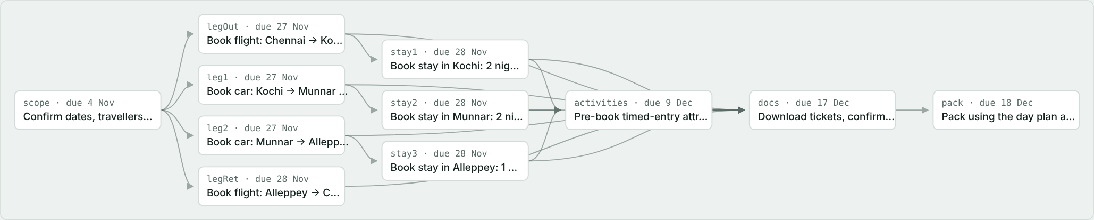
Fig. 6. Task dependency graph for the Kerala case study
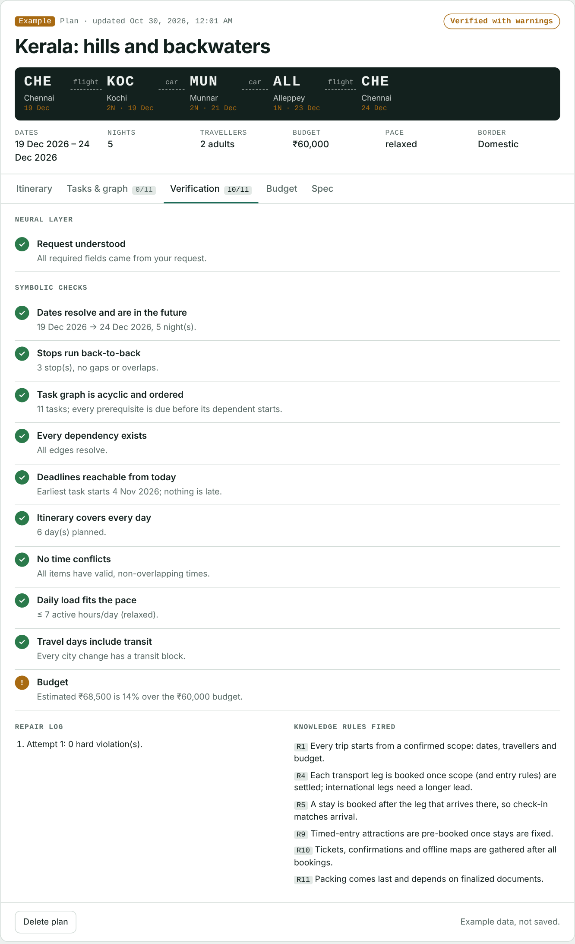
Fig. 7. Verification report for the Kerala case study
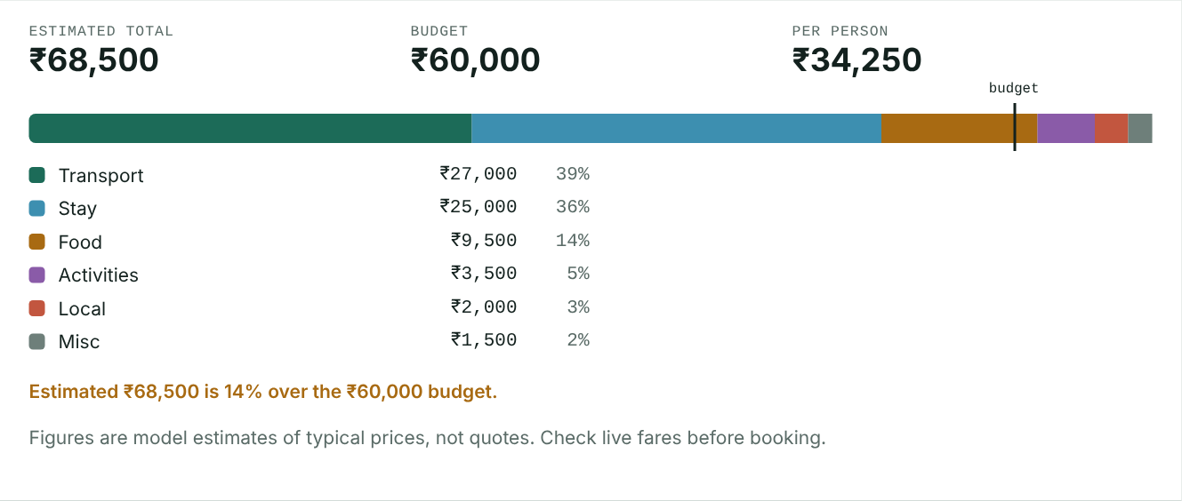
Fig. 8. Budget view showing the estimated cost against the budget

