

DEPARTMENT OF COMPUTER SCIENCE AND ENGINEERING
Name | Ch.Dinesh | Roll No | 23R21A05T9 | Date | 19/02/2025
Lab Name | DBMS | Week No. | 3 | Week Name | Selection Queries

WEEK-3 PROGRAMS
SELECTION QUERIES
Practicing Select command using following operations
a) AND,OR b) ORDERBY c) BETWEEN d) LIKE e) Apply CHECK constraint
- CREATE TABLE Employees ( EmployeeID INT PRIMARY KEY, Name VARCHAR(50), Age INT, Salary DECIMAL(10,2), Department VARCHAR(50), CONSTRAINT chk_Age CHECK (Age >= 18) -- CHECK CONSTRAINT to ensure age is at least 18 );
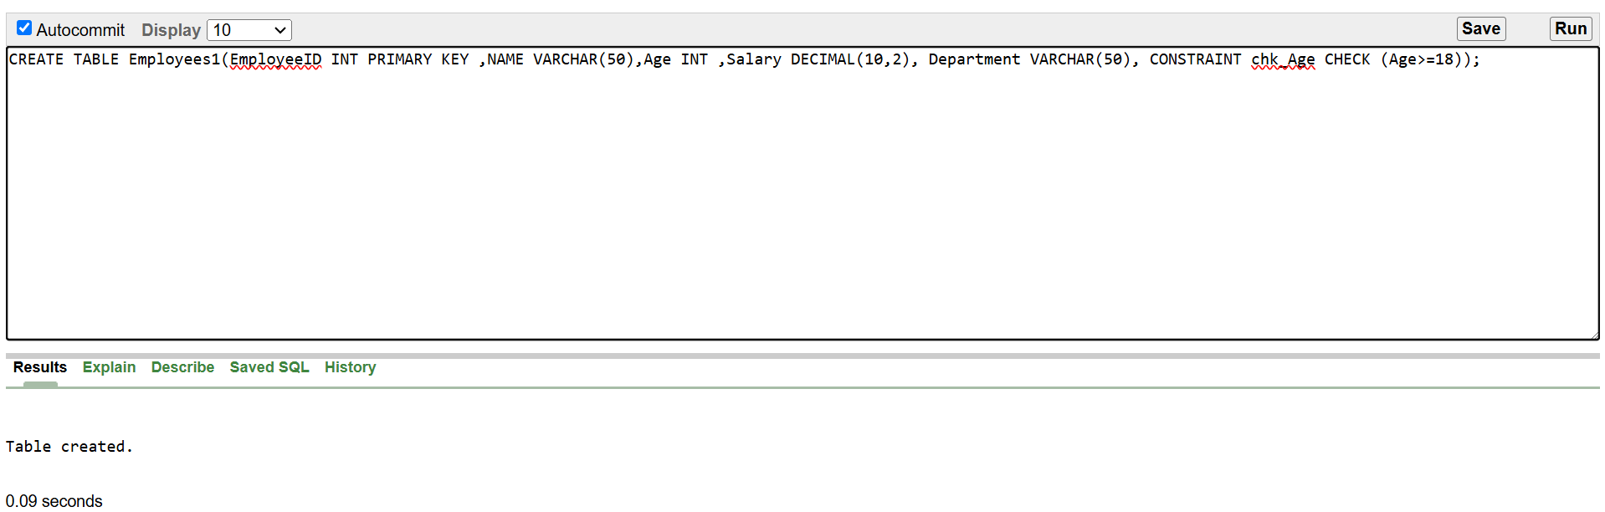
- INSERT INTO Employees (EmployeeID, Name, Age, Salary, Department) VALUES (1, 'Alice', 30, 55000, 'HR'), (2, 'Bob', 40, 75000, 'IT'), (3, 'Charlie', 22, 40000, 'Finance'), (4, 'David', 35, 90000, 'IT');
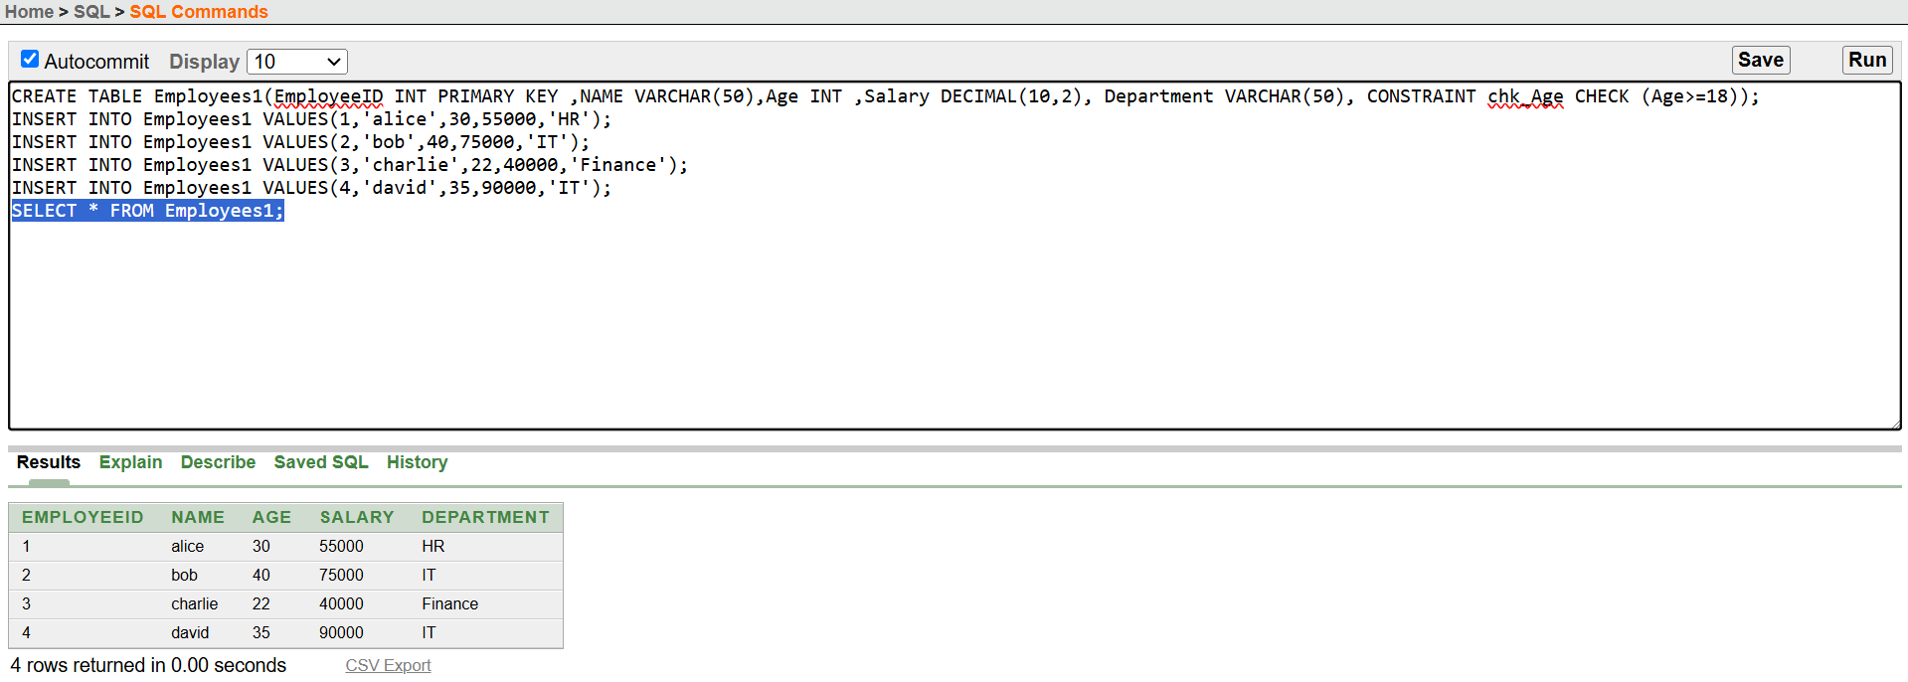
- Write a query to find out employees who are older than 25 AND earn more than 50,000.
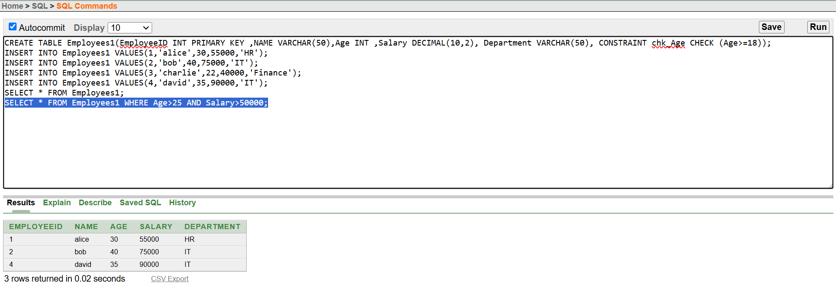
- Write a query to Returns employees whose name starts with 'A'.
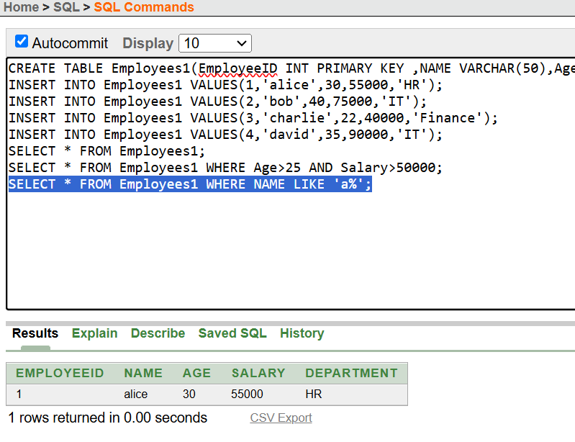
- Write a query to Returns employees whose name ends with 'id'.
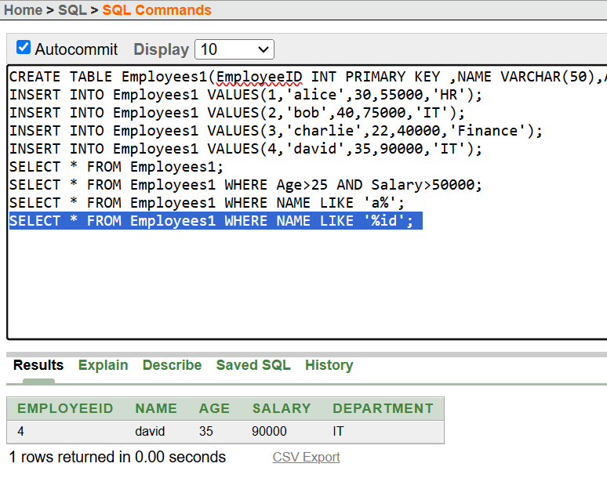
- Write a query to Returns employees whose second letter is 'a'.
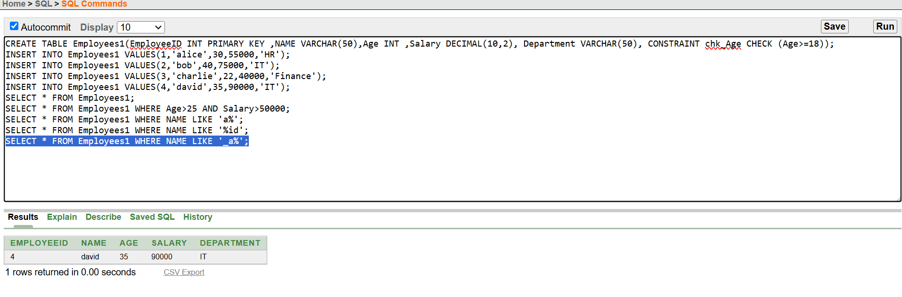
- Write a query to Returns employees with a salary between 40,000 and 80,000.
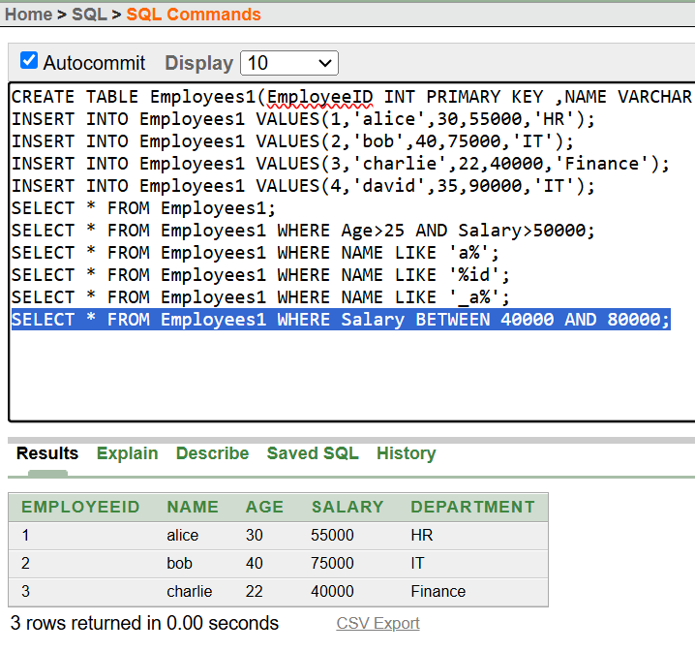
- Write a query to Returns employees aged between 30 and 50.
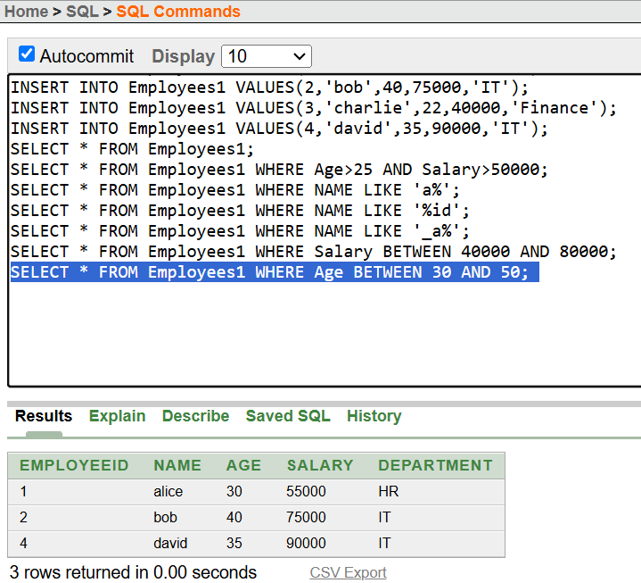
- Write a query to Returns employees sorted by salary in descending order.
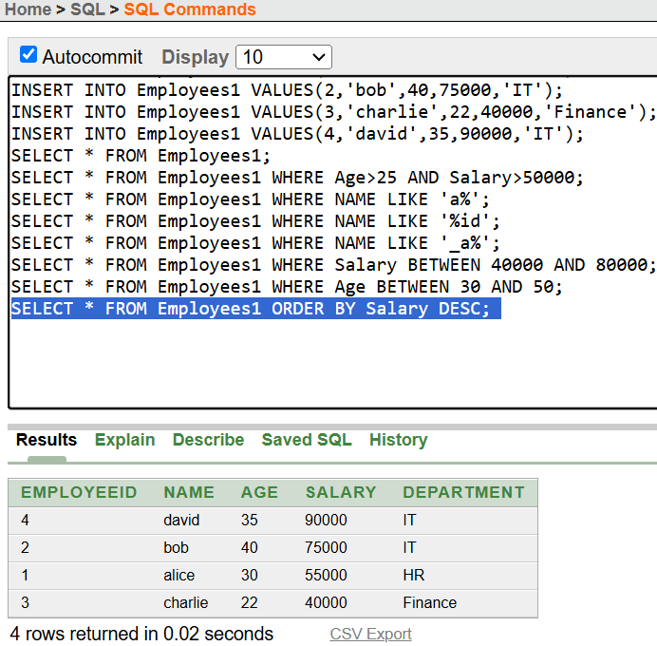
- Write a query to Returns employees sorted by name in ascending order; if names are the same, sorts by age in descending order.
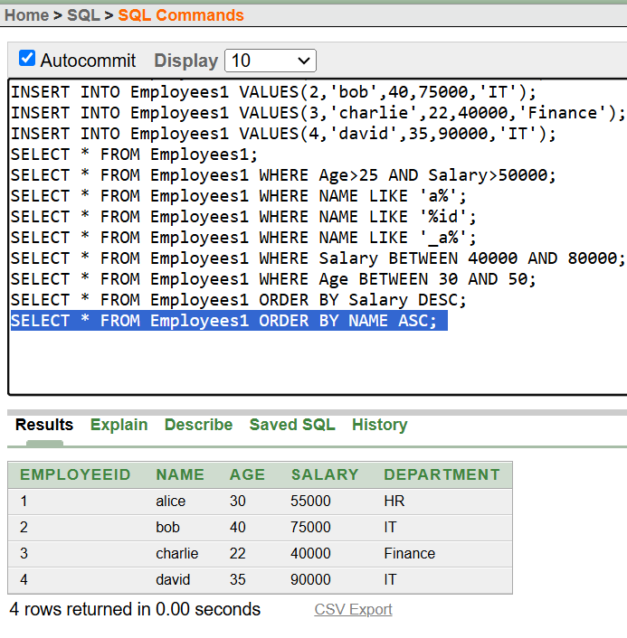
- Write a query to Ensures that salary cannot be less than 30,000.
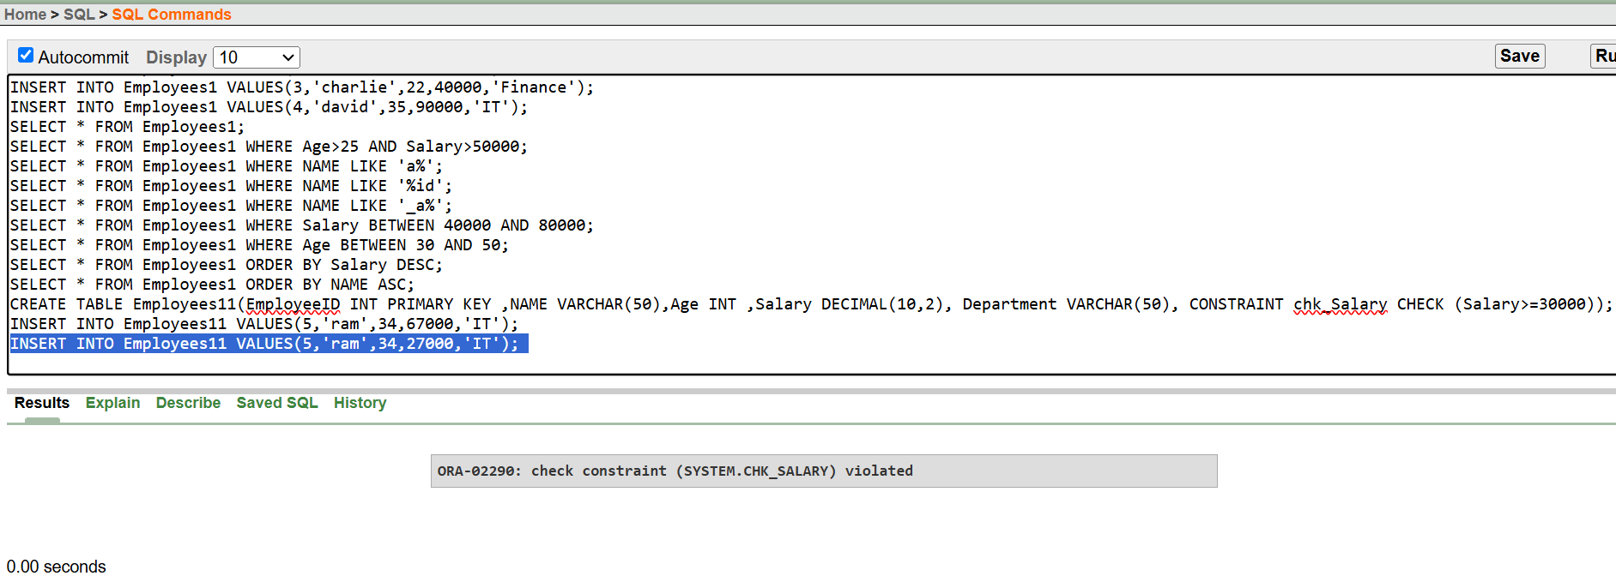
- Write a query to Returns employees in IT or HR department AND earning more than 50,000.
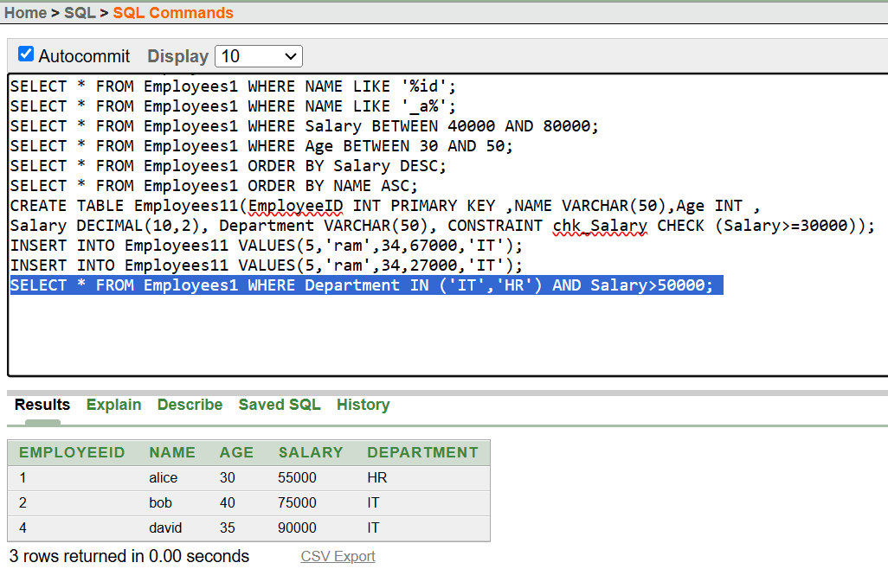
- Write a query to Returns employees younger than 30 OR those earning more than 70,000 in the Finance department.
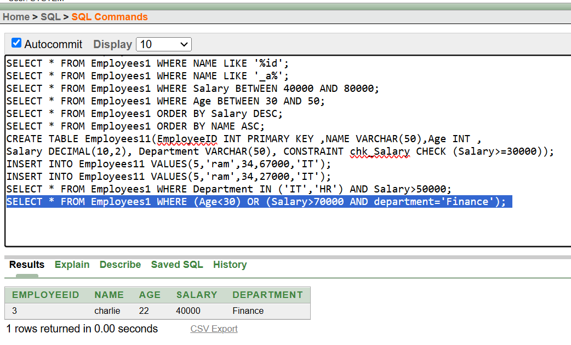
- Write a query to Matches departments like "HR", "HXR", etc.
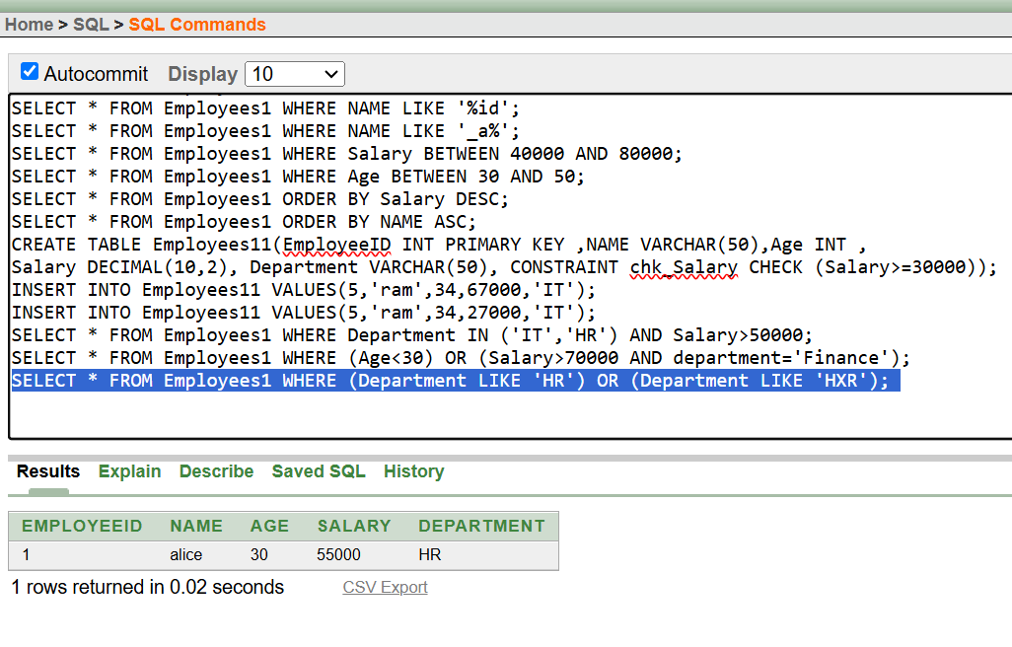
- Write a query to Sorts by employee name in ascending order (default).
- Write a query to returns employees earning between 50,000 and 90,000 AND working in IT or Finance.
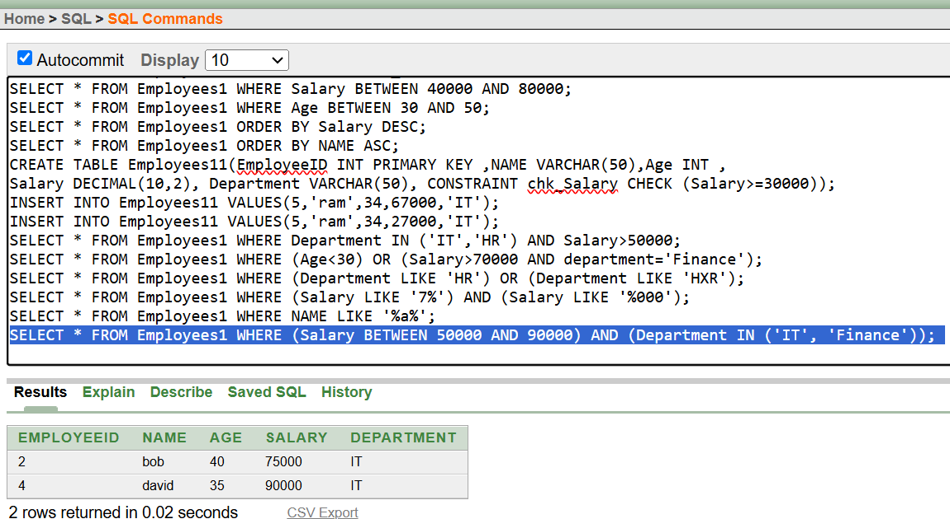
- Write a query to returns employees whose salary starts with 7 and ends with 000 (e.g., 70000, 75000)
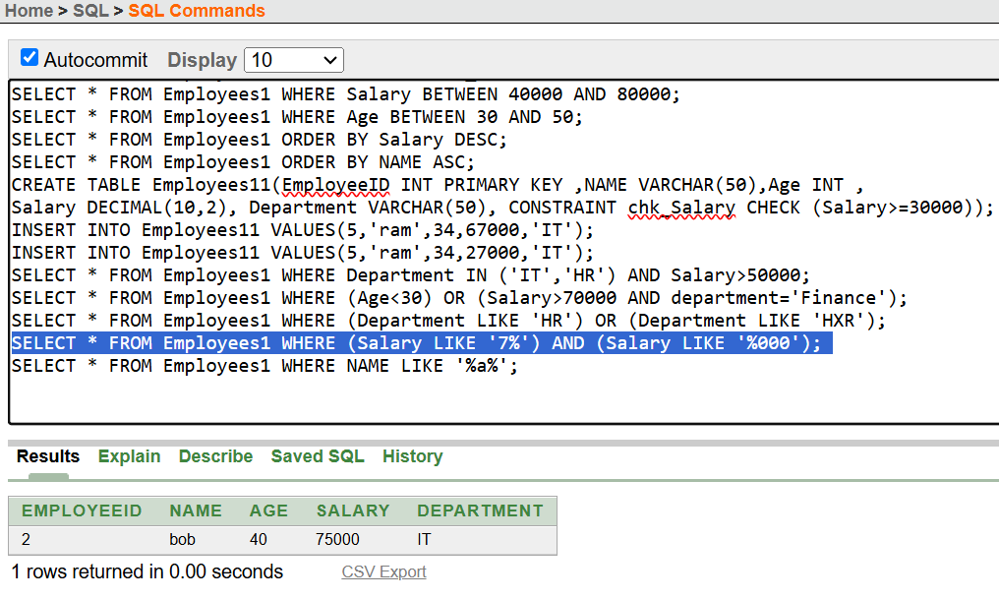
- Write a query to Returns employees whose name contains the letter 'a' anywhere.
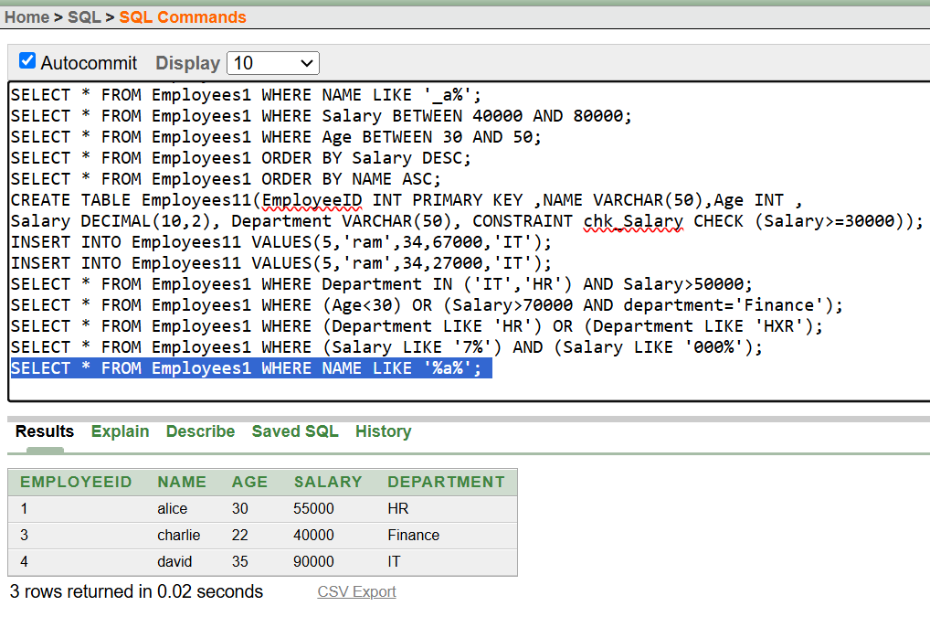
- Write a query to Returns employees aged between 25 and 50 and sorts them by salary (highest to lowest).
