USME
Omnichannel Order Intake Modernization
Detailed Design & Operational Playbook
Salesforce + Ascent Rental + Workato
Preserve customer submission methods at the edge; standardize product interpretation, deduplication and order creation behind the edge.

Architecture thesis
Every inbound order becomes a governed Salesforce intake record first. Workato handles transport, extraction and cross-system orchestration. Salesforce owns customer/product mappings, duplicate decisions and operational exceptions. Ascent owns the accepted rental order and downstream rental lifecycle.

Version 1.1 | EDI Strategy Revised | September 27, 2026

Contents
1. Executive Summary
2. Current-State Baseline and Statistics
3. Current-State Characteristics Considered
4. Target-State Architecture
5. Canonical Order Intake Data Model
6. Real-Time Workato Orchestration Design
7. Salesforce Configuration Design
8. Ascent Rental Configuration and Handoff
9. Channel-Specific Designs
10. Product Translation and Selection Service
11. Cross-Channel Deduplication and Amendment Logic
12. Experience Cloud Ordering Design
13. Exception Management and Operational Playbook
14. Security, PHI and Audit Controls
15. Monitoring, Reconciliation and KPIs
16. Transition and Cutover Plan
17. Testing Strategy
18. Governance, Support and Change Control
19. Decision Register and Open Items
Appendix A – Current-State IDN Detail
Appendix B – Proposed Field Dictionary
Appendix C – Workato Recipe Catalog
Appendix D – Reference Sources
How to use this document
Sections 2–3 are source-derived current state. Sections 4–19 are the recommended future-state design and operating playbook. Exact Ascent managed-package object/API names should be validated during implementation workshops; this playbook intentionally defines responsibilities and data contracts without inventing package-specific object names.

1. Executive Summary
USME should modernize order intake without making customer business-process change a prerequisite for the Salesforce + Ascent transformation. Fax can remain fax, email can remain email, SFTP can remain SFTP, procurement portals can remain in place, and EDI customers can continue ordering from their existing procurement/EMR systems. The modernization should happen behind those customer-facing channels. The revised EDI recommendation is to replace the current CLEO/VAN path during the implementation program rather than defer it: only two IDNs currently use EDI, they represent 1,697 YTD orders (6.3%), and the current-state materials identify an approximately $90K/year VAN cost-avoidance opportunity if that dependency can be eliminated. The EDI migration should therefore run as a dedicated parallel workstream with partner technical onboarding/certification, shadow processing and a controlled production cutover before or with Ascent go-live.
The recommended architecture establishes one logical order-intake front door: every request is captured as a Salesforce Order Intake record, normalized to a canonical order contract, translated into USME canonical product/model semantics, evaluated for cross-channel duplicates or amendments, and only then converted into an accepted Ascent rental/sales order.
Primary recommendation
Use Workato as the omnichannel transport/orchestration layer, Salesforce as the intake-control and master-data layer, and Ascent as the operational order/rental system of record. For EDI, implement Workato EDI + Orderful during the current Salesforce/Ascent program and retire CLEO/VAN after the two EDI trading partners are technically certified and shadow reconciliation passes. Do not embed long-lived product mappings, clinical/product-selection logic, or duplicate business rules inside Workato recipes.

Design objective | Recommended treatment
Seamless transition | Keep existing customer channels; replace backend automations progressively.
Eliminate technical debt | Retire customer-specific Power Automate flows, ServiceNow DocIntel/Flow, custom Azure Functions and RPA where modern interfaces exist; retire CLEO/VAN during implementation once EDI partner certification is complete.
One intake process | All channels create or update Order_Intake__c before Ascent order creation.
Product complexity | Centralize customer code/term/clinical-rule mappings in Salesforce as governed master data.
Cross-channel duplicates | Use technical idempotency first, business fingerprinting second, and human review for ambiguous cases.
Real-time operations | Webhook/API channels process in near real time; polling channels target a short interval and use the same downstream orchestration.
Operational resilience | Persist intake state before downstream processing, make every step replay-safe, and route failures to a Salesforce exception console.
Customer evolution | Use Experience Cloud, EDI/API and curated customer catalogs to reduce translation needs over time without forcing immediate change.
EDI modernization now | Only two IDNs use EDI. Treat Workato EDI + Orderful onboarding and partner certification as a current implementation workstream, targeting retirement of CLEO/VAN rather than postponing it to a later wave.

1.1 Key current-state facts that shape the design
Metric | Current-state observation | Architecture implication
2026 YTD order volume | 27,067 automated orders | Volume is material but not hyperscale; correctness and exception elimination matter more than raw throughput.
Dominant channel | Email = 52.5% | Email/document intake cannot be treated as a minor exception.
Fax + email + SFTP + secure email | 75.9% of orders | A backend modernization can address most volume without changing customer behavior.
EMR-originated | 76.0% | Unstructured/semi-structured input and clinical terminology remain central.
Explicit mapping / hierarchy dependency | 61.0% of orders | Product translation is a core service, not a peripheral lookup.
Mapping + inconsistent-catalog exposure | 67.3% | Roughly two-thirds of volume needs normalization or mapping controls.
Top 3 IDNs | 69.9% of volume | Customer-by-customer transition can move a large share of volume quickly.
Top 6 IDNs | 88.5% of volume | Wave planning should be IDN-specific, not only channel-specific.
EDI partner concentration | 2 IDNs: Encompass Health (1,695 YTD) and Ballad Health (2 YTD), totaling 1,697 EDI orders / 6.3% of volume. | The partner set is small enough to migrate and recertify during the Salesforce/Ascent implementation instead of carrying CLEO forward by default.
VAN cost-avoidance opportunity | Current-state materials identify approximately $90K/year of potential savings if the VAN dependency is eliminated. | Build the net business case as $90K gross avoidance plus reduced custom EDI support, less incremental Workato EDI/Orderful subscription and one-time partner certification costs.

2. Current-State Baseline and Statistics
Source note: GOUSME Automations.xlsx — Definitions, Automation Details, IDN Listing and Customer Listing. Statistics below are calculated directly from those tabs and represent the 2026 YTD order counts provided in the workbook.

2.1 Current inbound automation footprint
Automation / channel | YTD orders | Share | Current implementation pattern
USME Connect - Email | 14,199 | 52.5% | Power Automate + Blob Storage + Email
USME Connect - Fax | 4,544 | 16.8% | Power Automate + eFax + OCR + Blob Storage + Email
Sentinel RPA | 3,040 | 11.2% | Power Automate + RPA VM + site login + Blob
ServiceNowOrder | 1,798 | 6.6% | Email + ServiceNow DocIntel + ServiceNow Flow + GOUSME API
EDI Request | 1,697 | 6.3% | Azure Functions + CLEO VAN + AS2 + Blob + Email
USME Connect - SFTP | 1,551 | 5.7% | Power Automate + SFTP + Blob Storage + Email
USME Connect - Secure Email | 238 | 0.9% | Power Automate + Blob + ServiceNow RPA + secure site

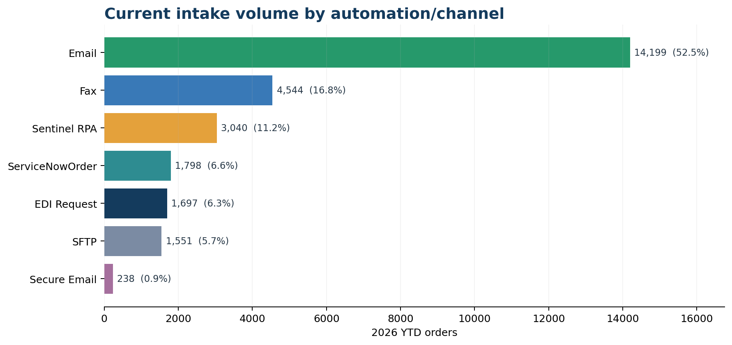
Figure 1. Current intake volume by channel / automation.

2.2 Customer and system concentration
IDN | YTD orders | Share | Partner/facility rows | Current system type
University of Colorado | 13,107 | 48.4% | 13 | EMR
Select Medical | 3,004 | 11.1% | 97 | Procurement
Atlantic Health | 2,805 | 10.4% | 6 | EMR
DaVita | 1,798 | 6.6% | 1112 | Procurement
Encompass Health | 1,695 | 6.3% | 79 | Procurement/EMR
Centra Health | 1,551 | 5.7% | 5 | EMR
Standalone | 1,464 | 5.4% | 4 | EMR
Prisma Health | 920 | 3.4% | 6 | EMR
North Memorial Health Care | 510 | 1.9% | 2 | EMR
Centrastate Medical Center | 190 | 0.7% | 1 | EMR

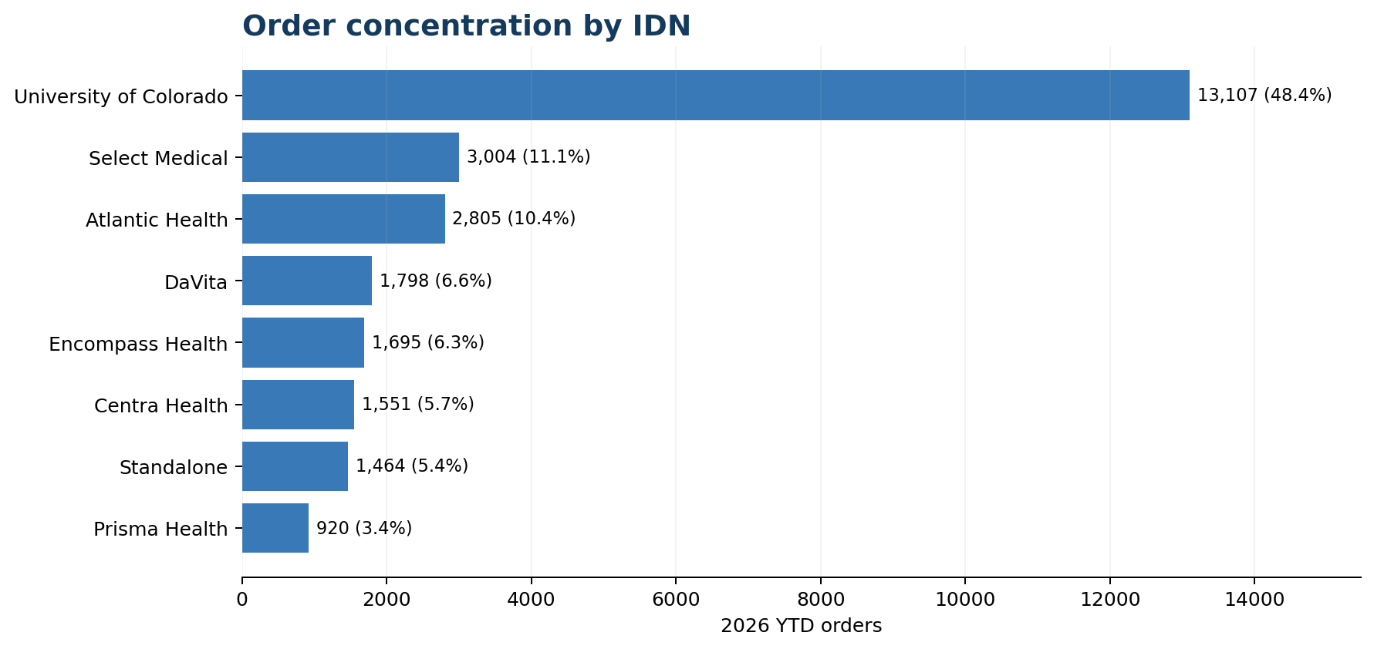
Figure 2. Current order concentration by IDN.
The Customer Listing contains 1,327 partner/facility rows. DaVita alone represents more than 1,100 listed partner locations, which reinforces the need for facility-level identity resolution and customer-specific configuration rather than code branches for every facility.

2.3 EMR vs. procurement-system mix
Source-system category | YTD orders | Share
EMR | 20,568 | 76.0%
Procurement | 4,802 | 17.7%
Procurement/EMR | 1,697 | 6.3%

The dominance of EMR-originated orders means the future design must support non-catalog terminology, documents and customer-specific clinical/category selection logic. A design that assumes every order arrives with an exact USME model ID would fail against the current operating reality.

2.4 Current-state architecture
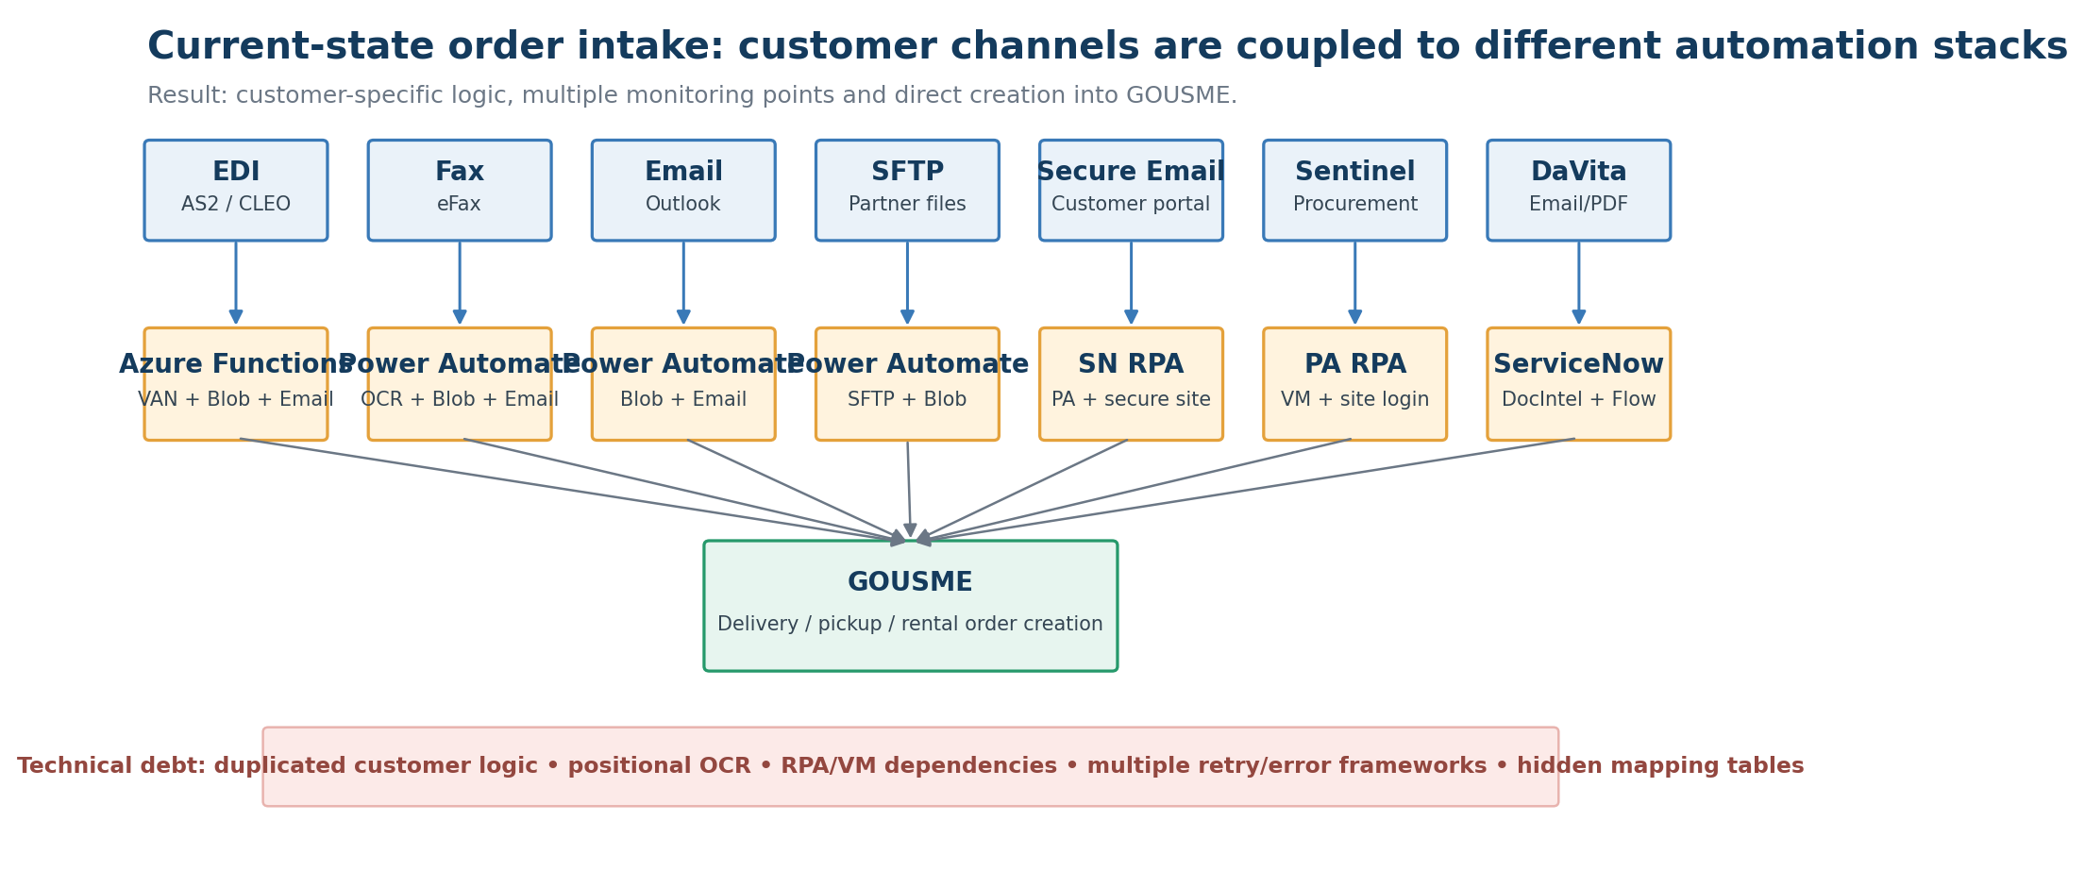
Figure 3. Current-state order-intake architecture synthesized from the workbook.

3. Current-State Characteristics Considered
Characteristic | Evidence / example from current state | Design response
Customer submission methods are heterogeneous | EDI/AS2, fax, email, SFTP, secure email and procurement/RPA are all active. | Preserve edge channels; converge behind them into a single canonical intake process.
USME Connect is largely unidirectional | Definitions tab describes USME Connect as fax/email/SFTP and not real-time interactive. | Add acknowledgments and intake status even when the submission channel itself remains one-way.
Customer-specific logic is pervasive | Definitions notes that nearly every customer has some difference in approach. | Move differences into Customer Integration Profiles and mapping/configuration records, not separate codebases.
Fax extraction is position-sensitive | Definitions notes word wrapping and edits shift data vertically. | Use IDP/semantic extraction with confidence scoring and an exception path; retire positional OCR logic.
RPA is slow and infrastructure-heavy | Definitions notes VM/machine-related technical debt and use only when necessary. | Treat RPA as a transitional adapter and replace with API/file/EDI integration when available.
EDI is standardized in format but not behavior | Workbook notes inconsistencies, missing model/BC values, substitutions and duplicate paths. | Keep partner-specific EDI profiles and run the same product-normalization/dedup engine after X12 parsing.
Customers may order through more than one channel | Encompass is specifically noted as using procurement plus phone/portal, causing duplicate/order-sequence risk. | Implement cross-channel canonical fingerprinting; do not deduplicate only inside each transport.
Product identity varies by customer | Colorado/Standalone use mapping tables; DaVita uses internal values; North Memorial uses contraindications. | Create a governed Product Translation & Selection Service in Salesforce.
Substitution causes invoice/PO mismatch | EDI notes call out substitution mismatch with ordered/delivered/invoiced product. | Persist Requested → Canonical → Fulfilled product separately; never overwrite the original request.
EDI transport footprint is concentrated | Only Encompass Health and Ballad Health are identified as EDI IDNs; Encompass carries virtually all current EDI volume. | Migrate EDI transport now as a bounded parallel workstream. Preserve customer business process, but complete technical endpoint/certificate/VAN changes and certification during implementation.
VAN / CLEO cost is a current-program opportunity | Definitions identify potential ~$90K/year savings if the VAN dependency is no longer required. | Target CLEO/VAN retirement at EDI production cutover, subject to Workato EDI/Orderful commercial validation and successful partner certification.

3.1 Product-identification archetypes
Archetype | Representative customers | Incoming product signal | Future handling
Exact USME model/product IDs | Atlantic, Centra, Prisma, Centrastate | USME model name/ID present | Validate against canonical catalog; no translation if exact and active.
Customer internal product code | DaVita | Procurement-system internal value | Exact customer crosswalk → USME canonical product/model.
Clinical/category terminology | University of Colorado, Standalone Pathway | No USME product; descriptive/category term | Approved customer terminology mapping and/or product class selection rule.
Clinical criteria / contraindications | North Memorial | No model; criteria drive selection | Versioned deterministic selection hierarchy; ambiguous cases require review.
USME catalog with inconsistencies | Encompass, Ballad | USME catalog generally present but not always consistent | Exact catalog match first; approved alias mapping second; exception third.
Procurement portal with USME products | Select Medical / Sentinel | USME product listed in source portal | Validate product, preserve external order ID and deduplicate across other channels.

Design consequence
At least 16,507 YTD orders (61.0%) clearly depend on product mapping or hierarchy-based selection. Including EDI catalog inconsistency, 18,204 orders (67.3%) have an identified product-normalization concern. Product translation must therefore be treated as a first-class architecture component.

4. Target-State Architecture
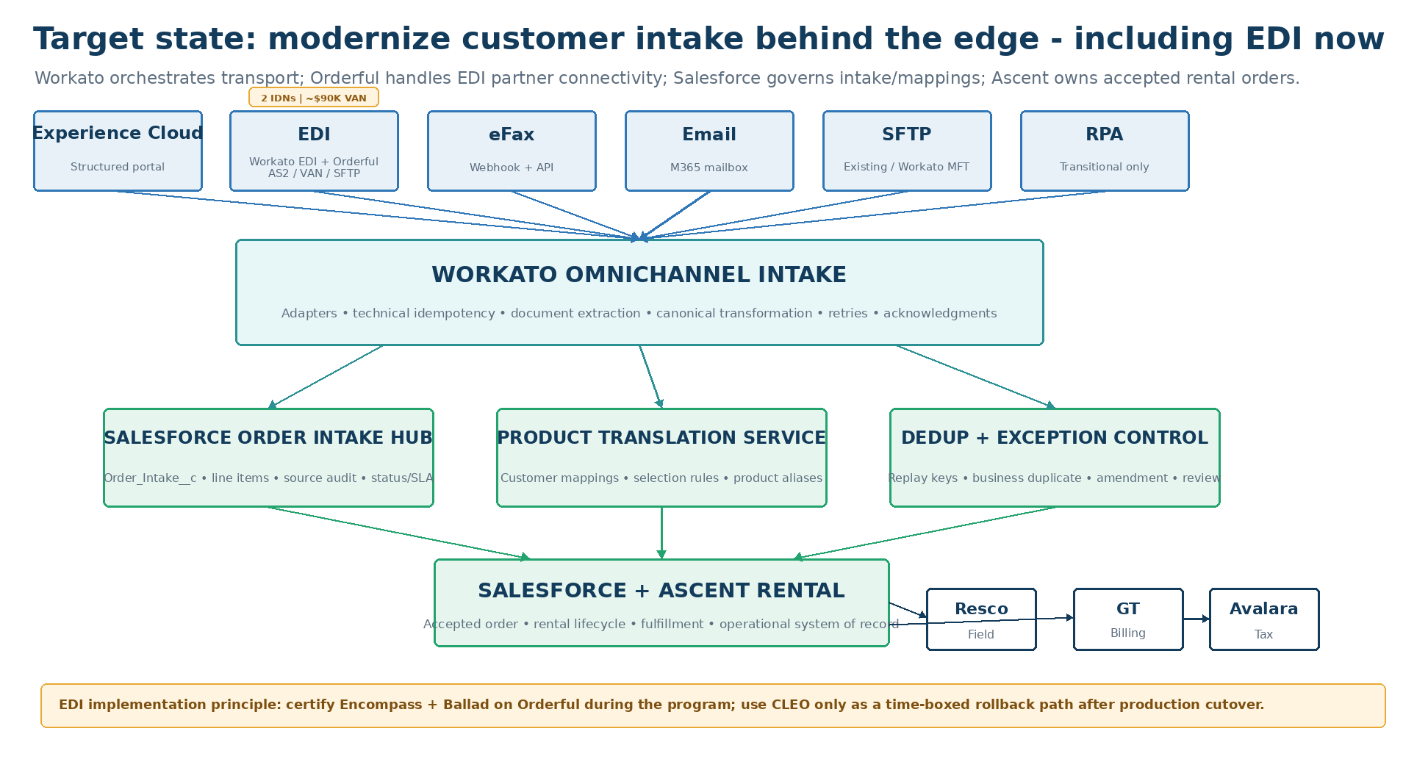
Figure 4. Recommended target-state architecture.

4.1 System responsibility boundaries
Layer / platform | Owns | Must not become
Workato | Transport adapters, inbound triggers, IDP invocation, canonical transformation, technical idempotency, cross-system orchestration, retries, acknowledgments, integration monitoring. | Product-master repository, duplicate system of record, rental business engine, long-lived clinical/product rules repository.
Salesforce Platform | Order Intake Hub, Account/facility resolution, customer profiles, product mappings, selection rules, duplicate decision, manual exceptions, security, audit state. | Raw transport engine for every external protocol or a replacement for Ascent rental functions.
Ascent Rental | Accepted rental/sales orders, rental lifecycle, reservation/fulfillment, assets/inventory, order status, work-order/rental operational processing. | Staging area for unreadable documents, likely duplicates or unresolved customer terminology.
Experience Cloud | Authenticated digital self-service, customer-specific catalog/terminology, structured order creation and status. | A separate order engine that bypasses the Order Intake Hub.
eFax / M365 / SFTP / EDI | Customer-edge transport and source-document delivery. | Places where USME business rules and product mappings are encoded.
GT / Avalara / Acumatica | Billing/rating, tax, accounting/GL respectively. | Order-intake masters. Preserve proven native/vendor interfaces where they are superior to iPaaS routing.

4.2 Architecture principles
- Preserve customer behavior first; optimize customer channels after the core platform stabilizes.
- Persist an intake record before creating an operational order.
- Make all integrations idempotent and replay-safe.
- Customer-specific product interpretation is master data/configuration, not middleware code.
- Keep the original customer request, normalized canonical product, fulfilled model and serialized asset as distinct data concepts.
- Duplicate detection must work across channels, not within a single integration only.
- Prefer same-org Salesforce Flow/Apex for Salesforce→Ascent object creation instead of routing object-to-object logic through Workato.
- Use native/vendor connectors for downstream billing/tax/accounting where they are mature; Workato should not become a mandatory hop for every enterprise transaction.
- Every exception must be visible and actionable in Salesforce with an owner and SLA.
- Every customer integration profile and mapping must be versioned, effective-dated and auditable.

5. Canonical Order Intake Data Model
The data model separates source evidence, customer interpretation, canonical product meaning and Ascent execution. This separation is what allows multiple customer submission methods to coexist without duplicating order logic.

5.1 Order_Intake__c
Field / group | Purpose | Configuration notes
Intake Number | Human-readable USME intake identifier | Auto-number; shown to operations and in customer acknowledgments.
Source Channel | Portal / EDI / Fax / Email / SFTP / RPA / Phone | Controlled picklist.
Source External ID | Unique transport-level identifier | External ID + unique; examples EFAX:<fax_id>, EMAIL:<message_id>, EDI:<control tuple>.
Source Received At | Original received timestamp | UTC stored; local display by user.
Source Document Hash | Detect repeat file/document delivery | SHA-256 produced in adapter where file payload exists.
Customer / Account | Resolved Salesforce Account/IDN | Do not trust raw text as canonical account.
Facility | Resolved operational facility/ship-to | Use facility alias/external-ID mapping.
Customer Integration Profile | Which customer/channel rule set applies | Required for automated intake.
Transaction Intent | NEW / CHANGE / CANCEL / PICKUP / RMA / OTHER | Derived from source or reviewed by operator.
PO / Requisition / Release | Commercial reference | Separate fields; PO alone is not globally unique.
Requested Service Date | Requested delivery/pickup date | Used in duplicate candidate logic.
Canonical Order Fingerprint | Business-level match key/hash | Generated after normalization; not the technical source ID.
Product Resolution Status | Resolved / Partial / Review / Failed | Roll-up from line-level resolution.
Duplicate Status / Score | New / Exact Duplicate / Likely Duplicate / Amendment | Business decision state.
Processing Status | Lifecycle state | Received → Extracted → Evaluating → Review / Ready → Submitted → Created / Duplicate / Failed.
Ascent Order Reference | Accepted operational order | Null until order creation succeeds.
Acknowledgment Status | Pending / Sent / Failed | Allows separate reprocessing of acknowledgments.
Error Category / Detail | Operational exception | User-readable error category plus technical job link/reference.
Source Artifact URI | Link to governed raw source document | Prefer governed archive rather than Workato job history as retention repository.
Profile / Mapping Version | Reproducibility | Allows support team to know which rules produced the decision.

5.2 Order_Intake_Line__c
Field | Purpose
Raw Product Code / Description | Exactly what the customer sent.
Raw Clinical / Contraindication Criteria | Preserved when the source provides criteria rather than a model.
Quantity / UOM | Normalized quantity and unit.
Customer Product Mapping | Exact crosswalk record used, if any.
Canonical Product / Product Class | USME normalized request.
Resolution Method | Exact USME ID / Crosswalk / Rule / Alias / Manual.
Resolution Confidence | Deterministic = 1.0; IDP/extraction confidence retained separately from business mapping confidence.
Requested Product | Original request semantics preserved.
Fulfilled Product / Model | Populated later from Ascent fulfillment.
Serialized Asset | Populated at execution where relevant.
Line Fingerprint | Normalized value used in dedup candidate comparison.

5.3 Master/configuration objects
Object | Purpose | Owner
Customer_Integration_Profile__c | Per-IDN/channel rules: preferred channel, allowed senders, PO behavior, duplicate window, parsing strategy, product-resolution mode, acknowledgment method. | Integration Product Owner + Business Operations
External_Product_Mapping__c | Customer code/term/alias → canonical USME product or product class. | Product Master Steward
Product_Selection_Rule__c | Versioned deterministic customer-specific selection rules for category/clinical criteria. | Product/Clinical Governance
Facility_Alias__c | External facility names/IDs → canonical Salesforce facility. | Customer Master Steward
Integration_Config__mdt / Custom Metadata | Weights, thresholds, system defaults and non-sensitive constants. | Salesforce Platform Owner
Optional Intake_Event__c | Major transition/error audit events if reporting requirements exceed field-history/workflow audit. | Integration Operations

6. Real-Time Workato Orchestration Design
Important design refinement
“Workato orchestrates” does not mean every business rule runs in Workato. Workato should coordinate transport and processing, while Salesforce owns persistent business decisions and Ascent owns rental execution. This prevents Workato from becoming the next GOUSME-like application.

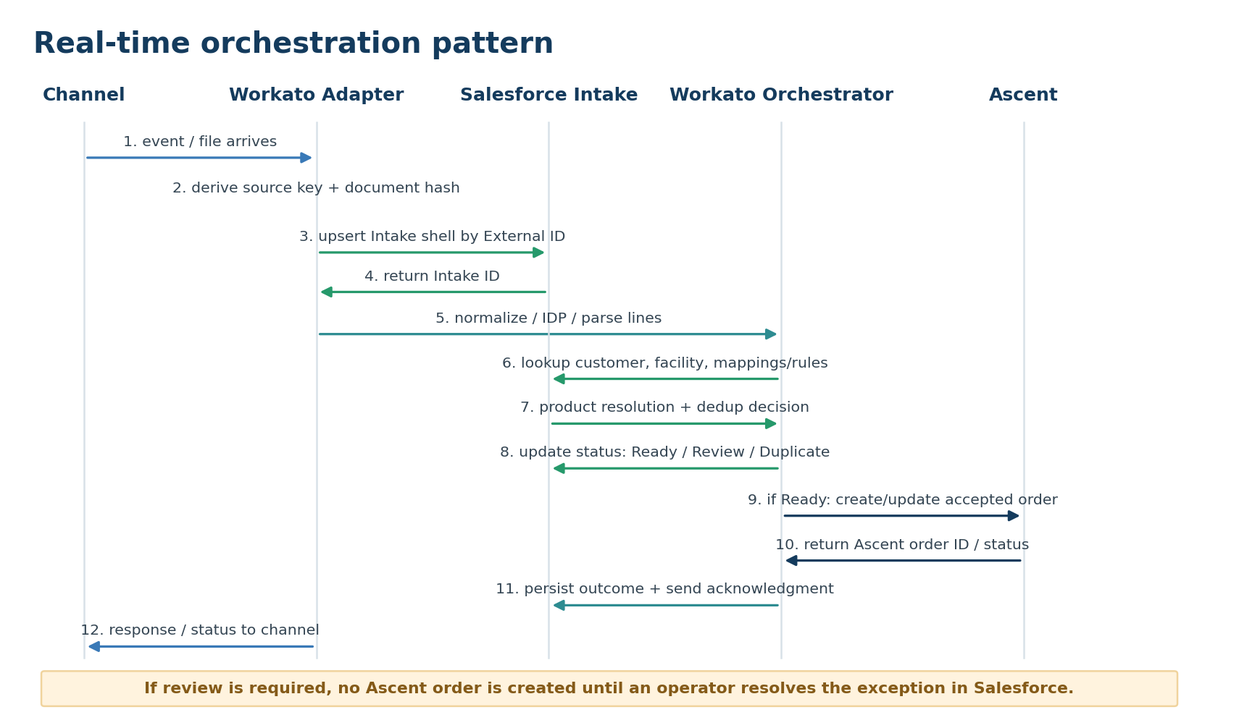
Figure 5. Real-time / near-real-time orchestration sequence.

6.1 Processing lifecycle in real time
1. Ingress — A channel adapter receives a webhook/API call, new email, new SFTP file, EDI payload or RPA result. Portal orders already exist as Salesforce Intake records.
2. Technical identity — The adapter derives Source_External_ID and, for documents/files, a document/file hash. This is used before any business processing.
3. Persist the intake shell — Workato uses Salesforce Upsert with Source_External_ID as an External ID. A replay therefore returns/updates the existing Intake rather than creating a second one. Workato’s Salesforce upsert action specifically supports External ID primary keys.
4. Persist or reference source artifact — Store the source PDF/file in the approved archive and write the URI/reference to Salesforce. Do not rely on Workato job history as the legal/operational document repository.
5. Parse / extract — Structured formats are mapped directly. Documents are sent to IDP where needed; values and confidence scores are captured. Low extraction confidence is a review trigger, not an invitation for blind order creation.
6. Canonicalize — Workato transforms channel-specific field names into the canonical Intake/Line schema. It does not decide customer product semantics beyond exact technical transformations.
7. Set Salesforce status = Ready for Evaluation — Salesforce automation then resolves customer/facility, product mappings/rules and duplicate candidates. Complex scoring can be implemented through invocable Apex called by a record-triggered Flow.
8. Salesforce decision — The record becomes Ready to Create, Review Required, Duplicate Suppressed, Amendment, or Validation Failed.
9. Ascent handoff — For Ready to Create / Amendment, Salesforce same-org automation creates/updates the Ascent order using approved Ascent interfaces/objects. Workato is not required for same-org object transformation unless Ascent’s supported design requires it.
10. Outcome + acknowledgment — Workato monitors status/outcome and sends EDI/email/file/API acknowledgments as required. Experience Cloud can show the status directly from Salesforce.
11. Monitoring / replay — Failures are captured with job URL/reference, category and retryability. Integration Operations can replay from the persisted Intake without asking the customer to resend.

6.2 Workato project structure
Project / folder | Purpose | Representative assets
00_Shared_Framework | Reusable functions and standards | Correlation ID, source-hash utility, file/archive utility, standard error handler, customer profile loader, acknowledgment formatter.
10_Channel_Adapters | One adapter per transport pattern | eFax, M365 email, SFTP, EDI-Orderful, RPA result, portal event.
20_Intake_Orchestration | Channel-independent processing | Canonicalizer, IDP wrapper, Salesforce intake upsert, line upsert, status coordination.
30_Acknowledgments | Channel-specific responses | Email receipt, EDI technical/business response, SFTP response file, exception notice.
40_Downstream_Integrations | Only where Workato is actually needed | Non-native integrations, supplemental portal/notification integrations; do not automatically reroute GT/Avalara native paths.
90_Ops_Monitoring | Operational observability | RecipeOps/job failure alerts, SLA breach monitor, aging exception monitor, reconciliation jobs.

6.3 Workato connection model
- Create dedicated non-human connection identities for Salesforce, Microsoft 365, SFTP and other systems; do not bind production recipes to named employees.
- Use separate sandbox/test and production connections. Promotion should change connections/configuration, not recipe logic.
- Use least-privilege Salesforce integration permissions limited to Order Intake objects, mapping objects, required master data and approved Ascent status/reference fields.
- Use OAuth/modern authentication where supported. Store secrets in an approved vault/integration secret mechanism rather than recipe formulas or documentation.
- For customer SFTP, prefer SSH key authentication and host-key fingerprint validation. For a future Workato-hosted SFTP endpoint, create isolated partner accounts and folders.

6.4 Workato recipe design pattern
Step | Workato configuration | Why
Trigger | Webhook/API recipe, connector trigger, or polling trigger based on source. | Use the transport’s strongest event mechanism; do not force polling where a webhook exists.
Source validation | Validate partner/source, expected file type/schema and minimum required metadata. | Reject unsupported/untrusted traffic before creating operational data.
Idempotency | Derive Source_External_ID; Salesforce Upsert Intake by External ID. | Makes transport retries safe.
Artifact handling | Download file/attachment; compute hash; archive/reference. | Preserves original evidence and allows later replay.
Extraction | Structured map or IDP action. Capture confidence. | Separates “what was in the document” from product/business interpretation.
Canonical transform | Map source fields to common schema; preserve raw values. | Every downstream step is channel-independent.
Salesforce persistence | Upsert Intake; upsert lines; set Ready for Evaluation. | Salesforce becomes durable control plane.
Wait / response pattern | For long processing, decouple ingress from downstream processing; API endpoints should return quickly after durable intake acceptance. | Avoid external webhook/API timeouts and duplicate retransmissions.
Error handling | Use Handle errors around network/API steps, conditional retries, error classification and operational alerting. | Workato supports retries and error blocks; retry only transient faults, not bad business data.
Completion | Update technical outcome/job reference and call acknowledgment recipe. | Separates order processing from customer response mechanics.

6.5 What “real time” should mean by channel
Channel | Target integration behavior | Expected pattern
Experience Cloud | Immediate | Salesforce creates Intake in the same transaction; Flow triggers evaluation and Workato only for external acknowledgments/integrations.
eFax | Real-time ingress | eFax webhook → Workato API recipe; Workato retrieves/receives PDF + metadata, creates Intake, then continues asynchronously.
EDI | Real-time / partner SLA | Orderful/Workato EDI receives validated partner transaction over AS2/VAN/SFTP; Workato preserves partner/control IDs, canonicalizes the business document, upserts Salesforce Intake and drives downstream evaluation. Transport acknowledgment is managed in the EDI transport layer; business acceptance/status is driven from the Salesforce Intake outcome.
Email | Near-real-time | Workato M365/Outlook connector monitors shared mailbox; process new message/attachments and preserve Internet Message ID.
SFTP | Near-real-time | Workato SFTP trigger polls for new/updated files; current documentation supports file triggers and batch CSV processing.
Secure portal / RPA | Event-driven where practical | RPA retrieves source and posts a structured result to a Workato API recipe; eliminate RPA when provider offers API/file integration.

7. Salesforce Configuration Design
Salesforce is the persistent control plane because the data belongs with customer, facility, product and order context and because operations need one queue to resolve exceptions. The following configuration should be implemented before migrating production channels.

7.1 Core objects and configuration steps
Configuration step | Salesforce implementation | Acceptance criterion
1. Create intake objects | Create Order_Intake__c and Order_Intake_Line__c with fields in Section 5. Make Source_External_ID a Unique External ID. | A duplicate upsert against the same source ID returns the same Intake record.
2. Create customer profiles | Customer_Integration_Profile__c with channel behavior, PO rules, parsing profile, product-resolution mode, duplicate window and acknowledgment settings. | Operations can alter customer behavior without modifying a Workato recipe.
3. Create product translation master | External_Product_Mapping__c and Product_Selection_Rule__c with approval status, effective dates, version and owner. | Every active mapping has a business owner and effective period.
4. Create facility aliases | Map external facility IDs/names to canonical account/facility records. | Common spelling/ID variants resolve without code branches.
5. Configure evaluation Flow | Record-triggered Flow fires when Intake = Ready for Evaluation. It resolves profile, validates required fields, calls product/dedup services and sets decision status. | A channel-independent Intake follows the same decision path regardless of source.
6. Implement product-resolution service | Use Flow for deterministic lookups; use invocable Apex where hierarchy/rule evaluation is too complex for maintainable Flow. | Colorado/DaVita/North Memorial patterns are supported without Workato condition trees.
7. Implement duplicate evaluator | Generate line/order fingerprint; query recent candidate Intakes/Ascent orders; apply customer-specific rule profile; return decision/score/candidates. | Portal + EDI / email + fax duplicates can be detected across transports.
8. Create exception console | Lightning App / list views for Product Review, Duplicate Review, Customer/Facility Mapping, Technical Failure and SLA Aging. | Operators can work all intake exceptions from one place.
9. Same-org Ascent handoff Flow | When Intake becomes Ready to Create, create/update supported Ascent order objects/records; write Ascent ID back to Intake. | No duplicate order is created if the Flow is replayed.
10. Security + audit | Permission sets, sharing, field history for decision fields, Shield/encryption where approved, restricted source-document access. | Integration identity cannot access unrelated CRM/PHI data; operator access follows role/facility needs.

7.2 Proposed intake status model
Status | Meaning | Who/what advances it
Received | Durable intake shell exists; source identified. | Workato adapter or Experience Cloud.
Extracting | Document/file parsing in progress. | Workato.
Ready for Evaluation | Canonical raw fields/lines are persisted. | Workato or portal flow.
Evaluating | Salesforce is resolving customer/facility/product/dedup. | Salesforce Flow/Apex.
Review Required | One or more business decisions need an operator. | Salesforce evaluator.
Duplicate Suppressed | Source retained; no new Ascent order will be created. | Salesforce evaluator / reviewer.
Ready to Create | All mandatory validations passed. | Salesforce evaluator / reviewer.
Creating Order | Ascent order creation is underway. | Salesforce Flow.
Created | Ascent order exists and is linked. | Salesforce/Ascent.
Acknowledged | Required customer/partner confirmation sent. | Workato or portal UI.
Failed – Technical | Transport/API/system problem; replayable. | Workato/Salesforce.
Rejected – Business | Invalid request or business rejection; not a system failure. | Operations/business workflow.

8. Ascent Rental Configuration and Handoff
Boundary rule
Ascent should receive only accepted, normalized orders. It should not be asked to determine whether a fax is a duplicate, translate a customer-specific clinical term, or retain unresolved source documents as operational orders.

Ascent configuration area | Recommended design | Implementation validation
Canonical product/item alignment | Define the authoritative Ascent product/item reference used by Salesforce mappings. Maintain stable external/canonical keys so mappings do not depend on display names. | Confirm exact Ascent object and key fields during solution design.
Order creation | Use supported Ascent order/rental APIs/managed-package objects from same-org Salesforce Flow/Apex. | Prove create is idempotent when Intake/Source ID already has an Ascent order reference.
Order intent | Map NEW/CHANGE/CANCEL/PICKUP/RMA into supported Ascent workflows rather than creating new orders for all events. | Demonstrate amendment, cancellation and pickup paths.
Requested vs fulfilled product | Retain requested/canonical values while Ascent records actual fulfilled model/serialized asset. | Confirm reporting can trace request → fulfillment.
Source references | Carry Intake ID, external PO/requisition/release and source channel into Ascent order header/related record as supported. | Operations can trace any Ascent order back to source.
Substitution | Use Ascent fulfillment/substitution capability while retaining original customer request. | Invoice/PO reconciliation does not lose requested-item identity.
Status callbacks | Expose order ID/status back to Intake; Workato uses this to send acknowledgments. | Portal/email/EDI status does not rely on polling GOUSME-like shadow data.
Downstream billing | Preserve the agreed Ascent→GT billing event architecture; do not couple intake modernization to a redesign of mature GT/Avalara/Acumatica paths. | Order-intake cutover can be tested independently from billing-engine replacement.

9. Channel-Specific Designs

9.1 Experience Cloud
Element | Configuration
Submission | Customer creates Order_Intake__c / lines through Experience Cloud, not Ascent order directly.
Identity | Portal user is mapped to Account and authorized facilities; the portal should not allow arbitrary Account IDs from the browser.
Catalog | Display customer-specific terminology/catalog. Translate the customer-facing selection to canonical USME product/class behind the page.
Duplicate protection | Generate a portal submission ID and source key at submit; Salesforce evaluates business duplicates across all channels.
Status | Expose Intake / Ascent order status from Salesforce. Portal user can see “Received”, “Needs information”, “Accepted”, “Scheduled”, etc. as appropriate.
Acknowledgment | Immediate on-screen Intake number; later order number/status once Ascent creation completes.

9.2 eFax
Recommended pattern: keep or port the existing customer-facing fax number to eFax Corporate, receive an inbound webhook, and retrieve/receive the PDF and metadata through the eFax API. eFax’s enterprise API supports send/receive, image and metadata download, webhook notifications and OAuth-based access.
Step | Layer | Configuration
1. Receive fax | eFax | Port/retain fax numbers, configure enterprise account, BAA, API/OAuth app and inbound notification/webhook.
2. Receive event | Workato | API recipe/webhook endpoint validates event, derives EFAX:<fax_id> source ID.
3. Retrieve document | Workato HTTP connector | Call eFax API for PDF/image + metadata if not included in webhook payload.
4. Persist intake | Workato→Salesforce | Upsert Intake shell before long-running extraction.
5. Extract | Workato IDP | Process PDF/image; persist extracted values and confidence scores.
6. Evaluate | Salesforce | Run customer profile, product translation and duplicate logic.
7. Create order | Salesforce/Ascent | Only for Ready to Create.
8. Respond | Workato | Optional receipt/exception response using customer preference; outbound fax should use eFax API rather than Email by Workato as the strategic production route.

9.3 Email
Step | Configuration
Mailbox | Use controlled M365 shared mailbox(es) such as orders@... with sender allowlists/customer profiles.
Trigger | Workato M365/Outlook connector monitors new messages; retain Internet Message ID and sender/domain as source metadata.
Attachment handling | Download attachments; choose the intended order document using customer profile rules; hash each source artifact.
Extraction | If structured body/template, map directly; otherwise IDP the attachment. Preserve raw subject/body where needed for audit.
Mapping | Salesforce product translation resolves customer terminology; Workato must not contain customer code→model branches.
Acknowledgment | Send “received” with Intake ID after durable persistence; send accepted/order reference after Ascent creation if customer profile requires it.

9.4 SFTP / Managed File Transfer
Stage | Recommended design
Day 1 | Workato connects as an SFTP client to existing customer/USME endpoints. Preserve current hostnames/paths where changing them would affect customers.
Source key | Partner + remote path + filename + file hash. Use filename alone only if the customer contract guarantees uniqueness.
Processing | Download file, validate schema/version, archive original, create canonical intake. For CSV, batch triggers can process rows in batches.
After success | Move/archive source file where the endpoint contract allows; otherwise rely on source key/hash to prevent reprocessing.
Future simplification | Evaluate Workato MFT as the hosted SFTP endpoint. Create isolated partner accounts, SSH keys, root directories and IP controls.
Response | If customer supports response files, generate acknowledgment/error file in outbound folder; otherwise use email/portal status.

9.5 EDI
Target state: Workato EDI + Orderful becomes the EDI transport/trading-partner layer during implementation, replacing the current CLEO/VAN path after certification. This is intentionally different from the prior version of this playbook, which deferred EDI transport modernization. The revised sequencing is justified by the bounded partner population (two IDNs), the material recurring VAN cost, and the opportunity to eliminate CLEO/Azure EDI technical debt while the integration program is already mobilized.
Important risk-control principle: change the EDI transport now, but do not make it a last-minute dependency. Orderful onboarding, partner configuration and transaction certification must start early as a parallel workstream, with shadow processing and a time-boxed CLEO rollback path until production control totals and acknowledgments are proven.
Revised EDI recommendation
Replace CLEO/VAN during the current Salesforce + Ascent implementation rather than deferring EDI modernization. USME has only two EDI IDNs, so the trading-partner change is bounded. Customer business users should continue using their existing procurement/EMR systems; the change is primarily technical on the USME side plus one-time EDI-team configuration/certification for each partner if endpoint/certificate/routing changes are required. Build Workato EDI + Orderful as a parallel workstream, certify both partners early, run shadow/dual processing, and cut EDI production traffic to the new path before or with Ascent go-live. Retain CLEO only as a time-boxed rollback path until production reconciliation is signed off.

Layer | Implementation configuration now | Acceptance / operational control
Orderful / trading partner | Create USME EDI account and trading partnerships for Encompass and Ballad; determine partner channel (direct AS2, VAN interconnect or SFTP); configure ISA/GS identifiers, AS2 IDs/URLs/certificates and IP allowlists where applicable; load partner guidelines/transaction relationships; establish test and production routing. | Connectivity test succeeds; partner technical certification complete; signed/encrypted AS2/MDN or agreed VAN/SFTP routing works; transaction/control numbers trace end to end.
Workato EDI | Use the Workato complete EDI solution with Orderful for partner management/protocol handling. Trigger on validated inbound transactions; preserve ISA/GS/ST control values; normalize 850/180 (as applicable) into the canonical order contract; invoke Salesforce Intake upsert; orchestrate business acknowledgments/status; generate outbound EDI where required. | Repeated X12 transaction is idempotent; failed processing can be replayed from persisted Intake; transport acknowledgment and business outcome are independently visible.
Salesforce | Configure EDI Customer Integration Profiles with trading-partner IDs, account/facility resolution, transaction intent, PO/release rules, product aliases/crosswalks, duplicate window and acknowledgment mode. Persist raw EDI references, canonical lines, product resolution and cross-channel duplicate result. | EDI request and portal/phone/email submission for the same business order are compared against the same canonical fingerprint; unresolved mapping never creates an Ascent order.
Ascent Rental | Map accepted canonical NEW/CHANGE/CANCEL/PICKUP/RMA intent to supported Ascent order/rental objects and workflows. Persist the Salesforce Intake ID and external EDI reference on the accepted order or related integration record. | Create/update is idempotent; one accepted EDI business request produces one authoritative Ascent outcome; replay does not create a second order.
GT / outbound invoice EDI | If the partner requires X12 810, use finalized/approved billing data from GT as the invoice source and let Workato/Orderful transform/deliver the EDI message; do not rebuild authoritative invoice logic in Ascent. | 810 control totals, invoice number, requested/canonical/fulfilled product references and financial totals reconcile to GT.
Trading partner technical team | No procurement-user workflow change. EDI/IT team may need to configure the Orderful AS2 endpoint/certificate/ID, VAN route, or SFTP credentials; complete test cases and approve production switch. | Partner signs off on connectivity and required transactions; customer business users continue ordering exactly as today.
Cutover / fallback | Run new path in shadow or controlled dual-processing mode; compare raw X12, canonical order, product mapping, duplicate result and Ascent outcome. Freeze mapping/config changes for the cutover window. Route production to Orderful after sign-off; keep CLEO time-boxed as rollback only. | No duplicate orders, no missing transactions, control totals match, acknowledgments succeed, and rollback criteria are documented.

9.6 RPA / secure email / Sentinel
RPA should remain only where the source system offers no practical API, file, EDI or portal integration. The target is to use RPA as an edge adapter that returns a structured payload to Workato, not as an end-to-end order automation platform.
- Retain current RPA temporarily for Sentinel and secure-email retrieval if necessary to protect continuity.
- Have the bot return source external order ID, customer/facility, raw product values, source artifact and action intent to a Workato API recipe.
- Apply the same Salesforce product mapping and duplicate engine used by every other channel.
- Do not embed product crosswalks or order-creation logic in the bot.
- Prioritize API/EDI/file replacement based on business volume, failure rate and support cost after Ascent stabilization.

10. Product Translation and Selection Service
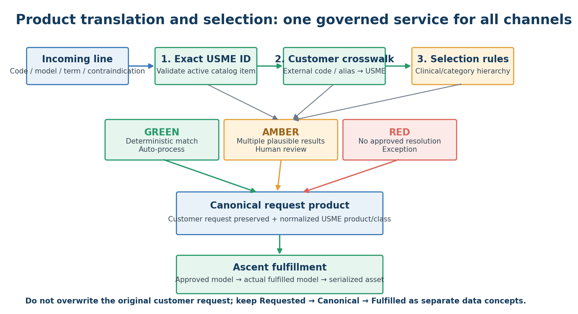
Figure 6. Product-resolution hierarchy.

10.1 Resolution order
Priority | Resolution method | Action
1 | Exact canonical USME/Ascent product ID | Validate active/effective; accept deterministically.
2 | Exact customer crosswalk | External code/alias + customer/profile → canonical USME product/class.
3 | Approved customer terminology mapping | Customer clinical/category phrase → canonical product class/model.
4 | Approved selection hierarchy | Deterministic criteria/contraindication rules → product class/model.
5 | Alias / fuzzy candidate | Present candidate(s) to operator; do not auto-create if multiple plausible products remain.
6 | Manual resolution | Operator chooses product/class and may submit a proposed mapping for approval.

10.2 Where configuration belongs
Configuration | Workato | Salesforce | Ascent
Customer terminology/code crosswalk |  | ✓ Authoritative mapping
Product selection rules / contraindications |  | ✓ Versioned business rule
Canonical USME product master | Read only as needed | ✓ Reference / presentation | ✓ Operational item/product authority
Source parsing schema | ✓ Adapter/IDP schema | Profile points to schema
Mapping confidence / approval | Read result | ✓ Status/approval/audit
Fulfilled model / asset |  | Read from Ascent | ✓ Authoritative execution

10.3 Mapping governance workflow
- Only approved mappings/rules may auto-resolve orders.
- Each mapping contains customer/IDN, external code/term, canonical product/class, effective-from/to dates, status, owner and source/evidence.
- Every manual resolution should offer “propose mapping” but should not automatically create an approved mapping.
- A Product Master Steward reviews proposed mappings daily/weekly based on volume and risk.
- Changes to clinical/contraindication-based selection rules require designated business/clinical approval and regression testing.
- Expired/inactive USME products should not resolve silently; the system should route to approved successor/substitution logic or review.

10.4 Customer examples
Customer | Current behavior | Future-state resolution
University of Colorado | Uses Pathway to direct user to product. Does not list our products. We use mapping table to our modelIDs. | Pathway term → approved Colorado mapping/rule → canonical USME product/class.
Select Medical | Orders delivery/pickup through Sentinel procurement system. We then receive associated order. Order does list our products. | Validate portal-provided USME product and external order ID; use RPA only as transport until a better interface is available.
Atlantic Health | Use order screen with our model name and IDs. | Validate provided USME model name/ID against canonical catalog; exception if inactive/unknown.
DaVita | Order from procurement system. They use internal model values. We use mapping table to our modelIDs. | DaVita internal model value → exact External_Product_Mapping__c crosswalk.
Encompass Health | Order from procurement system. Our catalog is uploaded and they pick our product. However, not always consistent. | Exact USME catalog match first; approved alias normalization when inconsistent; cross-channel dedup against portal/phone.
Centra Health | Use order screen with our model name and IDs. | Validate provided USME model name/ID against canonical catalog; exception if inactive/unknown.
North Memorial Health Care | Use contraindications. No models. We use hierarchy to determine modelIDs. | Contraindication/criteria → versioned deterministic Product_Selection_Rule__c; unresolved cases to review.

11. Cross-Channel Deduplication and Amendment Logic
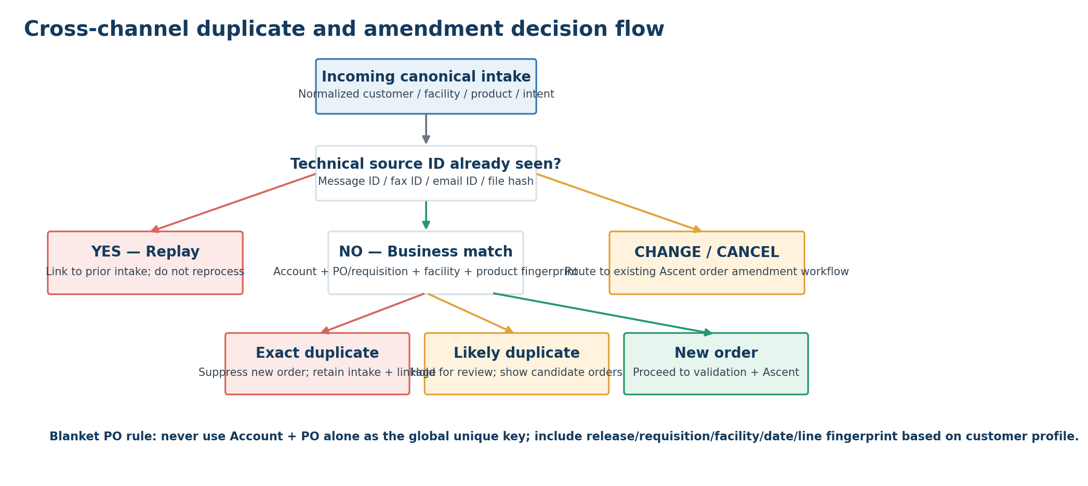
Figure 7. Duplicate/amendment decision flow.

11.1 Four control layers
Layer | Question | Implementation
1. Technical replay | Have we already processed this exact source event/document? | Source_External_ID + document/file hash. Auto-suppress replay; do not rerun business creation.
2. Exact business duplicate | Is this the same customer order sent again through another channel? | Customer profile-specific unique key/fingerprint using PO/requisition/release/facility/date/normalized lines.
3. Likely duplicate | Is the request probably the same but missing one or more identifiers? | Configurable score against recent Intake + Ascent orders; hold for human review above review threshold.
4. Amendment vs. duplicate | Is the second transaction actually a change/cancel/pickup? | Determine transaction intent first; route to existing order update workflow, not duplicate suppression.

11.2 Example configurable duplicate score
Match factor | Illustrative weight | Notes
Same PO / requisition / release | 35 | Customer profile decides which reference is meaningful.
Same account | 15 | Required for any cross-channel business match.
Same facility / ship-to | 10 | Use canonical facility, not raw text.
Same requested date | 10 | Allow configured tolerance if needed.
Same normalized product lines | 20 | Compare canonical products/classes, not raw descriptions.
Same quantities | 5 | Helps distinguish order changes.
Same requester / within time window | 5 | Useful when PO is absent.
TOTAL | 100 | Example only; calibrate on historical duplicates before production.

Illustrative thresholds: 95–100 = exact/auto duplicate only when no change indicators exist; 75–94 = review; below 75 = likely new. These are design starting points, not final production thresholds.

11.3 PO profiles
PO profile | Recommended key logic
Unique-order PO | Account + PO + release/requisition + facility + intent + normalized line fingerprint.
Blanket PO | Account + blanket PO + requisition/release + facility + requested date + normalized line fingerprint.
No PO / EMR request | Account + facility + requester/order reference + requested date/window + normalized line fingerprint.
EDI procurement | Trading-partner order ID + customer PO/release plus canonical business fingerprint for cross-channel comparison.

11.4 Duplicate handling rule
Never delete a duplicate intake
The duplicate source event should be retained and linked to the authoritative Intake/Ascent order. The system suppresses a second operational order; it does not erase evidence that the customer submitted another request.

12. Experience Cloud Ordering Design
Experience Cloud should become the preferred structured self-service channel over time, but it should participate in the same Intake Hub rather than bypassing it. This keeps portal orders comparable to EDI, email and fax for deduplication and reporting.

12.1 Customer-specific product experience
Customer type | Portal experience | Backend translation
Uses USME catalog | Show contracted/allowed USME products and model IDs. | Direct canonical product reference.
Uses internal codes | Display the customer’s familiar code/description where useful. | Customer crosswalk resolves to USME canonical product.
Uses clinical/category terms | Show guided categories/attributes rather than internal USME model numbers. | Selection rule returns canonical product class/model.
Contraindication/criteria-driven | Guided structured questionnaire based on approved rule set. | Deterministic rule engine; ambiguous outcome requires review.

12.2 Portal controls
- Account/facility access derived from authenticated user context; never trust a customer-supplied Account ID alone.
- Generate immutable portal Submission ID at final submit and store as Source_External_ID.
- Show Intake receipt immediately; show Ascent order number only after accepted order creation.
- If a likely duplicate is detected, do not expose internal scoring. Present a customer-friendly “We may already have this request” workflow or let operations resolve it depending on policy.
- Capture explicit change/cancel/pickup intent instead of forcing a second “new order” submission.
- Use customer profile to determine required PO/requisition fields and catalog/rule experience.

13. Exception Management and Operational Playbook

13.1 Exception queues
Queue | Trigger | Operator action | Target outcome
Product Resolution | No deterministic mapping; multiple candidate products; low-confidence extraction on required product field. | Review source document, select canonical product/class, optionally propose a mapping. | Resolved line; mapping proposal created if appropriate.
Customer / Facility | Account or facility cannot be uniquely resolved. | Choose correct record; add/approve alias if recurring. | Canonical customer/facility assigned.
Duplicate Review | Score in review range or conflicting same-PO request. | Compare candidate order, source channel, lines and timestamps; mark Duplicate / New / Amendment. | One authoritative operational order.
Business Validation | Missing required PO/requisition/date or customer policy violation. | Request missing information or correct permitted data. | Ready to Create or Rejected.
Technical Failure | Connector/API/IDP/Ascent transient failure after retries. | Review error category, replay Intake after dependency recovers. | Process completes without customer resubmission.
Acknowledgment Failure | Order created but response channel failed. | Retry acknowledgment only; do not recreate order. | Customer/partner receives confirmation.

13.2 Daily operating cadence
Cadence | Activity | Owner
Start of day | Check Workato project health, stopped recipes/connections, SFTP backlog, failed API jobs, prior-day reconciliation and aging exceptions. | Integration Operations
Continuous | Order Intake team works Product, Duplicate, Customer/Facility and Business Validation queues by SLA/priority. | Order Intake Operations
At least daily | Product Master Steward reviews proposed high-volume mappings and inactive/successor-product exceptions. | Product Master Steward
At least daily | Reconcile accepted Intakes vs. Ascent orders and unresolved Created/Acknowledged gaps. | Integration Operations
Weekly | Review top exception causes, touchless rate by customer/channel, new alias requests and recurring source-format changes. | Product Owner + Integration Owner
Monthly | Review customer-channel cost/performance, RPA usage, mappings/rules approaching expiration, and retirement candidates. | Architecture / Applications Governance

13.3 Replay / recovery procedure
- Locate the Salesforce Intake record first; never ask the customer to resend until USME has confirmed the source cannot be recovered.
- Confirm whether an Ascent order already exists. If yes, replay only the failed step (for example acknowledgment), not the creation path.
- For a technical failure before Ascent creation, correct the dependency or data issue, then set the Intake to an approved replay status or invoke the replay recipe using Intake ID.
- Replay recipes load the persisted canonical data from Salesforce; they should not re-interpret the original document unless extraction itself was the failed/changed step.
- Retain the original Workato job URL/error reference and the replay job reference for support traceability.
- If a source adapter is down, allow controlled manual creation/upload into the Salesforce Intake Hub so operations continue without bypassing dedup and product mapping.

13.4 New mapping creation procedure
Step | Action
1 | Operator resolves an unmapped external product/term during order review.
2 | Operator selects “Propose Mapping” and the system pre-populates customer, raw value and chosen canonical product/class.
3 | Product Master Steward verifies evidence, scope, effective date and whether the mapping is customer-specific or reusable.
4 | If clinical/contraindication logic is involved, route to designated rule approver rather than simple product steward.
5 | Approve and version the mapping/rule. Future orders use it automatically from the effective date.
6 | Include the new mapping in regression tests for the customer profile before the next production release if logic changed beyond simple exact crosswalk.

14. Security, PHI and Audit Controls
Control domain | Recommended control
Minimum necessary data | Extract/store only fields needed for order execution. Avoid carrying clinical narrative into downstream systems when a normalized product/order field is sufficient.
Source documents | Store in a governed repository with encryption, retention and access controls. Salesforce holds the link/reference and normalized values; attaching every raw fax/email to Salesforce is optional based on operational need and storage cost.
Workato job data | Avoid PHI in recipe names, job labels and alert emails. Configure retention/masking consistent with BAA and policy.
Integration identities | Dedicated non-human users with least privilege; no shared human credentials.
Secrets | Use OAuth, API keys/SSH keys and approved secret management; rotate on defined schedule.
eFax | Use enterprise API/secure fax service under BAA; secure webhook/API authentication and restrict endpoint exposure.
Salesforce | Permission sets/sharing, audit fields, field history, Shield/encryption where approved by the broader security design.
SFTP/MFT | SSH keys preferred; host-key verification; isolated partner directories; optional IP restrictions; log file access.
RPA | Use vault-managed credentials, hardened service accounts/VMs and minimize PHI persistence on bot desktops.
Audit | Every Intake retains source ID, received timestamp, source artifact reference, mapping/rule version, duplicate decision, reviewer (if any), Ascent reference and acknowledgment result.

15. Monitoring, Reconciliation and KPIs

15.1 Operational KPIs
KPI | Definition | Why it matters
Straight-through processing % | Accepted Ascent orders created without human intervention ÷ total eligible intake. | Primary measure of automation value.
Manual touch rate | Intakes touched by an operator ÷ total intake. | Tracks labor reduction and source quality.
Intake-to-order latency | Received timestamp → Ascent order created. | Customer responsiveness.
Duplicate detection rate | Suppressed/reviewed duplicate submissions ÷ total. | Quantifies cross-channel duplicate behavior.
Duplicate escape rate | Duplicates discovered after Ascent creation. | Critical quality/control metric.
Product-resolution exception % | Lines requiring manual product selection ÷ lines. | Shows mapping maturity.
Facility-resolution exception % | Intakes requiring facility mapping. | Measures customer-master quality.
IDP low-confidence rate | Documents with required-field confidence below threshold. | Measures document automation quality.
Technical retry/recovery rate | Jobs recovered automatically after transient failure. | Integration resilience.
Acknowledgment failure rate | Accepted orders whose customer acknowledgment failed. | Separates customer-communication reliability from order creation.
Cost per order by channel | Run/support cost ÷ order volume by channel. | Guides future channel migration priorities.
RPA order share | Orders dependent on RPA. | Direct tech-debt retirement measure.

15.2 Reconciliation controls
- Daily: source events received by channel vs. Salesforce Intake records created.
- Daily: Ready-to-Create / Creating records vs. Ascent orders successfully created.
- Daily: Created orders vs. required acknowledgments sent.
- Customer-specific: EDI inbound PO/RMA control totals vs. accepted/rejected business outcomes.
- Weekly: duplicate candidates resolved and any duplicates discovered after order creation.
- Weekly: unmapped product terms/codes by volume and customer.
- Monthly: Workato job errors by recipe and root cause; top recurring failures become backlog items.
- Monthly: retired-vs-active legacy automations and RPA instances.

16. Transition and Cutover Plan
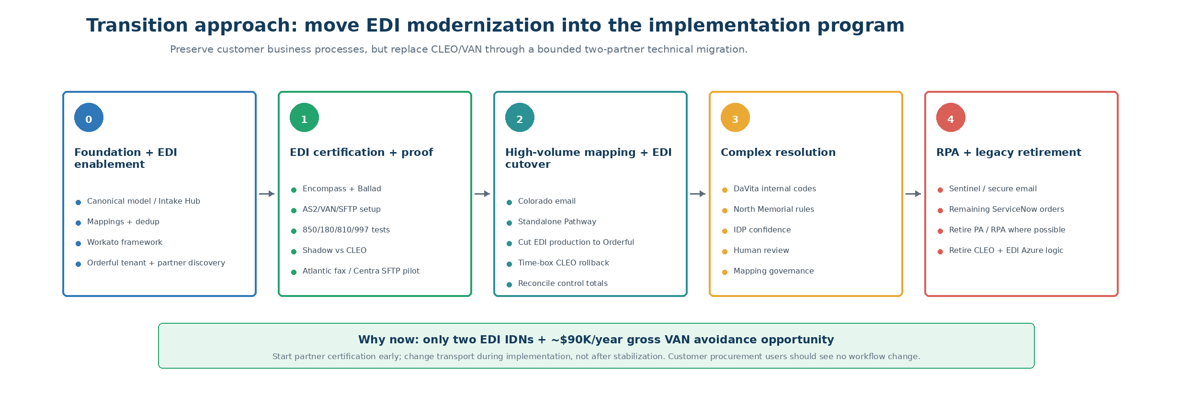
Figure 8. Recommended transition waves.

16.1 Migration sequence
Wave | Scope | Why this sequence | Exit criteria
0 – Foundation + EDI enablement | Salesforce Intake Hub, canonical schema, customer/product/facility mappings, dedup evaluator, Workato framework; in parallel, procure/enable Workato EDI + Orderful and complete connectivity discovery for Encompass and Ballad. | The common control plane and EDI partner work can be built concurrently; starting EDI early avoids carrying CLEO into steady state by default. | Synthetic Intake → evaluation → Ascent flow proven; Orderful tenant/trading-partner setup initiated; partner technical contacts, connection method and transaction set confirmed.
1 – EDI certification + low-risk channel proof | Certify Encompass and Ballad on Orderful/Workato; test 850/180/810/997 or current agreed transaction set; shadow against CLEO. In parallel, pilot Atlantic fax and/or Centra SFTP straight-through flows. | Only two EDI IDNs exist, so technical recertification is bounded and can be completed while the broader implementation is underway. | Partner connectivity certified; no X12 control-number gaps; shadow control totals reconcile; duplicate/product mapping paths proven; rollback documented.
2 – High-volume mapping | University of Colorado + Standalone Pathway email; cut EDI production traffic to Orderful when partner and Ascent readiness gates are met. | Moves the largest order volume while realizing the EDI tech-debt/cost benefit during the implementation window. | Approved mapping coverage and exception rate within target; EDI production reconciliation signed off; CLEO disabled except temporary rollback.
3 – Complex resolution | DaVita internal codes; North Memorial selection hierarchy; remaining higher-complexity document patterns. | Proves exact crosswalk and deterministic clinical/category selection patterns after the common intake platform is stable. | Rule/mapping governance and review controls approved; no unresolved product silently auto-resolves.
4 – RPA / secure channels + legacy retirement | Sentinel, secure email, remaining ServiceNow order automations; retire residual Power Automate/ServiceNow/CLEO/Azure integration components as cutovers complete. | Leaves the least modern channels until the common platform and exception operations are mature. | All remaining sources feed canonical Intake; direct GOUSME creation removed; legacy infrastructure decommissioned or formally retained by exception.

16.2 Cutover method: customer × channel × transaction type
Do not perform a single channel-wide “big bang.” Cut over in controllable units such as University of Colorado × Email × NEW/PICKUP or Encompass × EDI × 850. This supports targeted rollback and clean reconciliation.
Cutover stage | Required activity
Shadow | New adapter creates/evaluates canonical Intake without sending to Ascent; compare product, facility, intent and duplicate result to current GOUSME output.
Dual-control pilot | Small volume creates Ascent order with explicit operator approval while current system remains recovery path.
Controlled production | New path is authoritative for selected customer/channel/intent; current automation disabled or put in monitor-only mode.
Stabilization | Daily reconciliation, defect triage and exception-rate targets for defined period.
Retire | Remove legacy direct-order creation, credentials, schedules and support procedures only after evidence-based stabilization.

16.3 Technology retirement roadmap
Current component | Target treatment | Timing
Power Automate order flows | Replace with Workato channel adapters and central orchestration. | Waves 1–4 by customer/channel.
ServiceNow DocIntel / Flow order creation | Replace with Workato IDP + Salesforce Intake Hub. | Wave 3/4.
ServiceNow RPA / PA RPA VMs | Keep only for sources with no interface; progressively retire. | Wave 4+.
Customer-specific Azure Functions | Retire integration business logic; specifically retire Azure Functions used for the current EDI/CLEO path once Workato EDI + Orderful is live. Preserve Azure only where useful for governed archive or unrelated services. | As each channel migrates.
GOUSME order-creation APIs | Stop accepting channel automation after Ascent cutover. | Per customer/channel cutover.
Scattered mapping tables | Migrate into Salesforce mapping/rule objects with governance. | Wave 0–3.
CLEO VAN / AS2 | Replace with Workato EDI + Orderful during the implementation program. Keep CLEO only as a short-lived rollback path until both EDI IDNs are certified and production reconciliation is signed off. | Wave 0–2; target retirement at EDI production cutover / Ascent go-live window.
Legacy email-based technical alerts | Replace with Workato/operational monitoring and targeted actionable alerts. | During adapter migration.

17. Testing Strategy
The test strategy should be customer/scenario-driven. Reuse current production examples and known failure modes, not generic “happy path” records only.
Test scenario | Expected result
Same eFax webhook/fax ID delivered twice | One Intake; no second Ascent order.
Same order sent EDI then Experience Cloud | Likely/exact duplicate detected after canonical normalization.
Same order sent email without PO after EDI with PO | Duplicate review surfaces candidate based on facility/date/product/quantity.
Blanket PO used for two legitimate requests | Two distinct orders based on requisition/release/facility/date/lines.
Customer changes 2 units to 3 units | Recognized as amendment/change, not duplicate suppression.
Colorado Pathway term mapped to USME model | Correct approved mapping and mapping version recorded.
DaVita internal value mapped to model | Exact crosswalk, touchless processing.
North Memorial criteria match one rule | Deterministic approved selection.
North Memorial criteria match multiple/no rules | Review Required; no Ascent order.
Encompass substituted fulfilled model | Requested product remains intact; fulfilled model/asset recorded separately.
Fax OCR/IDP low confidence on quantity | Review Required; quantity not guessed.
Fax layout changes / text wraps | Semantic extraction still works or routes to review; no positional-coordinate failure.
SFTP file replay / renamed duplicate | File hash/source profile prevents duplicate order creation.
Salesforce temporarily unavailable | Workato retries transiently; event remains visible for replay; no silent drop.
Ascent order creation errors after Intake acceptance | Intake = Failed Technical; replay creates at most one Ascent order.
Acknowledgment fails after Ascent creation | Retry acknowledgment only.
Facility alias not found | Customer/Facility queue; mapping can be proposed.
Inactive canonical product | No silent mapping; successor/review path.
Source format changes unexpectedly | Schema validation rejects/queues and alerts integration operations.
PHI present in source document | No PHI appears in alert subject/recipe names; access controls/retention applied.

17.1 Production readiness thresholds
- Zero known duplicate-order defects in the agreed shadow/pilot sample.
- 100% technical replay idempotency for repeated message/file tests.
- All mapped top-volume customer terms/codes approved and loaded before customer cutover.
- All unresolved product/facility exceptions visibly route to Salesforce queues with owner/SLA.
- Ascent create/update path is replay-safe and returns authoritative order reference.
- Error alerts contain enough context to act but do not expose restricted data.
- Customer acknowledgment path is independently replayable.
- Reconciliation report is signed off by Operations and Integration Support before legacy automation is disabled.

18. Governance, Support and Change Control

18.1 Roles
Role | Primary responsibilities
Business Product Owner – Order Intake | Own intake policies, priorities, exception SLAs, channel strategy and business acceptance.
Integration Platform Owner – Workato | Own recipes, connections, deployments, monitoring, retries, connector lifecycle and technical runbook.
Salesforce Platform Owner | Own Intake Hub data model, Flow/Apex services, security, exception console and mapping framework.
Ascent Product Owner / SME | Own accepted order/rental configuration, supported order APIs/objects and rental lifecycle.
Product Master Steward | Own canonical product mapping quality, approvals, successor mapping and alias governance.
Customer/Facility Master Steward | Own account/facility alias resolution and customer hierarchy quality.
Order Intake Operations | Resolve product/duplicate/business exceptions and provide customer follow-up.
Security / Compliance | Approve PHI handling, BAA controls, retention, encryption and access model.
Customer Integration Owner | Own partner-specific transport configuration, testing, customer communication and recertification.

18.2 Change-control rules
- No customer-specific hardcoded recipe branch unless architecture review confirms that configuration cannot express the requirement.
- New product mappings follow business approval; Workato deployment is not required for a simple approved mapping change.
- New selection-rule logic follows versioned release, business/clinical approval and customer regression test.
- Channel format/schema changes are tested in non-production using sample customer payloads before activation.
- Recipe changes move Dev/Test/Prod through controlled promotion with environment-specific connections.
- Changes to duplicate weights/thresholds require evidence from historical false-positive/false-negative analysis.
- Legacy integration cannot be decommissioned until production reconciliation and rollback criteria are satisfied.

19. Decision Register and Open Items
Decision / validation item | Recommended direction | Owner / timing
Raw source-document repository | Prefer existing governed Azure/enterprise document storage for long-term originals; Salesforce stores normalized data + link unless operational need justifies file copy. | Architecture + Security – Wave 0
Workato API Platform entitlement | Confirm API recipe/API management licensing for eFax/RPA inbound endpoints. | Commercial / Workato – before build
Workato MFT entitlement | Use existing SFTP endpoints initially; price/validate MFT before partner migration. | Commercial / Workato – Wave 1/5
IDP model/schema strategy | Confirm standard vs custom extraction models and PHI/BAA configuration. | Integration + Security – Wave 0
Salesforce duplicate engine implementation | Use Flow + invocable Apex for candidate scoring/fingerprint if standard duplicate rules are insufficient for multi-line orders. | Salesforce Architect – Wave 0
Ascent exact order object/API pattern | Validate supported managed-package object/API and idempotent create/update method. | Ascent – design workshops
Experience Cloud product presentation | Define customer-specific catalog/terminology strategy by IDN segment. | Business + Salesforce – Wave 0/2
EDI transport replacement | Proceed during implementation: configure Workato EDI + Orderful, certify Encompass and Ballad, shadow against CLEO, and retire CLEO/VAN after production reconciliation. Treat ~$90K/year as gross cost avoidance, not net savings, until incremental Orderful/Workato cost and one-time certification costs are known. | Architecture + Procurement + Integration – Wave 0–2
RPA retirement | Inventory source providers for API/file options and rank by volume/support burden. | Integration Owner – Wave 4
Duplicate thresholds | Calibrate using historical known duplicates before enabling auto-suppression beyond technical replays. | Business + Data – Wave 0/1
Workato EDI / Orderful entitlement | Obtain commercial quote immediately; confirm partner-management, AS2/VAN/SFTP transport, EDI transaction handling, support and environments. Compare net recurring cost against current VAN/CLEO spend. | Commercial / Workato – before EDI build
EDI partner migration plan | For each of the two EDI IDNs, document current channel, ISA/GS IDs, certificate/endpoint/VAN routing, transaction set, test/prod process, certification lead time, customer technical owner and rollback plan. | Customer Integration Owner – Wave 0
EDI production cutover gate | Do not wait for a post-go-live wave. Cut when partner certification, shadow reconciliation, idempotency, product mapping, duplicate controls, Ascent create/update and acknowledgments all pass. | Program Governance – Wave 1/2

Appendix A – Current-State IDN Detail
IDN | Automation | YTD orders | System type | Current product/order characteristic
University of Colorado | USME Connect - Email | 13,107 | EMR | Uses Pathway to direct user to product. Does not list our products. We use mapping table to our modelIDs.
Select Medical | Sentinel RPA | 3,004 | Procurement | Orders delivery/pickup through Sentinel procurement system. We then receive associated order. Order does list our products.
Atlantic Health | USME Connect - Fax | 2,805 | EMR | Use order screen with our model name and IDs.
DaVita | ServiceNowOrder | 1,798 | Procurement | Order from procurement system. They use internal model values. We use mapping table to our modelIDs.
Encompass Health | EDI Request | 1,695 | Procurement/EMR | Order from procurement system. Our catalog is uploaded and they pick our product. However, not always consistent.
Centra Health | USME Connect - SFTP | 1,551 | EMR | Use order screen with our model name and IDs.
Standalone | USME Connect - Email | 1,092 | EMR | Uses Pathway to direct user to product. Does not list our products. We use mapping table to our modelIDs.
Prisma Health | USME Connect - Fax | 920 | EMR | Use order screen with our model name and IDs.
North Memorial Health Care | USME Connect - Fax | 510 | EMR | Use contraindications. No models. We use hierarchy to determine modelIDs.
Standalone | USME Connect - Secure Email | 238 | EMR | Use order screen with our model name and IDs.
Centrastate Medical Center | USME Connect - Fax | 190 | EMR | Use order screen with our model name and IDs.
Standalone | USME Connect - Fax | 119 | EMR | Use order screen with our model name and IDs.
Regency | Sentinel RPA | 21 | EMR | Orders delivery/pickup through Sentinel procurement system. We then receive associated order. They do list our products.
Standalone | Sentinel RPA | 15 | EMR | Orders delivery/pickup through Sentinel procurement system. We then receive associated order. They do list our products.
Ballad Health | EDI Request | 2 | Procurement/EMR | Order from procurement system. Our catalog is uploaded and they pick our product. However, not always consistent.

Appendix B – Proposed Field Dictionary
This is a logical field dictionary. Exact Salesforce API names, Ascent namespace/object references and field lengths should be finalized during technical design.
Object | Logical field | Type / behavior | Required when
Order Intake | Source External ID | Text, Unique External ID | Always
Order Intake | Source Channel | Picklist | Always
Order Intake | Source Received At | DateTime | Always
Order Intake | Customer Integration Profile | Lookup | Automated processing
Order Intake | Raw Account / Facility values | Text | Where source contains them
Order Intake | Resolved Account / Facility | Lookup | Before Ready to Create
Order Intake | Transaction Intent | Picklist | Before Ready to Create
Order Intake | Customer PO | Text | Per customer profile
Order Intake | Requisition / Release | Text | Per customer profile
Order Intake | Canonical Order Fingerprint | Text/hash | After normalization
Order Intake | Duplicate Score / Status | Number + Picklist | After evaluation
Order Intake | Processing Status | Picklist | Always
Order Intake | Ascent Order Reference | Lookup/Text | After accepted order creation
Order Intake Line | Raw Product Code | Text | If source sends code
Order Intake Line | Raw Product Description | Text | If source sends description
Order Intake Line | Raw Clinical Criteria | Long text / structured JSON only if approved | Criteria-driven customers
Order Intake Line | Canonical Product/Class | Lookup | Before Ready to Create
Order Intake Line | Resolution Method | Picklist | Resolved lines
Order Intake Line | Resolution Confidence | Decimal | IDP/heuristic results
External Product Mapping | Customer / IDN | Lookup | Always
External Product Mapping | External Code / Term | Text | Always
External Product Mapping | Canonical Product / Class | Lookup | Always
External Product Mapping | Status / Effective Dates | Picklist / dates | Always
Product Selection Rule | Criteria + Priority + Output | Structured fields / rules | Criteria-driven customers
Customer Integration Profile | PO Type / Duplicate Window | Picklist / number | Always
Customer Integration Profile | Parsing / Resolution Mode | Picklist | Always
Customer Integration Profile | Acknowledgment Mode | Picklist | Always

Appendix C – Workato Recipe Catalog
Recipe ID / name | Trigger | Primary actions | Output
CH-001 eFax Inbound | Workato API recipe / webhook | Validate event → HTTP eFax fetch → source key/hash → Salesforce intake upsert → IDP/canonicalizer | Intake ID + async processing
CH-002 Email Inbound | M365/Outlook new-mail monitoring | Filter sender/profile → attachment download → source ID/hash → canonicalizer | Intake + lines
CH-003 SFTP Inbound | New/updated file trigger | Validate filename/schema → download → hash → parse/batch → canonicalizer | Intake(s) + lines
CH-004 EDI Inbound – Orderful | Orderful / Workato EDI validated inbound transaction | Capture partner + ISA/GS/ST/control IDs → persist source ID → parse/map X12 850/180 as applicable → canonicalize → Salesforce Intake upsert → common evaluation | Intake + lines + EDI trace identifiers
CH-005 RPA Result | API recipe | Validate bot/source order ID → intake upsert → canonicalizer | Intake + lines
SF-001 Portal Intake Event | Salesforce real-time event/record trigger | Load existing Intake → call common orchestration as needed | Processing coordination
OR-010 Canonicalize Intake | Called recipe/function | Standardize dates/IDs/quantities → persist raw+normalized fields | Ready for Evaluation
OR-020 Document IDP | Called recipe/function | Process PDF/image → return values + confidence | Extracted payload
OR-030 Archive Source | Called recipe/function | Write approved archive / URI / hash | Artifact reference
ACK-010 Customer Receipt | Status/event driven | Send email/file/API acknowledgment based on profile | Ack status
OPS-001 Recipe Failure Monitor | RecipeOps/job-failed trigger | Classify → alert → create/update technical exception | Actionable failure
OPS-002 SLA/Aging Monitor | Scheduled | Find aging Intake statuses / exceptions | Operations alert/dashboard
OPS-003 Reconciliation | Scheduled | Compare source/intake/ascent/ack control totals | Reconciliation report
EDI-010 Technical/Business Acknowledgment | Inbound EDI accepted/failed + Intake status event | Let transport layer manage protocol acknowledgment where applicable; generate business response/status from governed Intake outcome; preserve partner/control references | Ack status + partner trace
EDI-020 Outbound 810 Invoice | GT finalized/approved invoice event or scheduled extract | Load authoritative GT invoice → map requested/canonical/fulfilled references → generate/validate X12 810 through Workato/Orderful → deliver to partner → persist control IDs/status | Partner invoice delivery + reconciliation
EDI-030 EDI Reconciliation | Scheduled + on-demand | Compare Orderful transactions, Salesforce Intake, Ascent orders, acknowledgments and outbound invoices by partner/control number | Partner-level control report

Appendix D – Reference Sources
Current-state source
- GOUSME Automations.xlsx — Definitions, Automation Details, IDN Listing, Customer Listing (user-provided source of current-state facts and order statistics).
- Existing USME future-state Salesforce/Ascent architecture materials supplied in prior design work (used for system-of-record boundaries and downstream GT/Avalara/Acumatica context).
External technical validation used for the design
Workato API recipes: https://docs.workato.com/api-mgmt/api-recipes/
Workato Salesforce upsert / External ID: https://docs.workato.com/en/connectors/salesforce/actions/upsert-record
Workato Salesforce real-time triggers: https://docs.workato.com/connectors/salesforce/real-time-triggers
Workato error handling best practices: https://docs.workato.com/recipes/best-practices-error-handling
Workato recipe steps / reusable recipe functions: https://docs.workato.com/recipes/steps
Workato SFTP connector: https://docs.workato.com/en/connectors/sftp
Workato Managed File Transfer: https://docs.workato.com/en/managed-file-transfer.html
Workato IDP process document action: https://docs.workato.com/en/connectors/idp-by-workato/process-document-action
Workato Outlook connector: https://docs.workato.com/en/connectors/outlook/outlook
eFax Enterprise Fax API: https://www.efax.com/integrations/fax-api
eFax Salesforce integration / webhook pattern: https://www.efax.com/integrations/salesforce
Implementation note
This playbook is intentionally platform-specific at the responsibility and configuration-pattern level, but it does not invent Ascent managed-package API names. During design workshops, map each logical object/action in this document to the supported Ascent object model and document the resulting implementation-specific interface contract.

Workato EDI tools / complete EDI with Orderful: https://docs.workato.com/en/features/edi/edi-by-workato
Orderful AS2 onboarding: https://docs.orderful.com/docs/connecting-to-orderful-via-as2
Orderful communication channels (AS2 / VAN / SFTP): https://help.orderful.com/docs/identifying-communication-channels

