

Customer Portal – Functional Requirement and Conceptual Design

Projects | USME – Ascent Rental Salesforce CRM Implementation
Prepared For | USME
Document Status | Issued

Document Change Control Log:
The Document Change Control Log is updated each time the document is modified. The log identifies the version number, the date of revisions, a brief description of the changes, and the author/reviewer
Version # | Date | Description | Author
V1.0 |  | Functional Requirements and Design | Durvah

Approvals from USME Team:
Version # | Date | Approver Role | Approver

Executive Summary
The new USME Customer Portal will be built on Salesforce Experience Cloud, replacing the legacy GoUSME portal for approximately 4,500 customer accounts and over 10,500 users. The foundational architectural principle is that the portal is a "channel, not an engine". It will not house duplicate business logic; instead, all portal actions will call the exact same unified Shared Intake Services (Flows and Apex) utilized by internal Customer Experience Center (CEC) agents. Furthermore, the single Salesforce org acts as the absolute boundary for Protected Health Information (PHI), with external systems receiving only tokenized references

USME Process Understanding
USME buys medical equipment and rents, rent-to-owns or sells it to hospitals, promising delivery within about 2 hours from strategically placed warehouses. Beds are the fast-moving core. The portal is a channel over this process, not a process of its own: every portal transaction must trigger the same validations and state changes as a call to the Customer Experience Center (CEC).
Two order shapes drive most design choices:
- BTS (bed / patient-linked): tied to a patient, so PHI applies. Needs patient name/ID, height, weight and delivery location. Billing is tokenized.
- MME (bulk / department-linked): multi-item, multi-quantity, no patient and no token. Serial matching at pickup is harder.

Functional Requirements

1. Identity and Account Administration
ID | Requirement
PRT-101 | Customer administrators invite, edit and deactivate portal users for their facilities.
PRT-102 | All users can authenticate with Login & Password, MFA; enterprise SSO (SAML) is supported.
PRT-103 | Each user holds one or more portal roles (Operations, Finance, Admin, Viewer) per account or facility.
PRT-104 | Visibility follows the account hierarchy: a user sees only facilities they are assigned to.
PRT-105 | About 10,500 existing logins are migrated from GoUSME with a forced password reset and a cutover notice to customers.
PRT-106 | Administrators maintain departments, PO references, delivery contacts and communication preferences.
PRT-107 | Users linked to more than one account or facility switch between them with an account selector at the top of every list and form, and every list and order form follows the selected account. The legacy portal shows this selector on all pages.

2. Ordering
ID | Requirement
PRT-201 | Catalog shows only products the account is entitled to, by contract, price book and eligibility rules.
PRT-202 | Operations users submit a rental order in three steps: (1) caller, department, contact email, delivery address and equipment type (MME or BTS); (2) add items; (3) requested date or ASAP with a time window, PO and notes. The branch comes from the account's service area and delivery address, never from the customer. A demo or loaner flag is available.
PRT-203 | Bed (BTS) orders capture patient first and last name, height (cm), weight (kg), unit and room; patient ID is optional unless the account requires it, and the unit sets the cost center. Patient data is stored only in Salesforce PHI structures.
PRT-204 | Bulk (MME) orders accept multiple items and quantities against a department, with no patient fields, and ask for the billing department.
PRT-205 | PO handling: enter a PO per order, or pick from the account's non-expired Blanket POs; show remaining balance as a non-blocking message. If the account requires a PO and none is entered, ask the user to confirm but do not block the order.
PRT-206 | Sales (purchase) orders use the same entitlement, pricing and PO rules as the assisted channel.
PRT-207 | A review step summarizes model, quantity and location before submit, and the user can edit or cancel while the order is Pending Branch Confirmation. Once it is Active, the customer can only ask CEC for a quantity change or a cancel; lines cannot be added.
PRT-208 | Delivery defaults to ASAP; a future date is allowed from the next business day.
PRT-209 | Substitutions are decided internally; the portal shows the delivered model, the original request and a substituted flag. The original line stays visible as Canceled with action Substitution, and billing follows the original model's price.
PRT-210 | Every portal order is stamped with source = Portal, the user and a timestamp.
PRT-211 | Saved order templates and reorder from history.
PRT-212 | The Add Items step offers tabs for preferred models, order history, current rentals, full catalog and bed packages.
PRT-213 | Users can order a bed package (bed, mattress and standard accessories) as one line.
PRT-214 | A billing department is selected on the order and defaults from the unit or department.
PRT-215 | Accessories are picked from a structured list per item, not typed as free text.
PRT-216 | Users can add or update the caller and contact inline during order entry.
PRT-217 | The delivery address can only be chosen from the account's stored addresses.
PRT-218 | The PO number field accepts PO numbers only. A visible note says no patient information may be entered in it.
PRT-219 | Model selection offers Favorites (star a model to save it), Recently Ordered and Catalog, with Catalog filters for category, model name and partner description, plus quantity and a note per model.
PRT-220 | Items go into a cart showing quantity and a note per item and a free-text box for delivery or handling instructions (for example delivery to a floor or a different entry). The user must confirm with an "Are you sure" prompt before the order is sent.
PRT-221 | After submit the portal shows the confirmation number, emails the caller, and states that a customer service representative will contact the user to confirm the order and give the expected delivery time.

3. Order Status and Tracking
ID | Requirement
PRT-301 | Order list and detail pages show current status and a time-stamped history using the final status model. The legacy call log uses Pending Branch Confirmation, Active, Out for Delivery, Delivered and Canceled; rental order lines and billing dates appear only once delivery is confirmed.
PRT-302 | Email and in-app notices on key events: submitted, activated, delivered, pickup scheduled, failed attempt, closed. Saving an order emails the caller at once and notifies the branch distribution list.
PRT-303 | Unfulfilled demand (late fill) shows an expected date and a contact path rather than silence.
PRT-304 | Home shows tiles for Active Rentals, Pending Pickups, Pending Delivery and Biomed Service Orders; each tile opens its list. Below them a chart shows active rentals for the last six months, switchable between bed (BTS) and bulk (MME) rentals.
PRT-305 | The Pending Delivery list shows patient name, patient ID, room, unit, confirmation number, ordered by, order date, department, equipment type (BTS or other), model and status (Pending Branch Confirmation), with a filter on every column. Patient fields are shown only to roles with PHI access.
PRT-306 | A user can cancel a pending delivery line from the list. A cancel note is captured and passed to CEC and the branch. Only lines still pending branch confirmation show the cancel action.

5. Pickup Requests
ID | Requirement
PRT-501 | Users select installed equipment, set a preferred date and access notes, and submit a pickup.
PRT-502 | Duplicate prevention: items already called off, or requested through another channel, are blocked with a message naming the existing request.
PRT-503 | Only users with the pickup permission for that facility can call off rentals; more than one authorized person per facility is allowed.
PRT-504 | Before submitting, the user sees that billing ends on the pickup-request date. [Validate] with GT
PRT-505 | For bulk (MME) items the user states quantities and serials where known, supporting partial returns.
PRT-506 | Documented pickup attempts (up to three) with customer notice and rescheduling; after the third failure the item moves to the recovery process.
PRT-507 | The Pending Pickup list shows confirmation number, ordered by, order date, department, model, barcode and call status, with column filters and a Show All switch.
PRT-508 | A user can cancel a pending pickup per item with a cancel note (for example "patient was not discharged after all"). The note goes to CEC and the branch.
PRT-509 | The pickup wizard selects items from Current Rentals, Models and Stand By tabs with a type filter (for example Anesthesia). Each selected item shows patient, room, unit, cost center, barcode and serial, takes its own note, and can be removed before confirming.
PRT-510 | The pickup form captures contact email, phone and extension, department, pickup address, reason for pickup (for example Usage Completed or PM Due), rental stop date, pickup date and time, and free-text instructions such as pickup from a floor or department.
PRT-511 | The confirmation screen gives the confirmation number, states that an email was sent, shows the date and time billing ends, and says a customer service representative will contact the user with questions, with the CEC phone number.

6. Service and Support
ID | Requirement
PRT-601 | Report an equipment issue against a specific asset or installed item, with severity, description and photos.
PRT-602 | The user can flag that a replacement is needed; CEC decides and the swap appears as status only.
PRT-603 | Case list, status, public comments and attachments for cases the user can access.
PRT-604 | A structured incident form covers three types: failure before use, failure in use with no harm, failure in use with harm.
PRT-605 | Service history for an asset can be shown to the customer when USME elects to expose it.

7. Invoices and Billing Visibility
ID | Requirement
PRT-701 | Invoice history lists invoices for authorized facilities that are flagged portal-visible: number, date, due date, total, balance, status.
PRT-702 | Users open or download the final PDF rendered in Salesforce from GT's finalized invoice data. No public links; every download is attributable.
PRT-703 | Patient or unit moves appear on the invoice as a stop on the current rental and a new rental line.
PRT-704 | Credit memos display linked to the original invoice.
PRT-705 | Preliminary (pro-forma) running charges, excluding tax, labelled as not final. Planned after the Feb 1 go-live; source is either GT preliminary-invoice events or an Ascent usage view (open decision).
PRT-706 | Payment status from Acumatica. This feed does not exist yet because GT will not return payment data to Salesforce.
PRT-707 | The authorized invoice list filters by From and To month and year and by account, and shows invoice number, date, month, year, grand total and a details link. The legacy limits are: invoices up to one year back, three months per search, and only invoices from the last three months or unpaid ones are listed; for older statements the user calls Billing.
PRT-708 | The preliminary invoice list shows date, month, year, grand total and last modified, with notices that these are not final invoices and may change. Preliminary invoices for movable medical equipment are available by the 15th of each month and for beds, therapeutic surfaces and ancillaries by the 25th. A billing email and phone number are shown.
PRT-709 | The Invoice History menu shows a count badge when new or preliminary invoices are available.

8. Dispute Management
ID | Requirement
PRT-801 | Finance users raise a dispute on an invoice or line with a reason code, comment and attachments. [Validate] (not yet discussed in workshops).
PRT-802 | Users track dispute status and exchange messages with billing.
PRT-803 | A resolved dispute that leads to a credit or rebill is shown on the invoice list with its outcome.

9. Help and Assistance
ID | Requirement
PRT-901 | Knowledge search and a visible way to contact CEC (phone, email, request).
PRT-902 | Announcements banner for planned changes, including the GoUSME to new portal cutover.
PRT-903 | Virtual agent for common intents with handoff of context to a live CEC agent.
PRT-904 | The header carries the User Guide, Support and Rental Service Request links, the signed-in user name with Change Password and Logout, and a Related Links page in the menu.

10. Usability and Change Management
ID | Requirement
PRT-1001 | Keep labels, order of steps and look close to today's portal where it is not a defect, to limit training and change risk for customers.
PRT-1002 | Customers can complete top tasks (order, update details, pickup) on a phone or tablet.
PRT-1003 | Every list can be exported to Excel (XLSX) from the page using the same filters and account as on screen.
PRT-1004 | Every list supports column filters and sorting by clicking a column header, and keeps its horizontal scroll for wide tables.
PRT-1005 | Adapt the UI and features same as today portal, ensure there is no additional training required to the customer users or change management

11. Equipment Sales and Purchase History
ID | Requirement
PRT-1101 | Purchase History lists equipment the account bought: product number, name, manufacturer, model, serial, sales order number, date sold, sale price, quantity and warranty, with a From date filter and Excel export.
PRT-1102 | Equipment Sales appears as its own menu group alongside Equipment Rental, so users can find purchases and sales orders (see PRT-206).

Customer Portal Architecture
The portal is a thin Experience Cloud layer over the single Salesforce org that also hosts Ascent. It keeps no data of its own and calls the same services as CEC, so a transaction raised in the portal and one raised by phone behave identically.
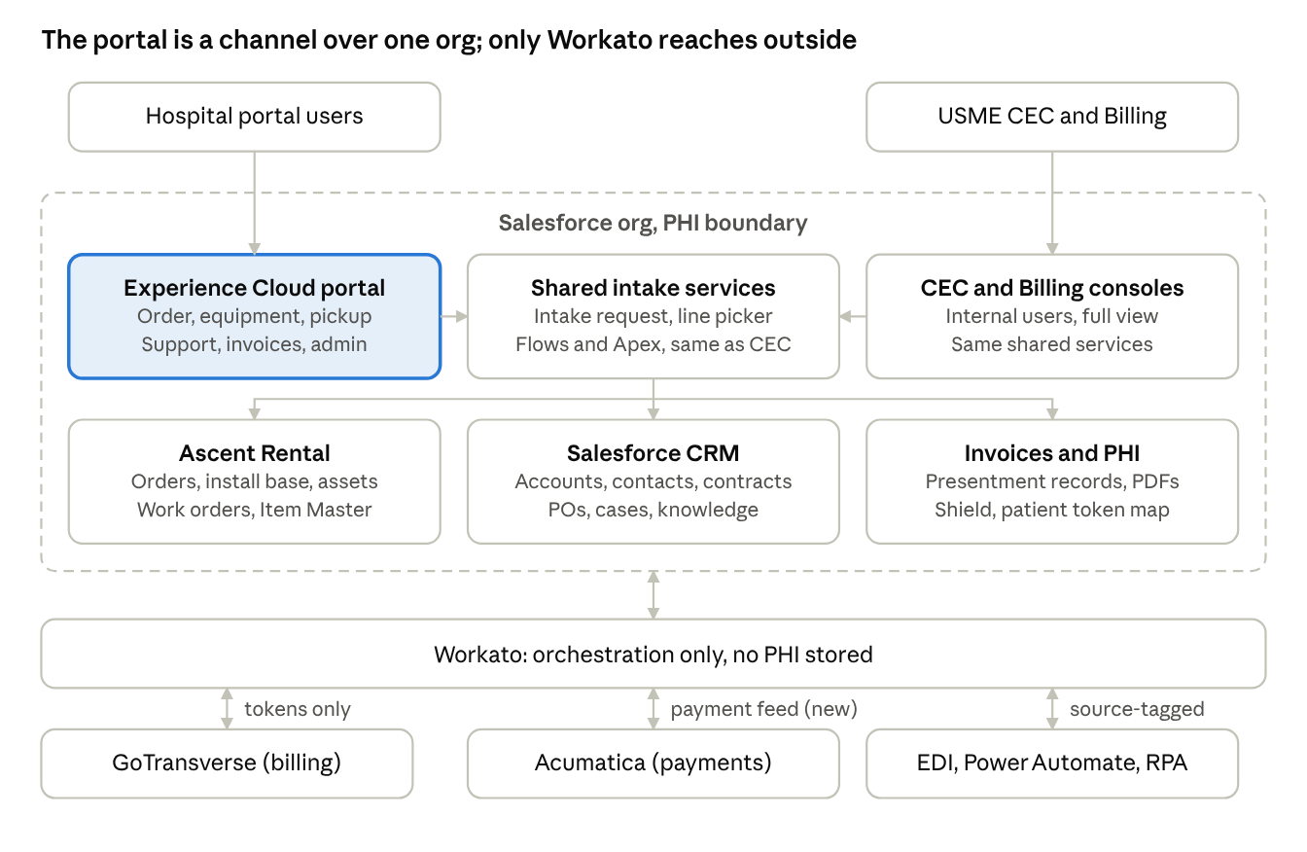
architecture · users, Salesforce org, Workato, external systems
Hospital users reach the portal; the portal, CEC and Billing consoles all call the same shared services over the same records. Workato carries tokenized events to GoTransverse and Acumatica and brings EDI and automation orders back through the same intake.
Design principles
- Channel, not engine. Portal actions call the shared flows and Apex services used by CEC (CF-11 portal parity).
- Entitlement first. Catalog, Intake, Order, Work Order, equipment and invoices are filtered by account or facility and by role before anything renders.
- Minimum necessary PHI. Patient fields appear only for bed rentals and only to roles that need them; token values, internal notes and integration errors never reach the portal.
- Salesforce is the PHI boundary. GT and Ascent receive tokens only; the portal reads invoices from Salesforce, never from GT directly.
- Duplicate-safe. A request raised through two channels, such as a phone call and a portal pickup for the same item, resolves to one record.
Pages and Menus
Page | Purpose | Main components | Personas
Home | Today at a glance | Open orders, pending pickups, open cases, unpaid invoices, announcements | All
Intake Request | Place rental or sales order | Entitled catalog, cart, delivery details, patient fields (beds), PO or Blanket PO picker | Operations
My Request | Track and amend | Request list and detail, status timeline, update details, cancel or amend rules | Operations
My Equipment | See what is on rent | Installed-base list by facility and unit, filters by model, status, consignment toggle, unit transfer | Operations, Admin
Request Pickup | Call off equipment | Select installed items, preferred date, access notes, duplicate warning | Operations
Biomed services | View equipment under PM and Repairs | List view to display all the equipment’s which are in PM and repair for under rental | Operations
Blanket PO | Create Blank PO and Manage | Customer Contact can Create, Modify and List view to display the Blanket PO, Expiry date, PO amount and Balance Amount | Operations
Dispute | Raise dispute against the invoice | Select the invoice for which dispute to be raised with reasons | Operations
Invoices and Billing | Pay-side visibility | Invoice list, PDF viewer, balance, dispute form | Finance
Account Admin | Manage the account | Users and roles, departments, PO references, notification preferences | Admin
IT Support | Create IT Support request for the Portal Application | Customer Protal can create an IT request for any application issue | IT
Help | Self-help | Knowledge search, contact CEC, later a virtual agent | All

Technical Design
Data Model

Entities
Entity | System of record | Key attributes | Relationships | Requirements
Account (facility hierarchy) | Salesforce Account | Partner Name, service area and fulfilling branch, PO-required flag, portal-visible flag | Parent of contacts, departments, addresses, POs, orders, equipment, invoices | PRT-104, PRT-202
Contact / portal user | Salesforce Contact + permission set | Work email as username, name, phone, role (Ops, Finance, Admin, Viewer), pickup permission, facility entitlement, MFA or SSO, status | N:1 Account (many facilities via entitlement); creates orders, pickups, cases, disputes | PRT-101 to PRT-105
Department / cost center | Salesforce (custom or Ascent) | Name, cost center, billing department, delivery contact | N:1 Account; referenced by Order | PRT-106, PRT-214
Delivery address | Salesforce | Street, city, state, zip, unit or room, access notes | N:1 Account; referenced by Order and Pickup | PRT-217
Blanket PO / PO reference | Salesforce (see Blanket PO FRD) | PO number, type (Blanket or single), limit, consumed, remaining, effective and expiry dates, status | N:1 Account; 1:N Order. Expired POs are hidden in the picker | PRT-205, PRT-106
Intake | Usme_intake__c | Intake Request type, Partner, Date, branch | N:1 Account, Department, Address, PO; 1:N Order line; 0..1 Patient
Intake Line | Usme_intake_line__c | Product, quantity, accessories (structured), bed package parent line, line status, delivered model | N:1 Order, Product; 0..1 Installed equipment once delivered
Order | Ascent Order__c | Order number, source (Portal), created by and time, type (BTS or MME), requested date or ASAP, legacy status name, demo or loaner flag, branch | N:1 Account, Department, Address, PO; 1:N Order line; 0..1 Patient | PRT-201 to PRT-211, PRT-301
Order line | Ascent Order_line__c | Product, quantity, accessories (structured), bed package parent line, line status, delivered model | N:1 Order, Product; 0..1 Installed equipment once delivered | PRT-212, PRT-213, PRT-215, PRT-204
Patient (PHI) | Salesforce only | First and last name, patient ID, room, height, weight | N:1 Order (BTS only); GT and Ascent receive a token, never the identity | PRT-203, SEC controls
Product / bed package | Salesforce product and price book | Model, family, BTS or MME, entitlement by contract or price book, package components, preferred-model flag per account | 1:N Order line | PRT-201, PRT-212, PRT-213
Installed equipment | Ascent rental asset | Serial, model, unit and room, status (On Rent, Pickup Requested, Consignment), PO and patient reference, on-rent since | Created from a delivered Order line; 1:N Pickup request, Case | PRT-401 to PRT-405
Pickup request | Salesforce / Ascent | Items, quantities or serials, preferred date, access notes, attempt count (max 3), status, source, duplicate-check key | N:1 Installed equipment, Contact | PRT-501 to PRT-506
Service case | Standard Case | Asset, severity, description, attachments, replacement-needed flag, linked swap, status, public comments | N:1 Installed equipment, Contact | PRT-601 to PRT-605
Invoice | GT finalized invoice, presented in Salesforce | Invoice number, dates, total, balance, status (Open, Disputed, Closed, Credit memo), PDF, portal-visible flag, payment status from Acumatica | N:1 Account; 1:N Dispute; credit memo links to the original invoice | PRT-701 to PRT-706
Dispute and messages | Salesforce (Case record type or custom) | Invoice or line, reason code, comment, status (New, In progress, Resolved), messages, attachments, credit or rebill outcome | N:1 Invoice, Contact | PRT-801 to PRT-803
Notification / announcement | Salesforce | Event type, channel (email, in-app), recipient preferences by role, planned-change banner text | N:1 Contact | PRT-302, PRT-902

Object mapping from the Technical Design Document
Object | Type | Purpose
Account | Standard | The facility or customer using the portal; drives Experience Cloud sharing
Blanket PO | Custom / Ascent | Based on the design agreed will maintain custom object or with in Oder(Ascent)
Usme_intake__c | Custom | One record per request, omnichannel for any intake
Usme_instake_line__c | Custom | The equipment models in the intake request
Order__c | Ascent | One record per online order or pickup request from the portal, with delivery or pickup address and required time
Order_Line__c | Ascent, child of Order__c | The equipment models in the order
Work_order__c | Ascent | One record per request
Work_order_lines__c | Ascent, Child of work_order_Line__C | The equipment models in the work order
Invoice__c | Ascent (custom) | Invoice headers shown in the portal's invoice history
Dispute__c | Custom | Dispute against invoice with reasons

Data rules
- PHI boundary. Patient data lives only on the Patient entity in Salesforce and is shown only to roles with PHI access. Orders, lines and invoices sent to GT or Ascent carry the patient token (see the tokenization requirements).
- Visibility. Every portal query is filtered by the user's account hierarchy, facility entitlement and role. Invoices and documents also need the portal-visible flag.
- Status mapping. Order status is stored once and shown to customers with the legacy names; the mapping table is configuration, not code (PRT-301, open decision on status model).
- Source stamping. Every order and pickup stores source, user and timestamp so reports and the duplicate check work across Portal, CEC, EDI and other channels.
- PO consumption. Remaining balance is read from the Blanket PO entity; the portal never edits consumed amounts. The Blanket PO design approach (custom parent object or Order self-lookup) is decided in the Blanket PO design
- Audit. Changes to patient fields, PO numbers and dispute status keep before and after values, user and time (SEC-04).
Data model decisions to confirm
- Ascent schema. Confirm which entities are Ascent objects (intake, intake lines, orders, lines, Work Order) and which the portal adds.
- Disputes. Confirm which entities are Ascent Object or create a custom object
- Support Request. Confirm which entities are Ascent Object or create a custom onbject.

Target State Architecture & Data Flow
- Unified Intake: Both external hospital portal users and internal CEC agents route transaction requests (orders, pickups, service) through a singular Shared Intake Service layer.

- PHI Security Boundary: Patient data (PHI) is strictly contained within Salesforce. Ascent Rental objects handle orders, install bases, and asset logic.

- Workato Orchestration: Workato serves strictly as an orchestration gateway and stores no PHI. It transmits tokenized events to GoTransverse (GT) for billing and Acumatica for payments.

- Order-Source Traceability: Every intake request is stamped with a source identifier (e.g., "Portal"), the originating user, and a timestamp to enable accurate reporting and duplicate prevention.

Authentication Types:
- Username & Password (Standard Authentication)
- Target Audience: Standard hospital portal users and external facility staff.
- Implementation: Utilizes standard Experience Cloud authentication for Customer Community Plus license holders. Users log in via the customized Experience Cloud login page.

- SSO (with Salesforce Authenticator / MFA)
- Target Audience: Internal USME CEC and Billing staff, and potentially enterprise hospital networks with their own Identity Providers (IdP).
- Implementation: Configured via SAML 2.0 or OpenID Connect for Single Sign-On. Enforces Multi-Factor Authentication (MFA) via the Salesforce Authenticator app to meet strict compliance standards.

- Public Access (Guest User Profile)
- Target Audience: Unauthenticated site visitors.
- Implementation: Enabled via the Experience Cloud Guest User Profile for specific, unsecured portal pages.

Portal Personas & Entitlements
- Customer Administrator: Manages users, roles, departments, PO references, and delivery preferences across their assigned facilities - does not view PHI unless explicitly granted.

- Operations User: Executes orders, tracking, unit transfers, and pickup requests - views patient fields strictly for bed rentals they manage.

- Finance User: Views invoices, downloads PDFs, and submits billing disputes - restricted from executing or editing equipment orders.

- Read-only Viewer: Restricted to viewing dashboards and high-level status metrics.

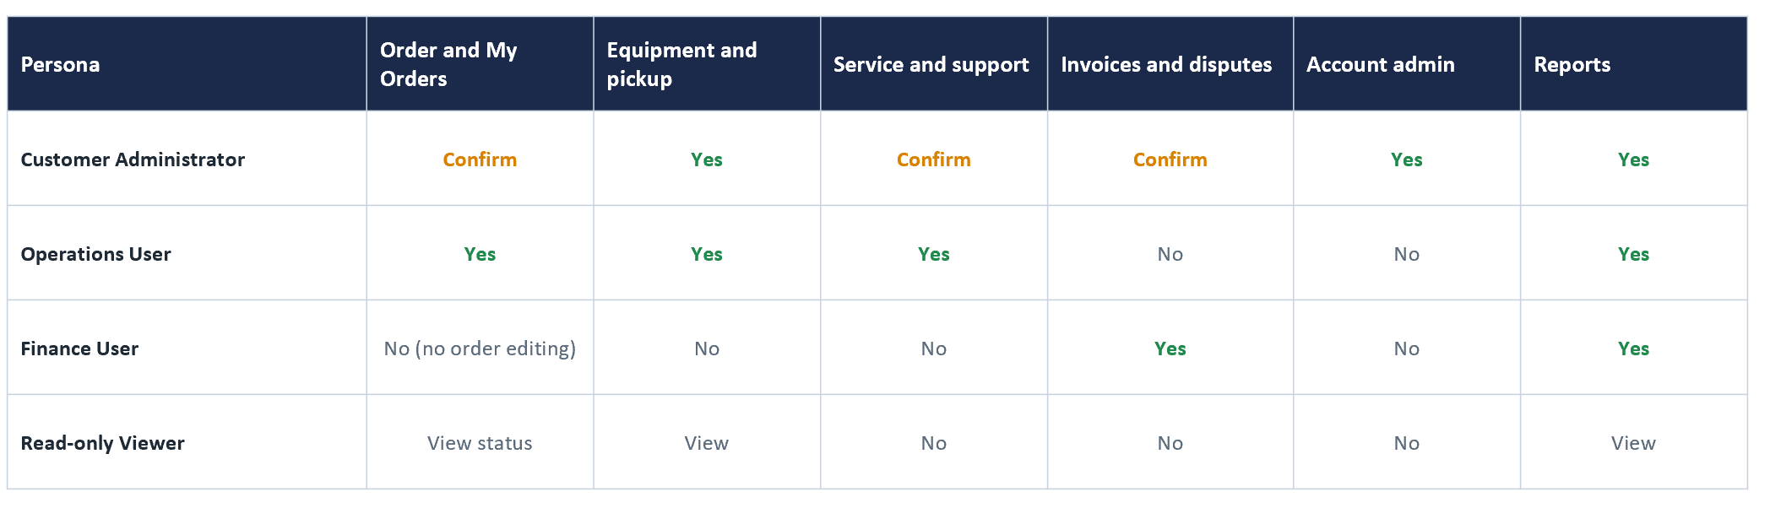

Compliance Controls
- Shield Platform Encryption: Encrypts sensitive patient fields (e.g., name, ID) at rest. This encryption must be rigorously regression-tested against Ascent's managed code prior to activation.

- Field Audit Trail: Tracks all customer-initiated changes, retaining the user, timestamp, and before/after values (e.g., patient name modifications, PO number edits).

- Data Retention: Portal user identities (Contacts) are deactivated rather than deleted upon departure to maintain historical auditability.

Field | Type | Notes
Patient_First_Name__c | Text (Encrypted) | Captured during the "Order Online" flow for unit/bed delivery
Patient_Last_Name__c | Text (Encrypted) | Captured during the "Order Online" flow
Patient_ID__c | Text (Encrypted) | Captured during the "Order Online" flow
Room_Number__c | Text | Location/Room Number for delivery/pickup routing

Functional Portal Flow

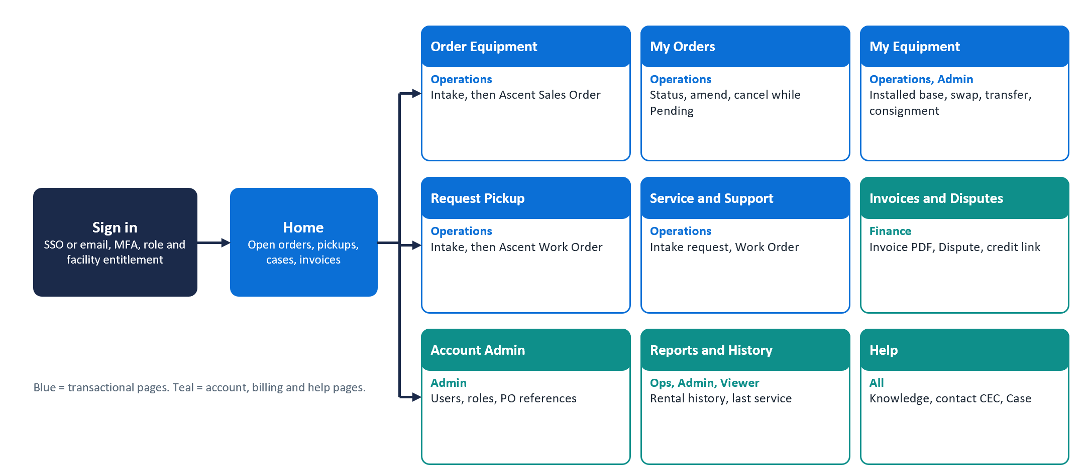

Order , Pick-up and Service Request

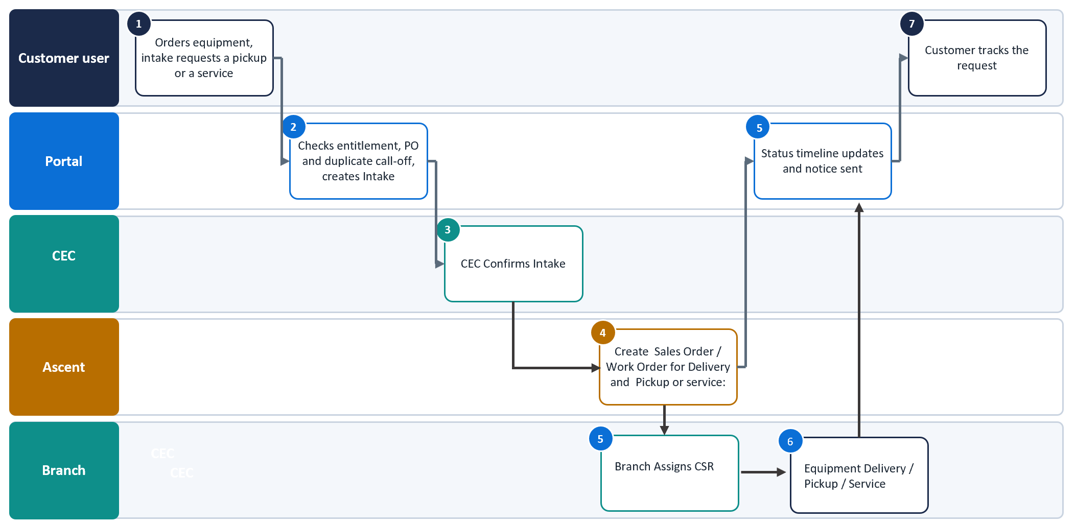

Invoice and Disputes flow

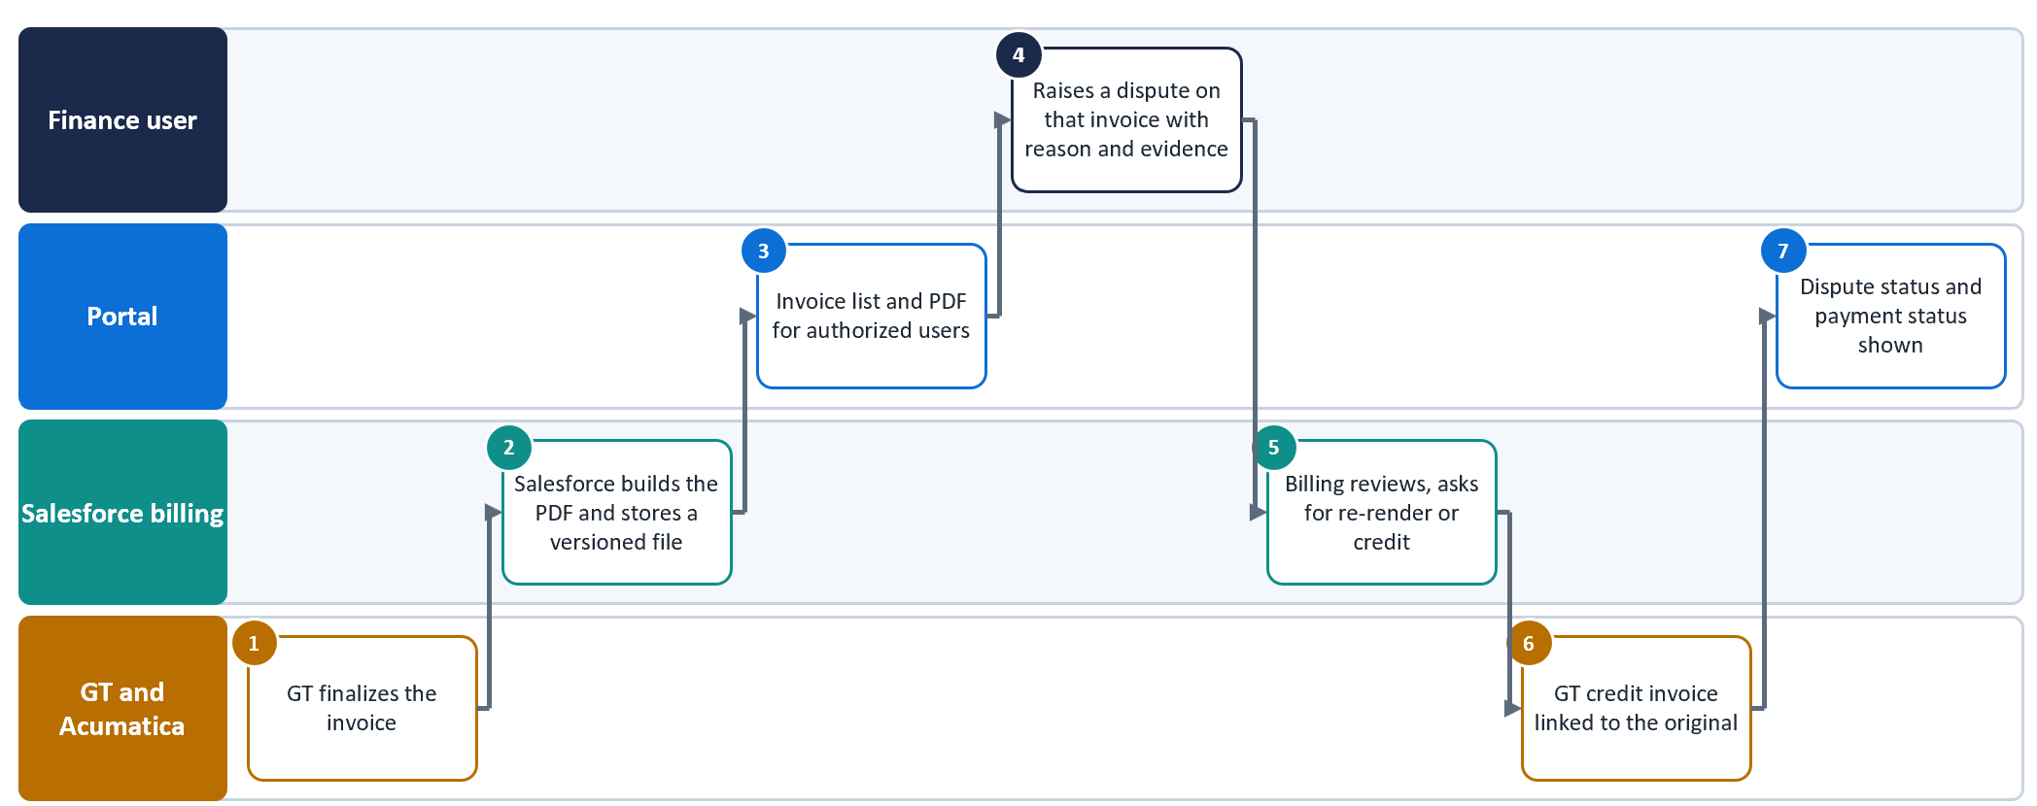

Technical Implementation of Functional Workflows
Ordering (BTS & MME Workflows)
- Entitlement-Filtered Catalog: The portal queries Ascent Trade agreement, contracts, and the Ascent Item Master to render only eligible products. The portal UI will intentionally omit pricing and stock availability, which remain strictly internal.

- BTS (Bed/Patient-Linked) Orders: The OrderOnlineWizard LWC conditionally renders PHI input fields (Patient Name, ID, Height, Weight, Delivery Location) only when a BTS equipment type is selected and the user has authorized access. This triggers the patient tokenization framework upon order activation.

- MME (Bulk/Department-Linked) Orders: Bypasses token creation. The LWC captures multiple items and quantities mapped to a specific hospital department without exposing patient fields.

- PO Handling: An integrated lookup component allows users to select from active, non-expired Blanket POs associated with their Account, returning a non-blocking remaining balance alert.

Rental Lifecycle Self-Service

- My Equipment View: An LWC data table queries the Ascent install base, filtering by facility and displaying real-time status flags (e.g., On Rent, Pickup Requested, Consignment).

- Update Details: Users can modify the Patient ID or PO number on active rentals. The Apex controller writes the before/after values to a custom history object, stamping the executing user and timestamp for audit purposes, while simultaneously notifying the billing system.

Pickup Requests & Duplicate Prevention

- Pickup Submission: The PickupWizard LWC allows users to select installed assets, input a preferred date, and add access notes. Upon submission, Apex automatically generates dispatch tasks within Ascent (one task per item).

- Duplicate Blocking: The Apex controller queries existing open requests across all intake channels (Portal, Phone, EDI) prior to DML insert. If a match is found for the asset, the transaction is blocked, and the UI surfaces an error referencing the existing request.

Rental Support Service

- Issue Reporting: An LWC form allows users to submit equipment failures (categorized as failure before use, failure in use without harm, or failure in use with harm). This request is recorded in the intake. This creates a Ascent Work Order record automatically linked to the specific Ascent equipment and Account.

Invoices & Billing

- Authorized Invoice List: An LWC queries Invoice__c records linked to the user's facility. Records are filtered via Account-based sharing rules.

- PHI-Secure PDF Download: A Visualforce-backed Apex controller (InvoicePdfController) renders GT's finalized invoice data combined with decrypted Salesforce PHI data. The PDF is generated dynamically on-click, logging the user and timestamp for each download action to satisfy audit requirements.

- Dispute Management: Finance users can submit a dispute via an LWC form containing a reason code and attachments. The dispute is linked directly to the Invoice presentment record and routed to the internal billing queue.

Blanket PO Management

- Blanket PO Page (Create, Modify, List): The BlanketPOManager LWC gives customer contacts a list view showing PO number, effective date, expiry date, PO amount, consumed amount and balance, with create and edit actions. All actions call the same Apex service layer used by CEC. Records are filtered by account hierarchy and facility entitlement (PRT-104).

- Create and Modify Rules: Apex validates before DML: the PO number must be unique per account, the PO amount must be greater than zero, and the expiry date must be on or after the effective date. Status (Active or Expired) is derived from the dates. Which portal roles may create or edit a Blanket PO is [Validate], as the page definition only states "Customer Contact".

- Balance Calculation: Balance equals PO amount minus consumed amount. The portal never writes the consumed amount; it is updated only when Orders reference the PO (Data Rules, PO consumption). Whether the balance is a roll-up or maintained by Ascent depends on the object decision below.

- Order Entry PO Picker: A reusable BlanketPOLookup component is embedded in OrderOnlineWizard. It returns only non-expired Blanket POs for the selected account and shows the remaining balance as a non-blocking alert (PRT-205). If the account requires a PO and none is entered, the user is asked to confirm but the order is not blocked. The PO number field accepts PO numbers only, with the visible "no patient information" note (PRT-218).

- Audit: Changes to PO number, PO amount and expiry date are tracked by Field Audit Trail, keeping user, timestamp and before/after values (SEC-04).

- Object Decision (Open): Either a custom Blanket_PO__c parent object or an Ascent Order self-lookup, as recorded in the Object Mapping table and Data Rules. The LWCs call an Apex service interface, so either option can be adopted without UI rework. Requirement IDs for create and modify (beyond the picker in PRT-205) still need to be added to the Ordering requirements.

Dispute Management (Detailed Build)

- Dispute Entry Point: The Dispute page and the dispute form on Invoices and Billing share one InvoiceDisputeForm LWC. It is launched from an invoice or an invoice line, so the link to Invoice__c is pre-populated (PRT-801).

- Submission: The form captures a reason code (configurable picklist), a comment and attachments stored as Salesforce Files. Apex creates a Dispute__c record with status New and stamps source = Portal, the user and a timestamp. The record is routed to the internal billing queue.

- Invoice Status and Duplicate Control: On creation the invoice status changes to Disputed. A second open dispute on the same invoice line is blocked, and the message names the existing dispute, consistent with pickup duplicate blocking (PRT-502).

- Tracking and Messaging: A DisputeTracker LWC lists the user's disputes with status New, In progress or Resolved, and a message thread with billing (PRT-802). Only public messages and attachments are shown; internal billing notes never reach the portal.

- Resolution and Outcome: Billing resolves the dispute in Salesforce and records the outcome (Credit, Rebill or No change). The portal invoice list shows the outcome, and credit memos link to the original invoice (PRT-803, PRT-704). Any credit or rebill event travels through Workato to GT and Acumatica as a tokenized event with no PHI. [Validate] with GT.

- Security, Audit and Notifications: Available to the Finance role only. Dispute status changes keep before/after values, user and time (SEC-04). Email and in-app notices are sent on submitted, status change and resolved (PRT-302).

- Object Decision (Open): The Object Mapping table lists Dispute__c as Custom, while the Data Model says Case record type or custom. This must be confirmed as it affects messaging and queue routing. The Pages table lists Operations for the Dispute page, while PRT-801 and Personas specify Finance; this also needs alignment.

Help and IT Support

- Help Page: Offers knowledge search using Salesforce Knowledge filtered by audience, and a contact panel with the CEC phone number, email and a request link (PRT-901).

- Announcements: An AnnouncementBanner LWC reads active announcements by role and date range, including planned changes and the GoUSME to new portal cutover notice (PRT-902). Content is maintained by administrators as configuration, not code.

- Header and Menu Links: The header carries the User Guide, Support and Rental Service Request links, the signed-in user name with Change Password and Logout, and a Related Links page in the menu (PRT-904).

- IT Support Request: An ITSupportRequestForm LWC creates a Salesforce Case with a dedicated Portal IT Support record type (Open Question 7). It captures application area, description and screenshots, and routes the Case to the USME IT queue. These cases are separate from equipment issues, which create Ascent Work Orders (Open Question 2).

- Case Tracking: Users see the IT cases they raised, with status, public comments and attachments.

- Virtual Agent (Later Phase): A virtual agent handles common intents and hands the conversation context to a live CEC agent through Omni-Channel (PRT-903). This is planned after go-live.

Integration Touchpoints
The portal does not communicate directly with external systems; all external data is brokered via the Salesforce integration layer.

Design artifacts: portal prototype screens
Salesforce Experience Cloud Portal

Open Questions and Next Steps
# | Question | Suggested owner
1 | Intake header and Lines Object will be used for all type of requests:  Sales and Rentals = Ascent sales order  Pickup and Services = Ascent Work Order | Durvah, Ascent (Paula)
2 | All Service Support will be created as Work Orders | Ascent
3 | Final portal profiles and permissions (customer admin, standard, restricted) and contact-level rules | Customer Ops, Security, Durvah, Ascent
4 | License type and the true user count (10,500 vs up to 15,000) | USME IT, Salesforce
5 | Need to understand which data to be displayed for Preferred Invoices | USME Customer Ops, Ascent
6 | Authorized Invoices are confirmed invoices which are pushed from GT. Please confirm
7 | Help/IT Support will be created as cases in salesforce | USME IT, Ascent
8 | What will be the Customer portal url

Next steps
- Ascent to provide the catalogue / item or product selection functionality - Ascent
- Ascent to provide the install base /Package for equipments - Ascent
- Finalize the portal mockup UI design
- Close all the open items from respective stakeholdres
- Kick-start the build activities after the functional requirement and design sign-off
- Convert approved requirements into user stories and UAT scripts, keeping PRT numbers for traceability.

