US MED-EQUIP (USME)
Technical Design Document
Custom Pricing & Discount Authorization and Approval Framework
Salesforce Sales Cloud
Prepared for: USME Executive Leadership (CEO, CFO, CRO) & Deal Desk Stakeholders
Prepared by: Durvah IT Consulting
Version 0.1 — Draft for Discussion
July 21, 2026
Confidential — Internal Use Only

Document Control
Version | Date | Author | Summary of Changes
0.1 | July 21, 2026 | Durvah IT Consulting | Initial draft based on Commercial Deal Framework, Strategic Value Score Guide, and Pricing/Discount Authorization deck (July 13).
Source documents reviewed: USME Commercial Deal Framework (Draft v1), USME Strategic Value Score Guide, Custom Pricing and Discount Authorization and Approval Framework deck (July 13), USME Project Information notes.

Table of Contents
Document Control 1
Table of Contents 1
1. Executive Summary 1
2. Business Context & Objectives 1
2.1 Business Background 1
2.2 Problem Statement 1
2.3 Objectives 1
3. Scope 1
3.1 In Scope 1
3.2 Out of Scope (this phase) 1
4. Current State Assessment 1
5. Solution Architecture Overview 1
5.1 Architectural Decision Point — Licensing 1
6. Out-of-the-Box vs. Custom Build Mapping 1
7. Data Model 1
7.1 Field Dictionary (per Commercial Deal Framework, Section 8) 1
Core fields — required on every quote 1
Conditional fields 1
8. Business Process Flow 1
9. Authority Matrix & Tiering Logic 1
9.1 Approver SLAs by Tier 1
10. Approval Process Design 1
10.1 Recommended Mechanism 1
10.2 Validation Rules (Guardrails) 1
11. Deal Desk Operating Model in Salesforce 1
12. Security & Sharing Model 1
13. Reporting & Analytics 1
14. Non-Functional Requirements 1
15. Open Technical Questions 1
16. Assumptions & Constraints 1
17. Project Timeline 1
18. Risks 1

1. Executive Summary
USME is a private-equity-owned medical equipment rental and lease-to-own provider, currently pursuing improved cash flow and EBITDA. Pricing and discount governance today is informal relative to the scale of the business, and there is no single, system-enforced way to determine who must approve a discount, what evidence is required, and how exceptions are tracked.
This document is the Technical Design Document (TDD) for building a Custom Pricing and Discount Authorization and Approval Framework on Salesforce Sales Cloud. It translates the business policy already defined in the USME Commercial Deal Evaluation & Pricing Governance framework, the Strategic Value Score Guide, and the Custom Pricing & Discount Authorization deck (July 13) into a concrete Salesforce technical design: what can be delivered using out-of-the-box (OOTB) platform capability, what must be custom-built, the data model, the process flows, the integration touchpoints with GOUSME (ERP) and ServiceNow, open technical questions, assumptions, and a phased delivery timeline.
The design center is the same one already articulated by the business: approval by exception, most-restrictive-factor-wins across five dimensions (discount depth, deal size, gross margin vs. floor, contract term, and non-standard concessions), a hard Finance gate for any deal priced below its product-family margin floor, and a full audit trail — every discount has a reason code, an approver, and an expiration date.

2. Objectives

2.1 Business Background
- USME procures medical equipment and leases/rents it to hospitals, with an option to lease-to-own; beds and other fast-moving equipment are core to the fleet.
- Strategic priorities set by ownership: improve cash flow, increase bottom-line profitability, and prepare the business for a possible sale within ~2 years.
- Key decision-makers sit at the CEO / CFO / CRO layer, with day-to-day commercial governance intended to run through a Deal Desk and a Pricing Council.
- Systems landscape: GOUSME is the ERP of record for customers and fulfillment/fleet operations; Salesforce (SFDC) is system of record for prospects, pricing, quotes, and contracts; ServiceNow supports service operations. The current environment carries legacy technical debt with elevated hosting, maintenance, and development costs.

2.2 Problem Statement
Pricing and discount decisions today are not consistently governed by a system-enforced policy. Discount authority, margin protection, and deal exceptions rely on manual judgment rather than platform controls, which limits visibility for the Deal Desk and Pricing Council and creates risk to gross margin and enterprise value ahead of a sale process.

2.3 Objectives
- Protect list-price integrity — list/contract pricing is the anchor; discounting is a managed exception, not the default.
- Enforce a multi-factor Authority Matrix in the system so the correct approval tier is calculated automatically, not self-selected.
- Guarantee that no deal below its product-family margin floor can be won without a mandatory Finance/Deal Desk gate.
- Require a reason code, an approver, and an expiration date on every custom discount, with full audit trail (who approved what, why, at what margin, until when).
- Give the Deal Desk and Pricing Council a analytics layer (auto-approval rate, cycle time, discount depth, margin realization, leakage, exception rate) to run quarterly governance.
- Do this on Sales Cloud in a way that supports — rather than fights — the existing GOUSME/SFDC data split (customers in GOUSME, prospects/quotes/contracts in SFDC).

3. Scope

3.1 In Scope
- Salesforce data model, automation, and UI to support: Price Books, discount request & reason codes, the multi-dimension Authority Matrix, tiered approval routing, Deal Desk queue/SLA handling, margin-floor enforcement, discount expiration/re-approval, and an audit/override log.
- Strategic Value Score as an informational field set (0–20) surfaced to approvers — explicitly non-gating, per the Strategic Value Score Guide.
- Reporting & dashboards for the Pricing Council KPIs defined in the Commercial Deal Framework (Section 13).
- High-level integration touchpoints to GOUSME (approved quote / contract data) — detailed integration design is called out as a dependent workstream, not fully specified here (see Open Questions).

3.2 Out of Scope (this phase)
- Full data migration / cleanup between SFDC and GOUSME (flagged in the project notes as required, but tracked as a separate workstream).
- ServiceNow process redesign — only the touchpoint is acknowledged.
- Automated workflow routing driven by the Strategic Value Score (explicitly deferred by the business — informational/analytics use only for now).
- Finalized margin floor values and reason code taxonomy — these are marked in the source deck as "to be customized post discussions" and are a dependency, not a deliverable, of this TDD.

4. Current State Assessment
System | Role Today | Relevant Data | Notes
Salesforce (SFDC) | Pricing, quotes, contracts, prospects | Opportunities, Quotes, Price Books, Contracts | Existing pricing/discount/approval logic is described as ad hoc relative to the new framework.
GOUSME (ERP) | System of record for customers; fulfillment & fleet | Customer master, orders, fleet/inventory | Legacy platform; high hosting/maintenance/dev cost cited as a pain point.
ServiceNow | Service operations | Service requests/tickets | Peripheral to pricing; touchpoint only.
Implication for design: because customers live in GOUSME and prospects/quotes/contracts live in SFDC, the Authority Matrix and margin calculations must be able to run entirely on data available within Salesforce at quote time, without a hard real-time dependency on GOUSME. Any GOUSME-sourced fields needed for margin or eligibility (e.g., current fleet utilization) should be identified explicitly and synced on a defined cadence rather than assumed to be live.

5. Solution Architecture Overview
The diagram below separates native Sales Cloud platform capability from the custom build required to implement the Authority Matrix, Deal Desk routing, and audit logging. Dashed lines indicate system touchpoints outside the core build.
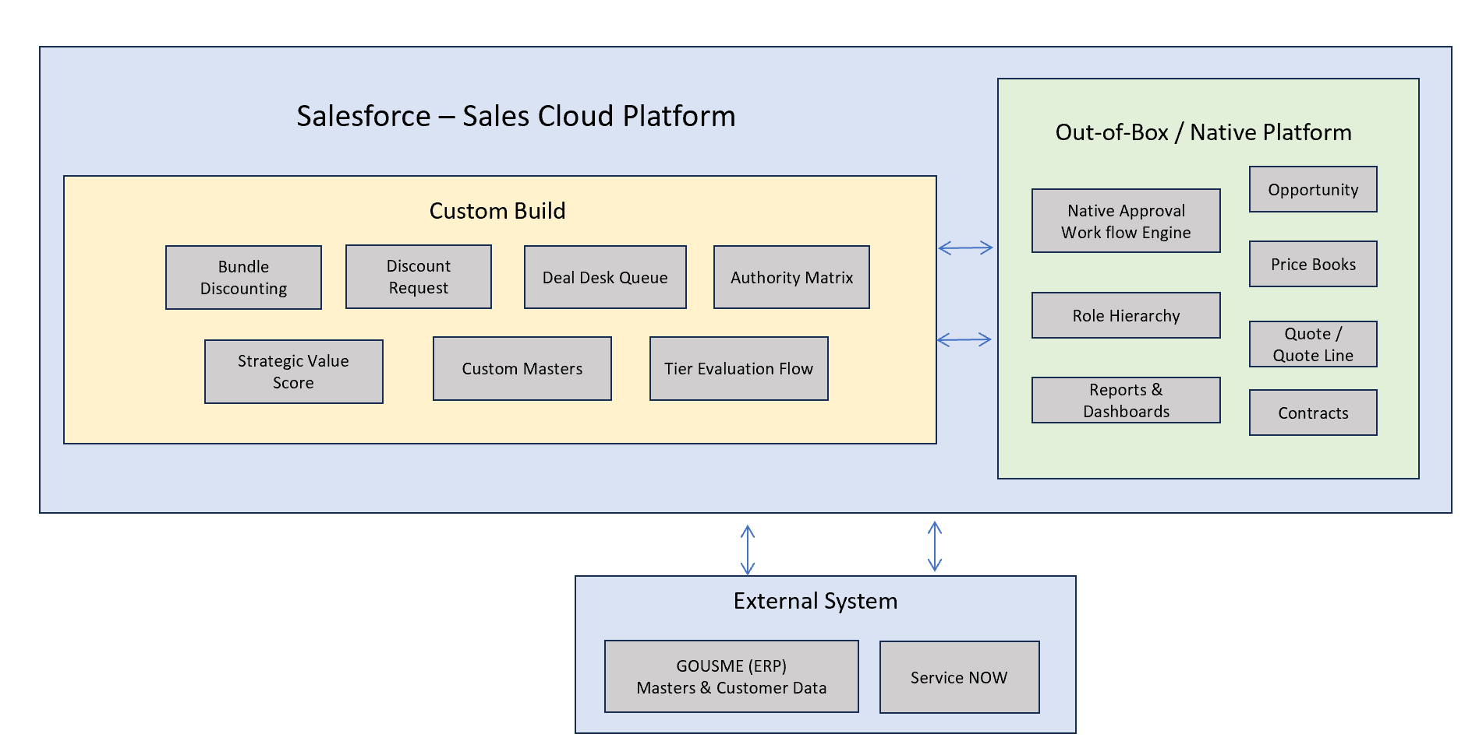
Figure 1 — High-level architecture: OOTB Sales Cloud, custom build, and external systems.

5.1 Architectural Decision Point — Licensing
Key design fork: CPQ / Revenue Cloud vs. Core Sales Cloud
- The requirement names “Price Rules,” “Advanced Approvals,” and “Quote Line Editor” — these are Salesforce CPQ / Revenue Cloud product features, not part of core Sales Cloud.
- Option A — If USME is licensed for Salesforce CPQ or Revenue Cloud: use native Price Rules, native Advanced Approvals, and the native Quote Line Editor. This is the fastest path and the one implied by the terminology in the requirement.
- Option B — If USME has core Sales Cloud only: the same behavior is custom-built using standard Quotes/Quote Line Items, Flow-based price/margin calculation, native (non-Advanced) multi-step Approval Processes, Custom Metadata Types for the Authority Matrix, and a custom Lightning Web Component as the quote-editing surface.
- This TDD documents both paths where they diverge and flags the licensing decision as the top open question (Section 15) — it materially changes cost, timeline, and the OOTB/custom split below.

6. Out-of-the-Box vs. Custom Build Mapping
This is the core of the technical design: for each capability named in the requirement, what Sales Cloud already provides vs. what must be configured or custom-built.
Capability | Out-of-the-Box (Sales Cloud / CPQ if licensed) | Custom Build Required
Price Books | Standard Price Book & Price Book Entry objects; multiple price books per product; standard/list pricing. | Custom fields for rental term tiers (daily/monthly/6-mo/12-mo) and product family if not already modeled; CPQ Price Rules if CPQ is licensed (Option A).
Discount capture | Quote Line Item standard Discount % field. | Custom Discount Request object (or fields) to capture Reason Code, non-standard concessions, expiration date, and justification text — not natively modeled on standard Quotes.
Margin calculation | None native on standard Quotes. | Formula field / Flow to calculate Gross Margin % and $ per line and per quote; Custom Metadata Type “Margin Floor by Product Family” (target + floor) owned by FP&A.
Authority Matrix (5-dimension tiering) | None native. | Custom Metadata Type storing tier thresholds per dimension (discount depth, deal size/ACV, margin vs. floor, term, concessions); Record-Triggered Flow that evaluates all five and returns the single most-restrictive tier.
Approval routing | Native Approval Process engine (multi-step, role- or queue-based); Advanced Approvals (parallel/dynamic chains, delegation, approve-by-email) if CPQ/Revenue Cloud licensed. | Entry criteria reading the calculated “Required Approval Tier” field; approver matrix by role/queue per tier; Deal Desk custom queue for Tier 4-5.
Margin floor override gate | None native. | Validation Rule / Flow that forces routing to Tier 4+ whenever calculated margin < floor, regardless of discount % (“most-restrictive-factor-wins” and “never below floor without Finance” rules).
Reason Code library | Standard picklist field capability. | Picklist (or lookup to a Reason Code custom object if codes need metadata like category/expiry rules) seeded from Section 9 of the Commercial Deal Framework.
Strategic Value Score | None native. | 8 custom number fields (0–3 or 0–2 each) + roll-up/formula for total (0–20); surfaced as read-only context on the Quote/Opportunity — explicitly not used in tier routing per the Strategic Value Score Guide.
Discount expiration & re-approval | None native. | Expiration Date field + scheduled Flow (batch or Flow with schedule trigger) that flags/deactivates expired discounts and forces re-approval at renewal.
Audit / override log | Field history tracking (limited retention, limited fields). | Custom “Approval / Override Log” object capturing approver, tier, decision, rationale, and timestamp for every discount, independent of field history limits.
Quote Line Editor UX | Standard Quote Line Editor if using standard Quotes; native CPQ Quote Line Editor if CPQ licensed. | If Option B (core Sales Cloud): a Lightning Web Component quote editor may be needed to surface tier, margin, and approval status inline, since the standard editor doesn’t show calculated tier/margin without customization.
Deal Desk queue & SLA | Queues (native); Case/Task assignment. | SLA timers (Flow + time-based actions) per tier per the SLA table in the deck; Deal Desk-specific list views/queue.
Reporting & Dashboards | Native Reports & Dashboards. | Custom report types joining Quote, Discount Request, Approval Log to surface auto-approval rate, cycle time, discount depth, leakage, and exception rate.

7. Data Model
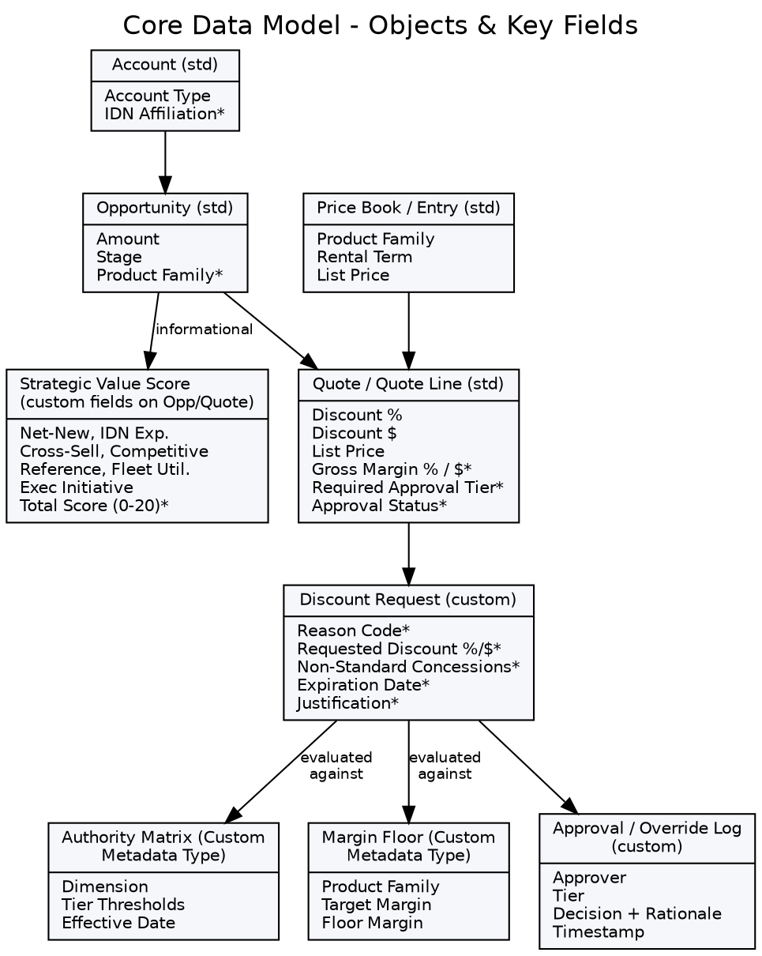
Figure 2 — Core objects and key fields (* = new/custom field or object).

7.1 Field Dictionary (per Commercial Deal Framework, Section 8)

Core fields — required on every quote
- Discount %, Discount $, Gross Margin %, Gross Margin $, Expected Annual Revenue, Total Contract Value, Product Family, Reason Code, Margin Floor Met (Y/N).

Conditional fields
- Capital Required, Fleet Availability, Strategic Value Score, Competitive Situation, Concessions, Approval Tier, Expiration Date, Approver.
Object placement recommendation: core and conditional fields above live on the Quote/Quote Line Item (or a related Discount Request record) rather than solely on the Opportunity, since discounting is evaluated at the quote level and a single Opportunity may carry multiple quote versions.

8. Business Process Flow
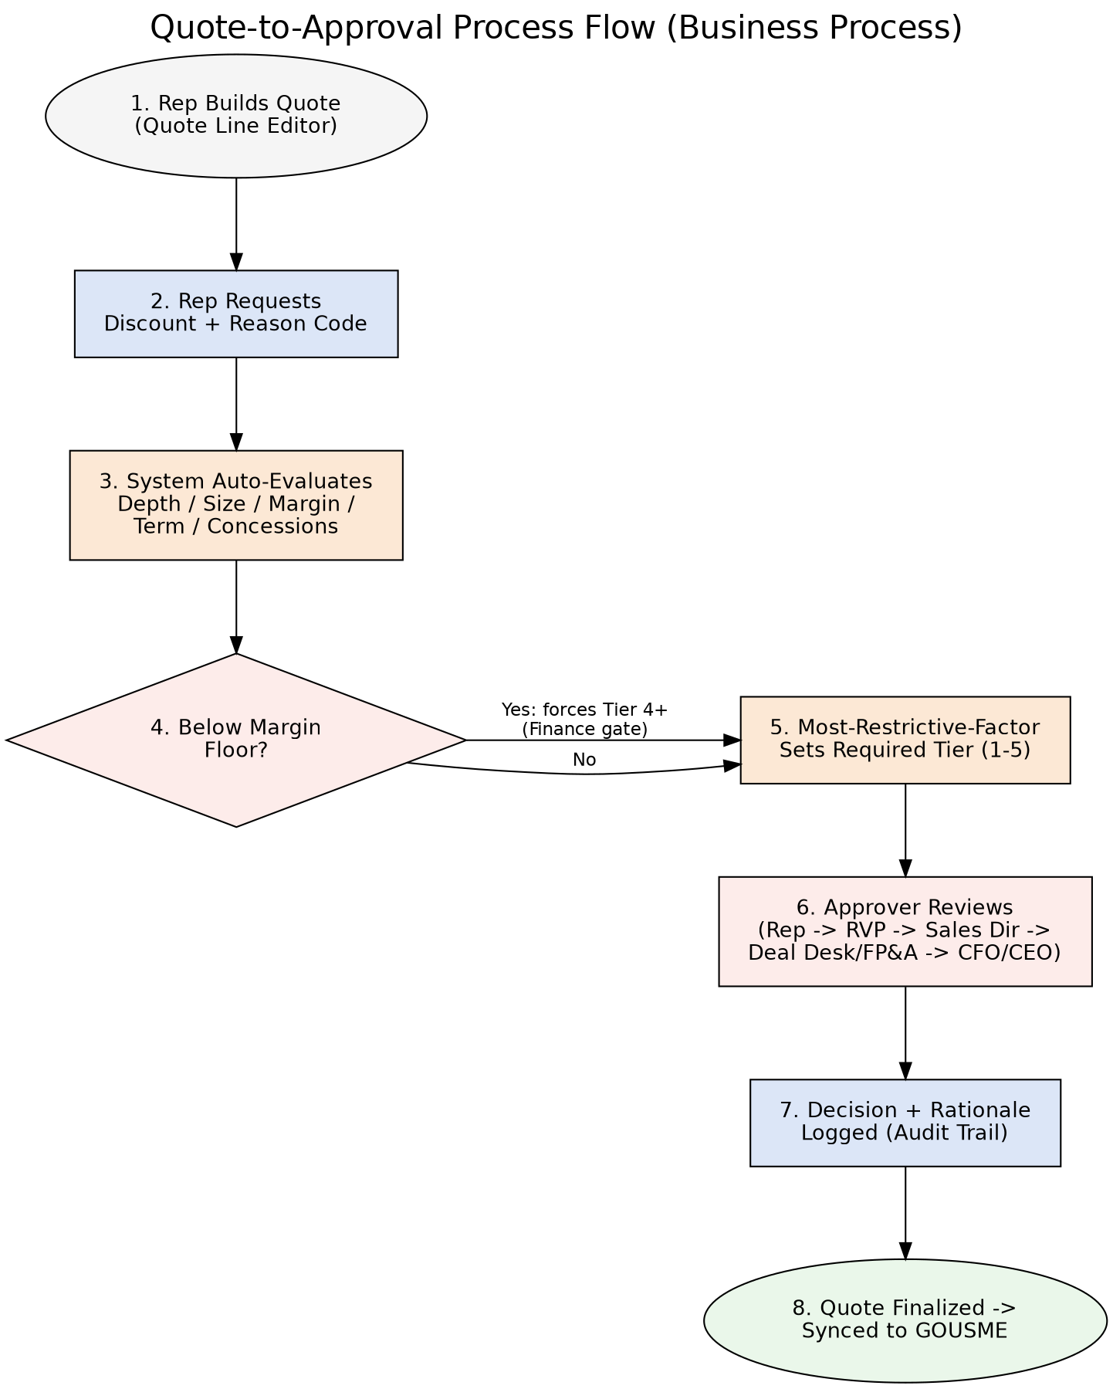
Figure 3 — Quote-to-approval process flow, steps 1–8.
Policy enforcement in this flow is absolute by design: no verbal or email approvals outside the system, no retroactive discounts after order, and no discount can be submitted without a reason code — each of these is enforced with a Validation Rule, not left to training or habit, per the source framework.

9. Authority Matrix & Tiering Logic
Reproduced from the Custom Pricing & Discount Authorization deck (Slide 6) as the authoritative source for tier thresholds pending business sign-off; values marked for customization post-discussion.
Dimension | Tier 1 — BDR | Tier 2 — RVP | Tier 3 — Sales VP | Tier 4 — CRO+FP&A | Tier 5 — CFO/CEO
Discount Depth | ≤ 5% | 5–10% | 10–20% | 20–30% | > 30%
Deal Size (ACV) | ≤ $25k | ≤ $100k | ≤ $250k | ≤ $500k | > $500k
Gross Margin | ≥ Target | ≥ Floor +5pts | ≥ Floor | < Floor | ≪ Floor
Term / Commitment | Standard | Standard | ≤ 24 mo | > 24 mo / evergreen | Atypical
Non-Standard Concessions | None | None | Minor (defined) | Any material | Precedent-setting / MFN
Override rule: any deal priced below its product-family margin floor routes to at least Tier 4 (Deal Desk + Finance), regardless of how small the discount percentage appears. The required tier for a quote is the highest tier triggered by any single dimension — “most-restrictive-factor-wins.”

9.1 Approver SLAs by Tier
Tier | Approver | May Approve | Target SLA
1 | Sales Rep (self-serve) | Shallow discounts, standard terms, above-target margin | Instant, at quote
2 | Regional VP | Moderate discounts, standard terms, healthy margin | ≤ 4 business hours
3 | Sales Director | Larger deals, deeper discounts to the floor, terms ≤ 24 mo | ≤ 1 business day
4 | Deal Desk + FP&A | Below-floor pricing, material concessions, large ACV, long terms | ≤ 2 business days
5 | CFO / CEO | Strategic, precedent-setting, deeply below-floor, or very large deals | Executive cadence

10. Approval Process Design

10.1 Recommended Mechanism
- Tier is calculated by a Record-Triggered Flow (before-save for formula-style fields, after-save where cross-object queries to Custom Metadata are needed) and written to a “Required Approval Tier” field on the Quote.
- A native multi-step Approval Process (or Advanced Approvals, if CPQ/Revenue Cloud is licensed) uses that field as entry criteria and routes to the correct approver by role hierarchy/queue per tier.
- Tier 4–5 route to a Deal Desk queue rather than an individual, with SLA timers (time-based workflow / Flow scheduled paths) matching the SLA table above.
- Every approval/rejection/recall writes a record to the Approval / Override Log object — this is the audit trail, independent of Salesforce's native (and time-limited) approval history.

10.2 Validation Rules (Guardrails)
- Discount % must be between 0 and 100; Discount $ must be less than list price.
- No discount can be activated above a role's delegated limit without a completed approval.
- Reason Code is required on any non-zero discount.
- Expiration Date is required on any approved discount; blocks quote activation if missing.

11. Deal Desk Operating Model in Salesforce
- Mandate: review Tier 4+ deals, validate economics, ensure policy compliance, track exceptions, and recommend policy refinements — implemented as a Deal Desk queue plus a dedicated list view/dashboard.
- Composition: Sales Ops (process/system owner), FP&A (margin/economics), CFO/executive sign-off for Tier 5 — modeled as queue membership plus an escalation path in the Approval Process.
- Authority: can approve within Tier 4 limits; must escalate Tier 5; cannot waive the below-floor Finance gate — enforced by making the Finance-gate Validation Rule non-bypassable regardless of role.
- MFN / precedent-risk flagging: a Concessions/Precedent-Risk checkbox routes to Legal/Finance review at Tier 4–5 and is surfaced on the Deal Desk queue.
- Concession costing: free periods and waived fees are treated as discounts (per the “hidden concessions are treated as discounts” principle) and included in the margin calculation, not modeled as separate zero-dollar products.

12. Security & Sharing Model
- Field-level security: margin, floor, and Strategic Value Score fields visible to Sales Ops/FP&A/Deal Desk roles; reps see calculated tier and their own discount fields but not raw floor values, consistent with “margin floor overrides discount authority” without exposing sensitive margin data broadly.
- Object-level/sharing: Discount Request and Approval/Override Log records shared via role hierarchy plus explicit sharing rules to Deal Desk and FP&A queues regardless of owner.
- Custom Metadata Types (Authority Matrix, Margin Floor) are protected/managed so only Sales Ops/Admin can edit thresholds — edit access should not require a deployment, per the “configurable without code” design goal.

13. Reporting & Analytics
Directly supports the Pricing Council's quarterly review cadence (Commercial Deal Framework, Section 13):
- Auto-approval / local-approval rate (Tier 1–2 share of total).
- Approval cycle time by tier, vs. SLA.
- Average discount depth by product family and by reason code.
- Gross margin realization vs. floor; margin-floor exception rate.
- Discount leakage — expired or out-of-policy discounts still in use.
- Discount volume and $ by reason code, rep, and region, to support coaching and policy tuning.

14. Non-Functional Requirements
- Auditability: every discount decision must be traceable to an approver, rationale, and timestamp indefinitely (or per USME's retention policy) — do not rely solely on standard field history (18-month/20-value limits).
- Configurability: tier thresholds and margin floors must be editable by Sales Ops without a code deployment (Custom Metadata Type, not hardcoded Flow logic).
- Performance: tier and margin calculation should complete synchronously at quote-save time so reps get instant feedback for Tier 1–2 deals (“instant / at quote” SLA).
- Data quality: Product Family and Reason Code should be tightly controlled picklists/lookups, not free text, to keep the KPI reporting layer trustworthy.
- Change management: Authority Matrix edits should be versioned with an effective date so historical deals are evaluated against the policy in force at the time.

15. Open Technical Questions
- Licensing: Is USME licensed for Salesforce CPQ or Revenue Cloud today, or only core Sales Cloud? This determines whether Price Rules, Advanced Approvals, and the native Quote Line Editor are available out-of-the-box (see Section 5.1) — it is the single highest-impact open question for cost and timeline.
- What is the authoritative object for a “quote” today — standard Salesforce Quotes, Opportunity-level fields, or something else? The current framework references “Quote Line Editor,” implying quotes are (or will be) modeled as a distinct object.
- Are GOUSME-held fields (e.g., fleet/equipment availability, existing customer contract data) needed at quote time for margin or eligibility checks, and if so, what is the integration pattern and refresh cadence (real-time callout vs. scheduled sync)?
- What are the finalized margin floor values by product family? The deck marks these “illustrative/best-guess” and “to be customized post discussions” — FP&A sign-off is a hard dependency before validation rules can go live.
- What is the final Reason Code list, and does any code carry additional metadata (e.g., auto-expiry rules, required documentation) beyond a label?
- Who are the actual named approvers/queues per tier (RVP, Sales Director, Deal Desk members, CFO/CEO), and does the existing Role Hierarchy already reflect this, or does it need to be rebuilt?
- Should the Strategic Value Score remain purely informational indefinitely, or is there a target date/criteria for revisiting its use in workflow routing, per the Guide's own recommendation to revisit after data collection?
- Data cleanup: what is the scope and owner of the SFDC/GOUSME data cleanup called out in the project notes, and does it block or run in parallel with this build?
- Is there an existing CPQ/Quoting tool in use today that this replaces, or is this the first structured quoting capability in Salesforce for USME?
- What are the reporting/BI requirements beyond native Salesforce dashboards — does the Pricing Council need this data in an external BI tool?

16. Assumptions & Constraints
- This design assumes core Sales Cloud unless/until CPQ or Revenue Cloud licensing is confirmed (Option B is the default build plan; Option A is adopted if licensing is confirmed).
- Margin floor values, the final reason code list, and the RACI in the source deck are placeholders pending business sign-off and are treated as configuration inputs, not fixed requirements, in this design.
- The Strategic Value Score remains informational-only in this phase, per explicit guidance in the Strategic Value Score Guide.
- GOUSME integration is limited to syncing finalized/approved quote or contract data outward; no bidirectional real-time dependency is assumed for tier/margin calculation.
- Existing Role Hierarchy and Queues in the org are assumed usable for approver routing; a gap analysis will confirm during Discovery.

17. Project Timeline
Phased per the Implementation Roadmap already outlined in the deck (Slide 13), expanded into a working timeline. Durations assume Option B (core Sales Cloud custom build) and a single Salesforce org; confirming Option A (CPQ/Revenue Cloud) could compress Phases 2–3.
Phase | Activities | Owner(s) | Est. Duration
1. Discovery & Policy Definition | Confirm licensing (CPQ/Revenue Cloud vs. core), finalize margin floors, reason codes, authority matrix thresholds, approver roles; resolve Section 15 open questions. | Sales Leadership, FP&A, Solution Architect | 2–3 weeks
2. Technical Design Sign-off | Finalize this TDD, data model, integration approach with GOUSME; review with CEO/CFO/CRO stakeholders. | Solution Architect, Sales Ops | 1–2 weeks
3. Configuration & Build | Build custom objects/fields, Custom Metadata Types (Authority Matrix, Margin Floor), Flows, Validation Rules, Approval Process(es), Deal Desk queue, audit log, dashboards. | Salesforce Dev/Admin team | 4–6 weeks
4. Pilot & UAT | Run real and edge-case scenarios end-to-end, including below-floor and concession cases; validate routing, SLAs, and reporting. | Sales Ops, FP&A, pilot reps/approvers | 2–3 weeks
5. Rollout & Enablement | Train reps and approvers; publish the one-page authority matrix; cut over from any legacy process. | Sales Enablement, Sales Ops | 1–2 weeks
6. Govern & Iterate | Stand up the Pricing Council cadence; quarterly threshold review; monitor KPIs and adjust. | Pricing Council (CFO, FP&A, CRO, CEO) | Ongoing
Indicative end-to-end duration from Discovery through Rollout: approximately 10–16 weeks, dependent primarily on how quickly Phase 1 policy inputs (margin floors, reason codes, licensing) are finalized.

18. Risks
Risk | Impact | Mitigation
Margin floor / reason code values remain undefined past Phase 1 | Blocks Validation Rule and Approval Process build in Phase 3 | Timebox Phase 1 decisions with FP&A; build against placeholder values in sandbox in parallel where safe
CPQ/Revenue Cloud licensing status unresolved | Rework of Price Rules / Advanced Approvals / Quote Line Editor components | Confirm licensing in week 1 of Discovery before Flow/Approval build begins
SFDC/GOUSME data quality issues surface mid-build | Delays integration and reporting accuracy | Scope data cleanup as an explicit parallel workstream with its own owner, not a Phase 3 dependency
Reps or approvers bypass system via email/verbal approval | Undermines audit trail and policy enforcement | Validation Rules block quote activation without a completed in-system approval; enablement reinforces policy
Legacy system costs and technical debt slow integration work | Timeline slippage on GOUSME touchpoints | Keep GOUSME integration scope minimal (approved-quote sync only) in this phase

