US MED-EQUIP (USME)
Technical Design Document
Custom Pricing & Discount Authorization and Approval Framework
Salesforce Sales Cloud
Prepared for: USME Executive Leadership (CEO, CFO, CRO) & Deal Desk Stakeholders
Prepared by: Durvah IT Consulting
Version 0.1 — Draft for Discussion - July 21, 2026
Confidential — Internal Use Only

Document Control
Version | Date | Author | Summary of Changes
0.1 | July 21, 2026 | Durvah IT Consulting | Initial draft based on Commercial Deal Framework, Strategic Value Score Guide, and Pricing/Discount Authorization deck (July 13).
1.0 | Aug 11th , 2026 | Durvah IT Consulting | Internal review and updates
Source documents reviewed: USME Commercial Deal Framework (Draft v1), USME Strategic Value Score Guide, Custom Pricing and Discount Authorization and Approval Framework deck (July 13), USME Project Information notes.

Table of Contents
Document Control 2
Table of Contents 3
1. Executive Summary 4
2. Objectives 4
2.1 Business Background 4
2.2 Problem Statement 4
2.3 Objectives 5
3. Scope 5
3.1 In Scope 5
3.2 Out of Scope (this phase) 5
4. Current State Assessment 6
5. Solution Architecture Overview 6
6. Out-of-the-Box vs. Custom Build Mapping 7
7. Data Model 9
7.1 Field Dictionary (per Commercial Deal Framework, Section 8) 9
Core fields — required on every quote 9
Conditional fields 9
8. Business Process Flow 10
9. Authority Matrix & Tiering Logic 10
9.1 Approver SLAs by Tier 11
10. Approval Process Design 11
10.1 Recommended Mechanism 11
10.2 Validation Rules (Guardrails) 11
11. Deal Desk Operating Model in Salesforce 12
12. Security & Sharing Model 12
13. Reporting & Analytics 12
14. Non-Functional Requirements 13
15. Open Technical Questions 13
16. Project Timeline 14

1. Executive Summary
USME is a private-equity-owned medical equipment rental and lease-to-own provider. Pricing and discount governance today is informal relative to the scale of the business, and there is no single, system-enforced way to determine who must approve a discount, what evidence is required, and how exceptions are tracked.
This document is the Technical Design Document (TDD) for building a Custom Pricing and Discount Authorization and Approval Framework on Salesforce Sales Cloud. It translates the business policy already defined in the USME Commercial Deal Evaluation & Pricing Governance framework, the Strategic Value Score Guide, and the Custom Pricing & Discount Authorization deck (July 13) into a concrete Salesforce technical design: what can be delivered using out-of-the-box (OOTB) platform capability, what must be custom-built, the data model, the process flows, the integration touchpoints with GOUSME (ERP) and ServiceNow, open technical questions, assumptions, and a phased delivery timeline.
The design center is the same one already articulated by the business: approval by exception, most-restrictive-factor-wins across five dimensions (discount depth, deal size, gross margin vs. floor, contract term, and non-standard concessions), a hard Finance gate for any deal priced below its product-family margin floor, and a full audit trail — every discount has a reason code, an approver, and an expiration date.

2. Objectives

2.1 Business Background
- USME procures medical equipment and leases/rents it to hospitals, with an option to lease-to-own; beds and other fast-moving equipment are core to the fleet.
- Strategic priorities set by ownership: improve cash flow, increase bottom-line profitability.
- Key decision-makers sit at the CEO / CFO / CRO layer, with day-to-day commercial governance intended to run through a Deal Desk and a Pricing Council.
- Systems landscape: GO-USME is the ERP of record for customers and fulfillment/fleet operations; Salesforce (SFDC) is system of record for prospects, pricing, quotes, and contracts; ServiceNow supports service operations currently which might be replaced by MCS(rental Platform). The current environment carries legacy technical debt with elevated hosting, maintenance, and development costs.

2.2 Problem Statement
Pricing and discount decisions today are not consistently governed by a system-enforced policy. Discount authority, margin protection, and deal exceptions rely on manual judgment rather than platform controls, which limits visibility for the Deal Desk and Pricing Council and creates risk to gross margin and enterprise value ahead of a sale process.

2.3 Objectives
- Protect list-price integrity — list/contract pricing is the anchor; discounting is a managed exception, not the default.
- Enforce a multi-factor Authority Matrix in the system so the correct approval tier is calculated automatically, not self-selected.
- Guarantee that no deal below its product-family margin floor can be won without a mandatory Finance/Deal Desk gate.
- Require a reason code, an approver, and an expiration date on every custom discount, with full audit trail (who approved what, why, at what margin, until when).
- Give the Deal Desk and Pricing Council a analytics layer (auto-approval rate, cycle time, discount depth, margin realization, leakage, exception rate) to run quarterly governance.
- Do this on Sales Cloud in a way that supports — rather than fights — the existing GO-USME/SFDC data split (customers in GO-USME, prospects/quotes/contracts in SFDC).

3. Scope

3.1 In Scope
- Salesforce data model, automation, and UI to support: Price Books, discount request & reason codes, the multi-dimension Authority Matrix, tiered approval routing, Deal Desk queue/SLA handling, margin-floor enforcement, discount expiration/re-approval, and an audit/override log.
- Strategic Value Score as an informational field set (0–20) surfaced to approvers — explicitly non-gating, per the Strategic Value Score Guide.
- Reporting & dashboards for the Pricing Council KPIs defined in the Commercial Deal Framework (Section 13).
- High-level integration touchpoints to GO-USME (approved quote / contract data) — detailed integration design is called out as a dependent workstream, not fully specified here (see Open Questions).

3.2 Out of Scope (this phase)
- Full data migration / cleanup between SFDC and GOUSME (flagged in the project notes as required, but tracked as a separate workstream).
- ServiceNow process redesign — only the touchpoint is acknowledged.
- Automated workflow routing driven by the Strategic Value Score (explicitly deferred by the business — informational/analytics use only for now).
- Finalized margin floor values and reason code taxonomy — these are marked in the source deck as "to be customized post discussions" and are a dependency, not a deliverable, of this TDD.

4. Current State Assessment
System | Role Today | Relevant Data | Notes
Salesforce (SFDC) | Pricing, quotes, contracts, prospects | Opportunities, Quotes, Price Books, Contracts | Existing pricing/discount/approval logic is described as ad hoc relative to the new framework.
GOUSME (ERP) | System of record for customers; fulfillment & fleet | Customer master, orders, fleet/inventory | Legacy platform; high hosting/maintenance/dev cost cited as a pain point.
ServiceNow | Service operations | Service requests/tickets | Peripheral to pricing; touchpoint only.
Implication for design: because customers live in GOUSME and prospects/quotes/contracts live in SFDC, the Authority Matrix and margin calculations must be able to run entirely on data available within Salesforce at quote time, without a hard real-time dependency on GOUSME. Any GOUSME-sourced fields needed for margin or eligibility (e.g., current fleet utilization) should be identified explicitly and synced on a defined cadence rather than assumed to be live.

5. Solution Architecture Overview
The diagram below separates native Sales Cloud platform capability from the custom build required to implement the Authority Matrix, Deal Desk routing, and audit logging. Dashed lines indicate system touchpoints outside the core build.
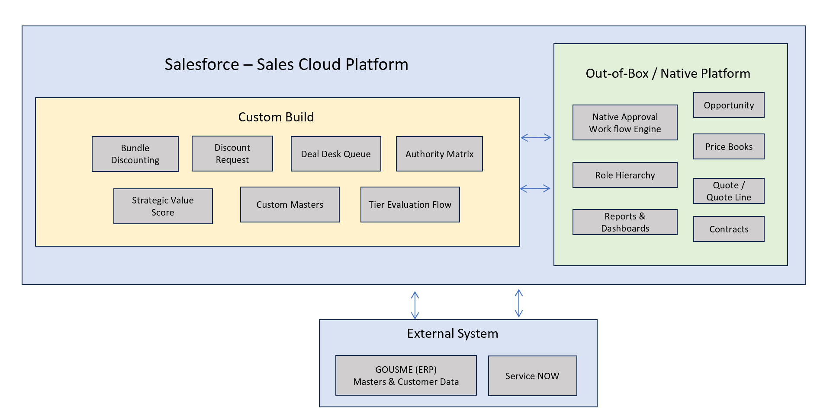
Figure 1 — High-level architecture: OOTB Sales Cloud, custom build, and external systems.

6. Out-of-the-Box vs. Custom Build Mapping
This is the core of the technical design: for each capability named in the requirement, what Sales Cloud already provides vs. what must be configured or custom-built.
Capability | Out-of-the-Box (Sales Cloud) | Custom Build Required
Price Books | Standard Price Book & Price Book Entry objects; multiple price books per product; standard/list pricing. | Custom fields for rental term tiers (daily/monthly/6-mo/12-mo) and product family if not already modelled.
Discount capture | Quote Line Item standard Discount % field. | Custom Discount Request object (or fields) to capture Reason Code, non-standard concessions, expiration date, and justification text — not natively modelled on standard Quotes.
Margin calculation | None native on standard Quotes. | Formula field / Flow to calculate Gross Margin % and $ per line and per quote; Custom Metadata Type “Margin Floor by Product Family” (target + floor) owned by FP&A.
Authority Matrix (5-dimension tiering) | None native. | Custom Metadata Type storing tier thresholds per dimension (discount depth, deal size/ACV, margin vs. floor, term, concessions); Record-Triggered Flow that evaluates all five and returns the single most-restrictive tier.
Approval routing | Native Approval Process engine (multi-step, role- or queue-based); Advanced Approvals (parallel/dynamic chains, delegation, approve-by-email). | Entry criteria reading the calculated “Required Approval Tier” field; approver matrix by role/queue per tier; Deal Desk custom queue for Tier 4-5.
Margin floor override gate | None native. | Validation Rule / Flow that forces routing to Tier 4+ whenever calculated margin < floor, regardless of discount % (“most-restrictive-factor-wins” and “never below floor without Finance” rules).
Reason Code library | Standard picklist field capability. | Picklist (or lookup to a Reason Code custom object if codes need metadata like category/expiry rules) seeded from Section 9 of the Commercial Deal Framework.
Strategic Value Score | None native. | 8 custom number fields (0–3 or 0–2 each) + roll-up/formula for total (0–20); surfaced as read-only context on the Quote/Opportunity — explicitly not used in tier routing per the Strategic Value Score Guide.
Discount expiration & re-approval | None native. | Expiration Date field + scheduled Flow (batch or Flow with schedule trigger) that flags/deactivates expired discounts and forces re-approval at renewal.
Audit / override log | Field history tracking (limited retention, limited fields). | Custom “Approval / Override Log” object capturing approver, tier, decision, rationale, and timestamp for every discount, independent of field history limits.
Quote Line Editor UX | Standard Quote Line Editor if using standard Quotes | If Option B (core Sales Cloud): a Lightning Web Component quote editor may be needed to surface tier, margin, and approval status inline, since the standard editor doesn’t show calculated tier/margin without customization.
Deal Desk queue & SLA | Queues (native); Case/Task assignment. | SLA timers (Flow + time-based actions) per tier per the SLA table in the deck; Deal Desk-specific list views/queue.
Reporting & Dashboards | Native Reports & Dashboards. | Custom report types joining Quote, Discount Request, Approval Log to surface auto-approval rate, cycle time, discount depth, leakage, and exception rate.
Quote PDF | Native | Customization if not getting generated in SFDC. Kindly provide the details

7. Data Model
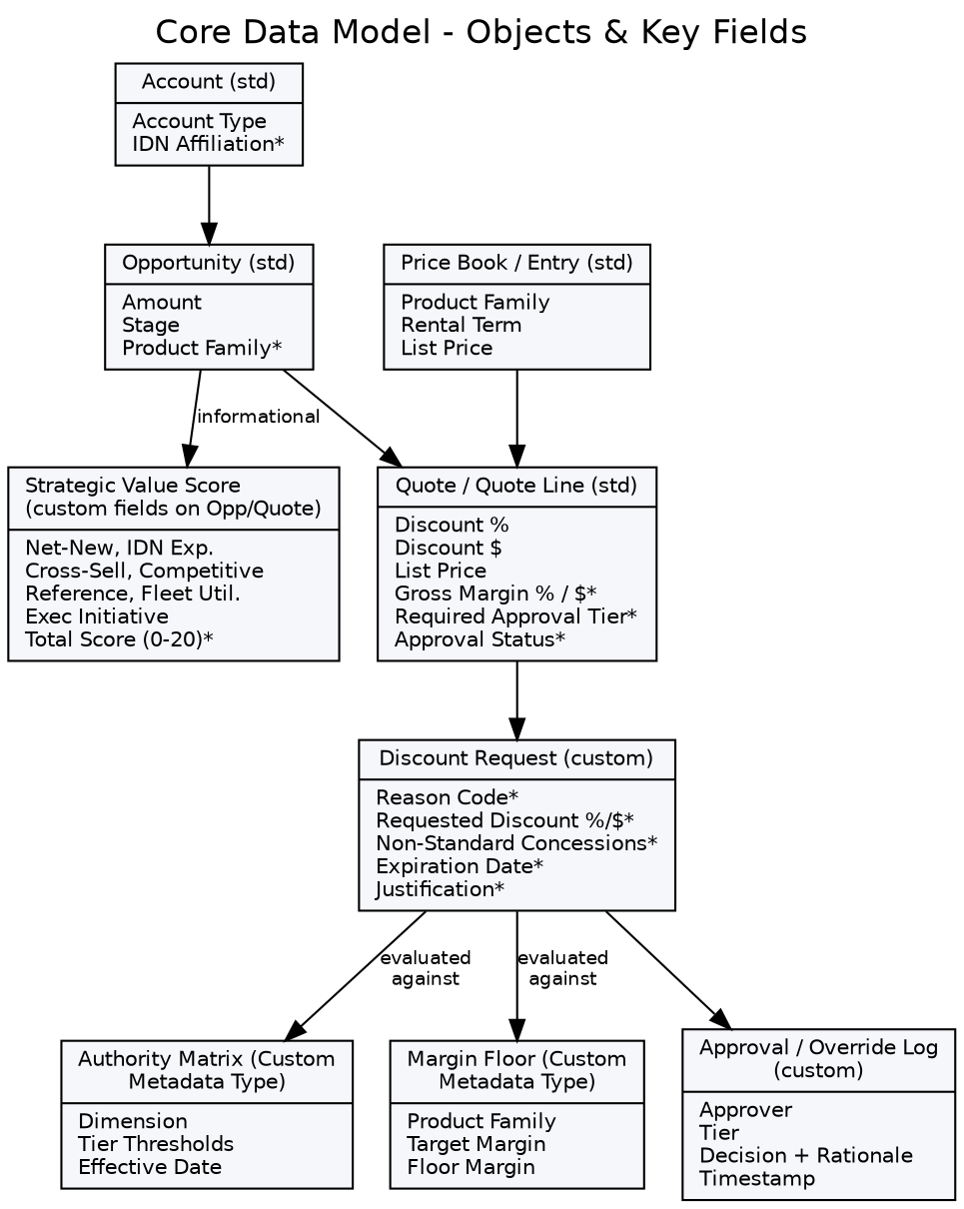
Figure 2 — Core objects and key fields (* = new/custom field or object).

7.1 Field Dictionary (per Commercial Deal Framework, Section 8)

Core fields — required on every quote
- Discount %, Discount $, Gross Margin %, Gross Margin $, Expected Annual Revenue, Total Contract Value, Product Family, Reason Code, Margin Floor Met (Y/N).

Conditional fields
- Capital Required, Fleet Availability, Strategic Value Score, Competitive Situation, Concessions, Approval Tier, Expiration Date, Approver.
Object placement recommendation: core and conditional fields above live on the Quote/Quote Line Item (or a related Discount Request record) rather than solely on the Opportunity, since discounting is evaluated at the quote level and a single Opportunity may carry multiple quote versions.

8. Business Process Flow
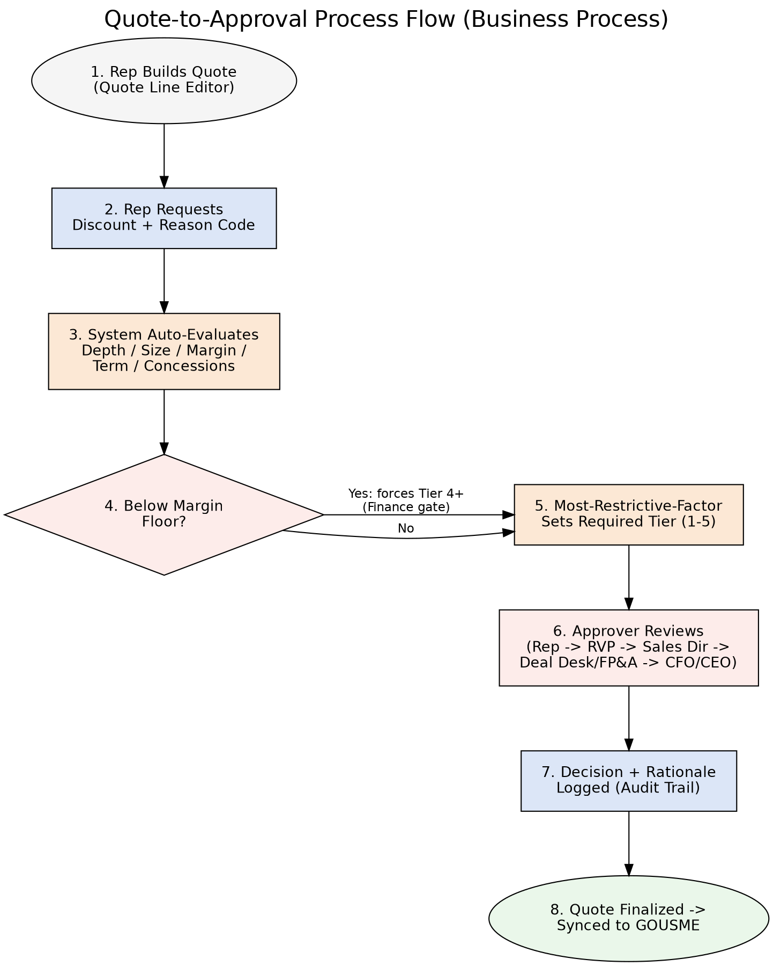
Figure 3 — Quote-to-approval process flow, steps 1–8.
Policy enforcement in this flow is absolute by design: no verbal or email approvals outside the system, no retroactive discounts after order, and no discount can be submitted without a reason code — each of these is enforced with a Validation Rule, not left to training or habit, per the source framework.

9. Authority Matrix & Tiering Logic
Reproduced from the Custom Pricing & Discount Authorization deck (Slide 6) as the authoritative source for tier thresholds pending business sign-off; values marked for customization post-discussion.
Dimension | Tier 1 — BDR | Tier 2 — RVP | Tier 3 — Sales VP | Tier 4 — CRO+FP&A | Tier 5 — CFO/CEO
Discount Depth | ≤ 5% | 5–10% | 10–20% | 20–30% | > 30%
Deal Size (ACV) | ≤ $25k | ≤ $100k | ≤ $250k | ≤ $500k | > $500k
Gross Margin | ≥ Target | ≥ Floor +5pts | ≥ Floor | < Floor | ≪ Floor
Term / Commitment | Standard | Standard | ≤ 24 mo | > 24 mo / evergreen | Atypical
Non-Standard Concessions | None | None | Minor (defined) | Any material | Precedent-setting / MFN
Override rule: any deal priced below its product-family margin floor routes to at least Tier 4 (Deal Desk + Finance), regardless of how small the discount percentage appears. The required tier for a quote is the highest tier triggered by any single dimension — “most-restrictive-factor-wins.”
Note: Confirmation on the above authority Matrix required from USME

9.1 Approver SLAs by Tier
Tier | Approver | May Approve | Target SLA
1 | Sales Rep (self-serve) | Shallow discounts, standard terms, above-target margin | Instant, at quote
2 | Regional VP | Moderate discounts, standard terms, healthy margin | ≤ 4 business hours
3 | Sales Director | Larger deals, deeper discounts to the floor, terms ≤ 24 mo | ≤ 1 business day
4 | Deal Desk + FP&A | Below-floor pricing, material concessions, large ACV, long terms | ≤ 2 business days
5 | CFO / CEO | Strategic, precedent-setting, deeply below-floor, or very large deals | Executive cadence

10. Approval Process Design

10.1 Recommended Mechanism
- Tier is calculated by a Record-Triggered Flow (before-save for formula-style fields, after-save where cross-object queries to Custom Metadata are needed) and written to a “Required Approval Tier” field on the Quote.
- A native multi-step Approval Process uses that field as entry criteria and routes to the correct approver by role hierarchy/queue per tier.
- Tier 4–5 route to a Deal Desk queue rather than an individual, with SLA timers (time-based workflow / Flow scheduled paths) matching the SLA table above.
- Every approval/rejection/recall writes a record to the Approval / Override Log object — this is the audit trail, independent of Salesforce's native (and time-limited) approval history.

10.2 Validation Rules (Guardrails)
- Discount % must be between 0 and 100; Discount $ must be less than list price.
- No discount can be activated above a role's delegated limit without a completed approval.
- Reason Code is required on any non-zero discount.
- Expiration Date is required on any approved discount; blocks quote activation if missing.

11. Deal Desk Operating Model in Salesforce
- Mandate: review Tier 4+ deals, validate economics, ensure policy compliance, track exceptions, and recommend policy refinements — implemented as a Deal Desk queue plus a dedicated list view/dashboard.
- Composition: Sales Ops (process/system owner), FP&A (margin/economics), CFO/executive sign-off for Tier 5 — modeled as queue membership plus an escalation path in the Approval Process.
- Authority: can approve within Tier 4 limits; must escalate Tier 5; cannot waive the below-floor Finance gate — enforced by making the Finance-gate Validation Rule non-bypassable regardless of role.
- MFN / precedent-risk flagging: a Concessions/Precedent-Risk checkbox routes to Legal/Finance review at Tier 4–5 and is surfaced on the Deal Desk queue.
- Concession costing: free periods and waived fees are treated as discounts (per the “hidden concessions are treated as discounts” principle) and included in the margin calculation, not modeled as separate zero-dollar products.

12. Security & Sharing Model
- Field-level security: margin, floor, and Strategic Value Score fields visible to Sales Ops/FP&A/Deal Desk roles; reps see calculated tier and their own discount fields but not raw floor values, consistent with “margin floor overrides discount authority” without exposing sensitive margin data broadly.
- Object-level/sharing: Discount Request and Approval/Override Log records shared via role hierarchy plus explicit sharing rules to Deal Desk and FP&A queues regardless of owner.
- Custom Metadata Types (Authority Matrix, Margin Floor) are protected/managed so only Sales Ops/Admin can edit thresholds — edit access should not require a deployment, per the “configurable without code” design goal.

13. Reporting & Analytics
Directly supports the Pricing Council's quarterly review cadence (Commercial Deal Framework, Section 13):
- Auto-approval / local-approval rate (Tier 1–2 share of total).
- Approval cycle time by tier, vs. SLA.
- Average discount depth by product family and by reason code.
- Gross margin realization vs. floor; margin-floor exception rate.
- Discount leakage — expired or out-of-policy discounts still in use.
- Discount volume and $ by reason code, rep, and region, to support coaching and policy tuning.

14. Non-Functional Requirements
- Auditability: every discount decision must be traceable to an approver, rationale, and timestamp indefinitely (or per USME's retention policy) — do not rely solely on standard field history (18-month/20-value limits).
- Configurability: tier thresholds and margin floors must be editable by Sales Ops without a code deployment (Custom Metadata Type, not hardcoded Flow logic).
- Performance: tier and margin calculation should complete synchronously at quote-save time so reps get instant feedback for Tier 1–2 deals (“instant / at quote” SLA).
- Data quality: Product Family and Reason Code should be tightly controlled picklists/lookups, not free text, to keep the KPI reporting layer trustworthy.
- Change management: Authority Matrix edits should be versioned with an effective date so historical deals are evaluated against the policy in force at the time.

15. Open Technical Questions
- Need Product Family master data
- Please confirm going forward, Price List will be managed in SFDC.
- After creating Quote and Quote line, how are the discount approval request getting created is it every line or a bundle request?
Approval Rejection is it by Quote line or by entire Quote.
- If any report templates are available, please share the same.
- Confirmation required on the authority Matrix defined in Section 9.
- Provide a list of email notifications required at various stages of the workflow.
- Is Salesforce already integrated with GO or after the final quote approval, the need is to integrate as part of the current scope.
- What is the authoritative object for a “quote” today — standard Salesforce Quotes, Opportunity-level fields, or something else? The current framework references “Quote Line Editor,” implying quotes are (or will be) modelled as a distinct object.
- Are GOUSME-held fields (e.g., fleet/equipment availability, existing customer contract data) needed at quote time for margin or eligibility checks, and if so, what is the integration pattern and refresh cadence (real-time callout vs. scheduled sync)?
- What are the finalized margin floor values by product family? The deck marks these “illustrative/best-guess” and “to be customized post discussions” — FP&A sign-off is a hard dependency before validation rules can go live.
- What is the final Reason Code list, and does any code carry additional metadata (e.g., auto-expiry rules, required documentation) beyond a label?
- Who are the actual named approvers/queues per tier (RVP, Sales Director, Deal Desk members, CFO/CEO), and does the existing Role Hierarchy already reflect this, or does it need to be rebuilt?
- Should the Strategic Value Score remain purely informational indefinitely, or is there a target date/criteria for revisiting its use in workflow routing, per the Guide's own recommendation to revisit after data collection?
- Data cleanup: what is the scope and owner of the SFDC/GOUSME data cleanup called out in the project notes, and does it block or run in parallel with this build?

16. Project Timeline

Delivery roadmap – 20 weeks

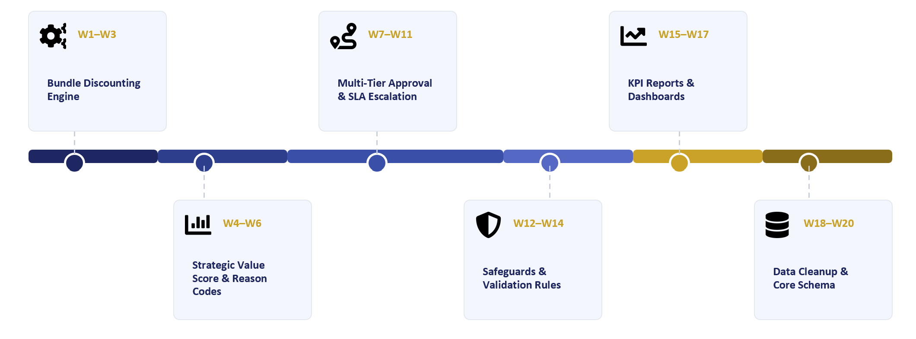
Indicative end-to-end duration from Discovery through Rollout: approximately 20 weeks.

