FlightFinder – Navigating Your Air Travel Options

1.Introduction
- Project Title: FlightFinder – Navigating Your Air Travel Options
- Team Members:
- Koppisett V V Sai Satya Sriram ( Role : Frontend Development)
- Syed Rasha (Role : Backend Development)
- Konduri Sadvi (Role : Backend Developmet)
- Manda Varshini (Role : Database Development)
2.Project Overview
- Purpose :
FlightFinder is a full-stack flight booking web application designed to simplify and enhance the air travel booking experience. The platform allows users to search, explore, and reserve flights efficiently based on their preferences. The goal is to provide a seamless, secure, and user-friendly flight reservation system.
- Features:
- Advanced Flight Search (source, destination, date)
- User Registration & Login (Authentication)
- Flight Booking System
- Booking History Management
- Admin Dashboard for Managing Flights
- Secure Authentication & Authorization
- Responsive User Interface

3.Architecture:
- Frontend:
The frontend of FlightFinder is developed using React.js as a Single Page Application (SPA). It follows a component-based architecture where UI elements such as search forms, flight listings, login, and booking pages are built as reusable components. Navigation is handled using React Router, and Axios is used to communicate with the backend APIs. Bootstrap is integrated for responsive design. The frontend manages user interactions and dynamically updates the UI based on API responses.
- Backend:
The backend is built using Node.js and Express.js, following a RESTful API architecture. Express handles routing, middleware, and request processing, while controllers manage the business logic for users, flights, and bookings. Security is implemented using bcrypt for password hashing and environment variables for sensitive configurations. The backend acts as an intermediary between the frontend and the database.
- Database :
The application uses MongoDB as a NoSQL database to store user, flight, and booking information. Mongoose is used as an Object Data Modeling (ODM) library to define schemas and perform CRUD operations. The database layer ensures structured data storage, validation, and efficient querying to support the application’s functionality.

4.Setup Instructions
- Prerequisites:
- Node.js & npm
- MongoDB (Local or Atlas)
- Git
- VS Code
- Installation:
- Clone Repository:
https://github.com/yourusername/FlightFinder.git
cd FlightFinder
- Install Backend Dependencies
- Install Frontend Dependencies
- Setup Environment Variables (.env in server folder)
5. Folder Structure
- Client :
- public/ – Static public files
- src/ – Main source code folder
- assets/ – Images and static resources
- components/ – Reusable UI components
- context/ – React Context for global state management
- pages/ – Page-level components (Login, Register, Home, etc.)
- RouteProtectors/ – Protected route components for authentication
- styles/ – CSS and styling files
- App.js – Main application component
- App.css – App-level styles
- index.js – Entry point of React app
- index.css – Global styles
- logo.svg – Logo file
- reportWebVitals.js – Performance measurement
- setupTests.js – Testing setup configuration
- package.json – Frontend dependencies and scripts
- package-lock.json – Dependency lock file
- Server:
  - index.js – Main server entry point
  - schemas.js – Mongoose schemas/models
  - package.json – Backend dependencies and scripts
  - package-lock.json – Dependency lock file
6. Running the Application
- Frontend: npm start in the client directory.
- Backend: npm start in the server directory.
7. API Documentation
- Register User
Endpoint: POST /register
Request Body:
{
"username": "John",
"email": "john@gmail.com",
"usertype": "user",
"password": "123456"
}
Response:
{
"_id": "userId",
"username": "John",
"email": "john@gmail.com",
"usertype": "user",
"approval": "approved"
}
- Login User
Endpoint: POST /login
Request Body:
{
"email": "john@gmail.com",
"password": "123456"
}
Response:
{
"_id": "userId",
"username": "John",
"email": "john@gmail.com",
"usertype": "user",
"approval": "approved"
}
- Add Flight
Endpoint: POST /add-flight
Request body :
{
"flightName": "Air India",
"flightId": "AI101",
"origin": "Chennai",
"destination": "Delhi",
"departureTime": "10:00 AM",
"arrivalTime": "12:30 PM",
"basePrice": 5000,
"totalSeats": 120
}

- Update Flight
Endpoint: PUT /update-flight
Response :
{
"message": "flight updated"
}
- Fetch All Flights
Endpoint: GET /fetch-flights
- Book Ticket
Endpoint: POST /book-ticket
Request body:
{
"user": "userId",
"flight": "flightId",
"flightName": "Air India",
"flightId": "AI101",
"departure": "Chennai",
"destination": "Delhi",
"email": "john@gmail.com",
"mobile": "9876543210",
"passengers": ["John Doe", "Jane Doe"],
"totalPrice": 10000,
"journeyDate": "2026-02-20",
"journeyTime": "10:00 AM",
"seatClass": "economy"
}
Response:
{
"message": "Booking successful!!"
}
- Fetch All Bookings
Endpoint: GET /fetch-bookings
- Cancel Ticket
Endpoint: PUT /cancel-ticket/:id
Response :
{
"message": "booking cancelled" }
8. Authentication
The FlightFinder application implements authentication using email and password verification with secure password hashing. During registration (POST /register), the user’s password is encrypted using bcrypt before being stored in the MongoDB database. This ensures that plain-text passwords are never saved, enhancing security.

During login (POST /login), the system verifies the user by checking whether the email exists in the database. If the user is found, bcrypt is used to compare the entered password with the hashed password stored in the database. If the credentials match, the user details are returned as a response.

The system also supports role-based access control using the usertype field (e.g., user or flight-operator). Flight operators require admin approval before gaining full access. Approval status is managed using the approval field (approved, not-approved, or rejected), and administrators can approve or reject operators through dedicated endpoints.

Currently, authentication is session-based through request validation (no JWT tokens implemented). Password encryption, user role validation, and operator approval together ensure basic application-level security.

9. User Interface
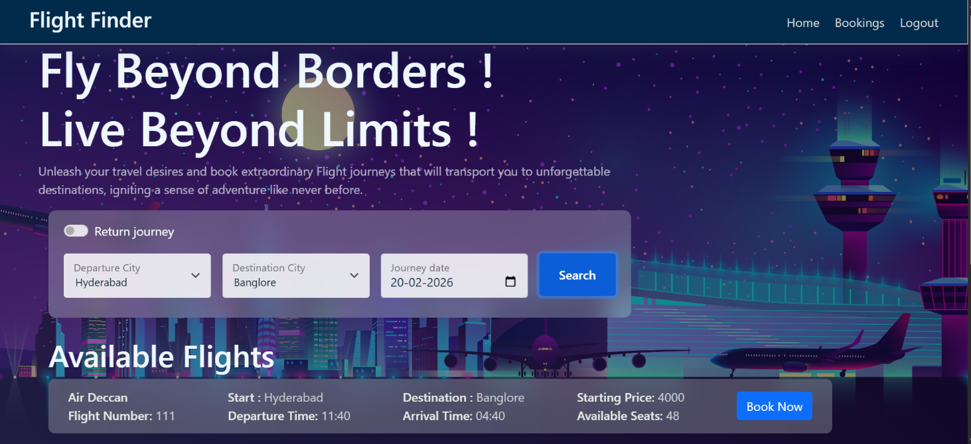
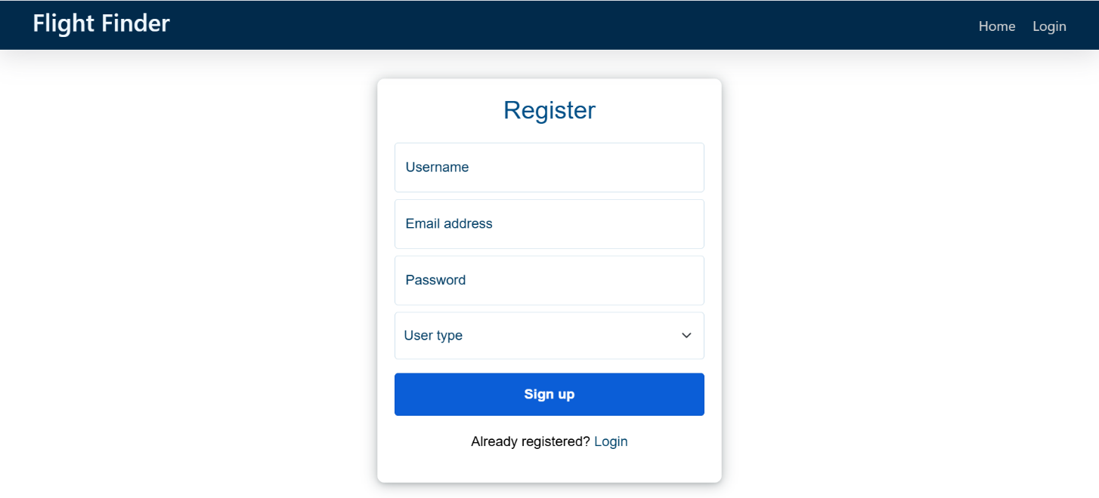
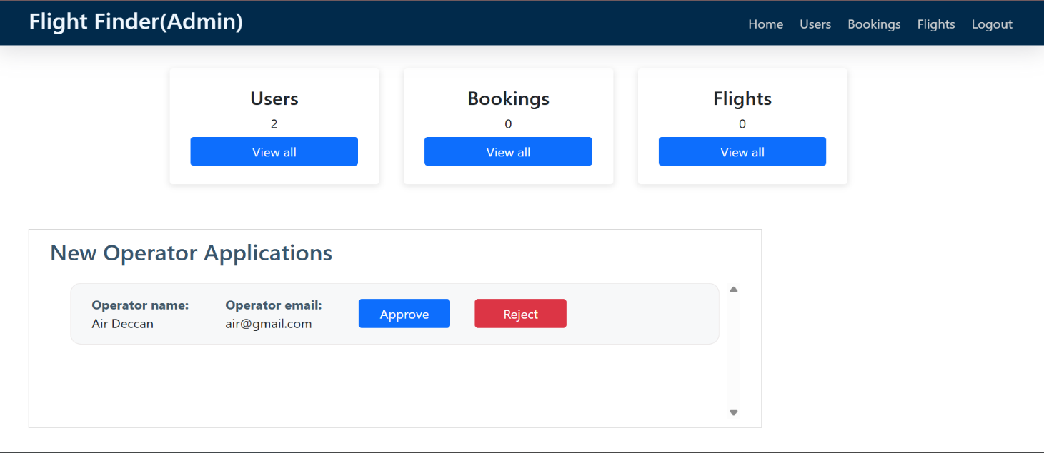
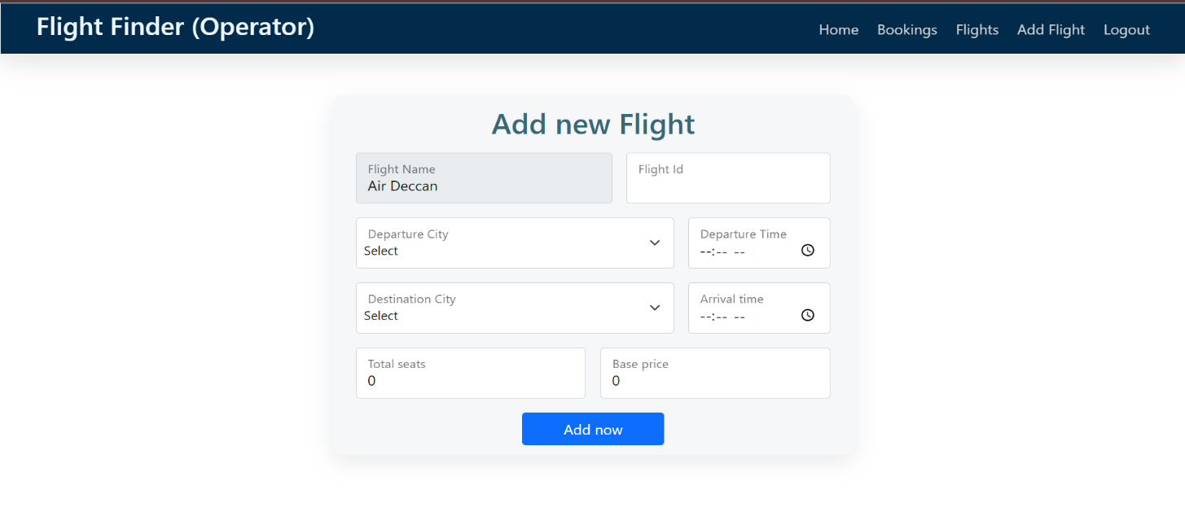
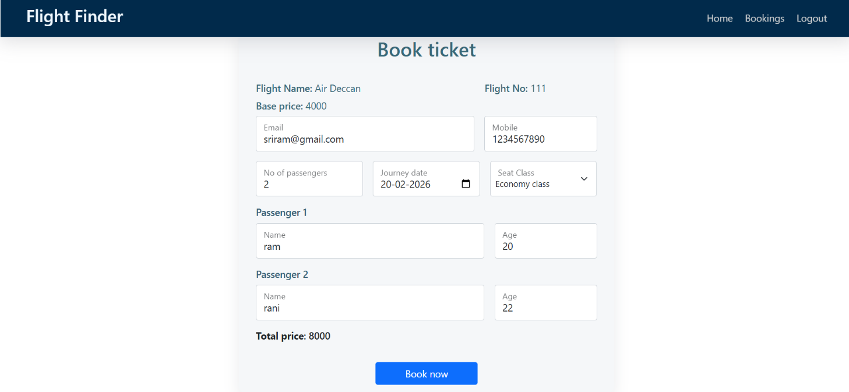
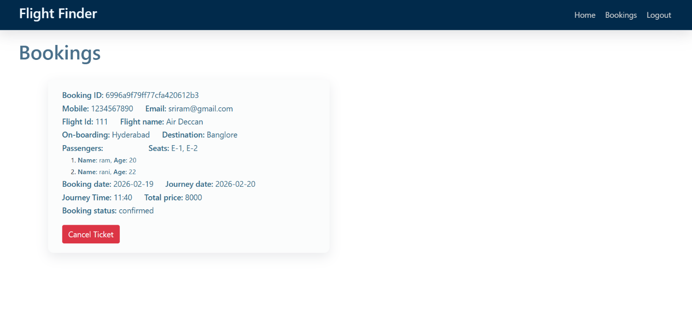
10. Testing
- Manual testing for UI flows
- API testing using Postman
- Error handling and validation checks
- Tested authentication and protected routes
11. Screenshots or Demo
Demonstration video link:
https://drive.google.com/file/d/1Nhksb7cDOC9UIViIJqojxTGZTPeEMzoY/view?usp=sharing

12. Known Issues
- No Payment Gateway Integration (Demo Booking Only):
The system currently supports demo bookings only and does not process real payments or handle transactions and refunds.
- Limited Filtering Options
Flight search includes only basic filters (origin and destination) without advanced options like price range, airline, sorting, or time-based filtering.
- Basic Admin Analytics
The admin panel provides limited insights and lacks advanced reports, revenue tracking, and graphical data visualization

13. Future Enhancements
- Payment Gateway Integration (Razorpay/Stripe)
- Advanced Analytics Dashboard
- Real-time Flight API integration
- Mobile App Version
- Reviews & Ratings System

