## ANGULAR AND SPRING BOOT APPLICATION

## Prerequisites

1. Install Java openjdk version "1.8.0_312"
2. Install Maven version 3.8.1
3. Install NodeJs v16.18.0
4. Install Angular CLI: 14.2.5

**Angular cli installation**

After installing NodeJs execute npm install -g @angular/cli in cmd

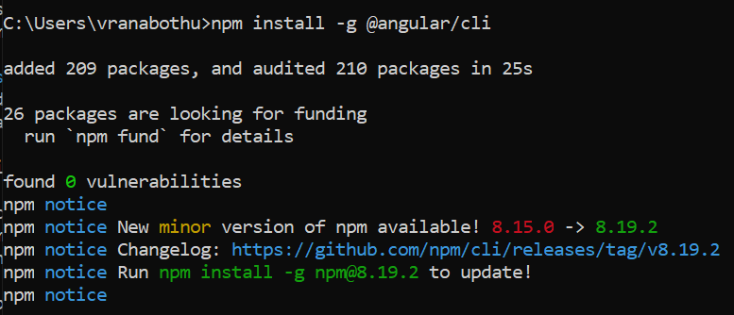

## Setting up environmental variables

1. Setting JAVA_HOME
2. After installing openjdk copy the path of the folder **C:\Program Files\RedHat\java-1.8.0-openjdk-1.8.0.312-2**
3. Search -> system and environmental variables -> environmental variable
4. In environmental variables under system variables click new then add Variable name as JAVA_HOME and variable value openjdk path.

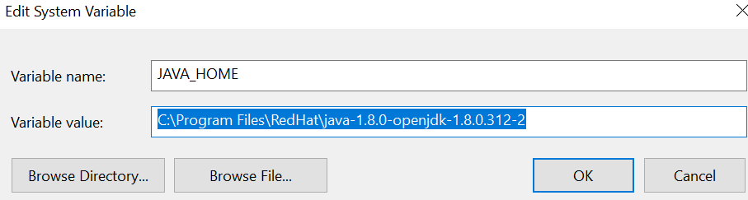

1. In environmental variables under system variables select path and add %JAVA_HOME%\bin

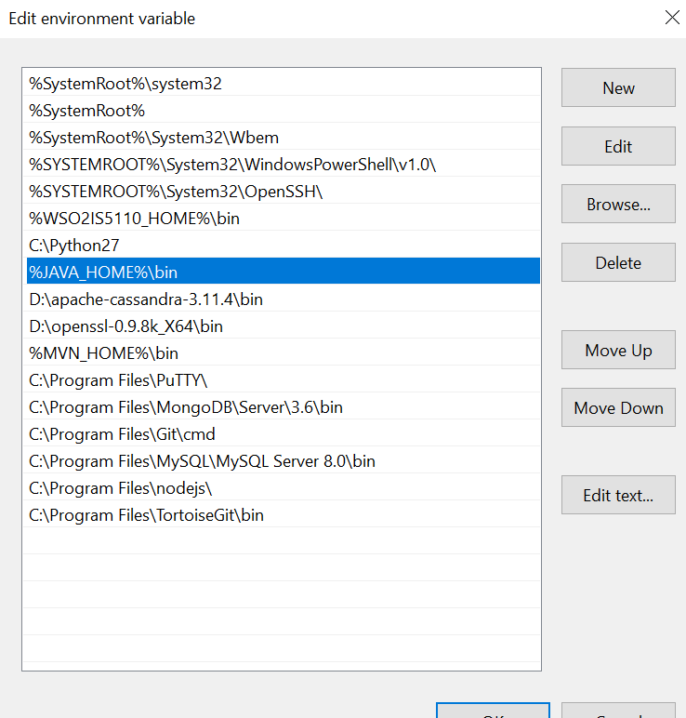

1. Check java version using java -version in cmd

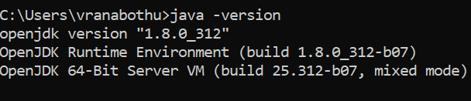

1. Setting MVN_HOME
2. After installing maven copy the path of maven folder **D:\apache-maven-3.8.1-bin\apache-maven-3.8.1**
3. Search -> system and environmental variables -> environmental variable
4. In environmental variables under system variables click new then add Variable name as MVN_HOME and variable value maven path.

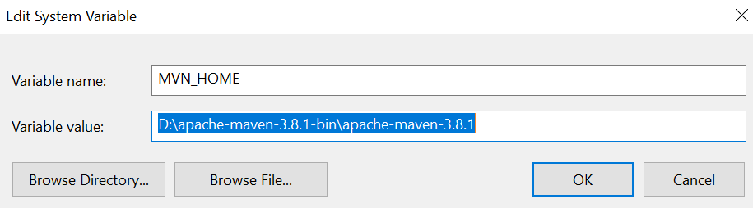

1. In environmental variables under system variables select path and add **%MVN_HOME%\bin**

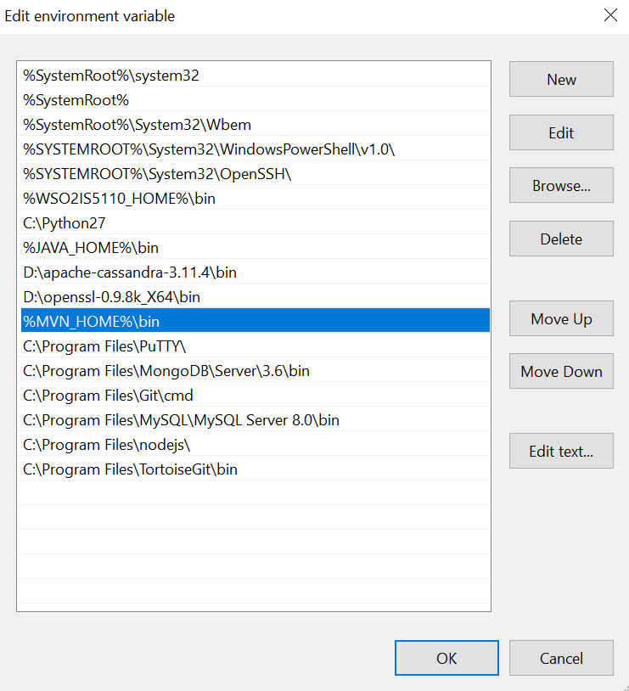

1. Check maven version using mvn -version

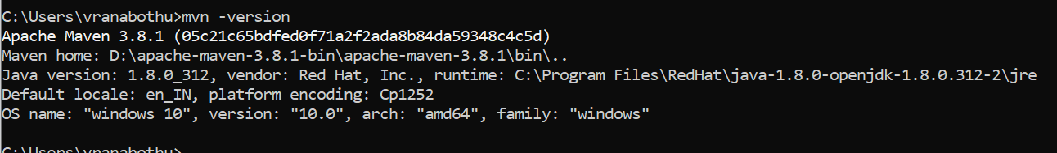

## Database setup

1. Create data base and table in MySQL using user-details.sql script

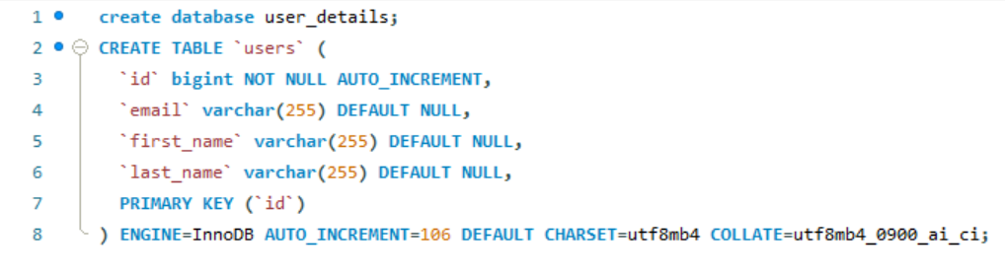

1. Note down the database url, user name and password

## Spring application setup

1. Dependencies used in application
2. Spring Web
3. MYSQL Driver
4. Spring data JPA
5. Spring boot Devtools
6. Update the application.properties file in spring-backend with database url, username, password.

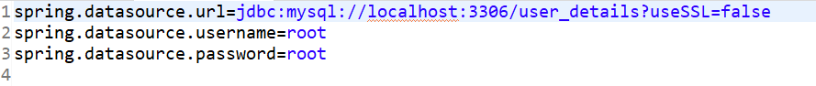

1. After updating application.properties file run the spring boot application using **mvn spring-boot:run** command on project path.

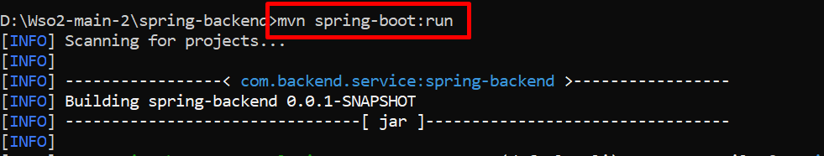

## Angular application setup

1. After running spring boot application and when it is up now update the spring application end point as **baseURL = http://hostname:port/api/users** in **\angular-frontend\src\app\user.service.ts**

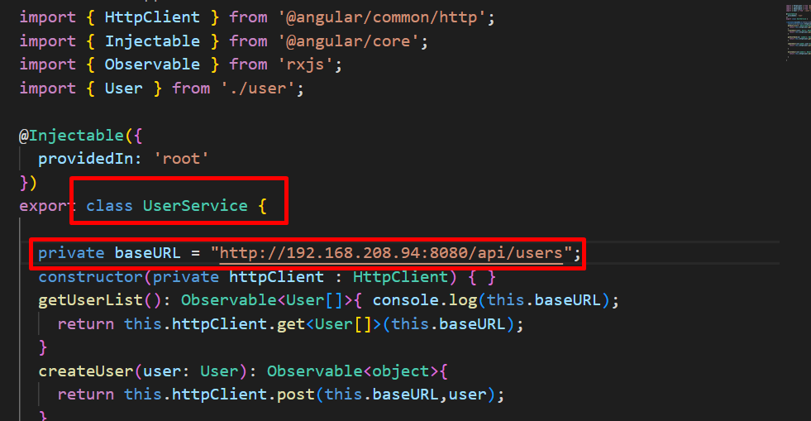

1. In order to access application with localhost run the command **ng serve** on project path.

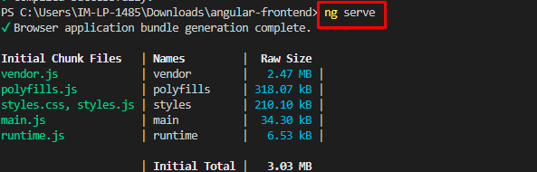

1. In order to run application on outside localhost we can follow any of the two steps
2. Now run the application by executing command **ng serve --host=0.0.0.0 --disable-host-check** on project path or we can follow step3 for updated steps.

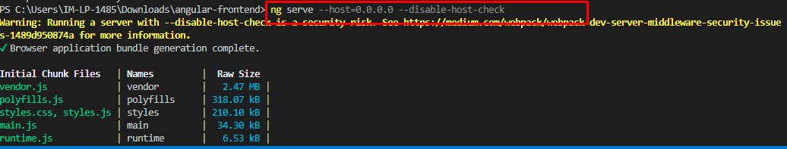

1. Update **\angular-frontend\package.json** as below and execute **npm start** to run application**.**

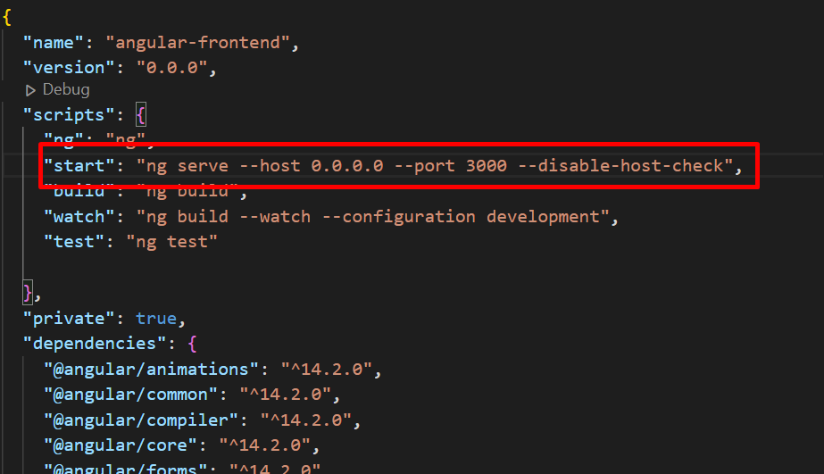

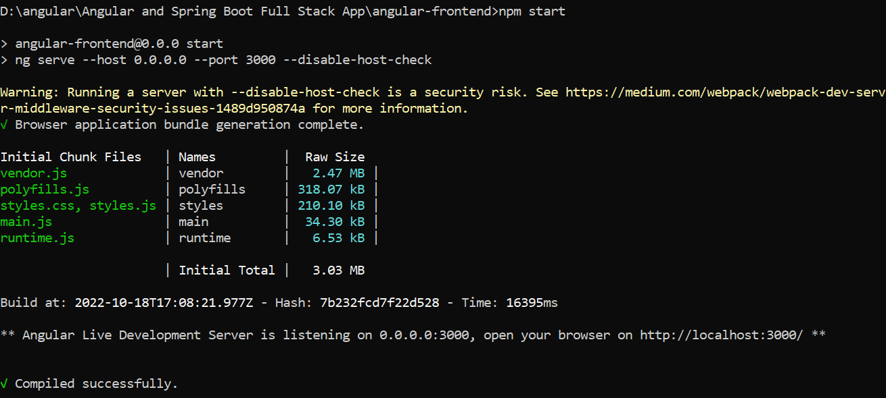

1. After the application is up and running hit the following end point **<http://hostname:port>**

