## Angular and Spring boot application

### spring-backend (Spring boot application)

This project describes the CURD management of users with spring boot as middleware.Here we used spring data jpa to persist data in the database.

1. **spring-backend configuration**

Here we configured local database as backend service which is MySql.

In order to configure remote database provide remote datasource url, username and password.

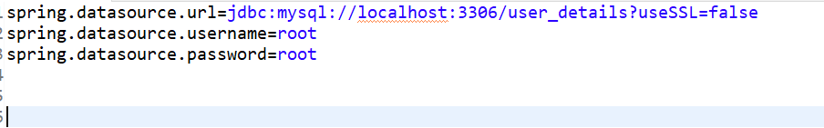

1. **Running Spring Boot Application (spring-backend)**

Here we use embedded tomcat server to run the application.

If there is any error in pom.xml upgrade spring boot version to 2.7.4.

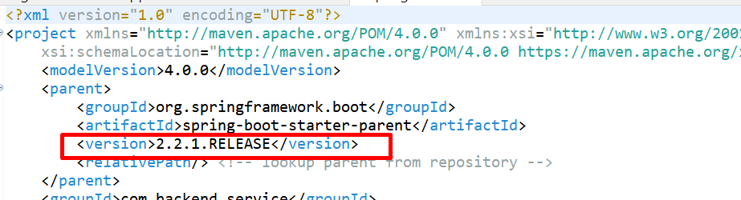

### angular-frontend (Angular application)

### **Prerequisites**

1. NodeJs v16.17.1
2. Install angular cli

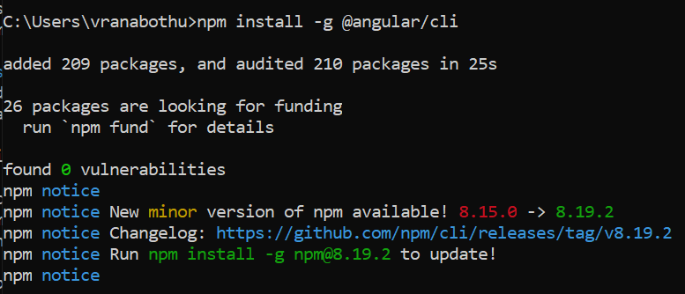

1. **For remote services**

Modify the baseUrl in user.service.ts with appropriate rest end point.

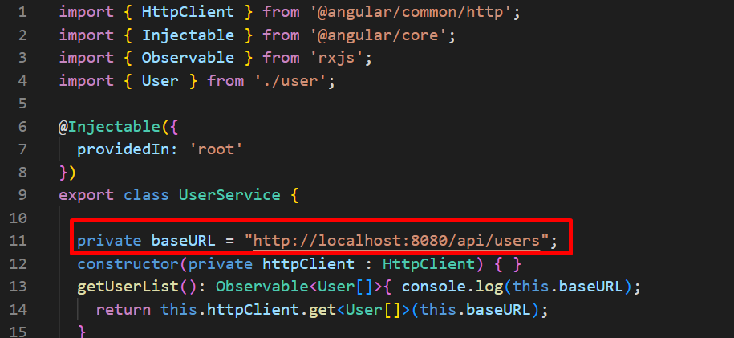

1. **Run Angular App**

To run angular app hit ng serve in application path.

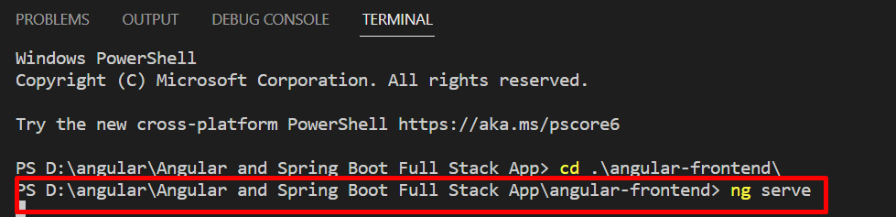

If an error as below arises perform the following.

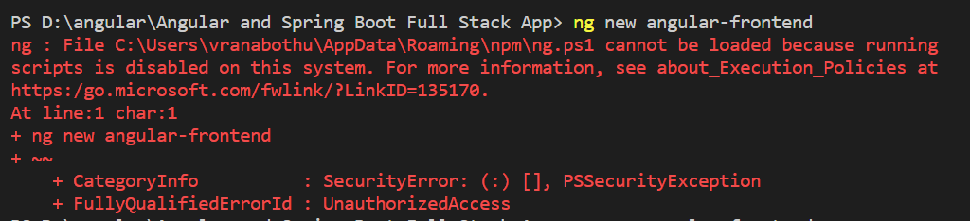

Execute this command on power shell **Set-ExecutionPolicy -Scope CurrentUser -ExecutionPolicy Unrestricted** and select A

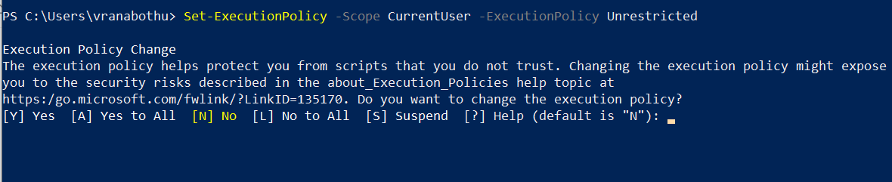

Hit <http://localhost:4200> to access resources