1:- VPC Setup

1.1:- VPC-
1.2:- Create 2 - Subnets with CIDR Blocks
1.3 :- Create IGW
1.4:- Create RoutTable-> Add Subnet association in Subnet assoctation and add IGW in
Routs

2:- Create Subnet Groups and MySQL DB in AWS

2.1 Before creating RDS we need to create SubnetGroup in RDS service

2.1.1:- Create DB SubnetGroup Follow below screen shots

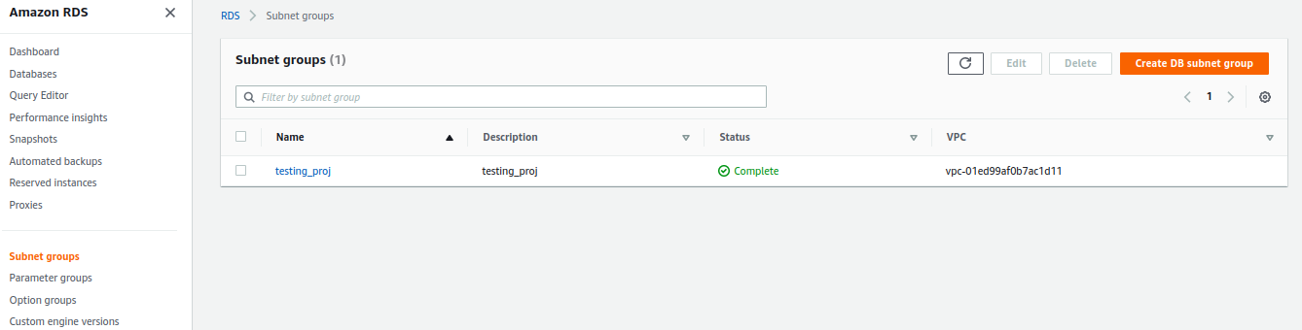

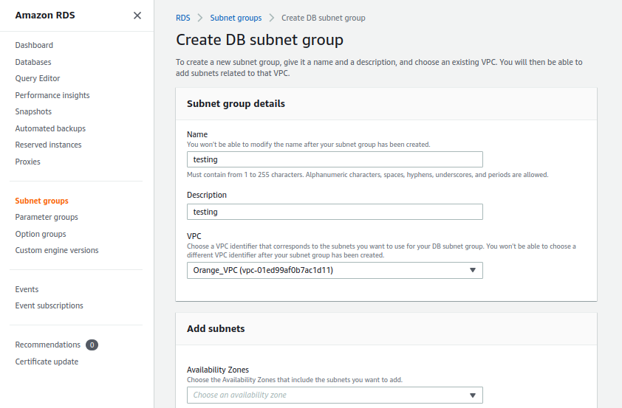

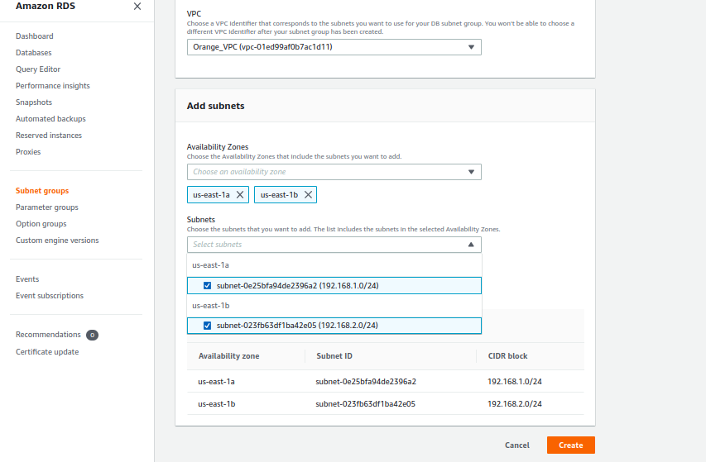
------------------------------------------------------------------------------------------------------------------

3:- Create DataBase
3.1 :- Create Database

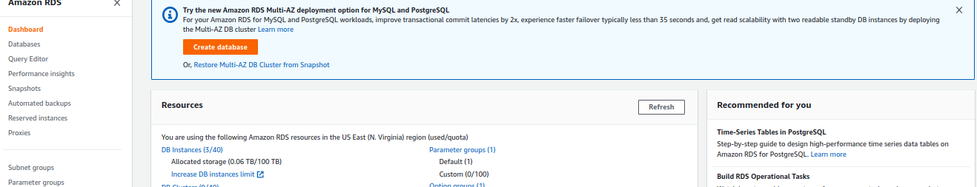

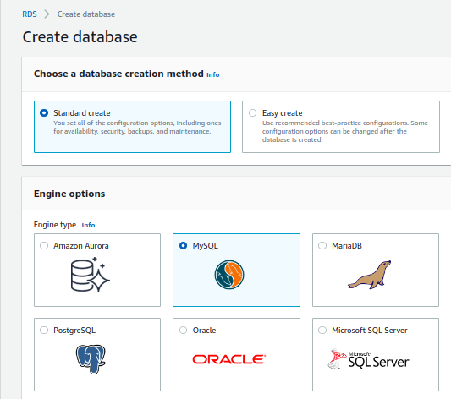

1

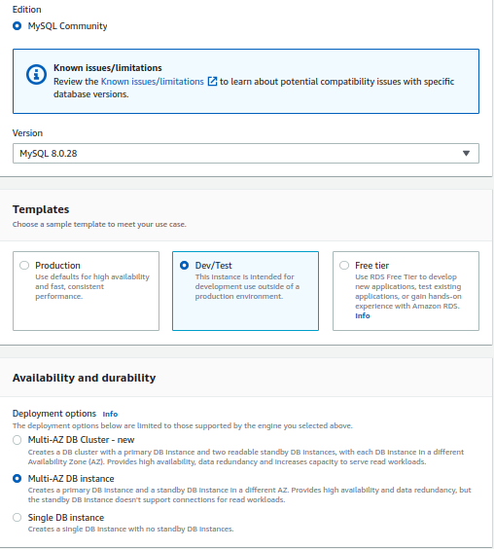
Db:- User and Password

User:- root
Password :- rootroot

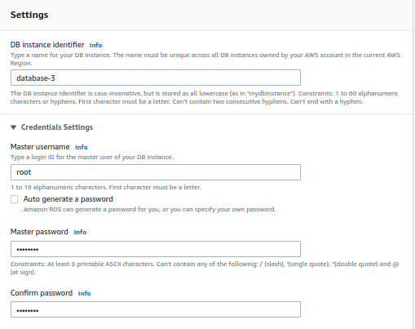

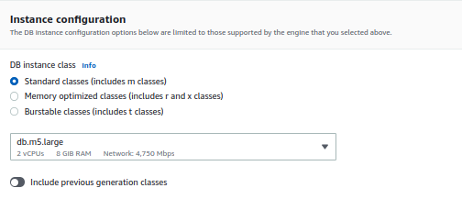
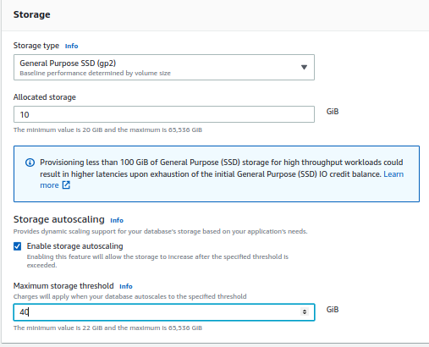

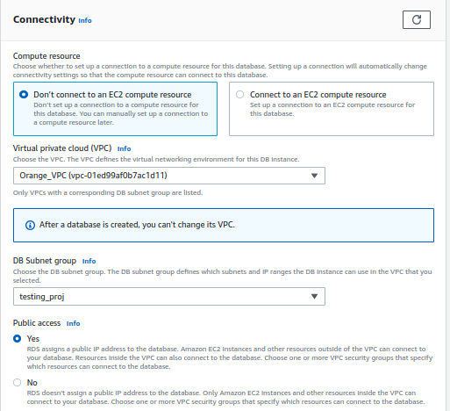

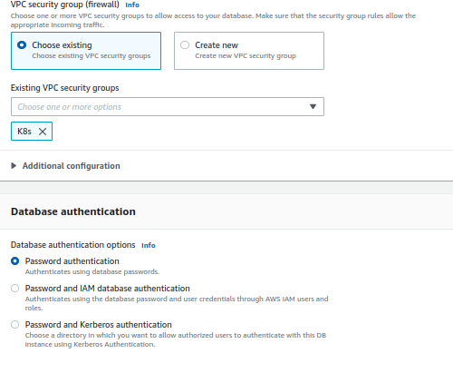

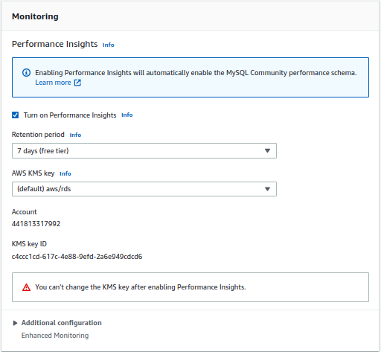

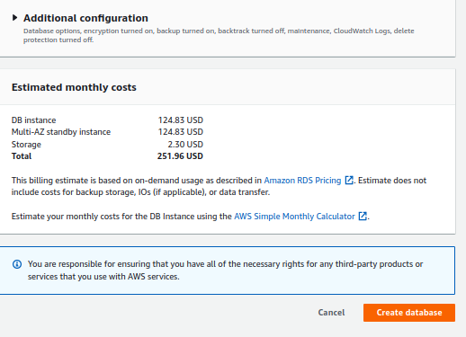
Create database

Output of data base :-
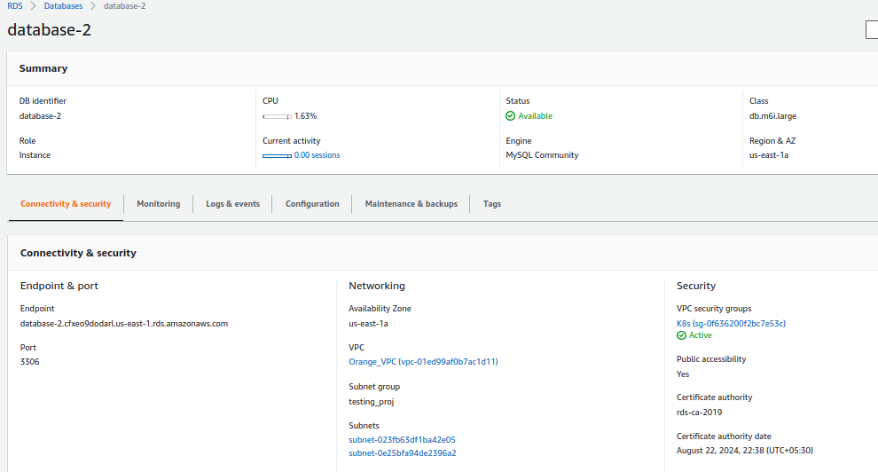

Create data base table in MySQL

create database user_details;
use user_details;
CREATE TABLE users (id bigint NOT NULL AUTO_INCREMENT, email varchar(255) DEFAULT NULL, first_name varchar(255) DEFAULT NULL, last_name varchar(255) DEFAULT NULL, PRIMARY KEY (id)) ENGINE=InnoDB AUTO_INCREMENT=106 DEFAULT CHARSET=utf8mb4 COLLATE=utf8mb4_0900_ai_ci;

(or)

create database user_details;
use user_details;
CREATE TABLE users (
id bigint NOT NULL AUTO_INCREMENT,
email varchar(255) DEFAULT NULL,
first_name varchar(255) DEFAULT NULL,
last_name varchar(255) DEFAULT NULL,
PRIMARY KEY (id)
) ENGINE=InnoDB AUTO_INCREMENT=106 DEFAULT CHARSET=utf8mb4 COLLATE=utf8mb4_0900_ai_ci;

------------------------------------------------------------------------------------------------------------------------
Create 2:- Ec2 instances in public subnets
------------------------------------------------------------------------------------------------------------------------
Instance 1:- OS :- Ubuntu
1:- install Maven
2:- install apt unzip
3:- Dowanload spring-backend.zip
4:- unzip spring-backend.zip
5: cd spring-backend
6:- Configure DB Creadiantials
6.1:- vim src/main/resources/application.properties
6.2 :- add DB Endpoint , port , Username and Password

#spring.datasource.url=jdbc:mysql://localhost:3306/user_details?useSSL=false
spring.datasource.url=jdbc:mysql://database-2.cfxeo9dodarl.us-east-1.rds.amazonaws.com:3306/user_details?useSSL=false
spring.datasource.username=root
spring.datasource.password=rootroot

7:- mvn spring-boot:run
------------------------------------------------------------------------------------------------------------------------
Instance 2:- OS :- Ubuntu

1:- apt upadate
2:- apt upgrade -y
3:- install nvm
curl -o- https://raw.githubusercontent.com/nvm-sh/nvm/v0.39.1/install.sh | bash
source ~/.bashrc
nvm list-remote
nvm install v16.17.1
nvm list
npm install -g @angular/cli
ng version | ng v
4:- install apt unzip
5:- Dowanload source code angular-frontend.zip
6 :- unzip angular-frontend.zip
7 :- cd angular-frontend.zip
8 :- vim /home/ubuntu/angular-frontend/src/app/user.service.ts
9 :- add Instance 1 (spring-backend) DNS
ec2-52-205-255-173.compute-1.amazonaws.com

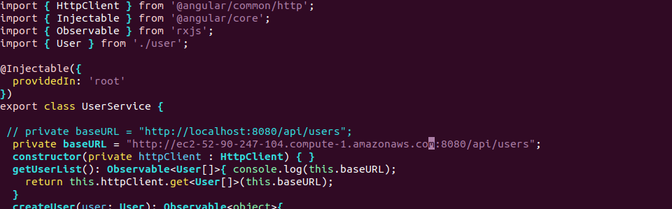
10 :- cd angular-frontend
11:- ng serve --host=0.0.0.0 –disable-host-check
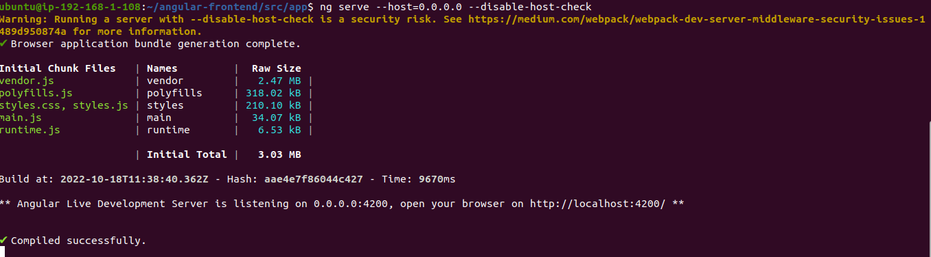

Run in UI :- ec2-52-205-255-173.compute-1.amazonaws.com :4200
