Game Design Document

Fill up the following document

1. Write the title of your project.

ZOMBIE RUNNER

1. What is the goal of the game?

The goal of game is that the player need to reach the finish line and needs

to get the materials required for medicine to the doctor by being alive

from the zombie apocalypse.

1. Write a brief story of your game.

In a small village, there was a guy named Harry who was the only one

not attacked by zombie’s. The one who can solve this problem was a

doctor but the doctor need materials to prepare the medicine and

Harry(YOU) need to get the materials (3 kinds of potions, 3 kinds of

leaves and test tube) to the doctor . You can protect yoursel f by

shooting zombie’s with gun.

4. Which are the playing characters of this game?

* Playing characters are the ones who respond to the user based on the input from the user.
* Cars, monkeys, dinos, wizards, etc., are the playing characters in the game.

|  |  |  |
| --- | --- | --- |
| Number | Character Name | What can this character do? |
| 1 | Harry | He need to give the materials to doctor and can protect him by zombies with a gun. |
| 2 |  |  |
| 3 |  |  |
| 4 |  |  |
| 5 |  |  |
| 6 |  |  |
| 7 |  |  |
| 8 |  |  |

1. Which are the Non-Playing Characters of this game?

* Non-Playing characters are the ones that don't have an action or behavior when the user interacts with the game.
* Hurdles, stones, bananas, coins, etc., are non-playing characters in the game.

|  |  |  |
| --- | --- | --- |
| Number | Character Name | What can this character do? |
| 1 | zombies | Attacks the playing character (Harry). |
| 2 | DOCTOR | Needs to prepare materials. |
| 3 | Life’s | Helps to increase harry’s health when he gets attacked. |
| 4 | 3 types of potion (materials of medicine) | It helps to prepare the medicine. |
| 5 | 3 types of leaves(materials of medicine) | It helps to prepare the medicine. |
| 6 | Test tube | It helps to prepare the medicine. |
| 7 | gun | Helps to kill the zombie’s. |
| 8 |  |  |

Draw your imagination of this game. What does this game look like?

* Draw the game either on your computer or on paper.
* Add images of the game scenes to show each of the playing and non-playing characters at least once.

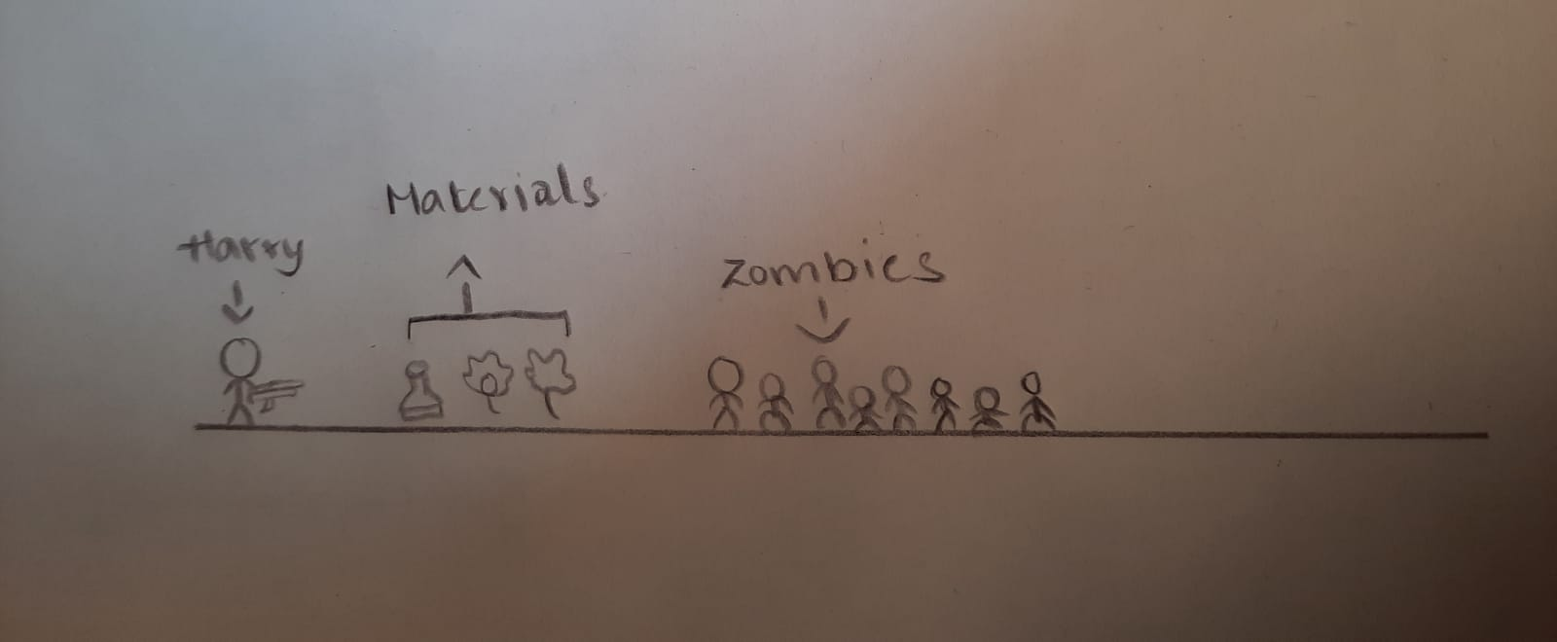

How do you plan to make your game engaging?

I want to make the game engaging by making the players kill the zombies

With help of gun, this makes the game enjoyable and fun.