CellSense AI
Industrial EV Fleet Asset Intelligence
ET AI Hackathon 2026 (2.0) · Detailed Solution Document
Problem Statement 3 — AI for Industrial EV Supply Chain & Asset Intelligence: Accelerating Net Zero
Theme: Sustainability / EV Manufacturing / Asset Performance Management / Supply Chain

Contents

1. Executive Summary
CellSense AI is an Asset Performance Management (APM) platform for industrial and commercial electric-vehicle fleets. It predicts each battery asset's State of Health (SoH) and Remaining Useful Life (RUL) from real cell-cycling data, ranks the fleet by risk, and — critically — converts every prediction into a grounded, cited maintenance decision using a multi-agent reasoning layer over OEM manuals and safety standards.
The project deliberately targets the operational bottleneck identified in Problem Statement 3: industrial fleet operators lack the asset-intelligence tooling to manage EV batteries with the same rigour they apply to conventional equipment. CellSense AI treats the battery as the asset, and applies predictive maintenance plus decision intelligence to it.
Our design principle is feasibility-first: a provable machine-learning core (measured against observed degradation) fused with a natural-language decision layer that no generic battery model provides. This combination maximises the two heaviest judging criteria — Innovation and Business Impact — while remaining fully buildable within the hackathon timeline on free, public data.
At a glance
What it does | Predicts battery SoH & RUL, ranks fleet risk, generates cited maintenance actions
Core innovation | Decision-Intelligence layer — prediction becomes a grounded, explainable action
Provable metric | RUL / SoH prediction error (RMSE) vs. observed degradation
Data | 100% free & public: NASA, Oxford, MIT battery datasets + public OEM/safety documents
Cost to build | Zero — free datasets, open-source stack, free-tier or local LLM

2. Problem Understanding

2.1 Context
India registered over 2 million EVs in FY2025, yet penetration in industrial and commercial segments — freight, mining, intra-plant logistics, construction equipment — remains below 2.5%. The barrier is no longer purely financial: incentives and total-cost-of-ownership parity with diesel are approaching. The real bottleneck is operational — operators cannot manage battery lifecycle, degradation, and maintenance with the discipline they apply to conventional industrial assets. Meeting India's 30% commercial-EV penetration target by 2030 depends on closing this asset-intelligence gap.

2.2 Core Problem
The battery is the single most valuable and most failure-prone asset in an industrial EV, yet its degradation is invisible until it fails. Operators lack (a) reliable remaining-life visibility, (b) fleet-level prioritisation of which asset to act on first, and (c) actionable, trustworthy guidance on what to do about it. The result is unplanned downtime and premature, capital-intensive battery replacement.

2.3 Root Causes
- Modelling gap — Battery degradation is non-linear and difficult to infer from raw telemetry without modelling.
- Decision gap — A predicted number alone is not a decision; operators need cause, severity, and a recommended action.
- Knowledge gap — OEM procedures, failure modes, warranty terms, and safety standards are fragmented and un-actioned at the point of need.

2.4 Pain Points
Pain point | Consequence
No remaining-useful-life visibility | Failures happen without warning; no planning horizon
Premature battery replacement | Wasted capital — the battery is 30–40% of vehicle cost
No fleet-level prioritisation | Maintenance effort is spread thin, not risk-targeted
Fragmented maintenance knowledge | Slow, inconsistent decisions; safety exposure
Thermal / anomaly events missed | Safety incidents and unplanned outages

2.5 Stakeholders
Stakeholder | What they gain
Fleet operations manager | Fleet-wide risk visibility and prioritised action list
Maintenance engineer | Predicted failures + grounded, cited repair/replace guidance
Sustainability / net-zero officer | Asset-level carbon and electrification progress tracking
CFO / capital planning | Avoided premature replacement; predictable capital cycles
OEM / battery supplier | Field degradation intelligence and warranty insight

3. Proposed Solution — CellSense AI

3.1 Overview
CellSense AI ingests battery-cycling data for each fleet asset, predicts its current SoH and forecasts its RUL, applies a deterministic rule engine to band risk (Healthy / Watch / Critical), and presents a risk-ranked fleet dashboard. When an operator opens a flagged asset, a three-agent pipeline diagnoses the probable cause, retrieves the relevant procedures from a document corpus, and produces a cited maintenance recommendation with an exportable report.

3.2 Core Innovation — Decision Intelligence over Prediction
Most battery projects stop at a prediction. CellSense AI closes the loop from prediction to grounded decision. The machine-learning core produces the number; a Retrieval-Augmented reasoning layer turns that number into an APM decision — for example: "Asset #14 crosses its degradation threshold in ~35 cycles; per maintenance procedure §4.2, schedule cell replacement before the next high-load shift." This is exactly the Asset Performance Management value proposition, delivered with citations for trust and auditability.

3.3 Key Differentiators
- Trustworthy core — Provable ML on real cell data — credibility, not a mock dashboard.
- Explainable & safe — RAG-grounded, cited recommendations — no hallucinated safety advice.
- Decision-first — Fleet-level prioritisation — ranks assets by degradation and operational criticality.
- Domain-aligned — Speaks the language of industrial Asset Performance Management end-to-end.

4. Scope & Feasibility Strategy
Problem Statement 3 is intentionally broad, spanning two prongs — fleet asset management and manufacturing supply chain. Attempting both fragments the narrative and the timeline. We commit fully to the fleet-APM prong and cut the rest deliberately.
Priority | Component | Decision
Must Have | Battery SoH + RUL prediction (ML core) | Build — provable metric
Must Have | Fleet risk-ranking dashboard | Build — decision surface
Must Have | RAG-grounded maintenance recommendation (agents) | Build — the innovation
Good to Have | Fleet electrification-readiness score + carbon stat | Only if core is demo-solid
Cut | Manufacturing quality intelligence (QMS/SPC) | Different domain — scatter
Cut | Multi-tier material supply-chain risk (Li/Co) | Separate data pipeline — scatter
Cut | Charging-infrastructure optimisation | Low demo payoff
Cut | Full digital twin / knowledge graph | Over-engineering — no marginal score
Rationale: one sharp, complete story scores higher than two blurry, half-finished ones. Every cut component would consume a full workstream while adding no marginal judging points beyond what the fleet-APM story already earns.

5. System Architecture
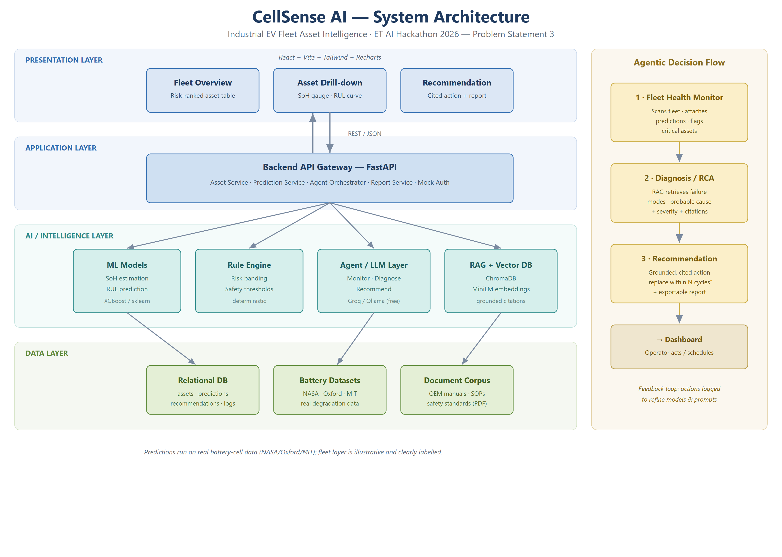
Figure 1 — CellSense AI layered system architecture and agentic decision flow.

5.1 Component Responsibilities
Layer / Component | Responsibility
Frontend (React) | Renders fleet table, per-asset SoH/RUL charts, recommendation panel. No business logic.
Backend (FastAPI) | Single API gateway; loads models, serves predictions, runs rule engine, orchestrates agents, persists results.
ML Models | Offline-trained SoH & RUL models loaded as artifacts; batch inference across the fleet.
Rule Engine | Deterministic risk banding and safety thresholds — owns all safety-critical decisions (no LLM).
Agent / LLM Layer | Three agents reason over predictions + retrieved documents to produce cited recommendations.
RAG + Vector DB | Embeds and retrieves OEM/procedure chunks (ChromaDB) to ground every recommendation.
Relational DB | System of record: assets, telemetry, predictions, recommendations, feedback log.
Auth | Mock single-role session only — deliberately out of scope for the prototype.

6. End-to-End Pipeline
The system runs in two modes: batch inference across the whole fleet, and on-demand agentic reasoning when an operator opens a flagged asset (keeping LLM calls minimal and the demo fast).
Battery cycle data + fleet metadata (Input) ↓
Data Ingestion — load datasets, normalise schema ↓
Data Cleaning — drop corrupt cycles, align sampling, handle gaps ↓
Feature Engineering — capacity-fade, cycle count, voltage/temperature curve features ↓
ML Inference — SoH now + RUL forecast per asset ↓
Rule Engine — risk banding: Healthy / Watch / Critical ↓
Agent Orchestration — Monitor → Diagnose (RAG) → Recommend ↓
Prediction + Recommendation persisted ↓
Dashboard Visualisation — fleet ranking + drill-down + reco panel ↓
User Action — acknowledge / schedule / dismiss ↓
Feedback Loop — actions logged to refine models & prompts

7. AI & ML Approach
AI is applied only where it earns its place. Prediction is done by traditional ML (deterministic and provable); reasoning and language are done by the LLM/RAG layer; safety-critical banding stays with a rule engine to avoid hallucination.
AI type | Where used | Why it is needed
Traditional ML | SoH estimation, RUL prediction | The provable core metric judges measure; fast and credible
Predictive analytics | Degradation-trajectory forecasting | Produces the RUL 'knee' curve — the visual hook
Rule engine | Risk banding, safety thresholds | Deterministic, auditable, no hallucination on safety
RAG | Grounding recommendations in documents | Trust + citations + auditability
LLM | Diagnosis narrative, recommendation, report | Turns numbers into decisions — Business Impact & UX
Agentic AI | Monitor → Diagnose → Recommend | Modular, demonstrable, clean demo narrative
Knowledge graph | Not used | Adds ontology effort for zero marginal demo value at this scope

8. Multi-Agent Design
Three agents only — minimal and reliable. Each has a single responsibility and passes structured output to the next.
Agent | Inputs | Outputs | Passes to
1 · Fleet Health Monitor | Telemetry + ML predictions + rule bands | Ranked list of flagged assets | → Diagnosis Agent
2 · Diagnosis / RCA | Flagged asset + RAG retrieval | Probable cause, severity, citations | → Recommendation Agent
3 · Recommendation | Diagnosis + RUL + context | Cited action + exportable report | → Dashboard

9. Data Strategy
The machine-learning core is trained and validated on real, public battery-degradation datasets. Only the fleet 'wrapper' (asset IDs, routes, duty cycles) is synthesised — and clearly labelled as illustrative. This keeps the provable metric honest while giving a realistic fleet narrative.
Dataset | Purpose | Public? | Difficulty
NASA PCoE Li-ion Aging | Train/validate SoH + RUL | Yes — free | Easy
Oxford Battery Degradation | Cross-validate generalisation | Yes — free | Easy
MIT–Stanford (TRI) cycle-life | Large-scale RUL benchmark | Yes — free | Easy–Med
OEM manuals / SOPs / safety standards | RAG grounding corpus | Partial (public PDFs) | Medium
Fleet metadata (routes, duty cycles) | Fleet framing & readiness | Synthesised | Easy
Integrity note for judges: all predictions run on real cell data (defensible error metrics); only the fleet wrapper is illustrative, and we state this openly.

10. Technology Stack
Layer | Choice | Why
Frontend | React + Vite + Tailwind + Recharts | Fast scaffold, strong charts
Backend | FastAPI (Python) + Uvicorn | Same language as ML; rapid REST
Database | SQLite (Postgres if hosted) | Zero-config, file-based
Vector DB | ChromaDB | Local, free, trivial retrieval
ML | scikit-learn + XGBoost | Reliable, fast, provable
LLM | Groq free tier / Ollama (local) | Zero cost; no GPU needed
Embeddings | sentence-transformers (MiniLM) | Local, free
Visualisation | Recharts / Plotly | Degradation curves, gauges
Deployment | Localhost + ngrok / HF Spaces | Zero cost, demo-reliable
Deliberately avoided: paid APIs, streaming infrastructure, Kubernetes, real auth providers, graph databases — none add judging value at this scope.

11. Development Roadmap
Phased for a multi-day build; the good-to-haves are gated behind a green core.
Phase | Objective | Output | Time
P0 Setup | Repo, envs, data download | Running skeleton | 0.5 day
P1 ML Core | Provable SoH + RUL | Model + RMSE metric | 1.5 days
P2 Backend + DB | Serve predictions | Live prediction API | 1 day
P3 RAG + Agents | Grounded recommendation | Cited output | 1.5 days
P4 Frontend | Decision surface | Working dashboard | 1.5 days
P5 Integration | End-to-end wiring | Full flow works | 0.5 day
P6 Demo Polish | Script, rehearse, deck, video | Deliverables ready | 1 day
Critical path: P1 → P2 → P3 → P5 → P6. The frontend (P4) is built against mock data in parallel so it is ready when real endpoints land.

12. Risk Analysis & Mitigation
Risk | Type | Mitigation
Weak model accuracy | Model | XGBoost baseline day 1; validate on Oxford; report gain vs. naive baseline
LLM hallucinates unsafe advice | Model | Rule engine owns safety bands; LLM only phrases; show citations
Thin RAG corpus | Data | Pre-assemble 20–40 PDFs + synthesised SOPs before P3
FE/BE integration crunch | Integration | Freeze API contract in P2; frontend on mock data early
LLM latency in demo | Technical | Free fast inference + cache demo-asset responses
Budget / API cost | Resource | Every dependency is free — no paid service anywhere
Scope creep | Timeline | Hard cuts fixed in Section 4; good-to-haves gated

13. Expected Outcomes & Success Metrics
Aligned to the Problem Statement's evaluation focus, success is measured — not asserted:
- Prediction accuracy — SoH / RUL prediction error (RMSE) versus observed degradation, benchmarked against a naive persistence baseline.
- Warning lead time — Lead time (in cycles) between a Critical flag and the actual end-of-life threshold.
- Grounding rate — Share of recommendations with a valid document citation (target: 100%).
- Business impact — Illustrative impact model (assumptions explicit) quantifying avoided premature replacement and downtime.

Illustrative impact model (assumptions stated openly):
Assumption | Value
Fleet size (industrial EVs) | 100 vehicles
Battery pack cost per vehicle | ₹8–12 lakh
Premature replacements avoided (APM) | 15–20%
Unplanned battery downtime reduced | ~25%
Indicative annual saving (illustrative) | ₹1.2–1.8 crore / fleet
Figures are illustrative and clearly assumption-based, as expected of a hackathon impact model — the method, not the exact number, is the deliverable.

14. Alignment with Judging Criteria
Criterion (weight) | Focus | How CellSense AI addresses it
Innovation (25%) | High | Decision-Intelligence loop — grounded, cited APM actions, not just a prediction
Business Impact (25%) | High | Avoided replacement + downtime, quantified; net-zero relevance
Technical Excellence (20%) | High | Real-data ML with measured RMSE; clean ML + rule + RAG separation
Scalability (15%) | Medium | Architecture generalises to any fleet; stateless services
User Experience (15%) | High | Operator-first dashboard: risk ranking, drill-down, cited action

15. Team & Roles
Team of up to four; roles map one-to-one to the folder structure to avoid collisions. (Replace with your members.)
Member | Role | Responsibility
[Name 1] | ML Lead | Data pipeline, SoH/RUL models, evaluation (critical path)
[Name 2] | Backend + Agents | FastAPI, database, agent orchestration, RAG wiring
[Name 3] | Frontend | React dashboard, charts, drill-down, recommendation panel
[Name 4] | AI/NLP + Integration + Demo | RAG corpus, LLM prompting, report generation, demo & deck

16. Conclusion
CellSense AI is scoped to win: a provable machine-learning core that earns trust, wrapped in a natural-language decision-intelligence layer that delivers genuine Asset Performance Management value. It is built entirely on free, public data with an open-source stack, is realistic for a small team within the hackathon timeline, and maps directly to the highest-weighted judging criteria. Prediction earns credibility; the grounded, cited decision earns the win.

Appendix — Primary data sources: NASA Prognostics Center of Excellence (battery aging); University of Oxford Battery Degradation Dataset; MIT–Stanford (Toyota Research) cycle-life dataset; public OEM manuals and lithium-ion safety standards.

