Experiment 2: Case Study
Problem Statement: Choose a real-world case study such as an E-Commerce System or KL ERP System, create user stories, select an appropriate software development process model, identify a suitable programming language, and propose an implementation and evaluation strategy.
Real-World case study: KL ERP System
1. Functional Requirements
Student
- Register/Login securely
- View personal profile
- Course registration
- View class timetable
- View attendance
- Check internal and semester marks
- Pay tuition and examination fees
- Download hall tickets
- View academic calendar
- Raise service requests
Faculty
- Faculty login
- Manage student attendance
- Upload internal marks
- View class timetable
- Manage course materials
- Generate student performance reports
- Approve student requests
Admin
- Manage student records
- Manage faculty records
- Manage courses and departments
- Generate academic reports
- Fee management
- User access management
- System monitoring and backup
2. User Stories
User ID | User Story | Priority | Priority Points
US-01 | As a student, I want to login securely so that I can access my ERP account. | High | 8
US-02 | As a student, I want to register courses every semester. | High | 8
US-03 | As a student, I want to check my attendance. | High | 7
US-04 | As a student, I want to view my examination results. | High | 8
US-05 | As a student, I want to pay tuition and examination fees online. | High | 7
US-06 | As a faculty member, I want to upload student attendance. | High | 8
US-07 | As a faculty member, I want to upload internal marks. | High | 8
US-08 | As an administrator, I want to manage student records. | High | 9
US-09 | As an administrator, I want to generate academic and administrative reports. | Medium | 5
US-10 | As an administrator, I want to manage user accounts and permissions. | Medium | 6
3. Selected Software Development Process Model
Agile Scrum
Reason for Selection
- Frequent requirement updates
- Continuous feedback from students and faculty
- Faster feature delivery
- Easy maintenance and bug fixing
- Suitable for large web-based ERP applications
- Supports iterative development
Sprint Plan
Sprint | Features
Sprint 1 | User Authentication (Student, Faculty, Admin)
Sprint 2 | Student Dashboard
Sprint 3 | Attendance Management
Sprint 4 | Marks & Results Module
Sprint 5 | Fee Payment Module
Sprint 6 | Faculty Dashboard

4. Programming Language Selection
Backend
- Java (Spring Boot)
Reasons
- Secure
- Scalable
- Enterprise-level applications
- REST API support
- Excellent database connectivity
Frontend
- HTML5
- CSS3
- JavaScript
- React.js

Database
- MySQL
Other Technologies
- REST API
- JWT Authentication
- Stripe/Razorpay Payment Gateway
- Git
- Docker
- AWS Cloud

5. System Architecture

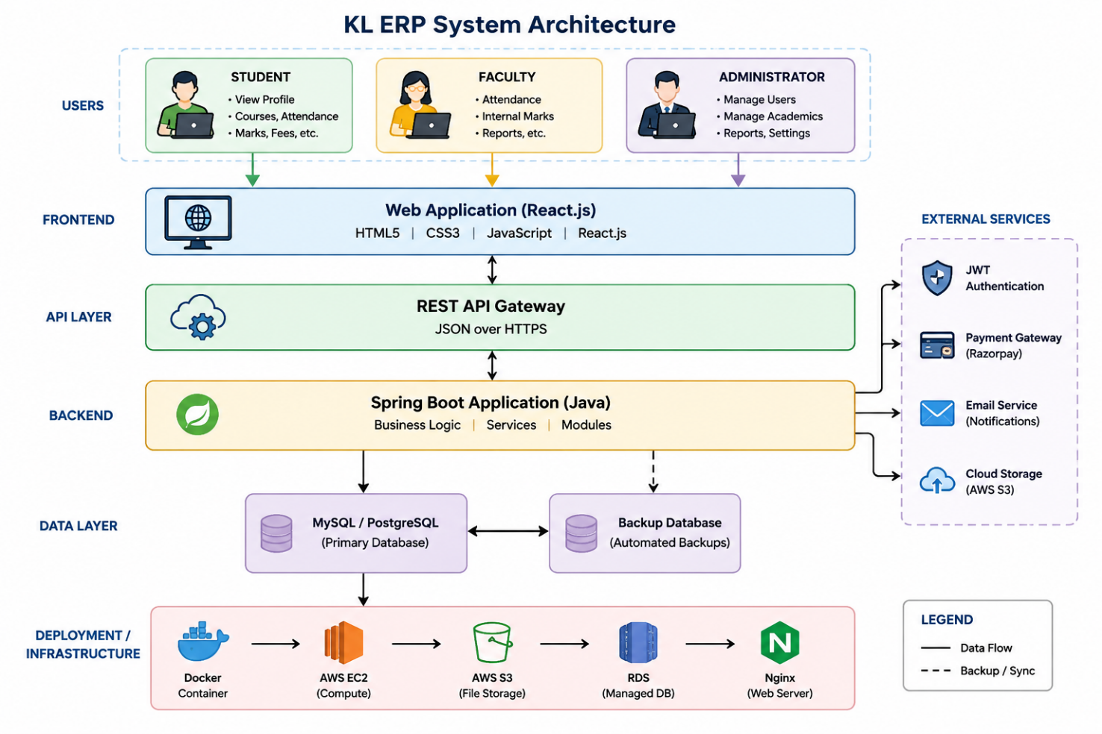
6. Implementation Strategy
Phase 1 – Requirement Analysis
- Gather requirements from students, faculty, and administrators.
- Prepare Software Requirement Specification (SRS).
- Design use case diagrams.
Phase 2 – System Design
- Design database schema.
- Design UI wireframes.
- Create UML diagrams.
- Develop system architecture.
Phase 3 – Development
- Implement user authentication.
- Develop student dashboard.
- Implement attendance management.
- Develop marks management.
- Integrate fee payment gateway.
- Develop faculty and admin dashboards.
Phase 4 – Testing
Unit Testing
- Login
- Registration
- Attendance
- Marks
- Fee Payment
Integration Testing
- Attendance + Student Dashboard
- Marks + Result Generation
- Fee Payment + Receipt Generation
System Testing
- Complete application testing
User Acceptance Testing (UAT)
- Verify academic and administrative requirements.

Phase 5 – Deployment
- Docker Container
- AWS EC2
- MySQL Database
- Nginx Web Server

7. Evaluation Strategy
Evaluation Parameter | Method
Functional Accuracy | Requirement verification
Performance | Load testing using JMeter
Security | Authentication and penetration testing
Reliability | Continuous monitoring
Usability | Student and Faculty feedback
Scalability | Concurrent user testing
Maintainability | Code review and documentation

8. Expected Outcomes
- Secure ERP portal for students, faculty, and administrators.
- Easy access to attendance and academic records.
- Efficient course registration and fee payment.
- Accurate marks and result management.
- Improved communication between students and faculty.
- Centralized academic administration.
- Scalable architecture supporting future enhancements.

