HTML Quick-Styler
AI-Powered HTML Page Generator with IBM Granite 3.3 2B

ABSTRACT:
HTML Quick-Styler is a simple tool used to style HTML web pages easily. It helps users change colors, fonts, sizes, and layouts quickly without writing complex CSS code. This tool is very useful for beginners who are learning web development. Users can design web pages in a fast and simple way using a user-friendly interface. It saves time and reduces coding effort while creating websites. HTML Quick-Styler also helps users create attractive and clean web pages. Overall, it makes website designing easier and more efficient for students and beginners.

INTRODUCTION:
HTML Quick-Styler is a simple web development tool used to apply styles to HTML web pages easily. In web design, styling is important to make a website look attractive and user-friendly. Normally, developers use CSS coding to style web pages, but beginners may find it difficult to write and understand CSS.
The HTML Quick-Styler project helps solve this problem by providing an easy way to add styles such as colors, fonts, sizes, and layouts. Users can quickly apply different styles without writing long CSS code. This makes web page designing faster and easier.
This project is mainly useful for students and beginners who are learning HTML and web design. It helps them understand how styling works in web pages and improves their creativity in designing websites. Overall, HTML Quick-Styler makes the process of styling web pages simple and efficient.

SYSTEM ANALYSIS:
HTML Quick Styler is a tool designed to help users quickly create and style HTML web pages. It simplifies the process of applying styles such as colors, fonts, layouts, and spacing without writing complex CSS code. The system mainly focuses on saving time and improving the efficiency of web development.

Existing System:
In the existing system, users must write HTML and CSS code manually to design and style web pages. This process requires good programming knowledge and more time. Beginners may face difficulty in understanding CSS properties and applying styles correctly. Errors in coding can also affect the webpage design and layout.

Proposed System:
The proposed system, HTML Quick Styler, makes web page styling faster and easier. It provides a simple interface where users can quickly apply styles to HTML elements. The system automatically generates styled output and shows instant preview. This reduces coding effort and helps users create attractive webpages efficiently.

ARCHITECTURE OVERVIEW:
HTML Quick-Styler is built as a modular platform combining Python backend with IBM Granite 3.3 2B Instruct model for intelligent HTML generation. The architecture prioritizes user experience, design quality, and code production through Gradio's interactive interface and sophisticated template generation.

CORE TECHNOLOGIES:
• Python 3.x: Core programming language for application logic
• IBM Granite 3.3 2B Instruct: AI model for intelligent content generation
• Gradio: Interactive web interface framework for user interaction
• HTML5/CSS3: Modern web standards for page generation
• JavaScript: Client-side interactivity and animations
• Google Colab: Cloud-based development environment
• Responsive Design: Mobile-first approach with media queries

SYSTEM SPECIFICATION:
System specification defines the technical requirements and features needed for the HTML Quick Styler system to work properly. It includes the hardware and software requirements, system functions, and user needs. The concept of system specification is to ensure that the system runs smoothly and efficiently. It also helps developers understand how the system should be designed and implemented.
HARDWARE REQUIREMENT:
• Processor: Intel i3 or equivalent (Colab runs on cloud)
• RAM: Minimum 4GB local (Colab provides GPU/TPU)
• Storage: 1GB free space for generated files
• Display: Minimum 1280x720 resolution for interface
SOFTWARE REQUIREMENT:
• Python 3.8+: Download from python.org
• Google Account: Required for Google Colab access
• Gradio: Install via pip (pip install gradio)
• Web Browser: Chrome, Firefox, Safari, or Edge
• Internet Connection: Required for Colab and model access

PROJECT WORKFLOW:
Phase 1: Environment Setup & Model Configuration
Establish Google Colab environment and configure Granite model
Activity 1.1: Set up Google Colab Environment
• Create new Google Colab notebook
• Enable GPU runtime for better performance
• Install required Python packages
• Verify environment configuration
Activity 1.2: Configure IBM Granite Model
• Access Hugging Face model repository
• Load Granite 3.3 2B Instruct model
• Test model inference capabilities
• Configure generation parameters
Activity 1.3: Install and Configure Gradio
• Install Gradio via pip
• Test basic Gradio interface
• Configure sharing options
• Verify interface rendering
Phase 2: Core Application Development
Build HTML generation engine and template system
Activity 2.1: Build Color Palette Generator
• Create ColorPaletteGenerator class
• Define 8 color palette schemes
• Implement palette selection logic
• Add color validation methods
Activity 2.2: Implement HTML Page Builder
• Create HTMLPageBuilder class
• Build section detection algorithm
• Implement template generation methods
• Create SEO meta tags generator
Activity 2.3: Develop CSS Generation Engine
• Build comprehensive CSS generator
• Implement responsive design rules
• Add animation and transition effects
• Create mobile-first media queries
Activity 2.4: Build Section Templates
• Create hero section template
• Build features grid template
• Implement portfolio gallery template
• Add contact form template
• Create pricing and testimonial templates

Phase 3: Gradio Interface Development
Create interactive user interface with multiple tabs
Activity 3.1: Interactive HTML Generation & Preview Interface
Activity 3 focuses on designing and implementing a complete HTML generation and visualization interface that enables users to create, customize, preview, and understand web page layouts through an intuitive, multi-section workflow.

Phase 4: Google Colab Deployment:
Integrate all components and perform comprehensive testing
Activity 4.1: End-to-End Integration
• Connect all interface components
• Test data flow between tabs
• Validate generation pipeline
• Test error handling

Phase 5: Deployment & Documentation
Deploy application and create comprehensive documentation
Activity 5.1: Functionality testing
• Configure Gradio sharing settings
• Enable public access link
• Test external access
• Document deployment steps

SYSTEM DESIGN:
System design explains how the HTML Quick Styler works. The system has a simple interface where users can enter HTML code and choose styling options. The system processes the input and applies the selected styles. Finally, it displays the styled web page as output with a quick preview.
PROJECT STRUCTURE:
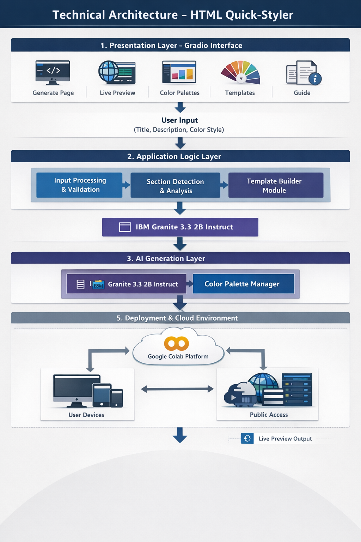

MILESTONE 1: Environment Setup & Model Configuration
Establish Google Colab environment and configure Granite model
Activity 1.1: Install Dependencies & Setup Environment
Create requirements.txt:
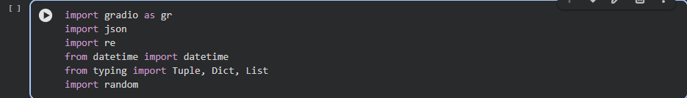

Activity 1.2: Configure IBM Granite Model
Access Hugging Face and load model:
Model: ibm-granite/granite-3.3-2b-instruct
Colab Notebook:
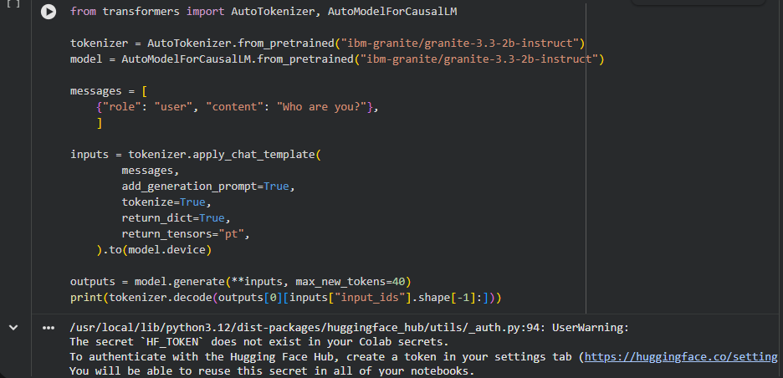
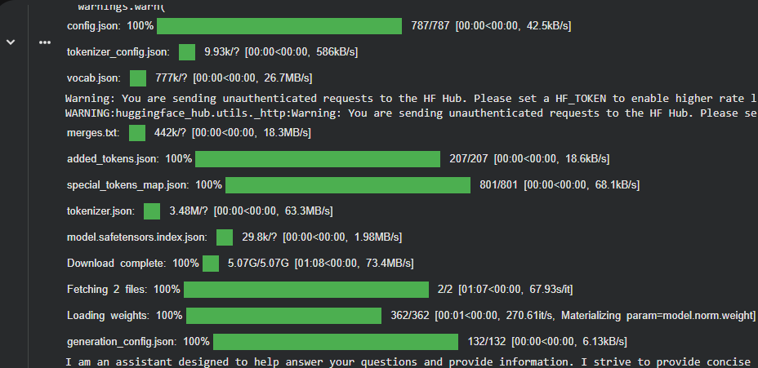

MILESTONE 2: Core Application Development
Activity 2.1: Color Palette Generator Implementation
Create ColorPaletteGenerator class with 8 predefined color schemes:
The ColorPaletteGenerator class provides cohesive color palettes for different design styles including modern, vibrant, ocean, forest, sunset, luxury, creative, and minimal. Each palette includes primary, secondary, accent, background, surface, text primary, text secondary, and border colors optimized for dark theme interfaces.
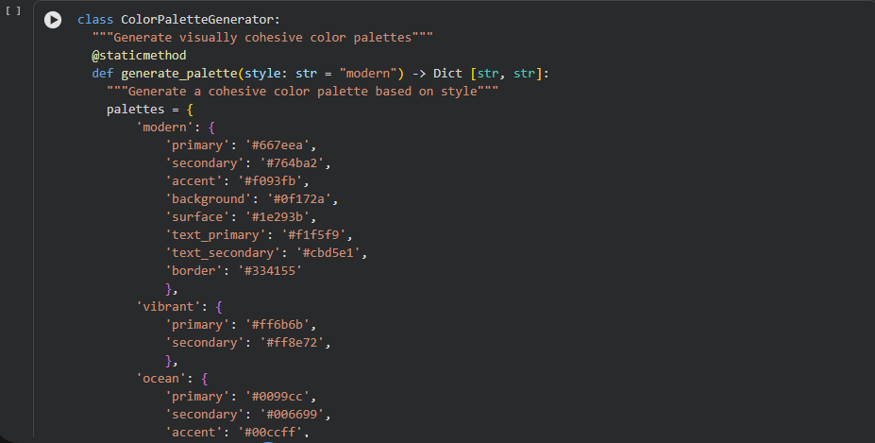
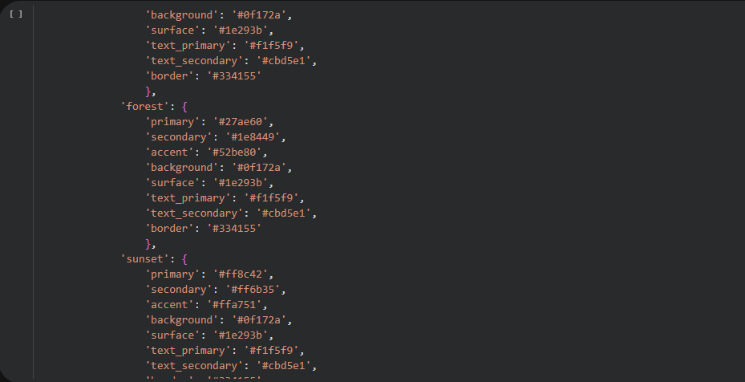
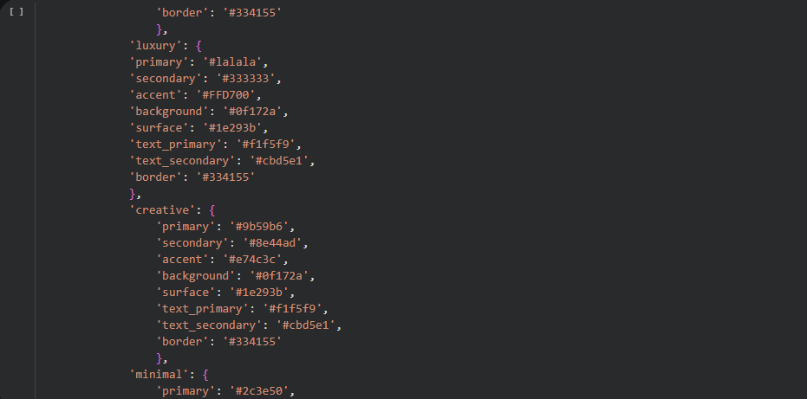
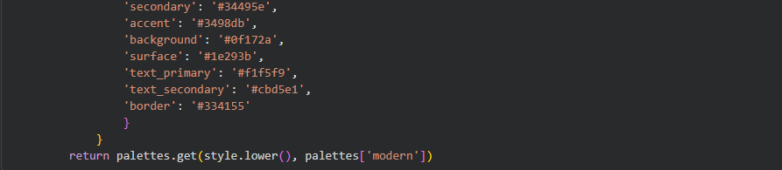

Activity 2.2: HTML Page Builder Implementation
The HTMLPageBuilder class includes:
• Section extraction from user descriptions
• Keyword detection for hero, features, about, portfolio, testimonials, pricing, contact, and footer sections
• SEO meta tags generation with Open Graph and Twitter Card support
• Individual section HTML generation with professional templates
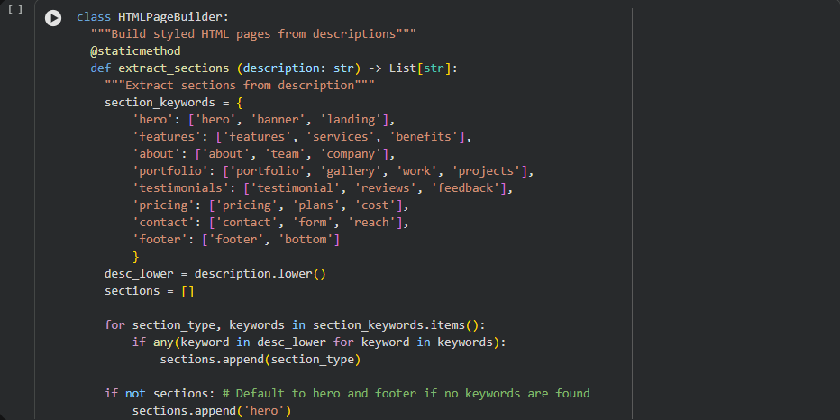
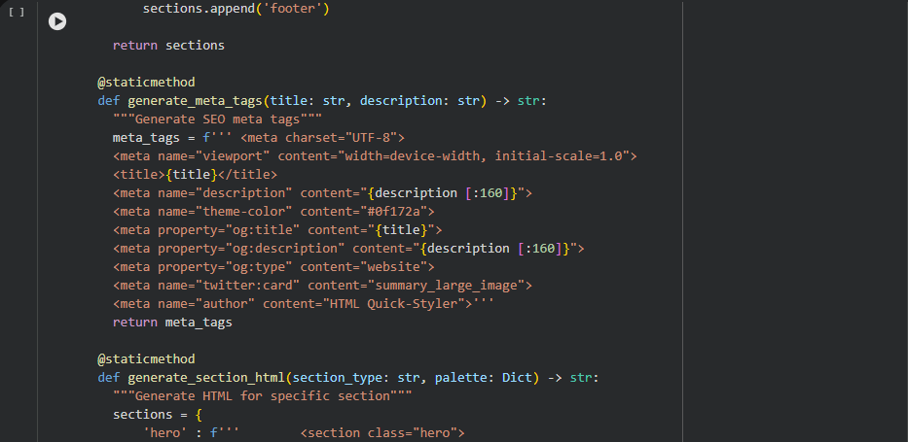
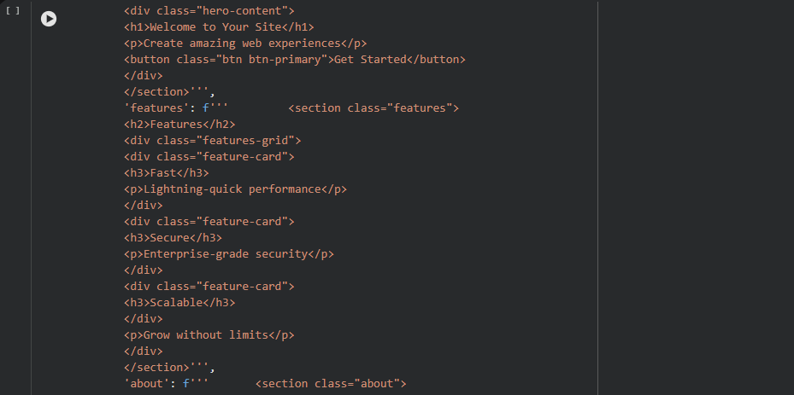
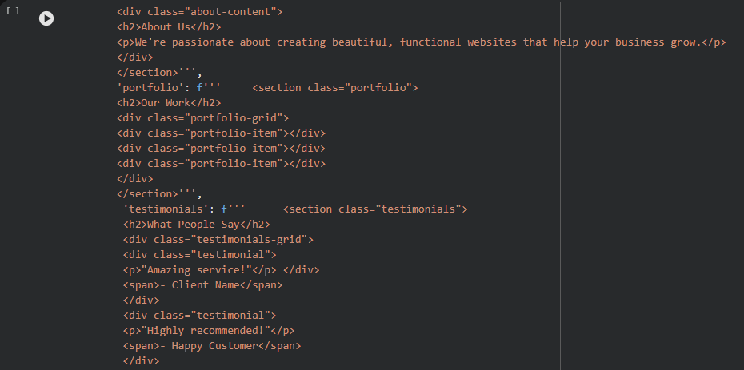
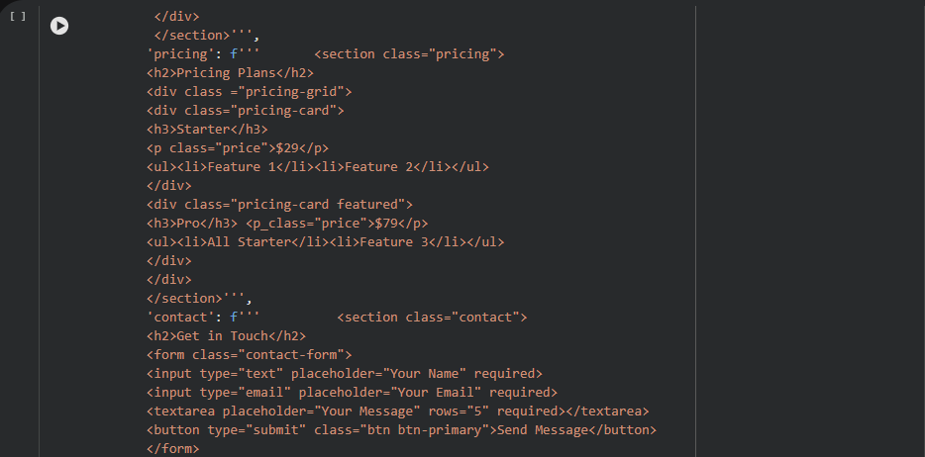
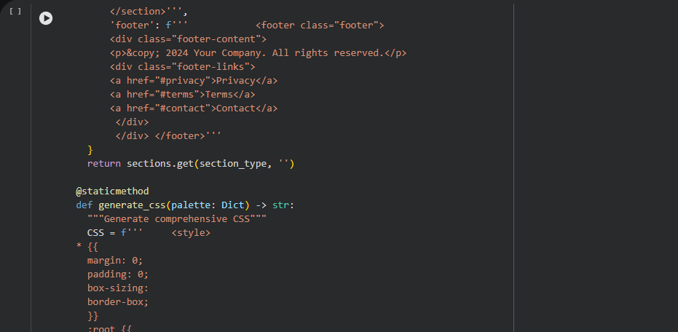
Activity 2.3: CSS Generation Engine
The CSS generator creates comprehensive styling including:
• CSS variables for dynamic color management
• Gradient backgrounds and modern animations
• Responsive grid layouts with Flexbox and CSS Grid
• Smooth transitions and hover effects
• Mobile-first media queries for tablets and phones
• Sticky header with backdrop blur effect
• Card-based components with depth and shadows
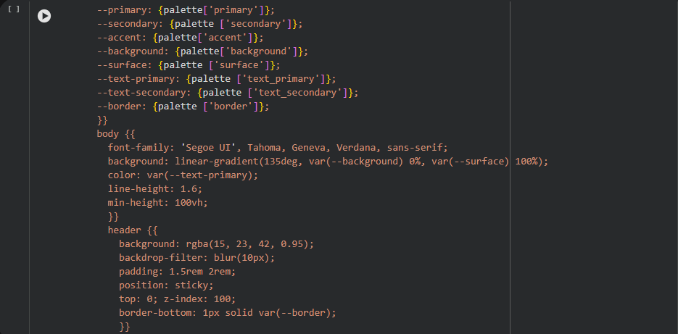
MILESTONE 3: Gradio Interface Development
Activity 3.1: Main Interface with Multiple Tabs
The Gradio interface includes 5 tabs:

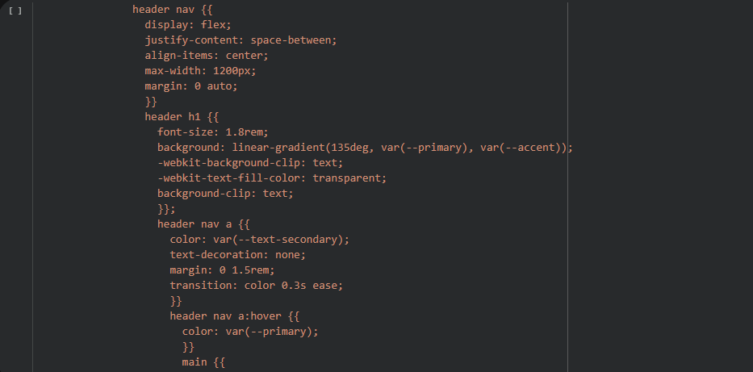
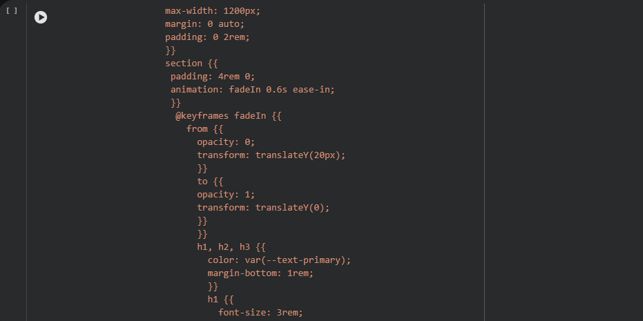
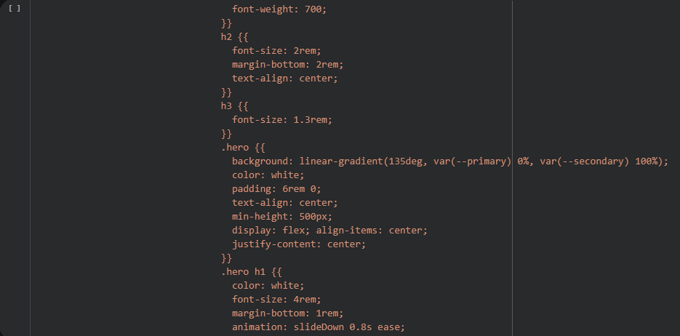
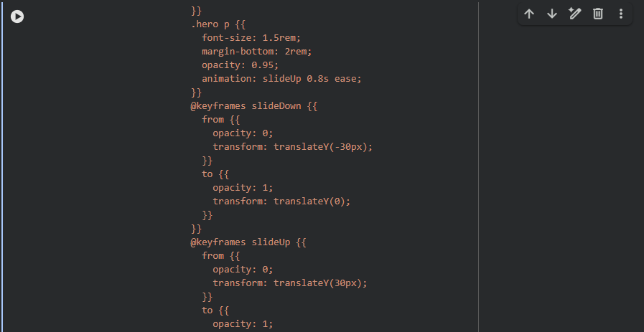
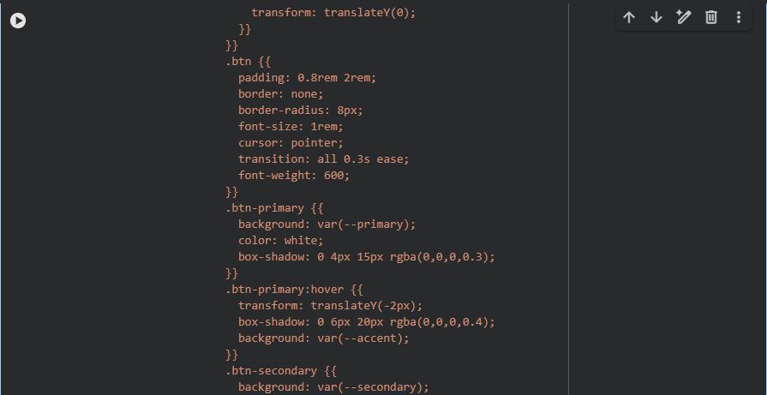
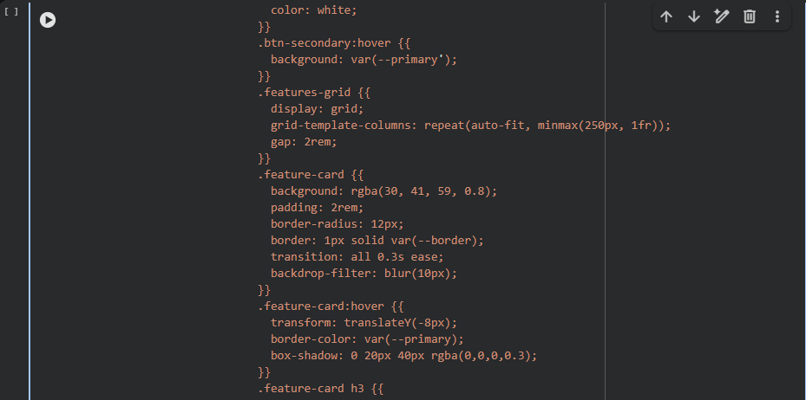
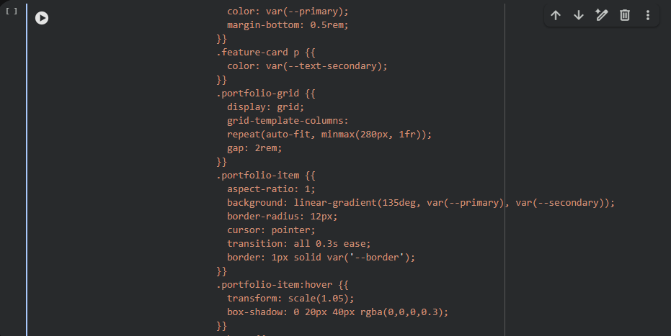
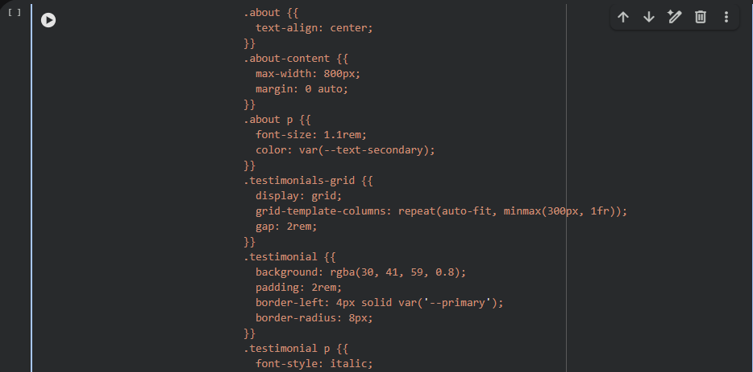
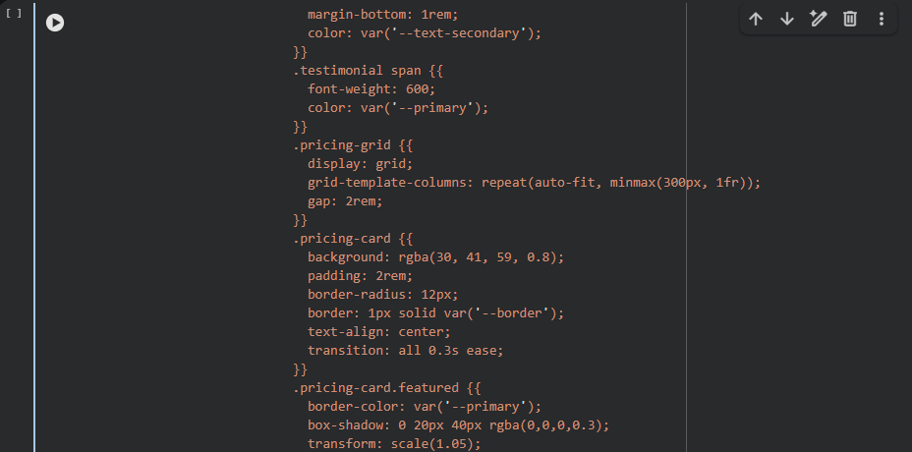
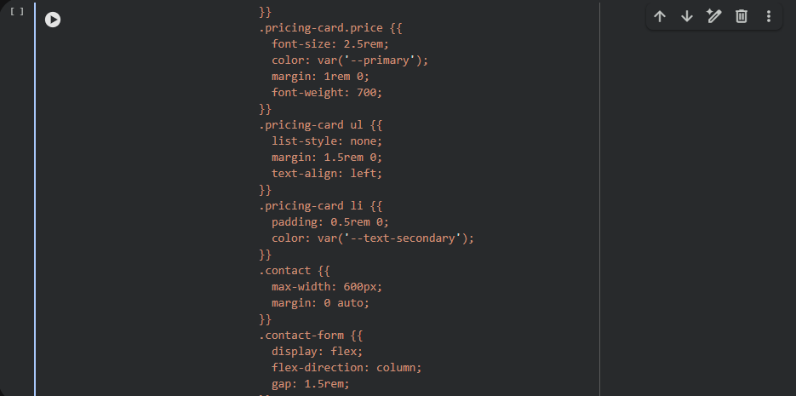
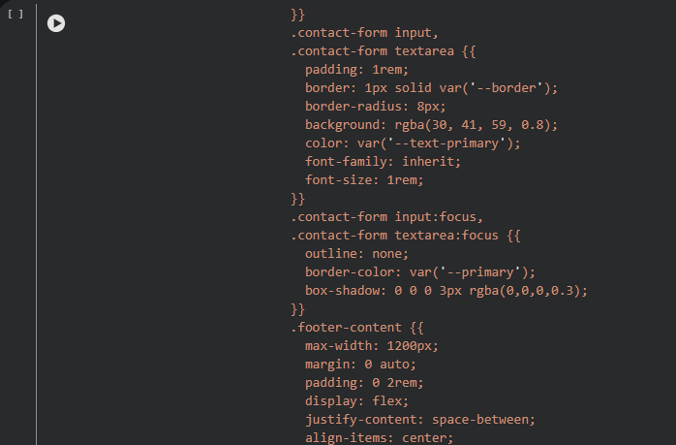
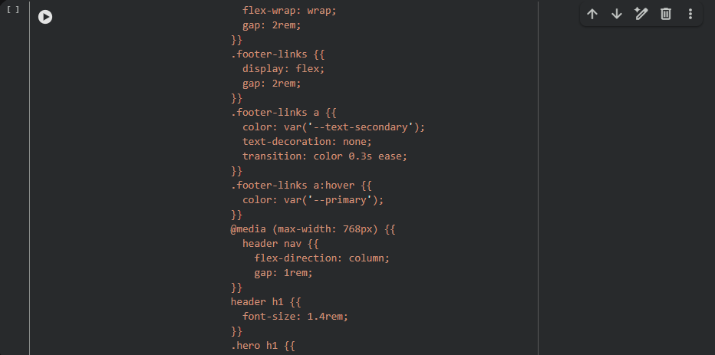
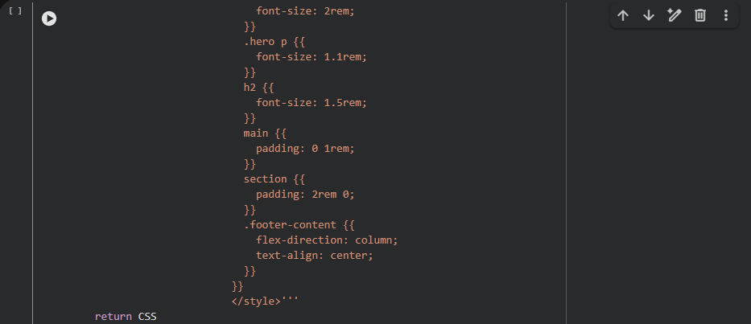
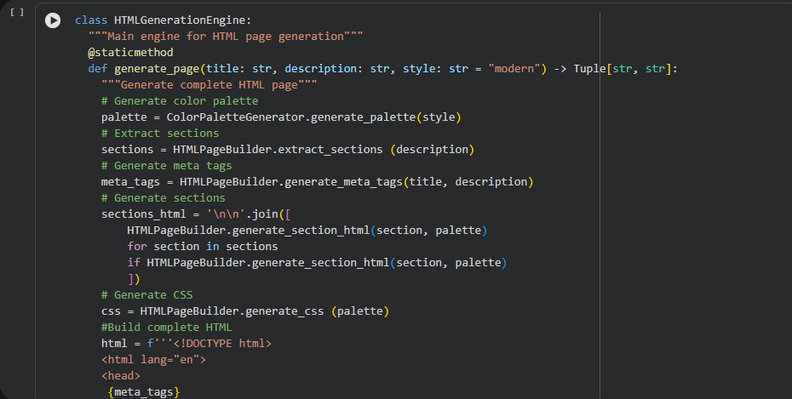
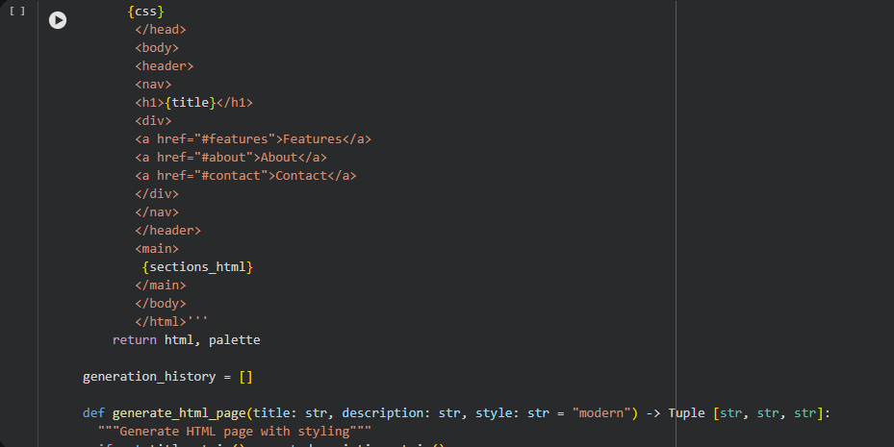
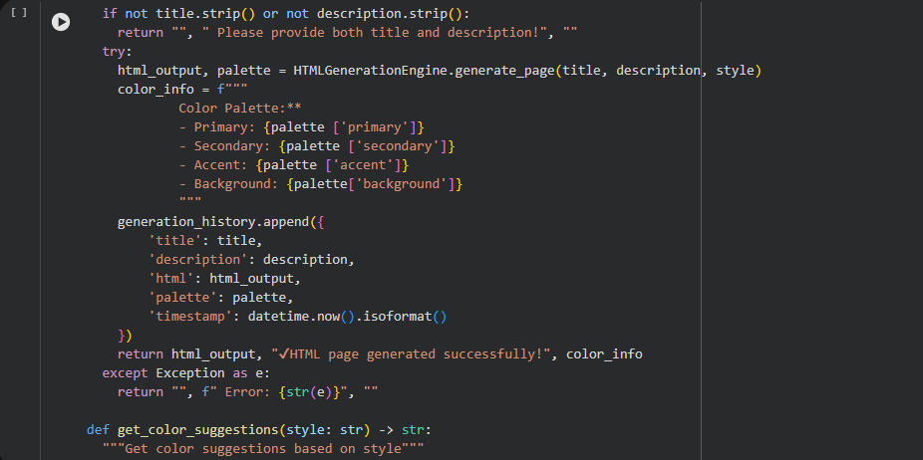
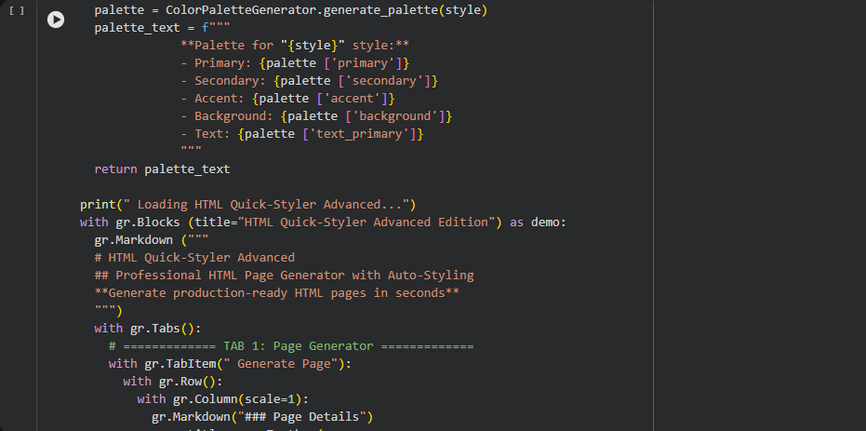
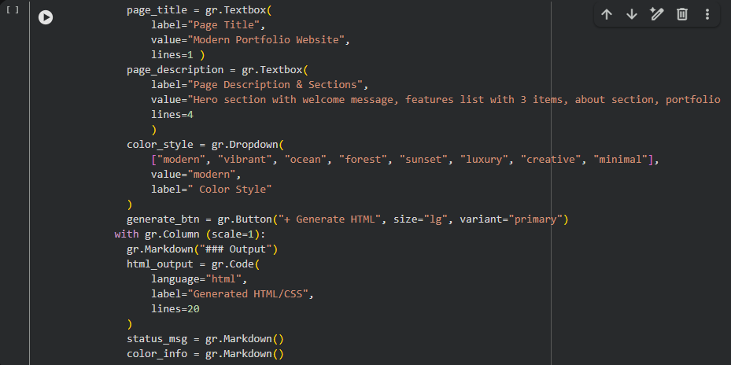
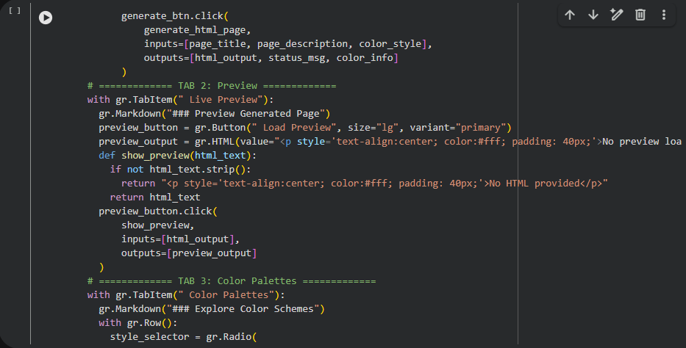
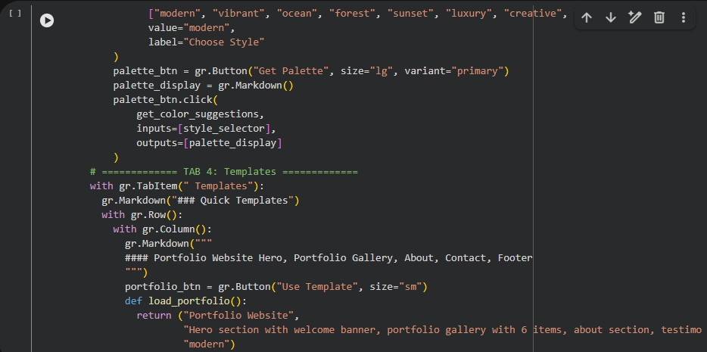
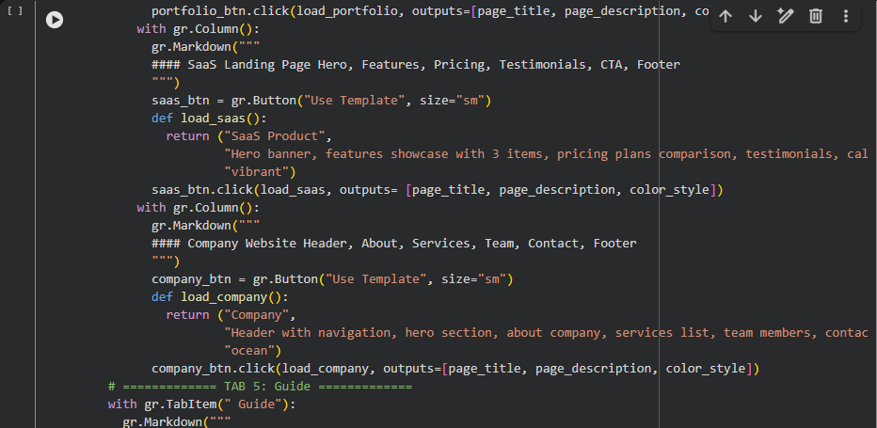
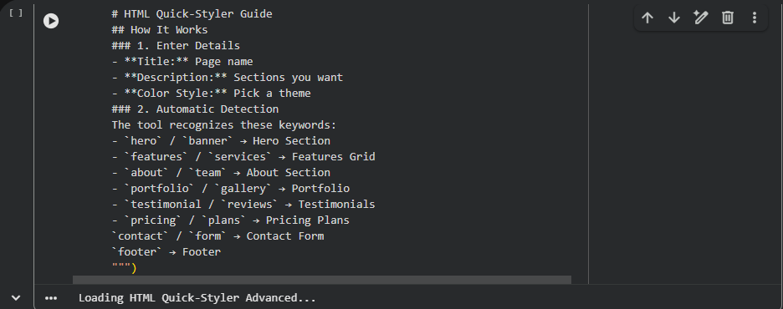

MILESTONE 4: Deployment
Activity 4.1: Google Colab Deployment
Launch the application in Google Colab:
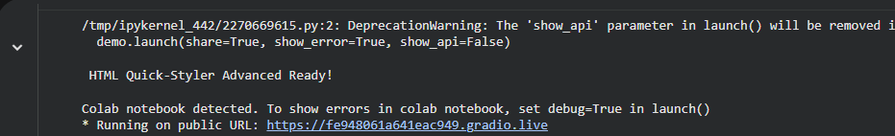
The application will be accessible via:
• Public URL: https://fe948061a641eac949.gradio.live
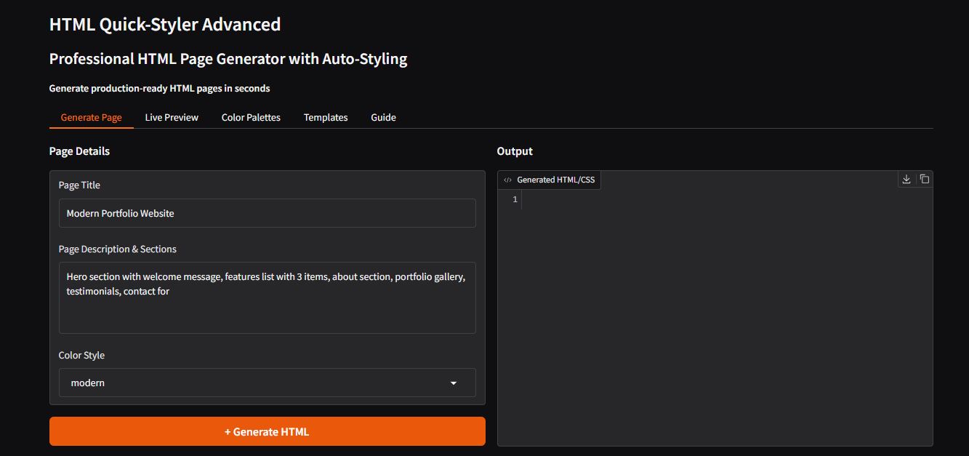

MILESTONE 5: Testing & Validation
Activity 5.1: Functional Testing
Test Case 1: Portfolio Website Generation
Input:
• Title: Modern Portfolio Website
• Description: Hero section with welcome message, features list with 3 items, about section, portfolio gallery, testimonials, contact form, and footer
• Color Style: modern

Expected Output:
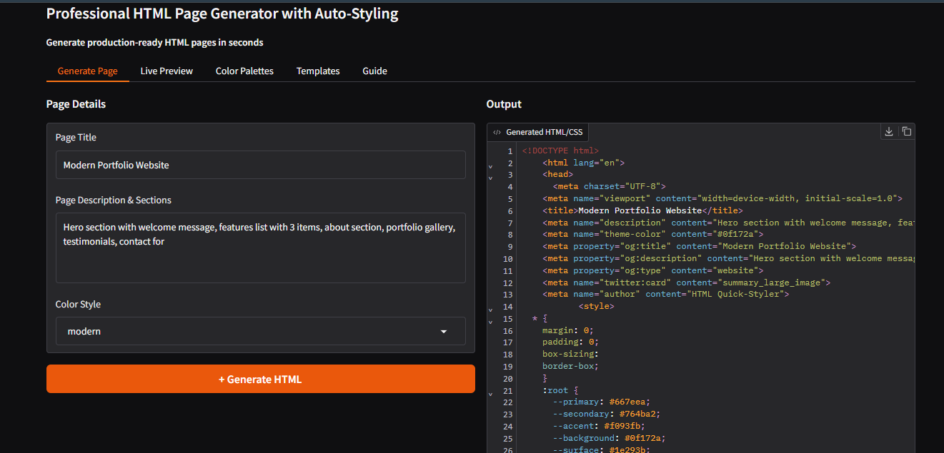
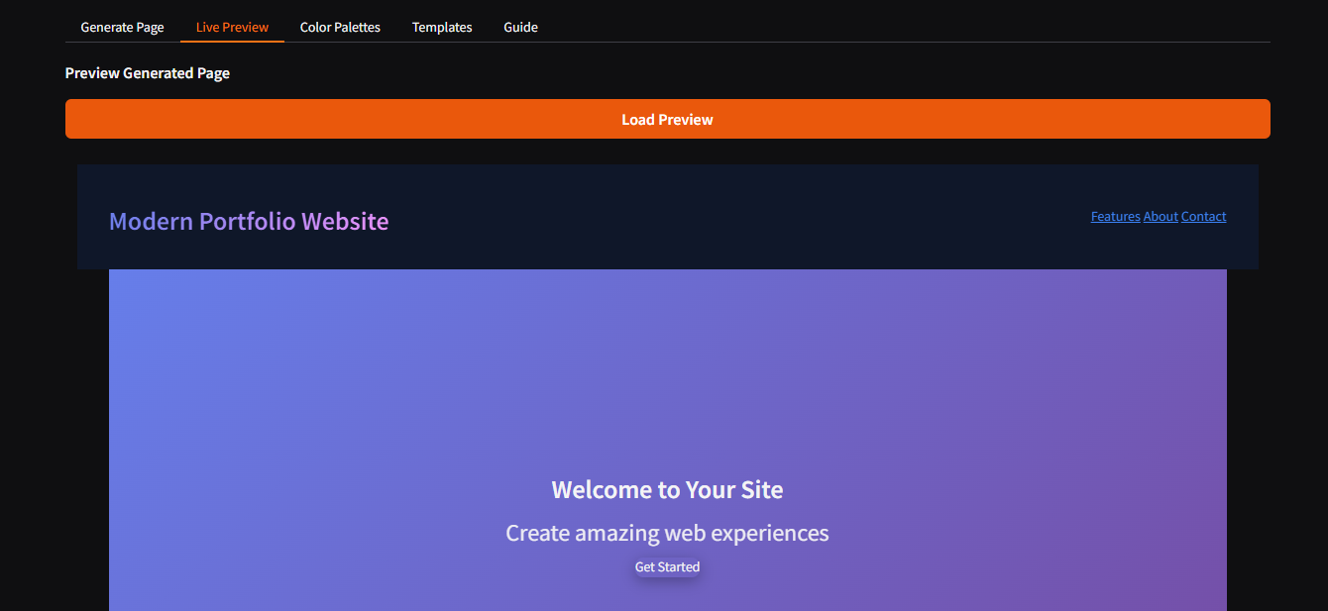
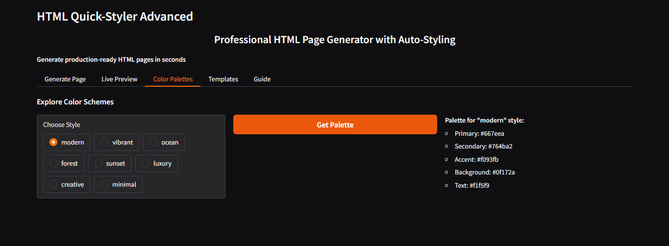
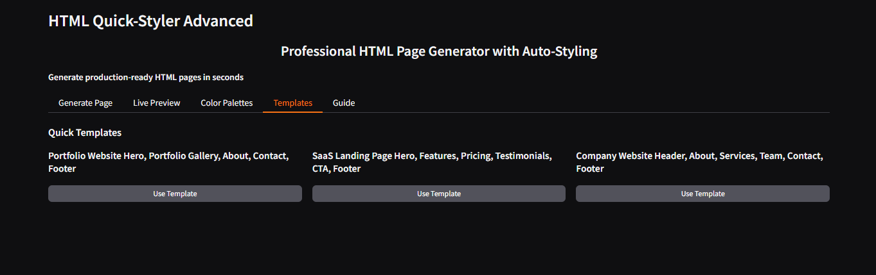
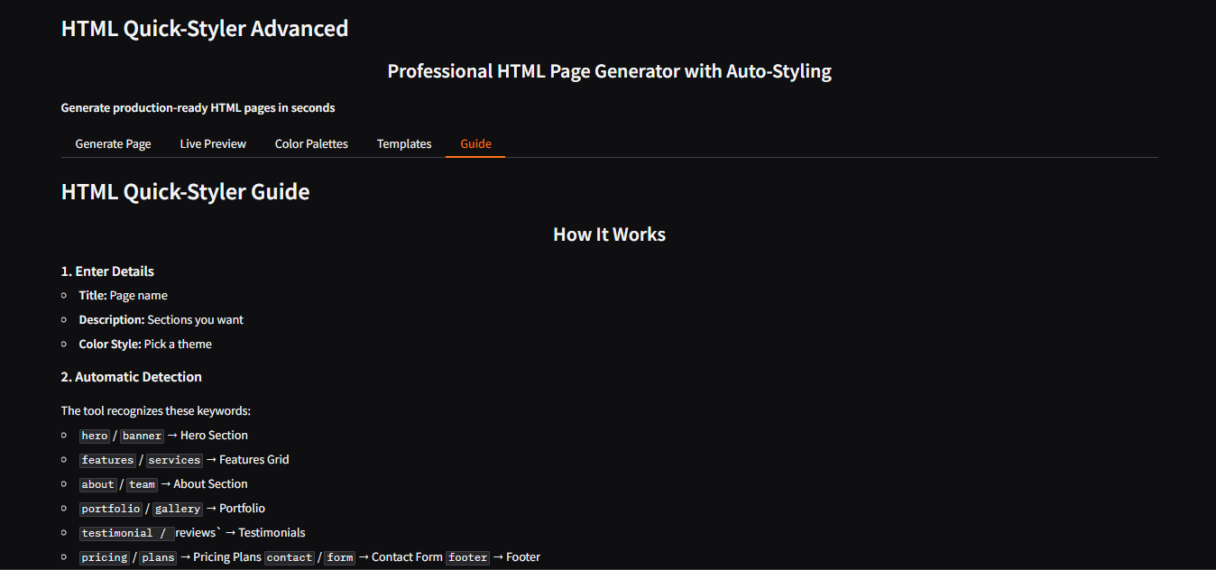

FUTURE ENHANCEMENT:
In the future, HTML Quick Styler can include more advanced styling options and templates for better webpage design. The system can also support more programming features like JavaScript integration. A drag-and-drop interface can be added to make designing even easier. It can also include AI suggestions to automatically improve webpage styles.

CONCLUSION:
HTML Quick Styler is a useful tool that helps users quickly design and style web pages. It reduces the difficulty of writing complex CSS code and saves time in web development. The system provides a simple and user-friendly interface for applying styles easily. Overall, it helps beginners and developers create attractive web pages more efficiently.

BIBLIOGRAPHY:
- Duckett, Jon. HTML and CSS: Design and Build Websites. Wiley Publications.
- W3Schools. “HTML and CSS Tutorials.” Available at: https://www.w3schools.com
- Mozilla Developer Network (MDN). “HTML and CSS Documentation.” Available at: https://developer.mozilla.org
- Freeman, Elisabeth & Robson, Eric. Head First HTML and CSS. O’Reilly Media.

