Ai-Driven Drug Repositioning Using Graph Neural Networks
Rushikesh Vinayak Jagtap¹, Srija Paul Chowdhury² and Mathan Kumar Mounagurusamy³
¹Student, Dept. of Computing Technologies, S.R.M. Institute of Science and Technology, Kattankulathur, India
²Student, Dept. of Computing Technologies, S.R.M. Institute of Science and Technology, Kattankulathur, India
³Assistant Professor, Dept. of Computing Technologies, S.R.M. Institute of Science and Technology, Kattankulathur, India
rj2672@srmist.edu.in, sp4125@srmist.edu.in, drmathan16@gmail.com
Keywords: Drug Repositioning, Graph Neural Networks, Link Prediction, Biomedical Knowledge Graph
Abstract: Drug repurposing is a strategy of identifying new therapeutic uses for existing, approved, or failed drugs, distinct from their original indication. However, many computational approaches rely on limited or homogeneous datasets, which restricts their ability to capture the complex multi-relational structure of biological systems. In this work, we propose an AI-driven drug repositioning framework based on Heterogeneous Graph Neural Networks to model large-scale biomedical knowledge graphs. The framework integrates three major biomedical databases: DrugBank (reports on 26,766 drug protein interactions which include 9,875 drugs and 5,096 proteins), STRING (which reports 472,588 high confidence protein-protein interactions from a filter at combined score of at least 700 out of 13.7 million interactions) and DisGeNET (which has 38,959 protein disease associations that are mapped through UniProt NCBI Gene ID). We use a 3-layer GraphSAGE encoder that produces contextual node embeddings, out of which a 2-layer MLP decoder is trained for drug-disease link prediction, which is based on biologically relevant pathways. We report performance of 86.8% accuracy, 82.6% precision, 93.4% recall, F1 score of 87.7% and an ROC-AUC of 0.942.

1 Introduction
Drug discovery is still a very resource intensive issue in modern medicine. It takes over a decade to develop a new therapeutic compound with a price tag of over a billion US dollars, and there is a high failure rate in clinical trials. Recent advances in graph representation learning, including Graph Neural Networks (GNNs) [3][4], have produced powerful tools to integrate multi-relational data. By looking at local graph neighborhoods, GNNs put together embeddings which encode structural and semantic relationships. When applied to heterogeneous graphs with many node and edge types, these models become very effective for biomedical discovery [6].
In our work we built a large-scale biomedical knowledge graph from DrugBank [9], STRING [10], and DisGeNET [11], connected via over 500,000 biologically relevant edges between drugs, proteins and diseases. We then trained a 3-layer Heterogeneous GraphSAGE model [4] with a link prediction decoder to present novel drug-disease associations. We also developed an interpretable drug recommendation system which uses multi-hop biological pathway traversal to rank the best candidate drugs for any given disease.
This study made the following major contributions: (1) We combine multiple biomedical datasets to create a large-scale heterogeneous biomedical knowledge graph, containing around 10,000 drugs, nearly 19,000 proteins and thousands of diseases. (2) We devise a three-layer Heterogeneous GraphSAGE encoder with a two-layer MLP decoder for accurate drug–disease link prediction. (3) The proposed model attained an accuracy of 86.8%, a precision of 82.6%, a recall of 93.4%, an F1-score of 87.7%, and a ROC-AUC of 0.942. (4) We propose an interpretable model for identifying drug candidates according to multi-hop biological pathway analysis.

2 Literature Survey
2.1 Traditional Drug Repositioning Methods
Early approaches to computational drug repurposing used drug similarity metrics based on chemical structure, gene expression and side effect signatures [13][14]. Gottlieb et al. [1] proposed the PREDICT framework for integration of drug and disease similarity matrices with supervised learning to predict new indications. While effective in limited settings, these methods rely on pairwise similarity between drugs and do not capture multi-hop biological relationships between drugs, proteins and diseases [18].
2.2 Network-Based Approaches
Network Medicine Approaches use Protein-Protein Interaction Networks for predicting drug-disease interactions, through the topological distance between the drug target and the protein associated with the disease [2]. Methods such as DIAMOnD and Network Proximity Scoring [15][18] have shown high levels of biological interpretability.

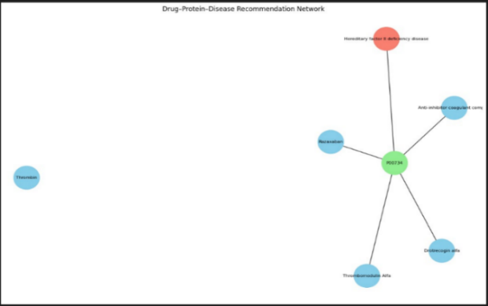
Fig Drug–Protein–Disease Recommendation Network
2.3 Graph Neural Networks in Biomedicine
Kipf and Welling proposed Graph Convolutional Networks (GCNs) for semi-supervised node classification [3] and Hamilton et al. proposed GraphSAGE for inductive learning of nodes on a graph with large number of nodes through neighborhood sampling and aggregation [4]. This work extends that, using Heterogeneous GraphSAGE through PyTorch Geometric [7] to enable relation-specific message passing across all edge types at once.
2.4 Knowledge Graph Embeddings
Methods such as TransE [17] learn low-dimensional entity and relation embeddings for biomedical link prediction. However, these methods treat entities as atomic vectors and cannot learn about graph structure through neighborhood aggregation [16]. Our approach is unique in combining GNN-based structural learning with multi-relational heterogeneous graph semantics.
2.5 Heterogeneous Graph Learning
Hu et al. introduced the Heterogeneous Graph Transformer which employs a type-specific attention mechanism for handling multi-relational graphs [8]. Although attention is powerful, the computational cost can be substantial. Therefore, we selected Heterogeneous GraphSAGE, utilizing a mean aggregation scheme as an efficient and scalable alternative for our large-scale biomedical graph containing over 500,000 edges.

3 Methodology
The proposed drug repositioning framework follows a systematic pipeline involving data collection, preprocessing, heterogeneous graph construction, and GNN-based link prediction. The methodology is organized into five subsections.
3.1 Dataset Description
Three major biomedical databases were integrated in this work.
DrugBank: A broad database of drug-target interaction information. Parsed in XML format using xml.etree.ElementTree. A total of 26,766 clean drug-protein interactions were extracted, with 9,875 unique drugs and 5,096 unique proteins.
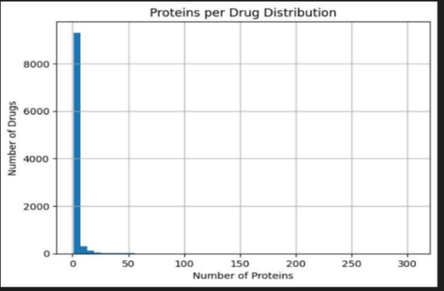
Fig. 1. Proteins per Drug Distribution

STRING: The STRING v12.0 database contains human protein-protein interaction networks (taxonomy ID: 9606) with 13,715,404 raw interactions. Filtering to a combined_score ≥ 700 reduced this to 473,860 interactions. After mapping Ensembl protein IDs to UniProt IDs, the final dataset contains 472,588 protein-protein edge pairs.
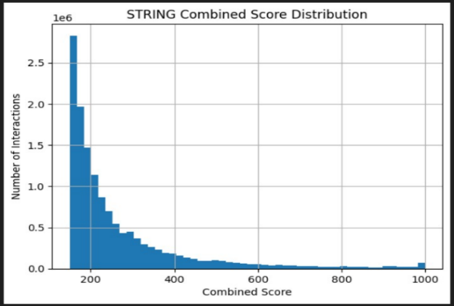
Fig. 2. STRING Combined Score Distribution
DisGeNET: Disease association data accessed via REST API. UniProt IDs were mapped to NCBI Gene identifiers via the UniProt REST API, and protein-disease associations were extracted for each gene, generating 38,959 protein-disease associations.
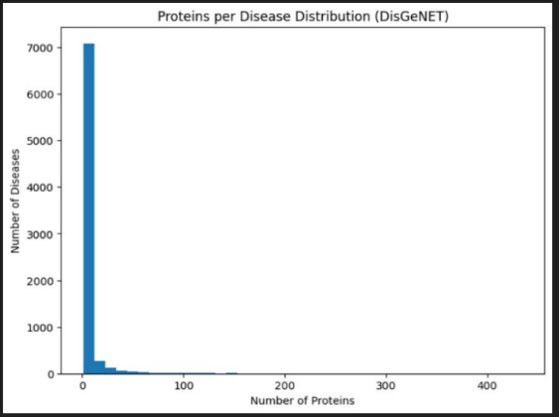
Fig. 4. Proteins per Disease Distribution (DisGeNET)
3.2 Data Preprocessing
Data Cleaning: All datasets were first filtered by removing null values, eliminating duplicates, and filtering out low-confidence interactions. STRING protein-protein interactions with combined score less than 700 were removed. Protein sequences were excluded if they could not be cross-mapped across all identifier namespaces.
Identifier Mapping: Ensembl IDs were mapped to UniProt IDs for STRING using an alias file. UniProt IDs were mapped to NCBI Gene IDs via the UniProt REST API for DisGeNET querying. All identifiers were harmonized to the UniProt namespace before graph construction.
Feature Initialization: All nodes were initialized with 64-dimensional random embedding vectors. Separate matrices were created for drug (9,875 × 64), protein (~19,000 × 64), and disease nodes. These embeddings are learned and refined during GNN training through neighborhood message passing.
3.3 Graph Neural Network Model
Graph Convolution Layers: The encoder is a three-layer Heterogeneous GNN built using HeteroConv with SAGEConv operators from PyTorch Geometric. HeteroConv applies a separate SAGEConv transformation per relation type, enabling relation-specific weight learning.
Embedding Learning: Node embeddings are updated through three rounds of message passing layers. After the first two layers, ReLU activation is applied followed by dropout regularization. The output of the last layer consists of 128-dimensional embeddings for all drug, protein and disease nodes used downstream for link prediction. The two-layer MLP decoder evaluates drug-disease associations.
3.4 Data Integration Process
Drug-protein interactions were acquired from the DrugBank XML dataset using iterative streaming parsing. The UniProt REST API was used to obtain the NCBI Gene ID for each DrugBank protein, and these identifiers were used to extract protein-disease associations from DisGeNET. Duplicate edges were removed and the final integrated dataset was constructed as a heterogeneous graph using PyTorch Geometric’s HeteroData framework.
3.5 Final Graph Structure
A heterogeneous biomedical knowledge graph was constructed using PyTorch Geometric’s HeteroData class integrating all three processed datasets. Table 1 shows node type counts and Table 2 shows edge type counts. The ToUndirected transform was applied to add three reverse edge relations, enabling bidirectional message passing. The complete graph exceeds 500,000 edges and was saved as hetero_graph.pt for model training.
Table 1. Node Type Table.
Node Type | Count
Drug nodes | 9,875
Protein nodes | ~19,000
Disease nodes | Several thousand
Table 2. Edge Type Table.
Relation | Count
Drug targets protein | 26,766
Protein interacts with protein | 472,588
Protein associated with disease | 38,959
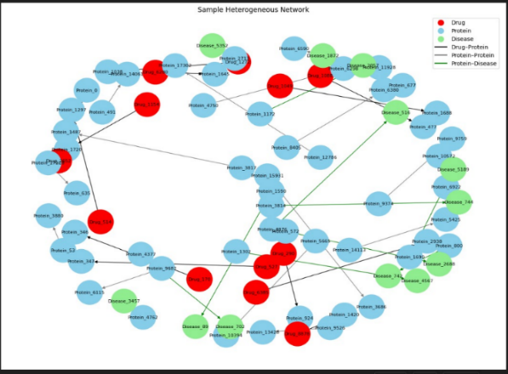
Fig. 5. Sample Heterogeneous Network

4. System Architecture
The architecture of the drug repositioning system is explained in Figure 1. The pipeline has six stages enabling insightful chemical recommendations from raw data. It starts with three data sources: DrugBank, STRING, and DisGeNET. Entity linking across shared identifiers creates a unified heterogeneous knowledge graph. This graph is then fed to the GNN Training phase, where a Heterogeneous GraphSAGE model is trained with an MLP decoder for link prediction. Finally, the Prediction and Ranking stage uses the trained model to perform drug-disease prediction and rank candidates.
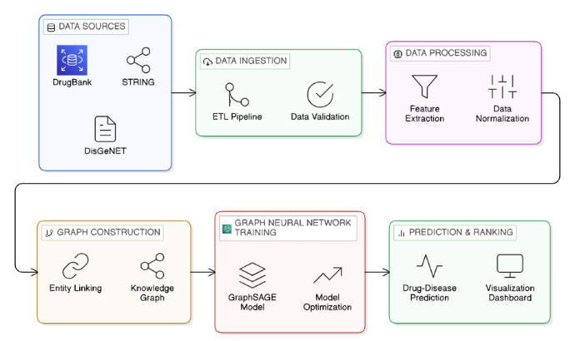
Fig. 6. Architecture Diagram.

5. Results and Evaluation
The proposed Heterogeneous GNN model was evaluated on the 20% held-out test set. The following subsections present a comprehensive analysis of the model performance across all evaluation metrics.
5.1 Classification Metrics
The model was evaluated using standard binary classification metrics on the held-out test set. The results are summarized in Table 3.
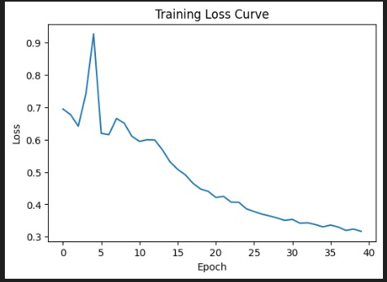
Fig. 7. Training loss curve over 40 epochs showing steady convergence from 0.69 to 0.31.
Metric | Score
Accuracy | 86.8%
Precision | 82.6%
Recall | 93.4%
F1-Score | 87.7%
ROC-AUC | 0.942
Table 3. Classification Metrics.
5.2 ROC-AUC Analysis
The ROC Curve is presented in Figure 2. The model attains an AUC of 0.942, placing it within the excellent classification range (AUC > 0.9). The curve hugs the upper left corner of the plot indicating high true positive rates across all thresholds. The model outperforms the trivial baseline (AUC = 0.5) at every operating point, confirming that the learned heterogeneous graph embeddings are discriminative.
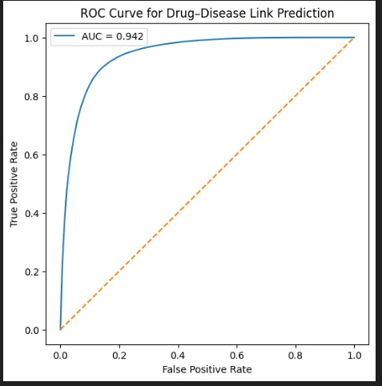
Fig. 8. ROC Curve
5.3 Confusion Matrix Analysis
The confusion matrix at a decision threshold of 0.5 is given in Figure 3. The model recognizes 74,580 drug-disease relationships as true positives and 64,221 true non-relationships as true negatives. The false negative total of 5,310 is significantly smaller than the false positive total of 15,669, consistent with the recall of 93.4% and precision of 82.6%. The 1:1 positive-to-negative sampling ratio during training has prevented class bias in predictions.
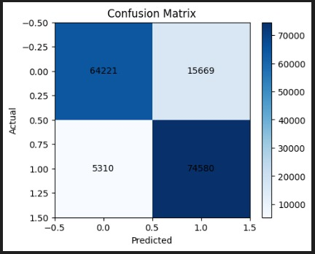
Fig. 9. Confusion Matrix

6. Conclusion
This paper presents an AI-driven system for drug repositioning using a heterogeneous biomedical knowledge graph integrating DrugBank, STRING, and DisGeNET. The system learns complex connections between drugs, proteins, and diseases. With three components working together for prediction, it achieves approximately 86.8% accuracy, 82.6% precision, 93.4% recall, and an ROC-AUC of 0.942. Future work includes incorporating molecular and protein structural details and using architectures such as the Heterogeneous Graph Transformer to further improve prediction accuracy.

Acknowledgment
The authors would like to thank the S.R.M. Institute of Science and Technology, Department of Computing Technologies, for providing the resources and support necessary to carry out this research.

References
[1] Gottlieb, S., Magger, O., Berman, I., Ruppin, C., and Sharan, E., 2011. PREDICT: a method for inferring novel drug indications with application to personalized medicine, Mol. Syst. Biol., 7(1), 496.
[2] Barabási, A. L., Gulbahce, N., and Loscalzo, J., 2011. Network medicine: a network-based approach to human disease, Nat. Rev. Genet., 12(1), 56–68.
[3] Kipf, T. N. and Welling, M., 2017. Semi-supervised classification with graph convolutional networks, arXiv preprint arXiv:1609.02907, .
[4] Hamilton, W. L., Ying, Z., and Leskovec, J., 2017. Inductive representation learning on large graphs, Adv. Neural Inf. Process. Syst., 30(1), 1024–1034.
[5] Zitnik, M., Agrawal, M., and Leskovec, J., 2018. Modeling polypharmacy side effects with graph convolutional networks, Bioinformatics, 34(13), i457–i466.
[6] Luo, Y. et al., 2017. A network integration approach for drug-target interaction prediction and computational drug repositioning from heterogeneous information, Nat. Commun., 8(1), 573.
[7] Fey, M. and Lenssen, J. E., 2019. Fast graph representation learning with PyTorch Geometric, arXiv preprint arXiv:1903.02428, .
[8] Hu, Z. et al., 2020. Heterogeneous graph transformer, arXiv preprint arXiv:2003.01332, .
[9] Wishart, D. S. et al., 2018. DrugBank 5.0: a major update to the DrugBank database for 2018, Nucleic Acids Res., 46(D1), D1074–D1082.
[10] Szklarczyk, D. et al., 2023. The STRING database in 2023: protein–protein association networks and functional enrichment analyses, Nucleic Acids Res., 51(D1), D638–D646.
[11] Piñero, J. et al., 2020. The DisGeNET knowledge platform for disease genomics: 2019 update, Nucleic Acids Res., 48(D1), D845–D855.
[12] Paszke, A. et al., 2019. PyTorch: an imperative style, high-performance deep learning library, Adv. Neural Inf. Process. Syst., 32(1), 8024–8035.
[13] Napolitano, M. et al., 2013. Drug repositioning: a machine-learning approach through data integration, J. Cheminform., 5(1), 30.
[14] Dudley, J. T., Deshpande, T., and Butte, A. J., 2011. Exploiting drug–disease relationships for computational drug repositioning, Brief. Bioinform., 12(4), 303–311.
[15] Guney, E., Menche, J., Vidal, M., and Barabási, A. L., 2016. Network-based in silico drug efficacy screening, Nat. Commun., 7(1), 10331.
[16] Schlichtkrull, M. et al., 2018. Modeling relational data with graph convolutional networks, Lect. Notes Comput. Sci., 10843(1), 593–607.
[17] Bordes, A., Usunier, N., Garcia-Duran, A., Weston, J., and Yakhnenko, O., 2013. Translating embeddings for modeling multi-relational data, Adv. Neural Inf. Process. Syst., 26(1), 2787–2795.
[18] Cheng, F. et al., 2019. A network-based approach to unraveling the system-level mechanisms of drug repositioning, Drug Discov. Today, 24(3), 793–800.
[19] Kingma, D. and Ba, J., 2015. Adam: a method for stochastic optimization, arXiv preprint arXiv:1412.6980, .
[20] Rolland, T. et al., 2014. A proteome-scale map of the human interactome network, Cell, 159(5), 1212–1226.
[21] Zeng, X. et al., 2019. deepDR: a network-based deep learning approach to in silico drug repositioning, Bioinformatics, 35(24), 5191–5198.
[22] Gysi, D. M. et al., 2021. Network medicine framework for identifying drug-repurposing opportunities for COVID-19, Proc. Natl. Acad. Sci., 118(19), e2025581118.
[23] Himmelstein, D. S. et al., 2017. Systematic integration of biomedical knowledge prioritizes drugs for repurposing, eLife, 6(1), e26726.
[24] Kipf, T. and Welling, M., 2016. Variational graph auto-encoders, arXiv preprint arXiv:1611.07308, .
[25] Huang, B. et al., 2023. MechDrug: a graph-based deep learning framework for drug repositioning via biological mechanism, Bioinformatics, 39(1), btac801.

