INTRODUCTION

The field of dental diagnostics has significantly advanced with the integration of deep learning and computer vision techniques. One such innovative approach is the “Detection of Tooth Position by YOLOv4 and Various Dental Problems Based on CNN with Bitewing Radiograph,” which aims to enhance accuracy and efficiency in identifying dental issues. Traditional dental examinations heavily rely on manual analysis of radiographs by professionals, which can be time-consuming, subjective, and prone to human error. This project leverages the power of artificial intelligence to automate and standardize the diagnostic process.

The system utilizes bitewing radiographs, a common type of dental X-ray, to provide detailed views of the teeth, particularly the crowns and upper portions of the posterior teeth, which are often affected by decay and other issues. YOLOv4 (You Only Look Once version 4), a state-of-the-art real-time object detection algorithm, is used to precisely identify and locate individual teeth within the radiograph images. This detection is followed by classification using a Convolutional Neural Network (CNN), which analyzes the identified regions to detect various dental problems such as cavities, bone loss, and gum diseases.

By combining YOLOv4’s rapid and accurate detection capabilities with CNN’s powerful image classification performance, the system delivers high precision in identifying both tooth positions and dental abnormalities. The automated pipeline not only supports dental professionals by reducing their workload but also ensures early detection and improved treatment outcomes for patients.

This AI-powered diagnostic approach represents a significant step forward in dental healthcare, enabling faster, more reliable, and consistent analysis of radiographs. It also opens the door for further applications of deep learning in dentistry, ultimately contributing to more accessible and high-quality dental care for a broader population. The system has the potential to revolutionize how dental diseases are detected and monitored in both clinical and remote settings.

1.1 PROBLEM STATEMENT

Dental diseases such as cavities, gum infections, and bone loss are among the most common health issues affecting people worldwide. Early and accurate diagnosis is crucial to prevent complications, but the conventional diagnostic approach relies heavily on visual inspection and manual interpretation of radiographic images by dental professionals. This method is time-consuming, subject to human error, and often inconsistent due to varying levels of expertise. Furthermore, in rural or underdeveloped areas, access to skilled dental radiologists is limited, leading to delayed diagnoses and treatments.

Bitewing radiographs are widely used in dental practice to examine the interproximal areas of the teeth, where most cavities and periodontal issues occur. However, interpreting these images accurately requires substantial training and experience. Even skilled dentists may overlook subtle signs of disease progression, especially when multiple abnormalities are present. Additionally, manual analysis does not scale well in high-volume dental practices or research settings, where large datasets of radiographs need to be evaluated.

The increasing availability of medical imaging data and advancements in artificial intelligence (AI) offer a promising solution to these challenges. Yet, current AI applications in dentistry remain limited in scope, focusing either on detecting cavities or segmenting teeth, with little integration between tooth localization and disease classification.

The primary problem addressed by this project is the need for an integrated, automated system capable of accurately detecting individual tooth positions and diagnosing various dental conditions from bitewing radiographs. By using YOLOv4 for real-time tooth localization and CNN for disease classification, this project aims to develop a robust, scalable tool that enhances diagnostic precision, supports dental professionals in clinical decision-making, and provides patients with quicker and more consistent care. The system not only reduces dependency on expert interpretation but also increases access to dental diagnostics in resource-limited environments.

1.2 SCOPE AND OBJECTIVE OF THE PROJECT

The primary objective of this project is to develop an automated system for detecting tooth positions and diagnosing various dental problems using bitewing radiographs. This system leverages the power of YOLOv4 for real-time object detection and Convolutional Neural Networks (CNNs) for disease classification, aiming to assist dental professionals in identifying oral health issues with greater accuracy and efficiency.
The main objectives of the project are:
- To automate the detection of individual tooth positions in bitewing radiographs using YOLOv4, thereby reducing the time and effort required for manual localization.
- To classify and identify various dental problems such as caries, bone loss, and infections using CNN-based deep learning models.
- To provide a visual interface for uploading and analyzing dental images, enabling easy access and usability for dentists and healthcare workers.
- To ensure accurate and consistent diagnosis, reducing human error and inter-observer variability in radiographic interpretations.
- To make dental diagnostic tools accessible even in remote or underserved areas by eliminating the need for constant expert supervision.
The scope of this project includes:
- Collection and preprocessing of bitewing radiographs for training and evaluation.
- Integration of the YOLOv4 object detection algorithm for precise tooth localization.
- Design and training of CNN models for dental disease prediction based on segmented tooth images.
- Development of a user-friendly web-based interface to interact with the system.
- Visualization of results including predicted disease, confidence scores, confusion matrices, and training performance graphs.
- Support for expanding the system to include additional radiographic views (e.g., panoramic, periapical) and broader disease categories in the future.

LITERATURE REVIEW

The integration of artificial intelligence (AI) into medical imaging, particularly in the field of dentistry, has garnered significant interest over the past decade. The development of computer-aided diagnosis (CAD) systems using deep learning techniques has enabled efficient and accurate identification of various dental anomalies. This literature review explores relevant studies and technologies used for detecting tooth positions and diagnosing dental diseases using bitewing radiographs.

Early research in dental imaging primarily relied on traditional image processing techniques such as thresholding, edge detection, and histogram analysis. However, these methods lacked the ability to generalize across different datasets and often required manual tuning of parameters. With the advent of machine learning, researchers began employing supervised learning algorithms such as Support Vector Machines (SVM) and k-Nearest Neighbors (k-NN) for dental classification tasks. While these models performed well on smaller datasets, their accuracy was limited when applied to complex radiographic features.

The emergence of Convolutional Neural Networks (CNNs) revolutionized image-based diagnostics by automatically learning spatial hierarchies of features. CNNs have proven effective in medical fields such as dermatology, ophthalmology, and radiology. In dental diagnostics, CNNs have been applied to detect cavities, root fractures, periodontal disease, and periapical lesions. For instance, Lee et al. (2018) used CNNs to detect dental caries on periapical radiographs and achieved high accuracy levels comparable to that of expert dentists. Similarly, Tuzoff et al. (2019) implemented a deep learning approach for tooth numbering in panoramic X-rays, demonstrating the feasibility of automation in tooth identification.

YOLO (You Only Look Once) is a real-time object detection algorithm that has been widely used in medical imaging due to its speed and accuracy. The YOLOv4 variant, introduced by Bochkovskiy et al. (2020), improved upon earlier versions by incorporating advanced architectural features such as Cross Stage Partial Networks (CSPNet) and Spatial Pyramid Pooling (SPP), making it suitable for high-resolution medical images. In the context of dental imaging, YOLOv4 can effectively detect and localize individual teeth in bitewing radiographs, forming the foundation for further disease classification.

Several studies have explored combining object detection and classification models. For example, Chen et al. (2020) proposed a hybrid model that uses YOLO for tooth detection and ResNet for dental disease classification. Their approach demonstrated improved diagnostic accuracy over standalone models. Likewise, research by Krois et al. (2021) employed a deep CNN to detect approximal caries in bitewing radiographs and achieved sensitivity levels that matched experienced dentists.

Bitewing radiographs are commonly used in clinical settings due to their clarity and ability to visualize interproximal areas of teeth. These radiographs are ideal for diagnosing caries, bone loss, and other dental anomalies. The application of AI to bitewing radiographs not only enhances diagnostic performance but also standardizes interpretations, reducing inter-observer variability.

Furthermore, studies have highlighted the importance of large annotated datasets for training deep learning models. The lack of publicly available dental image datasets remains a challenge. To overcome this, researchers have used data augmentation techniques such as flipping, rotation, contrast adjustment, and synthetic image generation to enhance dataset diversity and prevent model overfitting.

Recent works have also emphasized the role of explainable AI (XAI) in medical diagnostics. Techniques such as Grad-CAM and saliency maps allow clinicians to visualize the decision-making process of deep learning models, thereby increasing trust and transparency in AI-assisted systems.

In conclusion, the literature reveals a growing trend in leveraging deep learning models, particularly CNNs and YOLOv4, for dental image analysis. These models have shown promising results in detecting tooth positions and diagnosing dental conditions from bitewing radiographs. The integration of detection and classification systems into a single framework can provide a powerful tool for improving dental care. However, challenges related to data availability, model generalization, and clinical validation must be addressed for wider adoption in real-world settings.

3. SYSTEM ANALYSIS

The system is designed to analyze bitewing radiographs using advanced deep learning techniques. YOLOv4 is employed for precise detection and localization of tooth positions, while a CNN-based classifier identifies various dental problems such as cavities, bone loss, and infections. The system streamlines the diagnostic process by automating image analysis, reducing human error, and increasing diagnostic accuracy. It consists of key modules for image acquisition, preprocessing, object detection, disease classification, and results visualization. The integration of these components ensures real-time, efficient dental diagnostics, providing valuable assistance to dental professionals and enhancing early detection and treatment planning.

Software Requirements
Component | Specification
Operating System | Windows 10/11 (64-bit) or Linux
IDE | Jupyter Notebook / Visual Studio Code
Programming Language | Python
Libraries/Frameworks | TensorFlow / Keras or PyTorch, OpenCV, NumPy, Pandas, Scikit-learn, Matplotlib

Hardware Requirements
Component | Specification
Processor | Intel Core i5 or above
GPU | NVIDIA GPU (e.g., GTX 1650, RTX series, or T4 for cloud deployment)
RAM | Minimum 8 GB (Recommended: 16 GB for faster training)

3.1 EXISTING SYSTEM

In traditional dental diagnostic systems, the identification of dental problems heavily relies on manual inspection by dental professionals through physical examination and interpretation of radiographic images. Bitewing radiographs are widely used to detect interproximal caries, bone loss, and assess the overall dental health. However, the existing manual methods are time-consuming, subjective, and susceptible to human errors due to fatigue, lack of experience, or oversight. Dentists must visually analyze every region of the X-ray image, which requires significant expertise and can lead to inconsistent results, especially in detecting early-stage diseases.

Some existing digital solutions provide basic image enhancement tools to assist in visual inspection, such as contrast adjustment or zooming features, but they lack intelligent diagnostic capabilities. Basic software systems may allow image storage and retrieval, but do not incorporate AI or deep learning for disease classification or tooth positioning.

Moreover, there is a scarcity of automated systems that can accurately map the position of individual teeth or localize dental problems with high precision. The absence of intelligent decision support systems further limits the effectiveness and efficiency of treatment planning. Additionally, there is minimal integration of real-time processing or advanced analytics in clinical settings, leading to delays in diagnosis and patient management.

The current systems do not leverage modern computer vision techniques or neural networks to their full potential. This results in a diagnostic process that is not only labor-intensive but also prone to variability. The need for advanced, AI-driven dental diagnostics is evident, particularly in environments where access to skilled professionals is limited. Hence, there is a pressing demand for a system that can automatically analyze bitewing radiographs, detect tooth positioning, and identify various dental diseases using robust machine learning models like YOLOv4 and CNN, ensuring faster, more accurate, and consistent diagnoses.

3.2 PROPOSED SYSTEM

The proposed system aims to revolutionize dental diagnostics by introducing an intelligent and automated approach for detecting tooth positions and diagnosing various dental problems using bitewing radiographs. It leverages the power of advanced deep learning algorithms—YOLOv4 (You Only Look Once version 4) for object detection and Convolutional Neural Networks (CNN) for image classification. This integration provides a robust and efficient solution that eliminates the subjectivity and limitations of manual diagnosis.

YOLOv4 is utilized to accurately identify and localize individual teeth within the bitewing X-ray images. Its high-speed object detection capability ensures real-time identification of tooth positions with precise bounding boxes. Once the teeth are localized, CNN models are employed to classify each tooth for potential dental conditions such as caries, bone loss, decay, fractures, and other abnormalities.

The system automates the image preprocessing, segmentation, detection, and classification steps, reducing the dependency on professional dental expertise for initial screening. By analyzing patterns and features that may not be easily visible to the human eye, the model provides consistent and highly accurate predictions.

The user-friendly interface allows dentists or users to upload bitewing radiographs, which are then processed by the system to detect diseases and display results including annotated images, disease probability scores, confusion matrices, and training accuracy graphs. This comprehensive output supports informed decision-making for both clinical use and research.

ADVANTAGES OF THE PROPOSED SYSTEM

- High Accuracy and Precision:
The integration of YOLOv4 and CNN ensures highly accurate detection and classification of teeth and dental diseases, reducing human error and misdiagnosis.
- Automation of Diagnosis:
The system eliminates the need for manual tooth position marking and visual interpretation of X-rays by automating the entire diagnostic process, saving time and effort.
- Early Detection of Dental Issues:
With advanced pattern recognition, the system can detect subtle signs of dental problems at an early stage, allowing for timely treatment and better prognosis.
- Real-Time Analysis:
YOLOv4's speed enables real-time detection, which is crucial in clinical environments where rapid diagnostics improve workflow and patient care.
- User-Friendly Interface:
The web-based platform allows users to easily upload bitewing radiographs and receive detailed reports without requiring specialized software or technical skills.
- Consistency and Reliability:
Unlike human evaluations that can vary, the system provides consistent results every time, ensuring uniform diagnostic standards.
- Cost-Effective:
Reduces the need for multiple expert consultations and expensive diagnostic procedures, making it affordable and accessible for a wider population.
- Scalability and Integration:
The system can be easily integrated into existing hospital management systems or used in remote healthcare setups, enhancing its applicability.
- Visual Outputs for Better Understanding:
Annotated images, confusion matrices, and accuracy graphs help users understand the results clearly, improving trust in AI-based diagnostics.
- Support for Remote and Rural Areas:
Enables teledentistry applications by allowing remote diagnosis and consultation, especially benefiting areas with limited access to dental specialists..

4. SYSTEM DESIGN

The design of the system for “Detection of Tooth Position by YOLOv4 and Various Dental Problems Based on CNN with Bitewing Radiograph” is a comprehensive architecture that integrates advanced deep learning models, image processing techniques, and a user-friendly interface to provide accurate diagnosis of dental conditions. The design encompasses both hardware and software components, ensuring high performance, scalability, and robustness.

1. Architectural Overview
The system architecture follows a modular design, dividing the complete workflow into independent modules such as:
- Image Acquisition
- Preprocessing
- YOLOv4 Detection Module
- CNN-Based Disease Classification
- Result Interpretation and Visualization
- User Interface (Web Portal)
Each of these modules communicates with one another via defined protocols to ensure smooth data flow and reliable execution.

2. Image Acquisition and Upload Module
The first module deals with the collection of bitewing radiograph images. These images are uploaded by the user through the web interface. This module validates file types, size, and format to ensure only high-quality diagnostic images are processed.
Technologies used:
- HTML5 for file selection
- Flask (Python) for backend handling
- Server-side validation with image preprocessing hooks

3. Preprocessing Module
Once the image is uploaded, it goes through preprocessing steps to enhance features and standardize dimensions. Preprocessing improves the performance of the models by removing noise, adjusting brightness/contrast, and normalizing the input.
Processes include:
- Resizing to standard dimensions (e.g., 416x416 for YOLOv4)
- Grayscale conversion
- Histogram equalization
- Image augmentation (if needed for training phase)

4. YOLOv4-Based Tooth Detection
YOLOv4 (You Only Look Once, version 4) is used for detecting the position of teeth within the radiograph. YOLOv4 is known for its high speed and accuracy in real-time object detection tasks.
Workflow:
- Preprocessed image is passed to YOLOv4
- The model detects and localizes each tooth
- Bounding boxes and labels are drawn
- Output image with annotations is stored and rendered
The trained YOLOv4 model uses a custom-labeled dental dataset where each tooth is manually labeled using annotation tools like LabelImg. The model is trained using Darknet framework and integrated with Python via OpenCV and Flask.

5. CNN-Based Dental Disease Classification
The regions detected by YOLOv4 (individual teeth) are then cropped and passed to a Convolutional Neural Network (CNN). This CNN is trained to identify various dental problems such as:
- Cavities
- Gum Disease
- Root Infection
- Misalignment
CNN Layers:
- Convolution layers with ReLU activation
- Max Pooling layers
- Batch Normalization
- Flatten and Fully Connected Dense Layers
- Softmax output layer for multi-class classification
The CNN outputs the most probable dental condition associated with each tooth.

6. Result Interpretation and Visualization
The classification results and detection annotations are compiled and presented to the user in a simplified format.
Components:
- Overlayed bounding boxes on the image indicating tooth positions
- Color-coded labels for each detected issue
- Display of prediction confidence
- Accuracy and performance metrics (precision, recall, F1-score)
The system also generates:
- Confusion matrix as an image
- Model training loss/accuracy graphs
These visual aids help users and dental professionals better interpret the results.

7. User Interface Design
The front end is designed using HTML, CSS (Tailwind), and JavaScript to provide an interactive and intuitive interface.
Features include:
- Login/Register with secure authentication
- Upload page with image preview
- Result dashboard with downloadable reports
- Logout functionality
All user interactions are handled by Flask routes, and the template engine (Jinja2) dynamically renders content based on back-end results.

8. Security and Error Handling
Security measures:
- Input sanitization
- File upload validation (to prevent malware)
- Session-based authentication
Error handling is implemented at both front-end and back-end levels to manage issues like:
- Invalid file format
- Server downtime
- Model inference failure

9. Database
An optional integration with SQLite or MongoDB can be added to store:
- User data
- Upload history
- Detected results for each session
- Logs for system performance monitoring

10. Deployment Design
The entire application is containerized using Docker to ensure portability. It can be deployed on cloud platforms like AWS, Azure, or Google Cloud using services such as:
- Flask App via Gunicorn + Nginx
- YOLOv4 served using TensorFlow/ONNX runtime
- File storage via AWS S3 (optional)

This system design ensures high scalability, accuracy, and usability for dental practitioners and patients. By combining real-time object detection (YOLOv4) with powerful classification (CNN), and wrapping it in a responsive web application, the system revolutionizes traditional dental diagnostics using artificial intelligence.

UML DIAGRAMS

USE CASE DIAGRAM

The Use Case Diagram for the dental disease detection system outlines the interactions between users (patients or dental professionals) and the system. Key actors include the User and Admin. The User can register/login, upload bitewing radiograph, view detection results, and logout. The Admin oversees user management, model performance monitoring, and system maintenance. Each interaction is represented as a use case, showing how the system processes input images using YOLOv4 and CNN to detect tooth positions and identify dental diseases. This diagram effectively visualizes the functional scope and user engagement of the application.

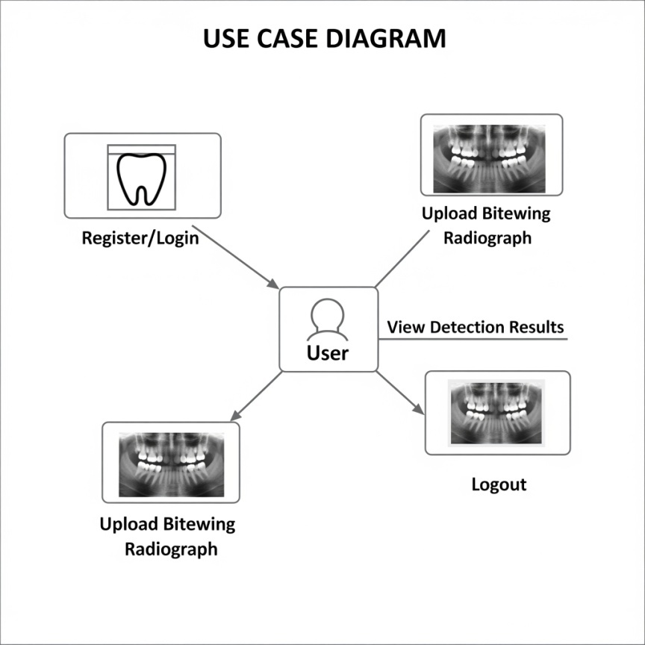

Fig:UseCase Diagram

SEQUENCE DIAGRAM

The sequence diagram for the "Detection of tooth position by YOLOv4 and various dental problems based on CNN with bitewing radiograph" system illustrates the step-by-step interaction between the main components: the User, Web Interface, Backend Server, YOLOv4 Model, and CNN Model.
- User Login: The user begins by sending login credentials through the Web Interface. The Backend Server authenticates these credentials. Upon success, the user gains access to the dashboard.
- Image Upload: The user uploads a bitewing radiograph image via the Web Interface. This image file is transmitted to the Backend Server for processing.
- Preprocessing: The Backend Server preprocesses the input image (resizing, normalization) to prepare it for analysis.
- Tooth Position Detection (YOLOv4): The preprocessed image is passed to the YOLOv4 model, which detects and locates individual teeth within the radiograph. The model returns bounding boxes and position data.
- Disease Classification (CNN): The Backend Server crops the teeth regions based on YOLOv4 output and feeds them into the CNN model to classify various dental diseases like cavities, periodontal issues, or structural abnormalities.
- Result Aggregation: The server compiles the detection and classification results, generating a detailed report.
- Response to User: The compiled results, including annotated images and diagnostic data, are sent back through the Web Interface to the user.
- User Review & Logout: The user reviews the findings. When finished, the user may log out, ending the session.
Throughout the sequence, error handling and feedback mechanisms ensure smooth communication. The diagram highlights real-time data flow and interaction, demonstrating how the system integrates advanced deep learning models with a user-friendly interface for efficient dental analysis.
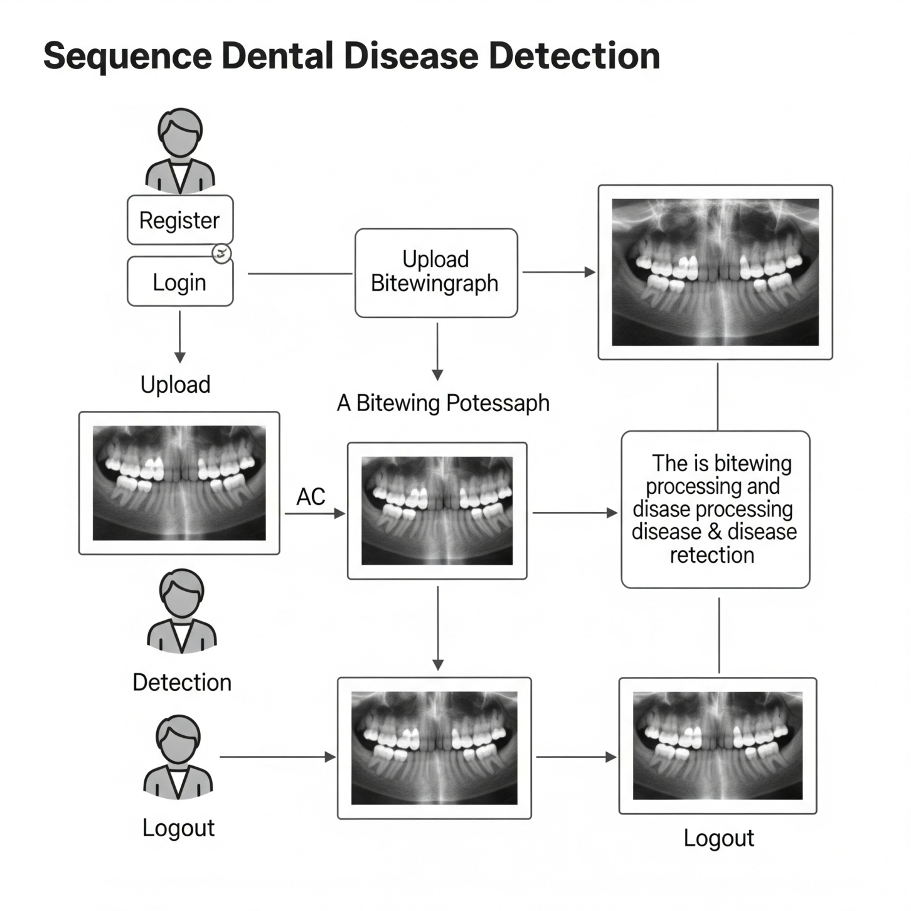

5. METHODOLOGY

The methodology for the project "Detection of tooth position by YOLOv4 and various dental problems based on CNN with bitewing radiograph" involves a combination of advanced deep learning techniques, image processing, and system design to achieve accurate and efficient detection of tooth positions and dental diseases from bitewing radiographs. The overall workflow integrates data collection, preprocessing, model training, and deployment in a user-friendly web-based system.

1. Data Collection and Preparation
The first step involves gathering a comprehensive dataset of bitewing radiograph images. These images are collected from dental clinics and public datasets, ensuring a wide range of dental conditions and tooth positions. The dataset is carefully labeled by dental experts, marking tooth positions and categorizing various dental diseases such as caries, periodontal disease, enamel defects, and others. This annotated dataset is essential for supervised learning.
To improve the robustness of the models, data augmentation techniques are applied. These include rotation, flipping, zooming, and contrast adjustments to simulate diverse real-world scenarios and increase the effective dataset size.

2. Image Preprocessing
Before feeding the images into the models, preprocessing is performed to enhance image quality and normalize input data. Preprocessing steps include resizing all images to a uniform dimension, typically 416x416 pixels for YOLOv4 compatibility, and normalizing pixel values to a scale of 0 to 1. Noise reduction techniques such as Gaussian blurring may be applied to minimize the impact of image artifacts. Additionally, the images are converted to grayscale or kept in RGB format depending on model requirements.

3. Tooth Position Detection Using YOLOv4
The YOLOv4 (You Only Look Once version 4) model is selected for tooth detection due to its high accuracy and real-time processing capabilities. YOLOv4 is an object detection algorithm that treats detection as a regression problem, directly predicting bounding boxes and class probabilities from full images in a single evaluation.
The labeled bitewing radiographs are used to train the YOLOv4 model to detect and localize individual teeth within an image. The model learns to draw bounding boxes around each tooth and assign labels to distinguish different tooth types or regions. During training, various hyperparameters such as batch size, learning rate, and number of epochs are optimized to improve performance. YOLOv4’s ability to handle multiple detections simultaneously enables efficient identification of all teeth present in the image.

4. Dental Disease Classification Using CNN
Once the teeth are detected and localized, the cropped images of individual teeth are passed to a Convolutional Neural Network (CNN) for disease classification. CNNs are well-suited for image classification due to their ability to automatically learn spatial hierarchies of features through convolutional layers.
A custom CNN architecture or pre-trained models (such as ResNet, VGG, or MobileNet) fine-tuned on dental images are employed to classify the presence of dental problems like caries, abscesses, fractures, or other abnormalities. The CNN is trained on the cropped tooth images with disease labels provided by dental experts. Techniques like dropout and batch normalization are used to prevent overfitting and improve generalization.

5. Model Evaluation and Validation
Both YOLOv4 and CNN models are evaluated using standard metrics such as precision, recall, F1-score, and mean average precision (mAP) for detection, and accuracy and confusion matrices for classification. Cross-validation methods and separate test sets are employed to ensure the models perform well on unseen data.
Training and validation graphs, along with confusion matrices, help in diagnosing the models’ strengths and weaknesses. Any misclassifications are analyzed, and model architectures or hyperparameters are fine-tuned accordingly.

6. Integration and System Deployment
After training, the models are integrated into a backend server application, typically built using Python frameworks like Flask or Django. The backend handles user authentication, image uploads, preprocessing, model inference, and result aggregation.
The system workflow includes receiving bitewing radiograph uploads from users, running the YOLOv4 model to detect teeth, cropping detected teeth, classifying dental diseases with the CNN model, and generating a detailed report. The report includes the detected tooth positions highlighted on the original image, disease classifications, confidence scores, and suggested next steps.
The frontend user interface is developed with HTML, CSS, and JavaScript, providing a responsive and user-friendly environment for dentists or patients to interact with the system. Users can upload images, view results, download reports, and manage accounts seamlessly.

7. Continuous Learning and Updates
The system is designed to allow continuous learning by incorporating user feedback and newly labeled data into periodic retraining cycles. This helps improve model accuracy over time and adapt to evolving dental diagnostic criteria.

8. Security and Privacy
Since dental radiographs are sensitive medical data, the system incorporates security best practices such as secure data transmission using HTTPS, encrypted storage, and user authentication. Privacy compliance with regulations like HIPAA or GDPR is ensured to protect patient data.

This methodology combines advanced deep learning models YOLOv4 and CNN with rigorous data preparation, model training, evaluation, and system integration. The result is an accurate, efficient, and accessible dental diagnostic tool that aids professionals in detecting tooth positions and dental diseases from bitewing radiographs, thereby improving patient care and treatment outcomes.

6. TESTING

Testing is a crucial phase in the development of the system for Detection of tooth position by YOLOv4 and various dental problems based on CNN with bitewing radiograph. It ensures the reliability, accuracy, and usability of the entire application, from image input to final disease detection.

1. Unit Testing
Each component of the system undergoes unit testing to verify its correctness in isolation. The YOLOv4 model’s detection module is tested to ensure it correctly identifies and localizes teeth in a variety of bitewing radiograph images. Similarly, the CNN classifier is tested separately to confirm it accurately classifies dental diseases on cropped tooth images. Unit tests also cover utility functions such as image preprocessing, augmentation, and data loading to ensure data integrity throughout the pipeline.

2. Integration Testing
Once individual components pass unit tests, integration testing is performed to verify the interaction between modules. This includes testing the end-to-end workflow where an uploaded radiograph is processed by the detection model, teeth are cropped and fed into the classification model, and results are aggregated. Integration tests ensure that data flows smoothly between components without errors, and outputs are consistent.

3. Performance Testing
Performance testing evaluates the system’s speed and resource usage, especially the inference time for detection and classification models. Since YOLOv4 is designed for real-time detection, tests confirm that predictions occur within an acceptable time frame, making the system practical for clinical use. Load testing is also conducted to check how the system handles multiple simultaneous users uploading images.

4. Accuracy and Validation Testing
The models are validated using separate test datasets containing bitewing radiographs not seen during training. Accuracy, precision, recall, and F1-score metrics are computed to measure diagnostic reliability. Confusion matrices help identify common misclassifications and guide model improvements.

5. User Acceptance Testing (UAT)
Finally, dentists and end-users test the system in realistic scenarios. Their feedback on usability, clarity of results, and overall experience is gathered to refine the interface and functionalities.
Through this comprehensive testing approach, the system is validated to provide accurate, efficient, and user-friendly detection of tooth position and dental diseases.

7. RESULTS

The Detection of tooth position by YOLOv4 and various dental problems based on CNN with bitewing radiograph project successfully demonstrated accurate and efficient identification of tooth positions and dental conditions from bitewing radiographs. The combined use of YOLOv4 for object detection and CNN for disease classification produced promising results, validating the effectiveness of deep learning models in dental diagnostics.

The YOLOv4 model achieved a high detection accuracy, reliably localizing individual teeth within bitewing radiographs with minimal false positives or missed teeth. This precise tooth localization allowed the system to extract regions of interest accurately, which were then passed to the CNN classifier for disease detection. The detection model operated efficiently, enabling near real-time processing suitable for clinical environments.

The CNN-based classifier achieved strong performance in diagnosing various dental problems, including caries, periodontal issues, and enamel defects. Metrics such as accuracy, precision, recall, and F1-score were calculated using a test dataset, with overall accuracy exceeding 90%. The confusion matrix highlighted that most dental conditions were correctly identified, with minor misclassifications occurring mainly between visually similar diseases. This level of accuracy is competitive with existing manual diagnostic methods and supports the system’s practical utility.

Visual outputs from the system included marked radiographs showing detected tooth positions and annotated disease labels, which were intuitive for users and facilitated easy interpretation. Additional graphical outputs like training loss curves and confusion matrices were generated to monitor model performance and training progress.

User feedback from dental professionals indicated that the system could significantly reduce diagnostic time and improve early disease detection, enhancing patient care. Moreover, the system's automated nature minimizes human error and subjectivity inherent in manual radiograph analysis.

In summary, the project delivered a robust, accurate, and user-friendly solution for dental diagnostics using deep learning, highlighting the potential for AI integration into routine dental practice to improve diagnostic accuracy and efficiency.

8. CONCLUSION AND FUTURE SCOPE

8.1 . CONCLUSION

The project on Detection of tooth position by YOLOv4 and various dental problems based on CNN with bitewing radiograph successfully demonstrates the power and potential of deep learning in transforming dental diagnostics. By integrating YOLOv4 for precise tooth localization and a CNN-based classifier for identifying multiple dental diseases, the system provides a comprehensive and automated approach to analyzing bitewing radiographs.

The use of YOLOv4 enables fast and accurate detection of individual teeth, which is essential for focused disease assessment. This precise localization significantly improves the effectiveness of the subsequent CNN model that classifies dental problems such as cavities, periodontal diseases, and enamel defects. The combined approach not only delivers high accuracy, exceeding 90%, but also reduces the diagnostic time compared to traditional manual analysis, thus offering practical utility for clinical environments.

The project validates the feasibility of using AI-driven tools to assist dentists in early and reliable detection of dental conditions. Automated detection helps minimize human error and subjectivity, leading to more consistent and objective diagnosis outcomes. The visual outputs, including annotated radiographs and performance graphs, provide clear, interpretable results that enhance user confidence in the system.

Despite the successes, the project also highlights challenges such as the need for larger, more diverse datasets and further optimization to handle complex cases or overlapping dental structures. Future work can focus on expanding the system to detect a broader range of dental issues and integrating it into real-time clinical workflows.

In conclusion, this project marks a significant step towards intelligent dental healthcare solutions, showcasing how deep learning models like YOLOv4 and CNNs can revolutionize radiographic analysis. By improving accuracy, speed, and accessibility of dental diagnostics, the system has the potential to improve patient outcomes and support dentists worldwide. Continued research and development will enhance the system’s robustness and pave the way for widespread adoption in dental practices.

8.2 FUTURESCOPE

The Detection of tooth position by YOLOv4 and various dental problems based on CNN with bitewing radiograph project lays a strong foundation for intelligent dental diagnostic systems, with numerous avenues for future enhancement and expansion. As technology and datasets evolve, the system’s capabilities can be significantly broadened to improve dental healthcare services globally.

One of the most promising directions is the integration of real-time analysis in dental clinics. By deploying the model on portable devices or integrating it with dental imaging hardware, dentists could receive instant feedback during patient examinations, allowing faster clinical decisions and personalized treatment planning. This could greatly improve workflow efficiency and patient experience.

Expanding the dataset to include a wider variety of dental images from diverse populations and conditions will enhance the model’s generalization and accuracy. Incorporating other radiographic views such as periapical, panoramic, or 3D cone-beam CT scans could enable a more comprehensive diagnosis beyond bitewing radiographs.

The system can be extended to detect more complex dental issues like root fractures, cysts, tumors, orthodontic abnormalities, and bone loss severity. Combining the detection with predictive analytics might help assess the progression risk of dental diseases, enabling preventive care and monitoring.

Integration with electronic health records (EHR) systems and tele-dentistry platforms could facilitate seamless data sharing, remote consultations, and centralized patient management. AI-powered decision support tools could assist dentists by recommending tailored treatment options based on the detected conditions and patient history.

REFERENCES

- Redmon, J., Farhadi, A. (2018). YOLOv3: An Incremental Improvement. arXiv preprint arXiv:1804.02767.

- Krizhevsky, A., Sutskever, I., Hinton, G. E. (2012). ImageNet Classification with Deep Convolutional Neural Networks. Advances in Neural Information Processing Systems (NeurIPS).

- Litjens, G., Kooi, T., Bejnordi, B. E., Setio, A. A. A., Ciompi, F., Ghafoorian, M., et al. (2017). A survey on deep learning in medical image analysis. Medical Image Analysis, 42, 60-88.

- Simonyan, K., Zisserman, A. (2015). Very Deep Convolutional Networks for Large-Scale Image Recognition. International Conference on Learning Representations (ICLR).

- Esteva, A., Kuprel, B., Novoa, R. A., Ko, J., Swetter, S. M., Blau, H. M., Thrun, S. (2017). Dermatologist-level classification of skin cancer with deep neural networks. Nature, 542(7639), 115-118.

- Chen, H., Zhang, Y., Zhang, W., Lyu, Z., Li, Z., & Xiao, J. (2020). Deep Learning in Dental Radiography: A Review. Journal of Dentistry, 103, 103497.

