**PROJECT REPORT**

**ON**

**(Course Management Website)**

SUBMITTED BY

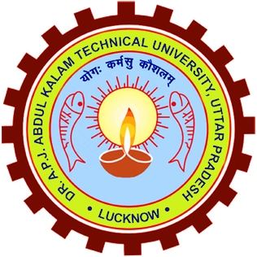

Dr. A.P.J Abdul Kalam Technical University, Uttar Pradesh LUCKNOW INDIA

**Jagriti Srivastava**

(220341530019)

**BACHELOR OF TECHNOLOGY**

(Artificial Intelligence & Machine Learning)

3rd Semester

UNDER THE GUIDANCE OF

**Mr. Anand Prakash Dwivedi**

**INDEX**

1. **Introduction………………………………………………………….**
2. **Objective…………………………………………………………….**
3. **Software Requirement………………………………………………**
4. **Hardware Requirement………………………………………………**
5. **Flowchart…………………………………………………………….**
6. **Literature Review……………………………………………………**
7. **Output……………………………………………………………….**
8. **Conclusion………………………………………………………….**
9. **Future Scope……………………………………………………….**
10. **References……………………………………………………………**

**Appendix**

* **Code of Solution**

I hereby declare that the Mini Project work being presented in this

report entitled “COURSE MANAGEMENT WEBSITE” submitted

in the Department of Computer Science & Engineering (AIML)

Maharana Pratap Engineering College, Kanpur is the authentic work

Carried out by me under the guidance of Mr. Anand Prakash Dwivedi

Assistant Professor Department of Computer Science, Maharana

Pratap Engineering College, Kanpur.

Date……………… Signature……………………

**STUDENT’S DECLARATION**

**INTRODUCTION**

The Project on COURSE MANAGEMENT WEBSITE is to manage the academic courses after intermediate (12th) for all boards. Although it is different to ensure yourself on the right career path thus, I try to make it a little much easy through my website you will information all various program occurring and get easier for you to decide the path after 12th because it was the only time for one right decision.

In the website, you login through your e-mail Id’s and get linked with the admin also you can learn, explore, think and choose the right career option for yourself. Through the query section you can drop your valid questions, suggestions,

anything else. With your e-mail Id’s I can wear to contact your anytime. There are Two Different Sectors -

* Private Sector
* Government Sector

This website includes all the program as well as the streams like Computer application, Law (LLB), Architect, Defend services, Navy and the Medical stream etc.

There are two different paths which are Medical and non-medical. Medical is continued with Biology and non-medical is followed by Math and Science. Although in future the website will contain more effective information about all program and the fields that going to be get advanced soon also the guidance and the consulting will be live provided to consult with the individual students on his/her though process with live interaction sessions.

### A step-by-step breakdown of the ways you can assure you embark on a profitable and correct journey for your future:

### Step 1: Research, Research, Research

The first step is to start researching what is available. Once you start this, you will explore a vast base of career options after 12th non-medical. It will help you find what you are passionate about, so that, you can start exploring various career options in non-medical.

Step 2: Take a career assessment test

The next step in your journey after researching career options in the non-medical field should be to take a career assessment test. This step is crucial if you are still unaware of your path after the research. A career assessment test assesses your skills and talents.

Step 3: Do a SWOT analysis

After you have completed your career assessment test, you should self-evaluate your strengths and weaknesses. A SWOT analysis helps you do this, SWOT stands for Strengths, Weaknesses, Opportunities and Threats.

 Step 4: Reach Out and Network

Networking will help you make acquaintances who can give you an insider picture of the industry.  For example, you wish to enter the world of marketing as one of the career options after class 12th.



Users can search for books and renewal books online. In the proposed system

, we assume that each member will be having an identity card which can be used for the library book issue, fine payment etc. They can recommend for new

Books by just sending messages to the librarian from anywhere in the college.

Whenever library member wish to take a book, the book issued by the authority

And store it in database. They can view the issued date and returned date

Required fine have to be paid by the member.

**OBJECTIVE**

The final year of school life, Class 12th is one of the most crucial times of the student life. It is the time to make some serious decision regarding life and career options, as the decision made today will determine the student’s future life. Now, when choosing career options is discussed the student have to come across these two main options; that are Medical and non-medical career options. If you have decided on the medical field, and are searching for the career after the 12 non-medical then this website will help you in doing so the path get easier for you. To provide a comprehensive online platform that offers engaging and interactive learning resources across various subjects, fostering a conducive environment for diverse learners to enhance their knowledge, critical thinking skills, and academic achievement. Our goal is to empower learners of all ages by delivering high-quality, accessible content that supports their educational journey and promotes lifelong learning.

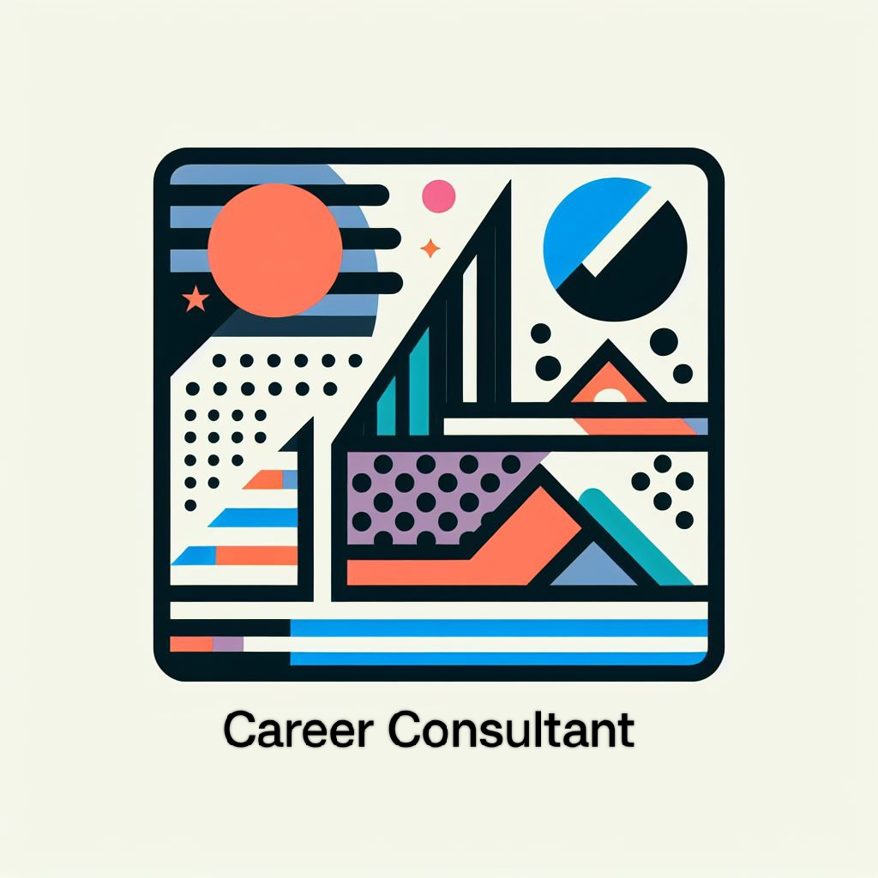



The Main Objective is to make sure that the upcoming generation can make them prettier sure about their career plans and the right path to travel in certain ways to get interact with themselves only.

**My Objective for a Career Consulting Website:**

To provide comprehensive career guidance, expert advice, and personalized consulting services aimed at empowering individuals to make informed decisions, navigate career transitions, develop professional skills, and achieve their full potential in today's dynamic and competitive job market.

It seems there might be a typo in your question. If you're asking for an objective related to a "good career," here's a suggestion:

To guide individuals towards establishing fulfilling and prosperous careers by providing tailored advice, resources, and support. Our objective is to assist in identifying suitable career paths, honing skills, and navigating professional landscapes to enable individuals to pursue rewarding and impactful careers aligned with their passions and ambitions.

Creating an objective for the "best" career field can be subjective as it largely depends on an individual's interests, skills, and the current job market. However, here's a general objective for a sought-after career field to assist individuals in identifying, pursuing, and excelling in high-demand career fields by offering insights, resources, and guidance tailored to their strengths and aspirations. Our objective is to help individuals thrive in industries known for growth, innovation, and opportunities for long-term success, fostering fulfillment and professional achievement. Thus, it will provide the necessary requirement for the certain fields hence by this means this website will act as the boasting path for the students who are there in class 12th now. It will help you find what you are passionate about, so that, you can start exploring various career options.

**SOFTWARE REQUIREMENT**

The software used for the manipulation of the website are

* HTML
* CSS
* JAVASCRIPT
* BOOTSTRAP

These are the software technology used here to create a complete frontend website. There is certain Website Development Software:

Text Editors (e.g., Sublime Text, Visual Studio Code): Used for coding HTML, CSS, JavaScript, and other programming languages required for building a website.

Integrated Development Environments (IDEs) (e.g., Atom, WebStorm): Provide a more comprehensive environment with tools and features specifically for web development.

Content Management Systems (CMS) (e.g., WordPress, Joomla, Drupal): Allow for easy content management and website creation without extensive coding knowledge.

The choice of software often depends on the specific needs of the project, the preferences of the designers and developers, and the nature of the website being created or maintained.

**HTML**

HTML stands for Hyper Text Markup Language. It is the standard markup language used for creating and structuring web pages and web applications. HTML provides the basic structure and content of a web page by using various elements and tags to define different parts of the content.

HTML is not a programming language; it's a markup language used to structure content on the web. It uses a system of tags and attributes to define different elements and their attributes within a web.

tags (e.g., `<tag name>content</tag name>`), defining different parts of the content such as headings, paragraphs, images, links, lists, forms, etc. It provides the foundational structure for web content. When combined with CSS for styling and layout, and JavaScript for interactivity, it forms the basis for creating rich and dynamic web experiences.

HTML documents consist of a hierarchical structure represented by nested elements. Elements are enclosed by opening and closing tags (e.g., `<tag name>content</tag name>`), defining different parts of the content such as headings, paragraphs, images, links, lists, forms, etc. It provides the foundational structure for web content. When combined with CSS for styling and layout, and JavaScript for interactivity, it forms the basis for creating rich and dynamic web experiences.

**CSS**

CSS stands for Cascading Style Sheets. It's a style sheet language used to describe the presentation, layout, and formatting of HTML (or XML) documents. CSS allows web developers to control how web pages appear on various devices and screen sizes by defining the visual aspects of the content. It separates the content of a web page (handled by HTML) from its presentation and design aspects. This separation allows for cleaner and more maintainable code. CSS uses selectors to target HTML elements and apply styles to them. Selectors can be element names, classes, IDs, attributes, or combinations of these. Styles can include properties such as color, font, size, margin, padding, positioning, and more.

**JAVASCRIPT**

JavaScript (JS) is a high-level, interpreted programming language primarily used to add interactivity and dynamic behavior to web page. It is mainly executed on the client-side (in web browsers). It allows developers to manipulate and interact with HTML and CSS, making web pages more dynamic and responsive. It is supported by all modern web browsers. Additionally, with the rise of Node.js, it's possible to use JavaScript for server-side programming as well, making it a full-stack language.

JavaScript empowers developers to create rich, interactive web experiences and is a fundamental technology for modern web development.

**HARDWARE REQUIREMENT**

**Memory -** 8GB

**Operating system -** Windows 11

**Processor -** AMD Ryzen 3 5300U with Radeon Graphics 2.60 GHz

**Hard drive** – 512 GB

**Other Requirement -**

* Monitor
* Keyboard
* Mouse

**FLOWCHART**

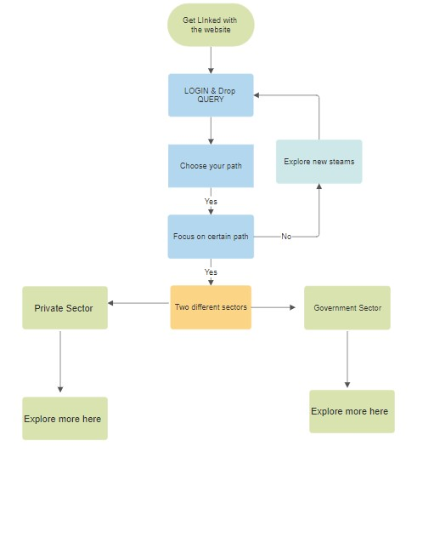

**LITERATURE REVIEW**

The website is for the beneficial purpose that the upcoming new generation can easily get introduced by the field and the career option that will going to make their future more and more bright thus, by this the website it is easily to resolve the problem that the upcoming future generation going to face in upcoming year because they don’t have some who will help them aur guide them, in future.

The two different field will make students confused about their career that it will make them feel depressed thus, it will get easier for the student who want to be in right field that is the career goal. They will get all the benefits like roadmap, perfect guidance, and many more. They especially value the ability to transmit documents and efficient communication enabled through the system. Instructor perception of the value of learning management systems to teaching and learning was highly variable, similarly suggesting along with student’s views.

Here the basic requirement for the students of the upcoming new generation hence, it is more important for the pupils as well. You can got linked with the page that it will be provided the further educational scope and the roadmap to allow the student can easily get placed to the perfect and certain progress report hence, this website is the best roadmap itself to map yourself and the progress that it will help you in making the centre align report will help in further process of the selection of career individual career options thus, it will be highly used web in future as well thus I try to make the webpage in this particular field. While student concerns are important, faculty issues cannot be forgotten, as instructors are the key to guide the educational experience of students. Thus, this webpage will help you in many multi purposes in the steam data. I took the refers of many book , the research paper and articles that helped me in going so that the webpage can easily be in used by many students and as well the people who well interested in knowing the refer data of the particular includes and can execute the whole serve itself through this educational website.

* First technology driven education start-up of India providing end-to-end solutions for students’ higher education needs.
* Operates on an extremely intuitive and user-focused technology & unique profile-based college recommendations engine that helps students find the best fit information for 35000+ colleges available on the website.
* Extensive personalized counselling to understand student’s needs and help them make the informed decision.
* Advanced products like College Selection, Practice Tests, Psychometric Tests to scientifically support higher education selection decisions.
* Our AI powered Chat-Bot that has handled 20L+ queries since its inception in 2019.
* One stop solution for all problems/issues related to higher education such as Education Loans, Insurance, Hostel Accommodation, Application Assistance, etc.
* Our test is easy to use and takes just a few minutes to complete. You'll receive a detailed report with personalized feedback, which can help you identify areas for improvement and set achievable goals.
* More Information

Use of this learning & exploring platform can help you to choose right career option One at a time thus, you can easily be found the right career path therefore it is easy for the students that they can find this way and it is the essential element of this generation thus, the whether distance or traditional student, residential or in any filed can easily. Here, the quality of content is specified that the students can view and can get good knowledge of the upcoming process of the educational system. Hence, the While student concerns are important, faculty issues cannot be forgotten, as instructors are the key to guide the educational experience of students. Instructors may come to e-learning in a variety of different ways. Some courses are completely online, while others may be a mix of face to face and online elements.

They especially value the ability to transmit documents and efficient communication enabled through the system. Instructor perception of the value of learning management systems to teaching and learning was highly variable, similarly suggesting along with student’s views

Literature considering part-time work found that there are positive economic outcomes for young people who engage in employment whilst at school. There are also educational benefits, if working hours are kept relatively low. Given that the incidence of young people in the UK partaking in part-time work is declining, it adds more importance for schools to provide young people with high quality, impartial careers education to assist in guiding them through their school-to-work transitions.

The literature review considered 96 different studies – 73 focused on careers education and 23 on part-time working studies. Only literature published from 1996 and concerning OECD countries were included in the analysis. All studies included had quasi-experimental or experimental methodologies.

**OUTPUT**

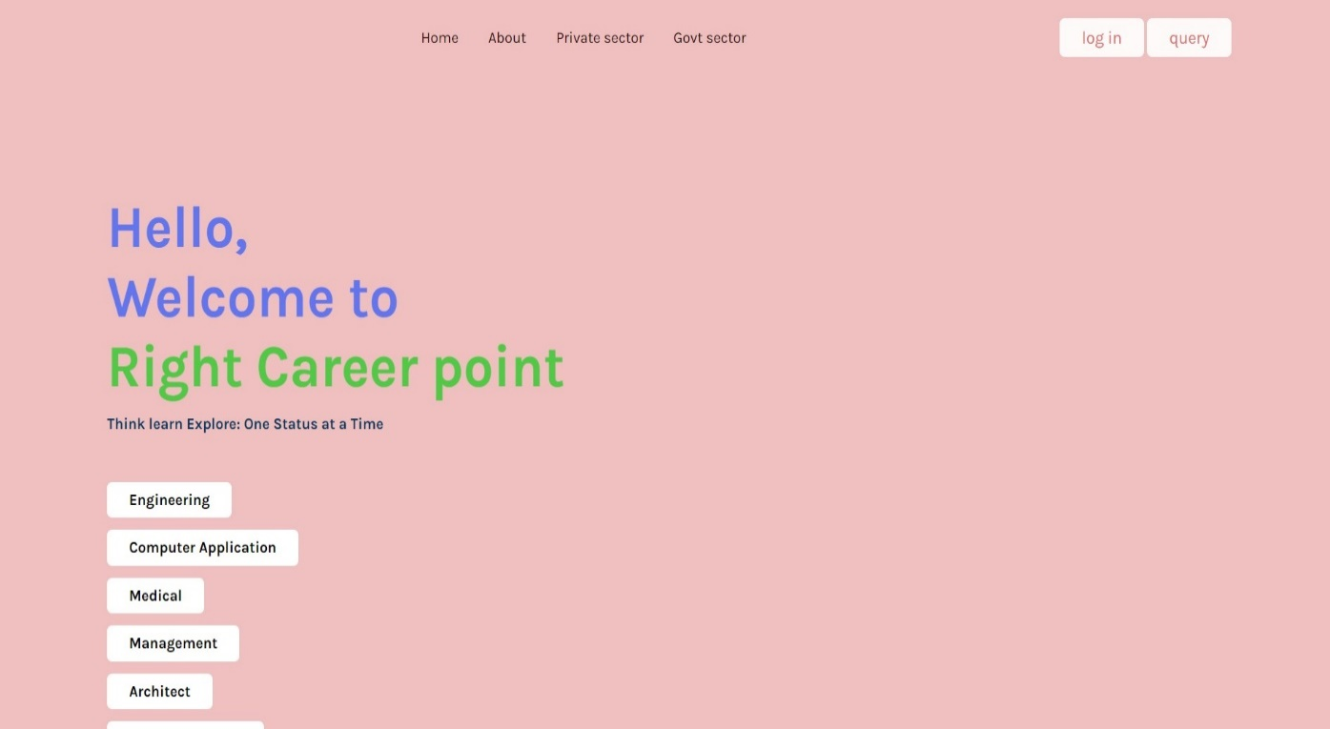

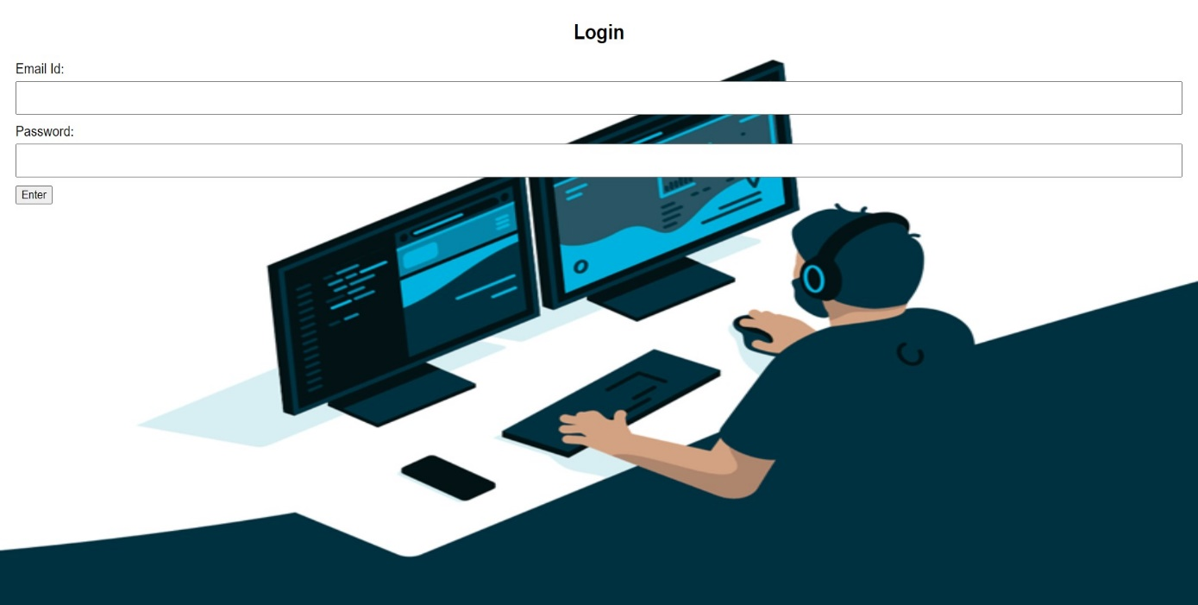

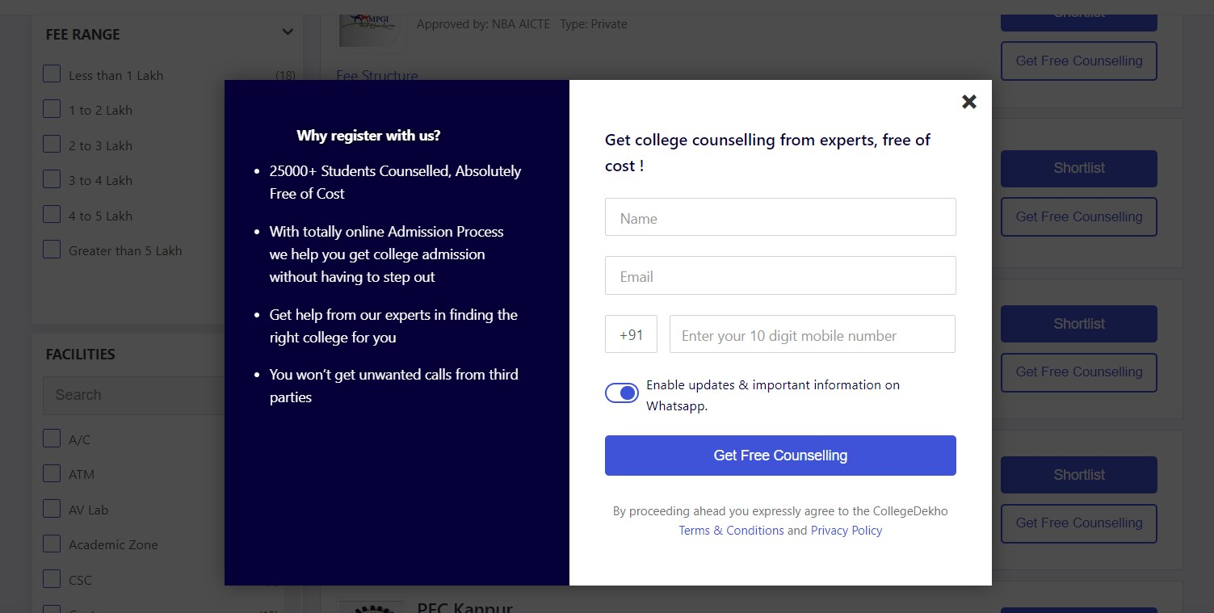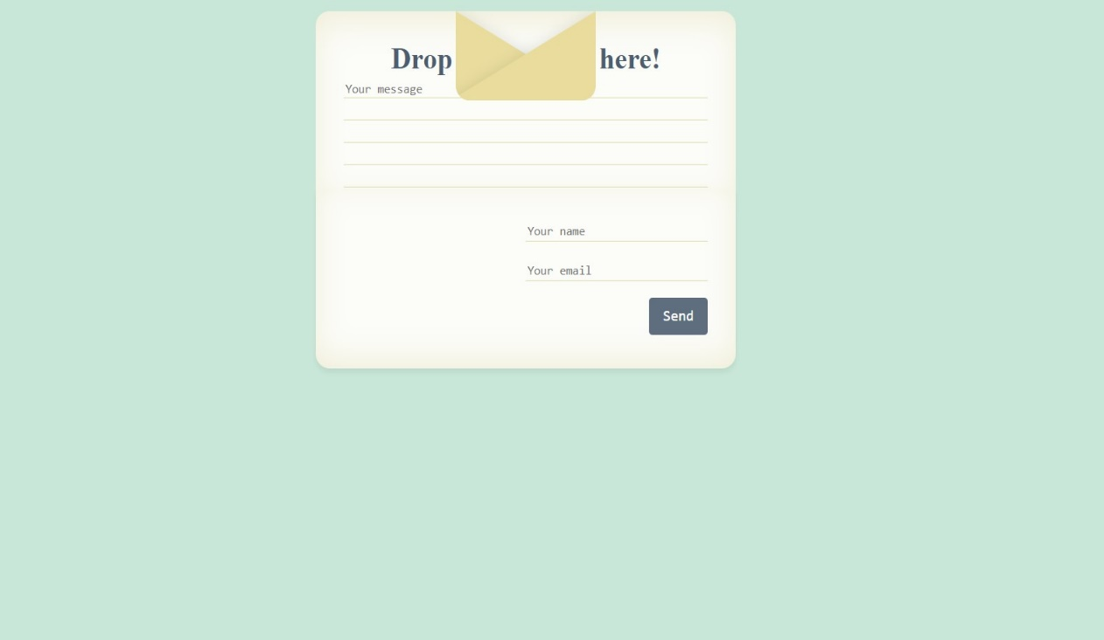

**Conclusion**

Career path planning is a crucial aspect of professional development, and it involves creating a roadmap for one’s career advancement. One example of career planning is identifying a career path based on skills and interests. For instance, a person with excellent communication skills can consider a career in marketing, public relations, or corporate communications. Another career plans example is a person transitioning to a completely different field, such as engineering to human resources, security to IT, or teaching to social work.

Career planning examples include two types of career paths: vertical and lateral. A vertical career path is one that involves promotions within an organization or industry. For instance, an entry-level sales associate can move up to a sales manager, then to a director of sales, and finally to a vice president of sales. A lateral career path involves changing careers without necessarily moving up the corporate ladder. For example, a nurse can change careers and become a marketing director for a healthcare company.

**Career pathing can be defined as the process of mapping out a future career progression plan with the aim of facilitating career development in an organization.** Simply put, it is a systematic approach to charting your goals, aspirations, and capabilities in order to achieve both personal and organizational growth. Career path planning is crucial to help individuals enhance their skills, gain experience, and advance in their careers. Career path meaning lies in creating a framework that guides an individual’s career journey from entry-level to executive-level positions. If wondering how to improve career development in an organization, it is important to set clear career goals and align them with the goals of the organization. This can be done by offering regular training and development programs, providing career roadmaps, and supporting employees in their quest for career growth. Effective career pathing creates a win-win situation for both the individuals and the organization, as it fosters employee engagement, retention, and organizational productivity. Therefore, investing in career development planning is an essential component of any successful business strategy

**FUTURE SCOPE**

The Website I made is beneficial for upcoming generation in such a way that by this he/she can easily decide their career plan. It can be summarized that the future scope of this project circle around maintaining information regarding:

* Easy to find ways beyond the different option to choose the right one ahead and move towards it.
* Can easily get linked with the best roadmap and the stream.
* Got linked with the different options as well as the ways to make future bright.
* **Quick access from anytime, anywhere.**
* Everyone learns at a different pace. In a classroom where everyone taught together, many students find it difficult to follow the lessons.
* The future of education cannot be digital only. Digital education has seen a huge jump during covid. however, it is not a widely accepted technique for learning.
* During this time, digital learning is helping people to learn, grow, and connect with learners and educators around the world.
* Studying online teaches you vital time management skills.

**REFERNCES**

I took the References from different sites, book and the cultural around us the educational system in India as well as in foreign itself.

There are following links refers as:

* <https://www.cheggindia.com/career-guidance/>
* <https://www.thebalancemoney.com/steps-to-choosing-career-525506>
* The educational career counsellor.
* Textbook & Growth career.
* <https://www.cheggindia.com/career-guidance/best-career-options-after-12th-non-medical-background/>
* Text from <https://www.techcrashcourse.com/>
* <https://moodle.org/>
* Central Class ideas from <https://www.classcentral.com/>

### Here are some related resources:

* [A Salary Guide on How Much Can You Earn in Merchant Navy?](https://www.cheggindia.com/career-guidance/merchant-navy-salary/)
* [BSc Nautical Science: Scope and Career Path](https://www.cheggindia.com/career-guidance/bsc-nautical-science/)
* [List of Top PCM Career Options after 12th in India](https://www.cheggindia.com/career-guidance/pcm-career-options/)
* [Top Computer Courses You Need to Keep On Your Radar](https://www.cheggindia.com/career-guidance/computer-courses/)
* [Best Career Options in India for Freshers and Experienced Candidates](https://www.cheggindia.com/career-guidance/best-career-options/)

**CAREER OPTIONS:**

