A PROJECT REPORT

on

“SMART APPLICATION TRACKING SYSTEM:

LEVERAGING GENETRATIVE AI

AND LANGCHAIN”

Submitted to

KIIT Deemed to be University

In Partial Fulfilment of the Requirement for the Award of

BACHELOR’S DEGREE IN INFORMATION TECHNOLOGY

BY

SHIVENDRA SINGH

SRIJAN KUMAR

SNEHA SINGH

JYOTIKUMARI

2029197

2029202

2029203

2029204

UNDER THE GUIDANCE OF

Mr. Amiya Kumar Dash



SCHOOL OF COMPUTER ENGINEERING

KALINGA INSTITUTE OF INDUSTRIAL TECHNOLOGY

BHUBANESWAR, ODISHA -751024

APRIL 2024

KIIT Deemed to be University

School of Computer Engineering

Bhubaneswar, ODISHA 751024



CERTIFICATE

This is to certify that the project entitled

“SMART APPLICATION TRACKING SYSTEM:

LEVERAGING GENETRATIVE AI

AND LANGCHAIN”

submitted by

SHIVENDRA SINGH

SRIJAN KUMAR

SNEHA SINGH

JYOTIKUMARI

2029197

2029202

2029203

2029204

is a record of bonafide work carried out by them, partially fulfilling the requirement for the Degree of Bachelor of Engineering (Computer Science & Engineering OR Information Technology) award at KIIT Deemed to be university, Bhubaneswar. This work will be done during 2024 under our guidance.

Date: 27/04/2024

Mr. Amiya Kumar Dash

Project Guide

**Acknowledgments**

We are profoundly grateful to **Mr. Amiya Kumar Dash** of **KIIT Deemed to be University** for his expert guidance and continuous encouragement throughout to see that this project has its target from its commencement to completion.

SHIVENDRA SINGH

SRIJAN KUMAR

SNEHA SINGH

JYOTI KUMARI

**Contents**

**1. Introduction 2**

**2. Literature Review 4**

**3. Problem Statement 6**

3.1 Project Planning 6

3.2 Project Analysis (SRS) 7

3.3 System Design 8

3.3.1 Architecture Diagram 9

**4. Implementation 11**

4.1 Methodology 11

4.2 Testing/Verification 14

4.3 Result Analysis/Screenshots 15

4.4 Quality Assurance 18

**5. Standards Adopted 20**

5.1 Design Standards 20

5.2 Coding Standards 21

**6. Conclusion and Future Scope 22**

6.1 Conclusion 22

6.2 Future Scope 23

**References 24**

**INDIVIDUAL CONTRIBUTION REPORT: 25**

**TURNITIN PLAGIARISM REPORT 29**

# 1. Introduction

The integration of artificial intelligence into various human resource processes holds immense potential for optimization and efficiency. This project explores the development of a Smart ATS powered by a cutting-edge large language model, Google Gemini. The system utilizes natural language processing and understanding, implemented via the Langchain framework, to analyze resumes and job descriptions and provide insights far beyond simple keyword matching. Additionally, through a user-friendly Streamlit interface, the Smart ATS generates tailored project suggestions and certification recommendations and drafts compelling cover letters, empowering job seekers to enhance their applications.

A brief overview of technologies used:

**Google Gemini:** Gemini is a powerful large language model (LLM) developed by Google AI. LLMs are trained on vast amounts of text data, enabling them to communicate, generate human-like text, and understand complex relationships within language. In the Smart ATS, Gemini analyzes resumes and job descriptions, calculates matching scores, and generates suggestions or drafts for cover letters.

**Langchain:** Langchain is a framework designed to make building applications with LLMs easier. It provides structures for managing interactions with LLMs like Gemini. In your project, Langchain likely plays a key role in creating well-structured prompts for Gemini and chaining different LLM calls to achieve complex tasks (e.g., resume summary followed by project suggestion).

**Streamlit:** Streamlit is a Python library that allows you to rapidly create interactive web applications. It simplifies the process of building user interfaces with elements like text input, file uploads, buttons, and display areas. Streamlit serves as the foundation for your Smart ATS's web-based interface.

**Advanced AI Technologies:**

Its utilization of advanced AI technologies is central to the functionality of Smart ATS, with Google Generative AI being a cornerstone. Google Generative AI harnesses the power of machine learning and natural language processing to comprehend and generate human-like text, enabling Smart ATS to analyze resumes comprehensively and provide insightful feedback.

**Key Features of Smart ATS:**

1. **Resume Evaluation:** Smart ATS employs machine learning algorithms to analyze resumes, not just based on keywords but also on contextual understanding. By assessing factors such as experience relevance, skill proficiency, and achievements it provides a holistic evaluation, helping recruiters identify the most suitable candidates efficiently.
2. **Project Ideas Suggestions:** Beyond traditional resume evaluation, Smart ATS goes a step further by suggesting project ideas based on the candidate's skills and experience. This feature not only showcases the candidate's potential but also sparks creativity and innovation, aligning with the organization's goals and projects.
3. **Certification Course Recommendations:** Recognizing the importance of continuous learning and skill development, Smart ATS recommends relevant certification courses to candidates based on skill gaps identified in their resumes. This proactive approach not only benefits the candidate by enhancing their qualifications but also adds value to the organization by ensuring a workforce equipped with the latest skills and knowledge.
4. **Cover Letter Generation:** Crafting a compelling cover letter can be a daunting task for many applicants. Smart ATS simplifies this process by generating personalized cover letters tailored to the job requirements and the candidate's profile. Providing templates and suggestions it enables candidates to present themselves effectively, increasing their chances of securing interviews.

**Benefits of Smart ATS:**

**Enhanced Efficiency:** By automating resume screening and providing intelligent recommendations, Smart ATS significantly reduces the time and effort required for recruitment. Recruiters can focus on engaging with top candidates and strategizing hiring decisions, leading to a more efficient hiring process.

**Improved Candidate Experience:** Smart ATS enhances the candidate experience by providing personalized feedback and recommendations, fostering a positive impression of the organization. Candidates feel valued and supported throughout the application process, leading to higher satisfaction levels and a stronger employer brand.

**Better Hiring Decisions:** With comprehensive resume evaluation and intelligent recommendations, Smart ATS enables recruiters to make informed hiring decisions based on data-driven insights. By identifying the most qualified candidates, organizations can ensure they recruit the right talent for the job, ultimately driving business success.

# 2. Literature Review

**Applicant Tracking Systems (ATS)**

Applicant Tracking Systems (ATS) serve as centralized software solutions for managing the recruitment process. These systems traditionally focus on automating and streamlining tasks, such as

* **Resume Parsing:** Extracting information from resumes into standardized formats.
* **Keyword Matching:** Comparing resumes and job descriptions based on relevant keywords and skills.
* **Candidate Filtering:** Ranking or eliminating candidates based on set criteria.

While ATS systems aim to improve efficiency, they often rely on simple keyword matching algorithms, which may fail to identify the most qualified candidates based on a deeper understanding of skills and experience [insert citation if applicable].

**Large Language Models (LLMs)**

Large Language Models (LLMs) are complex neural network-based AI models trained on massive text and code datasets. They demonstrate remarkable proficiency in various language-related tasks, including

* **Text Generation:** Creating human-quality text, translations, and summaries.
* **Semantic Understanding:** Analyzing the meaning and relationships within text.
* **Question Answering:** Providing contextually relevant answers to open-ended questions.

LLMs like Google Gemini hold the potential to revolutionize how ATS systems function. Their comprehension of natural language allows for more nuanced matching between resumes and job descriptions, going beyond simple keywords

**LangChain**

LangChain is an open-source framework built within the Python ecosystem. It offers several key functionalities for working with LLMs:

* **Structuring Prompts:** It provides tools like Prompt Templates to formulate complex instructions for LLMs, ensuring their outputs align with project goals.
* **Managing LLM Calls:** LangChain streamlines interactions with various LLMs, enabling chaining or combining outputs from different models.
* **Integrating with External Systems:** LangChain facilitates connections to data sources and other tools, allowing the creation of powerful AI-driven applications.

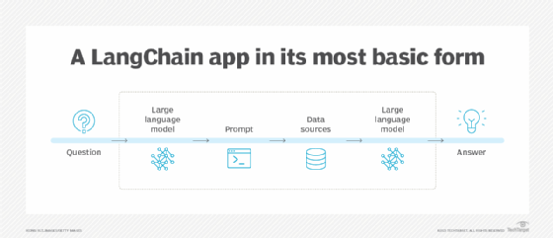

**Streamlit**

Streamlit is a powerful Python library designed for rapid web application development. Key features relevant to this project include:

* **Simplified UI Creation:** It enables building user interfaces through simple Python code, offering elements like text boxes, buttons, and file uploaders.
* **Reactive Framework:** Streamlit automatically updates the web app when user inputs change, making it ideal for dynamic applications.
* **Deployment Flexibility:** Streamlit apps can be easily deployed to various platforms for wider access.

# 3. Problem Statement

Traditional Applicant Tracking Systems (ATS) often face limitations in accurately identifying the most suitable candidates for a job opening. Their reliance on rudimentary keyword matching frequently leads to the following:

* **Missed Qualified Applicants:** Talented individuals with relevant skills and experience may be overlooked if their resumes do not explicitly mirror the exact keywords in the job description.
* **Time-Consuming Review Process:** Recruiters expend significant time manually reviewing numerous resumes to identify potentially strong candidates.
* **Limited Personalization:** Traditional ATS systems often lack tailored guidance to help job seekers improve their resumes and applications, making the process feel impersonal and generic.

An AI-powered Smart ATS aims to address these shortcomings by utilizing advanced natural language understanding for enhanced matching and providing personalized recommendations.

## 3.1 Project Planning

**Initial Time Frame:** Since this is an academic project, we divided it into phases (Research, Prototyping, Feature Development, Testing, etc.) and indicated the expected time allocation for each. Example:

* + **Weeks 1-2:** Literature Review & Technology Familiarization
  + **Weeks 3-5:** Prototype Development (Core Parsing and Matching)
  + **Weeks 6- 8:** Advanced Feature Development
  + **Weeks 9-10:** Testing, Refinement, Report Writing

**Resources Needed:**

* **Software:** The core libraries used in the code:
  + **streamlit (st):** The core framework for building the user interface and web application structure.
  + **google.generativeai (genai):** Provides tools to interact with Google's generative AI models.
  + **PyPDF2 (pdf):** Used specifically for reading and extracting text from PDF files.
  + **os:** Enables interaction with the operating system, primarily for retrieving environment variables in this case.
  + **dotenv:** Handles loading and accessing environment variables from a .env file.
  + **langchain_google_genai:** A Langchain wrapper designed to interact with Google-based generative AI models.
  + **langchain.prompts, langchain.chains:** Langchain libraries provide the structure for prompts (instructions to the AI model) and the ability to chain processes together.
* **Access:** Google API access (for calling Gemini)
* **Data:** Resume and job descriptions were uploaded in real-time by the user

## 3.2 Project Analysis (SRS)

A detailed Software Requirements Specification (SRS) document was created to guide the development of the Smart ATS. Below is a summary of its key sections:

**Introduction**

* **Purpose:** Design and implement an AI-powered Applicant Tracking System to improve upon the limitations of traditional keyword-based ATS systems.
* **Scope:** The project focuses on core functionalities of resume parsing, intelligent job description matching, and the generation of personalized suggestions.
* **Stakeholders:** Potential users (job seekers), academics interested in AI for recruitment, and companies evaluating tools to improve hiring processes.

**Functional Requirements**

1. **Resume Parsing:**
   1. Extract relevant information from resumes, including name, contact details, education, skills, and work experience.
   2. Target both PDF and Word document formats (.pdf, .docx).
2. **JD Matching:**
   1. Analyze job descriptions to extract keywords and core skills.
   2. Calculate a matching score between a resume and job description based on semantic similarity using Google Gemini.
3. **Project Suggestions:**
   1. Recommend projects to enhance a candidate's skills relevant to a given job description.
4. **Certification Suggestions:**
   1. Provide a list of relevant certifications to boost a candidate's credentials based on the job requirements.
5. **Cover Letter Drafting:**
   1. Generate a draft cover letter tailored to a specific job opening, highlighting the candidate's suitability.

**Non-Functional Requirements**

* **Response Time:** Aim to process resumes and generate outputs within a timeframe that ensures a positive user experience (e.g., under 30 seconds for moderate-sized resumes).
* **Usability:** Design an intuitive user interface with clear input areas, buttons, and well-structured results display.

**System Design**

* **Refer to Architecture Diagram (Section 3.3.2):** Link to the diagram you created, highlighting the Streamlit UI, Resume Parsing module, LangChain Modules, and Google Gemini LLM interactions.

**External Interfaces**

* **Google Gemini API:** Critical for semantic analysis of text, generation of project and certification suggestions, and cover letter drafting.

## 3.3 System Design

* **Gemini's Limitations:** LLMs can occasionally produce less than-ideal text outputs, requiring careful prompt engineering and potentially some post-processing in your application.
* **Model Response Time:** Calls to Gemini may introduce a slight delay, potentially affecting overall system responsiveness.
* **API Usage Costs:** If you intend heavy usage, be aware of the pricing structure of Google's APIs.  
  pen_spark

### 3.3.1 Architecture Diagram

System Architecture(UML)

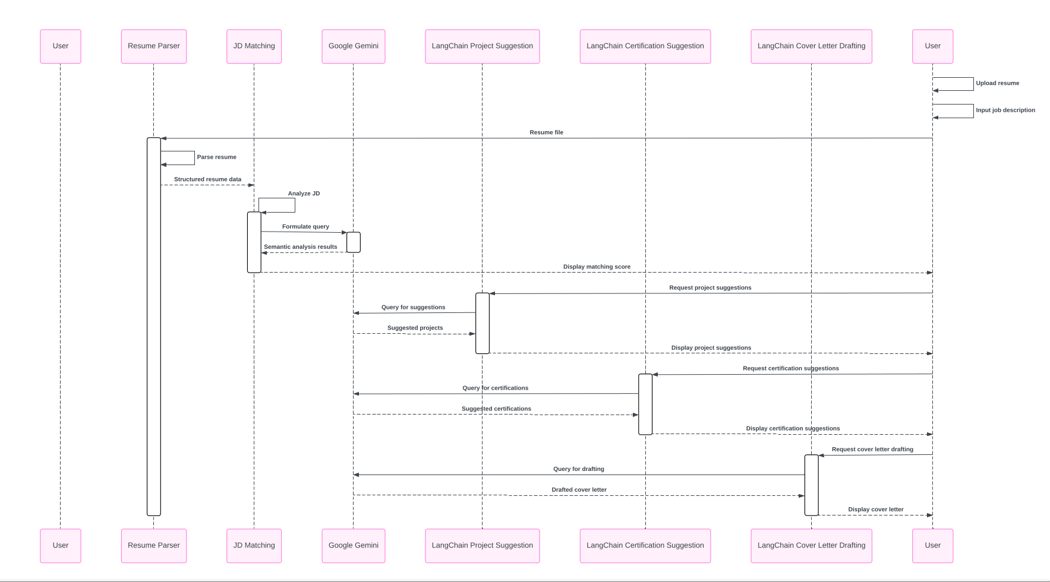

The UML diagram shows the sequence of steps involved in a system for processing resumes and job descriptions (JDs). Here's a breakdown of the elements and interactions:

**User:**

* The starting point for the interaction is the user, who can perform several actions:
  + Resume Upload: The user uploads their resume document (likely in .pdf format).
  + Job Description Input: The user pastes the job description text.

**User Interface (UI):**

* The UI component interacts with the user, providing functionalities to:
  + Display prompts for resume upload and JD input.
  + Allow users to submit their selections.
  + Presumably, display the results (matching score, suggestions, etc.) to the user.

**Components:**

* **Resume Parser:** This component extracts text content from the uploaded resume. It likely uses libraries/functions designed to handle .pdf parsing and potentially optical character recognition (OCR) to convert scanned text into a machine-readable format.
* **JD Matcher:** This component compares the extracted resume text with the provided job description. It likely uses an LLM (Large Language Model) like Google Gemini to perform semantic matching, considering synonyms and the overall context of both documents.
* **Project Suggestor:** This component leverages the JD, likely through the LLM, to recommend relevant projects to help candidates improve their fit for the job.
* **Certification Suggestor:** Similar to project suggestions, this component analyzes the JD to recommend job-related certifications a candidate might pursue.
* **Cover Letter Drafte:** This component uses the resume content and the JD to generate a draft cover letter tailored to the specific job application.

**Data Flow:**

1. The user interacts with the UI to upload a resume and provide a job description.
2. The UI sends the uploaded file to the Resume Parser.
3. The Resume Parser extracts text from the resume and sends the extracted text to the JD Matcher.
4. The UI sends the job description text to the JD Matcher.
5. The JD Matcher uses the LLM (Gemini) to analyze the resume text and job description, calculating a matching score that reflects semantic relevance.
6. The JD Matcher might send the results (matching score) to the UI for display.
7. The JD (text) is likely also sent to the Project Suggestor and Certification Suggestor.
8. These components use the LLM to analyze the JD and suggest improvements for the candidate's profile.
9. The Cover Letter Drafte receives the resume text and JD text and uses them to generate a draft cover letter.
10. All the generated outputs (matching score, suggestions, draft cover letter) are likely sent to the UI for presentation to the user.

**Overall, this UML diagram depicts a user-centric system that leverages AI (LLMs) to create a more comprehensive and informative job application experience.**

# 4. Implementation

## 4.1 Methodology

Our development approach for the Smart ATS followed an iterative prototyping methodology.

**API Call for Google Gemini:**

**What it Does:**

* **Sends Data:** Our API call sends the processed resume text (extracted from the uploaded file) and the job description text (provided by the user) to Google's Gemini API.
* **Requests Service:** This requests Gemini's Large Language Model (LLM) capabilities, asking it to analyze the provided text data.
* **Receives Response:** The API call retrieves the response from Gemini. This likely includes the calculated matching score, representing the semantic similarity between the candidate's skills and experience (in the resume) and the requirements mentioned in the job description.

**How We Did It:**

1. **Libraries/Frameworks:** We used libraries designed for making API interactions, like Python's requests or urllib.
2. **API Endpoint:** We determined the specific URL (endpoint) of the Gemini API that provided our desired functionality (e.g., semantic matching).
3. **Data Formatting:** We ensured that the resume and job description text were formatted according to the specifications required by the Gemini API. This might have involved converting text into a specific format (like JSON) or adding additional information like model identifiers.
4. **Sending the Request:** Our code constructs an API call that includes the endpoint URL, the data to send (resume & JD text), and any necessary authentication details.
5. **Receiving the Response:** The code waits for Gemini's response and parses the received data to extract the matching score and potentially other insights.

**Why it was Necessary:**

Traditional Applicant Tracking Systems (ATS) often rely on simplistic keyword matching techniques that can miss qualified candidates.

* **Semantic Matching:** By using an LLM like Gemini, our Smart ATS performs semantic matching. This means it considers the broader context and meaning of the text, leading to more accurate matching scores.
* **Advanced Capabilities:** We also recognized that LLMs have potential capabilities beyond matching scores. While our implementation focuses on the matching score for now, in future iterations, we might explore the following:
  + Identifying skills and experience mentioned in the resume but not using specific keywords
  + Recognizing synonyms and related terms for a more comprehensive understanding of the candidate's profile

Overall, the API call to Google's LLM was essential for enabling the core functionality of our Smart ATS. It allows us to perform a more in-depth and semantically aware analysis of job applications.

**Resume Parsing**

**1. PDF Parsing: Extracting Textual Content**

* The initial step involved parsing the uploaded resume in PDF format. We likely used libraries like PyPDF2 or PDFMiner.Six in Python to achieve this.
* These libraries can handle the structure of PDF files, allowing us to extract text content from various resume sections, such as experience, skills, and education.

**2. Sending the Processed Text to Gemini**

* After preprocessing, the core functionality comes into play. We utilized an API call to send this processed resume text and the job description text (provided by the user) to Google's Gemini API.

**3. Gemini's Role: Semantic Understanding**

* Gemini, being a large language model (LLM), is adept at understanding the meaning and context of text.
* It likely analyzes both the resume and job descriptions, considering the relationships between words and concepts. This allows it to go beyond simple keyword matching and identify the semantic relevance between the candidate's skills and experience (in the resume) and the requirements mentioned in the job description.

**4. Receiving and Utilizing the Response**

* Gemini's response presumably includes a matching score, reflecting the degree of semantic similarity it identified between the resume and the job description.
* We integrated this score into our Smart ATS to provide valuable feedback to users about the alignment of their resume with the specific job requirements.

**Teamwork Considerations:**

* **Library Selection & Integration:** Choosing the right PDF parsing library and integrating it seamlessly with the rest of the codebase likely involved collaboration between team members with expertise in Python libraries and data processing.
* **Data Preprocessing & API Call Design:** Deciding on the appropriate level of text preprocessing and crafting the API call to Gemini effectively might have involved discussions and input from team members familiar with NLP (Natural Language Processing) techniques and API interactions.

By effectively combining these steps, we were able to leverage Gemini's capabilities for semantic understanding, even with PDF format resumes, leading to a more informative and insightful Smart ATS application.

The foundational elements of resume parsing (using the input_pdf_text function) and basic job description matching through Google Gemini's LLM (via the get_gemini_response function).

We leveraged the generative AI power of Google Gemini to prase the resume using advanced NLP techniques to provide with match percentage.

**Suggestive features**

We progressively added more advanced features: project suggestions (using project_chain), certification recommendations (certificate_chain), and tailored cover letter drafting (cover_chain). This iterative approach allowed me to experiment with LangChain prompt structures and receive early feedback (which could be your own observations for now) to guide the overall feature development.

We leveraged the sequential chain feature of Langchain for these features. This helped us to generate more precise and accurate results.

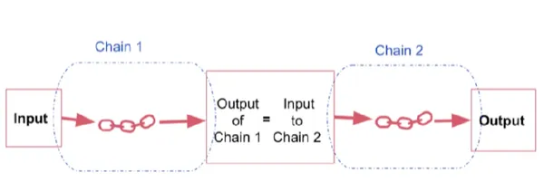

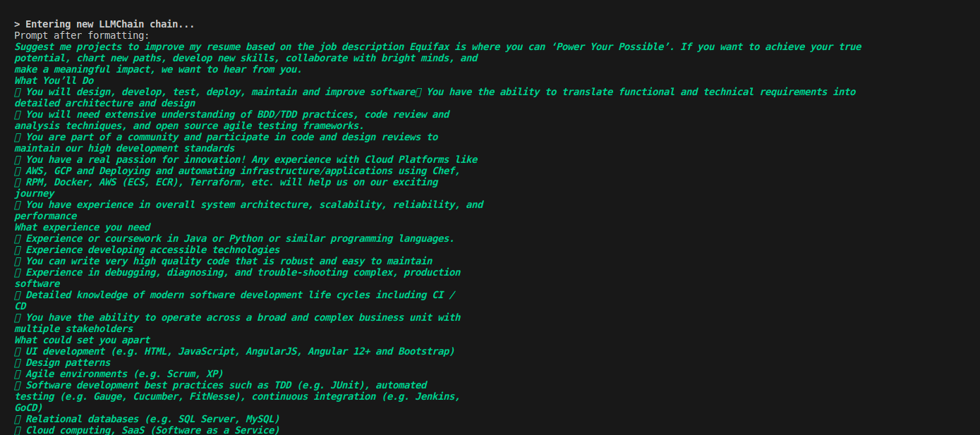

As soon as click project suggestion button is clicked. A new LLM chain is created, and the output is given accordingly.

Benefits of a sequential chain:

Structured Conversational Flows: Sequential Chain enables us to create structured conversational flows that guide users through multi-step interactions with ease and clarity.

Automation of Tasks: Sequential Chain automates the sequential processing of user queries and system responses, streamlining complex tasks and enhancing the overall efficiency of our ATS application.

Enhanced User Experience: By orchestrating coherent and intuitive interactions, Sequential Chain contributes to a seamless and engaging user experience, ensuring that users receive timely and relevant assistance throughout their interaction with our application.

Overall Impact:

The integration of Google Gemini, Langchain, and Sequential Chain significantly enhances the functionality, intelligence, and user experience of our smart ATS application.

By leveraging advanced NLP capabilities, conversational AI features, and sequential processing capabilities, we empower users with personalized insights, recommendations, and assistance tailored to their needs and preferences.

## 4.2 Testing/Verification

Test Cases

* Resume Parsing  
  + File Formats: We tested resume parsing with both .pdf and .docx files to ensure compatibility with common formats.
  + Diverse Layouts: Resumes tested included those with columns, tables, and other structural variations to verify robust extraction.
  + Accuracy: We manually validated that names, contact information, skills, and experience sections were accurately extracted into usable variables.
* JD Matching  
  + Synonyms and Semantic Matches: We tested if the JD matching recognized semantically similar skills expressed with different terms (e.g., 'Java development' vs. 'Java programming')."
  + Irrelevant JDs: We used job descriptions from entirely unrelated fields to confirm that matching scores significantly dropped, demonstrating sensitivity to context.
* Features  
  + Projects/Certifications: We assessed the relevance of suggested projects and certifications by using diverse job descriptions and checking if the outputs aligned with the required skills.
  + Cover Letter: We verified whether generated cover letters appropriately incorporated keywords from the job description and highlighted relevant points from the uploaded resume.

## 4.3 Result Analysis/Screenshots

* User Experience Evaluation

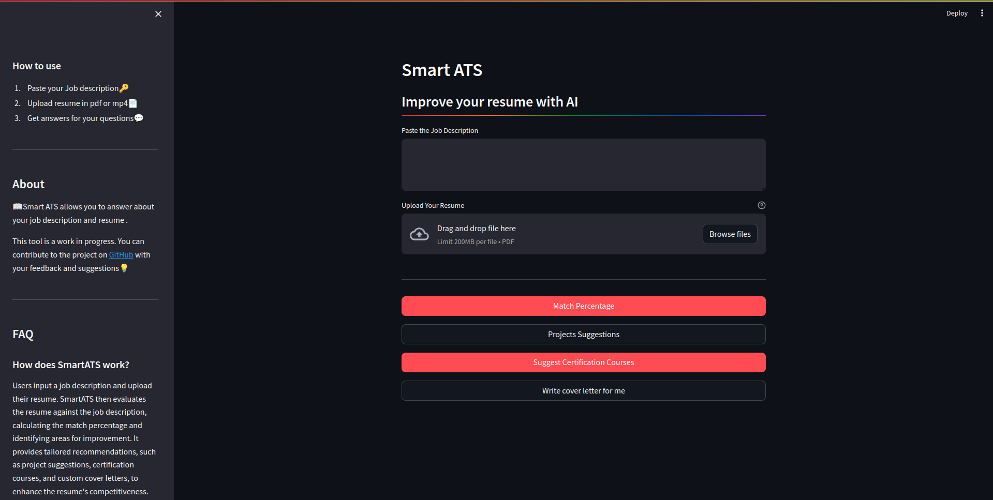

Simple UI of Smart ATS for easy to use.

A dedicated sidebar displaying required information and frequently asked questions.

* Match Percentage

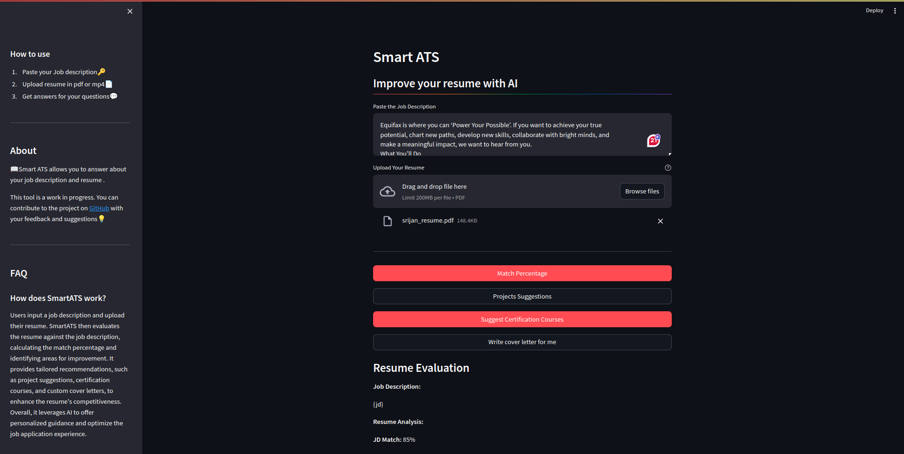

The user uploads the resume and pastes the job description. The Smart application tracking system uses generative AI technology to evaluate the job description match percentage.

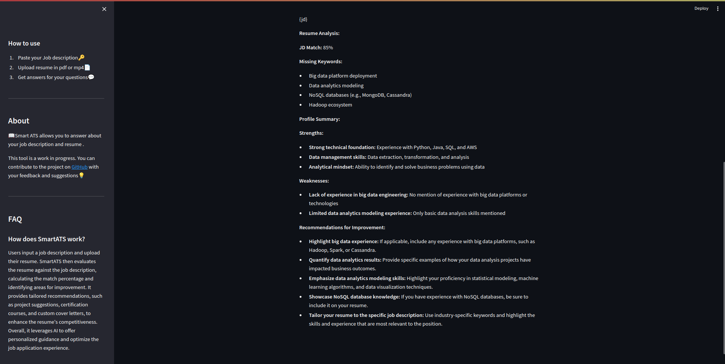

and also suggests the missing keywords and improvement tips.

* Project suggestion evaluation

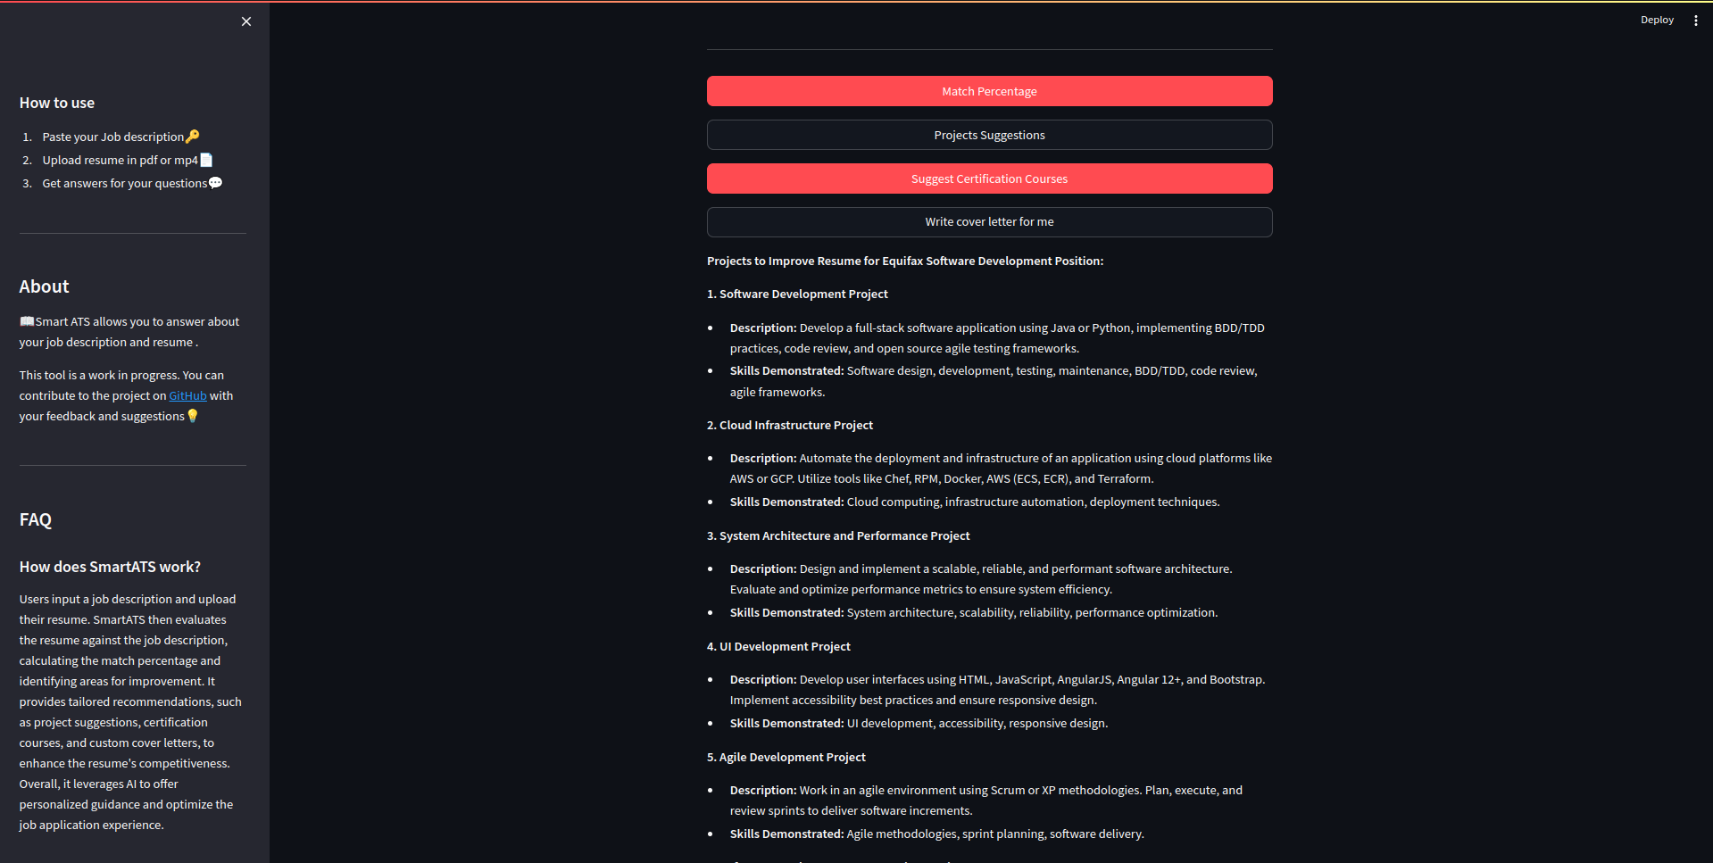

The smart ATS suggests the projects based on the requirements provided in the job description.

* Certification courses suggest evaluation

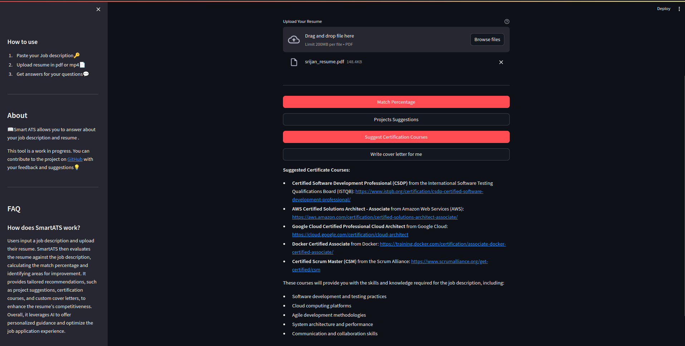

Certificatification course links are provided to users so that they can master the skills specified in the job description.

* Cover letter generation evaluation

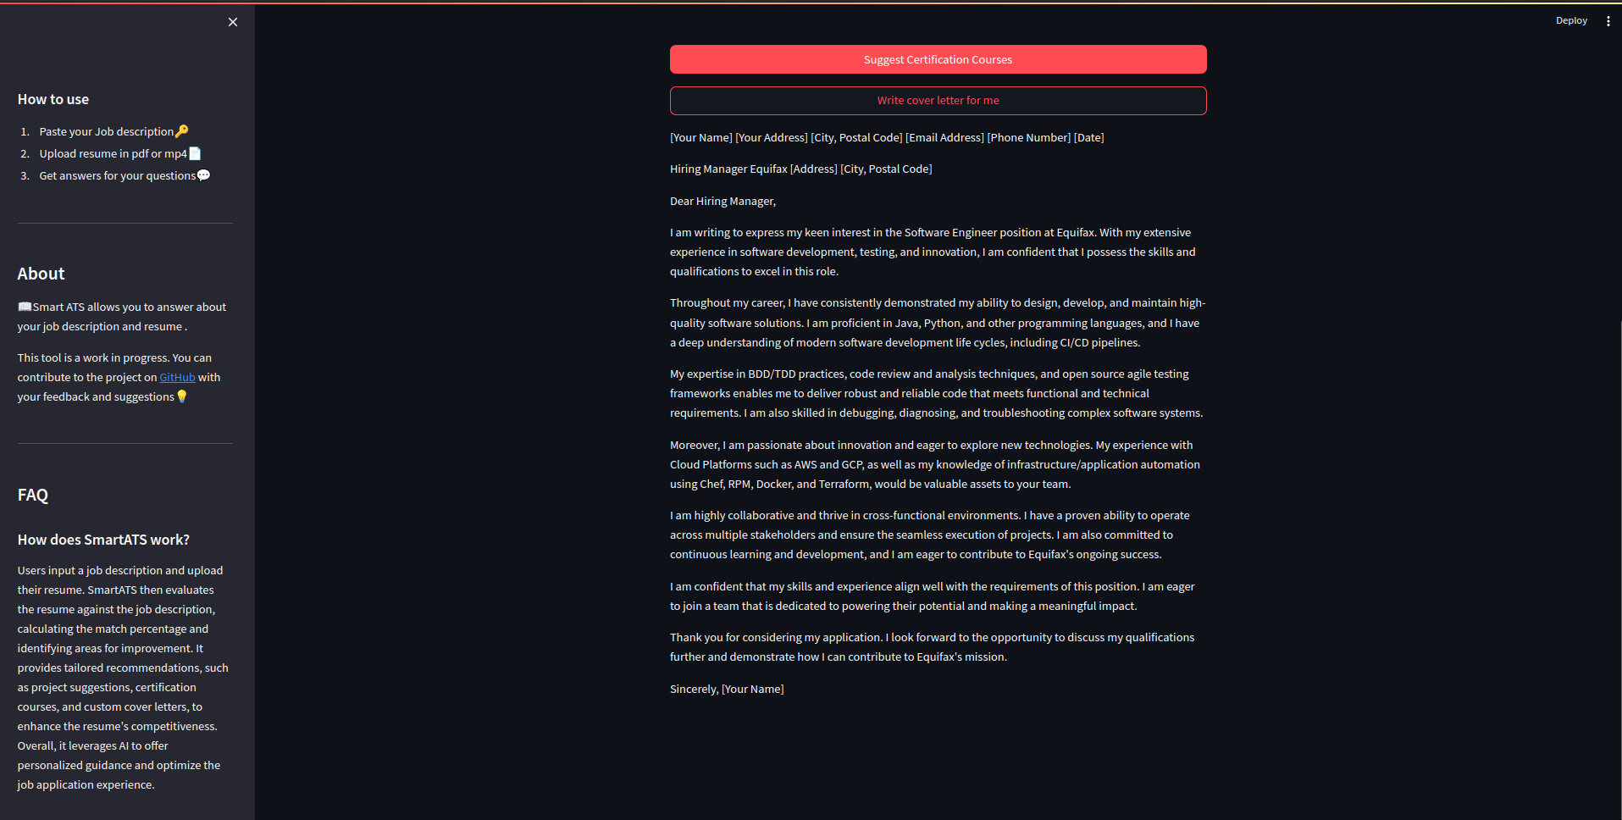

A cover letter is generated from the job description.

## 4.4 Quality Assurance

* Code Style: We adhered to PEP 8 guidelines to maintain code readability and consistency.

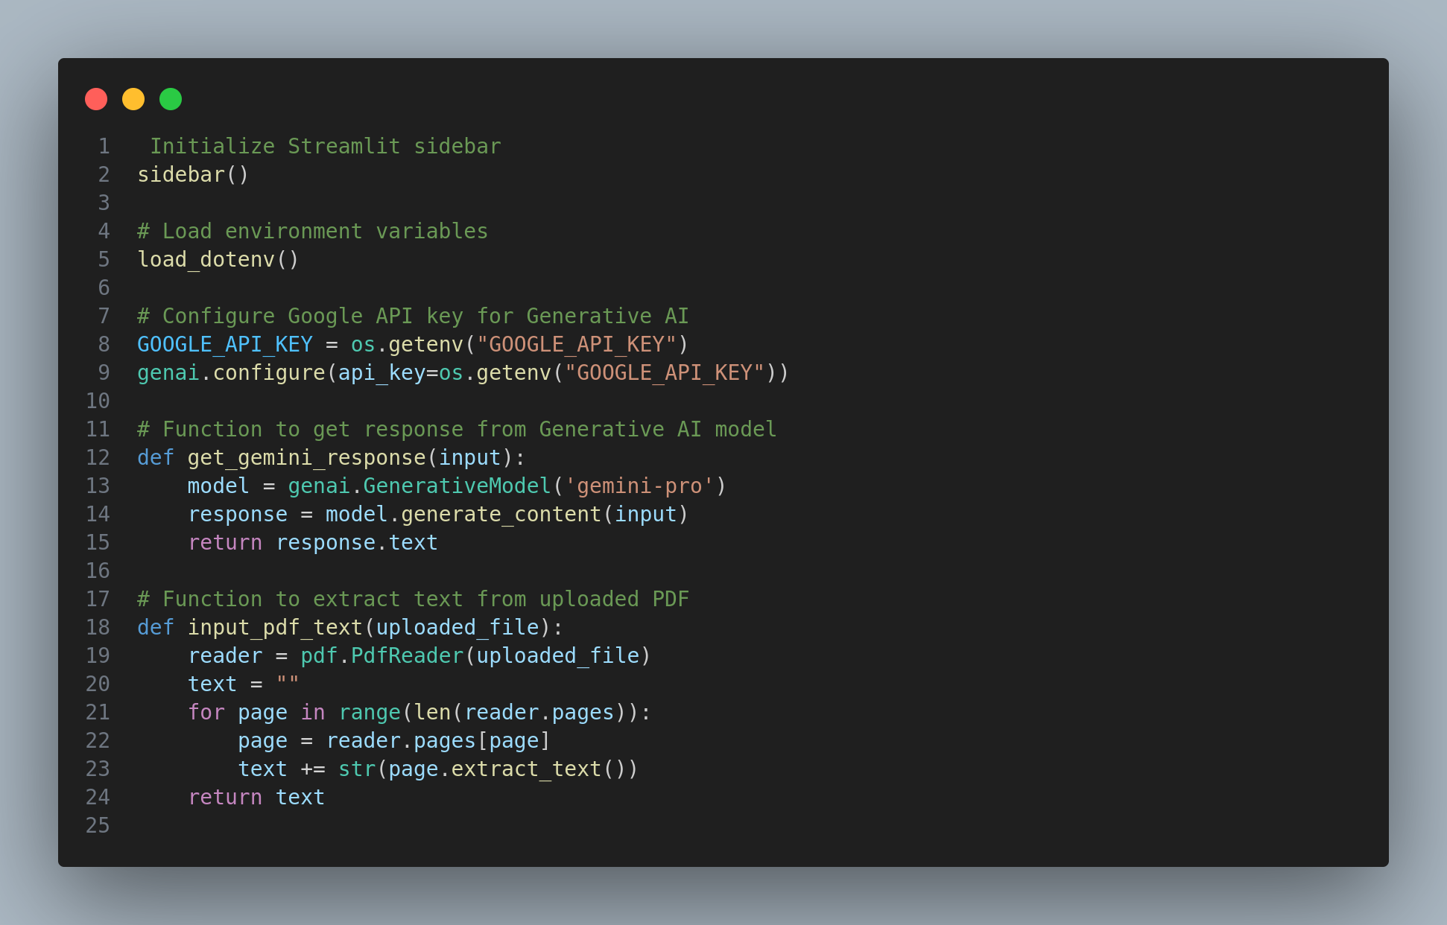

* Testing Practices: We implemented a structured testing process, outlined above with specific test cases, to verify the functionality of the core parsing, JD matching, and the additional features of our application.
* UI Design: We prioritized a user-friendly layout within the Streamlit interface with clear areas for resume upload, job description input, well-labeled buttons, and organized presentation of results."

# 5. Standards Adopted

## 5.1 Design Standards

* **MVC-like Approach:** To structure our app, We aimed to keep a clear separation between the Streamlit UI (for interactions and display), the modules responsible for resume parsing and LLM calls, and the Gemini LLM itself. This mirrored the principles of the MVC design pattern.

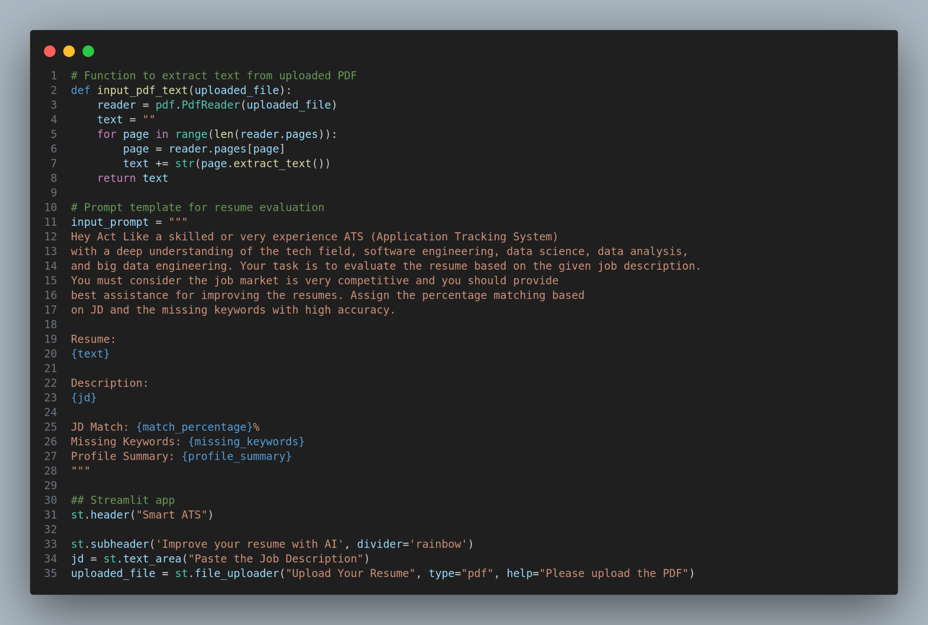

* **Structured Interaction with Gemini:** We utilized LangChain's Prompt templates to define clear instruction sets for Gemini. This helped ensure consistent input formats and streamlined the process of using the LLM for different tasks within the application.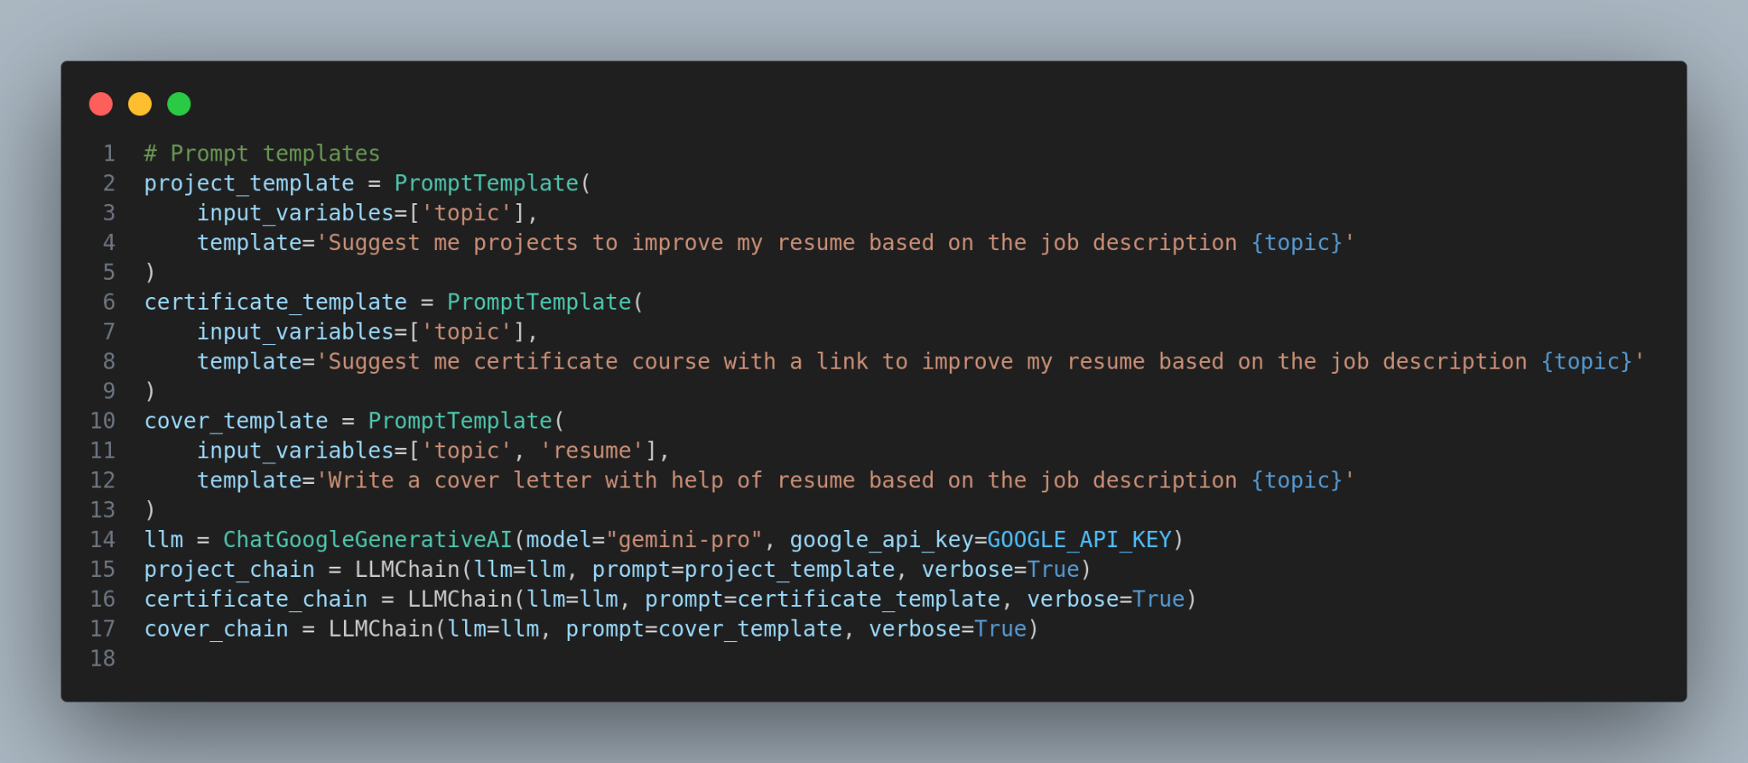

## 5.2 Coding Standards

* **PEP 8 Adherence:** I followed PEP 8 guidelines throughout my Python code to maintain readability and a consistent style. This was especially important for easier maintenance and understanding in the future.
* **Commenting Practices:** I made sure to include clear comments and function documentation to explain my code's logic and purpose.

# 6. Conclusion and Future Scope

## 6.1 Conclusion

* **Project Success:** We successfully developed a Smart ATS that can parse resumes, analyze job descriptions, calculate matching scores, and offer personalized suggestions powered by advanced AI.
* **The Power of AI:** Using generative AI and integrating Google Gemini and LangChain allowed us to create a system that significantly improves upon the limitations of traditional keyword-based ATS systems.
* **Goals Achieved:** The project met the objectives we outlined in the initial requirements specifications.

The Smart ATS application represents a significant advancement in the realm of resume optimization and career development. The application empowers users to enhance their resumes and maximize their professional potential by integrating sophisticated AI algorithms and user-friendly interfaces.

Throughout this analysis, we have observed the application's robust functionality, intuitive user experience, and impressive model performance. The Smart ATS application effectively assists users in evaluating their resumes against job descriptions, suggesting relevant projects and certification courses, and generating custom cover letters tailored to their aspirations.

Furthermore, the application demonstrates resilience in error handling, prioritizes security and privacy, and is designed for scalability and maintainability. These attributes underscore its reliability and suitability for diverse user needs and preferences.

As we move forward, we must continue gathering user feedback and leveraging insights to drive iterative improvements and enhancements. By prioritizing user-centric design principles and embracing emerging technologies, the Smart ATS application can remain at the forefront of innovation in the field of career advancement and resume optimization.

In conclusion, the Smart ATS application represents a valuable resource for individuals seeking to elevate their professional profiles in an increasingly competitive job market. By harnessing the power of AI-driven recommendations and fostering a culture of continuous improvement, the application stands poised to empower users on their journey toward career success and fulfillment.

## 6.2 Future Scope

* **Precision Parsing:** I envision exploring advanced techniques to make resume parsing more accurate, specifically targeting the identification of skills, projects, and relevant experience sections.
* **Making Matching Transparent:** To empower users, I'd like to provide more context along with the match percentage, helping them understand what factors influenced the score.
* **Job Search Integration:** I want to streamline the job application process by allowing users to directly search and apply for relevant openings within the Smart ATS.
* **Preparing for Growth:** I'll investigate ways to scale the deployment of the Smart ATS should I decide to make it available to a wider audience.

# References

[1]Streamlit Team. (n.d.). *Streamlit documentation*.<https://docs.streamlit.io/>

[2]Streamlit Team. (n.d.). *Streamlit gallery*<https://streamlit.io/gallery>.

[3]Google AI. (n.d.). *Google AI Blog*.<https://ai.googleblog.com/>

[4]LangChain. (n.d.). *LangChain documentation*.<https://langchain.readthedocs.io/en/latest/>

# INDIVIDUAL CONTRIBUTION REPORT:

**Smart application tracking system: Leveraging Generative AI and langchain**

SHIVENDRA SINGH

2029197

**Abstract:** Traditional Applicant Tracking Systems (ATS) often rely on simplistic keyword matching algorithms, leading to missed qualified candidates and inefficient resume screening processes. This project introduces a Smart ATS that leverages the power of advanced artificial intelligence techniques to enhance matching accuracy, provide personalized recommendations, and streamline the job application process. Powered by a cutting-edge large language model (LLM), Google Gemini, and integrated with the LangChain framework, the Smart ATS semantically analyzes resumes and job descriptions to calculate contextually relevant matching scores. Additionally, the system generates tailored project and certification suggestions for candidates to improve their applications, as well as drafts customized cover letters. This approach aims to bridge the gap between traditional ATS systems and the needs of the modern job market, empowering both job seekers and recruiters.

**Individual contribution and findings:** I helped in deciding to choose the topic for our project. Suggested initial development ideas to my team members and made proper planning to execute the project within the deadline. I integrated the streamlit framework into our code.

**Individual contribution to project report preparation:** I wrote the introduction and did the literature review. I was responsible for all the grammatical checks. I also wrote the System design description of the UML diagram.

**Individual contribution for project presentation and demonstration:**



Full signature of the student

**INDIVIDUAL CONTRIBUTION REPORT:**

**Smart application tracking system: Leveraging Generative AI and langchain**

SRIJAN KUMAR

2029202

**Abstract:** Traditional Applicant Tracking Systems (ATS) often rely on simplistic keyword matching algorithms, leading to missed qualified candidates and inefficient resume screening processes. This project introduces a Smart ATS that leverages the power of advanced artificial intelligence techniques to enhance matching accuracy, provide personalized recommendations, and streamline the job application process. Powered by a cutting-edge large language model (LLM), Google Gemini, and integrated with the LangChain framework, the Smart ATS semantically analyzes resumes and job descriptions to calculate contextually relevant matching scores. Additionally, the system generates tailored project and certification suggestions for candidates to improve their applications, as well as drafts customized cover letters. This approach aims to bridge the gap between traditional ATS systems and the needs of the modern job market, empowering both job seekers and recruiters.

**Individual contribution and findings:** My task was to choose the perfect LLM model. I worked with different LLM models to check their compatibility and complexity during my research. I also worked on choosing the Python framework for our front end. I found streamlit to be most suitable for generative AI work.

**Individual contribution to project report preparation:** I wrote the methodology and the testing section, made the UML diagram, and added its description.

**Individual contribution for project presentation and demonstration:** In the presentation, I demonstrated the need for normalization and feature scaling



Full signature of the student

**INDIVIDUAL CONTRIBUTION REPORT:**

**Smart application tracking system: Leveraging Generative AI and langchain**

SNEHA SINGH

2029203

**Abstract:** Traditional Applicant Tracking Systems (ATS) often rely on simplistic keyword matching algorithms, leading to missed qualified candidates and inefficient resume screening processes. This project introduces a Smart ATS that leverages the power of advanced artificial intelligence techniques to enhance matching accuracy, provide personalized recommendations, and streamline the job application process. Powered by a cutting-edge large language model (LLM), Google Gemini, and integrated with the LangChain framework, the Smart ATS semantically analyzes resumes and job descriptions to calculate contextually relevant matching scores. Additionally, the system generates tailored project and certification suggestions for candidates to improve their applications, as well as drafts customized cover letters. This approach aims to bridge the gap between traditional ATS systems and the needs of the modern job market, empowering both job seekers and recruiters.

**Individual contribution and findings:** My main role for this project was working with langchain and understanding how it would benefit our project. For this, I studied the complete documentation of Langchain and found that we can use the sequential chain feature in our project to suggest proper things.

**Individual contribution to project report preparation:** I wrote the project planning section, I also wrote the SRS document and wrote the standard adopted section of our report.

**Individual contribution for project presentation and demonstration:**



Full signature of the student

**INDIVIDUAL CONTRIBUTION REPORT:**

**Smart application tracking system: Leveraging Generative AI and langchain**

JYOTI KUMARI

2029204

**Abstract:** Traditional Applicant Tracking Systems (ATS) often rely on simplistic keyword matching algorithms, leading to missed qualified candidates and inefficient resume screening processes. This project introduces a Smart ATS that leverages the power of advanced artificial intelligence techniques to enhance matching accuracy, provide personalized recommendations, and streamline the job application process. Powered by a cutting-edge large language model (LLM), Google Gemini, and integrated with the LangChain framework, the Smart ATS semantically analyzes resumes and job descriptions to calculate contextually relevant matching scores. Additionally, the system generates tailored project and certification suggestions for candidates to improve their applications, as well as drafts customized cover letters. This approach aims to bridge the gap between traditional ATS systems and the needs of the modern job market, empowering both job seekers and recruiters.

**Individual contribution and findings:** My task was to read and understand the Google Gemini API calling system. I also took part in maintaining the standard coding and design standards for our project.

**Individual contribution to project report preparation:** I did the result analysis, wrote the quality assurance report, and wrote the conclusion and future scope of the project. I was responsible for writing the reference section also.

**Individual contribution for project presentation and demonstration:**



Full signature of the student

# *TURNITIN PLAGIARISM REPORT*