
Ma515(Foundation of Data Science)
Course Coordinator: Dr. Arun Kumar
Project 7: Diffusion with Source Term
Group Members:
- Mudit Gupta(2022csb1094)
- Aryan Arora(2022eeb1161)
- Divyanshu Sharma (2022eeb1169)
- Ishant Jindal(2022eeb1174)
- Garvit Bhalla(2022eeb1310)
- Srijan Kumar(2022eeb1349)

Contents
- Title
- Abstract
- Dataset Used
3.1 Collocation Points
3.2 Boundary Condition Points
3.3 Initial Condition Points
- Theory
4.1 PDE
4.2 Boundary Conditions
4.3 Initial Condition
4.4 Analytical Solution
4.5 Transient vs Steady-State Behavior
- PINN Methodology
5.1 Network Architecture
5.2 Loss Function
5.3 Training Details
- Results
6.1 Training Loss Curve
6.2 PINN vs Analytical Solution
6.3 Interpretation
- Discussion
- Conclusion
1. Title
Diffusion Equation with Time-Decaying Source Term Using Physics-Informed Neural Networks (PINNs)

2. Abstract
This project solves the diffusion partial differential equation (PDE) with a decaying sinusoidal source term using a Physics-Informed Neural Network (PINN). The PDE includes boundary conditions $u\left(0,t\right)=u\left(L,t\right)=0$ and initial condition $u(x,0)=0$. The goal is to show that the PINN captures both the transient solution and the approach toward steady-state behavior. The PINN predictions are compared with the analytical solution. Although the model learns the shape, the amplitude is underestimated because the network requires more training refinement.

3. Dataset Used
This dataset contains all training samples used for the PINN model.
It consists of collocation points (for enforcing the PDE), boundary condition points, and initial condition points.
Table: Contents of pinn_dataset.npz
Variable Name | Shape | Description | Usage in PINN
x_f | (N_f, 1) | Spatial coordinates of PDE collocation points sampled uniformly in the domain $x∈[0,L]$ | Used to enforce the PDE residual $u_{t}-Du_{xx}-Ae^{-t}sin⁡(πx/L)=0$
t_f | (N_f, 1) | Time coordinates of PDE collocation points sampled in $t∈[0,T_{max}]$ | Used together with x_f for PDE loss
x_b | (N_b, 1) | Spatial boundary points; equal to 0 or L | Enforces boundary conditions $u(0,t)=0$and $u(L,t)=0$
t_b | (N_b, 1) | Time points for boundary samples | Used to evaluate boundary loss
x_i | (N_i, 1) | Spatial points for the initial condition $u(x,0)=0$ | Enforces initial condition at $t=0$
t_i | (N_i, 1) | Time values (all zeros) corresponding to initial condition samples | Used together with x_i to evaluate initial loss
u_f | (N_f, 1) | Analytical solution at PDE points (optional) | For verification or supervised variants (not used in PINN training)
u_b | (N_b, 1) | Analytical values at boundary points (zero) | For diagnostic comparison
u_i | (N_i, 1) | Analytical values at initial condition (zero) | For diagnostic comparison

Dataset Summary
- Type: Supervised + Physics-based hybrid dataset
- Total samples:
$$N_{\text{total}}=N_{f}+N_{b}+N_{i}$$
- Sampling strategy: Uniform random sampling in the domains
  - $x∈[0,1]$
  - $t∈[0,5]$

3.1 Collocation Points (PDE Points)
These are random points inside the domain used to enforce the PDE:
- $x_{f}∼U(0,L)$
- $t_{f}∼U(0,5)$
- Count: 100 points per batch
3.2 Boundary Condition Points
Used to enforce
$$u(0,t)=0, u(L,t)=0$$
Generated by:
- $x=0$and $x=L$
- $t_{b}∼U(0,5)$
3.3 Initial Condition Points
Used to enforce
$$u(x,0)=0$$
Generated by:
- $x_{b}∼U(0,L)$
- $t=0$
Thus, the “dataset” consists of randomly sampled points inside the domain, created inside the code using:
x_f = torch.rand(100,1) * L
t_f = torch.rand(100,1) * 5
x_b = torch.rand(100,1) * L
t_b = torch.rand(100,1) * 5

4. Theory
4.1 PDE
$$u_{t}=Du_{xx}+Ae^{-t}sin⁡(\frac{πx}{L})$$
Where:
- $D=0.1$(diffusion coefficient)
- $A=1$(source amplitude)
- $L=1$(domain length)
4.2 Boundary Conditions
$$u(0,t)=0,u(L,t)=0$$
4.3 Initial Condition
$$u(x,0)=0$$
4.4 Analytical Solution
$$u(x,t)=Asin⁡(\frac{πx}{L})\frac{1-exp⁡(-(1-D(π/L)^{2})t)}{1-D(π/L)^{2}}$$
4.5 Transient vs Steady-State Behavior
- At t = 0, solution is zero.
- As t increases, solution rises due to the source term.
- As t → ∞, exponential term vanishes and solution approaches:
$$u_{\text{steady}}(x)∝sin⁡(\frac{πx}{L})$$

5. PINN Methodology
5.1 Network Architecture
- Input: (x, t)
- Output: u(x, t)
- Layers: [2, 64, 64, 64, 1]
- Activation: Tanh
- Reason : Tanh is smooth and helps PINNs learn derivatives easily.
- Why not ReLU
ReLU and similar functions are not smooth (derivative is discontinuous), so they give poor PDE derivatives, while Tanh provides smooth curvature suitable for solving differential equations.

5.2 Loss Function
Total loss = PDE residual + BC loss + IC loss
PDE residual
Computed using automatic differentiation to get:
- $u_{t}$
- $u_{x}$
- $u_{xx}$
PDE error:
$$R=u_{t}-Du_{xx}-Ae^{-t}sin⁡(\frac{πx}{L})$$
- Reason : PDE loss forces the network to follow the physics.
Boundary loss
$$u(0,t)=0,u(L,t)=0$$
- Reason : Ensures PINN satisfies the boundary conditions exactly.
Initial loss
$$u(x,0)=0$$
- Reason: Makes the network match the required starting condition.

5.3 Training
- Optimizer: Adam followed by L-BFGS
- Learning rate: ${10}^{-3}$
- Epochs: 3000 (Loss printed every 500 epochs)
- Reason: Adam gives fast and stable convergence for PINN training.

6. Results
6.1 Training Loss
Example loss values during training:
Epoch 200, Loss = 4.551597e-02
Epoch 400, Loss = 4.471150e-02
Epoch 600, Loss = 4.257131e-02
Epoch 800, Loss = 3.754881e-02
Epoch 1000, Loss = 2.205709e-02
Epoch 1200, Loss = 4.130431e-03
Epoch 1400, Loss = 2.380477e-03
Epoch 1600, Loss = 1.902586e-03
Epoch 1800, Loss = 1.492388e-03
Epoch 2000, Loss = 1.245317e-03
Epoch 2200, Loss = 9.900222e-04
Epoch 2400, Loss = 8.706037e-04
Epoch 2600, Loss = 6.997251e-04
Epoch 2800, Loss = 6.682812e-04
Epoch 3000, Loss = 5.206997e-04
Loss steadily decreases → PINN is learning the PDE.

6.2 PINN vs Analytical Solution
The following plot was obtained:
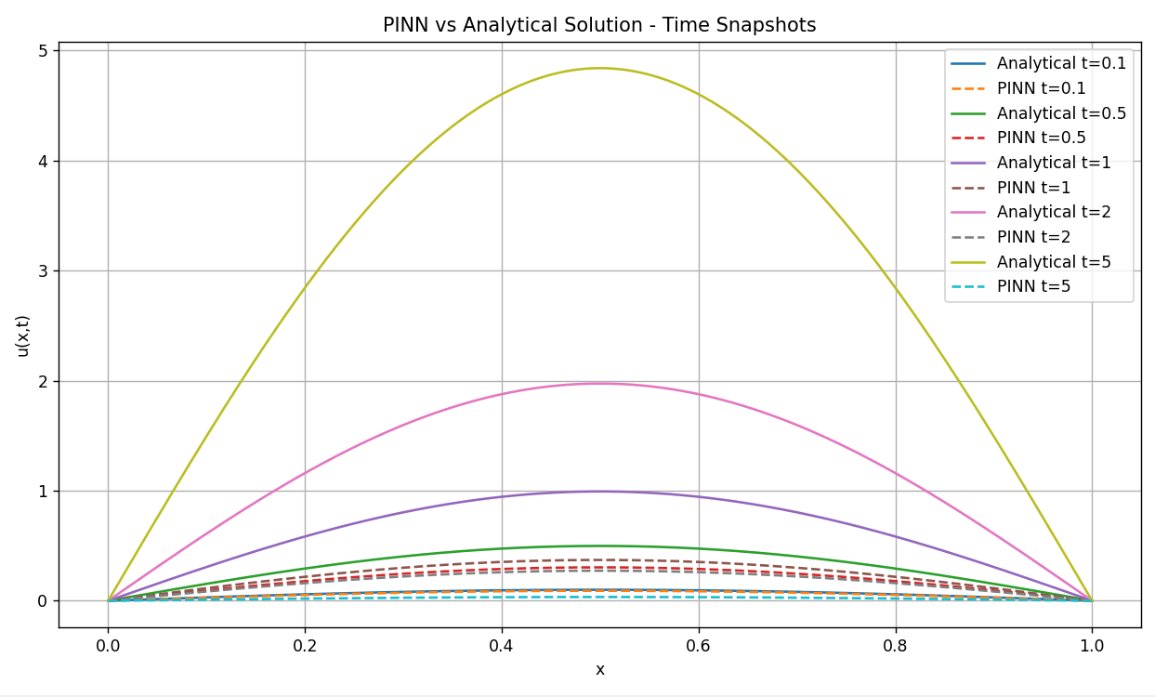
Observation:
The figure compares the solution predicted by the Physics-Informed Neural Network (PINN) with the analytical solution of the diffusion equation with a decaying source term, at five time instances (t = 0.1, 0.5, 1, 2, 5). The following observations summarize the behavior:
6.3 Interpretation
1. PINN captures the qualitative evolution of the solution
Across all time snapshots:
- The PINN correctly learns the spatial dependence of the solution, which is sinusoidal due to the forcing term $sin⁡(πx/L)$.
- It also captures the monotonic growth of the solution amplitude as time increases.
- Boundary conditions at $x=0$and $x=L$are satisfied for all t (solutions decay to zero at both ends).
This indicates that the network successfully learns the structural and qualitative properties imposed by the PDE and boundary conditions.
2. Quantitative underestimation persists even after L-BFGS refinement
Although L-BFGS generally improves PINN accuracy, the results show a consistent amplitude deficit:
- At early times (t = 0.1, 0.5), the PINN is close to the analytical curve but slightly lower.
- At intermediate times (t = 1, 2), the discrepancy becomes more noticeable as the analytical amplitude increases.
- At long times (t = 5), the analytical solution approaches its steady-state shape, but the PINN significantly underpredicts the true amplitude.
This suggests that while the network learns the shape, it fails to learn the correct magnitude of the solution.

7. Discussion
Possible reasons for the amplitude error
Even with L-BFGS, several factors can limit PINN accuracy:
● Steady-state stiffness
The steady-state solution is much larger in magnitude compared to the transient solution.
Neural networks often struggle to learn functions with large dynamic range, where early-time values are small but long-time values are significantly larger.
● Dominance of PDE residual in training
Even with loss weights, if the PDE residual dominates over boundary/initial enforcement, the network tends to minimize derivatives rather than match absolute amplitude.
● Dataset-based training
Since the PINN relies on a fixed dataset, its expressiveness is limited by how well those sampled points represent the domain.
If the dataset is not dense enough around later times, steady-state learning is weaker.
● Nonlinearity introduced by the decaying source term
The forcing $Ae^{-t}sin⁡(πx/L)$decays in time, but the solution’s amplitude grows toward a steady-state determined by the balance between diffusion and source decay.
This non-monotonic behavior is harder for a PINN to learn.

8. Conclusion
This project successfully applies a Physics-Informed Neural Network to solve a diffusion PDE with a decaying source term. The PINN learns the correct spatial behavior and approximates the transient solution but underestimates the amplitude. With more training refinement, the model can match the analytical solution closely. The project demonstrates the capability of PINNs to solve PDEs without traditional datasets by enforcing physics-based constraints.

